**2022 HOUSING CENSUS - MAIN RESULTS**

1. **Introduction**

This issue of Economic and Social Indicators (ESI) presents the main results of the 2022 Census of Dwellings (Housing Census), hereafter referred to as Housing Census, conducted in the Republic of Mauritius from 01 May to 31 May 2022 in line with the United Nations Principles and Recommendations for Population and Housing Censuses, Revision 3. It also includes a summary of the changes that occurred since the 2011 Housing Census in the number and other characteristics of buildings, housing units and households.

This is the first digital Housing Census using Computer Assisted Personal Interviews (CAPI) technology whereby tablets were used as an instrument to record answers from respondents. It is to be noted that the Housing Census was conducted successfully in the midst of the COVID-19 pandemic.

Figures for 2022 are provisional and are subject to revision.

A list of definitions and a set of detailed tables for the Republic of Mauritius and its main constituent islands are at Annexes I and II respectively.

1. **Highlights**
2. In 2022, a total of 329,000 buildings, 411,700 housing units and 369,000 private households were enumerated in the Republic of Mauritius.
3. Out of these 329,000 buildings, the majority (280,300 or 85.2%) were categorised as wholly residential buildings.
4. The number of housing units grew by 14.7%, from 359,000 in 2011 to 411,700 in 2022.
5. 84.5% of the housing units were categorised as principal residence, 1.5% of them as secondary residence and the remaining 14.0% were vacant ones.
6. Private households increased by 7.8% from 342,360 in 2011 to 369,000 in 2022.

The average household size showed a decrease from 3.6 to 3.3 during the same period.

1. Housing and living conditions improved from 2011 to 2022 with higher proportions of households:

* owning their houses (from 88.8% to 90.4%);
* having access to electricity (from 99.5% to 99.6%); and
* with piped water inside their house (from 94.3% to 96.4%).

1. From 2011 to 2022, access to internet has more than doubled (from 31.7% to 75.0%). Internet was used both for educational purposes and work from home as well as for entertainment.
2. **Housing Census Statistics**

**Table 1: Buildings, housing units, private households and population for Republic of Mauritius, 2011 and 2022 Censuses**

|  |  |  |  |  |  |  |  |  |
| --- | --- | --- | --- | --- | --- | --- | --- | --- |
|  | **Buildings** | | **Housing units** | | **Private households** | | **Population1** | |
|  | **2011** | **2022** | **2011** | **2022** | **2011** | **2022** | **2011** | **2022** |
| **Republic of Mauritius** | **311,500** | **329,000** | **359,000** | **411,700** | **342,360** | **369,000** | **1,260,400** | **1,251,000** |
| Island of Mauritius | 297,490 | 313,550 | 346,780 | 396,580 | 331,290 | 355,600 | 1,219,605 | 1,203,300 |
| Island of Rodrigues | 13,900 | 15,330 | 12,140 | 15,000 | 10,990 | 13,285 | 40,510 | 45,300 |
| Island of Agalega | 110 | 120 | 80 | 120 | 80 | 115 | 285 | 2,400 |

*1Population in both private and communal households*

* 1. **Buildings types**

***Wholly residential buildings still dominate the market***

There were 329,000 buildings enumerated in the Republic of Mauritius at the 2022 Housing Census. The majority consisted of wholly residential buildings used by private households, that is, 280,300 or 85.2%, compared to 261,600 or 84.0% in 2011.

**Table 2: Number of buildings by type, Republic of Mauritius, 2011 and 2022 Housing Census**



**3.2 Residential and partly residential buildings**

**Figure 1: Buildings by type, Republic of Mauritius, 2011 and 2022 Housing Censuses**

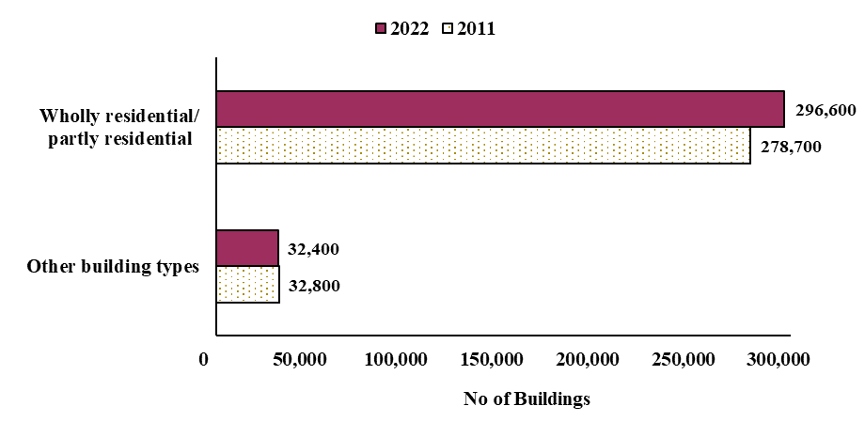

It is also worth noting that the increase in the stock of buildings by 17,500 (from 311,500 to 329,000) or 5.6% from 2011 to 2022, was mainly due to an increase in the number of wholly residential buildings, partly offset by decreases in non-residential and partly residential buildings.

Residential and partly residential buildings used for living purposes has witnessed an increase of 17,900, from 278,700 in 2011 to 296,100 in 2022.

***Dwellings in storeyed buildings is becoming more common***

From 2011 to 2022, buildings* with ground floor only registered a decline from 155,600 to 135,600, while the number of storeyed buildings increased by 38,100, from 122,400 to 160,500 during the same period.

Among the storeyed buildings, the number of buildings with more than one storey grew even faster, by 61.9%, from 8,400 to 13,600 during the same period, indicating a higher tendency for people to construct multi-storeyed buildings.

* Figures exclude 700 detached rooms in 2011 and 500 in 2022, used as part of household

**Figure 2: Non-storeyed and storeyed residential & partly residential buildings, Republic of Mauritius, 2011 and 2022 Housing Censuses**

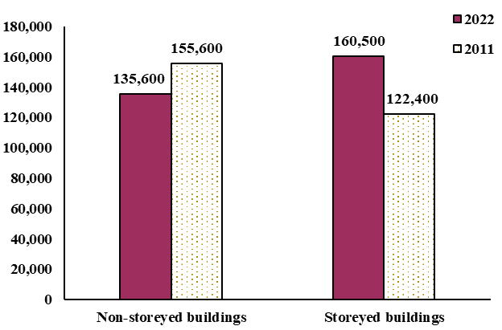

**[[[**

***Separate houses dominate***

Separate buildings, that is buildings made up of only one housing unit, dominate among residential and partly residential buildings, and comprised around 77.8% of such buildings, compared to 76.7% in 2011.

In contrast, the share of high-density housing units, that is semi-detached houses (comprising 2 housing units) and block of flats (comprising 3 or more housing units), has decreased from 16.3% to 15.5% during the 2011-2022 period, though it increased by around 600 in absolute number.

During the same period, the share of partly residential buildings decreased from 6.2% to 5.5%.

**Figure 3: Residential and partly residential buildings by type, Republic of Mauritius, 2011 and 2022 Housing Censuses**

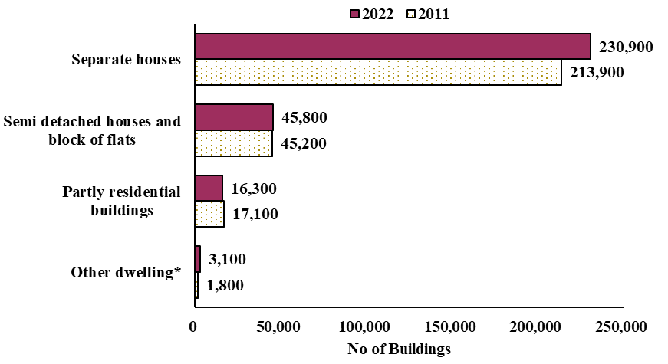

* Figures exclude 700 detached rooms in 2011 and 500 in 2022, used as part of household

***Decline in houses made of wooden walls & iron/tin/shingle roof***

People tend to build their houses (roof and wall) using concrete, resulting in an increase in the share of this type of building, from 255,800 (92.0%) in 2011 to 280,700 (94.8%) in 2022. Houses made of concrete walls and iron/tin roof is on the decline, 2.7% in 2011 against 2.3% in 2022.

Similarly, the stock of houses made of iron/tin walls and roof is declining in terms of absolute numbers, 5,100 fewer (from 12,600 in 2011 to 7,500 in 2022) such buildings reported in 2022, as well as in terms of share (4.5% in 2011 against 2.5% in 2022).

**Figure 4: Residential and partly residential buildings by construction material, Republic of Mauritius, 2011 and 2022 Housing Censuses**

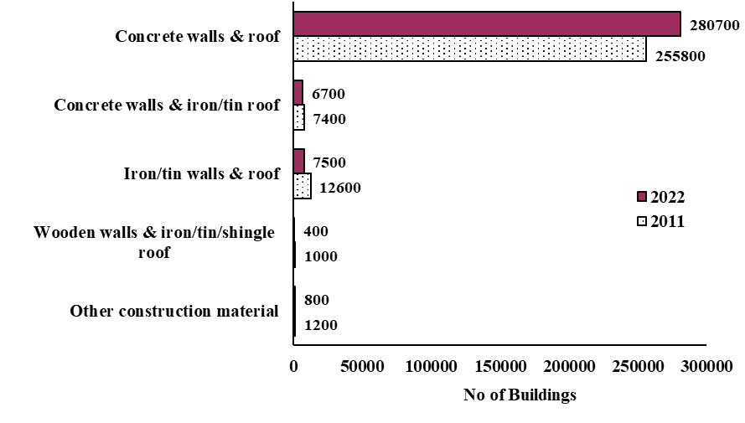

1. **Housing units**

***Vacant houses on the rise***

As in 2011, the majority of housing units in 2022 were being used as principal residence. An increase of 22,200 was noted from 325,800 in 2011 to 348,000 in 2022, though in terms of share it decreased from 90.8% to 84.5% during the same period. The number of vacant housing units has more than doubled from 28,000 to 57,500 and its share rising from 7.8% to 14.0% during the period 2011 to 2022.

**Table 3: Distribution of housing units by occupancy status, Republic of Mauritius, 2011 and 2022 Housing Censuses**

|  |  |  |  |  |
| --- | --- | --- | --- | --- |
| **Type of occupancy** | **2011** | | **2022** | |
| **Number** | **%** | **Number** | **%** |
| Housing units occupied as: |  |  |  |  |
| Principal residence | 325,800 | 90.8 | 348,000 | 84.5 |
| Secondary residence | 5,200 | 1.4 | 6,200 | 1.5 |
| Vacant Housing | 28,000 | 7.8 | 57,500 | 14.0 |
| **Total** | **359,000** | **100.0** | **411,700** | **100.0** |

***Home ownership without mortgage dominates***

From 2011 to 2022, an increase was noted in the proportion of private ownership of housing units, from 99.1% to 99.4%, mainly driven by a rise in home ownership without mortgage from 77.7% to 82.1%.

**Table 4: Housing units by ownership and mortgage status, Republic of Mauritius, 2011 and 2022 Housing Censuses**

|  |  |  |  |  |
| --- | --- | --- | --- | --- |
| **Ownership** | **2011** | | **2022****\*** | |
| **Number** | **%** | **Number** | **%** |
| Private | 355,600 | 99.1 | 352,300 | 99.4 |
| *Mortgaged* | *44,300* | *12.4* | *48,300* | *13.6* |
| *Non-mortgaged* | *279,000* | *77.7* | *290,850* | *82.1* |
| *Not Known* | *32,300* | *9.0* | *13,150* | *3.7* |
| Public | 1,100 | 0.3 | 600 | 0.2 |
| Not Stated | 2,300 | 0.6 | 1,300 | 0.4 |
| **Total** | **359,000** | **100.0** | **354,200** | **100.0** |

**\***Total for year 2022 exclude 57, 500 vacant housing units for which ownership were unknown

***Amenities in housing units***

In 2022, the proportion of households having the following amenities at housing unit level were:

* Solar water heater was 36.3%;
* Water pump was 44.3%;
* Domestic water tank/reservoir was 67.9%;
* Air conditioner was 29.9%;
* Room heater was 1.8%;
* Compost bin 4.6%;
* Rain water harvest tank was 4.0%; and
* Rain water absorption pit was 3.5%.

1. **Households**

***Household size continues to decrease***

The 2022 Housing Census enumerated 369,000 private households, representing an increase of 7.8% over the 2011 census figure of 342,360. Moreover, from 2011 to 2022,

* The average household size went down from 3.6 to 3.3 persons.
* The average number of persons per room used for living purposes improved from 0.8 to 0.6. With fewer persons in each household, more living space was available per person.

**Table 5: Number of private households, household size and number of persons per room, Republic of Mauritius, 2011 and 2022 Housing Censuses**

|  |  |  |
| --- | --- | --- |
|  | **2011** | **2022** |
| Number of Private households | 342,360 | 369,000 |
| Household size | 3.6 | 3.3 |
| Number of persons per room | 0.8 | 0.6 |

***Share of rented households on the decline***

In 2022, 90.4% of households owned the housing unit they occupied, compared to 88.8% in 2011. This resulted in the reduction in the proportion of private households who rented their houses, from 8.0% to 6.5%.

**Table 6: Distribution of households by tenure, Republic of Mauritius, 2011 and 2022 Housing Censuses**

|  |  |  |  |  |
| --- | --- | --- | --- | --- |
| **Tenure** | **2011** | | **2022** | |
| **Number** | **%** | **Number** | **%** |
| Owner | 304,140 | 88.8 | 333,550 | 90.4 |
| Tenant and Sub-tenant | 27,230 | 8.0 | 24,150 | 6.5 |
| Free and Other | 10,990 | 3.2 | 11,300 | 3.1 |
| **Total** | **342,360** | **100.0** | **369,000** | **100.0** |

Compared to 2011, the average monthly rent for housing nearly doubled in 2022 (from Rs 4,400 to Rs 8,200).

***Overall, availability of household amenities continues to improve ….***

A general improvement in the availability of basic amenities to household has been noted during the intercensal period 2011 to 2022, with a higher proportion of households having:

* Kitchen inside their houses;
* Bathroom with running water;
* Flush toilet;
* Garbage regularly collected by authorised collectors; and
* Piped water inside their houses.

**Figure 5: Proportion (%) of households with selected amenities, Republic of Mauritius, 2011 and 2022 Housing Censuses**

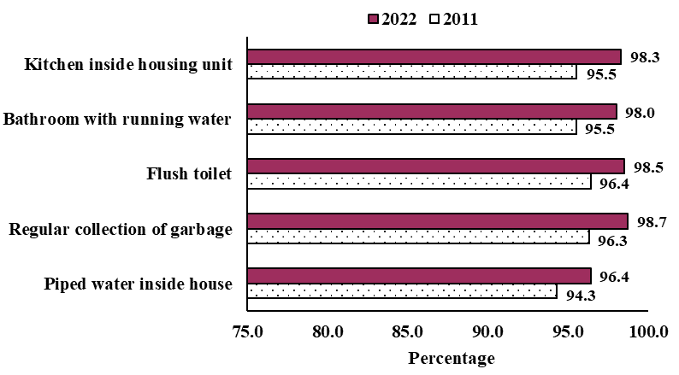

***… but some households are still without basic amenities***

Compared to 2011, the number of households without basic amenities such as, toilet, kitchen, piped water, bathroom, and electricity has decreased.

**Figure 6: Private households without basic amenities, Republic of Mauritius, 2011 and 2022 Housing Censuses**

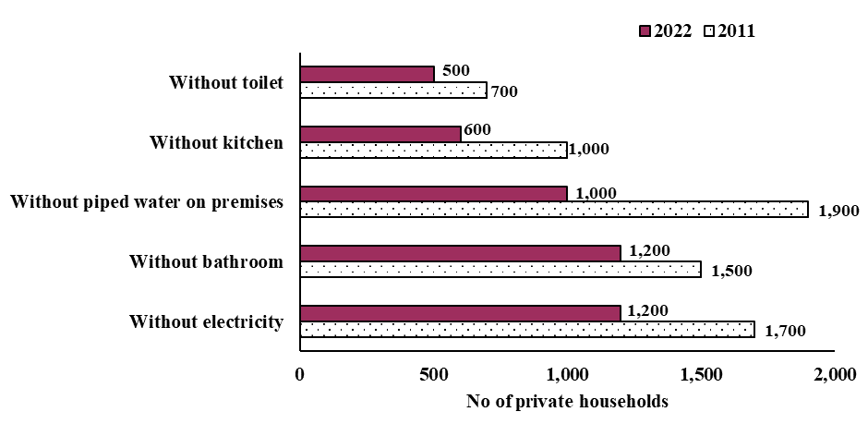

**5.4 Principal fuel for cooking**

In 2022, Liquefied Petroleum Gas (LPG) still remains the most common type of fuel used for cooking by households. Nearly all (99.2%) households used LPG as the principal type of cooking fuel as compared to 97.7% in 2011. On the other hand, the use of wood and charcoal decreased from 1.9% to 0.2%.

**5.5 Kitchen garden**

In 2022, out of 354,200 housing units (principal and secondary residence), 62,800 or 17.7% had a kitchen garden in its premise for a space of less than or equal to 1 perch/40 m2/11 toises.

**5.6 Outdoor space for recreational activities**

Some 165,670 or 46.7% households reported to have outdoor space for recreational activities as part of their housing units or adjacent to their buildings/apartments where they lived or within walkable distance.

**5.7 Parking Facilities**

In 2022, some 167,300 households reported to have a four-wheeled vehicle. Of these, 48.9% indicated having an open garage on their premises as main parking facility followed by 30.7% having a closed garage.

**5.8 ICT in Households**

***ICT penetration increases***

ICT use and access has become vital in households, especially with ‘online educational programs’ and ‘Work from Home’ which have become very popular with the restrictions on movement due to COVID-19 pandemic in 2020 and 2021. In 2022, the proportion of households having:

* mobile phone was 92.6%, up from 88.2% in 2011;
* computer was 47.0%, up from 37.6% in 2011; and
* internet was 75.0%, up from 31.7% in 2011.

Compared to 2011, a significant increase was noted in the availability of ICT devices/services in households in 2022, except for fixed telephone which is losing ground due to increased use of mobile phones.

**Figure 7: Proportion (%) of households with ICT devices/services, Republic of Mauritius, 2011 and 2022 Housing Censuses**

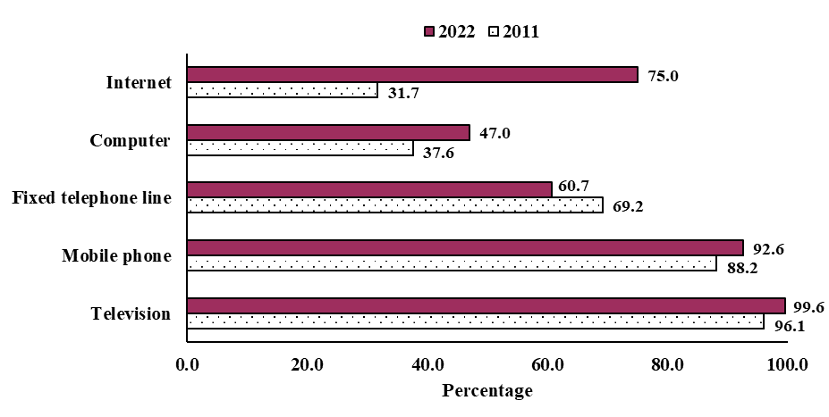

1. **Key results from the 2022 Housing Census for Rodrigues**

**6.1 Building and housing unit evolution**

From 2011 to 2022, Island of Rodrigues witnessed an increase of 10.3% in the number of buildings from 13,900 to 15,330. Around 88.7% of these buildings were wholly/partly residential buildings. A decrease was noted in the number of buildings under construction, from 730 to 630 for the period under study.

Around 86.5% of housing units were occupied as principal residence, 13.0% were vacant housing units and 0.5% were secondary residences.

***Home owners increased***

From 2011 to 2022, the number of households owning their homes increased by 19.3% from 10,315 to 12,310.

**6.2 Increased availability of basic amenities**

Availability of basic amenities to Rodriguans improved from 2011 to 2022 as follows:

* Piped water inside house from 54.5% to 72.2%;
* Kitchen inside housing unit from 79.6% to 92.4%;
* Bathroom with running water from 53.1% to 71.9%;
* Flush toilet from 50.9% to 72.4%; and
* Regular collection of garbage from 60.6% to 86.4%.

**Figure 8: Proportion (%) of households with basic amenities, Rodrigues, 2011 and 2022 Housing Censuses**

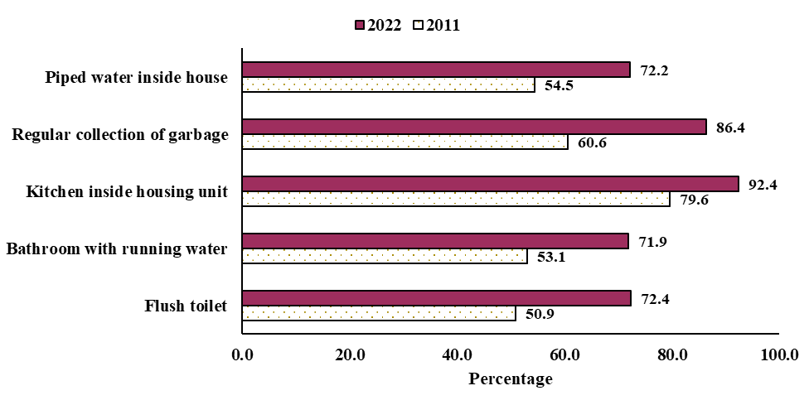

**6.3 Availability of ICT devices/ services in households**

Compared to 2011, Rodrigues has witnessed significant increase in the use of ICT in households in 2022:

* Internet availability from 17.3% to 76.4%;
* Computer from 20.4% to 28.4%;
* Mobile phone from 84.1% to 92.9%; and
* Television from 88.7% to 91.3%.

On the other hand, a decrease was noted for fixed telephone from 45.2% to 29.3% during the same period.

1. **Key results from the 2022 Housing Census for Agalega**

In Agalega, the houses are government-owned and almost all of them are equipped with flush toilet and bathroom with running water. Out of the 115 private households, all are supplied with electricity from generators and 96.3% have piped water inside their houses.

Proportion of households with availability of the following ICT devices/services in Agalega was:

* 97.4% for mobile phones;
* 89.6% for television;
* 44.3% for computer; and
* 76.5% for internet access

1. **Detailed publication**

A table report containing a comprehensive set of final tables on the housing and living conditions of the country will be published by the beginning of next year.

**Statistics Mauritius**

**Ministry of Finance, Economic Planning and Development**

**Port Louis**

**18 November 2022**

**Contact persons:**

(1) Mrs S. Soogun (Statistician)

Email: [ssoogun@govmu.org](mailto:ssoogun@govmu.org)

(2) Mrs L. Bhowon (Senior Statistical Officer) Email: [lbhowon@govmu.org](mailto:lbhowon@govmu.org)

Statistics Mauritius

LIC Centre, Port Louis

Tel: +230 2081800 Fax: +230 2114150

Note: Figures presented in tables or charts may not add up to totals due to rounding.

**Annex I**

**Definition of terms**

**Building**

A building is any independent free-standing structure, comprising one or more rooms and other spaces, covered by a roof and usually enclosed within external walls or dividing walls which extend from the foundations to the roof. A building may be used or intended for residential, commercial and industrial purposes or for the provision of services. It may be a detached housing unit, a block of flats, shop, warehouse, factory, workshop, school, church, etc.

**Housing unit**

A housing unit is a separate and independent place of abode intended for habitation by one household, or one not intended for habitation, but occupied for living purposes by a household at the time of the census.

**Household**

A household is either:

1. a one-person household, i.e., a person who makes provision for his own food or other essentials for living without combining with any other person to form part of a multi-person household; or
2. a multi-person household, i.e., a group of two or more persons living together who make common provision for food or other essentials for living. The persons in the group may pool their incomes and have a common budget to a greater or lesser extent; they may be related or unrelated persons or a combination of both.

**Single household**

A household is considered as single when all its members occupy a single housing unit in one and the same building.

**Combined household**

When a household occupies two (or more) buildings, that is, when some members of the household occupy a housing unit in a main building whilst one or more members occupy another building or buildings, then the term “combined” is used to describe the household type for the housing unit in the main building.

**Private household** consists of household types single and combined.

**Hospital, infirmary, asylum, prison**

This refers to all persons staying in the hospital, infirmary, asylum or prison at the time of census. The persons staying in each of the institutions mentioned are considered as one household. It excludes employees working at that time.

**Orphanage, old people’s home, convent**

This refers to all persons staying in orphanages, old people’s homes and convents at the time of census. The persons staying in each of the institutions mentioned are considered as one household. It excludes employees working at that time.

**Hotel population**

This refers to all guests in a hotel, guesthouse or tourist residence. It excludes any hotel employees or managers and their households who may be residing on the premises.

**Collective quarters**

The term “collective quarters” is used to identify a group of foreign workers living together in one or more apartments, lodgings, temporary shelters, etc. Such quarters may have certain common facilities, such as cooking and toilet installations, baths, dormitories, which are shared by the whole group.

**Communal Household** include inmates of institutions, in orphanage/convent, old people home, prison, asylum, hotel, tourist residence/guest house and collective quarters.

**Homeless**

This refers to persons who do not have a shelter. They carry their few possessions with them, sleeping under shop verandas, in doorways, on the streets or in any other space on a more or less random basis.

**Room**

A room is defined as a space in a housing unit enclosed by walls reaching from the floor to the ceiling or roof covering or at least to a height of two metres. It is of a size large enough to hold a bed for an adult. Its area is at least four-square metres.

**Annex II**

|  |  |  |  |  |
| --- | --- | --- | --- | --- |
| **Table I: Proportion (%) of households by amenities/facilities available, Republic of Mauritius, 2011 and 2022 Housing Censuses** | | | | |
| **Amenities available** | | **2011** | **2022** | |
| **1. Electricity** | | 99.5 | 99.6 | |
| **2. Water Supply** | |  |  | |
| 1. Piped water inside house | 94.3 | | 96.4 |
| 1. Piped water outside on premises | 5.1 | | 3.3 |
| 1. Public fountain, well river, etc. | 0.6 | | 0.3 |
| **3. Refuse disposal** | |  |  | |
| 1. Collected by authorised collectors | 98.1 | | 99.3 |
| 1. Ash pit on premises | 1.1 | | 0.3 |
| 1. Dumped on premises/roadside | 0.7 | | 0.3 |
| 1. Other method of refuse disposal | 0.1 | | 0.1 |
| **4. Bathroom** | |  |  | |
| 1. With running water | 95.5 | | 98.0 |
| 1. Without running water | 4.0 | | 1.7 |
| 1. Not available | 0.5 | | 0.3 |
| **5. Toilet** | |  |  | |
| 1. Flush toilet | 96.4 | | 98.5 |
| 1. Pit Latrine | 3.4 | | 1.2 |
| 1. Other type and Not available | 0.2 | | 0.3 |
| **6. Kitchen** | |  |  | |
| 1. Inside Housing Unit | 95.5 | | 98.3 |
| 1. Outside Housing Unit | 4.2 | | 1.5 |
| 1. Not available | 0.3 | | 0.2 |
| **7. Main fuel for cooking** | |  |  | |
| 1. Cooking gas (LPG) | 97.7 | | 99.2 |
| 1. Electricity | 0.3 | | 0.5 |
| 1. Wood and Charcoal | 1.9 | | 0.2 |
| 1. Other fuel used for cooking | | 0.1 | 0.1 | |

**Table II: General housing and living characteristics, 2022 Housing Census, Republic of Mauritius and its main constituent islands**

|  |  |  |  |  |
| --- | --- | --- | --- | --- |
| **Number** | **Republic of**  **Mauritius** | **Island of**  **Mauritius** | **Island of**  **Rodrigues** | **Island of Agalega** |
| **Buildings** | **329,000** | **313,550** | **15,330** | **120** |
| *of which* |  |  |  |  |
| Residential/partly residential buildings | 296,600 | 282,885 | 13,630 | 85 |
|  |  |  |  |  |
| **Housing units** | **411,700** | **396,580** | **15,000** | **120** |
| *of which* |  |  |  |  |
| Occupied | 354,200 | 341,020 | 13,070 | 110 |
|  |  |  |  |  |
| **Households** | **371,015** | **357,430** | **13,460** | **125** |
| Private households | 369,000 | 355,600 | 13,285 | 115 |
| Communal households and homeless | 2,015 | 1,830 | 175 | 10 |
|  |  |  |  |  |
| **Population (Persons)** | **1,251,000** | **1,203,300** | **45,300** | **2,400** |
| Private households | 1,202,143 | 1,157,430 | 44,340 | 373 |
| Communal households and homeless | 48,857 | 45,870 | 960 | 2,027 |
|  |  |  |  |  |
| **Average Household size** | **3.26** | **3.25** | **3.34** | **3.24** |
| **Proportion (%) of all private households by amenities available** | | |  |  |
| **Tenure** |  |  |  |  |
| Owner | 90.4 | 90.3 | 92.6 | 0 |
| Tenant and Sub-tenant | 6.5 | 6.7 | 2.0 | 0.0 |
| Free and Other | 3.1 | 3.0 | 5.4 | 100.0 |
|  |  |  |  |  |
| **Water Supply** |  |  |  |  |
| Piped water inside house | 96.4 | 97.3 | 72.2 | 96.3 |
| Piped water outside on premises | 3.3 | 2.4 | 26.3 | 2.8 |
| Other (public fountain, well, river, etc) | 0.3 | 0.3 | 1.5 | 0.9 |
|  |  |  |  |  |
| **Electricity** |  |  |  |  |
| Available | 99.6 | 99.6 | 99.1 | 100.0 |
| Not available | 0.4 | 0.4 | 0.9 | 0.0 |
|  |  |  |  |  |
| **Toilet** |  |  |  |  |
| Flush toilet | 98.5 | 99.5 | 72.4 | 99.1 |
| Pit latrine | 1.2 | 0.3 | 23.6 | 0.0 |
| Other and None | 0.3 | 0.2 | 4.0 | 0.9 |
|  |  |  |  |  |
| **Bathroom** |  |  |  |  |
| With running water | 98.0 | 99.0 | 71.9 | 98.8 |
| Without running water | 1.7 | 0.9 | 23.9 | 0.9 |
| None | 0.3 | 0.1 | 4.2 | 0.3 |
|  |  |  |  |  |
| **Kitchen** |  |  |  |  |
| Inside housing unit | 98.3 | 98.5 | 92.4 | 97.2 |
| Outside housing unit | 1.5 | 1.3 | 6.3 | 1.9 |
| None | 0.2 | 0.2 | 1.3 | 0.9 |
|  |  |  |  |  |
| **Refuse disposal** |  |  |  |  |
| Regular collection | 98.7 | 99.1 | 86.4 | 98.1 |
| Irregular collection | 0.6 | 0.6 | 0.9 | 1.9 |
| Ash pit on premises | 0.3 | 0.0 | 7.4 | 0.0 |
| Dumped on premises/roadside | 0.3 | 0.2 | 3.8 | 0.0 |
| Other | 0.1 | 0.1 | 1.5 | 0.0 |
|  |  |  |  |  |
| **Availability of ICT devices/services** |  |  |  |  |
| Television | 99.6 | 96.1 | 91.3 | 89.6 |
| Fixed telephone | 60.7 | 59.6 | 29.3 | 4.3 |
| Mobile phone | 92.6 | 89.1 | 92.9 | 97.4 |
| Computer | 47.0 | 45.9 | 28.4 | 44.3 |
| Internet | 75.0 | 72.1 | 76.4 | 76.5 |