WAGE RATE INDEX (WRI)
(Base: fourth quarter 2016 = 100)

First Quarter 2022

- Introduction

This issue of the Economic and Social Indicators (ESI) on Wage Rate Index presents data for the first quarter of 2022 using as base the fourth quarter of 2016 (Q₄ 2016=100).

The Wage Rate Index (WRI) measures changes in the price of labour, i.e., changes in the average rates actually paid by employers to their employees for work during normal working hours.

The methodology used for computing the index is given in the technical note at Annex 1.

Indices, presented here, are based on wage rates applicable during the month of March 2022.

- Movement of the overall wage rate index

The Wage Rate Index increased by 1.9% or 2.3 points to reach 123.4 in first quarter 2022 from 121.1 in fourth quarter 2021 (Tables 1 and 2).

Compared to first quarter 2021, the wage rate index, which stood at 114.6, increased by 7.7% or 8.8 points (Table 3).

- Movement of the sub-indices, 4th Quarter 2021 to 1st Quarter 2022

Main increases were registered in the following (Chart 1 & Table 2):

Administrative and support service activities | 6.5%
Education | 4.2%
Public administration and defence; compulsory social security | 3.4%
Human health and social work activities | 2.8%

Decreases were as follows:

Transportation and storage | -1.1%
Agriculture, forestry and fishing | -0.9%
Decreases in these sectors were mainly due to changes in the mix of employees within occupations and decrease in regular allowances during the off-peak season in the sugar sector in ‘Agriculture, forestry and fishing’.

2

Chart 1: % Change in Wage Rate Index from
4th Quarter 2021 to 1st Quarter 2022
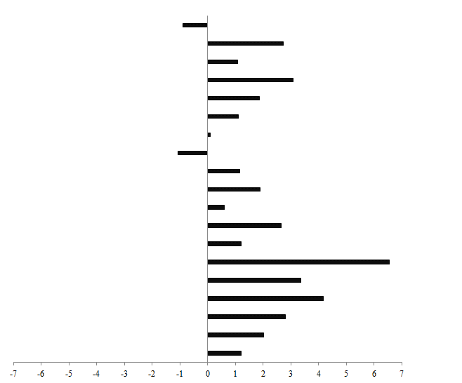
Information and communication
Construction
Financial and insurance activities
Water supply; sewerage, waste management & remediation activities
-0.9
Mining and quarrying
Arts, entertainment and recreation
Manufacturing
Education
Human health and social work activities
Wholesale & retail trade; repair of motor vehicles
Public administration and defence; compulsory social security
Administrative and support service activities
Professional, scientific and technical activities
Real estate activities
Accommodation and food service activities
Electricity, gas, steam and air conditioning supply
Other service activities
1.2
Transportation and storage
2.0
2.8
4.2
3.4
6.5
1.2
2.7
0.6
1.9
1.1
-1.1
0.1
1.1
3.1
1.9
1.1
2.7
Agriculture, forestry and fishing

The Wage Rate Index for the general government sector, comprising ministries, government departments and agencies operating under them, municipalities, district councils and Rodrigues Regional Assembly, increased by 3.1% or 3.7 points from 119.6 in fourth quarter 2021 to 123.3 in first quarter 2022.

Compared to first quarter 2021, the index, which stood at 112.6, increased by 9.5% or 10.7 points. This sector accounts for around 34% of the total weight of the wage rate index.

4. Movement of the sub-indices, 1st Quarter 2021 to 1st Quarter 2022

Table 3 compares the indices for the first quarter of 2021 with those of the corresponding quarter of 2022.

Main increases were registered in the following industry groups:

Manufacturing | 10.5%
Education | 9.5%
Public administration and defence; compulsory social security | 9.4%
Human health and social work activities | 8.9%
Transport and storage | 8.6%

3

5. Indices for the Private and Public sectors, Q1 2022

The index for the private sector which accounts for around 54% of the total weight of the wage rate index increased by 1.6% or 2.0 points from 121.5 in fourth quarter 2021 to 123.5 in first quarter 2022 (Tables 6 & 7).

Compared to first quarter 2021, the index for the private sector, which stood at 116.0, increased by 6.5% or 7.5 points (Table 8).

The index for the public sector which comprises general government and public enterprises and accounting for around 46% of the wage rate index, increased by 2.3% or 2.8 points from 120.6 in fourth quarter 2021 to 123.4 in first quarter 2022 (Tables 9 & 10).

Compared to first quarter 2021, the index for the public sector, which stood at 112.9, increased by 9.3% or 10.5 points (Table 11).

6. Past trend

Table 4 presents the quarterly indices from first quarter 2007 to first quarter 2022 with different base periods. As from 2017, the base period is fourth quarter 2016.

To enable comparison between the two series, chain link series, with fourth quarter 2016 as base, have been worked out and are provided in Table 5.

Chart 2 depicts the trend of the quarterly wage rate index from 2015 to 2022 using fourth quarter 2016 as base period. It shows a general upward movement in the index throughout the period up to fourth quarter 2021 except for a decline in second quarter 2020.

Chart 2 - Wage Rate Index,
1st quarter 2015 – 1st quarter 2022
(Base: fourth quarter 2016=100)

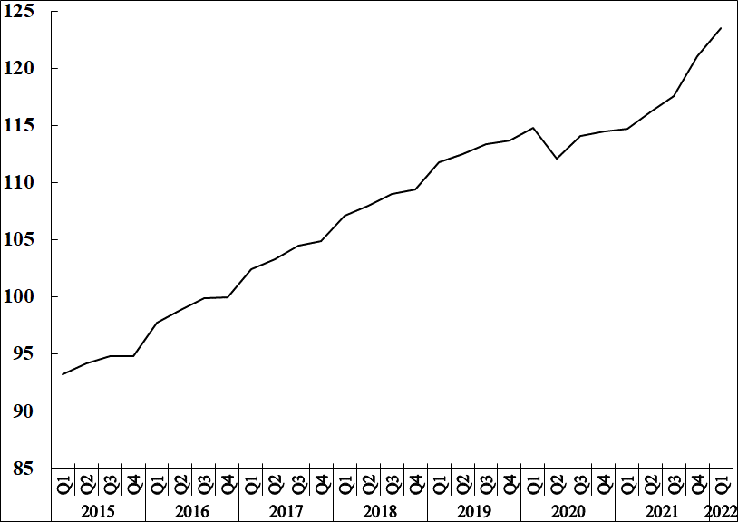

4

7. Revision of the Wage Rate Index
Users are informed that the Wage Rate Index is being rebased on ‘fourth quarter 2021’ and the series for the new base as from the first quarter of 2022 will be disseminated in the next issue.

Statistics Mauritius

Ministry of Finance, Economic Planning and Development
Port Louis
27 June 2022
Contact persons:

(1) Mrs. D. Gangaram (Statistician)
(2) Mrs. S. D. Venkatasami (Senior Statistical Officer)
Labour Unit
Statistics Mauritius
LIC Centre
Port-Louis
Tel: 208 1800 Fax: 213 0234
Email: cso_labour@govmu.org
cso_quarterlylabour@govmu.org

i Annex 1

Technical Note

Methodology used for the compilation of the Wage Rate Index

- Definition

The Wage Rate Index (WRI) measures changes in the price of labour, i.e., changes in the average rates actually paid by employers to their employees for work during normal working hours.

2. Adopted approach

To show genuine changes in the price of labour, it would have been necessary for wages of specific workers at specific establishments to be measured over time. Since this is not possible, the next best approach has been adopted, that is, to follow changes in the wages of groups of employees performing the same jobs. This gives a measure of changes in wage rates of specific occupations but has the following limitations:

    - any changes in the mix of employees within the selected occupations is bound to affect the calculated rates and hence the corresponding sectoral indices. Such changes occur, for example, with a new intake of employees in a specific group - when the wages of the new recruits pull down the average wages for the whole group from one period to the next.

    - wage adjustments resulting from changes in the tasks associated with a particular occupation, which cannot be separated from pure price changes of labour.

    - it is difficult to separate the effects of productivity from the overall change.

3. Coverage

The wage rate index is based on wage rates applicable in ‘large’ establishments only. Employment in these establishments accounted for around 55% of total employment in year 2017. ‘Large’ establishments comprise sugar cane plantations of 10 hectares or more; tea plantations of 2 hectares or more; other agricultural and non-agricultural establishments having 10 or more employees as well as General Government Services, i.e. ministries, government departments and agencies operating under them; municipalities; district councils and Rodrigues Regional Assembly.

The frame consists of a list of all ‘large’ establishments (about 2,750) as at March 2016. Establishments were stratified according to industry and arranged in order of size, i.e., the number of employees, within the industrial group. Within the strata, selection was proportional to size of establishment. A sample of about 9% was surveyed, representing some 250 establishments.

Time-rated as well as piece-rated wage earners and salaried employees are covered. Apprentices, workers on probation, part-time workers and employees working on a temporary basis are excluded.

4. Sectors covered

Indices are disseminated by the Public and Private sectors.

The Public sector comprises Ministries, Government departments and agencies operating under them; municipalities; district councils, the Rodrigues Regional Assembly and Public enterprises.

5. Calculating the Wage Rate Index

A Laspeyres formula is used. The occupational structure is held constant with reference to the base period of the index, i.e. December 2016. The relative changes in average wage rates are measured at the occupational level and these changes are then weighted to give a combined measure of the change. The following formula is used

I_{t} = Σw _{i} (R _{i}^{t} / R _{i}º) X 100

Σ w _{i}

where I_{t} = index for quarter t compared to base period o
w_{i} = Nº_{i}Rº_{i} which represents the total wages paid to all employees in the i ^{th}
occupation base period, December 2016
R_{i}º = wage rate of occupation i in base period, December 2016
R_{i}^{t} = wage rate of occupation i in quarter t

The index is, first, calculated for each industry group and the overall index (covering all industry groups) is computed as a weighted average of the individual industry group indices.

6. Reference period

The base period for the index is quarter 4 2016 (i.e. Quarter 4, 2016=100) as from the first quarter of 2017. The wage rate indices, for the first, second, third and fourth quarters of 2007 and 2008, are based on wage rates applicable during the months of February, May, August and November respectively. As from 2009, the wage rate indices, for the first to fourth quarter, are based on wage rates applicable during the months of March, June, September and December respectively.

7. Weights

Two sets of weights are used:

(i) Weight for the industry groups derived from the ‘Survey of Employment & Earnings, March 2015’ and

(ii) Weight for occupations within each activity (NSIC) sectorwise. Questionnaires were sent to around 1,200 large establishments at the end of March 2016 to cater for number employed in each category of occupation.

8. Wage rates used

The wage/salary rates of specific occupations, used in the calculation of the index, are the rates paid for normal time work, comprising basic wages and salaries, cost of living allowances and other guaranteed and regular allowances paid at the end of each pay period. Overtime payments are, therefore, excluded.

