WAGE RATE INDEX (WRI)
(Base: fourth quarter 2016 = 100)

Fourth Quarter and Year 2020

- Introduction

This issue of the Economic and Social Indicators (ESI) on wage rate index presents data for the fourth quarter and year 2020 using as base the fourth quarter of 2016 (Q₄ 2016=100).

The wage rate index measures changes in the price of labour, i.e., changes in the average rates actually paid by employers to their employees for work during normal working hours.

The methodology used for computing the index is given in the technical note at Annex 1.

- Movement of the overall wage rate index

The wage rate index (Base = fourth quarter 2016) increased by 0.1% or 0.1 point to reach 114.3 in fourth quarter 2020 from 114.2 in third quarter 2020 (Tables 1 and 2). However, in spite of the rise in the third and fourth quarters, after the decline in the second quarter, it was still below first quarter level.

Compared to fourth quarter 2019, the wage rate index, which stood at 113.8, increased by 0.4% or 0.5 point (Table 3).

- Movement of the sub-indices, 3rd Quarter 2020 to 4th Quarter 2020
Accomm. and food service act.

Increases were registered in all sectors except for ‘Agriculture, forestry and fishing’, ‘Mining and quarrying’, ‘Electricity, gas, steam and air conditioning supply’, ‘Transport and storage’ and ‘Education’.
Financial and insurance activities
Information & communication

Main increases were in the following industry groups (Chart 1 & Table 2):

Real estate activities | 2.0%  Arts, entertainment and recreation
Information and communication | 1.6%
Financial and insurance activities | 1.3%

Decreases were as follows:

Agriculture, forestry and fishing | -9.0%
Transportation and storage | -1.2%
Mining and quarrying | -0.4%
Electricity, gas, steam and air conditioning supply | -0.1%
Education | -0.1%

The decrease of 9.0% in ‘Agriculture, forestry and fishing’ is explained by lower wage rates after the sugar cane harvest period and that of 1.2% in ‘Transportation and storage’ by some reduction in salaries.

Chart 1: % Change in Wage Rate Index from
3rd Quarter 2020 to 4th Quarter 2020
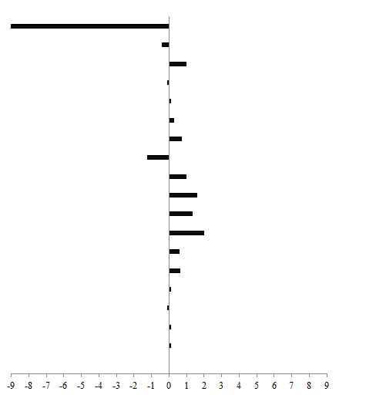
-9.0
Agriculture, forestry & fishing
-0.4
Mining and quarrying
1.0
Manufacturing
-0.1
0.1
Electricity, gas, steam etc.

Water supply, sewerage. etc.
0.3
Construction
0.7
Wholesale & retail trade etc.
Transportation and storage.
-1.2

1.0
1.6

1.3
Real estate activities
2.0
0.6
Professional, scientific etc.

Adm. & support service activities
0.6
Public adm. and defence etc.
0.1
-0.1
0.1
Education
Human health & social work act.
0.1

0.0

Other service activities

The wage rate index for the general government sector, comprising ministries, government departments and agencies operating under them, municipalities, district councils and Rodrigues Regional Assembly, registered no change from third to fourth quarter 2020. However, compared to fourth quarter 2019, the index, which stood at 105.5, increased by 4.5% or 1.6 points. This sector accounts for around 34% of the total weight of the wage rate index.

4. Movement of the sub-indices, 4th Quarter 2019 to 4th Quarter 2020

Table 3 shows main increases in fourth quarter 2020 compared to fourth quarter 2019 occurred in the following industry groups:

Real estate activities | 11.0%
Mining and quarrying | 4.9%
Water supply; sewerage, waste management and remediation activities | 4.9%
Public administration and defence; compulsory social security | 4.5%
Human health and social work activities | 4.5%
Information and communication | 4.4%
Main decreases were registered were in the following industry groups:

Transportation and storage | -11.3%
Professional, scientific and technical activities | -6.8%
Administrative and support service activities | -3.6%
Wholesale and retail trade | -2.0%

The decreases are mainly explained by changes in workforce and salaries, particularly regular allowances.

Table 3 also compares the indices for the four quarters of 2020 with the corresponding quarters of 2019. The first quarter 2020 index went up while that of second quarter 2020 dropped as a result of the negative impact of COVID-19 on establishments’ financial situation. It then picked up in the third and fourth quarters.

5. Indices for the Private and Public sectors, Q4 2020

The index for the private sector which accounts for around 54% of the total weight of the wage rate index improved by 0.3% or 0.4 point from 116.6 in third quarter 2020 to 117.0 in fourth quarter 2020, same level as in fourth quarter 2019 (Tables 7 & 8).

The index for the public sector which comprises general government and public enterprises and accounting for around 46% of the wage rate index, decreased by 0.3% or 0.3 point from 111.4 in third quarter 2020 to 111.1 in fourth quarter 2020 (Tables 11 & 12).

Compared to fourth quarter 2019, the index for the public sector, which stood at 110.0, increased by 1.0% or 1.1 points (Table 13).

6. Wage Rate Index, Year 2020

The wage rate index for the year 2020, worked out as the average of the quarterly indices, reached 113.9 compared to 112.9 for the year 2019, representing an increase of 0.9 % or 1.0 point (Table 4).

The wage rate index for the general government sector increased by 4.3% or 1.5 points to reach 110.3 in 2020 from 105.7 in 2019. This increase is explained by PRB interim allowance paid to employees as from January 2020.

The sectoral indices for year 2020, compared to 2019, show main increases in the following groups:

Water supply; sewerage, waste management and remediation activities | 8.5%
Mining and quarrying | 8.4%
Real estate activities | 7.3%
Agriculture, forestry and fishing | 5.3%
Public administration and defence; compulsory social security | 4.3%

Main decreases were registered in the following industry groups:

Transportation and storage | -7.4%
Professional, scientific and technical activities | -5.8%
Wholesale and retail trade | -1.8%
Manufacturing | -1.1%

7. Indices for the Private and Public sectors, Year 2020

The index for the private sector for year 2020, which is an average of the four quarters, worked out to 115.8 compared to 115.5 for year 2019. This corresponds to an increase of 0.3% or 0.3 point in the index (Table 10).

The index for the public sector for year 2020, worked out to 111.7 compared to 109.8 for year 2019, representing an increase of 1.7% or 1.9 points (Table 14).

8. Past trend

Table 5 presents the quarterly indices from first quarter 2007 to fourth quarter 2020 with different base periods. As from 2017, the base period is fourth quarter 2016.

To enable comparison between the two series, chain link series with fourth quarter 2016 as base has been worked out and is provided in Table 6.

Chart 2 depicts the trend of the quarterly wage rate index from 2014 to 2020 using fourth quarter 2016 as base period. It shows a general upward movement in the index throughout the period up to first quarter 2020, declined in the second quarter 2020 and picked up in the following two quarters.

Chart 2 - Wage rate index,
1st quarter 2014 - 4th quarter 2020
(Base: fourth quarter 2016=100)

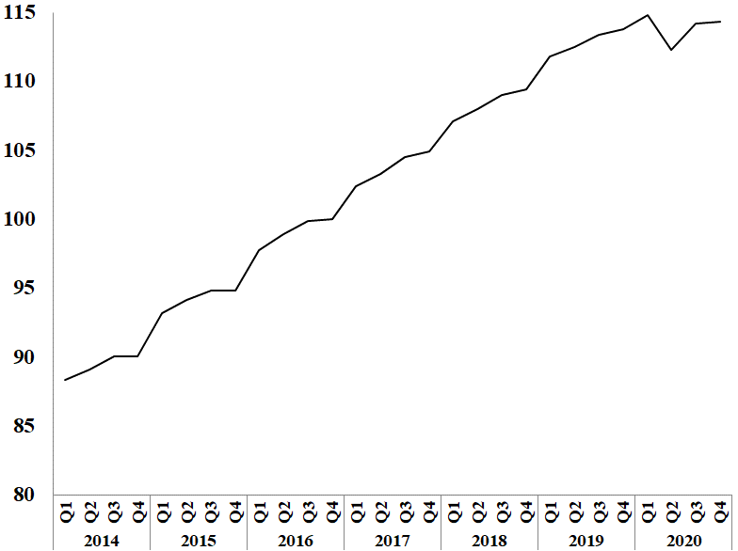

Statistics Mauritius

Ministry of Finance, Economic Planning and Development
Port Louis
26 March 2021

Contact persons:

(1) Mrs. C. Bandinah (Statistician)
(2) Mrs. S. D. Venkatasami (Senior Statistical Officer)

Labour Unit
Statistics Mauritius
LIC Centre
Port-Louis
Tel: 208 1800 Fax: 213 0234
Email: cso_labour@govmu.org

i Annex 1

Technical Note

Methodology used for the compilation of the Wage Rate Index

- Definition

The Wage Rate Index (WRI) measures changes in the price of labour, i.e., changes in the average rates actually paid by employers to their employees for work during normal working hours.

2. Approach adopted

To show genuine changes in the price of labour, it would have been necessary for wages of specific workers at specific establishments to be measured over time. Since this is not possible, the next best approach has been adopted, that is, to follow changes in the wages of groups of employees performing the same jobs. This gives a measure of changes in wage rates of specific occupations but has the following limitations:

    - any changes in the mix of employees within the selected occupations is bound to affect the calculated rates and hence the corresponding sectoral indices. Such changes occur, for example, with a new intake of employees in a specific group - when the wages of the new recruits pull down the average wages for the whole group from one period to the next.

    - wage adjustments resulting from changes in the tasks associated with a particular occupation, which cannot be separated from pure price changes of labour.

    - it is difficult to separate the effects of productivity from the overall change.

3. Coverage

The wage rate index is based on wage rates applicable in ‘large’ establishments only. Employment in these establishments accounted for around 55% of total employment in year 2020. ‘Large’ establishments comprise sugar cane plantations of 10 hectares or more; tea plantations of 2 hectares or more; other agricultural and non-agricultural establishments having 10 or more employees as well as General Government Services, i.e. ministries, government departments and agencies operating under them; municipalities; district councils and Rodrigues Regional Assembly.

The frame consists of a list of all ‘large’ establishments (about 2,750) as at March 2016. Establishments were stratified according to industry and arranged in order of size, i.e., the number of employees, within the industrial group. Within the strata, selection was proportional to size of establishment. A sample of about 9% was surveyed, representing some 250 establishments.

Time-rated as well as piece-rated wage earners and salaried employees are covered. Apprentices, workers on probation, part-time workers and employees working on a temporary basis are excluded.

4. Sectors covered

Indices are disseminated by the Public and Private sectors.

The Public sector comprises Ministries, Government departments and agencies operating under them; municipalities; district councils, the Rodrigues Regional Assembly and Public enterprises.

5. Calculating the Wage Rate Index

A Laspeyres formula is used. The occupational structure is held constant with reference to the base period of the index, i.e. December 2016. The relative changes in average wage rates are measured at the occupational level and these changes are then weighted to give a combined measure of the change. The following formula is used

I_{t} = Σw _{i} (R _{i}^{t} / R _{i}º) X 100

Σ w _{i}

where I_{t} = index for quarter t compared to base period o
w_{i} = Nº_{i}Rº_{i} which represents the total wages paid to all employees in the i ^{th}
occupation base period, December 2016
R_{i}º = wage rate of occupation i in base period, December 2016
R_{i}^{t} = wage rate of occupation i in quarter t

The index is, first, calculated for each industry group and the overall index (covering all industry groups) is computed as a weighted average of the individual industry group indices.

6. Reference period

The base period for the index is quarter 4 2016 (i.e. Quarter 4, 2016=100) as from the first quarter of 2017. The wage rate indices, for the first, second, third and fourth quarters of 2007 and 2008, are based on wage rates applicable during the months of February, May, August and November respectively. As from 2009, the wage rate indices, for the first to fourth quarter, are based on wage rates applicable during the months of March, June, September and December respectively.

7. Weights

Two sets of weights are used:

(i) Weight for the industry groups derived from the ‘Survey of Employment & Earnings, March 2015’ and

(ii) Weight for occupations within each activity (NSIC) sectorwise. Questionnaires were sent to around 1,200 large establishments at the end of March 2016 to cater for number employed in each category of occupation.

8. Wage rates used

The wage/salary rates of specific occupations, used in the calculation of the index, are the rates paid for normal time work, comprising basic wages and salaries, cost of living allowances and other guaranteed and regular allowances paid at the end of each pay period. Overtime payments are, therefore, excluded.

