External Merchandise Trade Statistics – 3rd Quarter 2016

Introduction

This issue of Economic and Social Indicators presents external merchandise trade statistics for the first three quarters of 2016 and for years 2014 & 2015. These statistics are compiled from declarations lodged at Customs by importers and exporters. Some of these declarations are at times revised at a later period and corrections made accordingly on the computerised database of the Mauritius Revenue Authority (MRA) - Customs Department.

Thus, while revised figures for 2014 and 2015 are published in this indicator, those for 2016 are still provisional and subject to revision as and when MRA - Customs Department latest submits latest amendments to Statistics Mauritius.

Data on external merchandise trade are compiled as per the recommendations of the United Nations General Trade System. According to this system, all goods entering and leaving the national frontier, including trading activities of the Freeport zone should be accounted for.

- Total value of trade and trade balance

Total external merchandise trade for the third quarter of 2016 was valued at Rs 62,606 million, i.e. 2.0% higher than the previous quarter but 4.7% lower compared to the corresponding quarter of 2015.

During the third quarter of 2016, total exports (including ship’s stores & bunkers) were valued at Rs 20,717 million against imports of Rs 41,889 million. The resulting trade deficit worked out to Rs 21,172 million, 11.7% higher than the deficit of Rs 18,955 million of the previous quarter and 15.9% higher than the deficit of 18,267 million of the corresponding quarter of 2015.

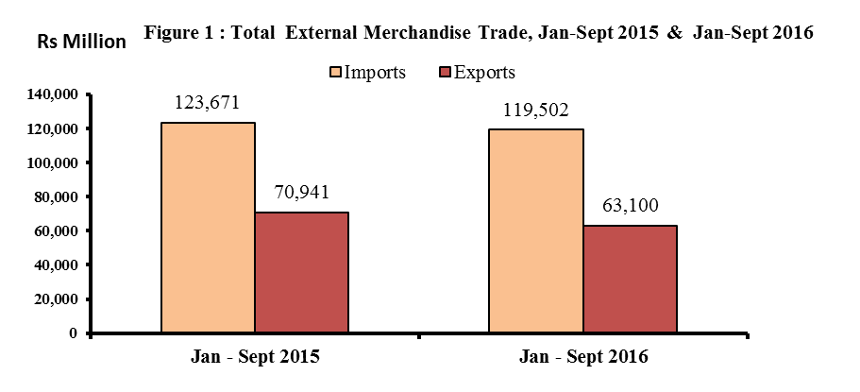

- Exports

3.1 Total exports (Tables 1 & 3) – 3rd Quarter 2016

Total export proceeds for the third quarter of 2016, including domestic exports¹, re-exports² and ship’s stores and bunkers amounted to Rs 20,717 million, showing a decrease of 2.4% compared to the previous quarter. This is mainly explained by decreases in the exports of “Manufactured goods classified by material” (-22.8%), and “Miscellaneous manufactured goods” (-1.5%), partly offset by increases in exports of “Machinery and transport equipment” (+14.3%) and “Ships’ stores & bunkers” (+11.1%).

Compared to the corresponding quarter of 2015, total exports for the third quarter of 2016 dropped by 12.6%. This is mainly explained by decreases in “Machinery and transport equipment” (-47.1%), “Miscellaneous manufactured goods” (-12.1%) and “Ship’s stores & bunkers” (-9.1%), partly offset by increases in “Chemicals & related products” (+4.2%) and “Food and live animals” (+2.6%).

Domestic exports amounting to Rs 13,855 million, accounted for 66.9% of total exports in the third quarter of 2016. Compared to a value of Rs 14,425 million recorded in the second quarter of 2016, domestic exports fell by 4.0%, while comparison against the corresponding quarter of 2015 shows a decrease of 9.3%.

In the third quarter of 2016, re-exports stood at Rs 5,362 million, i.e. lower by 1.6% compared to the previous quarter and 20.9% compared to the corresponding quarter of 2015. This is mainly due to decreases in the re-exports of “Telecommunications equipment & accessories” by 16.0% compared to the previous quarter and by 66.1% compared to the corresponding quarter of 2015. (Table 5)

3.2 Exports by SITC section (Tables 1 & 3) – Jan to Sept 2016
Around 39.5% of total exports for the first nine months of 2016 consisted of “Miscellaneous manufactured goods” (Rs 23,207 million), 33.3% of “Food and live animals” (Rs 19,582 million) and 9.3% of “Manufactured goods classified chiefly by material” (Rs 5,437 million).
Compared to the first nine months of 2015, the main changes by section are as follows:
- “Machinery and transport equipment” fell by 56.3%, due to a decrease in the re-exports of “Telecommunications equipment & accessories” (-66.1%).

- “Manufactured goods classified chiefly by material” declined by 20.2%, mainly explained by lower exports of “Pearls, precious and semi-precious stones” (-34.8%)”.

- “Miscellaneous manufactured goods” dropped by 2.0% mainly due to decreases in the exports of “Optical goods, n.e.s” (-20.1%), ‘Travel goods, handbags & similar containers” (-14.0%) and “Articles of apparel & clothing accessories” (-5.6%).

- “Food and live animals” registered an increase of 4.9%, mainly due to increases in exports of “Live primates” (+14.4%) and “Cane sugar” (+8.3%).

¹ Domestic exports are defined as goods of national origin
² Re-exports are goods which are exported in the same condition as imported or after undergoing minor operations which leave them essentially unchanged.

3.3 Exports of Export Oriented Enterprises (EOE) – Jan to Sept 2016

During the first nine months of 2016, exports of EOE amounted to Rs 33,399 million, showing a decrease of 8.8% compared to the corresponding period of 2015 (Table 1). Further details on these transactions will be presented in the issue of the Economic and Social Indicator on Export Oriented Enterprises, to be released on 22 December 2016.

3.4 Exports by country of destination (Table 7) – Jan to Sept 2016

Analysis of exports figures by country of destination for the first nine months of 2016 shows that the European countries were our main buyers, purchasing some 46.6% of our exports for a value of Rs 27,397 million. Among countries, the major destinations for our exports were U.K (11.9%), U.S.A (11.2%), France (11.1%), South Africa (8.2%), Madagascar (7.5%), Italy (6.5%) and Spain (4.6%).

Compared to the corresponding period of 2015, total exports to UAE went down by 79.8%, mainly explained by a decrease in re-exports of “Telecommunication equipment and accessories”. Exports to Italy, France and Madagascar went up by 20.2%, 11.5%, and 4.9% respectively. On the other hand, exports to Spain and UK dropped by the same percentage, i.e 14.7% while those to South Africa and USA fell by 7.1% and 3.1% respectively.
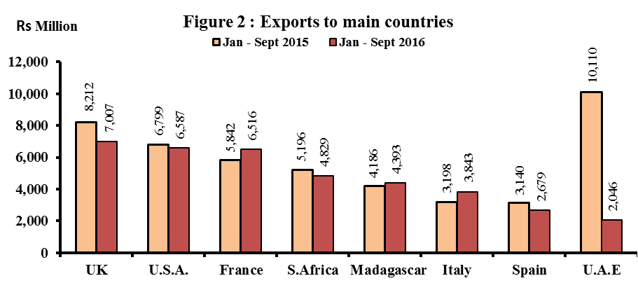
4. Imports

4.1 Total imports (Table 10) – 3rd Quarter 2016

Total imports for the third quarter of 2016 amounted to Rs 41,889 million, showing an increase of 4.3% over the previous quarter. This is mainly due to increases in imports of “Food and live animals” (+17.6%), Manufactured goods classified chiefly by materials” (+4.1%) and “Mineral fuels, lubricants and related products” (+2.5%), partly offset by decreases in “Miscellaneous manufactured articles” (-5.8%) and “Beverages and tobacco” (-21.8%).

Compared to the corresponding quarter of 2015, imports in the third quarter of 2016 fell slightly by 0.2%. This decline is mainly due to decreases in imports of “Manufactured goods classified chiefly by materials” (-11.6%) and “Mineral fuels, lubricants and related products” (-9.4%), partly offset by increases in the imports of “Food and live animals” (+9.7%), “Machinery and transport equipment” (+4.7%) and “Miscellaneous manufactured articles” (+2.4%).

4.2 Imports by SITC section (Tables 10) – Jan to Sept 2016

Around 25.1% of imports in the first nine months of 2016 consisted of “Machinery and transport equipment” (Rs 30,045 million), 21.4% of “Food and live animals” (Rs 25,542 million), 16.2% of “Manufactured goods classified chiefly by materials” (Rs 19,402 million) and 12.6% of “Mineral fuels, lubricants and related materials” (Rs 15,077 million).

Compared to the corresponding nine months of 2015, the main changes by section are as follows:

- “Miscellaneous manufactured articles” increased by 8.1%, mainly due to increases in “Professional, scientific & controlling instruments & apparatus, n.e.s” (+51.8%) and “Watches and clocks & optical goods” (+3.8%).

- “Food and live animals” increased by 9.6%, mainly due to higher imports of “Fish and fish preparations” (+13.5%), “Dairy products and bird’s eggs” (+8.7%) and “Cereal preparations” (+6.8%), partly offset by decreases in imports of “Rice” (-23.1%), “Wheat” (-20.7%) and “Meat and meat preparations” (-6.7%).

- “Mineral fuels, lubricants, & related products” decreased by 21.1%, mainly due to a drop of 21.9% in the imports of “Refined petroleum products”.

- “Manufactured goods classified chiefly by material” fell by 13.8%, mainly due to decreases in the imports of “Iron and steel” (-36.8%), “Pearls & precious stones” (-33.8%), “Cement” (-26.1%) and “Cotton fabrics” (-10.9%), partly offset by an increase in imports of “Other textile fabrics” (+7.5%).

- “Machinery and transport equipment” decreased by 3.4%, mainly due to decreases in imports of “Telecommunications and sound recording apparatus and reproducing apparatus and equipment” (-39.3%) and “Office machines & automatic data processing machines” (-13.3%), partly offset by increases in “Machinery specialized for particular industries” (+39.0%) and “General industrial machinery & equipment, n.e.s., & machine parts, n.e.s” (+26.0%).

  - Imports by country of origin – Jan to Sept 2016

During the first nine months of 2016, almost half of our imports originated from four main countries, namely: China (17.8%), India (15.9%), France (7.9%) and South Africa (7.5%) - (Table 13).

Among continents Asia was our main supplier with a share of Rs 62,593 million, representing 52.4% of total imports.

Compared to the corresponding period of 2015, total imports from India and China fell by 14.4% and 3.8% respectively while those from South Africa and France rose by 9.1% and 9.0% respectively.

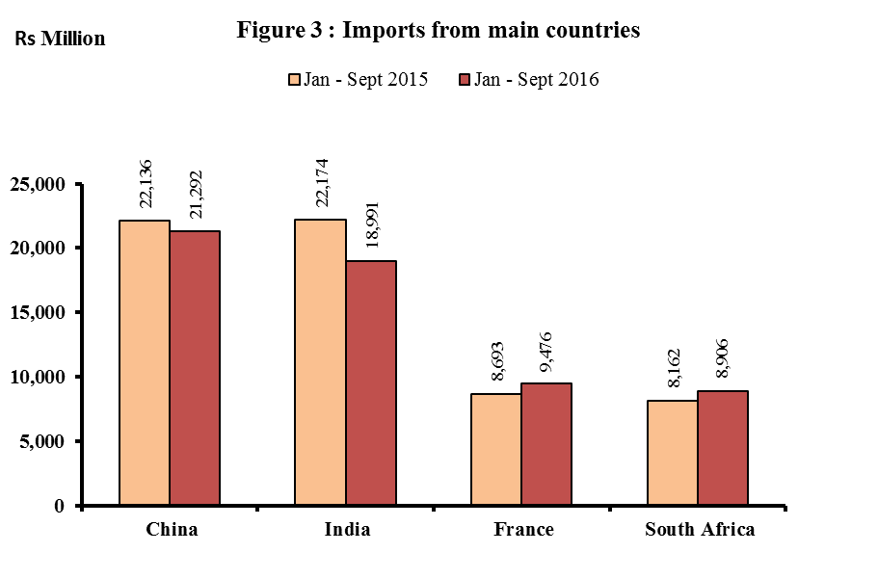

5. Trade with Member States of Regional Organisations – Jan to Sept 2016

During the first nine months of 2016, total exports to African, Caribbean and Pacific (ACP) States stood at Rs 11,881 million against imports of Rs 15,272 million (Table 14). The trade deficit with ACP countries worked out to Rs 3,391 million.

Exports to COMESA member states attained Rs 6,069 million while imports from these countries amounted to Rs 5,149 million, resulting in a trade surplus of Rs 920 million. Madagascar was the main buyer with a share of 72.4%. Our main suppliers were Seychelles (38.8%), Madagascar (19.8%) and Kenya (17.8%) - (Table 15).

Trade with SADC countries showed a deficit of Rs 3,066 million, resulting from imports of Rs 13,303 million against exports worth Rs 10,237 million. The main supplier was South Africa (66.9%) and our main buyers were South Africa (47.2%) and Madagascar (42.9%) - (Table 16).

6. Trade in Freeport Zone – Jan to Sept 2016

During the first nine months of 2016, total imports of the Freeport Zone stood at Rs 11,291 million, lower by 36.5% compared to corresponding period of 2015 – (Table 12). Re-exports were valued at Rs 12,196 million, representing a decrease of 32.1% over the first nine months of 2015 (Table 6). The main items imported and re-exported were “Fish and fish preparations” and “Telecommunications equipment & accessories”.

7. Forecast 2016

Based on quarterly trends and information from various sources, total exports for 2016 is forecasted at around Rs 88,000 million and imports at Rs 167,500 million. Trade deficit for 2016 is therefore expected to be around Rs 79,500 million.

Statistics Mauritius
Ministry of Finance and Economic Development

Port Louis

29 November 2016

Contact Persons

Mr B. Unmar
Senior Statistician

Mr E. Lukshmudu
Senior Statistical Officer

Statistics Mauritius
L.I.C Centre
J. Kennedy Street
Port Louis
Telephone: (230) 210 8091
Fax: (230) 211 4150
Email: cso_trade@govmu.org

Notes

(1) Scope and coverage

External merchandise trade statistics are compiled according to the General Trade System as recommended by the United Nations. Using the national boundary as the statistical frontier, the General Trade System is a record of all goods entering (imports) and leaving the country (exports).

Imports include goods brought in directly for domestic consumption plus goods imported into customs bonded warehouses.
Exports cover:

- Domestic exports defined as goods of national origin, that is goods produced in the exporting country.

- Re-exports which are exported in the same condition as imported or after undergoing minor operations which leave them essentially unchanged and include re-exports from customs bonded warehouses.

- Ship’s Stores and Bunkers (SSB) are included in total exports and are shown separately.

Trade by parcel post is also included in imports and exports.

(2) Valuation

Imports are valued on a C.I.F. (Cost, Insurance and Freight) basis whilst exports on a F.O.B. (Free on Board) basis.

Cost, Insurance and Freight (C.I.F) value is the value of a country's imports of goods, including all charges for transporting and insuring the goods from the country of exports to the given country but excluding the cost of unloading from the ship, aircraft unless it is borne by the carrier.

Free on Board (F.O.B) value is the value of a country's exports of goods, including all costs of transporting the goods to the customs frontier, export duties.

(3) Classification of commodities

Commodities are coded according to the Harmonised Commodity Description and Coding System Nomenclature (HS2012). However, for the purposes of economic analysis and to facilitate international comparison of trade by commodity data, the commodities are also classified according to the Standard International Trade Classification (Revision 4) (SITC Rev. 4). The HS and the SITC Rev. 4 are six and five digit codes respectively but have been extended to eight and seven digits to accommodate national requirements.

(4) Symbols used
- Nil or negligible
-.- Not applicable
... Not available

