POPULATION AND VITAL STATISTICS
REPUBLIC OF MAURITIUS, JANUARY – JUNE 2016

- Introduction

This issue of the Economic and Social Indicators presents provisional population estimates for mid-year 2016 and vital statistics for the first semester of 2016. Forecasts of vital events and rates for the year 2016 are also included.

It is to be noted that preliminary data for the compilation of vital statistics have been extracted from the computerised system in place at the Central Civil Status Office.

Definitions of terms used are at Annex.

- Key points

- The population of the Republic of Mauritius grew at a rate of 0.1% (+868) since mid-2015 and was estimated at 1,263,747 as at 1st July 2016.

- As at mid-2016, the female population outnumbered the male population by 12,987.

- The expected number of live births for the Republic of Mauritius for year 2016 is estimated at 12,960, corresponding to a crude birth rate of 10.3 per 1,000 mid-year population, compared to 10.1 in 2015.

- The estimated number of deaths for 2016 is around 10,240, giving a crude death rate of 8.1 per 1,000 mid-year population, compared to 7.7 in 2015.

- The forecast for the number of infant deaths for the Republic of Mauritius is around 180, representing an infant mortality rate of 13.9 per 1,000 live births, compared to 13.6 in 2015.

- The number of still births for 2016 is estimated at 120, giving a still birth rate of 9.2 per 1,000 total births, compared to 9.7 in 2015.

- The expected number of marriages for 2016 is 10,250, corresponding to a marriage rate of 16.2 persons married per 1,000 mid-year population, against 15.4 in 2015.

- Estimated resident population

Table 3.1 - Estimated resident population by sex, Republic of Mauritius, 1st July 2016

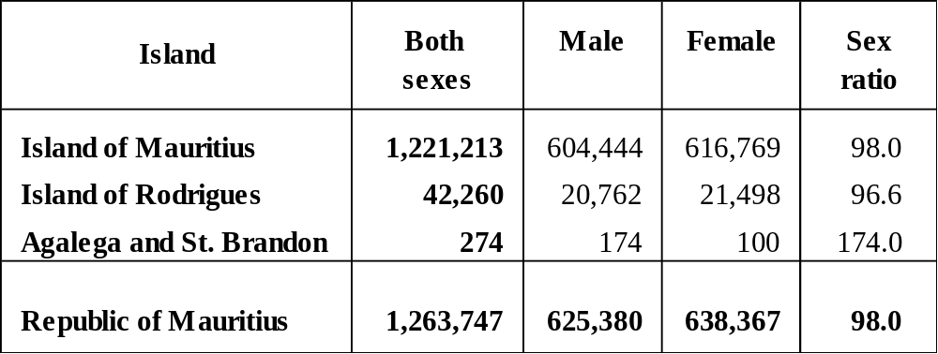

As at 1st July 2016, the population of the Republic of Mauritius was estimated at 1,263,747, of whom 625,380 were males and 638,367 females. There were 98 males for every 100 females.

The population of the Islands of Mauritius and Rodrigues were estimated at 1,221,213 and 42,260 respectively. In both islands, females outnumbered males.

Agalega and St. Brandon had an estimated population of 274, with 74 more males than females.

Table 3.2 - Population density, Republic of Mauritius, 1st July 2016

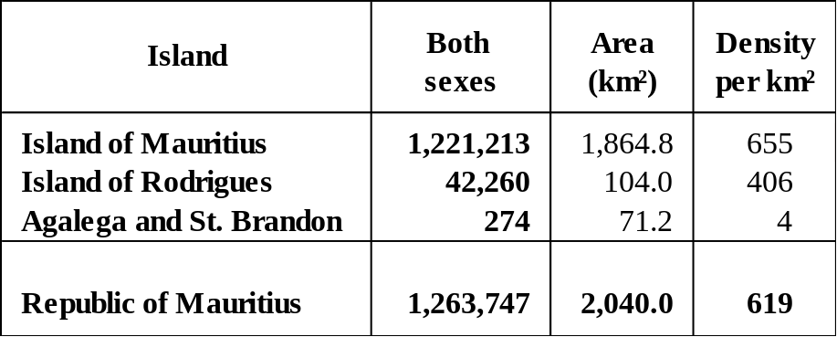

The Republic of Mauritius, with a total land area of 2,040 square kilometres, had a population density of 619 persons per square km as at mid-2016. The population densities of the Island of Mauritius and the Island of Rodrigues were 655 and 406 respectively.

Table 3.3 - Estimated resident population by sex and sex ratio, Republic of Mauritius, 2014 - 2016 (mid-year estimates)

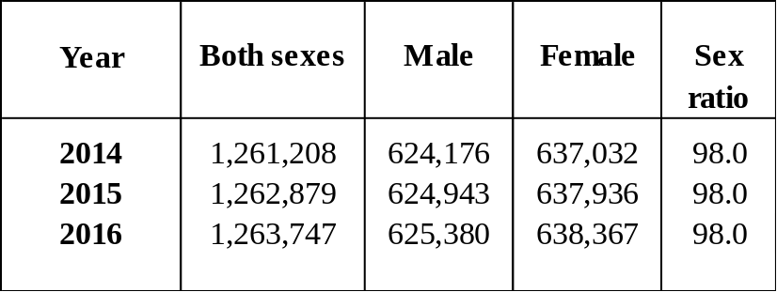

In the above table, population estimates and sex ratios for the past three years are given for comparative purposes. From 2014 to 2016, the sex ratio remained at 98.0.

- Population growth

Table 4.1 - Population change, Republic of Mauritius, 1st July 2015 and 1st July 2016

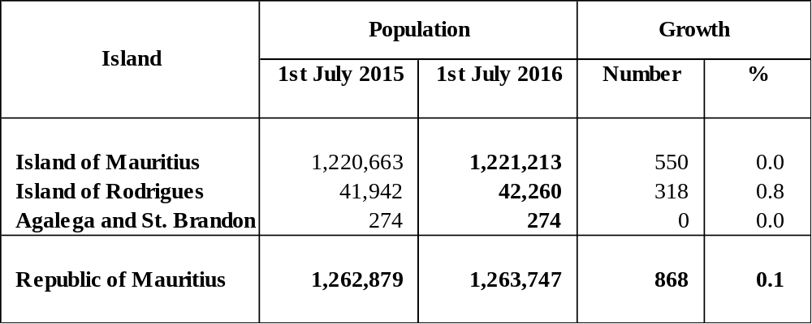

The population of the Republic of Mauritius increased by 868 (0.1%) from mid-2015 to mid-2016. The growth rate for the Island of Mauritius was 0.0% compared to 0.8% for the Island of Rodrigues.

Table 4.2 - Components of population growth during the first semester of 2015 and 2016, Republic of Mauritius¹

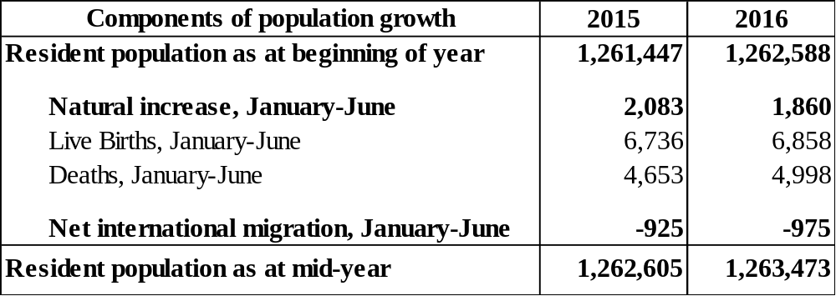
¹ excluding Agalega and St Brandon

Population growth has two components: natural increase (the number of live births minus the number of deaths) and its net international migration (the net movement of residents).

During the first semester of 2016, the population registered a natural increase of 1,860, which was the result of an addition of 6,858 live births and a subtraction of 4,998 deaths. For the same period, the net international migration of residents was estimated at -975.

- Vital statistics and rates

5.1 Live births and crude birth rate

Table 5.1 - Live births registered and crude birth rate, Republic of Mauritius, 2015 and 2016¹

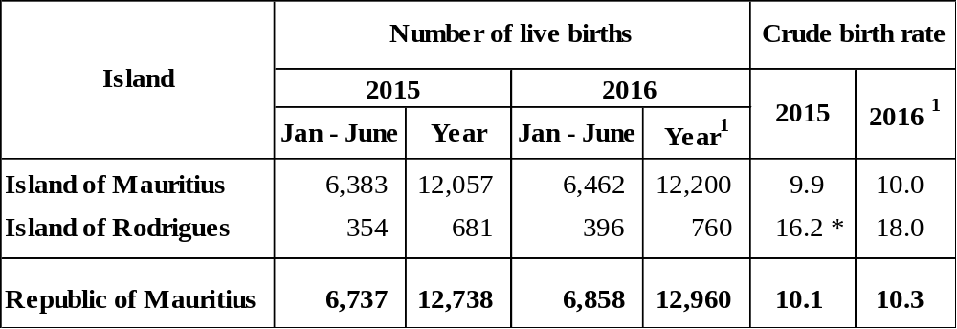
¹ Forecast
* Provisional

For the first six months of the current year, 6,858 live births were registered in the Republic of Mauritius, compared to 6,737 for the corresponding period of 2015. For the year 2016, the number of live births is estimated at 12,960, resulting in a crude birth rate (i.e, live births per 1,000 mid-year population) of 10.3, compared to 10.1 in 2015. The forecast for the Island of Mauritius is 12,200 live births (rate of 10.0), and for Rodrigues it is 760 (rate of 18.0).
5.2 Deaths and crude death rate

Table 5.2 - Deaths and crude death rate, Republic of Mauritius, 2015 and 2016¹

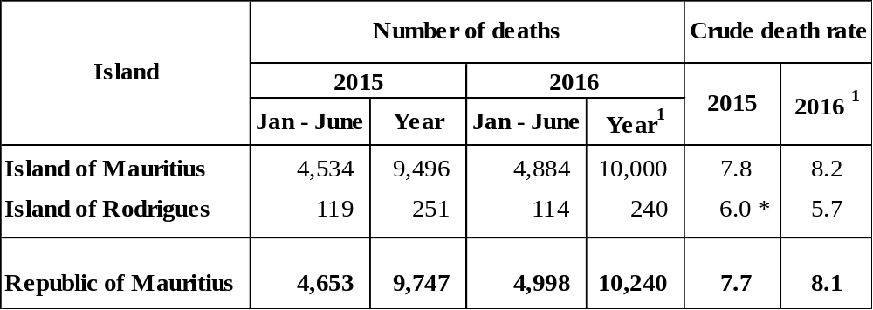
¹ Forecast
* Provisional

The number of deaths registered during the first semester of 2016 in the Republic of Mauritius was 4,998, compared to 4,653 for the corresponding period of 2015. The forecast for 2016 is estimated at 10,240 deaths, representing a crude death rate of 8.1 per 1,000 mid- year population. The expected number of deaths for the Island of Mauritius for 2016 is 10,000 (rate of 8.2) and that for Rodrigues is 240 (rate of 5.7).

5.3 Infant deaths and infant mortality rate

Table 5.3 - Infant deaths and infant mortality rate, Republic of Mauritius, 2015 and 2016¹

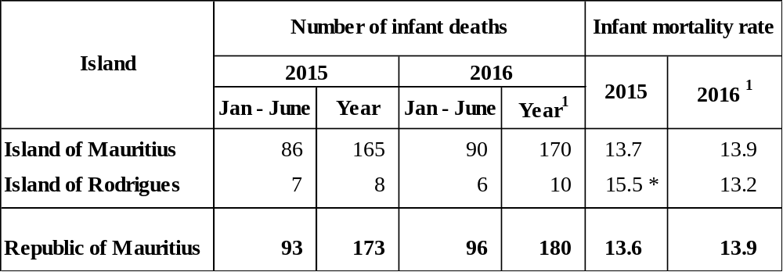

¹ Forecast
* Provisional

During the first semester of the year 2016, 96 infant deaths were registered in the Republic of Mauritius compared to 93 for the same period in 2015. 180 infant deaths are expected to occur in the Republic of Mauritius in 2016, giving an infant mortality rate of 13.9 infant deaths per 1,000 live births against 13.6 in 2015. The number of infant deaths forecast for the Islands of Mauritius and Rodrigues are 170 (rate of 13.9) and 10 (rate of 13.2) respectively.
5.4 Still births and still birth rate

Table 5.4 - Still births and still birth rate, Republic of Mauritius, 2015 and 2016¹

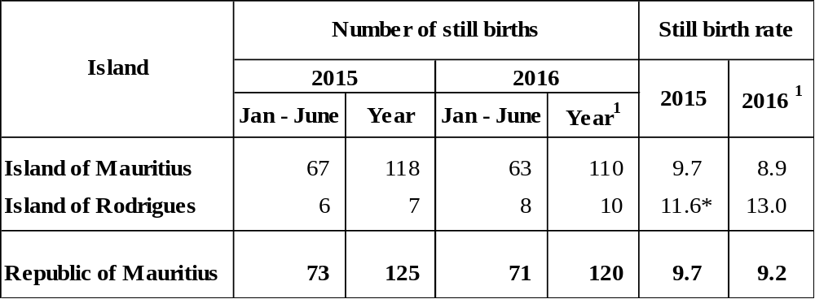
¹ Forecast
* Provisional

During the first six months of 2016, 71 still births were registered in the Republic of Mauritius compared to 73 for the same period in 2015, i.e. a 2.7% decrease. The expected number of still births for the Republic of Mauritius for 2016 is 120, giving a still birth rate of 9.2 still births per 1,000 total births against 9.7 in 2015. Forecasts for the Islands of Mauritius and Rodrigues for the year 2016 are 110 (rate of 8.9) and 10 (rate of 13.0) respectively.

5.5 Marriages and crude marriage rate

Table 5.5 - Marriages and crude marriage rate, Republic of Mauritius, 2015 and
2016¹

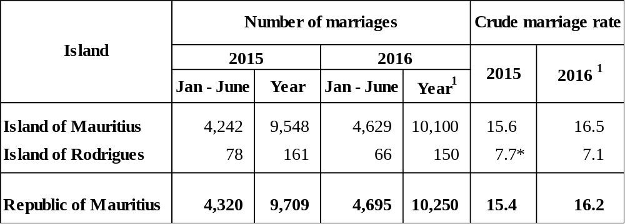
¹ Forecast
* Provisional
A total of 4,695 marriages were registered in the Republic of Mauritius during the first semester of 2016, representing an increase of 8.7% over the number registered (4,320) during the same period in 2015. The expected number of marriages for 2016 is 10,250, giving a crude marriage rate of 16.2 persons married per 1,000 mid-year population against 15.4 in 2015. The expected number of marriages for 2016 for the Island of Mauritius is 10,100 (rate of 16.5) and for the Island of Rodrigues is 150 (rate of 7.1).
- International comparison of vital rates

Vital statistics for different countries in the world are published in the UN publication “The Demographic Yearbook” and the United Nations Population and Vital Statistics Report. The table below displays some comparative figures available from the latest United Nations Population and Vital Statistics Report (2001 - 2015).

Table 6.1 - Vital rates for selected countries

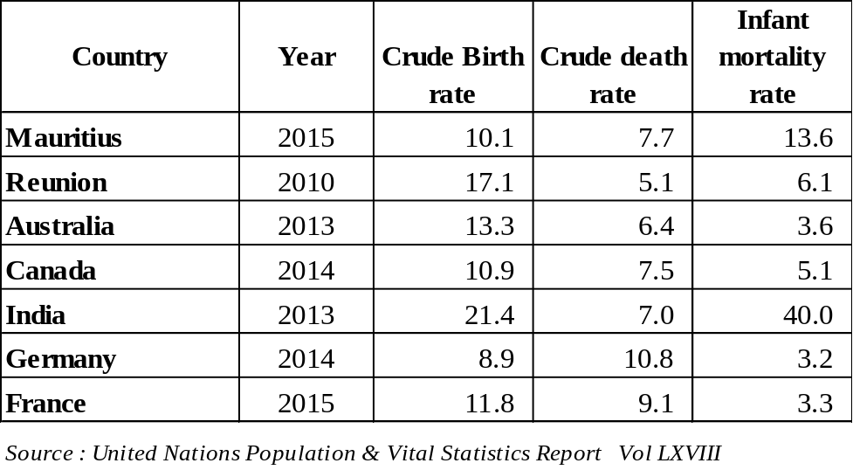

It is to be noted that the crude birth/death rates are strictly not comparable between countries as it is affected by the age structure of the population. For instance, the crude death rate for Mauritius is lower than that for France. This can be explained by the fact that Mauritius has a relatively young population compared to France and hence proportionately fewer deaths are expected.

Statistics Mauritius,
Ministry of Finance and Economic Development
Port Louis
August 2016

Contact person:
Mrs. C. Martial, Statistician
Demography Unit
Statistics Mauritius
LIC Centre
John Kennedy Street
Port Louis
Tel: 208 0859
Email: cso_demography@govmu.org

Annex

Definition of terms

1. Vital Statistics | The statistics pertaining to vital events which include live births, deaths, still births, marriages and divorces.
2. Population density | The number of persons per square kilometre.
3. Dependency ratio | The child population under 15 years of age and the elderly population aged 65 years and above per 1,000 population aged 15-64 years.
4. Sex ratio | The number of males to every 100 females.
5. Natural increase | The excess of live births over deaths.
6. Crude birth rate | The number of live births in a year per 1,000 mid-year population.
7. Crude death rate | The number of deaths in a year per 1,000 mid-year population.
8. Infant mortality rate | The number of deaths in a year of infants aged under one year per 1,000 live births during the year.
9. Still birth rate | The number of still births in a year per 1,000 total births (live births and still births) during the year.
10. Marriage rate | The number of persons married in a year per 1,000 mid-year population.

Note: The vital rates for Rodrigues are usually calculated as an average for three years in order to remove wide fluctuations in the yearly data. The rates for the year 2016 are however calculated on the basis of data for the year only.

