External Merchandise Trade Statistics – 2nd Quarter 2016

Introduction

This issue of Economic and Social Indicators presents external merchandise trade statistics for the first and second quarters of 2016 and for years 2014 & 2015. These statistics are compiled from declarations lodged at Customs by importers and exporters. Some of these declarations are at times revised at a later period and corrections made accordingly on the computerised database of the Mauritius Revenue Authority (MRA) - Customs Department.

Thus, while revised figures for 2014 are published in this indicator, those for 2015 are still provisional. These will be revised and published at latest by October 2016 based on latest amendments to be submitted by the MRA - Customs Department.

Data on external merchandise trade are compiled as per the recommendations of the United Nations General Trade System. According to this system, all goods entering and leaving the national frontier, including trading activities of the Freeport zone should be accounted for.

- Total value of trade and trade balance

Total external merchandise trade for the second quarter of 2016 was valued at Rs 61,405 million, i.e. 4.8% higher than the previous quarter but 9.6% lower compared to the corresponding quarter of 2015.

During the second quarter of 2016, total exports (including ship’s stores & bunkers) were valued at Rs 21,225 million against imports of Rs 40,180 million. The resulting trade deficit worked out to Rs 18,955 million, 16.5% higher than the deficit of Rs 16,275 million of the previous quarter and 6.5% higher than the deficit of 17,790 million of the corresponding quarter of 2015.

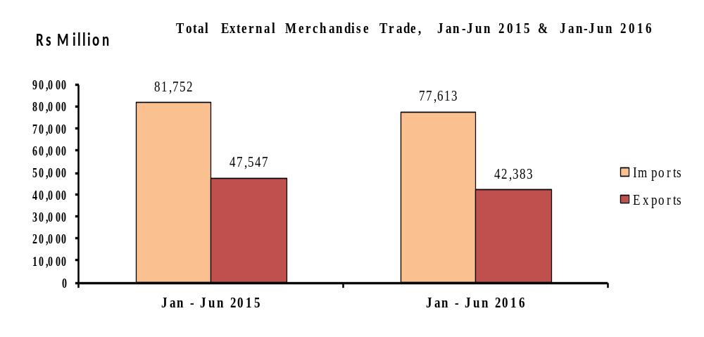

- Exports

3.1 Total exports (Tables 1 & 3) – 2nd Quarter 2016

Total export proceeds for the second quarter of 2016, including domestic exports¹, re-exports² and ship’s stores and bunkers amounted to Rs 21,225 million, showing a slight increase of 0.3% compared to the previous quarter. This is mainly explained by increases in the exports of “Manufactured goods classified by material” (+18.0%) and “Miscellaneous manufactured goods” (+3.5%), partly offset by decreases in exports of “Machinery and transport equipment” (-29.2%) and “Ships’ stores & bunkers” (-10.0%).

Compared to the corresponding quarter of 2015, total exports for the second quarter of 2016 dropped by 15.3%. This is mainly explained by decreases in “Machinery and transport equipment” (-65.6%) and “Ship’s stores & bunkers” (-37.2%), partly offset by increases in “Beverages & tobacco” (+37.8%) and “Food and live animals” (+5.6%).

Domestic exports amounting to Rs 14,425 million, accounted for 68.0% of total exports in the second quarter of 2016. Compared to a value of Rs 13,686 million recorded in the first quarter of 2016, domestic exports rose by 5.4%, while comparison against the corresponding quarter of 2015 shows a decrease of 5.5%.

In the second quarter of 2016, re-exports stood at Rs 5,450 million, i.e. lower by 8.7% compared to the previous quarter and 28.8% compared to the corresponding quarter of 2015. That was mainly due to decreases in the re-exports of “Telecommunications equipment & accessories” by 47.7% compared to the previous quarter and by 75.5% compared to the corresponding quarter of 2015. (Table 5)

3.2 Exports by SITC section (Tables 1 & 3) – First Semester 2016

Around 39.1% of total exports for the first semester of 2016 consisted of “Miscellaneous manufactured goods” (Rs 15,459 million), 32.9% of “Food and live animals” (Rs 12,994 million) and 9.7% of “Manufactured goods classified chiefly by material” (Rs 3,835 million).

Compared to the corresponding semester of 2015, the main changes by section are as follows:

- “Machinery and transport equipment” fell by 59.6%, due to a decrease in the re-exports of “Telecommunications equipment & accessories” (-66.1%).

- “Manufactured goods classified chiefly by material” declined by 16.9 %, mainly explained by lower exports of “Pearls, precious and semi-precious stones” (-28.8%)”.

- “Miscellaneous manufactured goods” went up by 2.5% due to increases in the exports of “Watches & clocks” (+12.2%) and “Jewellery, goldsmiths & silversmith wares” (+10.1%).

- “Food and live animals” registered an increase of 7.1%, mainly due to increases in exports of “Cane sugar” (+8.0%) and “Fish and fish preparations” (+3.7%).

¹ Domestic exports are defined as goods of national origin
² Re-exports are goods which are exported in the same condition as imported or after undergoing minor operations which leave them essentially unchanged.

3.3 Exports of Export Oriented Enterprises (EOE) – First Semester 2016

During the first six months of 2016, exports of EOE amounted to Rs 22,221 million, showing a decrease of 8.1% compared to the corresponding period of 2015 (Table 1). Further details on these transactions will be presented in the issue of the Economic and Social Indicator on Export Oriented Enterprises, to be released on 29 September 2016.

3.4 Exports by country of destination (Table 7) – First Semester 2016

Analysis of exports figures by country of destination for the first semester of 2016 shows that the European countries were our main buyers, purchasing some 47.0% of our exports for a value of Rs 18,563 million. The major destinations for our exports were U.K (12.0%), France (11.3%), U.S.A (10.4%), South Africa (8.0%), Madagascar (7.6%), Italy (7.3%), and Spain (4.2%).

Compared to the corresponding period of 2015, total exports to UAE went down by 78.9%, mainly explained by a decrease in re-exports of “Telecommunication equipment and accessories”. Exports to Italy, France, Madagascar and South Africa went up by 31.7%, 12.6%, 9.3% and 6.1% respectively. On the other hand, exports to Spain, UK and USA fell by 21.0%, 15.3% and 3.1% respectively.
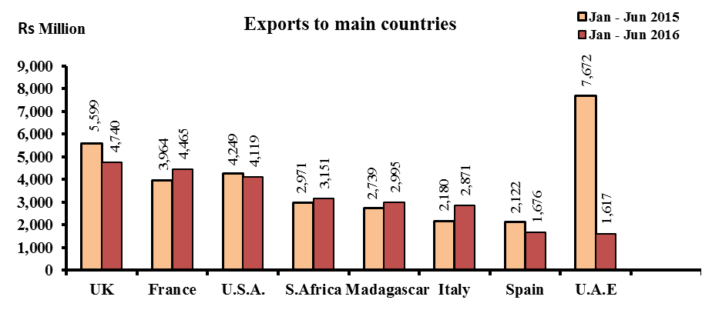
4. Imports

4.1 Total imports (Table 10) – 2nd Quarter 2016

Total imports for the second quarter of 2016 amounted to Rs 40,180 million, showing an increase of 7.3% over the previous quarter. This is mainly due to increases in imports of “Miscellaneous manufactured articles” (+33.5%), “Chemicals & related products” (+18.4%), “Mineral fuels, lubricants and related products” (+10.0%), “Manufactured goods classified chiefly by materials” (+9.4%), partly offset by a decrease in imports of “Machinery and transport equipment” (-1.5%).

Compared to the corresponding quarter of 2015, imports in the second quarter of 2016 fell by 6.2%. This decline is mainly the result of decreases in imports of “Mineral fuels, lubricants and related products” (-26.5%), “Manufactured goods classified chiefly by materials” (-17.4%) and “Machinery and transport equipment” (-8.6%), partly offset by increases in the imports of “Miscellaneous manufactured articles” (+14.9%), “Chemicals & related products” (+7.0%) and “Food and live animals” (+6.1%).

4.2 Imports by SITC section (Tables 10) – First Semester 2016

Around 25.9% of imports in the first semester of 2016 consisted of “Machinery and transport equipment” (Rs 20,084 million), 20.7% of “Food and live animals” (Rs 16,032 million), 16.2% of “Manufactured goods classified chiefly by materials” (Rs 12,566 million) and 12.6% of “Mineral fuels, lubricants and related materials” (Rs 9,811 million).

Compared to the corresponding semester of 2015, the main changes by section are as follows:

- “Miscellaneous manufactured articles” increased by 11.3%, mainly due to increases in “Professional, scientific & controlling instruments & apparatus, n.e.s” (+47.5%), “Watches and clocks & optical goods” (+12.6%) and “Footwear” (+8.9%).

- “Food and live animals” increased by 9.4%, due to higher imports of “Fish and fish preparations” (+24.9%), “Cereal preparations” (+6.6%) and “Dairy products and bird’s eggs” (+5.8%), partly offset by decreases in imports of “Rice” (-33.9%), “Wheat” (-8.1%) and “Meat and meat preparations” (-1.6%).

- “Mineral fuels, lubricants, & related products” decreased by 26.3%, mainly due to a drop of 30.1% in the imports of “Refined petroleum products”.

- “Manufactured goods classified chiefly by material” fell by 15.1%, mainly due to decreases in the imports of “Iron and steel” (-49.8%), “Pearls & precious stones” (-33.9%), “Cement” (-19.3%) and “Textile yarn” (-15.6%), partly offset by increases in imports of “Other textile fabrics” (+3.0%) and “Paper, paperboard & articles thereof” (+2.4%).

- “Machinery and transport equipment” decreased by 7.1%, mainly due to decreases in imports of “Telecommunications and sound recording apparatus and reproducing apparatus and equipment” (-39.0%) and “Office machines & automatic data processing machines” (-19.1%).

  - Imports by country of origin – First Semester 2016

Almost half of our imports originated from four main countries, namely: China (17.9%), India (15.7%), France (7.8%) and South Africa (7.3%) - (Table 13).
Among continents Asia was our main supplier with a share of Rs 40,664 million, representing 52.4% of total imports.

Compared to the corresponding semester of 2015, total imports from India and China fell by 21.3% and 6.5% respectively while those from France and South Africa rose by 10.2% and 8.0% respectively.

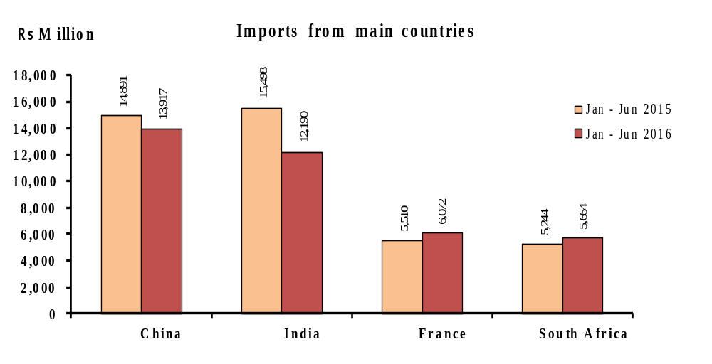

5. Trade with Member States of Regional Organisations – First Semester 2016

During the first semester of 2016, total exports to African, Caribbean and Pacific (ACP) States stood at Rs 7,658 million against imports of Rs 9,966 million (Table 14). The trade deficit with ACP countries worked out to Rs 2,308 million.

Exports to COMESA member states attained Rs 4,061 million while imports from these countries amounted to Rs 3,502 million, resulting in a trade surplus of Rs 559 million. Madagascar was the main buyer with a share of 73.8%. Our main suppliers were Seychelles (40.9%) and Madagascar (22.3%) - (Table 15).

Trade with SADC countries showed a deficit of Rs 2,048 million, resulting from imports of Rs 8,843 million against exports worth Rs 6,795 million. The main supplier was South Africa (64.1%) and our main buyers were South Africa (46.4%) and Madagascar (44.1%) - (Table 16).

6. Trade in Freeport Zone – First Semester 2016

During the first six months of 2016, total imports of the Freeport Zone stood at Rs 8,131 million, lower by 34.9% compared to corresponding period of 2015 – (Table 12). Re-exports were valued at Rs 8,136 million, representing a decrease of 35.4% over the first semester of 2015 (Table 6). The main items imported and re-exported were “Fish and fish preparations” and “Telecommunications equipment & accessories”.

7. Forecast 2016

Based on quarterly trends and information from various sources, total exports for 2016 is forecasted at around Rs 95,000 million and imports at Rs 171,000 million. Trade deficit for 2016 is therefore expected to be around Rs 76,000 million.

Statistics Mauritius
Ministry of Finance and Economic Development

Port Louis

29 August 2016

Contact Persons

Ms S. Bookal
Ag. Statistician

Mr E. Lukshmudu
Senior Statistical Officer

Statistics Mauritius
L.I.C Centre
J. Kennedy Street
Port Louis
Telephone: (230) 210 8091
Fax: (230) 211 4150
Email: cso_trade@govmu.org

Notes

(1) Scope and coverage

External merchandise trade statistics are compiled according to the General Trade System as recommended by the United Nations. Using the national boundary as the statistical frontier, the General Trade System is a record of all goods entering (imports) and leaving the country (exports).

Imports include goods brought in directly for domestic consumption plus goods imported into customs bonded warehouses.
Exports cover:

- Domestic exports defined as goods of national origin, that is goods produced in the exporting country.

- Re-exports which are exported in the same condition as imported or after undergoing minor operations which leave them essentially unchanged and include re-exports from customs bonded warehouses.

- Ship’s Stores and Bunkers (SSB) are included in total exports and are shown separately.

Trade by parcel post is also included in imports and exports.

(2) Valuation

Imports are valued on a C.I.F. (Cost, Insurance and Freight) basis whilst exports on a F.O.B. (Free on Board) basis.

Cost, Insurance and Freight (C.I.F) value is the value of a country's imports of goods, including all charges for transporting and insuring the goods from the country of exports to the given country but excluding the cost of unloading from the ship, aircraft unless it is borne by the carrier.

Free on Board (F.O.B) value is the value of a country's exports of goods, including all costs of transporting the goods to the customs frontier, export duties.

(3) Classification of commodities

Commodities are coded according to the Harmonised Commodity Description and Coding System Nomenclature (HS2012). However, for the purposes of economic analysis and to facilitate international comparison of trade by commodity data, the commodities are also classified according to the Standard International Trade Classification (Revision 4) (SITC Rev. 4). The HS and the SITC Rev. 4 are six and five digit codes respectively but have been extended to eight and seven digits to accommodate national requirements.

(4) Symbols used
- Nil or negligible
-.- Not applicable
... Not available

