EDUCATION STATISTICS - 2014
1. Introduction

This issue of the Economic and Social Indicators presents data on education, compiled on the basis of information collected through the annual survey conducted in schools in March 2014, together with data from other sources. The data refer to the Republic of Mauritius (excluding Agalega) and cover pre-primary, primary, secondary (general and pre-vocational), technical & vocational, tertiary as well as education in specialised institutions.

It is to be noted that the Gross Enrolment Ratios for 2014 are based on Population figures revised according to the 2011 Population Census data. Ratios for year 2010 to 2013 are revised figures.

2. Expenditure

Total government expenditure for the year 2014 has been estimated at Rs 113,712 million, of which, Rs 15,371 million (13.5%) has been allocated to education and training. This amount is 10 % higher than the figure of 2013.

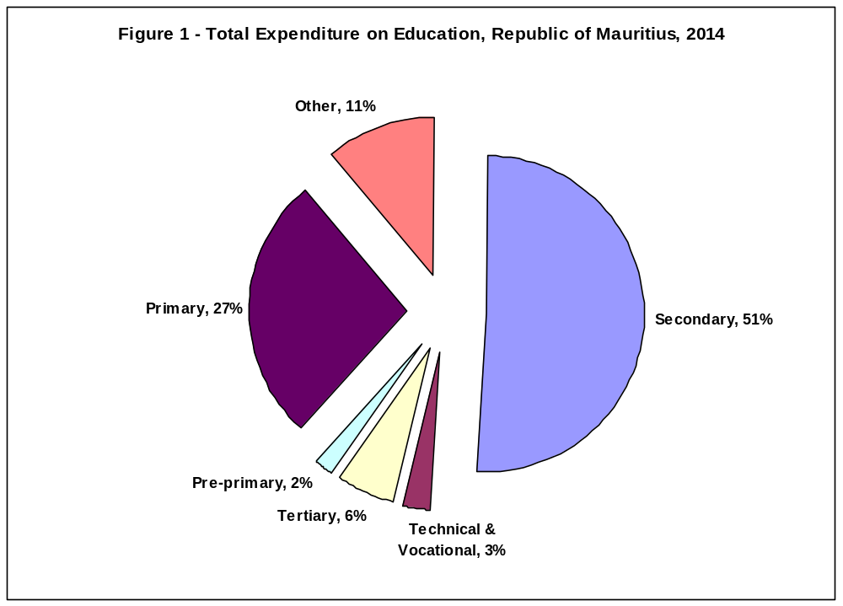 Out of the total budget on education and training for 2014, 51% is allocated to secondary education, 27% to primary education, 6% to tertiary education, 3% to technical and vocational education, 2% to pre-primary education and the remaining 11% to other expenses (Table 2.2 and Figure 1).
3. Pre-primary education

  - Schools

The number of schools providing pre-primary education stood at 957 in March 2014: 924 in the Island of Mauritius and 33 in Rodrigues. Of these schools, 706 (74%) were privately run institutions; 186 (19%), operating on government primary school premises, were administered by the Early Childhood Care and Education Authority (Ex Pre-School Trust Fund) and the remaining 65 (7%) were administered by either Roman Catholic (RC) or Hindu Education Authorities or Municipal/Village Councils (Table 3.1).

  - Enrolment

The pre-primary schools recorded a decline of 4% in enrolment from 31,419 in March 2013 to 30,142 in March 2014. Girls represented around 50% of the pre-primary school population (Table 3.3). The Gross Enrolment Ratio (pre-primary enrolment as a percentage of the population aged 4 and 5 years) works out to 98%, as in 2013.

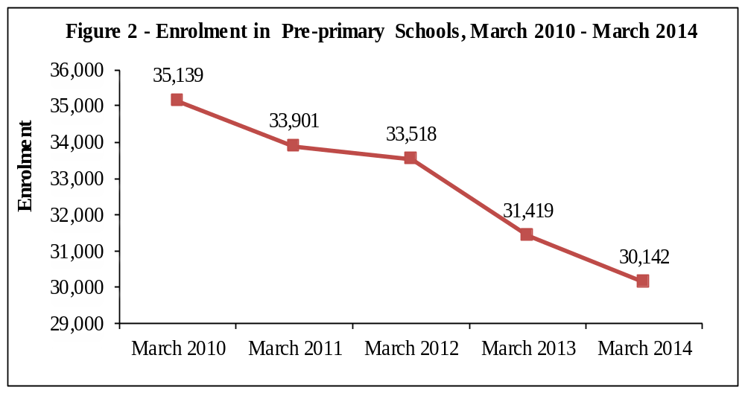
Figure 2 shows enrolment in pre-primary schools over the period 2010 to 2014. Enrolment dropped steadily from 2010 to 2012 followed by a marked decline from 2012 to 2014.

  - Personnel

In March 2014, total employment in pre-primary schools stood at 3,323 of whom 2,404 were teachers and 919 non-teaching staff. This represents a decrease of nearly 4% compared to 2013. The average number of pupils per teacher works out to 13, as in 2013.

4. Primary education

4.1 Schools

In March 2014, there were 320 schools providing primary education, same as in March 2013: 305 in the Island of Mauritius and 15 in Rodrigues. The majority (223) of the schools were run by government, 51 by the Roman Catholic Education Authority (RCEA),
2 by the Hindu Education Authority and the other 44 were private non-aided schools
(Table 4.1).

4.2 Enrolment

The primary school population in the Republic of Mauritius stood at 103,686 in 2014, a decrease of around 5% compared to 2013. Boys represented 51% of the 2014 primary school population. Around 70% of the primary school population was enrolled in government schools and the remaining was in private aided and non-aided schools (Table 4.3).

Distribution by grade (Table 4.5) shows that the highest number of pupils were in standard VI (19,044 pupils including 1,011 repeaters). The Gross Enrolment Ratio (primary enrolment as a percentage of the population aged 6 to 11 years) works out to 96%, against 98% in 2013.

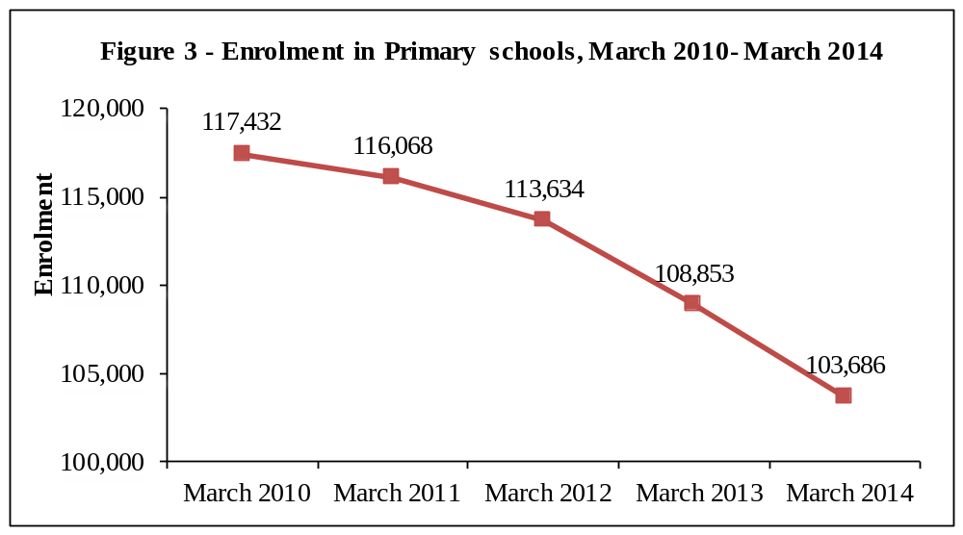

The graph shows a steady decline in primary enrolment from 2010 to 2012 followed by a more significant drop from 2012 to 2014.

4.3 Personnel

The number of persons employed in primary schools registered a slight decrease from 8,126 in March 2013 to 8,117 in March 2014. Of this number, 5,629 were teaching staff: 4,250 General Purpose Teachers and 1,379 Oriental Language Teachers. The remaining 2,488 comprised 289 Head Teachers, 920 Deputy Head Teachers and 1,279 administrative and other workers (Table 4.9). The pupil/teacher (general purpose) ratio in primary schools works out to 24 compared to 26 in 2013.

  - Certificate of Primary Education (CPE)

In 2013, the number of school candidates who took part in the CPE examination was 22,419. Excluding re-sit, the overall pass rate works out to 70.3% compared to 68.8% in 2012.

The performance of girls exceeded that of boys with respective pass rates of 76.9% and 64.1% (Table 4.11 and Figure 4).
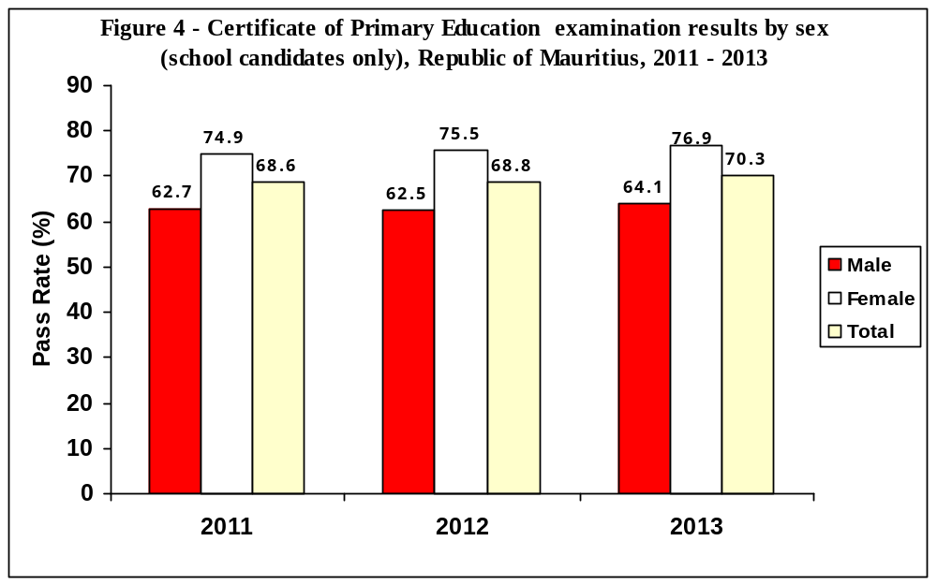

It is to be noted that with the introduction of re-sit exams in 2013, the pass rate among school candidates works out to 74.8% (68.9% boys and 81% girls).

According to the analysis carried out by the Mauritius Examinations Syndicate on performance, the pass rate among the 2012 cohort of school candidates works out to 83.5%. The pass rate relates to school candidates who either passed at their first sitting in 2012 or their second sitting in 2013.

5. Secondary General and Pre-vocational Education

5.1 General and pre-vocational education

As at March 2014, the number of secondary schools offering both general and
pre-vocational education stood at 116 while 60 schools were offering general education only and one pre-vocational education only.

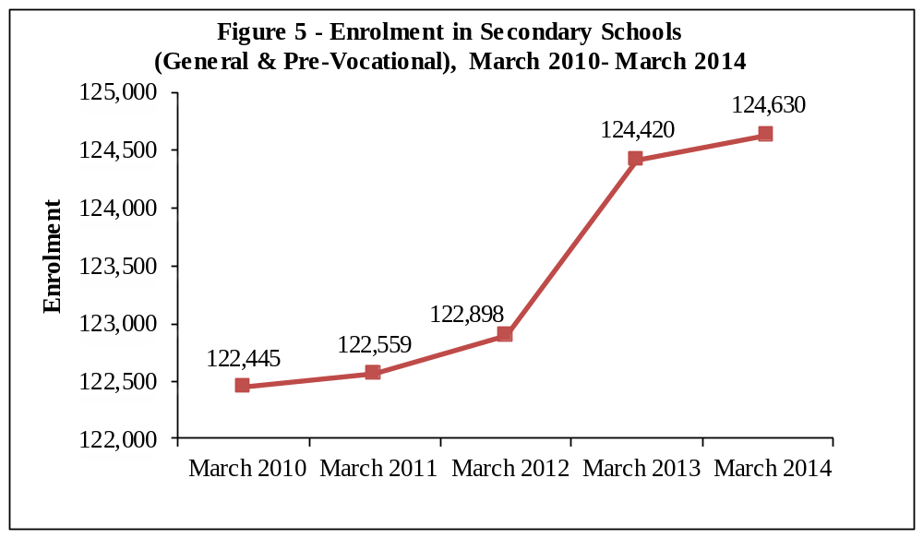 The graph depicts a steady rise in total secondary (including pre-vocational) enrolment from 2010 to 2012. Enrolment increased sharply in 2013 following the introduction of the new Prevoc Strategy whereby the pre-vocational stream was extended from 3 to 4 years. It then slowed down in 2014.

5.2 Secondary education (General)

5.2.1 Schools

Out of the 176 schools dispensing secondary general education, 170 were in the Island of Mauritius and 6 in Rodrigues. State administered schools numbered 68, while the other 108 were private aided and non-aided schools (Table 5.1).

5.2.2 Enrolment

Secondary education enrolment increased by 367 from 113,872 in 2013 to reach 114,239 in 2014. Table 5.3 shows that 59,649 (52%) were girls. Around 43% of the secondary school population was in state schools and 57% in private (aided and unaided) schools. Gross Enrolment Ratio (secondary education enrolment as a percentage of the population aged 12 to 19 years) for the general stream was 73% compared to 72% in 2013.

5.3 Pre-vocational education

5.3.1 Schools

As at March 2014, 117 schools were offering pre-vocational education: 111 in the Island of Mauritius and 6 in Rodrigues. Forty-three of these schools were state pre-vocational schools while the remaining 74 were private schools (Table 5.9).

5.3.2 Enrolment

Enrolment in the schools offering pre-vocational education was 10,391 comprising 6,736 boys (Table 5.11). Boys pre-dominate in secondary pre-vocational classes representing around 65% of enrolment. About 26% of the students in pre-vocational schools were in state schools.

5.4 Personnel

The number of teachers working in secondary schools offering general and
pre-vocational education decreased by 114 from March 2013 to reach 8,410 in March 2014.

The secondary education teaching staff in the general stream stood at 7,430 (2,954 males and 4,476 females), representing a decrease of 5% over the 2013 figure. The pupil/teacher ratio works out to 15. On the other hand, the pre-vocational education teaching staff was 980, of whom 590 were females, giving an average of 11 pupils per teacher.

5.5 Cambridge School Certificate (SC)

In 2013, out of 15,890 candidates (7,277 males and 8,613 females) who took part in the Cambridge School Certificate examination, 11,914 were successful. Comparison with the 2012 results shows that the overall pass rate decreased slightly from 75.7% to 75.0%
(Table 5.19 and Figure 6).

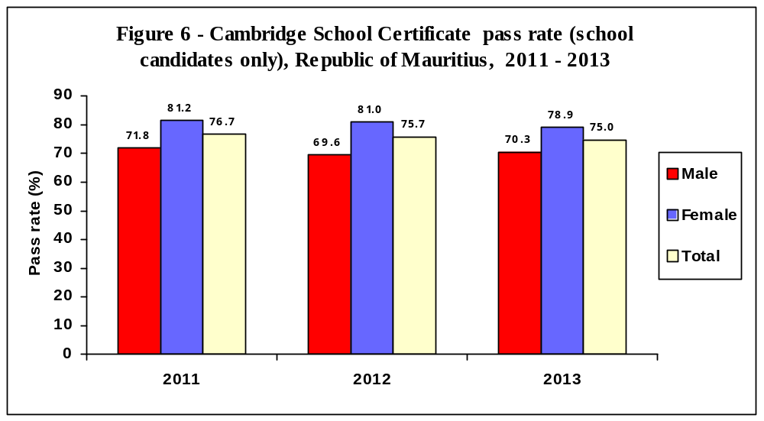

5.6 Cambridge Higher School Certificate (HSC)
The number of students taking part in the 2013 Cambridge Higher School Certificate examination stood at 10,287, of whom 58% were females. The overall pass rate is 77.9%, lower than the 2012 figure of 79.1% (Table 5.20 and Figure 7).
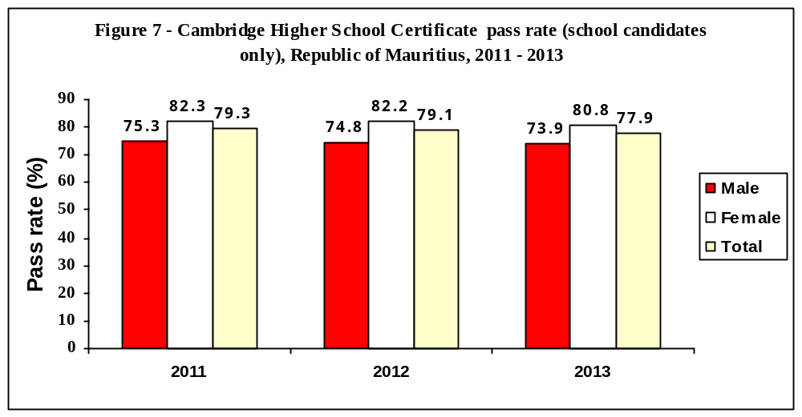

5.7 Technical and Vocational Education

In 2013, there were 10,463 students (of whom 72% were males) enrolled in publicly funded technical and vocational courses compared to 10,351 in 2012. Forty three per cent of the students were enrolled in full-time courses, 45% in part-time courses and the rest (12%) in apprenticeship courses (Table 5.22).

6. Special Education Needs (SEN)
6.1 Schools

As at March 2014, there were 59 Special Education Needs schools in the Republic of Mauritius registered with the Ministry of Education and Human Resources. Twelve schools were run by Government, while the other 47 were run by NGOs (Table 6.1).

6.2 Enrolment

The number of students enrolled in the 59 special schools stood at 2,291 (of whom 63% were boys) as at March 2014 compared to 2,008 in March 2013, representing an increase of 14% (Table 6.3).

Table 6.6 shows that the two most frequent types of impairment were Intellectual Impairment (35%) and Physical Disability (8%).

6.3 Personnel
As at March 2014, there were 607 persons employed in the special education needs institutions representing an increase of 8% compared to March 2013. Out of these, 362 were teaching staff, and 76 were medical and para-medical staff. The remaining 169 were administrative and ancillary workers (Table 6.7).

7. ICT in Education

In March 2014, out of the 957 pre-primary schools in the Republic of Mauritius 414, (43%) had computers. All primary and secondary schools (general & pre-vocational) were equipped with computers. Schools having internet access for students stood at 8% in
pre-primary, 49% in primary and 97% in secondary schools (Table 7.1).

8. Tertiary Education

As at December 2013, the total number of students (part-time and full-time) enrolled on tertiary-level programmes (including Distance Education) reached 50,579 compared to 49,625 in December 2012, representing an increase of 1.9%. In 2012, there was an increase of 8% compared to 2011.
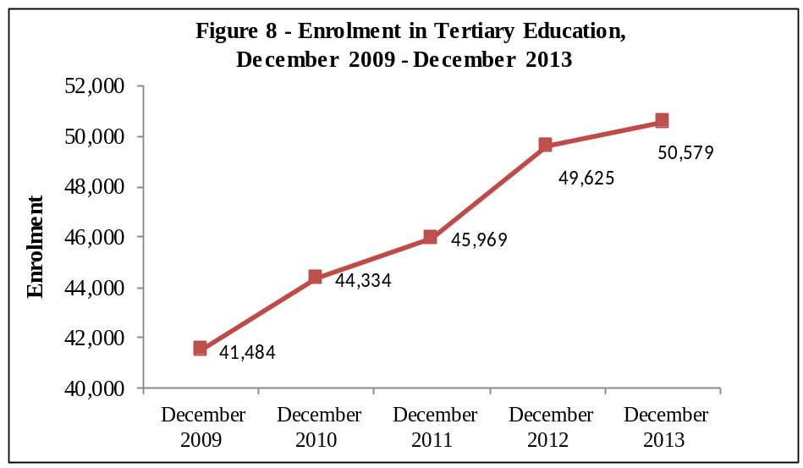

Figure 8 gives the evolution of total tertiary enrolment over the period 2009 to 2013. Total enrolment rose appreciably from 2009 to 2012, but slowed down in 2013.

The majority of students (82%) were enrolled in tertiary education locally in both public-funded institutions (47%) and private institutions (35%). The remaining 18% of the students were enrolled in tertiary education overseas (Table 8.1b).

The Gross Enrolment Ratio (tertiary education enrolment as a percentage of the population aged 20 to 24 years), which was 50.6 % in 2012, decreased to 50.1% in 2013.

Statistics Mauritius

Contact Person
F. Koussa (Mrs)
Statistician
Statistics Unit
Ministry of Education and Human Resources
Pont Fer, Phoenix
Tel: 601 5252, 601 5200, Ext. 5430, 5478
Email: fkoussa@mail.gov.mu
Ministry of Finance and Economic Development
Port Louis
Mauritius
September 2014

