POPULATION AND VITAL STATISTICS
REPUBLIC OF MAURITIUS, YEAR 2011

- Introduction
This issue of Economic and Social Indicator presents population estimates as at December 2011 and vital statistics including rates for the year 2011.
Statistics Mauritius compiles vital statistics from data obtained from the computerised system in place at the Central Civil Status Office.
Definitions of terms used are given at Annex.
- Key points
- The population of the Republic of Mauritius was estimated at 1,288,684 as at 31 December 2011, growing at a rate of 0.4% since end 2010.
- As at end 2011, the female population was higher than the male population by 18,974.
- In 2011, the population aged 0 to 14 years comprised 21.1 % of the total population. The population aged 15 to 64 years and that aged 65 years and over comprised 71.5 % and 7.4% respectively of the total population.
- The dependency ratio (the child population under 15 years of age and the elderly population aged 65 years and above per 1,000 population aged 15 to 64 years) decreased from 406 in 2010 to 398 in 2011.
- The number of live births registered during year 2011 was 14,701 representing a decrease of 2.0% over the figure of 2010.
- The number of deaths registered in 2011 stood at 9, 170, 0.4% higher than in 2010.
- The number of infant deaths increased by 1.1% from 187 in 2010 to189 in 2011.
- The number of still births increased by 35%, from 103 in 2010 to 139 in 2011.
- The number of marriages registered in 2011 was 10,499, that is, 0.5% less than in 2010.
- Estimated resident population
Table 3.1 - Estimated resident population by sex, Republic of Mauritius,
31 December 2011
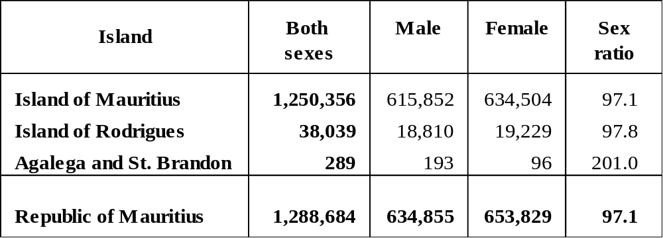

The estimated resident population of the Republic of Mauritius was 1,288,684 as at 31 December 2011. The female population was 653,829 compared to a male population of 634,855. There were 97.1 males for every 100 females.
The population was estimated at 1,250,356 and 38,039 respectively for the Island of Mauritius and the Island of Rodrigues. In both islands, females outnumbered males. However, Agalega and St Brandon, with an estimated population of 289, had more males (193) than females (96).

Table 3.2 - Population density, Republic of Mauritius, 31 December 2011

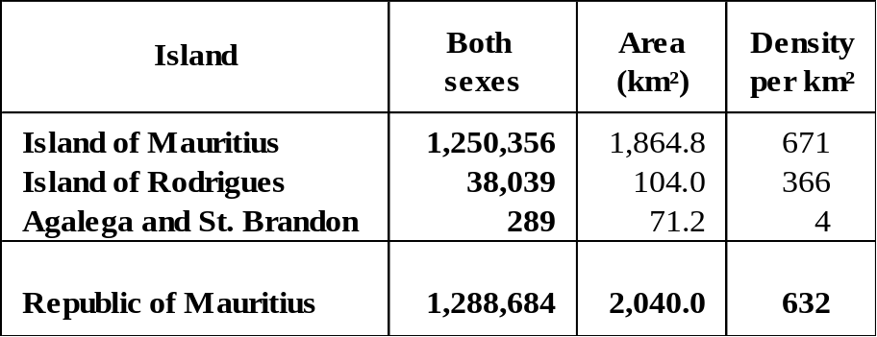

The Republic of Mauritius, with a total land area of 2,040 km² had a population density of 632 persons per km² as at end 2011. Among its constituent islands, the Island of Mauritius had the highest density (671), followed by Rodrigues (366). The population density for the Republic of Mauritius increased from 629 in 2010 to 632 in 2011.

Table 3.3 - Estimated resident population by sex, Republic of Mauritius,
2009 - 2011 (end of year estimates)

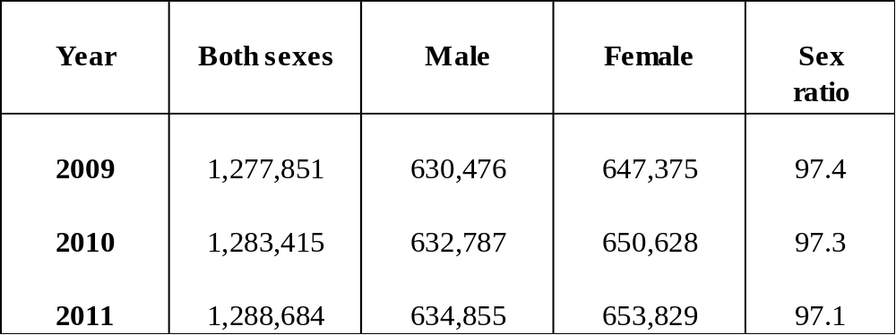

Comparative population estimates and sex ratios for the past three years are given in Table 3.3. From the year 2009 to 2011, there was a slight decline in the sex ratio indicating an increasing proportion of females over time.

- Population growth
Table 4.1 - Population change, Republic of Mauritius, 31 December 2010 and
31 December 2011

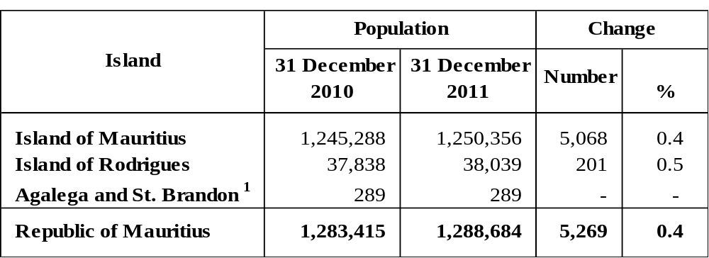
^{1/} the figures for Agalega and St Brandon refer to the 2000 Population Census

The population of the Republic of Mauritius increased by 5,269 persons from 31 December 2010 to 31 December 2011. The population growth rate was thus 0.4 % during the 12-month period. The growth rate for the Island of Mauritius was also 0.4 %; whilst for Rodrigues it was around 0.5 %.

Table 4.2 - Components of population growth, Republic of Mauritius^{1/}, 2010 and 2011
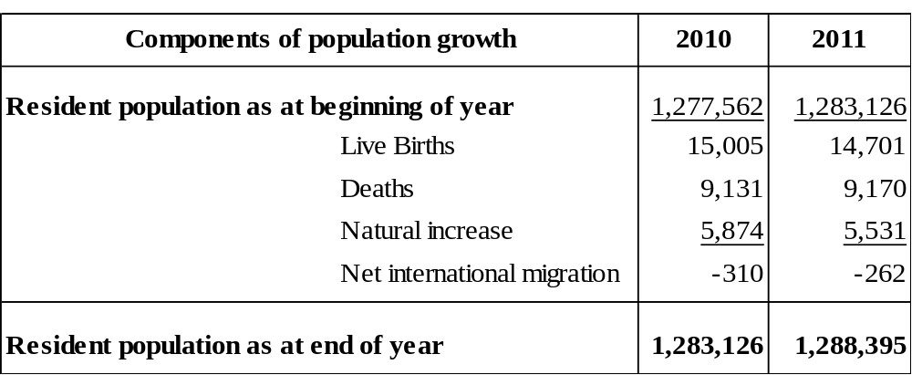
^{1/} excluding Agalega and St Brandon

Population growth has two components: natural increase (the number of births minus the number of deaths) and net international migration (net international movement of residents).

During the year 2011, the natural increase was 5,531, with births adding 14,701 babies and deaths removing 9,170 persons from the population. For the same period, net international migration of residents was estimated at -262 persons.

- Age distribution of the population
Table 5.1 - Estimated resident population^{1/} by broad age group and sex –
Republic of Mauritius^{2/}, 1 July 2010 and 1 July 2011

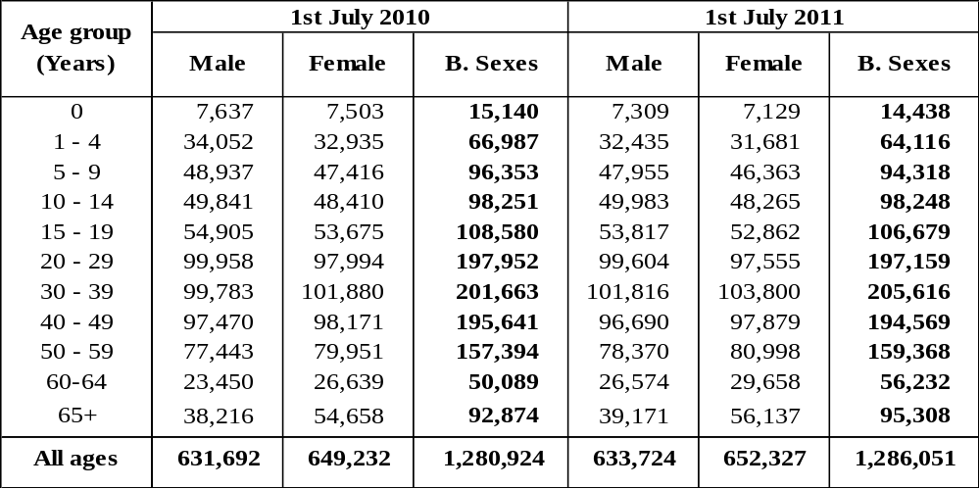
^{1/} based on 2000 Population Census data adjusted for underenumeration of young children
^{2/} excluding Agalega and St Brandon
The proportion of the population aged 0-14 years declined from 21.6% in 2010 to 21.1% in 2011. In contrast, increases were registered in the proportion aged 15-64 years from 71.1% to 71.5% and the proportion aged 65 years and above from 7.3 % to 7.4 % during the same period. The overall effect was a decrease in the dependency ratio from 406 to 398; (Figure 5.1).

Figure 5.1 - Dependency Ratio, 2003 - 2011

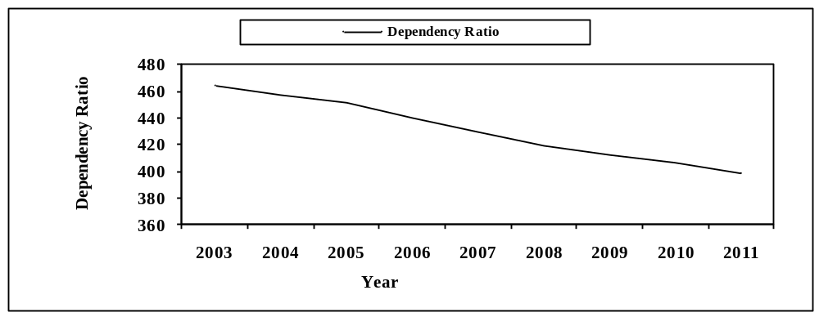

The population pyramid in Figure 5.2 compares the age structure of the population between 2001 and 2011. The main changes observed over time are:
- the shrinking of the base of the pyramid due to falling fertility;
- the thickening of the upper body of the pyramid indicating an increase in expectation of life;
- the relatively longer bars on the female side of the pyramid around its apex indicating the predominance of females among the elderly.

Figure 5.2 - Population pyramid – Republic of Mauritius, 2001 & 2011

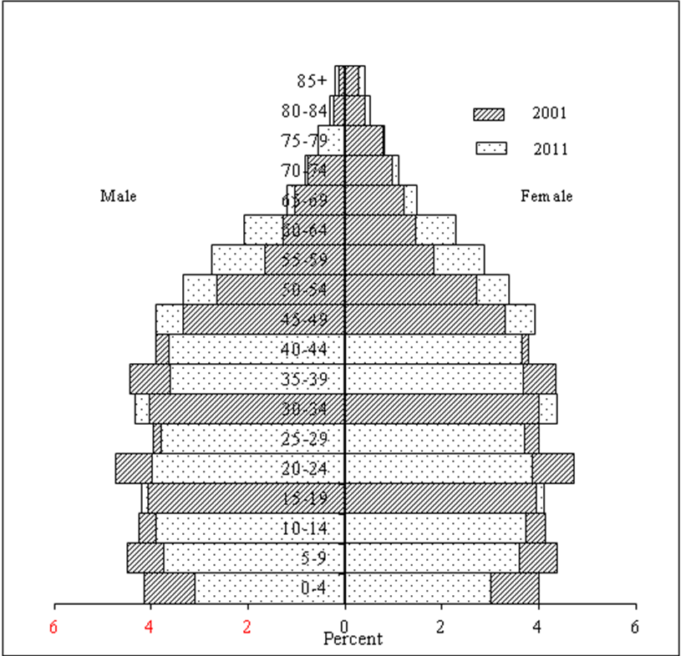

6 Vital statistics and rates
6.1: Live births and crude birth rate
Table 6.1 - Live births registered and crude birth rate, Republic of Mauritius,
2010 and 2011^{1/}
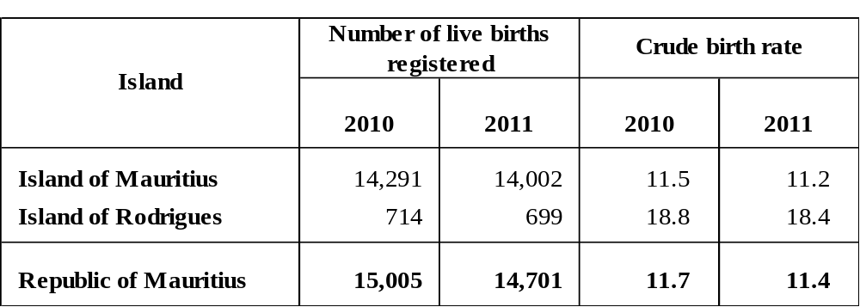
^{1/} Provisional

During the year 2011, 14,701 live births were registered in the Republic of Mauritius, representing a 2.0% fall over the 2010 figure of 15,005. The crude birth rate, i.e., the number of live births in a year per 1,000 mid-year population, fell from 11.7 in 2010 to 11.4 in 2011.
In the Island of Mauritius, the number of live births registered decreased from 14,291 in 2010 to 14,002 in 2011, bringing about a fall in the crude birth rate from 11.5 to 11.2. Similarly, for the Island of Rodrigues, the number of live births decreased from 714 (rate of 18.8) in 2010 to 699 (rate of 18.4) in 2011.

6.2: Deaths and crude death rate

Table 6.2 - Deaths and crude death rate, Republic of Mauritius, 2010 and 2011^{1/}

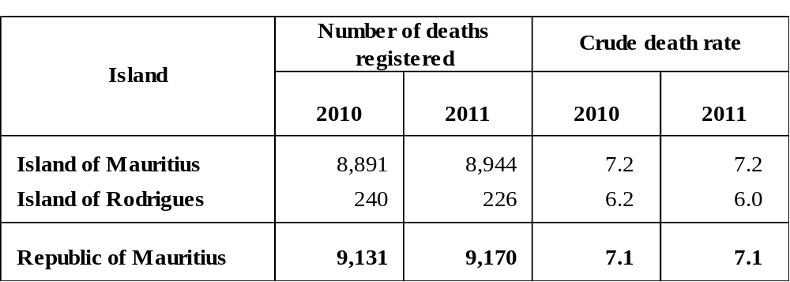

^{1/} Provisional

The number of deaths registered in the Republic of Mauritius in 2011 was 9,170, representing a 0.4% increase over the figure of 9,131 for 2010. The crude death rate, i.e., the number of deaths in a year per 1,000 mid-year population was 7.1 in both 2010 and 2011.
The Island of Mauritius registered an increase in the number of deaths, from 8,891 in 2010 (rate of 7.2) to 8,944 in 2011 (rate of 7.2). During the same period, the number of deaths in Rodrigues decreased from 240 (rate of 6.2) to 226 (rate of 6.0).

6.3: Infant deaths and Infant mortality rate

Table 6.3 - Infant deaths and infant mortality rate, Republic of Mauritius,

2010 and 2011^{1/}
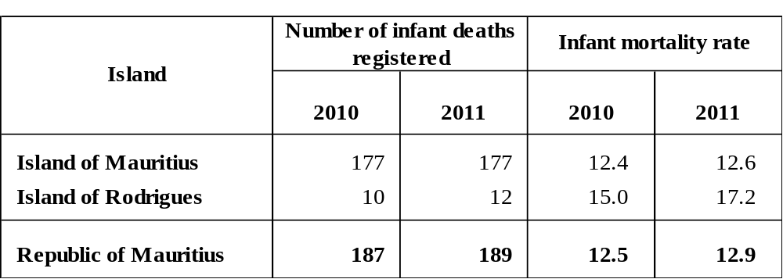
^{1/} Provisional

During the year 2011, 189 infant deaths (deaths to children aged under one year) were registered in the Republic of Mauritius against 187 in 2010, representing an increase of 1.1%. The infant mortality rate, defined as the number of infant deaths per 1,000 live births, increased from 12.5 in 2010 to 12.9 in 2011.
The number of infant deaths in the Island of Mauritius was 177 in both 2010 and 2011. The infant mortality rate however, increased from 12.4 to 12.6 during the same period. For Rodrigues, the number of infant deaths increased from 10 in 2010 to 12 in 2011and the infant mortality rate rose from 15.0 to 17.2 during the same period.

6.4: Still births and still birth rate
Table 6.4 - Still births and still birth rate, Republic of Mauritius, 2010 and 2011^{1/}
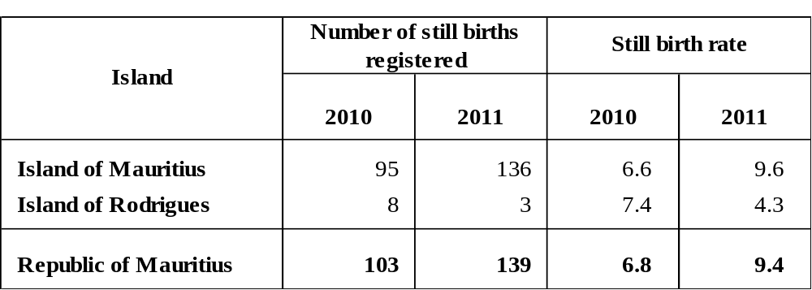
^{1/} Provisional

In 2011, 139 still births were registered in the Republic of Mauritius, which is 35.0% higher than the 2010 figure of 103. Consequently, the still birth rate which is the number of still births in a year per 1,000 total births during the year increased from 6.8 in 2010 to 9.4 in 2011.
The Island of Mauritius registered 136 still births in 2011 against 95 in 2010, with the still birth rate rising from 6.6 in 2010 to 9.6 in 2011. In Rodrigues, 3 still births were registered in 2011 compared to 8 in 2010. The still birth rate fell from 7.4 in 2010 to 4.3 in 2011.

6.5: Marriages and crude marriage rate
Table 6.5 - Marriages and crude marriage rate, Republic of Mauritius, 2010 and 2011^{1/}

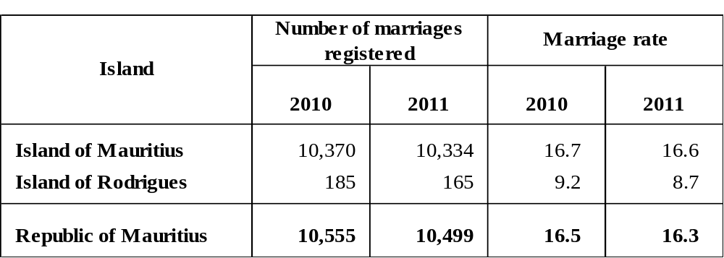
^{1/} Provisional

The number of marriages registered in the Republic of Mauritius decreased by 0.5% from 10,555 in 2010 to 10,499 in 2011. The crude marriage rate, i.e., the number of persons married in a year per 1,000 mid-year population, fell from 16.5 to 16.3 during the same period.

The number of marriages in the Island of Mauritius decreased from 10,370 in 2010 (rate of 16.7) to 10,334 in 2011 (rate of 16.6). The Island of Rodrigues also registered a decrease in the number of marriages from 185 in 2010 (rate of 9.2) to 165 in 2011 (rate of 8.7).

- International Comparison
Population growth rates for various countries in the world are published in the UN publication “The World Population Prospects 2010 Revision”. The figures indicate that the population growth rate for the Republic of Mauritius during the period 2005 to 2010 was 0.7%, lower than the estimated world’s population growth rate of 1.2%. The Republic’s growth rate was lower than that for Singapore (3.5%) and India (1.4%), but was higher than that for the United Kingdom (0.6%), Japan (0%) and Belgium (0.6%).

Statistics Mauritius
Ministry of Finance and Economic Development
Port Louis
27 February 2012

Contact person: Mr. C. Arianaick
Statistician (Demography Unit)
Statistics Mauritius
LIC Centre
John Kennedy Street
Port Louis
Tel: 208 0859
Email: cso_demography@mail.gov.mu

Annex

1. Vital Statistics: The statistics pertaining to vital events which include live births, deaths, still births, marriages and divorces
2. Population density: The number of persons per square kilometre
3. Dependency ratio: The child population under 15 years of age and the elderly population aged 65 years and above per 1,000 population aged 15 to 64 years.
4. Sex ratio: The number of males to every 100 females.
5. Natural increase: The excess of live births over deaths.
6. Crude birth rate: The number of live births in a year per 1,000 mid-year population.
7. Crude death rate: The number of deaths in a year per 1,000 mid-year population.
8. Infant mortality rate: The number of deaths in a year of infants aged under one year per 1,000 live births during the year.
9. Still birth rate: The number of still births in a year per 1,000 total births (live
births and still births) during the year.
10. Marriage rate: The number of persons married in a year per 1,000 mid-year
population.
Note: The vital rates for Rodrigues are usually calculated as an average for three years in order to remove wide fluctuations in the yearly data. The rates for year 2011 are however calculated on the basis of data for the year only.

