Labour force, Employment and Unemployment based on the results of the Continuous Multi Purpose Household Survey – Year 2010

Introduction
- This second issue of the Economic and Social Indicators presents a set of estimates of labour force, employment and unemployment for the year 2010, based on the results of the Continuous Multi-Purpose Household Survey (CMPHS). The estimates refer to the Mauritian population aged 16 years and above in the Republic of Mauritius; foreign workers are not included.
- The estimates in this publication are subject to sampling error that tends to be relatively large as the sample numbers are small.

Key figures
 | 2009 | 2010 | Change  2009 - 2010
Labour force | 566,300 | 581,300 | +15,000
Employment | 524,800 | 536,100 | +11,300
Unemployment | 41,500 | 45,200 | +3,700
Unemployment rate (%) | 7.3 | 7.8 | +0.5 pt
Activity rate (%) | 59.1 | 59.8 | +0.7 pt

Detailed estimates together with sampling error and confidence interval are given in Table 1 at Annex.

Key points
- Change from 2009 to 2010
- Labour force increased by 15,000 from 566,300 to 581,300
- Activity rate increased from 59.1% to 59.8%. Male activity rate remained unchanged at 76.1% while female activity rate rose from 42.6% to 44.2%
- Employment increased by 11,300 from 524,800 to 536,100 driven by an increase of 7,900 in female employment while male employment increased by 3,400
- Unemployment rate increased from 7.3% to 7.8%. Male unemployment rate increased from 4.4% to 4.6% and female unemployment rate from 12.3% to 13.0%

- Situation in 2010
- The workforce was made up of around twice as many men as women.
- Most of the workers were employees.
- The tertiary sector was the main source of jobs for Mauritians.
- Unemployed women outnumbered unemployed men though they were generally more qualified.

- Evolution from 2001 to 2010
- Men are more economically active than women but the gap is decreasing over time
- Female employment is increasing faster than male employment
- The tertiary sector is becoming increasingly important in terms of employment
- Unemployment rate has been increasing to reach a peak in 2005; it then decreased till 2009 when an upward trend was observed

Labour market overview
Chart 1 – The Labour Market, 2010
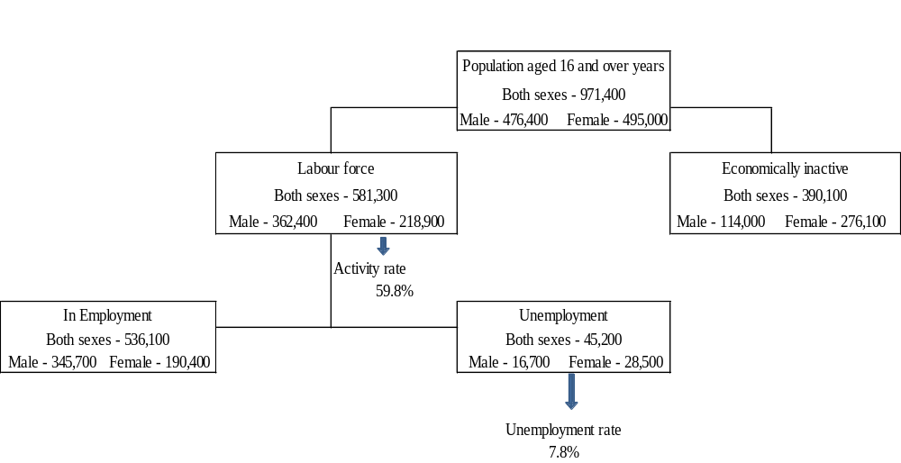
6. In 2010, the population of working age (aged 16 years and over) numbered 971,400, of whom 581,300 fell in the labour force (or were economically active) resulting in an activity rate of 59.8%. The number employed totalled 536,100 whilst the number unemployed stood at 45,200; the unemployment rate worked out to 7.8% of the labour force.
Chart 2 – Population structure by age, sex and economic activity, 2010
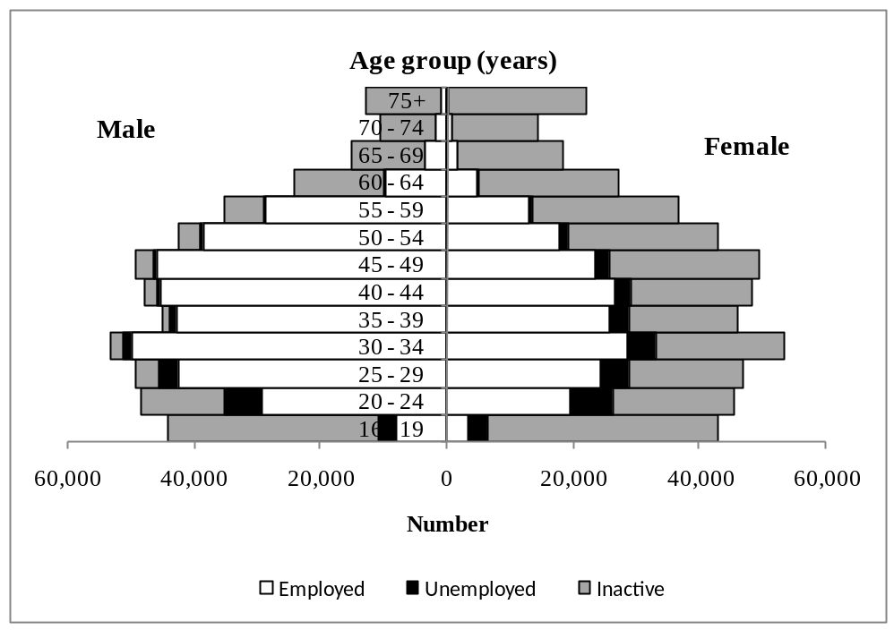

- The pyramid (Chart 2) and Table 2 indicates that in 2010:
- The number of inactive women was significantly higher than that of men at all ages;
- There were fewer women than men among the employed at all ages ;
- Unemployed women were more numerous than unemployed men at all ages;
- As from age 20 – 24 years, the number of unemployed generally tends to decrease as age increases.
Employment
- Total employment stood at 536,100 (345,700 males and 190,400 females) in 2010. The employment to population ratio was around 55% (73% for males and 38% for females).
Chart 3 – Age-sex structure of the employed population, 2010
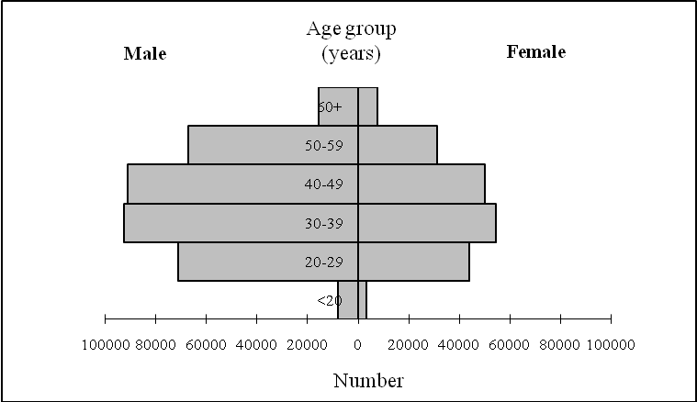

There are two times as many men as women in the workforce
- The workforce comprised around twice as many men as women and was concentrated in the age group 30 to 50 years. The mean age of a worker was 40.4 years for males and 39.4 years for females.

The workforce is mainly made up of married persons
- The workforce was mainly made up of married persons (68.1%), followed by persons in the single state (24.5%). A small proportion of the employed were widowed, divorced and separated (7.4%). Compared to the male workforce, the female workforce consisted of a higher proportion of widowed, divorced and separated persons (14.8% compared to 3.4%) (Table 3).
Chart 4 – Employed population by marital status and sex, 2010
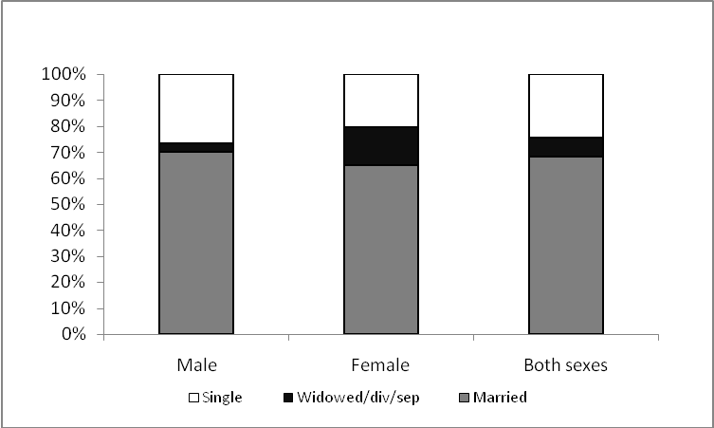

The workforce is mostly made up of employees
- Some 80% of the employed were employees while around 18% were self-employed (own account workers or employer) and the remaining 2% were contributing family workers. The female workforce as compared to the male workforce comprised a higher proportion of employees (83.5% against 77.9% among males) and contributing family workers (5.1% against 0.9%) but a smaller proportion of self employed (11.4% against 21.2% among males) (Table 4).

Chart 5 – Employed population by employment status and sex, 2010
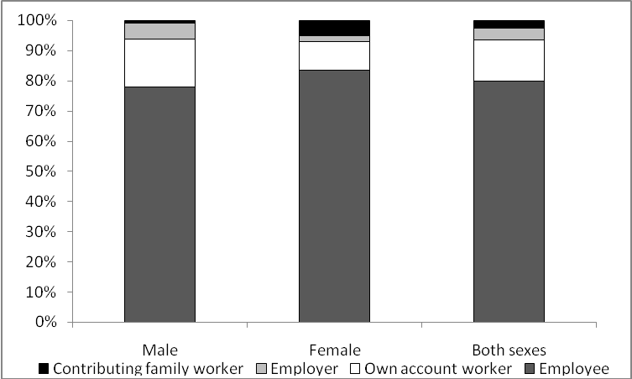

Employers worked longer hours than other categories of workers and earned the highest income
- On average, an employed person worked 40.5 hours per week. An employer put in 45.0 hours of work compared to 41.1 hours for an employee and 36.6 hours for an own-account worker (Table 5).
Chart 6 – Mean hours of work by employment status and sex, 2010

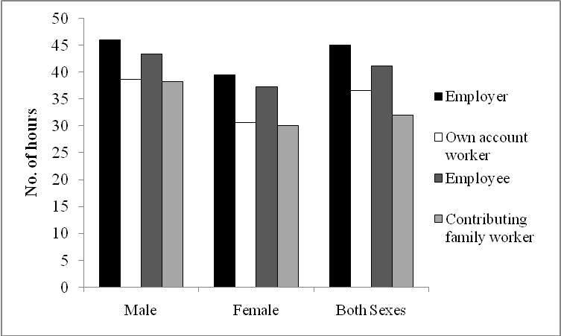

- Monthly income from employment, which includes income from paid work and income from business activities, amounted to Rs 13,900. The average monthly income for an employer was Rs 24,400 against Rs 9,600 for an own-account worker while that for an employee stood at Rs 14,100 (Table 6).

Chart 7 – Average monthly income from employment by employment status and sex, 2010

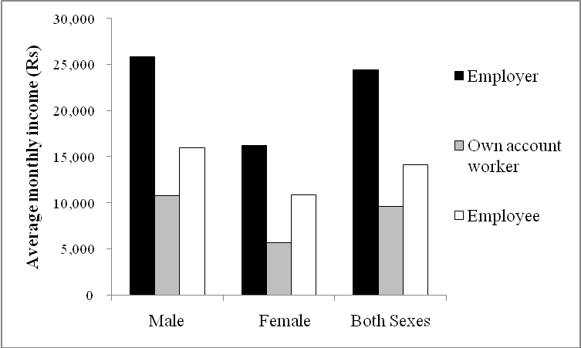

The tertiary sector provided jobs to 6 out every 10 workers and gave the highest pay
- Out of every 10 workers, 6 were employed in the tertiary sector (covering trade, hotels & restaurants, transport and all the other service industries), 3 in the secondary sector (covering manufacturing, electricity & water and construction) and 1 in the primary sector (covering agriculture and mining & quarrying) (Table 7).
- Income from employment was highest in the tertiary sector (Rs 15,800), followed by the secondary sector (Rs 11,200) and the primary sector (Rs 8,600) (Table 8).

Chart 8 – Average monthly income from employment by industrial sector and sex, 2010
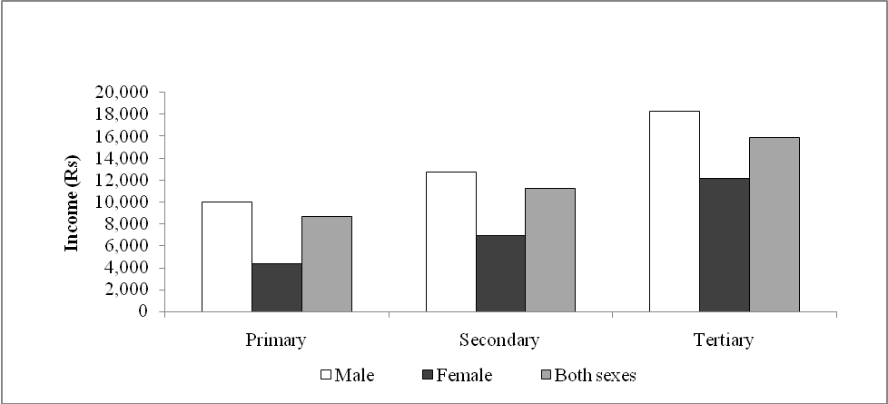

Workers in the primary sector had the highest length of service but worked for fewer hours
- Workers in the primary sector had the highest length of service with their present employer (12.6 years), followed by the tertiary sector (9.7 years) and the secondary sector (8.5 years) (Table 9).
Chart 9 – Mean length of service by industrial sector and sex, 2010
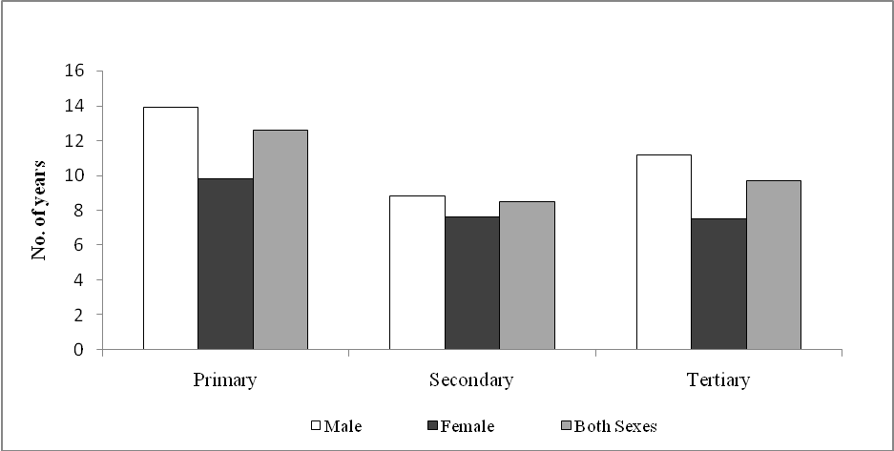

- Employed persons in the secondary sector had the longest hours of work (42.0 hours per week), followed by those in the tertiary sector (40.7 hours) and the primary sector (33.7 hours) (Table 10).
Chart 10 – Mean hours of work per week by industrial sector and sex, 2010
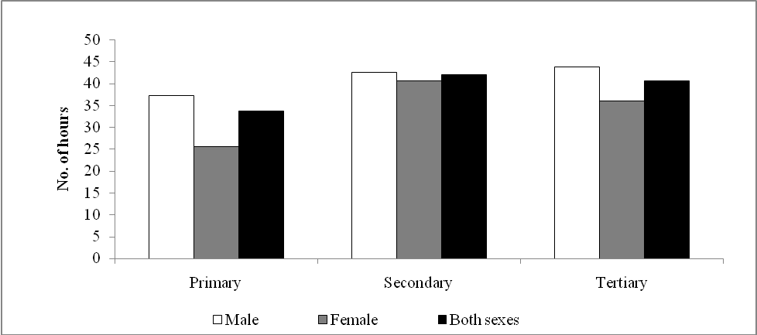

The Mauritian workforce is distributed across all occupational groups
- Some 17.6% of the workforce was engaged in the higher occupational group (ISCO 1-3) which comprises legislators, senior officials and managers; professionals; technicians and associate professionals. Clerks (ISCO 4) made up 10.2% of the workforce; service, shop and market sales workers (ISCO 5) 19.3%. Another 33.9% were skilled agricultural and fishery workers; craft and related trade workers; plant and machine operators and assemblers (ISCO 6-8). Those engaged in elementary occupations (ISCO 9) made up 19.0% (Table 11).

Workers engaged in higher occupational groups earned the highest income
- Legislators, senior officials and managers; professionals; technicians and associate professionals earned the highest income (Rs 29,600), followed by clerks (Rs 14,000). The lowest income was drawn by those engaged in elementary occupations (Rs 7,800) (Table 12).

Chart 11 – Average monthly income from employment by occupational group and sex, 2010
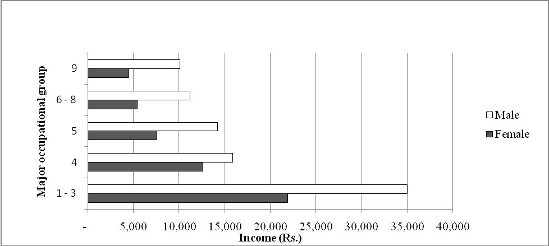

1 out every 5 workers was available for additional work
- In addition to this main job and secondary job (if any), 22.2% of the employed population were available for additional work. Employed women were less available for additional work than their male counterparts; 17.6% reported they were willing to work additional hours against 24.7% for men.
Only 5% of the employed had secondary jobs
- Out of the 536,100 employed, 27,000, that is, around 5% held a secondary job. Most of the secondary job holders (72%) were employees in their main job. The main sectors in which they got their secondary jobs were: agriculture (34.0%), wholesale and retail trade and repairs (13.4%), and construction (10.4%).

Unemployment
- The number of unemployed persons numbered 45,200, comprising 16,700 males and 28,500 females. The unemployment rate was 7.8%, higher among females (13.0%) than among males (4.6%).

There are more unemployed among females than among males
- The unbalanced shape of the pyramid in Chart 12 indicates the predominance of females among the unemployed at all age-groups. Women represented 63% of the total unemployed and they outnumbered men by 11,800.
Chart 12 – Age-sex structure of the unemployed population, 2010
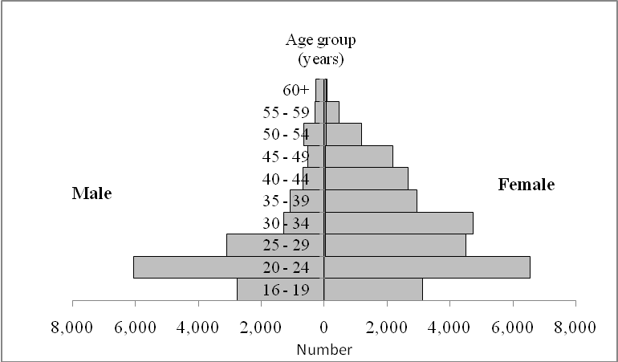
Unemployed males are younger than their female counterparts
- On average, an unemployed male was more than three years younger than his female counterpart. The mean age of the unemployed male was 28.4 years and that of unemployed female was 31.8 years.
Unemployment rate is highest among young persons
25. Unemployment rate was highest at the lowest age groups and decreased progressively with increasing age. It was 34.1% among those below 20 years and 2.4% at age 50 years and above (Table 13).
26. The disparity between male and female unemployment was highest in the lower age group; the difference was nearly 22 percentage points among the unemployed below 20 years and around 3 percentage points among those aged 50 years and above.
The unemployed men are mostly single while the unemployed women are mostly ever-married
27. Out of the total number of unemployed, around half were ever-married and half were single. Most of the unemployed men, however, were single (77.8%) whereas most of the unemployed women were ever-married (67.4%), i.e. currently married, widowed, divorced or separated (Table 14).

Chart 13 – Unemployed population by marital status and sex, 2010

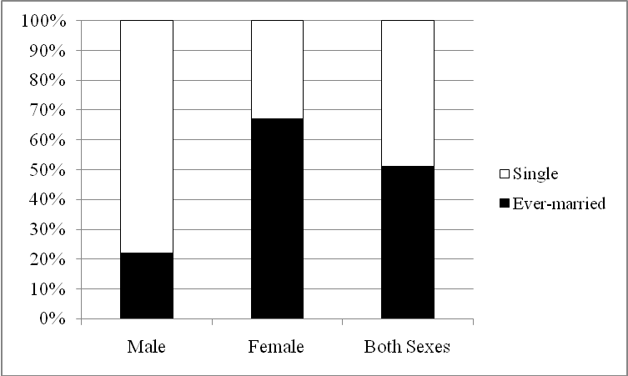
A large majority of the unemployed do not hold the School Certificate
28. Some 62% of the unemployed, representing 28,000 persons, were without a Cambridge School Certificate (SC): 19% had not reached the Certificate of Primary Education (CPE) level, 11% held the CPE certificate only, and a further 32% attended secondary school but did not pass the SC. The proportion with SC as highest attainment was 20% and that with Higher School Certificate (HSC) 10%. Unemployed having studied up to the tertiary level numbered some 3,600 and represented 8% of the total unemployed (Table 15).
Chart 14 – Unemployed population by education attainment and sex, 2010
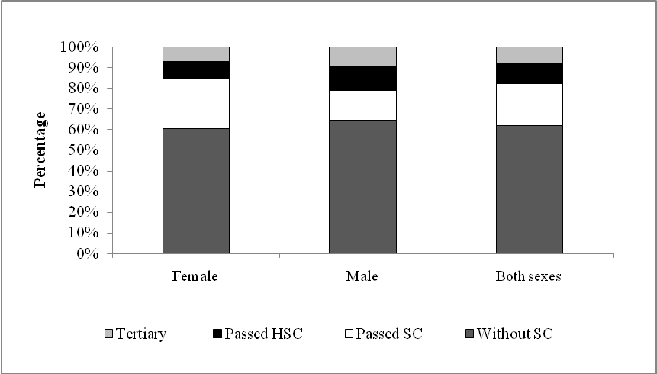

Unemployed women are generally more qualified than unemployed men
- Unemployed women were generally more qualified than their male counterparts; around 39% of them possessed the School Certificate or above against 35% among males. However, a higher proportion of unemployed men (10%) attained tertiary level education as compared to unemployed women (7%).
Women are in unemployment around three and a half months more than men
- On average, an unemployed person had been without a job for 10.8 months. Women remained unemployed for 12.2 months compared to 8.4 months for men. The duration of unemployment varies with age (Chart 15). The proportion unemployed for less than six months was generally highest among the youngest age groups while the proportion employed for more than 24 months was highest among those among those aged 30-39 years.
Chart 15 – Duration of unemployment by age group, 2010
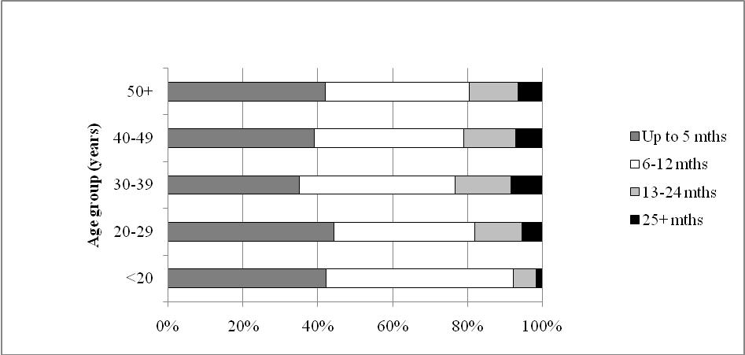

The unemployed is predominantly made up of persons with work experience
- Around two thirds of the unemployed had worked in the past. Slightly more than half (54%) had work experience in the tertiary sector, mainly ‘Wholesale & retail trade’ and ’Hotels & restaurants’. Another 42% had worked previously in the secondary sector, mainly in ‘Manufacturing’ followed by ‘Construction’.The remaining 4% previously worked in the agricultural sector.

One quarter of the unemployed who worked before lost their job following closures and downsizing of firms
- Some 24% of the unemployed lost their job following closure of firms or reduction in the workforce. Another 24% became jobless after completing their work/contract while around 23% were dissatisfied with their employment.

The most popular method of job search was ‘applied to prospective employers’and ‘checked at factories, worksites’
- The unemployed usually has recourse to more than one method of job search. The most common method was ‘applied to prospective employers’(53%) followed by ‘checked at factories,worksites, etc’ (51%). Around 43% were registered at the Employment Service. Less than 10% had taken steps to start a business of their own (Table 16).
Chart 16 – Unemployed population by method of job search and sex, 2010
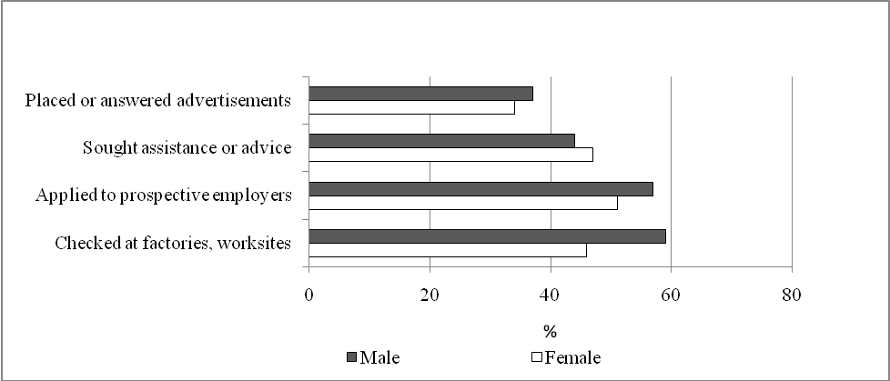

The unemployed were more willing to accept full time rather than part time employment
- The unemployed were more likely to accept full time employment (92.0%) rather than part time employment (66.6%). They showed a slight preference for work in the public sector; 87.4% would take up a job in the public sector against 81.9% in the private sector. Only 56.4% were willing to have a temporary job. The proportion who would accept a job below or outside their level of qualification or training was around 64.0% (Table 17).

Chart 17 – Unemployed population by type of job willing to accept and sex, 2010
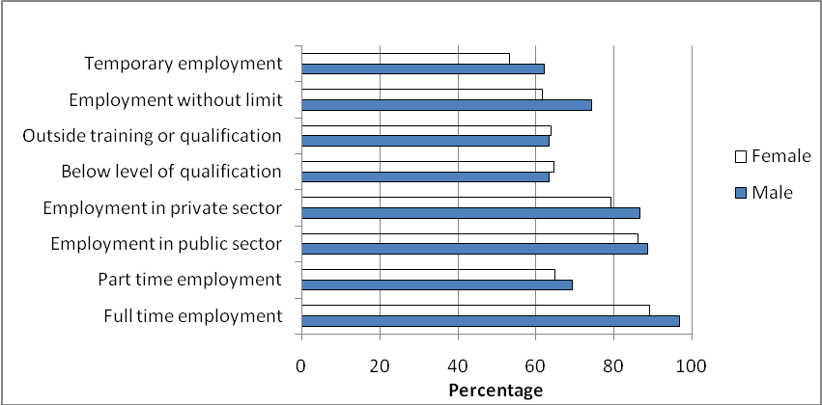

The unemployed relied mainly on their parents and spouse for financial support
- The main source of income support for the unemployed to meet their daily needs was their parents (47.4%) followed by their spouse/partner (37.6%). Other sources of support were from other relatives, savings and pensions.
Chart 18 – Unemployed population by main source of income to meet daily needs and sex, 2010
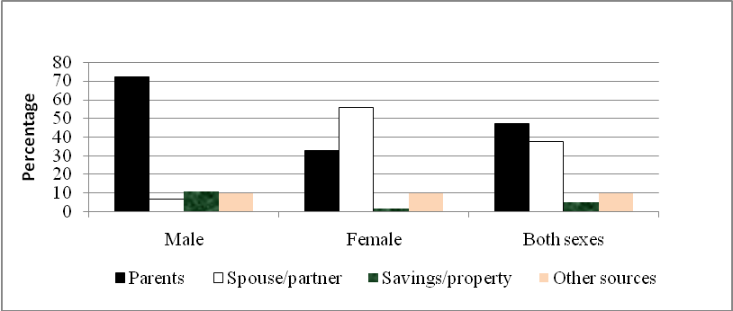

Inactive population
- The number of persons aged 16 years and over not forming part of the labour force (inactive population) stood at 390,100 (114,000 males and 276,100 females) (Table 18). Some 2,800 of them were classified as inactives although they were not working and were available for work; the main reason being that they were not actively looking for work. Those persons have not been classified as unemployed since they did not satisfy all the three criteria for unemployment, i.e., not working, looking for work and available for work. About 58% of these inactives did not look for work because they either believed that suitable jobs were not available or did not know where to look for work.
- The inactive population comprised 43.8% homemakers, 23.1% students, 22.5% retired or old persons and 7.7% sick or disabled persons.

Evolution from 2001 to 2010
Male activity rate is higher than for females but the gap is decreasing over time
- During the period 2001 to 2010, male activity rate was always higher than female activity rate (Chart 19). However, the gap is narrowing over time as the activity rate for men has been constantly decreasing over the years while that of females has been increasing (Table 19).
Chart 19 – Activity rate by sex, 2001 - 2010
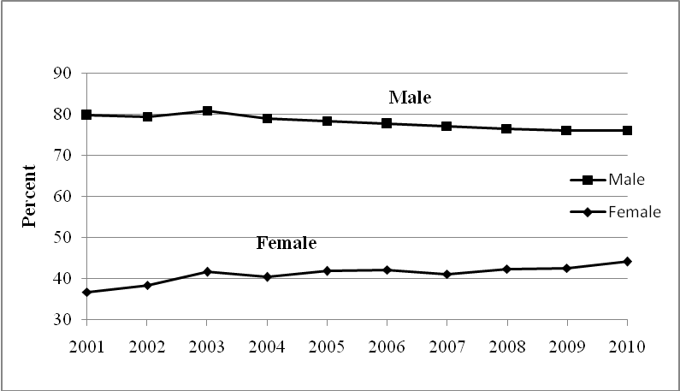
- Over the years, the shape of the curve for female activity rate by age (Chart 20) is tending towards that of the male. Increases in activity rate are noted for females aged 20 years and over, being more pronounced for women aged 20 - 44 years.

Chart 20 – Activity rate by age and sex – 2001 & 2010
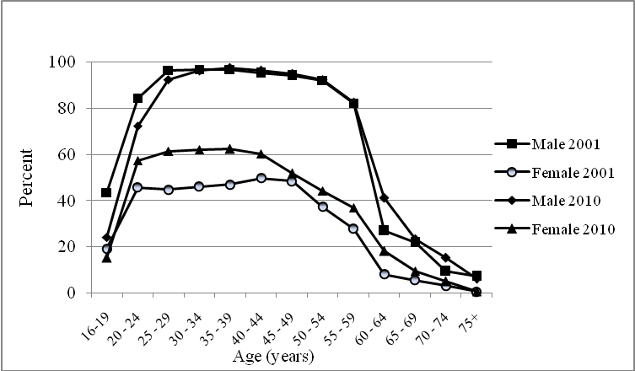
Female employment is increasing faster than male employment
- During the period 2001 to 2010, female employment increased at a faster rate than male employment. On average, female employment increased annually by 3,800 or 2.2% whereas male employment increased by 2,900 or 0.9%.
The tertiary sector is becoming increasingly important in terms of employment
- Over time, the tertiary sector is becoming increasingly important in terms of employment. From 2001 to 2010, employment in this sector rose from 245,800 to 336,100; its share over total employment also increased from 52% to 63%. In contrast, employment in the primary and secondary sectors has been declining over time. In the primary sector, employment went down from 57,300 in 2001 to 45,700 in 2010 mainly due to a decline in the agricultural sector. In the secondary sector, employment declined from 172,500 to 154,300 mainly due to a decreasing workforce in the manufacturing sector (Table 7).

Chart 21 – Employed population by industrial sector and sex, 2001 & 2010
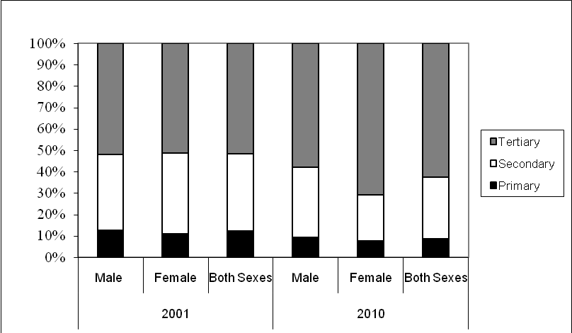

Mauritian workforce is moving up the occupation ladder
- The share of employment in the higher occupational groups (ISCO 1-3) comprising legislators, senior officials and managers; professionals; technicians and associate professionals increased from 13.8% in 2001 to 17.6% in 2010. Service workers and shop and market sales workers (ISCO 5) also had a larger share of employment in 2010, 19.3% against 15.4% in 2001. In contrast the share of employment in the lowest occupational group (ISCO 9) representing elementary jobs decreased from 23.7% to 19.0%. Also, skilled agricultural and fishery workers; craft and related trade workers; plant and machine operators and assemblers (ISCO 6-8) were less represented, 33.9% in 2010 against 38.7% in 2001 (Table 11).

Chart 22 – Employed population by occupational group, 2001 – 2010
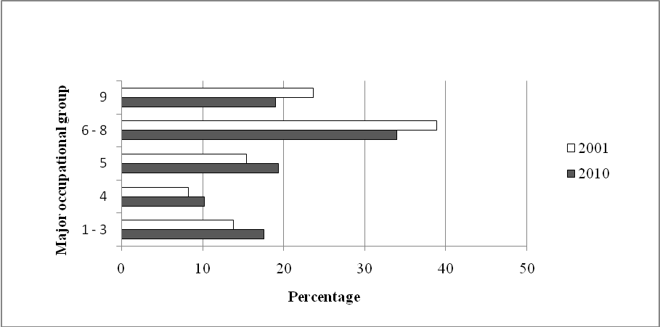

Unemployment rate has been decreasing since 2005 but has taken an upward trend as from 2009
Chart 23 – Unemployment rate by sex, 2001 - 2010
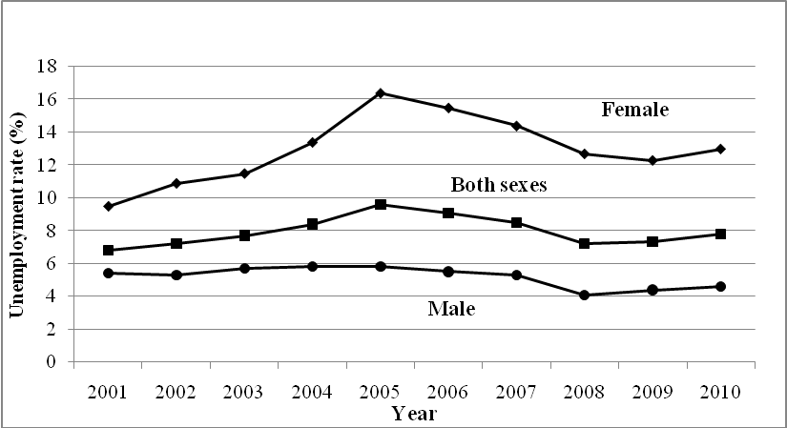

- The unemployment rate increased from 6.8% in 2001, to 9.6% in 2005 after which it started declining. It however rose from 7.2% in 2008 to 7.3% in 2009 and 7.8% in 2010 (Table 20).

- The change over time is quite smooth for male while female unemployment rate increased to attain a peak in 2005, after which it declined till 2009 when it took an upward trend. The disparity between male and female unemployment is higher in 2010 than in 2001.

Central Statistics Office
Ministry of Finance and Economic Development
Port Louis
May 2011

Contact person: Mr. C. K. Arianaick
Statistician
Central Statistics Office
LIC Centre, Port Louis
Tel: 2122316, 2122317
Fax: 2114150
email: carianaick@mail.gov.mu

