CONSTRUCTION PRICE INDEX
(Input Cost Index for the construction of a single storey house)

3rd Quarter 2026

1. Introduction

This issue of the Economic and Social Indicators presents the monthly Construction Price Index (residential) for the third quarter of 2026 with first quarter of 2018 as base period. Figures showing the evolution of the index during the past twelve months are also included.

The methodology used for compiling the index is given in the annexed technical notes. Figures have been rounded to one or two decimal places although they have been calculated to many decimal places.

2. Evolution of the Construction Price Index
(October 2025 to September 2026)

The Construction Price Index, which stood at 147.7 in October 2025, declined marginally by 0.1% to 147.6 in November. It remained stable in December 2025. In January 2026, the index recorded an increase of 1.6%, reaching 149.9, and continued to rise steadily over the following months to reach 156.0 in September 2026.

Chart 1: Construction Price Index
October 2025 to September 2026

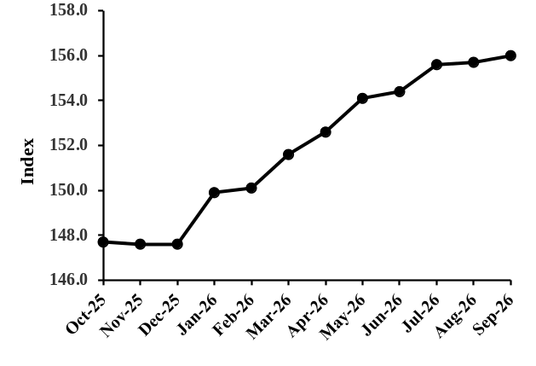

3. Changes in Construction Price Index
(July to September 2026)

In July 2026, the Construction Price Index rose by 0.8%, reaching 155.6. This increase was mainly attributed to higher prices of materials (+0.4%), coupled with higher transportation costs (+19.8%). The increase in the material sub-index is mainly due to higher prices of hardcore (+4.6%), aggregate (+3.9%), premixed mortar (+0.3%), steel bars (+0.7%), plumbing (+1.3%) and electrical installation (+1.1%).

In August 2026, the Construction Price Index increased by 0.1% to reach 155.7. This rise was mainly attributable to higher prices of premixed mortar (+0.3%), tiles and granite (+0.4%), paint (+0.6%) and plumbing (+0.1%), partly offset by a decrease in the price of timber carpentry (-0.8%).

The overall index increased by a further 0.2% in September 2026 to reach 156.0. This increase was mainly attributable to a rise in the rate for the hire of plant (+0.9%), coupled with higher material prices (+0.2%). The increase in the materials sub-index was mainly driven by higher prices of damp roofing (+4.3%), premixed mortar (+1.0%), timber carpentry (+1.7%), timber joinery (+0.2%), tiles and granite (+2.1%), and electrical installation (+1.4%).

Chart 2: Percentage change from
previous month
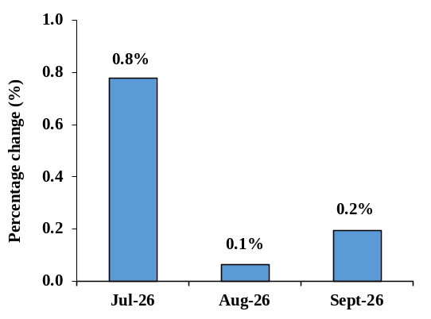
Compared with the corresponding months of the previous year, the index registered increases of 5.6% in both July and August 2026, and 5.8% in September 2026 (Table 1.3).

Chart 3: Percentage change from
corresponding month of previous year

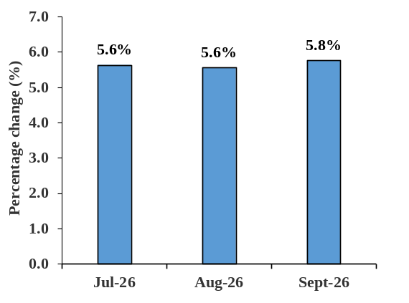

4. Changes by Input Categories

Changes by input categories are shown in Tables 1.1 to 1.5.

During the third quarter of 2026, changes were registered in the “Hire of Plant”, “Materials”, and “Transport” sub-indices.

The “Hire of Plant” sub-index increased by 0.9% in September 2026 due to higher hire rates, while no change was observed in July and August 2026.

The “Transport” sub-index increased by 19.8% in July 2026 and remained unchanged in August and September 2026.

The “Materials” sub-index increased by 0.4% in July 2026, mainly driven by higher prices of hardcore (+4.6%), aggregate (+3.9%), premixed mortar (+0.3%), steel bars (+0.7%), plumbing (+1.3%) and electrical installation (+1.1%). In August 2026, the sub-index rose by a further 0.1%, reflecting higher prices of premixed mortar (+0.3%), tiles and granite (+0.4%), paint (+0.6%) and plumbing (+0.1%), partly offset by a decrease in the price of timber carpentry (-0.8%). In September 2026, the sub-index increased by a further 0.2%, mainly due to higher prices of damp roofing (+4.3%), premixed mortar (+1.0%), timber carpentry (+1.7%), timber joinery (+0.2%), tiles and granite (+2.1%) and electrical installation (+1.4%)..

The net monthly contributions of the input categories to the index during the period October 2025 to September 2026 are shown in Table 1.4.

Quarterly averages of the monthly indices by input category and the percentage change from quarter to quarter are shown in Table 1.5.

5. Changes by Work Category

Changes by work category are shown in Tables 2.1 to 2.5.

In July 2026, the grey building sub-index increased by 1.2% to reach 156.0. This increase was mainly driven by higher prices of hardcore (+4.6%), aggregate (+3.9%), premixed mortar (+0.3%), steel bars (+0.7%).

At the level of work categories, the main changes are as follows: “Earthworks” (+3.0%), “Concrete works” (+0.7%), “Reinforcement” (+0.7%), “Formwork” (+1.7%), “Blockwork” (+1.7%), “Plastering to ceilings and walls” (+0.6%), “Screeding to floors and roofs” (+1.9%), “Electrical Works” (+0.7%), “Plumbing and Drainage” (+1.1%) and “Site overhead costs” (+1.5%).

In August 2026, the grey building sub-index remained unchanged at 156.0, as the increase in the price of premixed mortar (+0.3%) was offset by a decrease in the price of timber carpentry (-0.8%).

At the level of work categories, the main changes are: “Formwork” (-0.3%), “Plastering to ceilings and walls” (+0.1%), “Tiling” (+0.3%), “Painting” (+0.3%), and “Plumbing and Drainage” (+0.1%).

In September 2026, the grey building increased by 0.2% to reach 156.3. The 0.2% increase resulted mainly due to higher prices of damp roofing (+4.3%), premixed mortar (+1.0%), timber carpentry (+1.7%).

At the level of work categories, the main changes are:
“Earthworks” (+0.5%), “Concrete works” (+0.1%), “Formwork” (+0.5%), “Plastering to ceilings and walls” (+0.5%), “Internal openings and joinery works” (+0.2%), “Tiling” (+1.9%), “Electrical works” (+0.9%), “Plumbing and Drainage” (+0.2%) and “Site overhead costs” (+0.1%).

Table 2.4 shows the net monthly contributions of the work categories to the index since October 2025.

Quarterly averages of the monthly indices by work category and the percentage changes from quarter to quarter are shown in Table 2.5.

6. Past Trends

Table 3.1 summarises the monthly indices, the quarterly and yearly averages as well as the percentage changes in the yearly average since 2009. The base period for the calculation of the index as from 2009 up to 2018 is the second quarter of 2009. As from 2018, the base period used is the first quarter of 2018.

The series are not strictly comparable because of different base periods. However, for some particular purposes, comparison between the series may be necessary. A chain linked series with base period first quarter 2018, has been worked out and is given in Table 3.2.

Statistics Mauritius
Ministry of Finance
Port Louis
21 October 2026
Contact person: Mr. E. Romjon
(Statistician/Senior Statistician)

Statistics Mauritius
LIC Centre, Port-Louis
Tel: +230 605 1800
Fax: +230 211 4150
Email: cso_construction@ govmu.org

Annex

Technical Note

Methodology for the compilation of the Construction Price Index

- Introduction

A Construction Price Index measures the change in the level of construction prices. The construction industry is very broad and highly diversified with considerable variations from one type of construction to another. This makes it difficult to derive generalized indices that would be applicable to the industry as a whole. Hence, separate indices for the different types of construction need to be compiled. At present, Statistics Mauritius publishes an index that covers residential buildings only.

- Types of Construction Price Indices

Different approaches to index number compilation are used depending on the purpose for which the index is required. There are two main types of construction price indices:

The Output Price Index
In this approach, specific projects representative of the various categories of construction works are selected as models and construction firms are surveyed and asked to provide estimates of the prevailing market prices for each of the projects. As such, the output price indices respond to the changes in prices of materials used and cost of labour, as well as changes in overhead costs and profits.

The Input Price Index
The index is based on prices of a representative selection of basic inputs (labour, plant, materials and transport) that go into the construction work. Hence, the input price index measures the change in the cost of resources to the contractor, and not the change in the price that the client pays.

The office opted for the input price index which, though more limiting than the output price index, is simpler and less expensive to construct and maintain.

- Selection of representative dwelling

Since it would have been too time-consuming and costly to include all major types of residential dwellings, it was decided to restrict the index to a model dwelling, representing the most common type of dwelling in 2017. This model dwelling was determined on the basis of the 2011 Housing Census data and developments assumed to have taken place during the period 2011 to 2017. The drawings of the prototype model dwelling were provided by the Mauritius Housing Company Ltd. A description of the model is given at paragraph (viii) below.

- Weighting scheme

The quantity survey work to determine the weighting pattern for the index was entrusted to a private Quantity Surveyor following established procedures.

Any given construction consists of an assembly of a certain number of stages or work categories. Seventeen stages or broad work categories were identified and detailed costs of inputs in terms of labour, plant, materials and transport that go into the construction of the selected model were calculated under each of the work categories. The weights have been worked out in such a way that they can be presented in terms of inputs as well as work categories. For publication purposes, weights and sub-indices are also shown for broad input categories of labour, plant, materials and transport, and also for “grey building”.

- Data collection

The data needed for the computation of the index are collected every month from a sample of around 70 outlets in 8 regions of the island. Prices are collected in respect of some 91 items, representative of all items that go into the computation of the index.

- Calculation of the Construction Price Index

The Construction Price Index is a weighted average of price relatives of individual items, based on the modified Laspeyres formula:

Σ W_{i} (P_{it} / P_{io}) x 100
I_{t} =
Σ W_{i}

where I_{t} = index for current period t
P_{io} = price of item i at base period 0
P_{it} = price of item i at current period t
W_{i} = weight of item i

The base period is the 1st quarter of 2018.
At the level of individual items, the Jevons formula is used to calculate price relatives, that is, the geometric mean is used to compute the lowest level indices.

- Uses

- Construction price indices give an indication of the change in the level of prices of construction works. As such, they are used as deflators for the measurement of real growth in the construction sector.

- They are also useful for evaluating cost fluctuations in contracts regarding construction works and for renegotiating owner-tenant agreements.

- Description of model dwelling

The model used is a single storey (ground floor) detached house of 137 square meters (1,475 square feet) in floor area measured at plinth level to the external face of the external walls. The overall area is inclusive of 17 square metres (183 square feet) in respect of a garage.

It comprises three bedrooms, a living-dining room, a kitchen, a toilet, a bathroom, a porch and an attached garage. The building has concrete block walls, reinforced concrete flat roof, internal flush plywood doors, aluminium openings for windows and entrance door, screeded floor and roof, tiling to floors, walls of w.c. and bathroom and kitchen worktop, laminated flooring in bedrooms; the ceilings and walls are rendered and painted both internally and externally. Plumbing, sanitary installation and electrical installation are included as well as drainage which is to be connected to the sewerage system. The dwelling is also equipped with solar water heater and water tank.

Provision has been made, in the form of more substantial foundations and of stub columns on the roof, for converting the single into a two-storey house eventually. Site works are restricted to spreading and leveling surplus excavated material around the site.

The index excludes the cost of the building permit and the draughtman’s fee.

It is assumed that although the house is not constructed by a contractor, the client has recourse to the services of a foreman.

