Quarterly National Accounts

Second Quarter 2026

Introduction

This issue of Economic and Social Indicators on Quarterly National Accounts (QNA) presents quarterly estimates of GDP for the first quarter of 2022 to the second quarter of 2026. Estimates have been worked out using both the production and the expenditure approach, based on latest available data.

For more meaningful trend analysis, seasonally adjusted estimates of quarterly GDP from the production approach have been worked out. The derived quarter-to-quarter growth rates, together with some analysis are presented in section 6 of this publication.

Definitions of terminology are given on pages 9 and 10. The data sources and methods used, including the method used for seasonal adjustment are described in the Annex.

2. Revision in this issue

The quarterly estimates of value added presented in this issue have been updated based on the results of the 2023 Census of Economic Activities (CEA), and are therefore not strictly comparable with series published earlier, which were based on the 2018 CEA. Furthermore, the revision exercise brought other improvements in the estimation process and coverage of economic activities in addition to enhancements in the compilation of GBC estimates and the incorporation of the recommendations of the latest 2025 Systems of National Accounts (SNA) in a phased manner. The revised series for 2013 to 2025 will be posted on the office website before the end of October 2026.

3. Highlights

Gross Value Added (GVA) at current basic prices for the second quarter of 2026 was estimated at R180,286 million, representing an increase from R166,365 million recorded in the corresponding quarter of 2025. During the same period, indirect taxes net of subsidies amounted to R28,799 million, resulting in Gross Domestic Product (GDP) at current market prices of R209,085 million, compared to R193,810 million in the second quarter of 2025.

GDP at market prices grew by 3.0% in the second quarter of 2026, compared with 1.7% in the previous quarter, reflecting a strengthening in economic growth.

3. Quarterly Gross Value Added (GVA) estimates at current basic prices

Figure 1 presents quarterly estimates of Gross Value Added (GVA) at current basic prices over the period from the first quarter of 2022 to the second quarter of 2026. The series displays a clear and recurring seasonal pattern. GVA typically records its lowest level in the first quarter, increases progressively during the second and third quarters, peaks in the fourth quarter, and moderates at the beginning of the following year. This pattern is particularly pronounced in 2025, with GVA increasing from R159,975 million in the first quarter to R166,365 million in the second quarter, accelerating to R181,985 million in the third quarter, and reaching a peak of R199,552 million in the fourth quarter. GVA subsequently declined to R171,367 million in the first quarter of 2026, reflecting the seasonal slowdown observed at the start of each year.

Fig 1: Quarterly GVA estimates at current basic prices, Q₁ 2022 – Q₂ 2026

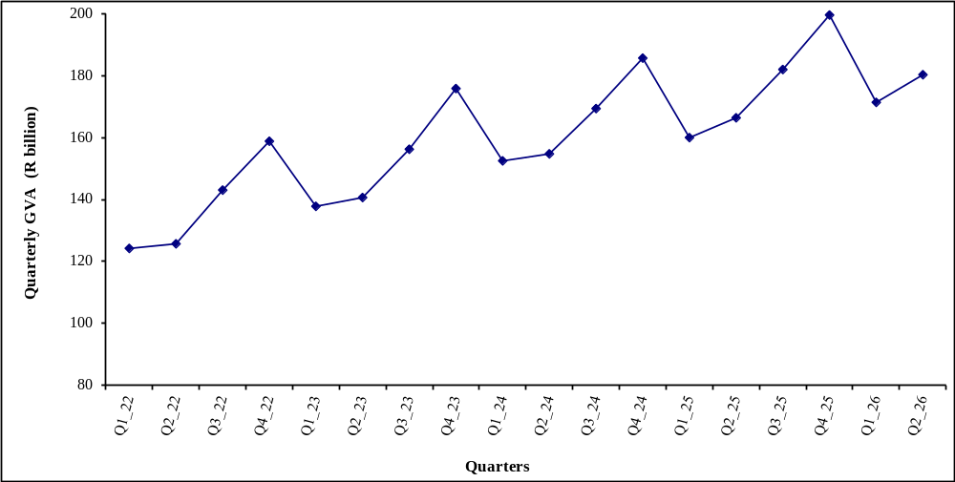
The lower GVA figures observed during the first quarters may reflect lower economic activities resulting from temporary closures of firms during the month of January because of New Year festivities. On the other hand, the higher GVA figures during the last quarters could be explained by more activities in “Accommodation and food service activities” due to high tourist arrivals, “Manufacturing” and “Wholesale and retail trade” to meet the high demand for consumption goods for end of year festivities.

4. Quarterly growth rates (based on data unadjusted for seasonality) – Table 2

4.1 Growth rates, Q₁ 2022 – Q₂ 2026, (year-on-year change)

Table 2 shows year-on-year quarterly growth rates by industry group during the first quarter of 2022 to the second quarter of 2026. The rates are based on value added unadjusted for seasonality and represent the percentage change in real value added over the same quarter of the previous year.

Figure 2 shows quarterly growth rates as well as annual growth rates.

Fig 2: GVA growth rates, quarterly (percentage change over corresponding period of previous year) and annual, Q₁ 2022 – Q₂ 2026

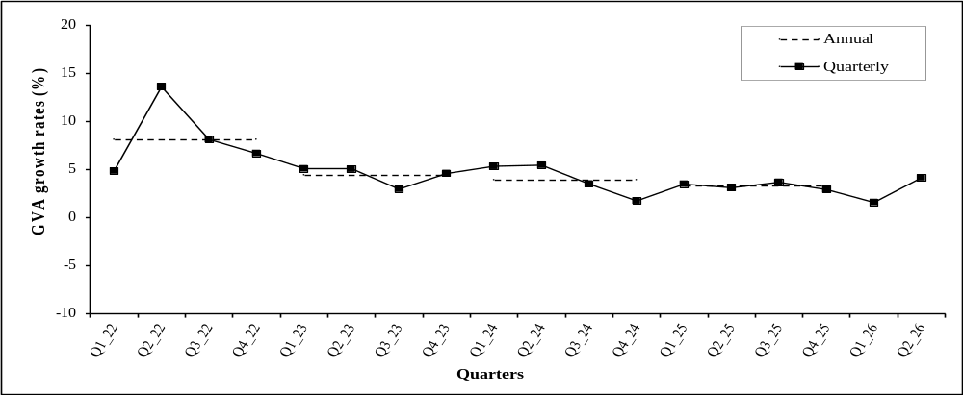

Quarterly GVA growth increased from 4.8% in the first quarter of 2022 to a peak of 13.6% in the second quarter, before moderating to 6.7% by the fourth quarter. Growth continued to ease during 2023, declining from 5.1% in the first quarter to 3.0% in the third quarter, before recovering slightly to 4.6% in the fourth quarter. In 2024, growth remained relatively stable during the first three quarters, ranging between 3.5% and 5.4%, before slowing to 1.7% in the fourth quarter. Growth fluctuated between 2.9% and 3.7% throughout 2025, before slowing to 1.6% in the first quarter of 2026 and recovering to 4.2% in the second quarter.

4.2 Growth rates, (year-on-year), Q₁ 2026

GVA growth rate for the first quarter of 2026 over the corresponding quarter of 2025 is revised downwards to 1.6% from 2.0% as estimated in June 2026.

4.3 Growth rates, (year-on-year), Q₂ 2026

Year-on-year growth rates for the second quarter of 2026 are compared with the year-on-year growths one quarter earlier.

Total GVA growth rate for the second quarter of 2026 over the corresponding quarter of 2025 is estimated at 4.2%. Growth rates by industry group were as follows:

“Agriculture, forestry, and fishing” sector expanded by 4.3%, compared with 13.2% in the previous quarter. Growth was supported by increases in “Sugarcane” (6.7%), “Crops” (4.9%) and “Other agriculture” (3.3%).

The “Manufacturing” sector grew by 1.9%, compared with 2.1% in the preceding quarter. Growth was supported by “Sugar” (4.2%), “Food (excluding sugar)” (2.1%) and “Other manufacturing” (3.3%), partly offset by a 3.7% contraction in “Textile”.

“Electricity, gas, steam and air conditioning supply” grew by 1.3%, slightly below the 1.5% recorded in the previous quarter.

“Water supply, sewerage, waste management and remediation activities” grew by 7.4%, following a 2.2% contraction in the preceding quarter.

“Construction” contracted by 4.0%, following a 3.5% contraction in the previous quarter.

“Wholesale and retail trade; repair of motor vehicles and motorcycles” expanded by 2.7%, compared with 2.9% in the previous quarter.

“Transportation and storage” grew by 4.5%, slightly higher than the 4.4% recorded in the preceding quarter.

“Accommodation and food service activities” contracted by 1.3%, compared with 5.7% growth in the previous quarter.

“Information and communication” grew by 4.9%, up from 4.7% in the preceding quarter.

“Financial and insurance activities” grew by 4.5%, compared with 4.6% in the previous quarter.

“Real estate activities” grew by 2.5%, up from 1.9% in the preceding quarter.

“Professional, scientific and technical activities” grew by 3.4%, unchanged from the growth recorded in the previous quarter.

“Administrative and support service activities” grew by 3.0%, compared with 3.1% in the previous quarter.

“Public administration and defence; compulsory social security” grew by 7.9%, following a 10.5% contraction in the preceding quarter.

“Education” grew by 9.3%, following a 3.7% contraction in the previous quarter.

“Human health and social work activities” recorded strong growth of 18.9%, following a 1.5% contraction in the first quarter of 2026.

“Arts, entertainment and recreation” grew by 4.2%, up from 3.4% in the previous quarter.

“Other service activities” grew by 2.6%, compared with 2.1% in the preceding quarter.

4.4 Contribution of industry groups to GVA growth, second quarter 2026

The contribution of an industry to GVA growth depends on two factors, namely, its share in GVA and the change in its real value added. From Table A and Figure 3, it is observed that the 4.2% growth in GVA during the second quarter of 2026 was mainly due to:

- “Human health and social work activities” (0.8 percentage point);
- “Financial and insurance activities” (0.5 percentage point);
- “Public administration and defence compulsory social security” (0.5 percentage point);
- “Wholesale and retail trade; repair of motor vehicles and motorcycles” (0.4 percentage point);
- “Education” (0.4 percentage point);
- “Transport and storage” (0.3 percentage point);
- “Agriculture, forestry and fishing” (0.2 percentage point);
- “Manufacturing” (0.2 percentage point);
- “Information and communication” (0.2 percentage point); and
- “Professional, scientific and technical activities” (0.2 percentage point).

Table A: Contribution of industry groups to GVA growth (percentage point), Q₁ 2025 – Q₂ 2026
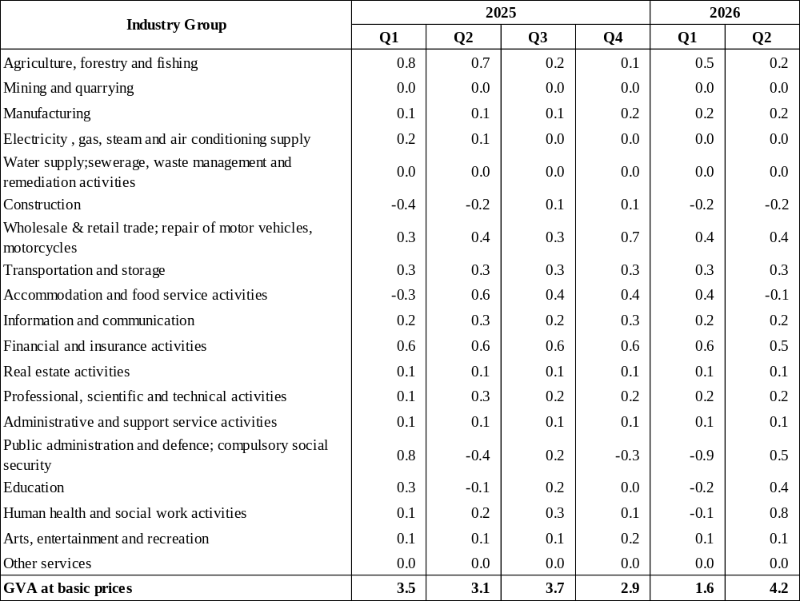
Contribution of an industry group to GVA growth is calculated as the product of its share in the economy and the year-on-year growth rate.
Note: Figures may not add up to totals due to rounding.

Fig 3: Contribution of industry groups to GVA growth (percentage point), second quarter 2026
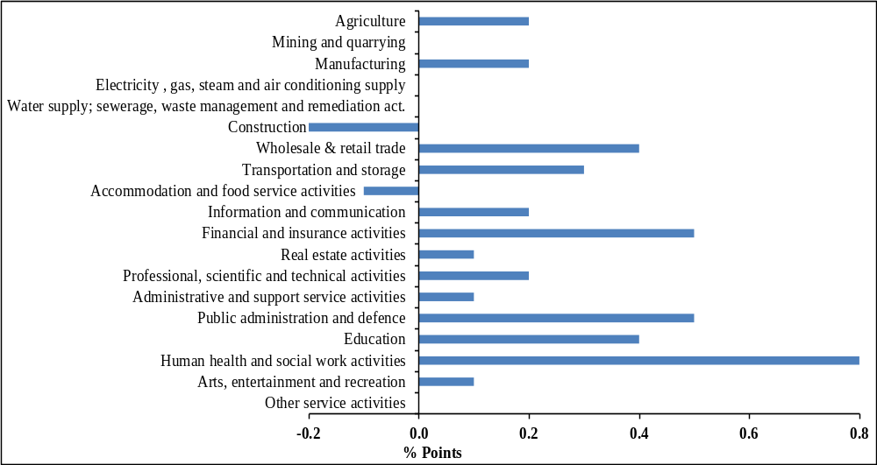

5. Quarterly GDP by expenditure

5.1 Quarterly expenditure components at current prices

During the second quarter of 2026, final consumption expenditure which comprises of consumption expenditure of households and general government, amounted to R175,113 million, representing 84% of the quarterly GDP at market prices. Of the 84% of the quarterly GDP, final consumption of households represented 68% or R141,965 million and that of general government 15% or R32,080 million (Table 3).

Analysis of quarterly data shows seasonality in household consumption expenditure with highest consumption occurring during the fourth quarters. In 2025, it is noted that household consumption expenditure during the fourth quarter represented 29% of the yearly total compared to 22% in the first quarter, 23% in the second quarters, and 25% in the third quarter.

“Exports of goods” are generally lowest in the first quarters. “Exports of services”, which comprises mainly tourist earnings and revenue of the national airline from foreign travellers, are normally highest during the fourth quarters.

Imports of goods are highest in the fourth quarters, mainly explained by high consumption at the end of the year. Import of services are generally highest in the fourth quarters.

There is no distinct seasonal pattern in the data for general government consumption expenditure and Gross Fixed Capital Formation (GFCF).

5.2 Growth rates (year-on-year) of expenditure components, Q₂ 2026 – Table 4

Analysis of year-on-year quarterly GDP by expenditure shows that total final consumption expenditure in real terms increased by 3.5% in the second quarter of 2026 when compared to the corresponding quarter of 2025. Final consumption expenditure of households increased by 2.2% and that of general government by 9.6%.

Investment (Gross Fixed Capital Formation) contracted by 9.7%, compared to the growth of 6.1% recorded in the previous quarter. The 9.7% decline was the result of the combined decreases in “Building and construction work” (-3.7%) and “Machinery and equipment” (-16.8%).

The 3.7% decline in "Building and construction work" was driven by contractions in "Residential building" (-3.3%) and “Non-residential building” (-13.5%), partly offset by growth in “Other construction work” (7.1%).

The decline of 16.8% in “Machinery and equipment” resulted from decreases in “Passenger car” (-65.0%) and “Other transport equipment” (-35.4%), partly offset by an increase in “Other machinery and equipment” (1.0%).

Exports of goods and services increased by 2.6%, after that of 9.4% recorded in the previous quarter. This 2.6% increase was the result of an increase in exports of services (8.0%), partly offset by a contraction in exports of goods (-1.5%).

Imports of goods and services went down by 10.2%, compared to a growth of 2.3% observed in the previous quarter. The decline was due to an decreases in imports of goods (-4.9%) and imports of services (-16.1%).

6. Seasonally adjusted quarterly GVA

Table B and Figure 4 show the year-on-year quarterly GVA growth rates based on unadjusted data and the quarter-to-quarter growth rates based on seasonally adjusted data for first quarter of 2022 to second quarter of 2026.

As indicated earlier, while the year-on-year growth rates can be used to analyse trends, the quarter to quarter growth rates provide a more meaningful trend analysis with the advantage of being able to detect trend changes much earlier. For example, the year-on-year growth rates show a turning point in the first quarter of 2026; however the quarter-to-quarter seasonally adjusted data show a turning point as early as the second quarter of 2025.

Seasonally adjusted data indicate that the quarter-to-quarter GVA grew by 1.9% in the second quarter of 2026, following that of 0.9% registered in the previous quarter.

Users may consult the website of Statistics Mauritius (https://statsmauritius.govmu.org) for seasonally adjusted growth rates by industry group.

Table B: Quarterly GVA growth rates ¹, Q₁ 2022 – Q₂ 2026

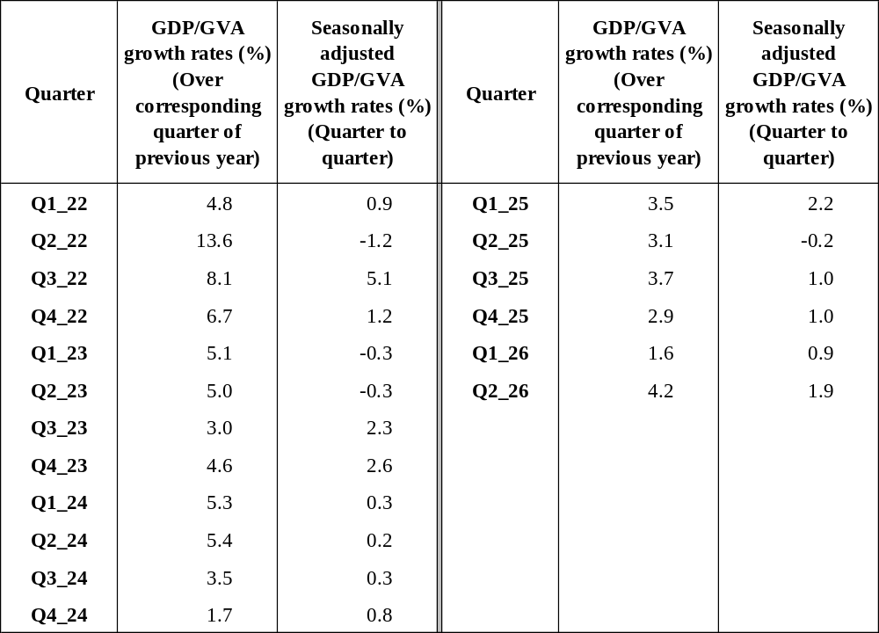
1/ Growth rates prior to the second quarter of 2026 have been revised and that of the second quarter is a first estimate.

Fig 4: GVA growth rates (over corresponding quarter of previous year and quarter-to- quarter), Q₁ 2022 – Q₂ 2026

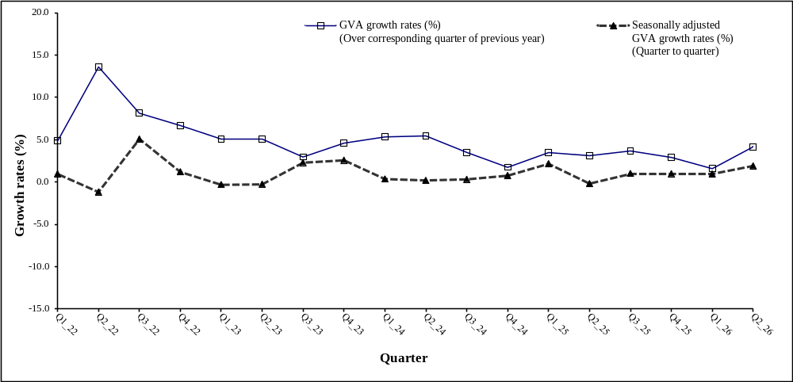

Definition of terminology used

1. Gross Domestic Product (GDP)

GDP is the aggregate money value of all goods and services produced within a country out of economic activity during a specified period before provision for depreciation.

2. Gross Value Added (GVA) at basic prices

Gross Value Added at basic prices is obtained as the difference between output and intermediate consumption whereby output is valued at basic prices and intermediate consumption at purchasers' prices.

The basic price is the amount receivable by the producer exclusive of taxes on products and inclusive of subsidies on products. The equivalent for imported products is the c.i.f. value, i.e. the value at the border of the importing country.

The purchasers' price is the amount payable by the purchaser exclusive of deductible taxes on products (e.g. deductible value added tax).

3. GDP at market prices

GDP at market prices is equal to the Gross Value Added at basic prices plus taxes (net of subsidies) on products.

4. Final Consumption expenditure

Final Consumption expenditure refers to the expenditure made on goods and services by households and government.

5. Gross Fixed Capital Formation (GFCF)

GFCF is the net additions to the physical assets of the country in a year. These consist mainly of investment in buildings, plants, machinery and transport equipment, all valued at market prices.

6. Exports and Imports of goods and services

Exports and imports of goods are measured on an f.o.b. basis. Insurance and freight, which represent the difference between the c.i.f. and f.o.b. values of imports of goods, are recorded as import of services.

Exports and imports of goods are compiled according to the General Trade System, using the national boundary as the statistical frontier. All goods entering the country are recorded in imports and goods leaving the country in exports.

7. Export Oriented Enterprises (EOE)

Export Oriented Enterprises comprise enterprises formerly operating with an export certificate and those export manufacturing enterprises holding a registration certificate issued by ex - Board of Investment.

8. Change in inventories

Change in inventories includes the value of the physical change in inventories of raw materials, work in progress, and finished goods held by producers.

9. Implicit Financial Services on Loans and Deposits

Implicit Financial Services on Loans and Deposits is the value of services not explicitly charged by financial institutions (banks and similar institutions) and is imputed in respect of all loans and deposits irrespective of source of funds. As recommended by the 2025 SNA, it is allocated to users as follows: intermediate consumption of businesses, final consumption of households and government, and a component of exports of services.

10. Global Business

The global business sector includes activities of GBCs and services purchased by GBCs from local enterprises (e.g. management, accounting, auditing, legal, advertising, real estate, banking, etc.).

Note: Figures in some tables may not add up to the total published due to rounding off.

Statistics Mauritius
Ministry of Finance
Port Louis
30 September 2026

Contact Person: Mr. E. Romjon (Statistician/Senior Statistician)

Statistics Mauritius
L.I.C. Centre
Port-Louis
Tel: (230) 650-1800
Fax: (230) 211-4150
Email: cso_qna@govmu.org

-

Annex

Concepts, Data Sources and Methods for Compiling Quarterly National Accounts Estimates

- Concepts and definitions

The quarterly estimates have been compiled according to guidelines provided in the IMF manual entitled “Quarterly National Accounts Manual – Concepts, Data sources and Compilation”, which is itself based on the System of National Accounts (SNA) of the United Nations and are therefore consistent with annual estimates of the National Accounts.

2. Sources of data

The objective of the Quarterly National Accounts (QNA) is to provide the best indication of quarterly movements. Indicators for QNA have therefore been chosen according to their ability to capture the movements in the performance of the various sectors.

The main sources of data for compiling QNA estimates include quarterly production accounts of various organisations, quarterly surveys on income and expenditure among enterprises considered as drivers in specific sectors, quarterly quantity produced, quarterly expenditure of Government from the Accountant General Department, quarterly data from administrative sources such as building permits from local government, foreign trade and VAT data from the Mauritius Revenue Authority, tourism receipts from the Bank of Mauritius, as well as some indirect indicators such as employment.

3. Methods used

When data on both output and input are available, the quarterly value added estimates are computed as the difference between the output and the intermediate consumption (inputs consumed in the process). When the quarterly output only is readily available or is compiled on the basis of quarterly data on quantity produced, the value added is computed using the production structure of the industry obtained at the latest Census of Economic Activities or from the latest annual production accounts available. When indicators on quarterly volume produced and price only are available, these are applied to the last quarterly value added figures to have the estimates for the quarter under review.

Estimates in volume terms exclude price effects of prices and therefore provide real growths. The estimates in volume terms are computed using the double deflation method for sectors where information on both inputs and outputs is available. In practice such data are difficult to obtain, hence ‘proxy indicators’ of volume changes are used if available, otherwise value series are deflated by an appropriate price index.

As recommended in the Quarterly National Accounts Manual, the Annual Overlap Technique has been used to derive quarterly estimates in volume terms, instead of the traditional fixed-base year estimates in volume terms. This technique entails compiling estimates for each quarter at the weighted annual average prices of the previous year. The volume data of QNA are then chain-linked to obtain the series in volume terms.

4. Seasonal adjustment of quarterly GDP

Value added by sector and total GDP have been seasonally adjusted and are published on the web site of the office. The methodology adopted in the seasonal adjustment exercise is briefly given below. Seasonally adjusted time series has historically been a common practice in analyzing business cycles. Currently this is widely used by a majority of statistical offices, central banks and policy analysts to describe and understand the most recent economic developments.

4.1 Procedures for seasonal adjustment of quarterly GDP

QNA data are subject to seasonal variations which are recurrent within a year pattern. For example, activities of “Wholesale and retail trade” are usually lowest in the first quarters, but highest in the fourth quarters in line with the high demand for consumption goods at the end of the year; activities of “Hotels and restaurants” are highest in the first and last quarters in line with high tourist arrivals during these quarters. For meaningful comparison of quarter to quarter growth, particularly for identifying turning points, the seasonal component must be removed from the data.

The procedures for carrying out the seasonal adjustment exercise are as follows:

(i) The software, Demetra, developed by Eurostat and which includes the X-13 Arima-Seats program has been used.

(ii) Forward adjustment, instead of concurrent adjustment, has been used for quarterly series up to the most recently completed year, that is seasonal factors for the four quarters ahead are estimated using the X-13 procedure. When a new data point becomes available, the seasonally adjusted value of the new data point is obtained by dividing it by the appropriate forward factor if model is multiplicative or subtracting from it the appropriate forward factor if the underlying model is additive.

(iii) The seasonal adjustment exercise has been reworked using data estimated up to the most recently completed year. In the light of the new seasonal factors, the seasonally adjusted growth rates have been revised.

(iv) Direct adjustment of the aggregate GVA has been used to obtain seasonally adjusted GVA.

(v) Adjustments have been made so that the sums of quarterly seasonally adjusted data are equal to the original yearly totals.

It should be noted that different seasonal adjustment methods, no matter how carefully they have been implemented, do not always yield identical results if applied to the same time series. In addition, even if the same seasonal adjustment method is applied, there may be substantial revisions, particular towards the end of the time series, when new data are included in the calculation and taking account of possible shifts in the seasonal movements. Consequently, seasonally adjusted data remain provisional for longer than unadjusted figures, which are also subject to revisions.

5. Data sources, methods and indicators used for the estimation of Quarterly National Accounts Estimates

The table below gives the data sources, methods and indicators used for the estimation of quarterly national accounts estimates at current prices and in volume terms.

- Production Approach
Industry Group | Data Sources | Methods | Indicator – In volume terms
A. Agriculture, forestry and fishing
Sugar Cane | - Annual production and price of sugar.  - Survey of sugar factories for the quarterly cost structure. | - Final estimates: Based on the final annual production accounts. Annual gross output and intermediate consumption are allocated to quarters according to cost structure of cane growing furnished by surveyed sugar factories. The value added is thereafter derived.  - Preliminary estimates: value added for the year based on expected production and price of sugar is quarterlised using the latest value-added structure. | - Preliminary quarterly changes are based on the annual price deflator.
Tea | - Quarterly production and prices of tea from Tea Board.  Benchmark ratios from Agricultural Cost of Production Survey (ACOPS 2005). | - Output based on quarterly production and prices.  - Value added derived using the production structure obtained at the ACOPS 2005. | - Double deflation using relevant component of PPI-A for output and a weighted price index based on retail prices of relevant inputs for intermediate consumption (IC).
Food crops | - Monthly quantities of food crops from Food and Agricultural Research and Extension Institute (FAREI).  - Retail prices through the monthly consumer price surveys.  - Benchmark ratios from ACOPS 2005. | - Output is based on quarterly quantities of food crops produced and producers’ price obtained from retail prices adjusted for transport and trade margins.  - Value added derived using the production structure obtained at the ACOPS 2005. | - Double deflation using relevant component of PPI-A for output and a weighted price index based on retail prices of relevant inputs for IC.
Flowers | - Quarterly exports of flowers from Trade Statistics. An estimate is worked out for locally sold flowers, based on number of weddings, deaths, religious ceremonies, etc. | - Output is based on quarterly quantities produced and on producers’ price obtained from retail prices adjusted for transport and trade margins  - Value added derived using the production structure obtained at the ACOPS 2005 | - Double deflation using relevant component of PPI-A for output and a weighted price index based on retail prices of relevant inputs for IC.
Fruits | - Monthly production of some fruits from FAREI.  - Quarterly production of other fruits based on 2014 Census of Agriculture, supplemented with data from other sources.  - Benchmark ratios from ACOPS 2005. | - Value added based on quarterly quantities produced and on producers’ price obtained from retail prices adjusted for transport and trade margins. | - Deflation using component of PPI-A.
Livestock, Poultry and Related Products | - Quarterly production of poultry from survey among main breeders.  - Monthly quantity of livestock slaughtered from the Mauritius Meat Authority (MMA) adjusted for illegal slaughtering.  - Export value of live primates from Trade Statistics.  - Retail prices. | - Value added based on quarterly quantities produced and on producers’ price derived from retail prices adjusted for transport and trade margins.  - For live primates, gross output is based on export value. | - Deflation using component of PPI-A.
Government Services | - Expenditure of Budgetary Central Government from the Accountant General Department.  - Expenditure for Rodrigues from Rodrigues Regional Assembly (RRA).  - Expenditure for Extra Budgetary Units (EBUs) and Local Government from quarterly surveys. | - Value added is estimated at cost, that is, it is equal to remuneration of employees + depreciation + net return to capital. | - Remuneration of Employees is deflated using the annual wage rate index based on salary compensation.  - Depreciation is deflated using the quarterly Construction Price Index (for Construction items), Vehicle Price Index (for vehicles) and a combination of PPI and Import Price Index (IPI) (for machinery and equipment excluding vehicles).
Fishing | - Quarterly quantities of fish caught from the Albion Fisheries Research Centre (AFRC)  Retail prices. | - Value added based on quarterly quantities of fish caught and producers’ price derived from retail prices adjusted for trade margins. | Deflation by quarterly changes in the estimated producers’ price based on retail prices.
B. Mining and quarrying
Mining and Quarrying | - Quarterly quantities of salt produced and sand extracted, and their prices through surveys of establishments. | - Value added derived using data collected from quarterly surveys | - Deflation using appropriate component of CPI.
Mining and Quarrying | - Quarterly Value Added Tax (VAT) data from the Mauritius Revenue Authority (MRA). | - Value added compiled from quarterly VAT data. | - Deflation using Index of Aggregate CoPI.
C. Manufacturing
Sugar Milling | - Annual production and price of sugar.  - Final annual production accounts.  - Survey of sugar factories to have the quarterly cost structure. | - Final estimates: Based on the final annual production accounts; Annual gross output and intermediate consumption are allocated to quarters according to cost structure of sugar milling activities furnished by surveyed sugar factories. The value added is thereafter derived.  - Preliminary estimates: value added for the year based on expected production and price of sugar. The estimate is quarterlised using the latest value-added structure. | - Double deflation using PPI-A for output and a weighted price index based on relevant components of the CPI for inputs.  - Preliminary quarterly changes are based on the annual price deflator.
Export Oriented Enterprises (EOE) | - Quarterly exports from Trade statistics.  - Quarterly survey of establishments.  - Level of stock from quarterly stock surveys  - Quarterly turnover from VAT data. | - Quarterly value added based on quarterly gross output compiled from these sources and last annual technical ratio. | - Volume index by industry from Quarterly Index of Industrial Production (QIIP).
Non – EOE | - Quarterly exports from Trade Statistics.  - Quarterly turnover from the VAT data.  - Production of excisable goods from Customs and Excise Department  - Quarterly survey of establishments.  - Level of stock from quarterly stock surveys. | - Quarterly value-added estimates based on quarterly gross output compiled from these sources and latest annual technical ratio. | - Volume index by industry from QIIP.
D. Electricity, gas, steam and air conditioning supply
Electricity, gas and steam | - Quarterly production accounts from Central Electricity Board (CEB) | - Value added compiled from quarterly accounts. | - Volume based on quarterly quantity of electricity sold (All sales by CEB).
Electricity, gas and steam | - Quarterly production data of the Independent Power Producers. | - Value added derived from the value of electricity purchased by CEB and quarterly technical ratio of the previous year.
E. Water supply; sewerage, waste management and remediation activities
Water supply | - Quarterly production accounts from Central Water Authority (CWA) | - Value added compiled from quarterly accounts of CWA. | - Volume based on quarterly quantity of water sold.
Sewerage and waste management activities | - Quarterly VAT data. | - Value added based on quarterly VAT data. | - Deflation by appropriate component of CPI.
F. Construction
Construction | - Monthly building permits from Municipalities and District Councils.  - Quarterly capital expenditure estimates of General Government from Ministry of Finance.  - Maintenance expenditure by households from latest Household Budget Survey.  - Administrative sources, eg. Economic Development Board. | - Quarterly output based on these sources and quarterly value added derived using the production structure obtained at the 2023 Census of Economic Activities (CEA). | - Deflation by quarterly Construction Price Index.
G. Wholesale and retail trade, repair of motor vehicles and motorcycles
Wholesale and Retail Trade | - Quarterly imports from Trade statistics  - Local production from Agriculture statistics and Industrial statistics | - For imported goods, gross output based on trade margins computed from quarterly imports.  - For local production, gross output based on trends of production of crops and production of the non-EOE sector (local consumption).  - Value added derived using the production structure obtained at the 2023 CEA. | - Change in volume of imports derived by deflating imports by sector by relevant IPI components.  - For local component, deflation by overall CPI.
Repair of motor vehicles and motorcycles | - Imports of spare parts.  - Quarterly VAT data.  - Road transport statistics (number of vehicles registered and number of accidents). | - Quarterly estimates based on imports of spare parts, changes in number of vehicles registered and number of accidents. | - Deflation by overall CPI.
H. Transport and storage
Bus/Light rail | - Quarterly production accounts of bus companies and bus fleet from National Land Transport Authority (NLTA).  - Quarterly survey on receipt and expenditure  - Quarterly VAT data | - Value added compiled from quarterly accounts. | - Deflation using relevant components of CPI.
Taxi | - Quarterly licences of taxi cars from NLTA.  - Taxi fares from monthly consumer price surveys. | - Output based on the quarterly number of licences delivered and taxi fare.  - Value added derived using the production structure obtained at the 2023 CEA. | - Deflation using relevant components of CPI.
Lorries | - Quarterly licences of lorries from NLTA.  - Lorry charges based on 2023 CEA. | - Output based on the quarterly licences of lorries.  - Value added derived using the structure obtained at the 2023 CEA. | - Deflation using relevant components of CPI.
Water transport | - Quarterly number of passengers from Mauritius Shipping Corporation. | - The number of passengers and fares charged as per CPI are used to estimate quarterly output.  - Value added is derived using the production structure obtained at the 2023 CEA. | - Volume based on number of passengers.
Air transport | - Quarterly receipts and expenditure from Air Mauritius Ltd. | - Value added compiled from quarterly accounts | - Deflation using relevant components of CPI.
Services allied to transport | - Quarterly receipts and expenditure from Mauritius Ports Authority and Cargo Handling Corporation.  - Quarterly indicators such as tourist arrivals and number of Mauritian travelling abroad. | - Value added compiled from quarterly accounts where available.  - For other related activities, annual estimates are quarterlised using the quarterly indicators. | - Goods: Volume based on tonnage of goods loaded and unloaded.  - Passengers: Volume based on quarterly indicators.
Storage | - Quarterly VAT data. | - Value added compiled from the quarterly VAT data. | - Deflation using overall CPI
I. Accommodation and food service activities
Accommodation and food service activities | - Quarterly tourist arrivals and passenger traffic from Tourism statistics.  - Quarterly tourist earnings from Bank of Mauritius.  - Expenditure on food and accommodation by tourists from Survey of Inbound Tourism. | - Output for tourist component derived from quarterly tourist earnings and proportion of output sold to tourists as observed in 2023 CEA.  - Output of local component is estimated using turnover from a sample of establishments comprising major fast food chains.  - Output for food contractors serving airplanes is derived from change in number of passengers departing by air and change in the CPI component measuring price of meals in bars and restaurants.  - Value added is estimated using the production structure obtained from 2023 CEA. | - Volume based on number of tourist arrivals for tourist component.  - Local component and food contractors are deflated by CPI component measuring price of meals in bars and restaurants.
J. Information and communication
Telecommunication services | - Quarterly VAT data. | - Value added compiled from quarterly VAT data. | - Deflation by changes in the price of telephone calls.
Activities related to information and communication | - Quarterly VAT data. | - Value added compiled from quarterly VAT data. | - Deflation by overall CPI.
K. Financial and insurance activities
Financial and insurance activities | - Quarterly surveys of banks, insurance companies and other financial institutions  - Quarterly VAT data | - Value added compiled from quarterly accounts.  - Value added for Central Bank is estimated at cost, that is, it is equal to remuneration of employees + depreciation + net return to capital. | - Central Bank: Deflation using a wage rate index.  - Banks and similar institutions: Deflation using changes in “IFSLD rate” and inflation rate.  - Insurance: Volume based on changes in the number of life and non-life insurance policies.  - Financial leasing and other credit granting institutions: Price indicator in line with deflator of commercial banks.  - Other financial institutions: Deflation using changes in exchange rates and local inflation rate.
L. Real estate activities
Owner-occupied housing services | - Number of housing units from Housing Census  - Household budget surveys  - Interest on housing loans from the Bank of Mauritius.  - Stock of residential building  - Building permits from local authorities | - Value added is compiled annually according to the User Cost Method based on:  - an operating surplus calculated on interest rate on housing loans,  - taxes paid on dwellings and  - depreciation of the building.  - The annual figure is then quarterlised. | - Volume based on net stock of residential buildings.
Other real estate activities | - Quarterly VAT data. | - This sector includes agencies involved in the sale or lease of property. | - Deflation by overall CPI.
M. Professional, scientific and technical activities
Professional, scientific and technical activities | - Quarterly VAT data.  - Trends in related sectors  - Indirect indicators such as cases lodged in court. | - This sector covers the units which offer their services to different activities both onshore and offshore including own account professional workers such as lawyers, accountants, notaries , surveyors etc. | - Deflation by overall CPI.
N. Administrative and support service activities
Administrative and support service activities | - Quarterly VAT data.  - Trends in related sectors  - Indirect indicators such as tourist arrivals | - This sector covers units engaged in rental and leasing activities, cleaning activities, travel agencies, call centers and other business support activities | - Deflation by overall CPI.
O. Public administration and defense; Compulsory social security
Public administration and defence; Compulsory social security | - Expenditure of Budgetary Central Government from the Accountant General Department.  - Expenditure for Rodrigues from RRA.  - Expenditure for EBUs and Local Government from quarterly surveys. | - Estimates are made at cost, that is,  Gross output = Value added (VA) + purchase of goods and services (IC)  - Value added = Remuneration of employees + depreciation + net return to capital | - Remuneration of Employees is deflated using the annual wage rate index.  - Depreciation is deflated using the quarterly Construction Price Index (for Construction items), Vehicle Price Index (for vehicles) and a combination of PPI and IPI (for machinery and equipment excluding vehicles).  - Goods and services are deflated using quarterly CPI.
P. Education
Education  (Public) | - Expenditures related to education (preprimary, primary, secondary and tertiary sectors) incurred by the different levels of the General Government (mainly Budgetary Central Government (BCG) and EBUs) are used to estimate value added, intermediate consumption and gross output of education in the public sector. | - Estimate are made at cost, that is,  - Gross output = Value added (VA) + purchase of goods and services (IC)  - Value added = Remuneration of employees + depreciation + net return to capital | - Remuneration of Employees is deflated using the quarterly wage rate index.  - Depreciation is deflated using the quarterly Construction Price Index (for Construction items), Vehicle Price Index (for vehicles) and a combination of PPI and IPI (for machinery and equipment excluding vehicles).  - Goods and services are deflated by using quarterly CPI.
Education  (Private) | - Annual data on enrolment from the Ministry of Education  - Enrolment from private schools and Mauritius Institute of Training and Development (MITD)  Percentage change in fees charged for private tuition estimated from the sub-index for “Education” obtained from the CPI Unit | - Private schools and MITD: annual output are divided by 4.  - Private tuition fees: output based on ten months only (February to November). | - Volume based on enrolment statistics.  - Deflation by CPI component.
Q. Human health and social work activities
Health and social work activities (Public) | - Expenditure related to Health and Social Work incurred by the different levels of the General Government (mainly BCG and EBUs) are used to estimate value added, intermediate consumption and gross output of Health and Social Work in the public sector. | - Estimate are made at cost, that is,  - Gross output = Value added (VA) + purchase of goods and services (IC)  - Value added = Remuneration of employees + depreciation + net return to capital | - Remuneration of Employees is deflated using the quarterly wage rate index.  - Depreciation is deflated using the quarterly Construction Price Index (for Construction items), Vehicle Price Index (for vehicles) and a combination of PPI and IPI (for machinery and equipment excluding vehicles).  - Goods and services are deflated using quarterly CPI.
Health and social work activities (Private) | - Annual production accounts of clinics.  - Quarterly data on admissions in clinics and hospitals from the Ministry of Health.  - No. of private medical practitioners from the Ministry of Health.  - Fees charged from monthly consumer price surveys. | - Annual value added for private health services is computed using available production accounts of clinics and supplemented with indicators on private practitioners. | - Deflation by CPI component.
R. Arts, entertainment and recreation
Arts, entertainment and recreation activities | - Quarterly VAT data.  - Quarterly data on government revenue from gambling and betting taxes. | - Includes gambling, sports, amusement and recreational activities  - Quarterly gross output derived from VAT data.  - Value added estimated using technical coefficients obtained from latest available annual final production accounts. | - Deflation by CPI component.
S. Other service activities
Other service activities | - Quarterly turnover from VAT data.  - Demographic statistics such as births, deaths and marriages.  - Tourist arrivals | - Includes activities of membership organizations, units engaged in repair of computers and household goods and other personal service activities  - Quarterly gross output derived from VAT data.  - Value added estimated using technical coefficients obtained from latest available annual final production accounts.  - For companies not registered at the VAT: annual estimates are quarterlised using indirect indicators such as quarterly number of births, deaths, marriages, and tourist arrivals. | - Deflation by overall CPI.
T. Activities of households as employers, etc
Private households with employed persons | - Number of employees based on number of household with domestic employees as collected in Household Budget Survey (HBS).  - Wage Rate from monthly consumer price surveys. | - Annual estimate, based on the number of persons employed and average wage, is divided by 4. | - Deflation by wage increase due to salary compensation of every year.

- Expenditure Approach
Type of  expenditure | Sources and Methodology | Indicator – In Volume Terms
A. Final consumption expenditure
Household | Annual estimates are quarterlised using Continuous Multi-Purpose Household Survey (CMPHS) and HBS structure adjusted for conceptual difference with national accounts. | - Deflation by CPI.
General Government | Final Consumption Expenditure for the General Government is equal to Gross Output (Remuneration of Employees + Depreciation + net return to capital + value of goods and services purchased) less sales of goods and services plus expenditure on social benefits in kind.  Quarterly data for Budgetary Central Government is available from the Accountant General Department.  Quarterly data for Rodrigues is available from the RRA's finance department.  Quarterly data for EBUs and Local Government are obtained from quarterly surveys. | - Remuneration of Employees is deflated using the quarterly wage rate index.  - Depreciation is deflated using the quarterly Construction Price Index (for Construction items), Vehicle Price Index (for vehicles) and a combination of PPI and IPI (for machinery and equipment excluding vehicles).  - Value of goods and services is deflated using quarterly CPI.  - Social benefits in kind are deflated using the annual wage rate index based on salary compensation.
Central Bank | Final Consumption Expenditure for the Central Bank is equal to Gross Output (Remuneration of Employees + Depreciation + net return to capital + value of goods and services purchased). | - Remuneration of Employees is deflated using quarterly wage rate index.  - Depreciation is deflated using the quarterly Construction Price Index.  - Value of goods and services is deflated using quarterly CPI.
B. Gross fixed capital formation (GFCF)
Building and construction
Residential building | Quarterly investment in residential buildings based on quarterly data on floor area from building permits (with a lag of 1 quarter) and quarterly Construction Price Index, together with quarterly data from Economic Development Board (EDB), Ministry of Finance and other sources, and an estimate for projects for which no permit has been issued. The cost per unit of floor area has been revised in 2018 based on the last revision in the Construction Price Index. | - Deflation by quarterly construction price index.
Non-residential building and other construction wo  rk | Quarterly investment in non-residential buildings and other construction work based on quarterly building permits for non-residential buildings (with a lag of 1 quarter) and quarterly Construction Price Index, and quarterly data from EDB and Ministry of Finance (PSIP).
Machinery and equipment
Aircraft | Based on information provided by Air Mauritius Ltd and Ministry of Finance (PSIP). | - Exchange rate of the currency in which asset is purchased.
Marine vessel | Based on information provided by Ministry of Finance (PSIP) and from administrative sources. | - Exchange rate of the currency in which asset is purchased.
Transport equipment | Based on information on registered vehicles provided by NLTA classified as final consumption expenditure or investment according to purchasers. For transport equipment for which no registration is necessary, imports statistics are used. | - Deflation by a vehicle price index
Other machinery and equipment. | Estimates are mostly based on quarterly Trade Statistics given that most of the machinery and equipment are imported. The imported machinery and equipment goods are brought to purchasers' prices by adding all duties and taxes, landing cost, transport cost and margins. Duties and taxes are available from MRA, landing cost from MPA while rates of transport and margin are based on the results of the 2023 CEA. Local production of machinery is estimated from outputs of companies producing capital goods. | IPI components for “Machinery and equipment” excluding transport equipment are used to construct the deflators.
Exports and Imports of goods and services | Data available from the Quarterly Balance of Payments (BOP) of the Bank of Mauritius adjusted for import and export of implicit financial services on loans and deposits.  For import and export of goods, import and export price indices are used as deflators. For export of services, each component is deflated with concerned output deflators.  For import of services, a combined index is compiled based on exchange rate and inflation of trading countries. | - Deflation using respective quarterly price indices.

- Implicit Financial Services on Loans and Deposits (IFSLD)
Item | Sources and Methodology | Indicator – In Volume Terms
Allocation of IFSLD by sector | The quarterly figure of IFSLD calculated from data available on deposits, loans and prevailing rates is distributed by sector following recommendation in SNA. | - Deflated by an overall IFSLD deflator

