SURVEY OF EMPLOYMENT AND EARNINGS IN LARGE

(employing 10 or more persons) ESTABLISHMENTS (SEE)

March 2026 (Preliminary results)

- Introduction

Statistics Mauritius carries out the annual Survey of Employment and Earnings in ‘large’ establishments with March as reference period so as to obtain a continuous series of comparable data on the level of employment and earnings in these establishments. This issue of the Economic and Social Indicators presents the preliminary results for March 2026 with comparative figures for 2024 and 2025.
Concepts and definitions are provided at section 4.

Response

The preliminary results of the survey presented below are based on responses obtained from 64% of large establishments, representing 73% of total employment in this category of establishments. Estimates have been worked out for non-response on the basis of previous data, observed trend and employment figures from the statistics unit of the Ministry of Industry, SME and Cooperatives.

Main results

Employment Level, March 2025 - March 2026

A preliminary estimate of total employment in large establishments is 309,681 in March 2026 compared to 309,186 in March 2025, representing an increase of 495 (Table 1). This is the net result of employment increases in some industrial groups, partly offset by decreases in some other groups.

A sectorwise analysis shows that employment in the primary sector decreased by 409 from 9,056 in March 2025 to 8,647 in March 2026. During the same period, employment in the secondary sector showed decrease by 366 from 66,990 to 66,624 while the tertiary sector increased by 1,270 from 233,140 to 234,410.

The total employment 4,665 figure includes persons working in large establishments in Rodrigues, compared to 5,025 in March 2025. They are mainly government employees of the Rodrigues Regional Assembly numbering 2,865 in March 2025.

As at March 2026, the number of foreign workers stood at 29,370 (24,444 males and 4,926 females) of whom 16,597 were engaged in activities of the ‘Manufacturing’ sector, 5,873 in ‘Construction’, 2,323 in ‘Wholesale and retail trade; repair of motor vehicles and motorcycles’ and 1,343 in ‘Accommodation and food service activities’ (Table 6).

Employment by Industry

Between March 2025 and March 2026, main increases occurred in the following industrial groups: Administrative and support service activities (+1,306), ‘Accommodation and food service activities’ (+845), ‘Financial and insurance activities’ (+580), and Information and communication (+376).

Decrease in employment was in ‘Public administration and defence’ (-2,223) (Chart 1).
2,462
Public administration and defence; compulsory social security
414
-165
408
888
109
542
Professional, scientific and technical activities
Financial and insurance activities
Accommodation and food service activities
Transportation and storage
654
Human health and social work activities
Information and communication

Administrative and support service activities

Employment by Sex

As at March 2026, among the 309,681 employees in large establishments, 181,783 or 58.7% were males. Compared to March 2025, male employment decreased by 140 while female employment increased by 635.
Male employment decreased mainly in ‘Public administration and defence; compulsory social security’ (-1,772), ‘Financial and insurance activities’ (-401), ‘Wholesale and retail trade; repair of motor vehicles and motorcycles’ (-471) and ‘Construction’ (-164) (Table 1).

Female employment increased mainly in ‘Financial and insurance activities’ (+981); ‘wholesale and retail trade; repairs of motor vehicles and motorcycles’ (+513) and ‘Transportation and storage’ (+224).

Employment in General Government Sector

Employment in the General Government Sector decreased by 2,513 from 82,150 in March 2025 to 79,637 in March 2026. Male employment decreased by 1,935 from 44,495 to 42,560 and female employment decreased by 578 from 37,655 to 37,077 (Tables 3, 3a & 3b).

Employment in large establishments of the Export Oriented Enterprises (EOE) sector

The number of persons employed by large establishments of the EOE sector decreased by 1,835 from 29,259 (15,360 Mauritians and 13,899 foreigners) in March 2025 to 27,424 (14,131 Mauritians and 13,293 foreigners) in March 2026 (Table 4). The main decreases were in the ‘Wearing apparel (except footwear)’ (-893) and ‘Food’ (-402).

From March 2025 to March 2026, the number of male employees decreased by 705 from 16,735 to 16,030 and the number of female employees by 1,130 from 12,524 to 11,394.

Employment of foreign workers

The number of foreign workers in large establishments in March 2026 stood at 29,370 (24,444 males and 4,926 females) compared to 28,157 (23,317 males and 4,840 females) in March 2025, showing a net increase of 1,213 (+1,127 males and +86 females) (Table 6).

Male employment increased mainly in ‘Accommodation and Food Service Activities’ (+319).

Female employment decreased mainly in ‘Manufacturing’ (-263).

Earnings

The level of average earnings is influenced mainly by changes in basic salaries and wages. However, fluctuations may also occur because of:
- Changes in the mix of employees of various categories or with various lengths of service. For example, a large intake of professionals by, say, an architectural firm can cause a sudden jump in the average monthly earnings. On the other hand, a large intake of employees at the lower end of a wage scale has the effect of lowering the average earnings.

- Changes in overtime, regular bonuses and commissions.

Earnings in large establishments

The industrial group with the highest average monthly earnings was ‘Electricity, gas, steam and air conditioning supply’ (Rs 82,230) followed by ‘Financial and insurance activities’ (Rs 74,676), ‘Professional, scientific and technical activities’ (69,155) and ‘Information and communication’ (Rs 67,815). Lowest averages were registered in ‘Manufacturing’ (Rs 34,062), and in ‘Administrative and support service activities’ (Rs 35,526). Within the ‘Manufacturing’ group, ‘Textiles and wearing apparel’ registered average monthly earnings of Rs 31,177.

Overall average monthly earnings in large establishments increased by 6.2% from Rs 43,511 in March 2025 to Rs 46,229 in March 2026. Highest increases were registered in: ‘Information and communication’ (+38.4%) and ‘Human health and social work activities’ (+28.2%) (Chart 2).

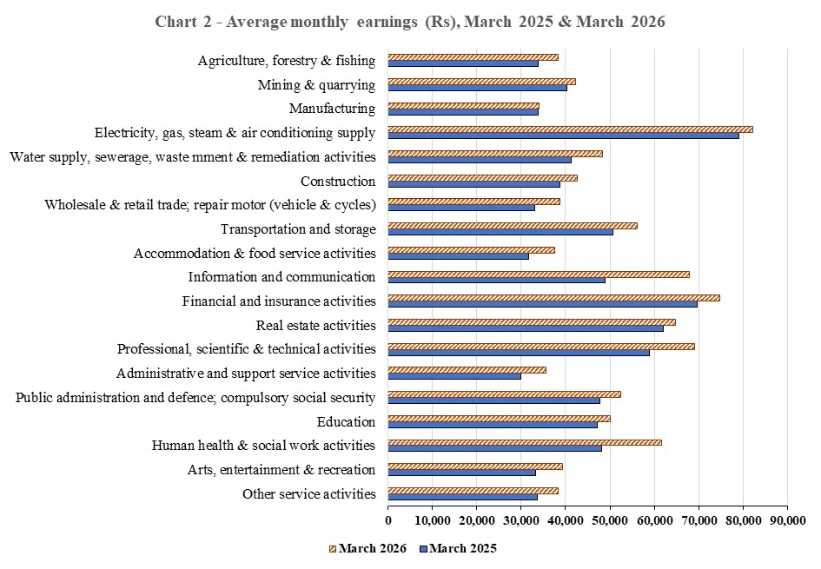

    - Earnings in large establishments of the EOE sector

The average monthly earnings in this sector stood at Rs 33,990 in March 2026, showing an increase of 13.1% over the March 2025 figure of Rs 30,052 (Table 7). The average monthly earnings in the manufacturing establishments were Rs 30,345 compared to Rs 48,756 in the non-manufacturing establishments. The corresponding figures for 2025 were Rs 26,104 and Rs 44,416 respectively (Table 8).

Concepts and definitions

  - Large establishments include:

- Agricultural establishments comprising:
- sugar cane plantations of 10 hectares or more;
- tea plantations of 2 hectares or more;
- Other agricultural establishments employing at least 10 persons during the reference period (March 2026).

- Non-agricultural establishments employing at least 10 persons during the reference month. It is to be noted that “outworkers”, that is, piece rate workers who are working in their own homes on materials provided by the establishment, are excluded although they are remunerated by the establishment.

- All central, regional and local government departments.

  - Primary, Secondary and Tertiary sector
Primary sector comprises activities classified in the industrial groups:
- Agriculture, forestry and fishing
- Mining and quarrying
Secondary sector comprises activities classified in the industrial groups:
- Manufacturing
- Electricity, gas, steam and air conditioning supply
- Water supply; sewerage, waste management and remediation activities
- Construction
Tertiary sector comprises activities classified in the industrial groups:
- Wholesale and retail trade; repair of motor vehicles and motorcycles
- Transportation and storage
- Accommodation and food service activities
- Information and communication
- Financial and insurance activities
- Real estate activities
- Professional, scientific and technical activities
- Administrative and support service activities
- Public administration and defence; compulsory social security
- Education
- Human health and social work activities
- Arts, entertainment and recreation
- Other service activities

4.3 The General Government sector is made up of (i) Central Government (ii) Regional Government and (iii) Local Government.

4.3.1 Central Government covers all units that are agencies of the country’s central authority. It consists of Budgetary Central Government and Extra Budgetary Units.
Budgetary Central Government includes all ministries and departments.

Extra Budgetary Units are agencies responsible for the performance of specialized governmental functions in such fields as health, education, social welfare, construction and so on, under the authority of Central Government

4.3.2 Regional Government consists of the administration of Rodrigues.

4.3.3 Local Government consists of municipalities and district councils / village councils exercising an independent competence as government units.

4.4 Export Oriented Enterprises (EOE) comprise enterprises formerly operating with an export certificate and those export manufacturing enterprises holding a registration certificate issued by the Board of Investment.

4.5 Employment in Large establishments covers all persons in regular or casual employment and includes:
- Persons temporarily absent on paid sick or vacation leave; and
- Persons holding managerial posts, family workers receiving wages or salaries, and paid apprentices.

4.6 Earnings of employees in large establishments comprise all payments in cash made to employees in connection with work done. Amounts reported include overtime, productivity bonuses, commissions, travelling allowances, attendance bonuses, housing and rent allowances and other regular cash payments before any deductions such as taxes, insurance and pension contributions paid by the employees. They exclude pension payments, family allowances and other similar special benefits paid by the employers. Also excluded are arrears payments made at the end of March in respect of previous pay periods.

Statistics Mauritius
Ministry of Finance
Port Louis
29 September 2026

Contact persons:
Mrs D. Gangaram (Statistician/Senior Statistician)
Mrs H. Pursun (Statistical Officer/Senior Statistical officer)
Labour Unit
Statistics Mauritius
LIC Building, Port Louis
Tel: 650 1829, 6501830
Fax: 213 0234
Email: cso_labour@govmu.org
cso_quarterlylabour@govmu.org

