WAGE RATE INDEX (WRI)
(Base: fourth quarter 2021 = 100)

Fourth Quarter and Year 2025

- Introduction

This issue of the Economic and Social Indicators (ESI) on Wage Rate Index presents data for the fourth quarter of 2025 using as base the fourth quarter of 2021 (Q₄ 2021=100).

The Wage Rate Index (WRI) measures changes in the price of labour, i.e., changes in the average rates actually paid by employers to their employees for work during normal working hours.

The methodology used for computing the index is given in the technical note at Annex 1.

Indices, presented here, are based on wage rates applicable during the month of December 2025.

- Movement of the overall Wage Rate Index

The Wage Rate Index increased by 0.7% or 0.9 point to reach 134.0 in fourth quarter 2025 from 133.1 in third quarter 2025 (Tables 1 and 2).

Compared to fourth quarter 2024, the Wage Rate Index, which stood at 129.7, increased by 3.3% or 4.3 points (Table 3).

- Movement of the sub-indices, 3rd Quarter 2025 to 4th Quarter 2025

Main increases were registered in the following (Chart 1 & Table 2):

Information and communication | 4.1%
Financial and insurance activities | 2.2%
Manufacturing | 1.5%
Accommodation and food service activities | 1.3%

Main decrease was as follows:

Agriculture, forestry and fishing | -1.3%

Decrease in this sector was mainly due to decrease in regular allowances.

2

Chart 1: % Change in Wage Rate Index from
3rd Quarter 2025 to 4th Quarter 2025
-1.3
Agriculture, forestry and fishing
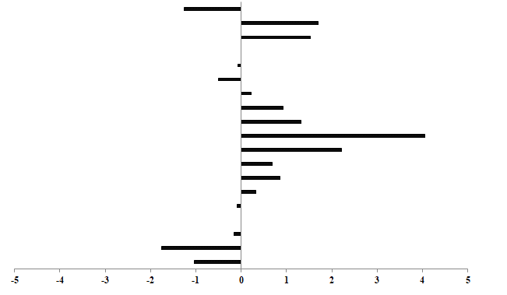
-1.8
0.9
Real estate activities
Arts, entertainment and recreation
Construction
Electricity, gas, steam and air conditioning supply
0.0
Water supply; sewerage, waste management and remediation activities
-0.1
-0.5
0.2
Wholesale and retail trade; repair of motor vehicles and motorcycles
0.9
Transportation and storage
1.3
Accommodation and food service activities
4.1
Information and communication
2.2
Financial and insurance activities
0.7
Professional, scientific and technical activities
0.3
Administrative and support service activities
-0.1
Public administration and defence; compulsory social security
Education
-0.2
-1.0
0.0
Human health & social work activities
Other service activities
1.5
Manufacturing

1.7
Mining and quarrying

The Wage Rate Index for the General Government sector, comprising Ministries, Government departments and agencies operating under them, municipalities, district councils and Rodrigues Regional Assembly remained at 119.2 in fourth quarter 2025.

Compared to fourth quarter 2024, the index, which stood at 116.9, increased by 2.0% or 2.3 points.
This sector accounts for around 34% of the total weight of the Wage Rate Index.

4. Movement of the sub-indices, 4th Quarter 2024 to 4th Quarter 2025

Table 3 compares the indices for the fourth quarter of 2025 with those of the corresponding quarter of 2024.

Main increases were registered in the following industry groups:

Transportation and storage | 9.3%
Information and communication | 6.0%
Administrative and support service activities | 5.5%
Accommodation and food service activities | 4.0%
Manufacturing | 3.5%
Education | 2.7%
Public administration and defence; compulsory social security | 1.5%

3

5. Indices for the Private and Public sectors, Q4 2025

The index for the private sector which accounts for around 54% of the total weight of the Wage Rate Index, increased by 1.1% or 1.5 points from 141.4 in third quarter 2025 to 142.9 in fourth quarter 2025 (Tables 7 & 8).

Compared to fourth quarter 2024, the index for the private sector, which stood at 137.4, increased by 4.0% or 5.5 points (Table 9).

The index for the public sector which comprises General Government and public enterprises and accounting for around 46% of the Wage Rate Index, increased by 0.6% or 0.7 point from 122.7 in third quarter 2025 to 123.4 in fourth quarter 2025 (Tables 11 & 12).

Compared to fourth quarter 2024, the index for the public sector, which stood at 119.3, increased by 3.4% or 4.1 points (Table 13).

6. Wage Rate Index, Year 2025

The Wage Rate Index for year 2025, worked out as the average of the quarterly indices, reached 132.7 compared to 126.5 for year 2024, representing an increase of 4.9% or 6.2 points. (Table 4).

The Wage Rate Index for the General Government sector increased by 2.7% or 3.1 points to reach 119.5 in 2025 from 116.4 in 2024.

The sectoral indices for year 2025, compared to 2024, show main increases in the following groups:

Administrative and support service activities | 8.6%
Transportation and storage | 8.0%
Accommodation and food service activities | 7.8%
Manufacturing | 6.2%
Financial and insurance activities | 4.5%
Education | 3.9%
Public administration and defence; compulsory social security | 1.9%

7. Indices for the Private and Public sectors, Year 2025

The index for the private sector for year 2025, which is an average of the four quarters, worked out to 140.6 compared to 132.8 for year 2024. This corresponds to an increase of 5.9% or 7.8 points in the index (Table 10).

The index for the public sector for year 2025, worked out to 122.7 compared to 118.4 for year 2024, representing an increase of 3.6% or 4.3 points (Table 14).

4

8. Past trend

Table 5 presents the quarterly indices from first quarter 2012 to fourth quarter 2025 with different base periods. As from 2022, the base period is fourth quarter 2021.

To enable comparison between the two series, chain link series, with fourth quarter 2021 as base, have been worked out and are provided in Table 6.

Chart 2 depicts the trend of the quarterly Wage Rate Index from 2019 to 2025 using fourth quarter 2021 as base period. It shows a general upward movement in the index throughout the period up to fourth quarter 2025 except for a decline in second quarter 2020.

Chart 2 - Wage Rate Index,
1st quarter 2019 – 4th quarter 2025
(Base: fourth quarter 2021=100)

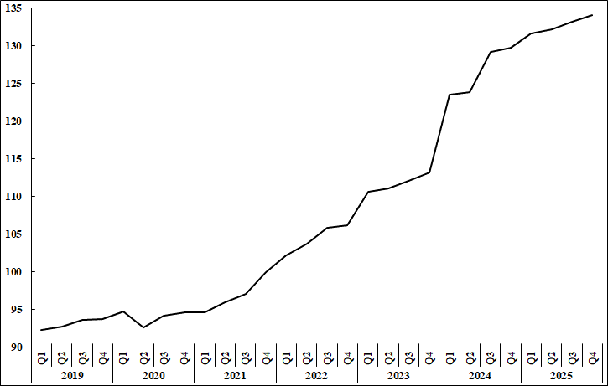

Statistics Mauritius

Ministry of Finance
Port Louis
27 March 2026
Contact persons:

- Mrs. D. Gangaram (Statistician/Senior Statistician)
- Mrs. S. D. Venkatasami (Principal Statistical Officer)
Labour Unit
Statistics Mauritius
LIC Centre
Port Louis
Tel: 650 1829/30 Fax: 2130234
Email: cso_labour@govmu.org
cso_quarterlylabour@govmu.org

i

Annex 1

Technical Note

Methodology used for the compilation of the Wage Rate Index

- Definition

The Wage Rate Index (WRI) measures changes in the price of labour, i.e., changes in the average rates actually paid by employers to their employees for work during normal working hours.

2. Adopted approach

To show genuine changes in the price of labour, it would have been necessary for wages of specific workers at specific establishments to be measured over time. Since this is not possible, the next best approach has been adopted, that is, to follow changes in the wages of groups of employees performing the same jobs. This gives a measure of changes in wage rates of specific occupations but has the following limitations:

    - any changes in the mix of employees within the selected occupations is bound to affect the calculated rates and hence the corresponding sectoral indices. Such changes occur, for example, with a new intake of employees in a specific group - when the wages of the new recruits pull down the average wages for the whole group from one period to the next.

    - wage adjustments resulting from changes in the tasks associated with a particular occupation, which cannot be separated from pure price changes of labour.

    - it is difficult to separate the effects of productivity from the overall change.

3. Coverage

The Wage Rate Index is based on wage rates applicable in ‘large’ establishments only. Employment in these establishments accounted for around 59% of total employment in year 2021. ‘Large’ establishments comprise sugar cane plantations of 10 hectares or more; tea plantations of 2 hectares or more; other agricultural and non-agricultural establishments having 10 or more employees as well as General Government Services, i.e. ministries, government departments and agencies operating under them; municipalities; district councils and Rodrigues Regional Assembly.

The frame consists of a list of around 2,500 ‘large’ establishments as at March 2021. Establishments were stratified according to industry and arranged in order of size, i.e., the number of employees, within the industrial group. Within the strata, selection was proportional to size of establishment. A sample of about 12% was surveyed, representing some 300 establishments. Time-rated as well as piece-rated wage earners and salaried employees are covered. Apprentices, workers on probation, part-time workers and employees working on a temporary basis are excluded.

4. Sectors covered

Indices are disseminated by the Public and Private sectors.

The Public sector comprises Ministries, Government departments and agencies operating under them; municipalities; district councils, the Rodrigues Regional Assembly and Public enterprises.

5. Calculating the Wage Rate Index

A Laspeyres formula is used. The occupational structure is held constant with reference to the base period of the index, i.e. December 2021. The relative changes in average wage rates are measured at the occupational level and these changes are then weighted to give a combined measure of the change. The following formula is used

I_{t} = Σw _{i} (R _{i}^{t} / R _{i}º) X 100

Σ w _{i}

where I_{t} = index for quarter t compared to base period o
w_{i} = Nº_{i}Rº_{i} which represents the total wages paid to all employees in the i ^{th}
occupation base period, December 2021
R_{i}º = wage rate of occupation i in base period, December 2021
R_{i}^{t} = wage rate of occupation i in quarter t

The index is, first, calculated for each industry group and the overall index (covering all industry groups) is computed as a weighted average of the individual industry group indices.

6. Reference period

The base period for the index is quarter 4 2021 (i.e. Quarter 4, 2021=100) as from the first quarter of 2022. The wage rate indices, for the first to fourth quarter, are based on wage rates applicable during the months of March, June, September and December respectively.

7. Weights

Two sets of weights are used:

(i) Weight for the industry groups derived from the ‘Survey of Employment & Earnings, March 2020’ and

(ii) Weight for occupations within each activity (NSIC) sectorwise. Questionnaires were sent to around 2,500 large establishments at the end of March 2021 to cater for number employed in each category of occupation.

8. Wage rates used

The wage/salary rates of specific occupations, used in the calculation of the index, are the rates paid for normal time work, comprising basic wages and salaries, cost of living allowances and other guaranteed and regular allowances paid at the end of each pay period. Overtime payments are, therefore, excluded.

