EDUCATION STATISTICS – 2025
1. Introduction

This issue of the Economic and Social Indicators presents educational statistics, compiled based on data obtained from an annual survey conducted in schools together with data from other sources. The data refer to the Republic of Mauritius (excluding Agalega) and cover
pre-primary, primary, secondary, technical and vocational, tertiary education as well as education in specialised institutions.

2. Expenditure

Total government expenditure for the financial years 2024/2025 and 2025/2026 are estimated as follows:
- Financial year 2024/2025: Rs 301,265 million, of which, Rs 24,061 million (8.0%) has been allocated to education and training; and
- Financial year 2025/2026: Rs 305,412 million, of which, Rs 25,199 million (8.3%) has been allocated to education and training.

Total budget on education and training has been allocated as follows:
- Financial year 2024/2025: 48.0% to secondary education, 23.8% to primary education, 9.5% to tertiary education, 5.1% to pre-primary education, 1.3% to technical and vocational education and the remaining 12.3% to other expenses; and
- Financial year 2025/2026: 47.0% to secondary education, 22.4% to primary education, 9.4% to tertiary education, 4.5% to pre-primary education, 2.4% to technical and vocational education and the remaining 14.3% to other expenses
(Figure 1).

Figure 1 - Total Expenditure on Education and Training, Republic of Mauritius

Financial Year: 2024/2025 Financial Year: 2025/2026

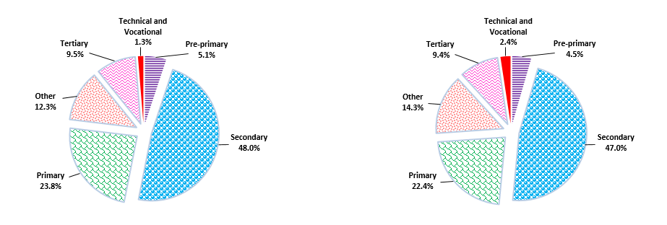

3. Pre-primary Education

  - Schools

The number of schools providing pre-primary education stood at 801 in March 2025: 767 in the Island of Mauritius and 34 in Rodrigues. Of these schools, 564 (70.4%) were privately run institutions; 186 (23.2%), operating on government primary school premises, were administered by the Early Childhood Care and Education Authority and the remaining 51 (6.4%) were administered by either Roman Catholic (RC) or Hindu Education Authorities or Municipal/Village Councils.

  - Enrolment

Enrolment in pre-primary schools decreased by 2.9%, from 27,495 in March 2024 to 26,704 in March 2025. Girls represented 49.3% of the pre-primary school population. The Gross Enrolment Ratio (pre-primary enrolment as a percentage of the population aged 4 and 5 years) works out to 103.0% compared to 106.6% in 2024.
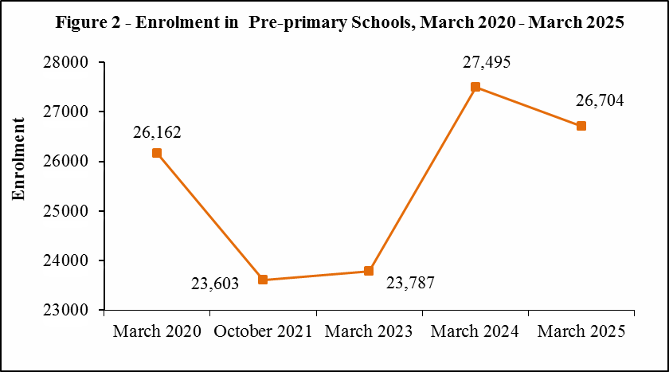

An analysis of the trends, as per figure 2, shows that pre-primary enrolment dropped from 26,162 in March 2020 to 23,603 in October 2021 and then stabilized in March 2023. There was an increase in enrolment in March 2024, reaching 27,495, before falling to 26,704 in March 2025.

  - Personnel

In March 2025, total employment in pre-primary schools stood at 3,786, representing a decrease of 3.5% compared to March 2024, of whom 1,893 were teaching and 1,893 non-teaching staff. The average number of pupils per teacher works out to 14.

4. Primary Education

4.1 Schools

In March 2025, there were 344 schools providing primary education: 327 in the Island of Mauritius and 17 in Rodrigues. The majority (220) of the schools were run by government, 51 by Roman Catholic Education Authority, 2 by Hindu Education Authority and the other 71 were private non-aided schools.

4.2 Enrolment

In March 2025, the primary school population in the Republic of Mauritius stood at 82,974, of whom 49.2% was girls. Some 56% was enrolled in government schools and the remaining was in private aided and non-aided schools.

Distribution by grade shows that grade 4 with 16,843 pupils, accounted for the highest number of pupils. The Gross Enrolment Ratio (primary enrolment as a percentage of the population aged 6 to 11 years) works out to 106.3% in 2025.

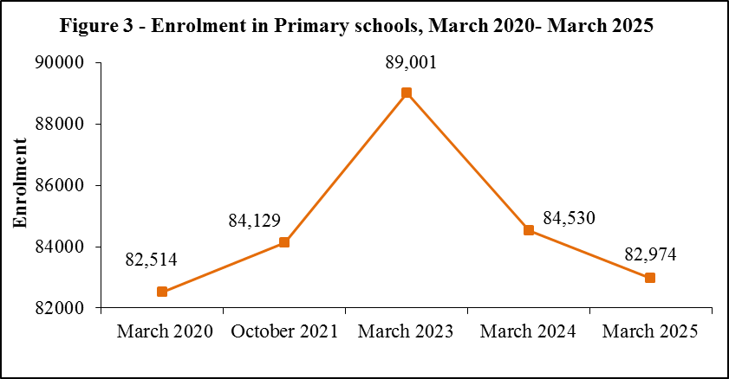

Figure 3 shows an increase in enrolment from 82,514 in March 2020 to 84,129 in October 2021; thereafter it rose to a peak of 89,001 in March 2023. After March 2023, the trend reverses. Enrolment drops to 84,530 in March 2024 and further declines to 82,974 in March 2025.

4.3 Personnel

The number of persons employed in primary schools registered a decrease of 59 from 9,414 in March 2024 to 9,355 in March 2025. Of this number, 5,776 were teaching staff: 4,583 General Purpose teachers and 1,193 Asian Language/Arabic/Kreol Morisien teachers. The remaining 3,579 comprised 317 Head Masters, 1,104 Deputy Head Masters and 2,158 administrative and other workers. The pupil/teacher (general purpose) ratio in primary schools works out to 18 compared to 17 in March 2024.

  - Primary School Achievement Certificate (PSAC)

In 2024, the number of school candidates who took part in PSAC Assessment was 13,866. Excluding re-assessment, the overall percentage meeting PSAC requirement works out to 76.7.

It is to be noted that the percentage meeting PSAC requirement, including re-assessed school candidates, works out to 79.5. The performance of girls, including re-assessment exceeded that of boys with respective pass rates of 82.2% and 76.8% (Figure 4).

5. Secondary Education

5.1 Programmes of study

All children completing Primary Grade 6 move on to Grade 7 in a secondary school to complete the final three years of the nine-year continuous basic education cycle. However, pupils who have not reached the minimum standards in the Primary School Achievement Certificate (PSAC) assessment have two options. They can either repeat Grade 6 or be channeled into the new Foundational Programme in Literacy, Numeracy and Skills (FPLNS).

Introduced in 2025, the FPLNS runs for three years. Upon successful completion, students in the FPLNS will be awarded the National Certificate Level 2 (NC2).

Exceptionally, in 2025, students in Grade 9+ of the previous Extended Programme were given options of either move to a MITD centre for a NC2 vocational course or complete Grade 9+ and sit for the National Certificate of Education (NCE) in 2025.

It is important to note that the Grade 9+ level will no longer exist from 2026 onwards. The introduction of the FPLNS allows learners who do not meet the minimum standards in the PSAC assessment to follow an alternative learning pathway that provides them with a certification after they complete the programme.

As at March 2025, the number of secondary schools stood at 176 out of which 139 were offering the Regular Programme, the FPLNS from Grades 7 to 9 and Grade 9+ of the previous Extended Programme.

At the end of Grade 9, students continue their studies leading to Cambridge O/A level qualifications in either the same secondary school or in an Academie.
Figure 5 depicts a continuous fall in secondary enrolment from March 2020 to
March 2025.

5.2 Secondary Schools

5.2.1 Schools

Out of the 176 schools dispensing secondary Regular Programme, FPLNS and
Grade 9+, 168 were in the Island of Mauritius and 8 in Rodrigues. State administered schools numbered 69, while the other 107 were private aided and non-aided schools.
5.2.2 Enrolment

Secondary education enrolment decreased by 2,244 from 94,747 in March 2024 to 92,503 in March 2025. Some 43.2% of the secondary school population was in state schools and 56.8% in private (aided and unaided) schools. Gross Enrolment Ratio (secondary education enrolment as a percentage of the population aged 12 to 19 years) was 75.8%.

5.2.3 Personnel

The number of teachers working in secondary schools increased by 145 from 8,841 in March 2024 to 8,986 in March 2025. The pupil/teacher ratio works out to 10.

5.3 National Certificate of Education (NCE)

Upon completing Grade 9, students take the National Certificate of Education (NCE) assessment. Following this assessment, learners have the option to either progress to upper secondary education or enroll in vocational and technical education programmes.

In 2024, a total of 13,652 students took the National Certificate of Education assessment, consisting of 6,717 males and 6,845 females. The overall pass rate was 69.5%, which is lower than the 74.6% pass rate recorded in 2023. Girls performed better than boys, with a pass rate of 73.6% compared to 65.3% for boys (Figure 6).

5.4 Cambridge School Certificate (SC)

In 2024, out of 12,527 candidates (5,618 males and 6,909 females) who took part in the Cambridge School Certificate examination, 9,101 were successful. Comparison with the 2023 results shows that the overall pass rate decreased from 73.7% to 72.7% (Figure 7).

5.5 Cambridge Higher School Certificate (HSC)

The number of students taking part in the 2024 Cambridge Higher School Certificate examination stood at 7,425, of whom 57.5% were females. The overall pass rate was 78.9%, which is lower compared to the 84.4% recorded in 2023 (Figure 8).

5.6 Technical and Vocational Education

In 2024, there were 7,585 students (of whom 73.4% were males) enrolled in publicly funded technical and vocational courses compared to 8,730 in 2023. Some 36.2% of the students were enrolled in full-time courses, 34.0% in part-time courses and the rest (29.8%) in apprenticeship courses.

6. Special Education Needs (SEN)
6.1 Schools

As at March 2025, there were 80 Special Education Needs schools in the Republic of Mauritius registered with the Ministry of Education and Human Resource. Twelve schools were run by Government, while the other 68 were run by NGOs, the SEN Roman Catholic Education Authority and the Special Education Needs Resource and Development Centre.
6.2 Enrolment

The number of students enrolled in the 80 special schools stood at 2,929 (of whom 70.6% were boys) as at March 2025, representing an increase of 2.8% compared to the 2024 figure of 2,848.

The three most frequent types of impairment among the pupils were intellectual/ learning disability (35.5%), autism spectrum disorder (24.1%) and language/ communication impairment (7.6 %).

6.3 Personnel

As at March 2025, there were 1,041 persons employed in the special education needs institutions, representing an increase of 9.6% compared to 950 as at March 2024. Out of these, 504 were teaching staff and 61 were medical and para-medical staff. The remaining 476 were administrative and ancillary workers.

7. ICT in Education

In March 2025, out of the 801 pre-primary schools in the Republic of Mauritius, 668 (83%) had computers. All primary and secondary schools were equipped with computers. Availability of internet access for students in schools was as follows: 43% in pre-primary, 86% in primary and 93% in secondary.

8. Tertiary Education

As at December 2024, the total number of students (part-time and full-time) enrolled on tertiary-level programmes (including Distance Education) was 51,860 compared to 50,011 in December 2023, representing an increase of 3.7%.

Figure 9 gives the evolution of total tertiary enrolment over the period 2020 to 2024. Tertiary enrolment showed a general increase from December 2020 to December 2024.
The number of students rose from 48,568 in 2020 to 50,566 in 2022. Although there was a decline to 50,011 in 2023, enrolment picked up again in 2024, reaching 51,860.

The majority of students (84.3%) were enrolled in tertiary education locally in both public-funded institutions (57.6%) and private institutions (26.7%). The remaining 15.7% of the students were enrolled in tertiary education overseas.

The Gross Enrolment Ratio (tertiary education enrolment as a percentage of the population aged 20 to 24 years) for 2024 works out to 54.9 %.

.

9. Main Indicators on Education
The main indicators are given below:
Table 1 - Main Indicators, Republic of Mauritius, 2020 - 2025
 | 2020 |  | 2021/2022 |  | 2023 |  |  | 2024 |  | 2025
Pre-primary
Number of schools | 828 |  | 789 |  | 770 |  |  | 818 |  | 801
Enrolment | 26,162 |  | 23,603 |  | 23,787 |  |  | 27,495¹ |  | 26,704
Number of teachers | 2,103 |  | 1,831 |  | 1,762 |  |  | 1,962 |  | 1,893
Gross Enrolment Ratio (%) (3-4 years) ² | 102.5 |  | 91.2 |  | 92.3 |  |  | 106.0¹ |  | 105.9
Gross Enrolment Ratio (%) (4-5 years) | 102.0 |  | 91.9 |  | 91.8 |  |  | 106.6¹ |  | 103.0
Pupil/Teacher Ratio | 12 |  | 13 |  | 14 |  |  | 14 |  | 14
Primary
Number of schools | 318 |  | 319 |  | 325 |  |  | 342 |  | 344
Enrolment | 82,514 |  | 84,129 |  | 89,001 |  |  | 84,530¹ |  | 82,974
Number of teachers | 5,903 |  | 5,936 |  | 5,640 |  |  | 6,144 |  | 5,776
Gross Enrolment Ratio (%) (5-10 years) ² | 98.0 |  | 103.9 |  | 113.0 |  |  | 108.4¹ |  | 107.3
Gross Enrolment Ratio (%) (6-11 years) | 95.1 |  | 101.4 |  | 111.0 |  |  | 107.4¹ |  | 106.3
Pupil/Teacher Ratio | 18 |  | 18 |  | 20 |  |  | 17 |  | 18
Primary School Achievement Certificate (PSAC) | 78.0 |  | 83.1 |  | 82.0 |  |  | 79.5 |  | n.a
Secondary
Number of schools | 179 |  | 178 |  | 179 |  |  | 175 |  | 176
Enrolment | 107,049 |  | 102,722 |  | 98,900 |  |  | 94,747 |  | 92,503
Number of teachers | 9,542 |  | 9,379 |  | 9,098 |  |  | 8,841¹ |  | 8,986 ³
Gross Enrolment Ratio (%) (11-17 years) ² | 87.0 |  | 88.9 |  | 89.8 |  |  | 89.3 |  | 89.5
Gross Enrolment Ratio (%) (12-19 years) | 73.1 |  | 73.4 |  | 74.4 |  |  | 73.7 |  | 75.8
Pupil/Teacher Ratio | 11 |  | 11 |  | 11 |  |  | 11 |  | 10³
National Certificate of Education | 71.6 |  | 65.4 |  | 74.6 |  |  | 69.5 |  | n.a
Cambridge School Certificate Pass Rate | 85.7 |  | 78.5 |  | 73.7 |  |  | 72.7 |  | n.a
Cambridge Higher School Certificate Pass Rate | 90.0 |  | 92.3 |  | 84.4 |  |  | 78.9 |  | n.a
 |  | 2020 |  | 2021 |  | 2022 | 2023 |  | 2024
Tertiary ⁴
Number of institutions registered |  | 54 |  | 52 |  | 46 | 42 |  | 43³
Enrolment |  | 48,568 |  | 49,497 |  | 50,566 | 50,011 |  | 51,860³
Gross Enrolment Ratio (%) |  | 47.8 |  | 48.3 |  | 49.5 | 49.2 |  | 54.9³
Expenditure |  | 2021/2022 |  | 2022/2023 |  | 2023/2024 | 2024/2025¹ |  | 2025/2026⁵
Total Government Expenditure  (Rs million) |  | 190,131 |  | 214,942 |  | 229,366 | 301,265 |  | 305,412
Total Government Expenditure on Education (Rs million) |  | 16,448 |  | 18,602 |  | 19,588 | 21,716 |  | 22,825
Total Government Expenditure on Education as a % of GDP at market price |  | 3.1 |  | 3.0 |  | 2.9¹ | 3.0 |  | 3.0⁶
Total Government Expenditure on Education as a % of Total Government Expenditure |  | 8.7 |  | 8.7 |  | 8.5 | 7.2 |  | 7.5

¹ Revised
² Based on the UNESCO definition of Gross Enrolment Ratio, i.e., total enrolment in a specific level of education, regardless of age expressed as a percentage of the eligible official school-age population
³ Provisional
⁴ Source: Higher Education Commission
⁵ Budget Estimates
⁶ Forecast
n.a: Not Available

Table 2- Total Government Expenditure, Republic of Mauritius, 2023/2024 - 2025/2026
(Rs million)
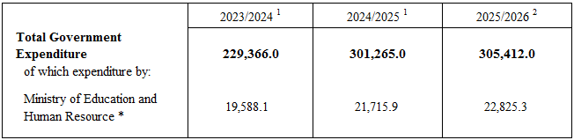

Table 3 - Government Expenditure on Education by sector, 2023/2024 - 2025/2026
(Rs million)
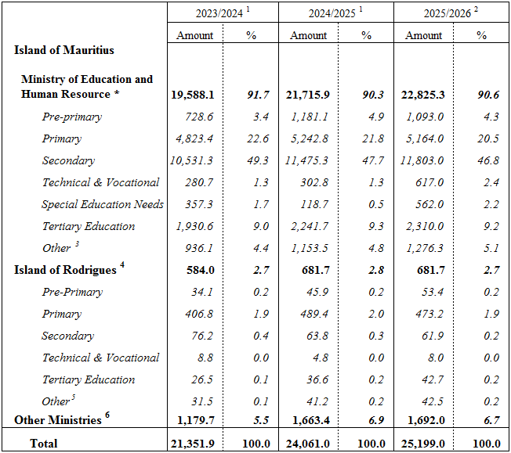¹ Revised ² Budget estimates
³ Includes policy and management costs for education and human resources and includes grant to parastatal bodies falling under the aegis of the Ministry of Education and Human Resource
⁴ Expenditure on Education under Ministry of Rodrigues Vote
⁵ Administrative costs
⁶ Includes expenditure incurred by other Ministries to support education activities and training dispensed by all
Ministries/Departments in line with the concept of lifelong learning
Note: Totals may not add up due to independent rounding of figures
*The Ministry of Education and Human Resource was formerly known as the Ministry of Education, Tertiary
Education, Science and Technology until November 2024
The following tables along with the web version of the publication can be found on the Statistics Mauritius website. To access them, follow these steps:
1. Go to the Statistics Mauritius website: https://statsmauritius.govmu.org
2. From the homepage, click on “STATISTICS”
3. Select “Statistics by subject”
4. Click on “Education”
5. Under the heading “Economic and Social Indicators” and sub heading “Education Statistics”, click on “Year 2025” and select the relevant publication to download the tables and access the full report.
This will give the detailed education statistics for the year 2025.

List of tables

Tables by Zone

1 PRE-PRIMARY EDUCATION
1.1 Distribution of pre-primary schools by zone and type of administration, 2025
1.2 Enrolment and personnel in pre-primary schools by zone and sex, 2025
2 PRIMARY EDUCATION
2.1 Distribution of primary schools by zone and type of administration, 2025
2.2 Enrolment in primary schools by zone, type of administration and sex, 2025
2.3 Enrolment in primary schools by zone and grade, 2025
2.4 Enrolment in primary schools by grade and sex, 2023 - 2025
2.5 Enrolment in primary schools by type of administration, grade and sex, 2023 - 2025,
Republic of Mauritius
2.6 Personnel in primary schools by zone and occupational status, 2025
2.7 Primary School Achievement Certificate (PSAC) Assessment by sex, 2024

3 SECONDARY EDUCATION - GENERAL
3.1 Distribution of secondary schools (general) by zone and type of administration, 2025
3.2 Enrolment in secondary schools (general) by zone and grade, 2025
3.3 Teaching staff in secondary schools (general) by zone and sex, 2025
3.4 Enrolment in secondary schools (general) by zone, type of administration and sex, 2025
3.5 Enrolment in secondary schools (general) by grade and sex, 2023 - 2025
3.6 Enrolment in secondary schools (general) by type of administration, grade and sex,
2023 - 2025, Republic of Mauritius
3.7 National Certificate of Education (NCE) Assessment, 2021/2022 - 2024
3.8 Cambridge School Certificate (SC) examination results by type of school administration and sex, 2022 - 2024
3.9 Cambridge Higher School Certificate (HSC) examination results by type of school administration and sex, 2022 - 2024
3.10 Enrolment in Mauritius Institute of Training and Development (MITD) Centres, Republic of Mauritius, 2024
3.11 Enrolment in Mauritius Institute of Training and Development (MITD) Centres by course level, year of study and sex (Full Time), Republic of Mauritius, 2024

4 SPECIAL EDUCATION NEEDS
4.1 Distribution of Special Education Needs (SEN) schools by zone and type of administration, 2025
4.2 Enrolment in Special Education Needs (SEN) schools by sex and zone, 2023 - 2025
4.3 Enrolment in Special Education Needs (SEN) schools by age and sex, Republic of Mauritius, 2023 - 2025
4.4 Number of pupils in Special Education Needs (SEN) schools by type of impairment and sex,
Republic of Mauritius, 2025
4.5 Personnel in Special Education Needs (SEN) schools by sex, Republic of Mauritius,
2023 - 2025

5 ICT
5.1 ICT in pre-primary, primary and secondary schools - Republic of Mauritius, 2025
6 POST SECONDARY EDUCATION
6.1 Enrolment at Tertiary Education Level, both Locally and Overseas, by Source and Field of Study, as at December 2023
6.2 Enrolment at Tertiary Education Level, both Locally and Overseas, by Source and Field of Study, as at December 2024

Tables by District

7 PRE-PRIMARY EDUCATION
7.1 Distribution of pre-primary schools by district and type of administration, 2025
7.2 Enrolment and personnel in pre-primary schools by district and sex, 2025
8 PRIMARY EDUCATION
8.1 Distribution of primary schools by district and type of administration, 2025
8.2 Enrolment in primary schools by district, type of administration and sex, 2025
8.3 Enrolment in primary schools by district and grade, 2025
8.4 Personnel in primary schools by district and occupational status, 2025

9 SECONDARY EDUCATION - GENERAL
9.1 Distribution of secondary schools (general) by district and type of administration, 2025
9.2 Enrolment in secondary schools (general) by district, type of administration and sex, 2025
9.3 Enrolment in secondary schools (general) by district and grade, 2025
9.4 Teaching staff in secondary schools (general) by district and sex, 2025

10 SPECIAL EDUCATION NEEDS
10.1 Distribution of Special Education Needs (SEN) schools by district and type of administration, 2025
10.2 Enrolment in Special Education Needs (SEN) schools by sex and district, 2023 - 2025
Definition of Indicators

Statistics Mauritius
Ministry of Finance
Port Louis

23 September 2025

Contact Person
Mrs F. Koussa (Statistician/Senior Statistician)
Statistics Unit
Ministry of Education and Human Resource
10th Floor, NPF Bldg, Rose Hill
Tel: (230) 454 1411 Ext 4030
Email: fkoussa@govmu.org

