**Quarterly Index of Industrial Production (QIIP)**

**Second Quarter 2025**

**(Base year: 2018 =100)**

**1. Introduction**

The Index of Industrial Production shows the evolution of the volume of output of the Industrial Sector, which covers “Mining and quarrying”, “Manufacturing”, “Electricity, gas, steam and air conditioning supply” and “Water supply; sewerage, waste management and remediation activities”. The value added of these activities accounts for around 15% of Gross Value Added (GVA). The index compiled on a quarterly basis is one of the most important industrial short-term indicators, which aims at measuring, on a quarterly basis, the changes in the volume of industrial output.

**2. Contents of publication**

This issue of “Economic and Social Indicators” presents the quarterly indices for the first quarter of 2019 to the second quarter of 2025.

The indices are given separately for the four sections, namely, “Mining and quarrying”, “Manufacturing”, “Electricity, gas, steam and air conditioning supply” and “Water supply; sewerage, waste management and remediation activities”. Within “Manufacturing”, estimates by broad group, namely “Export Oriented Enterprises” (EOE), “Non-EOE” and “Sugar milling” as well as by main industry group are given. Wherever possible, the annual averages of the quarterly indices have been worked out and included in the tables. It is to be noted that, due to incomplete data, indices for the second quarter of 2025 are provisional and published at section and broad group level only. They are therefore subject to revision in future issues of the Economic and Social Indicators on QIIP.

The published indices are not seasonally adjusted. The user is therefore advised to base comparisons for a particular quarter of a year on the corresponding quarter of the previous year.

The methodology used for the computation of QIIP including its limitations, are given at Annex.

**3. Overall index - Industrial Sector**

In the second quarter of 2025, the overall index of industrial production increased by 5.0% compared to the previous quarter and by 1.7% when compared to the corresponding quarter of 2024.

The index for the year ending second quarter 2025, which is the average of quarterly indices for the period under review, grew by 1.8%. This is explained by expansions in “Mining and quarrying” (5.4%), “Electricity, gas, steam and air conditioning supply” (+4.6%), “Water supply; sewerage, waste management and remediation activities” (+1.5%) and “Manufacturing” (+1.5%)

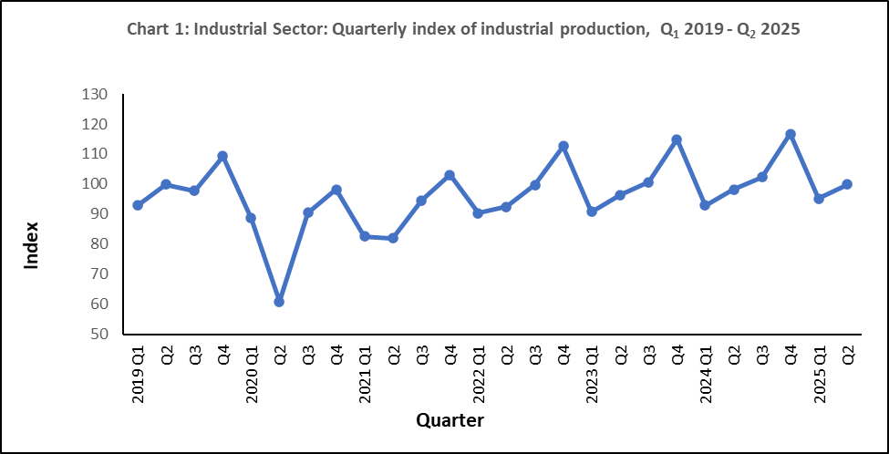

**4. Changes by section**

**4.1 Mining and quarrying**

“Mining and quarrying” comprise activities relating to quarrying of decorative stones, sand and salt extraction as well as stone crushing and represents only 2% of the output of the industrial sector. In the second quarter of 2025, real output grew by 21.7% compared to the previous quarter but declined by 2.4% compared to the corresponding quarter of 2024. However, in year ending second quarter 2025, a growth of 5.4% was noted (Table 1).

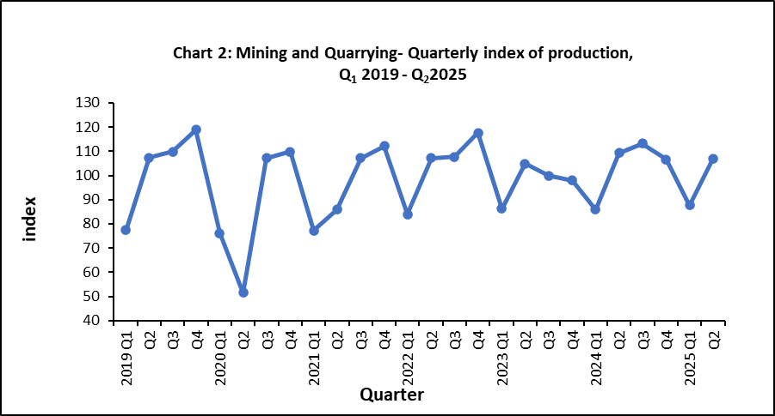

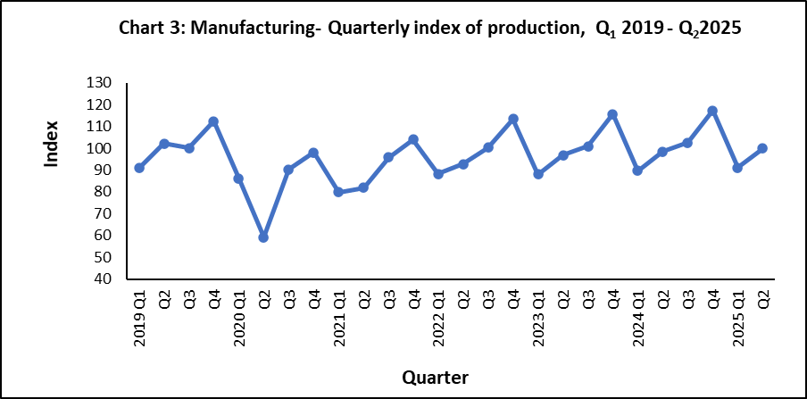 **4.2 Manufacturing**

Manufacturing output, which covers the production of a wide range of goods, represented 85% of the output of the industrial sector in 2018. For analysis purposes, “Manufacturing” is broken down into the following broad groups:

* Sugar milling representing 1.3% of manufacturing output
* EOE (40%)
* Non–EOE (59%)

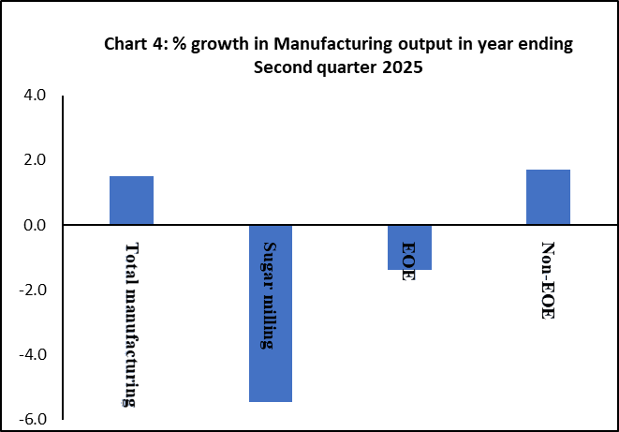Manufacturing output in the second quarter of 2025 grew by 9.7% compared to the previous quarter and by 1.5% compared to the corresponding quarter of 2024 (Table 1). In year ending second quarter 2025, a growth of 1.5% was noted in real manufacturing output. This is due to positive growths in “Non-EOE” (+1.7%) partly offset by negative growth of 5.5% in “Sugar milling” and 1.4% in “EOE”. The performances of “EOE” and “Non-EOE” by detailed industry group up to first quarter 2025 are analysed separately in Section 5.

**4.3 Electricity, gas, steam and air conditioning supply**

“Electricity, gas, steam and air conditioning supply” accounts for 10.5% of the output of the industrial sector. In the second quarter of 2025, real output of this sector decreased by 29.4% compared to the previous quarter and increased by 5.4% compared to the corresponding quarter of 2024. In year ending second quarter 2025, production grew by 4.6% (Table 1).

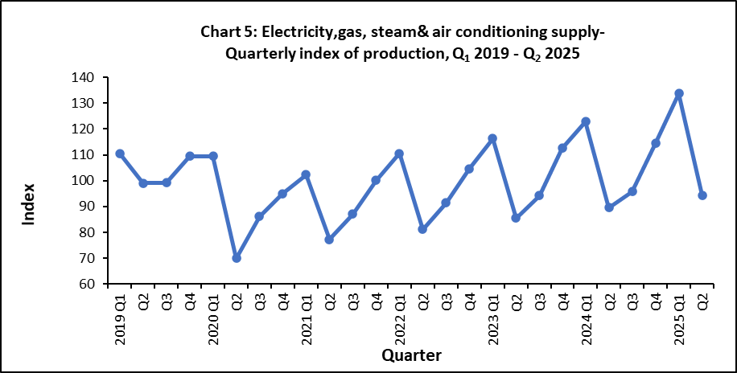

**4.4 Water supply; sewerage, waste management and remediation activities**

“Water supply; sewerage, waste management and remediation activities” accounts for around 2.4% of the output of the industrial sector. In the second quarter of 2025, real output of this sector increased by 5.1% compared to the previous quarter and by 1.0% when compared to the corresponding quarter of 2024. In year ending second quarter 2025, real output went up by 1.5% (Table1).

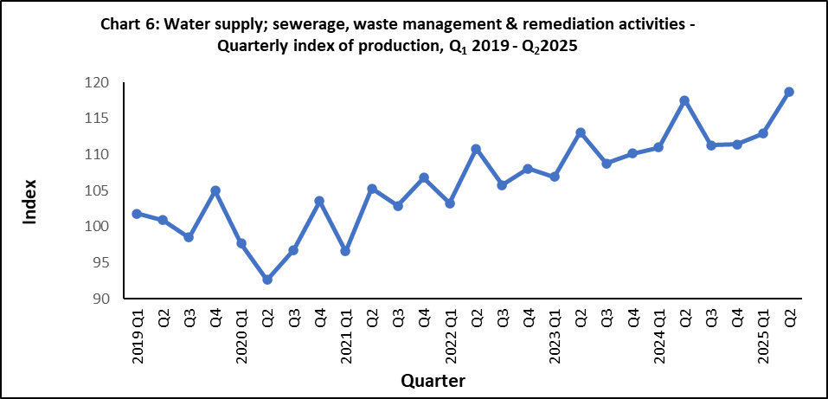

**5. Changes by broad group**

**5.1 Export Oriented Enterprises (EOE)**

Real output of EOE sector increased by 9.7% in the second quarter of 2025 compared to the previous quarter but contracted by 1.0% compared to the corresponding quarter of 2024. In year ending second quarter 2025, the EOE sector decreased by 1.4% (Table 1).

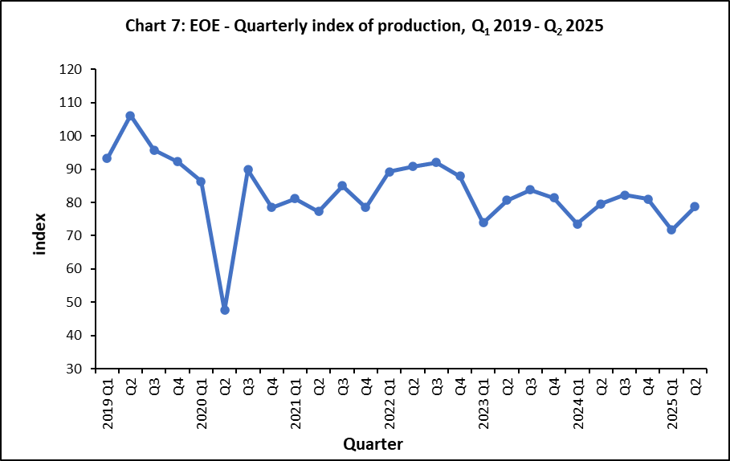

Lower-level indices for the second quarter of 2025 are not yet available. However, an indication of the annual performance at sub-group levels can be obtained by comparing indices available for year ending first quarter 2025 to those for year ending first quarter 2024 (Table 3). The real output of “Wearing apparel,” the largest industry group within the EOE, declined by 12.0%, while “Textiles” experienced a growth of 10.3%. Together, these two sub-groups represent nearly 63% of the total weight assigned to the EOE.

**Year and quarter**

Other sub-groups also showed mixed performance: “Other manufacturing” expanded by 3.7%, whereas “Food products” declined by 2.1%. More significant decreases were seen in “Computer, electronic and optical products” (-6.5%) and “Jewellery, bijouterie, and related articles n.e.c.” (-37.7%).

Further details on the changes within selected sub-groups are illustrated in Chart 8.



**5.2 Non-EOE excluding “Sugar milling”**

**Chart 6**

In the second quarter of 2025, the real output of Non-EOE sector increased by 9.1% compared to the previous quarter and by 2.1% when compared to the corresponding quarter of 2024. In year ending second quarter 2025, it grew by 1.7% (Table 1).

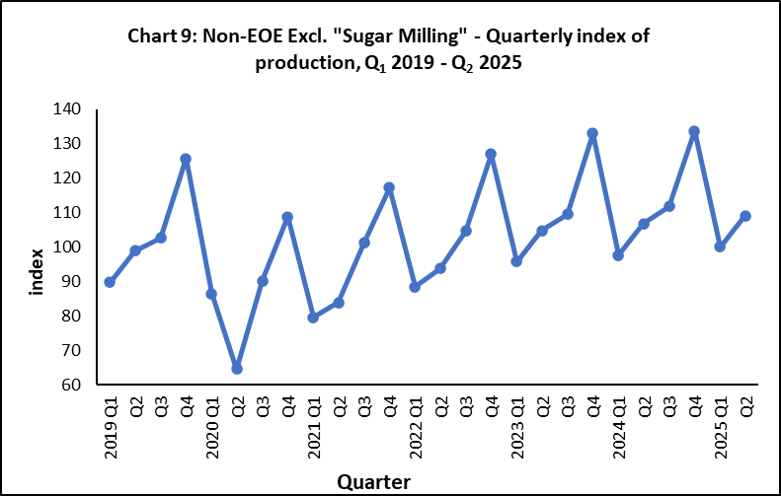

The annual performance at sub-group level is obtained by comparing the detailed indices available for year ending first quarter 2025 to those for year ending first quarter 2024 (Table 4). Expansions were observed in several areas of manufacturing. The “Plastic and non-metallic product” recorded the highest growth of 10.2% followed by “Beverages” (+7.4%), and “Furniture” (+5.2%). Increases were also seen in “Basic metals and fabricated metal products” (+4.3%), Chemicals & chemical products” (+3.7%) and “Printing and reproduction of recorded media” (+3.2%), whereas decline were registered in, “Textiles & wearing apparel” (-7.5%) “Food products excluding sugar” (-3.1%) and “Other manufacturing” (-0.5%) as illustrated in Chart 10.

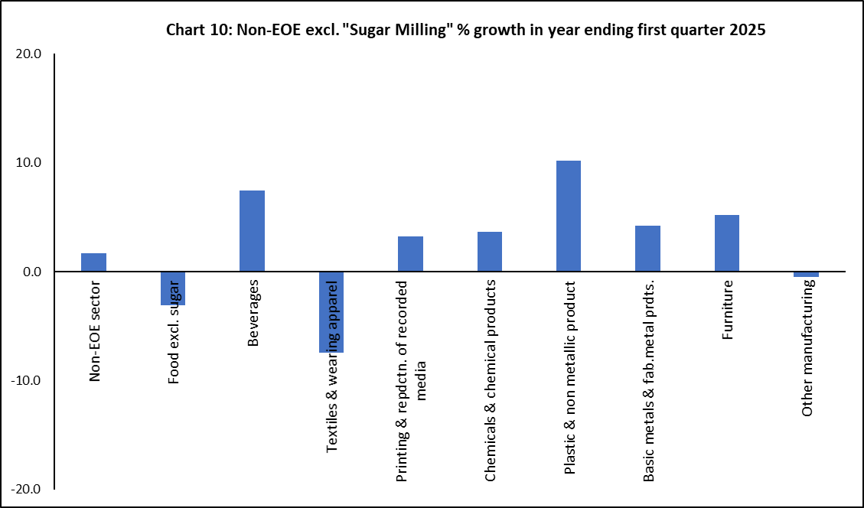

**Statistics Mauritius**

**Ministry of Finance**

**PORT LOUIS**

**23 September 2025**

**Contact Person:**

Mrs. V. Rama-Lahootan (Statistician/Senior Statistician)

Manufacturing Unit

Statistics Mauritius

5th Floor LIC Building

Port Louis

Tel : (+230) 208 1800

E-mail : varama@govmu.org