**2024 CENSUS OF AGRICULTURE - MAIN RESULTS**

# 1. Introduction

This issue of the Economic and Social Indicators (ESI) presents the preliminary main results of the 2024 Census of Agriculture (CA2024) carried out from July to December 2024 in the Republic of Mauritius.

The CA2024 was conducted in three phases - Phase I covering a complete census of some 170 agricultural businesses (i.e. those operating in the non-household sector, namely corporations, NGOs, Government institutions etc), Phase II covering a sample 10,200 household farms and Phase III covering a sample of 8,700 private households. Data collection for Phase I was carried out from July to December 2024, Phase II from July to September 2024 and Phase III from October to November 2024.

The concepts and definitions used in this publication are given at Annex I, and the methodology including the scope, coverage and the sampling design at Annex II.

Further to the publication of this ESI, Statistics Mauritius will next undertake a more detailed analysis and evaluation of the census data including estimates of sectors not covered by CA2024 (sugarcane and tea) and the results will be published, through a consolidated report, in December 2025.

**Note to users**

The data published in this ESI:

1. are provisional and may be subject to revisions in subsequent publications of CA2024 after further analysis and evaluation with other data sources;
2. may differ from agricultural data published in other publications of SM due to difference in methodology used for data collection.

**2. Historical background**

The first Census of Agriculture was carried out in 1930 and this was followed by a similar exercise in 1940. Since then, there has not been any complete census, although data on agricultural statistics are collected on a regular basis by several organisations including Statistics Mauritius through surveys and also through established administrative reporting systems. Statistics Mauritius conducted the third Census of Agriculture in 2014 after more than 70 years and in 2024, SM carried out the fourth Census of Agriculture.

**3. Objectives**

The main objectives of the 2024 Census of Agriculture were:

(a) To provide important information on the organisational structure of farms at geographic level for better and informed decision making (e.g farm size, land use, land tenure, crop area harvested, presence of irrigation, livestock numbers, farm labour as well as the number of holdings with each crop and livestock type);

(b) To improve estimates on the contribution of agriculture for the economy;

(c) To provide information on the household sector including subsistence farming which is important for food security; and

(d) To improve the completeness of existing sampling frame that will be used as the base for sample selection for future agricultural surveys.

**4. Main findings**

**4.1 Agricultural Holdings**

**4.1.1 Area**

Based on information collected during period July 2023 to June 2024 at CA2024, the total number of agricultural holdings (excluding sugarcane and tea only) was estimated at 24,145 (Island of Mauritius: 19,246 and Island of Rodrigues 4,899) as shown in Table 1, compared to 23,456 (Island of Mauritius: 18,350 and Island of Rodrigues 5,106) in CA2014 and were predominantly (99%) in the household sector during both censuses.

In the Island of Mauritius, out of a total area of 62,880 hectares occupied by the holdings, 83% were used by businesses/institutions from the non-household sector while the remaining 17%, by household farms during period July 2023 to June 2024 in CA2024, compared to 64,683 hectares in CA2014 (83% used by businesses/institutions from the non-household sector and 17%, by household farms). This allocation was quite different in Rodrigues with more than 99% of the holdings’ area occupied by household farms in CA2024, same as in CA2014.

The average area per holding in the household and non-household sectors on the Island of Mauritius worked out to 0.6 hectare and 361 hectares respectively in CA2024, compared to 0.6 hectare and 594 hectares in CA2014. On the other hand, during period July 2023 to June 2024 in CA2024, in the Island of Rodrigues, the average size of holding was estimated at 0.3 and 0.4 hectare in the household and non-household sectors respectively, compared to 0.3 hectare and 0.5 hectare in CA2014.

**Table 1: Number and area of holdings by sector, July 2023 - June 2024, Islands of Mauritius and Rodrigues**



The distribution of the size of holdings in the Island of Mauritius, as shown in Table 2, indicated that 58% (compared to 48% in CA2014) of the holdings in the household sector had an area of less than 100 perches (around 0.4 hectare) of which 46% (compared to 76% in CA2014) had an area of less than 50 perches (around 0.2 hectare) during period July 2023 to June 2024 in CA2024. In the non-household sector, only 23% of the holdings had an area of less than 100 perches, while 47% had a size of at least 500 perches (around 2.1 hectares) in CA2024, compared to 18% and 59% respectively in CA2014.

In CA2024, during period July 2023 to June 2024 the distribution of the size of household farms in the Island of Rodrigues showed that 74% had an area of less than 100 perches, of which 53% had a size of less than 50 perches, compared to 40% having an area of less than 100 perches, of which 66% had a size of less than 50 perches in CA2014. In the non-household sector, 80% of the holdings had an area of less than 100 perches, while only 8% had a size of at least 500 perches during period July 2023 to June 2024 in CA2024, as compared to 52% of the holdings having an area of less than 100 perches and only 4% having a size of at least 500 perches in CA2014.

**Table 2: Percentage distribution of holdings by size and sector, July 2023 - June 2024, Islands of Mauritius and Rodrigues**



**4.1.2 Activity**

In the Island of Mauritius, the majority (80%) of the holdings in the household sector and those in the non-household sector (52%) were growing crops in CA2024, compared to 55% of the holdings in the household sector growing crops while 44% in the non-household sector doing mixed farming in CA2014.

As regards to the Island of Rodrigues during period July 2023 to June 2024 in CA2024, most (62%) of the holdings in the household sector were engaged in mixed farming while the majority (56%) of those in the non-household sector were growing crops, compared to 78% of the holdings in the household sector doing mixed farming while the majority (44%) of the non-household sector growing crops in CA2014.

**Table 3: Percentage distribution of holdings by Activity and Sector, July 2023 - June 2024, Islands of Mauritius and Rodrigues**



**4.1.3 Land Use**

Out of the total area of holdings covered by the non-household sector in the Island of Mauritius, 60% were under permanent crops while 8% were under temporary crops during period July 2023 to June 2024 in CA2024 (Table 4), compared to 69% under permanent crops and 5% under temporary crops in CA2014. On the other hand, in the household sector18% of the areas were under permanent crops, while 73% were used for growing temporary crops.

As regards to the Island of Rodrigues, majority of the areas in both the non-household and household sectors were under temporary crops (43% and 69% respectively).

**Table 4: Percentage distribution of area of holding by land use and sector, July 2023 – June 2024, Islands of Mauritius and Rodrigues**



**4.1.4 Land Tenure**

Table 5 shows the distribution of the total area of holdings by land tenure.

In the Island of Mauritius, most (88%) of the area in the non-household sector was owned by the farmers. In the household sector, around 38% of the lands were owned by the farmers, while most of the remaining lands were either rented from other owners or leased from Government.

For the Island of Rodrigues, most of the lands in both the non-household and household sectors (78% and 65% respectively) were leased from Government.

**Table 5: Percentage distribution of area of holding by land tenure and sector, July 2023 – June 2024, Islands of Mauritius and Rodrigues**



**4.1.5 Land parcel**

The number of land parcels operated by the household farms was estimated at 29,196 and 5,976 on the Islands of Mauritius and Rodrigues respectively. The average number of parcels per farm works to 1.5 and 1.2 respectively.

**4.2 Farmers in the Household Sector**

**4.2.1 Gender**

Figure 1 shows that 78% of household farmers were males in the island of Mauritius compared to 60% in the Island of Rodrigues.

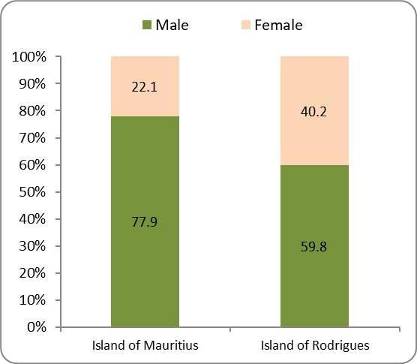

**Figure 1: Percentage distribution of household farmers by sex, July 2023 - June 2024, Islands of Mauritius and Rodrigues**

**4.2.2 Age structure**

Figure 2 depicts the age structure of farmers in the household sector. It is observed that in both Islands of Mauritius and Rodrigues the majority of them fell in the age group of 40 years and over (85 % and 78% respectively).

The mean age of farmers worked out to 54.8 years (males = 52.9 years and females = 56.2 years) in the Island of Mauritius. The higher mean age for female farmers is explained by a high proportion of them falling in the age bracket of 40 to 49 years compared to male farmers. In the Island of Rodrigues the mean age of farmers worked out to 50.2 years (males = 48.9 years and females = 51.5 years).

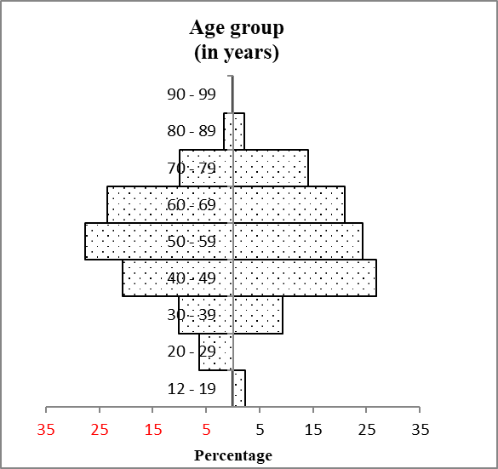

Female

Male

**(in years)**

**Figure 2a: Percentage distribution of farmers (household sector) by age group and sex, Island of Mauritius**

Female

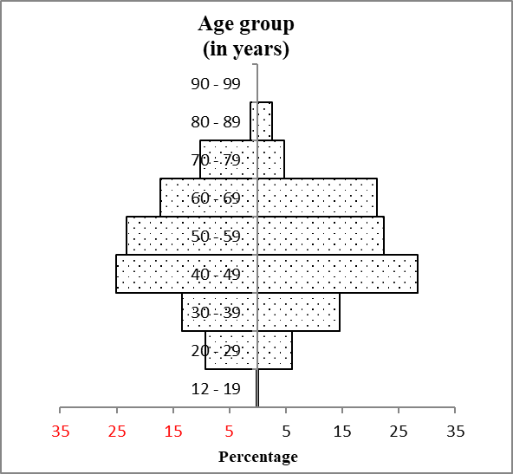

Female

Male

**Figure 2b: Percentage distribution of farmers (household sector) by age group and sex, Island of Rodrigues**

**4.2.3 Activity of household members**

Farmer's household members aged 12 years and over in the Island of Mauritius numbered 27,337 (71% were males and 29% were females) and those in the Island of Rodrigues were estimated at 6,783 (58% for males and 42% for females).

Regarding the activity status of farmer's household members aged 12 years and over on the Island of Mauritius, over the period July 2023 to June 2024, it was found that 74% were engaged in agricultural work on the household farms. Out of these agricultural workers 71% were working on a full-time basis. As regards to the Island of Rodrigues, 77% were engaged in agricultural work on the household farms. Out of these agricultural workers 75% were working on a full-time basis. (Table 6)

**Table 6: Percentage distribution of farmer's household members by sex and activity, July 2023 – June 2024, Islands of Mauritius and Rodrigues**



**4.2.4. Profile of paid employees on the farm**

Table 7 shows that during the period July 2023 to June 2024 the non-household farms on the Island of Mauritius had 74% male and 26% female paid employees and they were mostly Mauritians (94%) compared to 6% of foreign workers. As regards to the Island of Rodrigues, the non-household farms comprised 53% male and 47% female paid employees and they were all Mauritians.

The household farms on the Island of Mauritius had 58% male and 42% female paid employees and they were mostly Mauritians (80%) compared to 20% of foreign workers. It is to be noted that the majority (72%) of them were employed on a part-time basis.

As regards to the Island of Rodrigues, the paid employees of the household farms were made up of 54% males and 46% females and they were mostly Mauritians (96%). The majority (82%) of them were employed on a part-time basis.

**Table 7: Percentage Distribution of Holding's Paid Employees by sex, source of employee and type of employment, July 2023 - June 2024, Islands of Mauritius and Rodrigues**



**4.2.5 Main Purpose of Production**

Figure 3 shows that the majority of household farms on the Islands of Mauritius (95%) and Rodrigues (80%) were growing crops and/ or raising livestock and poultry mainly for sale.

The lower figure for the Island of Rodrigues indicates higher importance of subsistence farming compared to the Island of Mauritius.

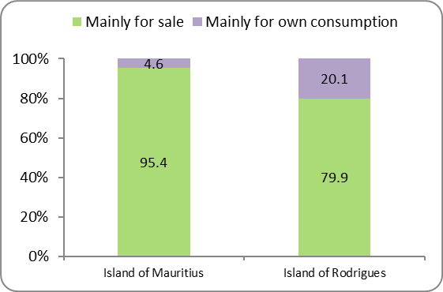

**Figure 3: Percentage distribution of household farms by main purpose of production, July 2023 - June 2024, Islands of Mauritius and Rodrigues**

**4.2.6 Agricultural households**

Figure 4 shows that household farms on the Islands of Mauritius (36%) and Rodrigues (20%) were deriving more than half of their household income from agriculture. These households are therefore classified as agricultural households (An agricultural household is a household whose largest source of income consists of income derived from agricultural production).

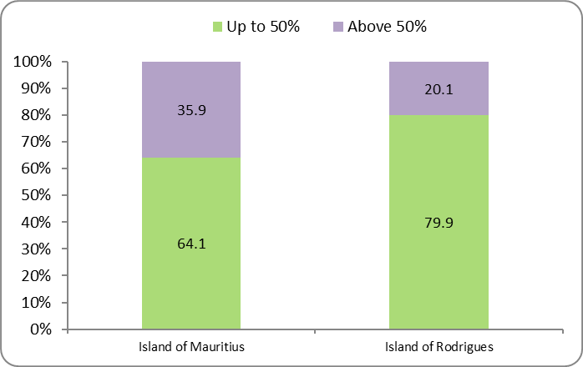

**Figure 4: Percentage distribution of household farms by proportion of household income from agriculture, June 2024, Islands of Mauritius and Rodrigues**

**4.3 Harvested and planted area**

**4.3.1 Vegetables and cereals**

The total harvested area of vegetables (including melons, oilseed crops, root/tuber crops and leguminous crops) and cereals on the Island of Mauritius was estimated at around 9,300 hectares, while that in Rodrigues worked out to 726 hectares.

**Table 8a: Harvested area of vegetables and cereals by agricultural practice, July 2023 - June 2024, Island of Mauritius**

Hectare



**Table 8b: Harvested area of vegetables and cereals by agricultural practice, July 2023 – June 2024, Island of Rodrigues**

Hectare



**4.3.2 Fruits and nuts**

The area under fruits and nuts on the Island of Mauritius was estimated at 1,974 hectares.

The five most common fruits in terms of size of planted area on the Island of Mauritius were:

* Banana (37%)
* Pineapple (20%)
* Mango (18%)
* Lychee (8%)
* Coconut (3%)

The area under fruits and nuts on the Island of Rodrigues was estimated at around 110 hectares.

The five most common fruits in terms of size of planted area on the Island of Rodrigues were:

* Mango (42%)
* Banana (13%)
* Lemon (10%)
* Pineapple (9%)
* Pawpaw (3%)

**4.3.3 Horticulture (Flowers and decorative leaves)**

The total harvested area of horticultural products on the Island of Mauritius was estimated at around 50 hectares, the majority of which from open field plantations represented (79%), while (21%) was from under cover plantation.

**Figure 5a: Percentage distribution of harvested area of selected flowers by agricultural practice, July 2023 - June 2024, Island of Mauritius**

The total harvested area of horticultural products on the Island of Rodrigues was estimated at around 0.7 hectare.

**Figure 5b: Percentage distribution of harvested area of selected flowers by agricultural practice, July 2023 - June 2024, Island of Rodrigues**

**4.4. Livestock, poultry and apiculture**

**4.4.1** **Livestock and poultry**



**4.4.2 Apiculture**

The number of productive and non-productive beehives on the Island of Mauritius was estimated at 2,832 and 1,540 respectively. The corresponding figures for Island of Rodrigues were 2,937 and 734 respectively.

The production of honey in the Islands of Mauritius and Rodrigues was estimated at around 42 tonnes for both islands. It is to be noted that most of the honey was produced by household farms on both islands. (Table 9)

**Table 9: Number of beehives and production of honey, July 2023 - June 2024, Islands of Mauritius and Rodrigues**



*1 as at 30 June 2024; 2 covers the period July 2023 to June 2024*

**4.5 Agricultural and Marketing Practices**

**4.5.1** **Agricultural Practices**

Table 10 presents the agricultural practices reported by both household and non-household farmers. In many cases farmers reported more than one practice.

It is worth noting that there were significant differences in the household sector in some agricultural practices among the farmers of the Islands of Mauritius and Rodrigues, namely: use of irrigation system (50% and 24% respectively), use of chemical fertilisers (83% and 22% respectively), use of organic fertilisers (50% and 59% respectively) and use of improved seeds (56% and 29% respectively).

**Table 10a: Percentage distribution of farms by agricultural practices, July 2023 - June 2024, Islands of Mauritius and Rodrigues**

Percent



**4.5.2 Type of Farming**

Table 10b shows the type of farming practiced by farmers during the period June 2023 to July 2024 in both Islands of Mauritius and Rodrigues. Inorganic farming was mostly used (77%) in the Island of Mauritius compared to organic farming (44%) in the Island of Rodrigues in the Household Sector.

In the non-household sector, inorganic farming (54%) and organic farming (60%) were used in the Islands of Mauritius and Rodrigues respectively

**Table 10b: Percentage distribution of farmers by types of farming, Island of Mauritius and Rodrigues**



**4.5.3 Marketing Practices**

Table 11a to Table 11d show the percentage distribution of marketing practices of selected agricultural products for non-household and household sectors in the Islands of Mauritius and Rodrigues respectively.

The main channel used to market some selected agricultural products on the Island of Mauritius was as follows:

**Non-household sector**

* Vegetables through Wholesalers (34.4%)
* Fruits through Consumers (28.7%)
* Flowers through Consumers (53%)
* Cattle through Consumers (60%)
* Goats through Consumers (85.7%)
* Sheep through Consumers (85.7%)
* Pigs through Wholesalers (50%) and through Retailers (50%)
* Poultry meat through Wholesalers (55.3%)
* Eggs through Consumers (51.1%)
* Honey through Consumers (98.8%)

**Household sector**

* Vegetables through Consumers (32.1%)
* Fruits through Consumers (39.0%)
* Flowers through Consumers (69.6%)
* Cattle through Consumers (91.0%)
* Goats through Consumers (89.1%)
* Sheep through Consumers (86.8%)
* Pigs through Consumers (45.2%)
* Poultry meat through Consumers (54.7%)
* Eggs through Consumers (64.0%)
* Honey through Consumers (85.5%)

For the Island of Rodrigues, the main channel used by farmers to market their agricultural products was as follows:

**Non-Household sector**

* Vegetables through Consumers (56.2%)
* Fruits through Consumers (40%)
* Flowers through Consumers (88%)
* Cattle through Retailers (100%)
* Sheep through Retailers (100%)
* Pigs through Consumers (50%) and through Retailers (50%)
* Poultry meat through Consumers (62.5%)
* Eggs through Retailers (57.5%)
* Honey through Consumers (100%)

**Household sector**

* Vegetables through Consumers (67.1%)
* Fruits through Consumers (66.8%)
* Flowers through Consumers (85.1%)
* Cattle through Retailers (52.6%)
* Goats through Retailers (54.2%)
* Sheep through Retailers (56.5%)
* Pigs through Consumers (60.7%)
* Poultry meat through Consumers (80.2%)
* Eggs through Consumers (72.0%)
* Honey through Consumers (85.8%)

**Table 11a: Percentage distribution of marketing practices of selected agricultural products in Non-Household sector, July 2023 - June 2024, Island of Mauritius**



1 includes poultry-broilers, poultry-layers and poultry-local

**Table 11b: Percentage distribution of marketing practices of selected agricultural products in Household sector, July 2023 - June 2024, Island of Mauritius**



**Table 11c: Percentage distribution of marketing practices of selected agricultural products in Non-Household sector, July 2023 - June 2024, Island of Rodrigues**



**Table 11d: Percentage distribution of marketing practices of selected agricultural products in Household sector, July 2023 - June 2024, Island of Rodrigues**



**4.5.3 Mechanisation**

Table 12 below shows application of mechanisation in the Household sector and the non-household sector

During the period July 2023 to June 2024, farms in the household sector reporting use of mechanisation of selected operations, the main results are as follows: land preparation (51%: out of which 32% was 100% mechanisation), irrigation (31%: out of which 20% was 100% mechanisation) and pesticides application (21%: out of which 8% was 100% mechanisation) in the Island of Mauritius. As regards to Island of Rodrigues, the main results are as follows: land preparation (20%: out of which 8% was 100% mechanisation), irrigation (11%: out of which 5% was 100% mechanisation) and pesticides application (9%: out of which 6% was 100% mechanisation).

During the period July 2023 to June 2024, farms in the non-household sector reporting use of mechanisation of selected operations, the main results are as follows: land preparation (47%: out of which 26% was 100% mechanisation), irrigation (52%: out of which 30% was 100% mechanisation) and pesticides application (34%: out of which 14% was 100% mechanisation) in the Island of Mauritius. As regards to Island of Rodrigues, the main results are as follows: land preparation (20%: out of which 4% was 100% mechanisation), irrigation (20%: out of which 8% was 100% mechanisation) and pesticides application (12%: all of which partly mechanised).

**Table 12: Percentage distribution of farms by types of mechanisation (100% and partly), July 2023 - June 2024, Islands of Mauritius and Rodrigues**



**4.6 Main constraints**

The five main constraints reported by farmers of the household sector on the Island of Mauritius were:

* Natural disaster (58%)
* Theft (55%)
* Pests/Diseases (48%)
* High price of fertilisers and pesticides (45%)
* Unavailability of labour (38%)

For the Island of Rodrigues, the five main constraints reported by farmers of the household sector were:

* Unavailability of water (78%)
* Pests/Diseases (58%)
* Natural disaster (26%)
* High price of feeds (17%)
* Theft (13%)

**Table 13: Main constraints, July 2023 - June 2024, Islands of Mauritius and Rodrigues**



**4.7 Registration of farmers**

Farmers were registered mostly with Small Farmers Welfare Fund (80% and 34%) for both Islands of Mauritius and Rodrigues (80% and 34%) respectively.

**Table 14: Percentage distribution of Registration of farmers in household farm, July 2023-June 2024, Islands of Rodrigues and Rodrigues**



**Statistics Mauritius**

**Ministry of Finance**

**Port Louis**

**August 2025**

**CONTACT PERSONS:**

**Mr. B. Unmar**, Deputy Director of Statistics (Temp)

# Mr. D. Chinnee, Statistician/Senior Statistician

**Mrs. R. Bundhun Sahye**, Statistical Officer/Senior Statistical Officer

Statistics Mauritius

L.I.C Centre

J. Kennedy Street

Port Louis

Tel: (230) 208 1800

Fax: (230) 211 4150

Email: statsmauritius@govmu.org

**2024 Census of Agriculture – Symbols and Acronyms**

***Symbols:***

ha Hectare

‘000 Thousand

Mn Million

- Nil

... Negligible

***Acronyms:***

FAO Food and Agricultural Organisation of the United Nations

FAREI Food and Agricultural Research and Extension Institute

MAIFS Ministry of Agro-Industry and Food Security

NGO Non-Government Organisation

SFWF Small Farmers Welfare Fund

SM Statistics Mauritius

WCA2020 World Programme for the Census of Agriculture 2020

## Annex I

**Concepts and Definitions**

The concepts and definitions follow the recommendations of the World Census of Agriculture 2020 (WCA2020) of the Food Agricultural Organisation (FAO).

1. An **Agricultural Census** is a collection of agricultural data related to the structure of holdings in a country. It covers all units engaged in agricultural production activities, regardless of size or importance.
2. A **farm** (agricultural holding) is an economic unit of agricultural production under single management, comprising total land area, cultivated or under fallow, and livestock owned, managed, rented or operated by the holder. A holding may be landless where there is no significant land area used for agricultural production as may be the case with livestock/poultry.
3. There two types of holdings in an agricultural census: **household** based (usually identified through a household census or survey) and **non-household** based (private agricultural enterprises, government farms, school farms, prison farms, church farms, etc.). For the purpose of the CA2024, a farm is classified in either the **household** or **non-household sector.**
4. A **farmer** (agricultural holder) is defined as the civil or juridical person who makes the major decisions regarding resource use and exercises management control over the agricultural holding operation. The agricultural holder has technical and economic responsibility for the holding and may undertake all responsibilities directly, or delegate responsibilities related to day-to-day work management to a hired manager.
5. **Area of holding** is the combined area of all the holding's parcels in the country, including land owned by the holder, rented from others and land under other tenure forms. Land parcels owned by the holder but rented to others are excluded.
6. A **land parcel** is a piece of land entirely surrounded by other land, water, road, forest or other features not forming part of the holding.
7. A **household** is defined as:

either *A person living on his/her own*.

or *A group of two or more persons, who may or may not be related, but who live*

*together and make common provision for food and other essentials for living*.

1. The **head of household** is any adult member, male or female, who is acknowledged as such by the other members of any household.
2. An **agricultural household** is a household whose largest source of income consists of income derived from agricultural production.
3. **Persons engaged** in a production unit refer to the total number of persons who work in or for the unit. It includes working proprietors, employees and contributing (unpaid) family workers.

1. An **employee** is a person who works in a paid job and receives wages/salary in cash or in kind.
2. An **employer** is a person who works in his/ her own production unit and engages one or more persons to work for him/her as employees.
3. An **own account worker** is a person who works in his/her own production unit alone or with the help of unpaid family members and does not hire any employees.
4. A **contributing** **family worker** is a family member of the owner of the unit, who is actively engaged in the business, without any remuneration.
5. **Part-time** workers are those persons who work less than half of the usual working hours of the unit.
6. **Land under temporary crops** is land used for crops with a less than one year growing cycle. This includes all vegetables and food crops with a growing cycle of less than one year such as, melons, some types of flowers and also fodder crops.
7. **Land under temporary meadows and pastures** is land temporarily cultivated with herbaceous forage crops for mowing or pasture. A period of less than five years is used to differentiate between temporary and permanent meadows.
8. **Land fallow** is arable land at rest for a period of time before it is cultivated again (maximum 5 years). This may be part of the holding’s crop rotation system or because the normal crop cannot be planted because of flood damage, lack of water, unavailability of inputs, or other reasons.
9. **Land under permanent crops** is land which is cultivated with crops which occupy it for a year or longer and which do not have to be planted after harvest. For example land under trees and shrubs producing crops, fruits and flowers, such as roses and jasmine.
10. **Land under permanent meadows and pastures** is land used permanently (for five years or more) to grow herbaceous forage crops, through cultivation or naturally (wild prairie or grazing land) including land used solely for livestock.
11. **Forest or other wooded land** is land which includes wood lots or tracts of timber, natural or planted, which have or will have value as wood, timber or other forest products. Nurseries of forest trees are classified under this category.
12. **Hydroponic farming** is a high-tech growing method, where vegetables are grown without soil. The roots of the plants are grown in a nutrient solution or in a medium such as perlite or gravel.
13. An **exercise yard** is an open enclosed (unroofed) where animals e.g. cattle, goats, sheep, deer etc excluding birds, poultry, pigs and animals living in pasture.
14. An **irrigation system** consists of an intake structure, a conveyance system, a distribution system and a field application system.
15. **Mechanisation** in agriculture is the process of using agricultural machinery to increase farm worker productivity.
16. **Organic fertilisers** are derived from animal or vegetable matter. (e.g. compost, manure).
17. **Improved/selected seeds** are normally seeds that farmers purchase as opposed to their own-produced seeds.

**Annex II**

## Methodology

**Objectives**

1. The main objectives of the 2024 Census of Agriculture (CA2024) were:

(i) To provide important information on the organisational structure of farms at geographic level for better and informed decision making (e.g farm size, land use, land tenure, crop area harvested, presence of irrigation, livestock numbers, farm labour as well as the number of holdings with each crop and livestock type);

(ii) To improve estimates on the contribution of agriculture for the economy;

(iii) To provide information on the household sector including subsistence farming which is important for food security; and

(iv) To improve the completeness of existing sampling frame that will be used as the base for sample selection for future agricultural surveys.

**Scope and coverage**

1. The CA2024 covered farms both in the household and non-household sectors of the Islands of Mauritius and Rodrigues. It, however, excluded

(i) sugarcane since most of the data required is available at the Sugar Insurance Fund Board (SIFB);

(ii) tea since most of the data required is available at NAPRO (ex-Tea Board); and

(iii) tobacco since nearly all tobacco growers have stopped cultivating tobacco due to the fact that this activity will cease in 2015.

### Unit of enquiry

1. The unit of enquiry was an agricultural production unit (**farm or agricultural holding**) producing primarily for sale. In addition, all agricultural production units producing mainly for own consumption with at least 5 perches of land for garden crops and/or with a minimum number fruit trees in the backyard of private households, were considered as farms. The following thresholds were used:

(i) Any household cultivating a piece of land, on own account, and for commercial production (at least 5 perches)

(ii) Any housing unit having a kitchen garden (at least 5 perches)

(iii) Any housing unit having fruit trees on the premises with a certain cut-off:

* Breadfruit, Lychee, Mango (at least 5 trees)
* Lemon, Mandarin, Coconut, Guava, Other citrus, Mixed fruit trees (at least 10 trees)
* Banana, Pawpaw (at least 20 trees)
* Pineapple, Lychee, Vegetables, Fruits-other, Crops-other (at least 5 perches)

(iv) All honey producers

(v) All deer farms

(vi) No minimum size for livestock and poultry

### Sampling frame for household farms

1. The sampling frame for household and non-household farms consisted of a list of agricultural production units obtained from the databases of Ministry of Agro-Industry & Food Security (MAIFS) and Food & Agricultural Research Extension Institute (FAREI) for livestock & poultry breeders, supplemented with information from other administrative sources such as small farmers registered at the Small Farmers Welfare Fund, persons engaged in growing of crops - vegetables, fruits and flowers (including vegetable crops in kitchen gardens and fruit trees in backyard) mainly for sale or own consumption with at least 5 perches of land (identified from the 2022 Housing Census), etc.

**Frame for non-household farms**

1. The frame for non-household farms consisted of a list of agricultural establishments obtained from the databases of MAIFS and FAREI for crops, livestock & poultry breeders, supplemented with information from other administrative sources.

**Phase 1 - Census of non-household farms (agricultural establishments)**

1. Some 200 agricultural establishments, which are mostly private sector establishments and Government institutions involved in agricultural production (excluding sugarcane, tea and tobacco) were surveyed in the Islands of Mauritius and Rodrigues.

**Phase 2 - Sampling design for** **household farms**

1. The sample comprised 10,237 units (8,187 for the Island of Mauritius and 2,050 for the Island of Rodrigues) which were allocated to the different strata according to disproportionate stratified random sampling. The stratifying factors were agricultural intensity, types of crops/livestock and geographical region. This type of allocation was considered to be more appropriate than the usual proportional allocation. Within the strata, selection of units was effected by Systematic Random Sampling to ensure representativeness. it covers all large farms and samples of medium and small farms. The sample represented some 38% of the estimated number of household farms.

**Phase 3 - Sampling design for Survey of private households**

1. A random sample of around 8,727 private households was interviewed. The sampling design was a stratified cluster sampling. The clusters or Primary Sampling Units (PSUs), around 1550 for Island of Mauritius and 46 for Rodrigues, were stratified according to their agricultural intensity. A representative sample of PSUs (50 for Mauritius and 10 for Rodrigues) was drawn. Each private household in the selected PSU was interviewed. The sample represented 3% of households in the Island of Mauritius and 22% in the island of Rodrigues.

**Data capture and processing**

1. CA1 (Business questionnaire) was conducted using paper questionnaires which were sent by post to agricultural businesses. CA 2 (Farm questionnaire) and CA3 (Household questionnaire) were administered using tablet using CAPI (Computer Assisted Personal Interview). The tables were compiled in-house using the software STATA and Excel.

**Reference period**

1. The reference period for the collection of information on area harvested and production of crops (vegetables, fruits & flowers), livestock & poultry sold live or for slaughter and production of honey was one year (1 July 2023 – 30 June 2024). Similarly, same reference period was used for the number of persons engaged in the farms.

**Reference date**

1. The reference date for the collection of information on the number of livestock and poultry was at June 2024.

**Legal authority and confidentiality**

1. The 2024 Census of Agriculture was conducted according to the provisions laid down in the Statistics Act 2000. The Statistics Act provides for an obligation on selected farms to furnish to the Director of Statistics such information as requested in the approved questionnaires and at the same time guarantees the confidentiality of all information provided.

**Concepts, definitions and classifications**

1. The FAO World Programme for the Census of Agriculture 2020 (WCA2020) provides guidelines for data to be collected in a Census of Agriculture. The concepts, definitions and classifications used in CA2024 follow the recommendations of the WCA2020. (**see Annex 1**)

**Adjustment based on Household questionnaire (CA3) results**

1. The findings from the data collected from the CA2 questionnaire showed that the frames used for Islands of Mauritius and Rodrigues for the Farm questionnaire (CA2) were not exhaustive and thus adjustments for overall Census results were done.