Environment Statistics - 2024

1. Introduction

This issue of Economic and Social Indicators presents statistics on Environment for year 2024 based on data gathered from various institutions.

The main environment indicators for the years 2023 and 2024 are given in Table 1, while technical notes are given at Annex. Figures presented in the tables may not add up to totals due to rounding.

2. Forestry and Agriculture

2.1 Forestry

Preservation of forests is vital for the protection of the ecosystem. The total forest area reported for the year 2024 was 42,012 hectares as compared to 41,997 hectares in the year 2023. This small increase of 15 hectares has occurred mainly in plantations of state-owned lands and Pas Geometriques. Some 22,012 hectares (52.4%) of the total forest area in 2024 was state-owned and the remaining 20,000 hectares (47.6%) was privately-owned (Table 2).

Out of the 22,012 hectares of state-owned forest area, 11,768 hectares (53.5%) were planted areas, while the Black River Gorges National Park and the nature reserves accounted for 6,574 (29.9%) and 799 (3.6%) hectares respectively. “Pas Geometriques” covered about 601 hectares (2.7%), other nature parks, 908 hectares (4.1%), Ramsar sites, 46 hectares (0.2%) and other forest lands, 1,316 hectares (6.0%).

The 20,000 hectares of privately-owned forest lands consisted of 13,447 (67.2%) hectares of plantation, forest lands, scrub and grazing lands, and 6,553 (32.8%) hectares of mountain, rivers and nature reserves.

2.2 Agriculture

The area harvested of sugar cane decreased from 35,863 hectares in 2023 to 34,759 hectares in 2024. The production of sugar cane went down by 10.5% from 2,452,653 tonnes in 2023 to 2,195,802 tonnes in 2024 (Table 3). The average yield has decreased by 7.6% from 68.39 tonnes per hectares in 2023 to 63.17 in 2024.

The production of sugar decreased by 5.6% from 238,854 tonnes in 2023 to 225,547 tonnes in 2024. Compared to 9.74% in 2023, the average extraction rate was 10.28% in 2024, representing an increase of 5.5%.

The area under food crops harvested increased by 4.1% from 9,211 hectares in 2023 to 9,585 hectares in 2024. Production of food crops increased by 8.3% from 155,219 tonnes in 2023 to 168,125 tonnes in 2024.

The area harvested under tea plantation in 2024 was 623 hectares as compared to 627 hectares in 2023. The production of green tea leaves went down from 6,762 tonnes in 2023 to 6,018 tonnes in 2024, representing a decrease of 11.0%.

2.3 Import of fertilisers and pesticides

Intensive use of chemical-based fertilisers and other agro-chemicals may contribute to the pollution of the environment through the leaching of nitrate to ground water.
2

From 2023 to 2024, import of fertilisers increased by 9.1% from 24,445 tonnes to 26,673 tonnes. Import of pesticides increased by 50.8% from 2,368 tonnes to 3,572 tonnes (Table 4).

3. Greenhouse Gas (GHG) Emissions

GHG are gases occurring naturally but are also resulting from human-induced activities (anthropogenic emissions from production and consumption). They contribute directly or indirectly to global warming. Some main GHG are Carbon Dioxide (CO₂), Methane (CH₄) and Nitrous Oxide (N₂O).

3.1 Total GHG emissions by sector

The total GHG emissions (excluding Forestry and Other Land Use) in 2024 were 6,407.6 Gg carbon dioxide equivalent (CO₂₋eq) compared to 6,256.8 Gg CO₂₋eq in 2023, representing an increase of 2.4 %. In 2024, there was a general rise in emissions in the energy sector. A slight decrease in emissions was observed in the following sectors, namely; industrial processes and product use, agriculture forestry and other land use and waste (Table 6). The contribution of GHG to total global GHG emission stood at 0.01% (Source: United Nations Environment Programe (UNEP), Emissions Gap Report 2023).

The energy sector remains the largest contributing sector and accounted for 78.3 % (5,016.3 Gg CO₂₋eq) of the total emissions, followed by the waste sector with 11.8 % (757.6 Gg CO₂₋eq), the industrial processes and product use sector with 8.7 % (556.0 Gg CO₂₋eq) and the agriculture sector, 1.2% (77.7 Gg CO₂₋eq) - (Figure 1).

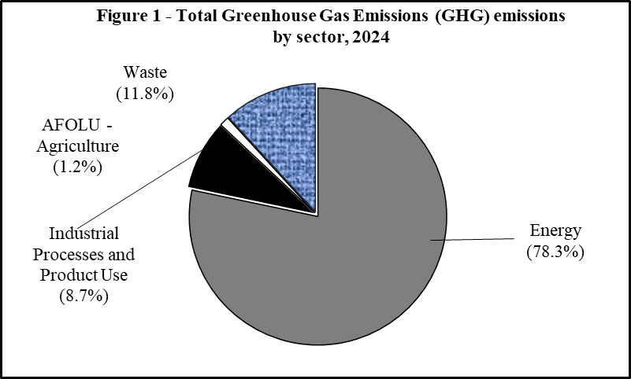

3.2 Total GHG emissions by type gases

In 2024, carbon dioxide (CO₂) was the main GHG representing 78.0 % (4,999.1 Gg) of total GHG emissions. Methane (CH₄) contributed 12.3 % (785.3 Gg CO₂-eq), hydrofluorocarbons (HFCs) 8.1% (517.9 Gg CO₂-eq), and nitrous oxide (N₂O) 1.6% (105.2 Gg CO₂-eq) -(Figure 2).

3

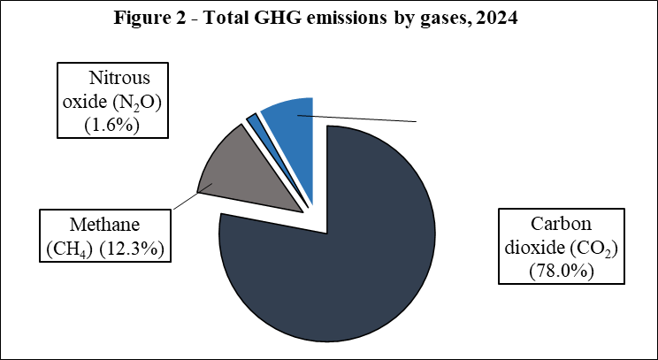
HFC's
(8.1%)

3.3 Net GHG emissions

In 2024, GHG emissions have increased mainly due to a higher fuel consumption in electricity generation activities and transport from the Energy sector. On the other hand, a slight increase was observed in GHG removals due to an addition of 15 hectares of state-owned forest lands. The overall net GHG emissions, after accounting for the removal of Carbon Dioxide by Forestry and Other Land Use sector, stood at around 6,026.1 Gg CO₂₋eq in 2024, up by 2.5% from 5,878.0 Gg CO₂₋eq in 2023 (Table 6).

3.4 Energy and Greenhouse gas (GHG)

3.4.1 Energy sector

Though vital for economic development and households, the production and consumption of energy release greenhouse gases. Carbon dioxide is the main component of greenhouse gases.

3.4.2 Primary energy requirement

Total primary energy requirement (total primary energy requirement = local production + imports of primary energy - re-exports of primary energy – international bunkers – stock changes) was 1,614.9 thousand tonnes of oil equivalent (ktoe) in 2024, 5.0% higher than in 2023 (1,537.6 ktoe) - (Table 5).

In 2024, some 9.1% (147 ktoe) was met from locally renewable energy sources (hydro, wind, landfill gas, photovoltaic, bagasse, fuelwood, and charcoal), while 90.9% (1,468 ktoe) were from imported fossil fuels (petroleum products and coal).

In 2024, there was a slight decrease of 2.4 % in energy supply from local renewable sources. Energy sources from bagasse decreased by 6.5% from 124 ktoe in 2023 to 116 ktoe in 2024, landfill gas decreased by 27.3% from 1.1 ktoe to 0.8 ktoe, hydro increased by 28.4% from 8.1 ktoe to 10.4 ktoe, photovoltaic increased by 19.5% from 12.8 ktoe to 15.3 ktoe, wind increased by 71.4% from 0.7 ktoe to 1.2 ktoe and fuelwood decreased by 5% from 4.0 ktoe to 3.8 ktoe in 2024.

4
From 2023 to 2024, energy supply from imported fossil fuels increased by 5.8% from 1,387 to 1,468 ktoe. Energy supply from petroleum products increased by 0.3% from 983 ktoe in 2023 to 986 ktoe in 2024. Supply from coal increased by 19.3% from 404 ktoe to 482 ktoe (Table 5).

3.4.3 Electricity generation

Total electricity generated increased by 4.7% from 3,266 GWh in 2023 to 3,418 GWh in 2024. In 2024, around 39.1% of electricity was generated from coal, 42.5% from diesel and fuel oil, and 18.2% from renewable sources. Electricity generated from coal increased by 22.0% from 1,095 GWh in 2023 to 1,336 GWh in 2024; that from diesel and fuel oil together decreased by 7.9% from 1,576 GWh in 2023 to 1,451 GWh in 2024 (Table 8).

Electricity generated from renewable sources increased from 574 GWh to 621 GWh, up by 8.2%. Landfill gas decreased by 30.8% from 13 GWh to 9 GWh, hydro increased by 28.7% from 94 GWh to 121 GWh and photovoltaic increased by 19.5% from 149 GWh to 178 GWh. Electricity generated from bagasse decreased by 3.2% from 309 GWh to 299 GWh whereas that generated by wind increased approximately by 55.6% from 9 GWh to 14 GWh (Table 8).
3.4.4 Fuel input for electricity generation

Fuel input for electricity generation from petroleum products, coal and bagasse as shown in Table 9 indicates that:

- In 2024, coal (54.2%) was the major fuel used to produce electricity followed by petroleum products (33.3%) and bagasse (12.6%);

- Between 2023 and 2024, fuel input increased by 5.0% from 806 ktoe to 846 ktoe;

- Input of fuel oil decreased by 8.3%, from 302 ktoe in 2023 to 277 ktoe in 2024 and that of coal increased by 19.5%, from 384 ktoe in 2023 to 459 ktoe in 2024;

- Some 106 ktoe of bagasse was used to produce electricity in 2024 compared to 113 ktoe in 2023, down by 6.2%.

3.4.5 Energy sector emissions

In 2024, GHG emission from the energy sector stood at 5,016 Gg CO₂₋eq, up by 6.7% from 4,703 Gg CO₂₋eq in 2023. Within the energy sector, the sub-sector that contributed most of the GHG emission was the electricity generating industries which accounted for 54.9 % (2,755 Gg CO₂₋eq) of the total emissions. Next came the transport sector which made up 31.8% (1,593 Gg CO₂₋eq) of the total emissions, the manufacturing industries and construction making up another 7.5% (376 Gg CO₂₋eq) and the other sectors accounting for the remaining 5.8% (292 Gg CO₂₋eq) - (Table 7).

5
3.4.5.1 Energy industries (electricity generation)

GHG emission from the generation of electricity (energy industries) stood at 2,755 Gg CO₂₋eq in 2024 compared to 2,546 Gg CO₂₋eq in 2023, representing an increase of 8.2% (Table 7). This is mainly attributed to a 19.5% increase (from 384 ktoe to 459 ktoe) in the amount of coal used to produce electricity (Table 9).

3.4.5.2 Transport industries

In 2024, GHG emission from transport industries was estimated at 1,593 Gg CO₂₋eq compared to 1,520 in 2023, up by 4.8% (Table 7). The number of registered motor vehicles went up by 5.1% from 676,441 in 2023 to 710,605 in 2024 (Table 11), the energy consumed by transport sector increased slightly by 4.4% from 500 ktoe to 522 ktoe - (Table10).

3.4.5.3 Manufacturing industries and construction

Manufacturing industries and construction registered an increase of 4.7% in GHG emissions in 2024, from 359 to 376 Gg CO₂₋eq (Table 7). The amount of coal consumed by the sector increased from 20.3 ktoe to 22.8 ktoe, consumption of fuel oil increased from 34.0 ktoe to 34.8 ktoe, diesel and LPG increased from 51.4 ktoe to 53.3 ktoe (Table10).

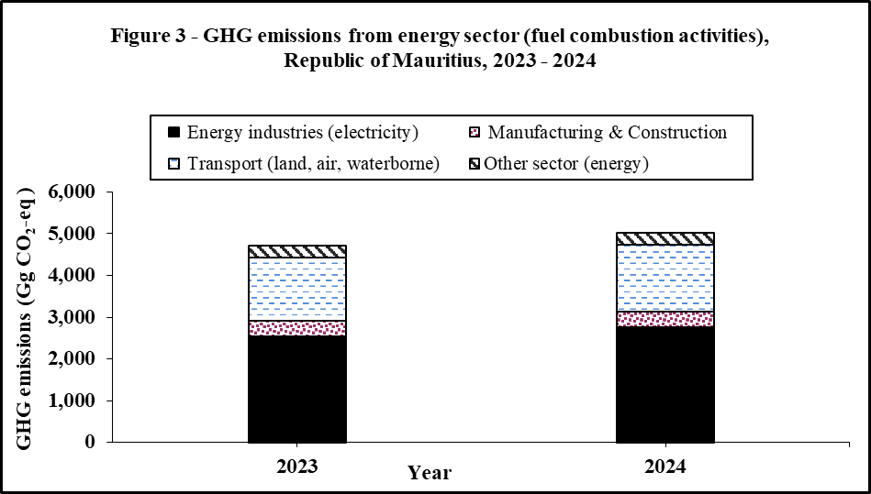

4. Temperature

Table 12 indicates that, in 2024, the monthly mean temperature, the monthly maximum mean temperature and the monthly minimum mean temperature were slightly above their respective long term (1991-2020) means. January was the warmest month of the year with an average maximum of 30.4 ˚C and July was the coolest month with an average minimum of 17.0 ˚C.

6

The highest maximum temperature recorded on 03 March 2024 at Rivière Noire was 35.6 ˚C.

The lowest minimum temperature was 10.1 ˚C, which was recorded on 12 July 2024 at Union Park.

5. Water

Water, being a basic support element for human life and ecosystems, is of vital environmental and biological importance.

5.1 Rainfall

During the year 2024, the mean amount of rainfall recorded around the Island of Mauritius was 2,180 millimetres (mm), representing a decrease of 14.3% compared to 2,543 mm in 2023.

The wettest month in 2024 was January with a mean of 573 mm, which represented a surplus of 203% relative to the long term (1991-2020) mean of 282 mm. September was the driest month with a mean of 39 mm of rainfall, registering a deficit of 46%, compared to the long term (1991-2020) mean of 85 mm (Table 13).

5.2 Water Balance

In 2024, the Island of Mauritius received 4,077 million cubic metres (Mm³) of water from precipitation (rainfall), 14.0% lower when compared to 4,742 Mm³ in 2023. Nearly 10 % (408 Mm³) of the water went as ground water recharge, while evapotranspiration and surface runoff accounted for 30% (1,223Mm³) and 60% (2,446 Mm³) respectively (Table 14).

5.3 Water utilisation

Total water utilisation was estimated at 1,020 Mm³ in 2024. Around 84% (853 Mm³) of the total water utilisation was met from surface water and 16% (166 Mm³) from ground water.

The agricultural sector accounted for 27% (280 Mm³) of the water utilised, domestic, industrial and tourism sector 34% (342 Mm³), and hydropower 39% (398 Mm³) - (Table 15).

Compared to 2023, water utilisation increased by 6.7%, from 956 to 1,020 Mm³ with changes as follows:
- agriculture (-5.4%);
- domestic, industrial and tourism (+5.9%); and
- hydropower (+18.1%).

7

6. Waste

6.1 Waste disposal at Mare Chicose Landfill

The total amount of solid waste landfilled at Mare Chicose decreased by 7.9% from 541,141 tonnes in 2023 to 498,309 tonnes in 2024 (Table 16). The trend of the total amount of solid waste landfilled and the per capita solid waste landfilled are as shown in Figure 4. The per capita total solid waste landfilled increased by 12.9% from 1.01 kg/day in 2015 to 1.14 kg/day in 2024.

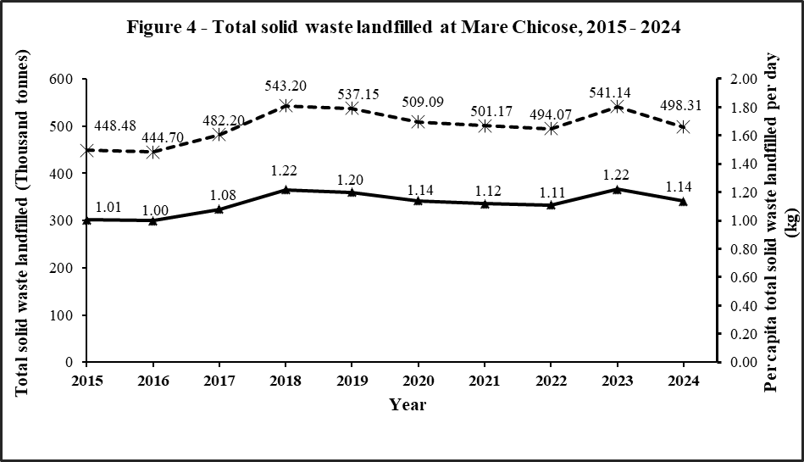

7. Complaints

Effective environmental management needs appropriate coordination and monitoring of environmental problems. The Ministry of Environment, Solid Waste Management and Climate Change addresses complaints received from the general public according to a complaint handling protocol.

Complaints attended by the Pollution Prevention and Control Division of the Ministry of Environment, Solid Waste Management and Climate Change (including those received from the Citizen Support Portal) are categorised at Table 17. The number of complaints attended decreased by 4.1% from 436 in 2023 to 418 in 2024. The main categories of complaints were as follows: bare land (19.6%), noise pollution (17.9%), air pollution (13.2%), wastewater (7.4%), odour (6.9%) and solid waste (6.7%).

8

8. Environmental Impact Assessment (EIA) Licences and Preliminary Environmental Report (PER) Approvals

8.1 EIA Licences and PER Approvals

In 2024, some 36 EIA licences were granted, which comprised 11 for land parcelling (morcellement), 10 for “other projects, 5 for photovoltaic farms, 4 for coastal hotels and related works, 3 for “housing/integrated resort scheme/property development scheme/smart city”, 2 for development in port area and 1 for industrial development (Table 18).

During the same period, 9 PER approvals were issued, which comprised 5 for industrial development, 3 for poultry rearing and 1 for “other projects”. (Table 19).

Statistics Mauritius
Ministry of Finance
Port Louis
31 July 2025

Contact Persons:
Ms. D. Mewa Hurdowar
Statistician/Senior Statistician

Mr. L.K. Dindoyal
Principal Statistical Officer

Ministry of Environment, Solid Waste Management and Climate Change
Ken Lee Tower
Port Louis
Tel. (230) 210-6186
Website : https://statsmauritius.govmu.org
Email cso_envi@govmu.org

9

ANNEX

Technical notes

Concepts and definitions

Environment

Environment: The totality of all the external conditions affecting the life, development and survival of an organism.

Environment Statistics: Environment statistics are environmental data that have been structured, synthesized and aggregated according to statistical methods, standards and procedures. The scope of environment statistics covers biophysical aspects of the environment and those aspects of the socioeconomic system that directly influence and interact with the environment.

Environmental indicator: Environmental indicators are environment statistics that have been selected for their ability to depict important phenomena or dynamics. Environmental indicators are used to synthesize and present complex environment and other statistics in a simple, direct, clear and relevant way.

Land use, Agriculture and Forestry

Pas Geometriques: Pas Géométriques are a narrow belt, theoretically 81.21 metres (250 French feet) in width, round the coast and are State-owned. There are several cases where the width is less than 81.21 metres or does not exist at all.

Ramsar Sites: The Convention on Wetlands also known as the Ramsar Convention defines wetlands as “Areas of marsh, fen, peat land or water, whether natural or artificial, permanent or temporary, with water that is static or flowing, fresh, brackish or salt, including areas of marine water the depth of which at low tide does not exceed six metres”. Mauritius became a contracting party to the Ramsar Convention on 30 September 2001.

Land use: Land use reflects both the activities undertaken and the institutional arrangements put in place for a given area for the purposes of economic production, or the maintenance and restoration of environmental functions. Consequently, there are areas of land that are “not in use” by human activities.

Built-up areas: Built-up areas consist of land under houses, industrial zones, quarries or any other facilities, including their auxiliary spaces, deliberately installed so that human activities may be pursued.

Energy and Greenhouse gas

Greenhouse gases (GHG): These gases occur naturally and also result from human-induced activities (anthropogenic production and consumption) that contribute directly or indirectly to global warming. Some main GHG are Carbon Dioxide (CO₂), methane (CH₄) and Nitrous Oxide (N₂O). Other gases such as Carbon monoxide (CO), oxides of Nitrogen (NOx), non methane volatile organic compounds (NMVOC) and Sulphur dioxide (SO₂), contribute indirectly to global warming. GHG act much like a glass greenhouse, trapping heat in the lower levels of the atmosphere and reflecting the heat back to the earth’s surface, causing it to heat up.
20

Carbon dioxide equivalent (CO₂-eq): It is a measure used to compare the emissions from various greenhouse gases based upon their global warming potential (GWP). The carbon dioxide equivalent of a gas is derived by multiplying the weight of the gas by its associated Global Warming Potential (GWP).

Global Warming Potential (GWP)

The Global Warming Potential (GWP) was adopted from the Intergovernmental Panel on Climate Change (IPCC) Fifth Assessment Report (SAR – 100 years‟ time horizon) as in the table below.

GHG | GWP
Carbon Dioxide CO₂ | 1
Methane CH₄ | 28
Nitrous Oxide N₂O | 265
Hydrofluorocarbon 152a | 138
Hydrofluorocarbon 32 | 677
Hydrofluorocarbon 134a | 1300
Hydrofluorocarbon 125 | 3170
Hydrofluorocarbon 227ea | 3350
Hydrofluorocarbon 143a | 4800
Hydrofluorocarbon 23 | 12400

Primary energy requirement: It is the sum of imported fuels and locally available fuels less re-exports of bunkers and aviation fuel to foreign aircraft after adjusting for stock changes.

Renewable energy: Renewable energy is captured from sources that replenish themselves. It includes solar (photovoltaic and thermal), hydroelectric, geothermal, tidal action, wave action, marine (non-tidal currents, temperature differences and salinity gradients), wind and biomass energy, all of which are naturally replenished, even though their flow may be limited.

Final energy consumption: Energy consumption by final user, i.e energy which is not being used for transformation into other forms of energy.

Water

Water balance: The water balance is based on long term records of annual average rainfall and indicates how freshwater resources are distributed.

Precipitation: Rain falling from the atmosphere and deposited on land or water surfaces.

Evapotranspiration: Combined loss of water by evaporation from the soil or surface water and transpiration from plants and animals.

Surface runoff: The flow of surface water from rainfall, which flows directly to streams, rivers and lakes. Runoff may cause soil erosion.

Groundwater recharge: Process by which water is added from outside to fresh water found beneath the earth surface.

21

Waste

Solid waste: Solid waste includes domestic garbage, industrial and commercial waste, sewage sludge, wastes resulting from agricultural and animal husbandry operations and other connected activities, demolition wastes and mining residues.

Landfill: Final placement of waste in or on the land in a controlled or uncontrolled way according to different sanitary, environmental protection and other safety requirements.

Environmental impact assessment

Environmental impact assessment (EIA): Analytical process that systematically examines the possible environmental consequences of the implementation of projects, programmes and policies.

Preliminary environmental report

Preliminary environmental report (PER): PER is a short form of EIA and this preliminary analysis is undertaken to identify the impacts associated with the proposed development and the means of mitigation.

Economy

Gross Domestic Product (GDP): GDP is the aggregate money value of all goods and services produced within a country out of economic activity during a specified period, usually a year, before provision for the consumption of fixed capital.

Energy intensity: Energy intensity provides a measure of the efficiency with which energy is being used in production or energy used (tonnes of oil equivalent) per Rs 100,000 GDP (at constant prices).

22
Abbreviations

Rs | Rupees
Rs mn | Rupees million
% | Percentage
000 | Thousand
Mm³ | Million cubic metres
Gg | Gigagram(thousand tonnes)
toe | Tonne of oil equivalent
ktoe | Thousand tonnes of oil equivalent
GWh | Gigawatt hour
PER | Preliminary environmental report
EIA | Environmental impact assessment
µg/m³ | Micrograms per cubic metre

Symbols

- | Nil
NA | Not available
Napp | Not applicable

Conversion factor

1 square kilometre | = 100 hectares

23

