Crime, Justice and Security Statistics, 2024
(Police, Prosecution, Judiciary, Prisons and Probation)

- Introduction

This is the eighteenth issue of the Economic and Social Indicator (ESI) on Crime, Justice and Security (CJS) statistics. It is based on administrative data for 2024 from the Mauritius Police Force (MPF), the Office of Director of Public Prosecutions (ODPP), the Judiciary, the Mauritius Prison Service (MPS) and the Probation and After Care Service.

All data in this ESI relate to the Republic of Mauritius, unless otherwise stated.

Table 1 presents the key indicators of Crime, Justice and Security Statistics while detailed tables are given at Annex 1. To assist in interpreting the figures, a reference chart of the flow through the criminal justice system is at Annex 2. A glossary of terms and a general structure of International Classification of Crime for Statistical Purposes (ICCS) Version 1.0 as per United Nations Office on Drugs and Crime (UNODC) are at Annex 3 and Annex 4 respectively.

More detailed statistics will be released in September 2025 through the “Digest of Crime, Justice & Security Statistics, 2024”.

- Summary Statistics
Table 1: Crime, Justice and Security Statistics, Republic of Mauritius, 2023 & 2024
Key indicator | 2023 | 2024
Overall offence rate (excluding contraventions) per 1,000 population | 46.6 | 42.8
Intentional homicide rate¹ per 100,000 population | 2.1 | 2.8
of which murder | 2.1 | 2.8
Theft rate per 1,000 population | 11.5 | 8.6
Drug rate per 1,000 population | 3.3 | 3.5
Road traffic contravention² rate per 1,000 population | 105.8 | 254.6
Juvenile delinquency rate per 1,000 population | 7.4 | 7.1
Conviction rate³ pronounced in court per 1,000 population (excluding contraventions) | 23.2 | 18.0
Imprisonment rate⁴ per 100,000 population | 196.6 | 210.3
Average prison occupancy level ⁵ (%) | 65.0 | 70.2
¹ Intentional homicide rate excludes "abortion" and "arson causing death"
² As from year 2024, data include contraventions established under fixed penalty notice
³ Number of offences that led to conviction (as opposed to the number of persons convicted) per 1,000 population
⁴ Daily average number of detainees per 100,000 population
⁵ Prison population as a percentage of the prison capacity

- Police Statistics

  - Offences reported to police (Annex 1 – Table A1.1)

The offence rate (excluding contraventions) decreased from 46.6 in 2023 to 42.8 in 2024

- From 2023 to 2024, cases reported to the police (which include overall offences and other occurrences) increased by 67.8%, from 259,391 to 435,250. In 2024, some 56,263 cases were related to offences not classified as crime and misdemeanours against 56,869 in 2023, representing a fall of 1.1%.

- Some 14.1% of the overall offences reported in 2024 were linked to crimes (1.8%) and misdemeanours (12.3%). The remaining 85.9% were contraventions, the majority of which were related to road traffic offences.

- Between 2023 and 2024, the general level of crime and misdemeanour, excluding contraventions, decreased from 58,794 to 53,331 (-9.3%).

- The offence rate (excluding contraventions) per 1,000 population decreased from 46.6 in 2023 to 42.8 in 2024.

- Contravention rate per 1,000 population increased from 114.0 to 261.5 during the same period, mostly due to increases in certain road traffic contraventions by type of offence such as “Motor vehicle licence not affixed” and “Contraventions established under fixed penalty notice” (Table 2 and Table A1.3).

Table 2: Offence rate per 1,000 population by type, Republic of Mauritius, 2023 & 2024
 | Offences | 2023 | 2024
 | Crimes¹ | 5.6 | 5.4
 | Misdemeanours¹ | 41.1 | 37.4
 | Offence rate (excl. contraventions) | 46.6 | 42.8
 | of which drug offences | 3.3 | 3.5
 | Contraventions² | 114.0 | 261.5
¹ Crime and misdemeanour rates include drug offences
² As from year 2024, data include contraventions established under fixed penalty notice

  - Reported offences (Annex 1 - Tables A1.2 & A1.7)

Homicide

40.0% of the victims for intentional homicide were committed in private households

- From 2023 to 2024, the number of intentional homicide increased from 26 to 35 (+34.6%), resulting in a rise in the rate of intentional homicide per 100,000 population from 2.1 to 2.8 (Table A1.2). It is to be noted that non intentional homicide decreased from 40 to 11 while attempted intentional homicide increased from 17 to 26.

- In 2024, 68.6% (24 of the 35) victims of intentional homicide were male (Table A1.7). Some 48.6% of the victims were aged 45 years & over and another 34.3% between 25 and 44 years (Chart 1). Some 40.0% (14 of the 35) victims were killed in private households, of whom 57.1% (8) were related to their offenders.

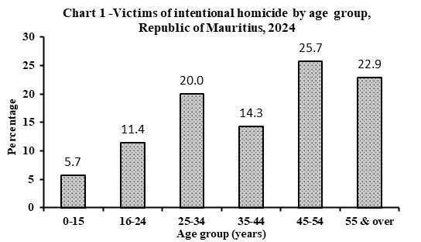

Assault

55.3% of victims were related to their offenders in 2024

- In 2024, some 9,474 assaults (serious and minor) were reported, representing a decrease of 2.4% over the figure of 9,711 in 2023. The rate per 100,000 population fell from 770.2 in 2023 to 760.7 in 2024 (Table A1.2).

- Some 51.2% of the 9,564 victims of assaults registered in 2024 were female and more than half (55.3%) were related to their offenders. Some 62.2% of victims were assaulted in private households, 29.6% in public places such as commercial area, hotel, bungalow, public road and public beach while the remaining 8.2% in educational institutions and other places such as workplace, hospital, airport, concert, etc. (Table A1.7).

Sexual violence and sexual exploitation

The majority (93.2%) of victims of sexual violence and sexual exploitation were female

- Between 2023 and 2024, the number of reported sexual violence and sexual exploitation decreased by 0.9% from 688 to 682 while the rate per 100,000 population rose from 54.6 to 54.8. It is to be noted that rape showed a fall from 61 to 55 and for the same period sodomy also decreased from 34 to 21 (Table A1.2).

- From 2023 to 2024, the female victimisation rate for sexual violence and sexual exploitation rose from 101.9 to 102.7 per 100,000 female population. Among the 693 victims of these sexual offences, 93.2% were female, 64.7% were aged below 16 years (Chart 2), 66.8% were students, 24.0% had family relationship with their offenders and 66.8% occurred in private households (Table A1.7).

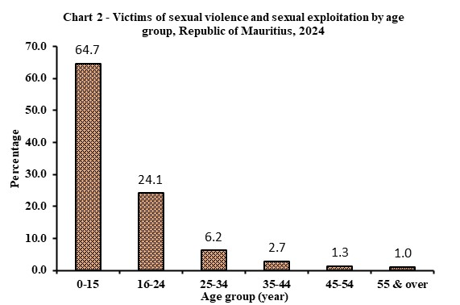

Theft/Robbery/Burglary

Theft decreased in year 2024 compared to year 2023

- From 2023 to 2024, theft decreased by 26.2% from 14,519 to 10,719 mainly due to a fall in “simple larcenies”. Consequently, theft rate per 1,000 population decreased from 11.5 to 8.6. For the same period, a decrease was registered for ‘larceny from motor vehicles’ from 730 to 481 (Table A1.2).

- During the same period, burglary showed a fall of 15.1% from 1,136 to 964 while robbery also decreased by 22.7% from 765 to 591.

Drug offences

Drug offences increased in year 2024 compared to year 2023

- From 2023 to 2024, the number of registered drug offences increased by 4% from 4,205 to 4,373 resulting in a rise in the drug offence rate per 1,000 population from 3.3 to 3.5 (Table A1.2).

- In 2024, out of the 4,373 drug offences reported, 40.9% were cannabis (commonly known as “gandia”) related offences, 27.6% for synthetic cannabinoids 15.4% for heroin related offences and 1.7% for sedatives/tranquilizers. Other type of drugs, comprising mainly methadone and hashish, represented 14.4% of drug offences.
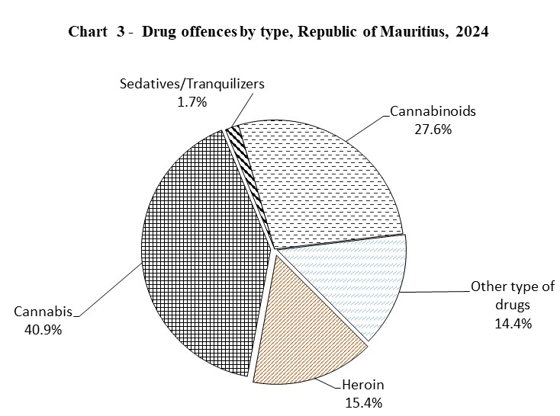
- The market value of all drugs seized in 2024 was estimated at around Rs 1.56 billion.

- Some 36,221 plants of cannabis were uprooted by Anti-Drug and Smuggling Unit (ADSU) in 2024 against 54,419 in 2023.

Road traffic offences

Contraventions (Annex 1 - Tables A1.2 & A1.3)

Road traffic contraventions increased between 2023 and 2024

- The number of registered road traffic contraventions excluding contraventions established under fixed penalty notice increased by 62.1% from 133,434 in 2023 to 216,326 in 2024.

- From 2023 to 2024, road traffic contraventions showed increases mainly for “Motor vehicle licence not affixed” from 7,625 to 21,562 (+182.8%), “Other road traffic contraventions” from 37,350 to 61,258 (+64.0%) and “exceeding speed limit” from 55,630 to 72,109 (+29.6%). Decreases were noted mainly for road traffic contraventions such as “Breach of conditions attached to provisional licence” from 2,321 to 1,737 (-25.2%), “Parking on double yellow line” from 1,378 to 1,241 (-9.9%) and “Driving without due care and attention” from 1,233 to 1,152 (-6.6%), among others.
Cumulative Road Traffic Offences (CRTO)

- From January to December 2024, 36.7% of fines paid were due to exceeding speed limit.

- From January to December 2024, some 17,574 persons were convicted for offences specified in the third schedule as CRTO. Some 1,393 drivers (7.9%) had been convicted for more than once under the third schedule as CRTO, of whom, 21 (1.5%) had already been convicted for four offences and above.
- Thirty-three Mauritians and one foreign driver holding competent driving licences have been disqualified due to the CRTO from January to December 2024.
  - Investigation and prosecution

Persons suspected, arrested and/or cautioned (Annex 1 - Table A1.4)

- The number of persons suspected, arrested and/or cautioned increased by 0.2% from 28,796 in 2023 to 28,858 in 2024. For the same period in this category, decreases were noted mainly for property damage from 859 to 434 (-49.5%), sexual violence and sexual exploitation from 599 to 457 (-23.7%), negligence from 365 to 280 (-23.3%), homicide 205 to 176 (-14.1%) and fraud/forgery/counterfeiting/corruption from 792 to 692 (-12.6%).

- In 2024, offences for which persons were being suspected, arrested and/or cautioned were mostly in robbery (86.4%), followed by burglary (51.3%) and drug offences (2.9%).

Persons prosecuted (Annex 1 - Table A1.5)

- The number of persons prosecuted rose by 0.1% from 25,862 in 2023 to 25,877 in 2024.

- The number of persons prosecuted by type of offence between 2023 and 2024 rose mostly in burglary from 938 to 1,219 (+30.0%) and drug offences from 1,761 to 2,058 (+16.9%) while theft declined from 4,104 to 2,694 (-34.4%).

- Prosecution - Office of Director of Public Prosecutions (ODPP)

- From 2023 to 2024, the total number of cases referred by the Police for advice to ODPP decreased by 0.8% from 10,265 to 10,176. Out of 10,176 cases in 2024, 50.6% (5,153) of them were referred to ODPP for initial advice after enquiry, based on their seriousness, complexity and special nature, i.e., parties involved including civil servants and minors, government property involved, etc.

- The number of cases referred by ODPP to the Intermediate and Supreme Courts decreased by 45.5% from 987 in 2023 to 538 in 2024.
- In 2024, 55 cases were lodged by ODPP before the Assizes against 87 in 2023.
- In 2024, 83 criminal “Appeal and motions” were conducted by ODPP before the Supreme Court compared to 134 in 2023.

- Judiciary statistics

Civil and Criminal cases (Annex 1 - Table A1.8)

Rise in divorce cases lodged in year 2024 compared to year 2023

Lodged

Between 2023 and 2024, the number of civil cases lodged in Court decreased by 10.3%, from 15,832 to 14,202, with a fall in ‘cases under the Protection from Domestic Violence Act’ from 1,627 to 1,507 (7.4%). However, the number of divorce cases increased from 2,836 to 3,148 (11.0%) from 2023 to 2024.
For the same period, the number of criminal cases lodged in Court decreased by 16.0% from 88,531 to 74,384.
Disposed of

The number of civil cases disposed of increased by 4.6% from 14,930 in 2023 to 15,612 in 2024. During the same period, a rise in divorce cases from 3,100 to 3,445 (11.1%) and a fall in “cases under the Protection from Domestic Violence Act” from 1,576 to 1,521 (3.5%) were noted respectively.

For the same period, a rise of 1.1% was noted in the number of criminal cases disposed, from 77,063 to 77,909.

Outstanding

From 2023 to 2024, outstanding cases fell by 12.8% for civil cases from 16,594 to 14,475 and by 36.5% for criminal cases from 82,534 to 52,444.

Conviction

Conviction rate decreased from year 2023 to year 2024

- Some 75,404 criminal offences were disposed of by Courts in 2024. The prosecuted persons were found guilty in 57.8% (43,554) of these offences, of whom nearly all were adults. The remaining 42.2% (31,850) were dismissed or discontinued.

- From 2023 to 2024, the overall convicted offences decreased by 22.9% from 56,499 to 43,554, mainly due to decreases in theft (-26.4%), homicide (-35.2%) and fraud/forgery/counterfeiting (-43.8%). (Annex 1 - Table A1.9).

- In 2024, 48.0% of the convicted offences were due to the conviction for non-injurious traffic violations.

- From 2023 to 2024, the conviction rate per 1,000 population decreased from 23.2 to 18.0 (Annex 1 - Table A1.9).

Convicted offences (Annex 1 - Table A1.9)
Homicide
From 2023 to 2024, there have been a rise in convictions for intentional homicide from 9 to 19 and a fall in non-intentional homicide from 91 to 35 respectively.

Assault
In 2024, there were 857 convicts for assault representing a fall of 37.6% over the figure of 1,373 in 2023.

Sexual violence & sexual exploitation
From 2023 to 2024, there was a decrease in convictions for sexual violence and sexual exploitation from 109 to 69 (36.7%) due to a fall in convictions for rape and sodomy from 13 to 6 and from 9 to 5 respectively.

Theft/Robbery/Burglary
Compared to the previous year, convictions for robbery and theft in 2024 decreased by 37.5% from 1,792 to 1,120 and by 26.4% from 3,472 to 2,556 respectively. Similarly, burglary showed a decrease of 11.8% from 1,131 to 998.

Drug offences
From 2023 to 2024, the conviction for drug offences rose by 22.9% from 1,422 to 1,747.

Sentence imposed (Annex 1 - Table A1.9)

- Out of the 43,554 offences for which sentences have been imposed in 2024, the accused persons were either sentenced to pay fines (84.7%) or imprisoned (12.7%). The remaining 2.6% were committed to community service works, issued with probation orders or discharged either conditionally or absolutely.

- From 2023 to 2024, the number of fines imposed decreased by 24.9% from 49,152 to 36,901 as opposed to imprisonment which rose marginally from 5,509 to 5,521.

- Statistics from Mauritius Prison Service

  - Prison and detention statistics (Annex 1 - Tables A1.10 to A1.13)

The majority of adult convicts admitted were re-offenders

- Out of every 100 detainees in prison in 2024:

- 50 were convicted detainees and 50 were on remand awaiting trial;

- 93 were male adult detainees, 6 were female adult detainees and one was juvenile
inmate.

- The daily average for remand and trial population decreased by 0.3% from 1,322 in 2023 to 1,318 in 2024.
- The imprisonment rate per 100,000 mid-year population rose from 196.6 in 2023 to 210.3 in 2024.

- In 2024, the average prison occupancy level was 70.2%, with the highest occupancy level being 100.0% and the lowest, 35.9%. From 2023 to 2024, the occupancy rate has increased from 65.0% to 70.2%.

- The number of convicted detainees admitted increased by 3.0% from 4,937 in 2023 to 5,085 in 2024 (Annex 1 - Table A1.11).

- Out of every 100 convicted detainees admitted to prison in 2024 (Annex 1 - Table A1.11):

- 96 were male and 4 were female;

- 49 were in the age group 18 - 30 years.
- In 2024, the convict admission rate peaked at the age group of “26-30 years” (Chart 4) same as in 2023.
- Out of the 5,085 convicts admitted in 2024, some of the offences they committed were theft (31.9%), offences related to acts against public order (18.7%), robbery (16.6%), burglary (11.7%), assault (2.6%), drug offences (7.0%) and breach of protection order (4.9%).

- From 2023 to 2024, the increase in the number of admissions was mainly due to a rise of 50.8% in the admissions for breach of condition of release from 325 to 490. It is to be noted, for the same period, the admissions for theft decreased from 1,630 to 1,621 (Annex 1 - Table A1.13).

- The adult convicted detainees, who were readmitted to prison, increased by 7.4% from 3,471 in 2023 to 3,728 in 2024 (Annex 1 - Table A1.10). Regardless of any observation period, out of every 100 adult convicted detainees admitted to prison in 2024:

- 73 were re-offenders who had been imprisoned in the past;
- 56 were imprisoned more than once in the past.

- The number of convicts with short sentences of less than one month decreased by 3.3% from 1,810 in 2023 to 1,750 in 2024 whereas, those sentenced for 1-3 months increased by 0.8% from 1,551 to 1,563 (Annex 1 - Table A1.13). There were no convicted detainees who were sentenced to life imprisonment in 2024 similar to 2023.

- From 2023 to 2024, the number of fine defaulters admitted to prison decreased by 11.4% from 551 to 488 (Annex 1 - Table A1.12). The admissions due to non-payment of fines of Rs 30,000 or less fell from 510 in 2023 to 459 in 2024.

- The main offences committed by fine defaulters were theft (14.5%), non-injurious traffic violations (14.3%), simple larcenies (14.1%), breach of condition of release (13.3%) and drug offences (11.4%).

- There were two escapes from prison in 2024, same as in 2023.

- An average amount of Rs 934 was spent daily on each detainee in 2024 in the Island of Mauritius compared to Rs 955 in 2023.

- Probation statistics

Offenders subjected to Probation orders decreased by 5.8% and Community Service Orders decreased by 7.9%

- In 2024, 50 probation orders were issued (48 for male and 2 for female), representing a fall of 3.8% compared to 52 (44 for male and 8 for female) in 2023. The number of offenders placed on probation decreased by 5.8% from 52 (41 adults and 11 juveniles) in 2023 to 49 (49 adults and no juveniles) in 2024.

- The number of offenders, subjected to Community Service Orders, decreased by 7.9% from 367 in 2023 to 338 in 2024. In 2024, the majority (91.1%) of the offenders were male.

- Juvenile statistics

Juvenile offenders (Annex 1 - Table A1.6)

Number of juvenile offenders for year 2024 increased by 6.3%

- From 2023 to 2024, the juvenile offenders (excluding those who had contraventions) involved in crimes and misdemeanours decreased by 8.9% from 492 to 448.
Sexual violence and sexual exploitation fell from 97 to 46, assault from 132 to 107 and homicide from 7 to 2. For the same period, drug offences rose from 28 to 56. An increase of 125.4% was noted in the number of juveniles contravened from 63 to 142. Out of the 142 juvenile offenders for contraventions in 2024, all were road traffic contraveners.

- In 2024, the juvenile delinquency rate (excluding contraventions) decreased to 7.1 per 1,000 juvenile population from 7.4 in 2023. The rate for boys was 11.9 compared to 2.3 for girls in 2024.
Juvenile victims of offences against person (Annex 1 - Table A1.7)
Homicide
In 2024, there were two juvenile victims for intentional homicide and non-intentional homicide. However, there was only one female victim for attempted-intentional homicide in 2024.

Assault
The number of victims for assault decreased by 21.3% from 723 in 2023 to 569 in 2024. Juveniles were mostly victims of simple assaults. Some 59.1% of victims for simple assaults were boys.

Sexual violence & sexual exploitation
- From 2023 to 2024, victims of sexual violence and sexual exploitation increased by 2.2% from 535 to 547 mainly due to a rise in “Causing child to be sexually abused; accessing to a brothel; and engaging in prostitution” from 234 to 303 (+29.5%) and partly offset by a fall in “Sexual intercourse with minor under the age of 16” from 121 to 105 (-13.2%). It is to be noted that rape increased from 21 to 58 and in 2024 sodomy also rose from 18 to 23.

- The majority (93.0%) of the juvenile victims of sexual violence and sexual exploitation were female.

Juvenile conviction in Court (Annex 1- Table A1.9)

There has been a marginal fall in juvenile conviction rate

- In 2024, the number of convictions, which involved juveniles, stood at 7 compared to 21 in 2023. Out of the 7 convicts all were sentenced to ‘Correctional Youth Centre (CYC)’.

- The juvenile conviction rate per 1,000 juvenile population fell marginally from 0.2 in 2023 to 0.1 in 2024.

Juvenile detainees (Annex 1 - Tables A1.10 & A1.11)

The seven juveniles admitted to CYC were due to burglary, theft, robbery and aiding and abetting in the commission of a crime / misdemeanour.

From year 2023 to 2024, the conviction rate per 100,000 juveniles increased from 3.0 to 11.1.

Correctional Youth Centre (CYC)

From year 2023 to 2024, the number of juveniles admitted (remand and convict) decreased by 18.2% from 22 to 18. The seven juveniles admitted to CYC were due to robbery, theft, burglary and aiding and abetting in the commission of a crime / misdemeanour.

Rehabilitation Youth Centre (RYC)

Four juveniles were admitted for detention and training at RYC in 2024 compared to zero in 2023.

Probation Home/Hostel

The number of juveniles admitted in probation institutions decreased from 14 in 2023 to 7 in 2024.

  - Parenting Support Intervention (PSI)

From year 2023 to 2024, the number of parenting support intervention (Children’s Act 2020) carried out decreased by 42.8% from 145 (63 males and 82 females) to 83 (41 males and 42 females).

  - Child Assessment

- Child Suspect under 14 years

From year 2023 to 2024, the number of assessments carried out for children suspect under 14 years not criminally responsible increased by 58.3% from 36 (31 boys and 5 girls) to 57 (50 boys and 7 girls).

- Juvenile offenders aged 14 years or above but below the age of 18

From year 2023 to 2024, the number of assessments carried out for juvenile offenders above 14 years decreased by 17.1% from 381 (317 males and 64 females) to 316 (292 males and 24 females).

  - Other juvenile sentencing

- No juvenile was under probation orders in 2024 compared to 11 in 2023.

- No juvenile was ordered to perform community service work in 2024 same as in 2023.

- Longer time series

Offence rate (crimes and misdemeanours) & contraventions

From 2012, the general level of crime and misdemeanour (offence rate) was 32.6 per 1,000 population. It, then, declined gradually to stabilize at around 33.3 from 2012 to 2014, increased to 37.8 in 2017, fell to around 35.8 in 2018 to 2019, increased to 57.6 in 2021, declined to 46.6 in 2023 and to finally decrease to 42.8 in 2024 (Chart 5).

On the other hand, as from 2012, contravention rate per 1,000 population was oscillating around the level of 182.3. Thereafter, it picked up followed by a rising trend from 195.3 in 2016 to peak at 204.6 in 2018. After a decline to 100.0 in 2022, it gradually increased to 114.0 in 2023, to further increase to 261.5 in 2024.

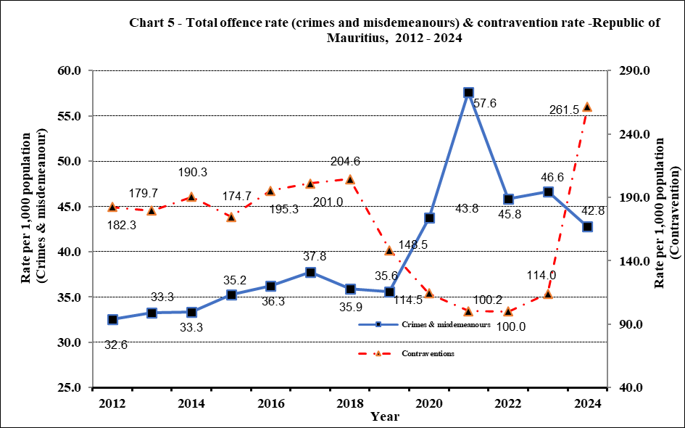

Conviction rate (excluding contraventions)

In 2014, the conviction rate per 1,000 population stood at 20.7 (Chart 6). It increased to 22.8 in 2015 followed by a gradual decrease from 2015 to 2019 reaching 19.2. Thereafter, the rate dropped to 13.5, due to the fact that courts were closed during the COVID 19 pandemic. A sharp increase followed in 2021 and peaked at 24.8 in 2022. The rate then declined again to 18.0 in 2024.

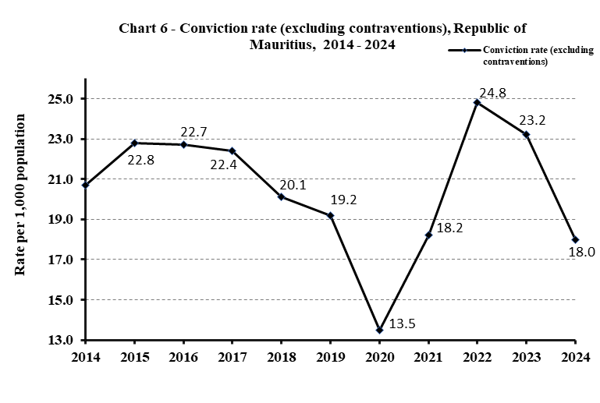

Imprisonment rate

From 2010 to 2012, the imprisonment rate per 100,000 mid-year population showed an increasing trend to reach 214.2 in 2012 (Chart 7). It then declined gradually to 169.0 in 2015 but rose again during the period 2016 to 2019 and declining again during the period 2020 to 2023. However, the rate for 2024 (210.2) is higher than in 2023 (196.6).

- Notes to Users

Release of data on Crime, Justice and Security statistics

This indicator is released on a yearly basis according to an advance release calendar posted on the website of Statistics Mauritius
(http://statsmauritius.govmu.org/English/Publications/Pages/Publication-Programme.aspx).

More information on Crime, Justice and Security statistics can be obtained from the website of Statistics Mauritius on the fol. URL:
https://statsmauritius.govmu.org/Pages/Statistics/By_Subject/CJS/SB_CJS.aspx

Specific information on:
Judiciary can be accessed at: https://supremecourt.govmu.org
Prisons can be accessed at: http://prisons.govmu.org/English/Pages/default.aspx

Caution to users

The following points should be recalled when drawing any conclusions from the figures in this publication:

- When comparing figures, it should be realised that police and judiciary figures are based on offences but prison and probation figures are based on offenders, and that an offender can be sentenced for more than one offence.

- Offences can sometimes be reclassified, usually as less serious, as they proceed from police investigation through prosecution to final court sentence. This is usually due to evidence not being as robust as at first thought or more evidence coming to light following the initial report.

- The trends in offences like drug offences and road traffic contraventions should be interpreted with caution since they may be subject to fluctuations as a result of sensitisation/awareness campaigns and intelligence-led operations. For example, the Road Traffic Act has been amended in August 2018.

- Police statistics are often better indicators of prevalence of law and willingness to report offences than actual prevalence. Therefore, surveys on the experience of victimization from the public together with the data from the reported cases can give a more comprehensive picture on the actual number of victims.

- Care should be taken while comparing statistics on the number of cases lodged and disposed of over time. Cases lodged in Court are more directly comparable. However, cases disposed of are not comparable, given that these cases might have been lodged during the reference year or any year before.

List of tables (Annex 1)

Table A1.1: Cases reported and offence rate per 1,000 population by type, Republic of Mauritius, 2023 & 2024
Table A1.2: Reported offences and rate per 100,000 population by offence, Republic of Mauritius, 2023 & 2024
Table A1.3: Road traffic contraventions, Republic of Mauritius, 2023 & 2024
Table A1.4: Persons suspected, arrested and/or cautioned by type of offence, Republic of Mauritius, 2023 & 2024
Table A1.5: Persons prosecuted by type of offence, Republic of Mauritius, 2023 & 2024
Table A1.6: Offences involving juveniles reported by type, category and sex, Republic of Mauritius, 2023 & 2024
Table A1.7: Victims of selected offences by socio-demographic and other characteristics, Republic of Mauritius, 2023 & 2024
Table A1.8: Number of civil and criminal cases, Republic of Mauritius, 2023 & 2024
Table A1.9: Convicted offences involving adults and juveniles by outcome of judgment and offence, Republic of Mauritius, 2023 & 2024
Table A1.10: Daily average and admission of detainees for adults and Juveniles, Republic of Mauritius, 2023 & 2024
Table A1.11: Convicts admission rate by age-group and sex, Republic of Mauritius, 2023 & 2024
Table A1.12: Fine defaulters admitted to prisons by amount of fine due, Republic of Mauritius, 2023 & 2024
Table A1.13: Admission of convicts to prisons by offence and length of sentence, Republic of Mauritius, 2023 & 2024

Contacts

For further information, please contact:

- Mr J.A. Laloo, Statistician/ Senior Statistician

- Ms H. Murdan, Statistical Officer /Senior Statistical Officer (Police)

- Mr V. Sewnundun, Statistical Officer /Senior Statistical Officer (Police)

- Ms J. Nuckchady, Statistical Officer /Senior Statistical Officer (Prison/ Probation)

- Ms. V. Busgeeth, Statistical Officer/Senior Statistical Officer (Judiciary)
- Ms H. Bausram, Statistical Officer/Senior Statistical Officer (ODPP)

Office address : Statistics Mauritius, L.I.C Centre, Port-Louis

Email : jlaloo@govmu.org

smurdan@govmu.org

vsewnundun@govmu.org

vbusgeeth@govmu.org

sm-cjs@govmu.org

Tel: (230) 213-0710 (Police)
: (230) 213-3055 (Judiciary)
: (230) 401-6600 ext 6694 (Prison)
: (230) 465-1156 (Probation)
: (230) 405-5673 ext 116 (ODPP)

Statistics Mauritius
Ministry of Finance
Port Louis
27 June 2025

Annex 3
GLOSSARY
- Absolute discharge is complete and unconditional release.
- Acts against liberty is taking away or limiting the movement or liberty of a person.
- Admission rate is defined as the number of people admitted to prison in a given year per 100,000 mid-year population.
- Assault is defined as intentional or reckless application of physical force inflicted upon the body of a person.
- Acquitted means dismissed.
- Burglary is defined as unlawful entry into someone else’s premises with the intention to commit a theft.
- Cases to the police are:
- either offences punishable by law such as crimes (which are punishable by penal servitude and/or a fine exceeding Rs 10,000), misdemeanours (which are punishable by imprisonment for a term exceeding 30 days and/or a fine exceeding Rs 10,000) and contraventions (which are punishable by imprisonment for a term not exceeding 30 days and/or a fine not exceeding Rs 10,000),
- or relate to other occurrences such as accidental deaths, accidental fires, suicides or attempted suicides and street accidents.
- Children’s Act 2020
The Children’s Act received presidential assent in December 2020 and was proclaimed on 24 January 2022. The Act caters for

- children in need of assistance, care and protection
- child offenders
- child victims and witnesses

The first category includes ‘children with serious behavioural concerns’, while the second category can be split into two types:
(a) child suspects under the age of criminal responsibility i.e below the age of 14, and
(b) juvenile offenders aged 14 or above but below the age of 18.

Children with serious behavioural concerns and child offenders are under the responsibility of the Probation and After Care Service.

- Child Assessment
Every child alleged to have committed an offence is required to undergo an assessment by a probation officer.
- Coercion is demanding a particular course of action through the use of force, threat intimidation, threat to reveal compromising information, or threat of defamation.

- Community Service Order is a sentence requiring an offender to perform unpaid community work in lieu of imprisonment or non-payment of fines.

- Conditional discharge is a sentence whereby an offender is released under certain conditions, e.g. to be of good behaviour for a specified period of time.

Contraventions (least serious offences) are defined as offences that are punishable by:
  - imprisonment for a term not exceeding 30 days;

  - fine not exceeding 10,000 rupees.

- Cost of detainee is based on the recurrent expenditure of the prisons, the social aid granted to the detainees’ ward(s) and the value of labour contribution of detainees to the prisons’ workshops.

- Crimes (most serious offences) are defined as offences that are punishable by:
  - penal servitude;

  - fine exceeding 10,000 rupees.

- Criminal case is a case dealing with an offender indicted for an offence.
- Cumulative Road Traffic Offences (CRTO)
Cumulative Road Traffic Offence (CRTO) means an offence stipulated in the third Schedule of the Road Traffic Act (Sect 123 AG of RTA).
  - Where a person is convicted on a fourth occasion for one or more offences specified in the third schedule and those offences committed within a period of 24 months, the Court shall disqualify him/her from holding or obtaining a driving license for all classes of motor vehicles for a period of not less than 6 months nor more than 12 months.
  - Whereas when a person is convicted on a second occasion for a Cumulative Road Traffic Offence (CRTO) within a period of 24 months, the Licensing Officer shall inform that person by way of a Notice that he/she has been convicted two times for a CRTO.

- Fines for exceeding speed
As per the Road Traffic (Amendment) Act 2018 (Act No. 12 of 2018), with effect from 01 October 2018, a new graduated scale of fines for exceeding speed limits was introduced as follows:
  - fine of Rs 2,500 for exceeding the speed limit by not more than 15 km per hour;
  - fine of Rs 5,000 for exceeding the speed limit by more than 15 but not more than 25 km per hour and
  - fine of Rs 10,000 for driving at a speed exceeding the authorised speed limit by more than 25 km per hour.

- Dangerous acts are bodily harm or potential for bodily harm caused by a person’s dangerous behaviour or act carried out with the knowledge that the act has potential to cause harm.
- Detainee is referred to as any person confined to prison and is classified as follows:
  - Convict: person sentenced to imprisonment.
  - Person on remand and trial: person charged for an offence with a court of law and awaiting judgment.
- Drug offences are as spelt out under the Dangerous Drug Act 2000. They relate mainly to drugs like gandia, heroin, hashish, opium, cocaine and other psychotropic substances.
- Embezzlement is defined as the wrongful appropriation of another person’s property that is already in the possession of the person doing the appropriating.
- Fine defaulters are convicts sentenced to imprisonment for non-payment of fines; they either stay in prison for a specified period, benefit from a community service order or are released as soon as they pay the fines.
- Forgery/counterfeiting is creating, manufacturing, selling, passing or possessing a false imitation of goods, or an instrument to create a false imitation of goods.
- Fraud is defined as the acquisition of another person’s property by deception.
- Illegal feticide is defined as unlawful death of a foetus intentionally procured or conducted by a person.
- Intellectual property offences are unlawful copying, using, reproducing or other infringements of copyrights, patents, trademarks or other intellectual property.

- Intentional homicide is defined as unlawful death inflicted upon a person with the intent to cause death.
- Investigation and prosecution
On completion of police enquiries/investigations, cases are taken to court for prosecution either as decided by Police or upon the advice of the Director of Public Prosecutions (DPP). However, for some cases, prosecution does not follow for the following reasons: (a) false or doubtful complaint, (b) no offence committed (c) trifling cases, (d) accused unknown, (e) accused absconded, (f) evidence insufficient, (g) accused dead or insane, (h) caution administered, (i) no further action as advised by the DPP.
- Juvenile is defined as person aged below 18 years.
- Juvenile delinquency rate is defined as the number of juvenile offenders involved in offences (excluding contraventions) per 1,000 juvenile population.
- Minor assault is intentional or reckless application of minor physical force inflicted upon the body of a person resulting in no injury or minor bodily injury.

Misdemeanours (less serious offences) are defined as offences that are punishable by:
  - imprisonment for a term exceeding 30 days;

  - fine exceeding 10,000 rupees.

- Murder is unlawful death inflicted upon a person with the intent to cause death or serious injury, including when premeditated and/or with malice aforethought.
- Negligence is defined as bodily harm or potential for bodily harm from a person’s negligent, reckless or careless behaviour.
- Non-adjudicated is the formal withdrawal of charge(s) by the Police, Director of Public Prosecutions or Attorney-General or by the courts; it includes nolle prosequi and struck out.
- Non-injurious traffic violations is the criminal acts under the traffic code and traffic regulations by a person that do not result in injury or death.
- Non-intentional homicide is unlawful death unintentionally inflicted upon a person by another person.
- Parenting Support intervention (PSI)
A parental support intervention is conducted by a probation officer in cases involving a child with serious behavioural concerns, with the aim of assisting the parents in managing the child's behaviour effectively.
- Prison occupancy level is defined as the prison population divided by the prison capacity (number of beds).
- Probation order is a sentence whereby an offender is placed under the supervision of a probation officer for a period not less than one nor more than three years.
- Property damage is willful destruction, damage or defacement of property.
- Robbery is defined as the theft of property from a person, overcoming resistance by force or threat of force.
- Serious assault is defined as intentional or reckless application of serious physical force inflicted upon the body of a person resulting in serious bodily injury.
- Sexual violence is defined as unwanted sexual act, attempt to obtain a sexual act, or contact or communication with unwanted sexual attention without valid consent or with consent as a result of intimidation, force, fraud, coercion, threat, deception, use of drugs or alcohol, or abuse of power or of a position of vulnerability.
- Sexual exploitation is defined as acts of abuse of a position of vulnerability, power or trust, or use of force or threat of force, for profiting financially, physically, socially or politically from the prostitution or sexual acts of a person.
- Theft is defined as unlawfully taking or obtaining of property with the intent to permanently withhold it from a person or organization without consent and without the use of force, threat of force or violence, coercion or deception.
- Victim is referred to as a person who has been affected by an offence committed by another person.

Annex 4
General Structure of International Classification of Crime for Statistical Purposes (ICCS) Version 1.0
Section 01 Acts leading to death or intending to cause death
0101 | Intentional homicide
0102 | Attempted intentional homicide
0103 | Non-intentional homicide
0104 | Assisting or instigating suicide
0105 | Euthanasia
0106 | Illegal feticide
0107 | Unlawful killing associated with armed conflict
0109 | Other acts leading to death or intending to cause death
Section 02 Acts causing harm or intending to cause harm to the person
0201 | Assaults and threats
 |  | 02011 Assault
 |  |  |  | 020111 Serious assault
 |  |  |  | 020112 Minor assault
 |  | 02012 Threat
 |  | 02019 Other assaults or threats
0202 | Acts against liberty
0203 | Slavery and exploitation
0204 | Trafficking in persons (TIP)
0205 | Coercion
0206 | Negligence
 |  | 02063 Making use of cellular phone whilst driving
0207 | Dangerous acts
 |  | 020721 Driving motor vehicle with alcohol concentration above prescribed limit
0208 | Acts intended to induce fear or emotional distress
0209 | Defamation or insult
0210 | Discrimination
0211 | Acts that trespass against the person
0219 | Other acts causing harm or intending to cause harm to the person
Section 03 Injurious acts of a sexual nature
0301 | Sexual violence
 |  | 03011 Rape
 |  | 03019 Sodomy
0302 | Sexual exploitation
0309 | Other injurious acts of a sexual nature
Section 04 Acts against property involving violence or threat against a person
0401 | Robbery
0409 | Other acts against property involving violence or threat against a person
Section 05 Acts against property only
0501 | Burglary
0502 | Theft
050211 Theft of a motorized land vehicle (Larceny of motor vehicles)
050229 Other theft of personal property (e.g. simple larcenies)
 | Intellectual property offences
0504 | Property damage
0509 | Other acts against property only
Section 06 Acts involving controlled drugs or other psychoactive substances
0601 | Unlawful acts involving controlled drugs or precursors
0602 | Unlawful acts involving alcohol, tobacco or other controlled substances
0609 | Other acts involving controlled drugs or other psychoactive substances
Section 07 Acts involving fraud, deception or corruption
0701 | Fraud
0702 | Forgery/counterfeiting
0703 | Corruption
 |  |  | 07031 Bribery by public official
 |  |  | 07031 Bribery of public official
0704 | Acts involving the proceeds of crime
0709 | Other acts involving fraud, deception or corruption
Section 08 Acts against public order, authority and provisions of the State
0801 | Acts against public order behavioural standards
0802 | Acts against public order sexual standards
0803 | Acts related to freedom of expression or control of expression
0804 | Acts contrary to public revenue or regulatory provisions
0805 | Acts related to migration
0806 | Acts against the justice system
0807 | Acts related to democratic elections
0808 | Acts contrary to labour law
0809 | Other acts against public order, authority and provisions of the State
Section 09 Acts against public safety and state security
0901 | Acts involving weapons, explosives and other destructive materials
0902 | Acts against health and safety
0903 | Acts against computer systems
0904 | Acts against state security
0905 | Acts related to an organized criminal group
0906 | Terrorism
0907 | Non-injurious traffic violations
0907 | Speeding
0907 | Failing to wear seat belt whilst driving
0907 | Driving without licence
0907 | Protective helmet improperly secured
0909 | Other acts against public safety and state security
Section 10 Acts against the natural environment
1001 | Acts that cause environmental pollution or degradation
1002 | Acts involving the movement or dumping of waste
1003 | Trade or possession of protected or prohibited species of fauna and flora
1004 | Acts that result in the depletion or degradation of natural resources
1009 | Other acts against the natural environment
Section 11 Other criminal acts not elsewhere classified
1101 | Acts under universal jurisdiction
1102 | Acts contrary to youth regulations and acts on minors
1109 | Other criminal acts not elsewhere classified

