Quarterly Index of Industrial Production (QIIP)
First Quarter 2025
(Base year: 2018 =100)

1. Introduction
The Index of Industrial Production shows the evolution of the volume of output of the Industrial Sector, which covers “Mining and quarrying”, “Manufacturing”, “Electricity, gas, steam and air conditioning supply” and “Water supply; sewerage, waste management and remediation activities”. The value added of these activities accounts for around 15% of Gross Value Added (GVA). The index compiled on a quarterly basis is one of the most important industrial short-term indicators, which aims at measuring, on a quarterly basis, the changes in the volume of industrial output.
2. Contents of publication
This issue of “Economic and Social Indicators” presents the quarterly indices for the first quarter of 2019 to the first quarter of 2025.
The indices are given separately for the four sections, namely, “Mining and quarrying”, “Manufacturing”, “Electricity, gas, steam and air conditioning supply” and “Water supply; sewerage, waste management and remediation activities”. Within “Manufacturing”, estimates by broad group, namely “Export Oriented Enterprises” (EOE), “Non-EOE” and “Sugar milling” as well as by main industry group are given. Wherever possible, the annual averages of the quarterly indices have been worked out and included in the tables. It is to be noted that, due to incomplete data, indices for the first quarter of 2025 are provisional and published at section and broad group level only. They are therefore subject to revision in future issues of the Economic and Social Indicators on QIIP.
The published indices are not seasonally adjusted. The user is therefore advised to base comparisons for a particular quarter of a year on the corresponding quarter of the previous year.
The methodology used for the computation of QIIP including its limitations, are given at Annex.
3. Overall index - Industrial Sector
In the first quarter of 2025, the overall index of industrial production decreased by 18.3% compared to the previous quarter and grew by 2.6% when compared to the corresponding quarter of 2024.
The index for the year ending first quarter 2025, which is the average of quarterly indices for the period under review, grew by 1.9%. This is explained by expansions in “Electricity, gas, steam and air conditioning supply” (+4.4%), “Water supply; sewerage, waste management and remediation activities” (+1.9%) and “Manufacturing” (+1.6%).

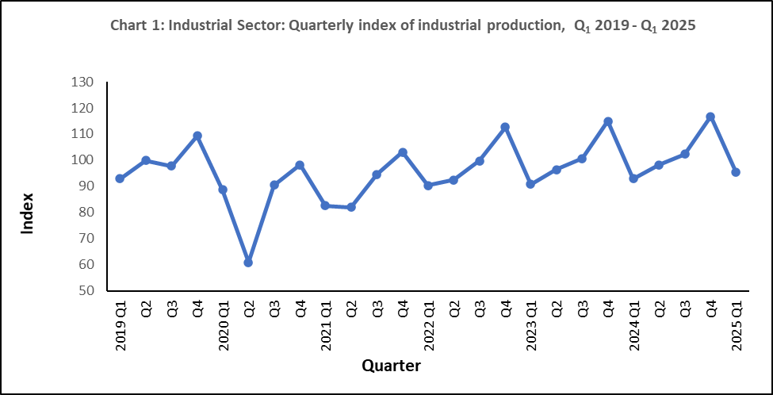

4. Changes by section

4.1 Mining and quarrying

“Mining and quarrying” comprise activities relating to quarrying of decorative stones, sand and salt extraction as well as stone crushing and represents only 2% of the output of the industrial sector. In the first quarter of 2025, real output decreased by 17.8% compared to the previous quarter but increased by 2.2% compared to the corresponding quarter of 2024. In year ending first quarter 2025, a growth of 7.3% was noted (Table 1).

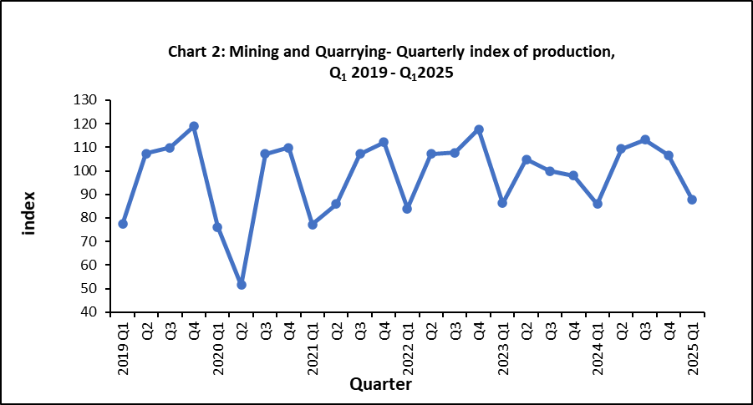

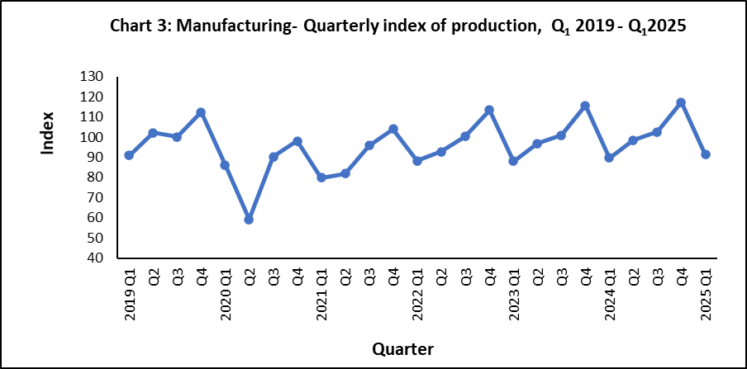
4.2 Manufacturing
Manufacturing output, which covers the production of a wide range of goods, represented 85% of the output of the industrial sector in 2018. For analysis purposes, “Manufacturing” is broken down into the following broad groups:
- Sugar milling representing 1.3% of manufacturing output
- EOE (40%)
- Non–EOE (59%)
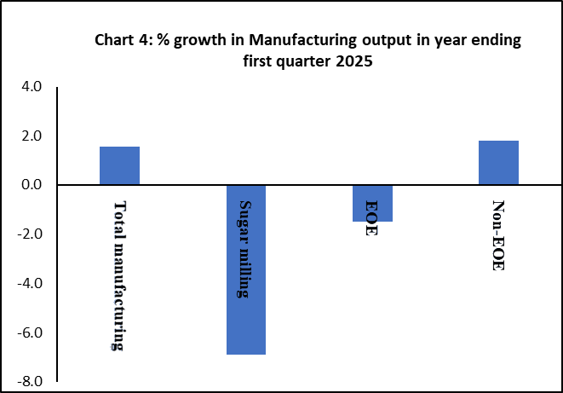
Manufacturing output in the first quarter of 2025 decline by 22.2% compared to the previous quarter and increased by 1.8% compared to the corresponding quarter of 2024 (Table 1). In year ending first quarter 2025, a growth of 1.6% was noted in real manufacturing output. This is due to a positive growth in “Non-EOE” (+1.8%) partly offset by negative growths in “EOE” (-1.5%) and “Sugar milling” (-6.9%). The performances of “EOE” and “Non-EOE” by detailed industry group up to fourth quarter 2024 are analysed separately in Section 5.

4.3 Electricity, gas, steam and air conditioning supply
“Electricity, gas, steam and air conditioning supply” accounts for 10.5% of the output of the industrial sector. In the first quarter of 2025, real output of this sector grew by 16.9% compared to the previous quarter and by 8.9% compared to the corresponding quarter of 2024. In year ending first quarter 2025, production grew by 4.4% (Table 1).
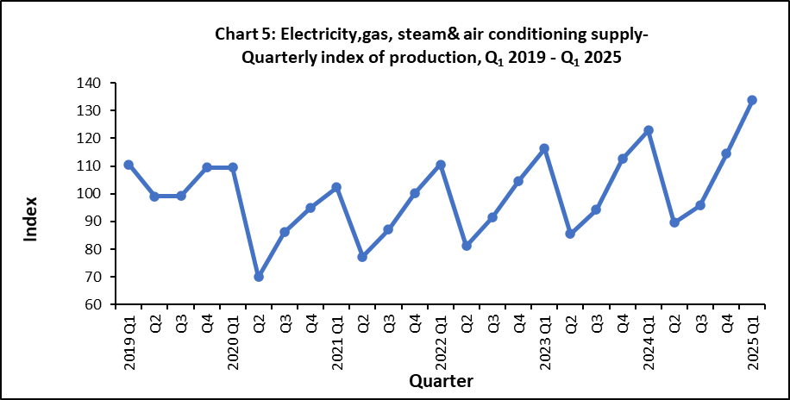

4.4 Water supply; sewerage, waste management and remediation activities
“Water supply; sewerage, waste management and remediation activities” accounts for around 2.4% of the output of the industrial sector. In the first quarter of 2025, real output of this sector decreased by 0.3% compared to the previous quarter but increased by 0.1% when compared to the corresponding quarter of 2024. In year ending first quarter 2025, real output went up by 1.9% (Table 1).

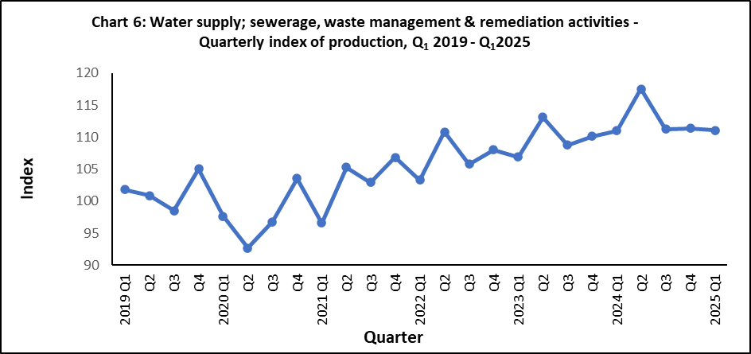

5. Changes by broad group
5.1 Export Oriented Enterprises (EOE)
Real output of EOE sector contracted by 11.5% in the first quarter of 2025 compared to the previous quarter and by 2.5% compared to the corresponding quarter of 2024. In year ending first quarter 2025, the EOE sector decreased by 1.5% (Table 1).

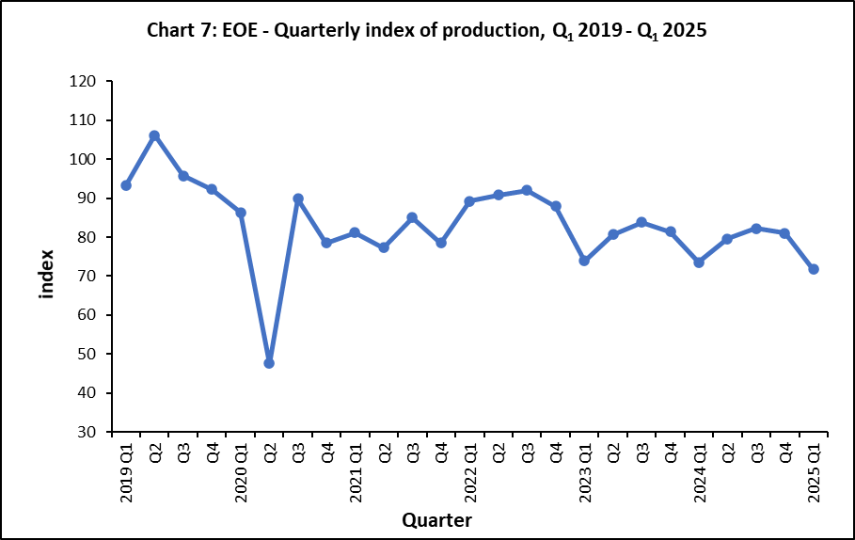

Lower-level indices for the first quarter of 2025 are not yet available. However, an indication of the annual performance at sub-group levels can be obtained by comparing indices available for year 2024 to those for year 2023 (Table 3). Real output of “Wearing apparel”, the most important industry group within the EOE, declined by 13.2% but “Textiles” grew by 5.9%. These two sub-groups account for almost 63% of the total weight allocated to the EOE. Furthermore, positive growths were noted in “Other manufacturing” (+12.4%) and “Computer, electronic and optical products” (+1.2%) partly offset by negative growths in “Food products” (-4.6%) and “Jewellery, bijouterie & related articles n.e.c” (-41.4%). Details of changes of selected sub-groups are shown in Chart 8.
Year and quarter

5.2 Non-EOE excluding “Sugar milling”
Chart 6
In the first quarter of 2025, the real output of Non-EOE sector went down by 24.8% compared to the previous quarter and grew by 3.0% when compared to the corresponding quarter of 2024. In year ending first quarter 2025, it grew by 1.8% (Table 1).
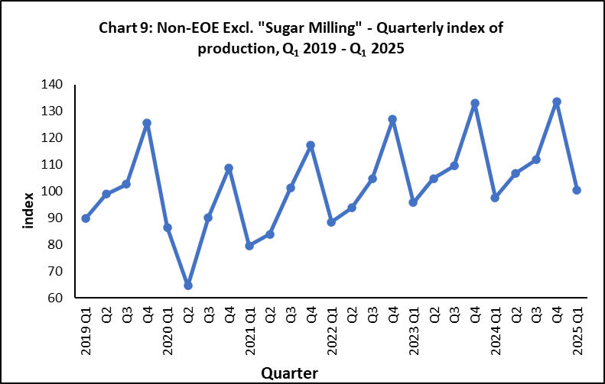

The annual performance at sub-group level is obtained by comparing the detailed indices available for year 2024 to those for year 2023 (Table 4). Expansions were noted in “Beverages” (+8.0%), “Plastic and non-metallic product” (+7.1%), “Furniture” (+4.4%), “Chemicals & chemical products” (+6.1%), “Basic metals and fabricated metal products” (+4.8%), and “Printing and reproduction of recorded media” (+3.0%), while negative growths were noted in “Food products excluding sugar” (-2.0%), “Textiles & wearing apparel” (-8.7%), and “Other manufacturing” (-5.2%) as illustrated in Chart 10.

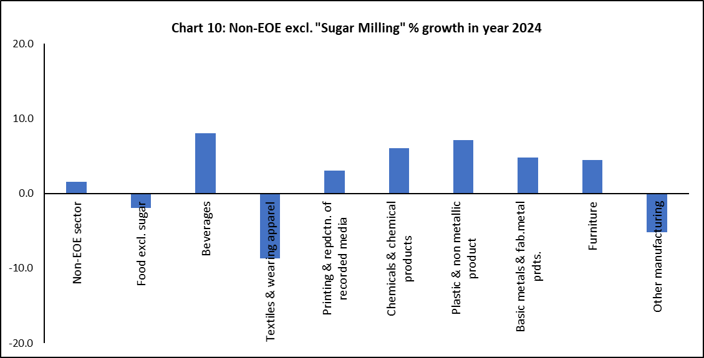

Statistics Mauritius
Ministry of Finance
PORT LOUIS
20 June 2025

Contact Persons:
Mrs. V. Rama - Lahootan (Statistician/Senior Statistician)
Manufacturing Unit
Statistics Mauritius
5th Floor LIC Building
Port Louis
Tel. (+230) 208 1800
E-mail : sm-qiip@govmu.org

