**INTERNATIONAL TRAVEL AND TOURISM**

**1st Quarter 2025**

1. **INTRODUCTION**

This issue of the Economic and Social Indicators presents data on International Travel and Tourism for the first quarter of 2025. A brief on the compilation of these statistics is given at Annex I and a glossary of terms at Annex II.

1. **INTERNATIONAL TRAVEL**

**Passenger traffic, 1st Quarter, 2024 and 2025**

|  |  |  |  |  |
| --- | --- | --- | --- | --- |
|  | | **1st Quarter 2024** | **1st Quarter 2025 1** | **% Change** |
| Arrivals by | |  |  |  |
|  | Air | 445,224 | 443,560 | -0.4 |
|  | Sea | 43,825 | 43,024 | -1.8 |
|  | *of which cruise travellers* | *41,560* | *41,299* | *-0.6* |
| **Total** |  | **489,049** | **486,584** | **-0.5** |
| Departures by | |  |  |  |
|  | Air | 463,986 | 463,014 | -0.2 |
|  | Sea | 44,283 | 42,339 | -4.4 |
| **Total** |  | **508,269** | **505,353** | **-0.6** |

*1 Provisional*

* 1. **Arrivals in 1st Quarter 2025**

Compared to 1st Quarter 2024:

1. total passenger arrivals decreased by 0.5% from 489,049 to 486,584;
2. total tourist arrivals decreased by 5.8% from 346,562 to 326,389; those arriving by air decreased by 3.6% from 328,477 to 316,604 and those arriving by sea decreased by 45.9% from 18,085 to 9,785 (Table 6b). Among those arriving by sea, 8,309 were cruise tourists compared to 16,857, representing a decline of 50.7%.
3. the number of excursionists (arriving and leaving on the same day) increased by 59.0% from 15,002 to 23,854.

In the first quarter of 2025, 20 cruise ships arrived in the country and carried some 41,299 cruise travellers comprising 8,309 tourists, 19,063 excursionists, 190 Mauritian residents and 13,737 crew members.

* 1. **Departures in 1st Quarter 2025**

Compared to 1st Quarter 2024:

1. total passenger departures decreased by 0.6% from 508,269 to 505,353 and
2. departures of Mauritian residents rose by 6.8% from 76,645 to 81,866 (Table 2).

Comparative figures for the first quarters of 2024 and 2025 for Mauritian departures by main country of disembarkation are given in Figure 1 and Table 2. In the first quarter of 2025, the main countries of disembarkation (country of final destination or transit country) for Mauritian residents were United Arab Emirates (19,016 or 23.2%), India (15,015 or 18.3%), Reunion Island (9,878 or 12.1%), France (7,246 or 8.9%), Republic of South Africa (6,994 or 8.5%) and United Kingdom (4,676 or 5.7%).

**Figure 1 - Mauritian departures by main country of disembarkation,**

**1st Quarter 2024 and 1st Quarter 2025**



1. **TOURISM**

**Figure 2 –Main tourism indicators, 1st Quarter 2024 and 1st Quarter 2025**



* 1. **Tourist arrivals in 1st Quarter 2025**

Compared to the first quarter of 2024, tourist arrivals decreased by 20,173 (-5.8%) to reach 326,389 in first quarter 2025 as a result of main changes in tourist arrivals from selected markets as shown in Figure 3.

**Figure 3 – Main changes in tourist arrivals by selected country of residence,**

**1st Quarter 2025 compared to 1st Quarter 2024**

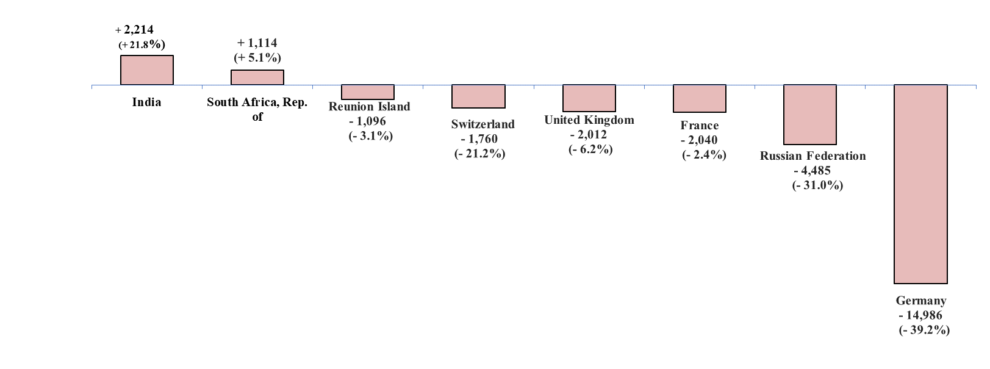

Compared to the first quarter of 2024, tourist arrivals from France, our top tourist generating country, decreased by 2,040 from 85,024 to 82,984. Among the main markets, increases were observed for India (+2,214 or +21.8%) and Republic of South Africa (+1,114 or +5.1%) while decreases were observed in the other selected markets as follows:

Germany (-14,986 or -39.2%), Russian Federation (-4,485 or -31.0%), United Kingdom (-2,012 or -6.2%), Switzerland (-1,760 or -21.2%) and Reunion Island (-1,096 or -3.1%).

**Figure 4 – Tourist arrivals from top ten markets, 1st Quarter 2024 and 1st Quarter 2025**



* 1. **Tourist arrivals by age group**

During the period under review, the number of tourists aged 60 years and above was 67,113 representing 20.6% of tourist arrivals. Among those who arrived by sea, the proportion was much higher at 39.6%

(Table 6b).

**Figure 5 - Tourist arrivals by age group, 1st Quarter 2025**



* 1. **Tourist arrivals by air and by main port of last embarkation for selected markets**

From Table 7, it is observed that during the first quarter of 2025, tourists from United Kingdom (65.6%), France (61.4%), Switzerland (57.2%) and Germany (53.1%) arrived mainly by direct flights from their own country of residence. Tourists from Russian Federation, People’s Republic of China and Netherlands travelled mainly through United Arab Emirates which was the most used transiting port. For the period under review, the proportion of tourists from Russian Federation, People’s Republic of China and Netherlands who travelled to Mauritius through United Arab Emirates were 84.3%, 58.9% and 48.9% respectively.

**3.4 Tourist arrivals - Selected tourist destinations in the Indian Ocean region**

Compared to the first quarter of 2024, tourist arrivals in Mauritius during the first quarter of 2025 decreased by 5.8% from 346,562 to 326,389 while increases in tourist arrivals were noted for the following tourist destinations in the Indian Ocean region:

Sri Lanka (from 635,784 to 722,276 or +13.6%), Maldives (from 604,004 to 632,424 or +4.7%) and Seychelles (from 97,517 to 97,798 or +0.3%).

**Figure 6 - Tourist arrivals for Mauritius, Maldives, Sri Lanka & Seychelles,**

**1st Quarter 2024 and 1st Quarter 2025**

*Source: Ministry of Tourism, Republic of Maldives; Sri Lanka Tourism Development Authority; Seychelles National Bureau of Statistics*

* 1. **Tourist Nights**

Compared to 1st Quarter 2024:

* the number of nights spent by tourists who departed during the first quarter of 2025 decreased by 3.6% from 4,236,631 to 4,083,079; and
* the average length of stay decreased from 11.9 to 11.7 nights (Table 8).
  1. **Employment**

Employment data for the tourism sector obtained from the Survey of Employment and Earnings, relate to employment in food service, hotels and travel and other services establishments with 10 or more workers. Latest available data for March 2024 indicate that employment in these establishments increased by 1.5% to 28,445 as compared to 28,014 for March 2023 (Table 11).

* 1. **Accommodation**

1. Licensed hotels in the Island of Mauritius

As at end of March 2025, there were 111 licensed hotels of which one was temporarily closed. The total room capacity of the 110 hotels in operation was 14,059 with 31,486 bed places (Table 9).

During the 1st Quarter 2025,

* the room occupancy rate of all licensed hotels in operation averaged 68%, lower compared to 69% in first quarter 2024; and
* the bed occupancy rate was 61%, lower compared to 62% in first quarter 2024 (Table 10).

1. ‘Large’ hotels in the Island of Mauritius

At the end of March 2025, there were 61 ‘large’ hotels (i.e. well-established beach hotels with more than 80 rooms) in operation. The total room capacity of these 61 ‘large’ hotels was 11,331 with 25,750 bed places. These ‘large’ hotels represent 55% of all licensed hotels in operation but comprise 81% of total room capacity and 82% of total bed places (Table 9).

During the 1st Quarter 2025,

* the room occupancy rate of ‘large’ hotels was 70%, lower than the 71% registered in first quarter 2024; and
* the bed occupancy rate was 63% lower than the 64% recorded in first quarter 2024 (Table 10).

**Statistics Mauritius**

**Ministry of Finance**

**Port Louis**

**30 May 2025**

**Contact persons**

Mrs. T. Joomun, Statistician/Senior Statistician

Mrs. M. Koolwant-Beesoondoyal, Statistical Officer/

Senior Statistical Officer

Statistics Mauritius

LIC Centre, John Kennedy Street, Port Louis

Tel: (230) 208 1800, Fax: (230) 211 4150

Email: sm-tourism@govmu.org

### ***ANNEX I***

### **COMPILATION OF PASSENGER TRAFFIC STATISTICS**

### **Sources of data**

The main source of data for the compilation of passenger traffic statistics is the Passport and Immigration Office, which maintains a database of all travellers entering and leaving the country. The data are collected from the passport of travellers, disembarkation cards filled in by non-residents and questions put to non-residents entering the country. At the end of every month, the electronic database of passenger traffic for that particular month is downloaded and supplied to the statistics unit of the Ministry of Tourism within ten days. Additional data on cruises are obtained from the Mauritius Ports Authority.

### **Tourism earnings**

The Bank of Mauritius (BoM) is responsible for the estimation of tourism earnings based on monthly statements of Inward and Outward Remittances of Commercial Banks. As from 2015, BoM is also including data culled from Money changers and Foreign exchange dealers.

### **Monthly Occupancy Rates**

Survey questionnaires are emailed to all hotels at the end of every month to collect data on room/bed nights available and rented during the month for the calculation of room and bed occupancy rates. Non-responses are contacted by phone.

### **Short-term projections of tourist arrivals**

A Tourism Statistics Committee grouping various stakeholders of the tourism industry meet regularly under the chairmanship of Statistics Mauritius to discuss performance of the tourism sector and to provide information for short-term forecast of tourist arrivals.

### **Publications**

The regular publications of the unit are:

1. Monthly tourist arrivals uploaded on Statistics Mauritius website
2. Fortnightly tourist arrivals uploaded on Statistics Mauritius website
3. Quarterly Economic and Social Indicators on International Travel and Tourism (with a lag of seven weeks)
4. Yearly Digest of International Travel and Tourism
5. Yearly Handbook of statistical data on tourism
6. Report of the Survey of Inbound Tourism

***ANNEX II***

# GLOSSARY OF TERMS

**1. Tourist**

A tourist is defined as a non-resident staying overnight but less than a year, and who has no employer-employee relationship with a resident.

**2. Transit**

A transit passenger is one who stops over in the country for flight connections to other destinations. There are two types of transit passengers:

***Type I***: Passengers who do not leave the transit area of the airport or the harbour.

***Type II***: Passengers who do leave the airport or harbour and stay in the country overnight but only for flight connection purposes.

Only Type II transit passengers, as defined above, are included in the definition of “Tourists”.

**3. Excursionist or same-day Visitor**

Excursionists are non-resident visitors, other than those who do not leave the airport, who depart on the same day they arrived.

**4. Tourist nights**

"Tourist nights" for year Y refer to nights spent by tourists who departed in year Y.

**5. Large hotels**

Large hotels are well established beach hotels with more than 80 rooms.

**6. Occupancy rate**

The room/bed occupancy rate is the ratio of room/bed nights rented to the total number of room/bed nights available.

= Total number of room/bed nights rented x 100

### Total number of room/bed nights available