Quarterly Index of Industrial Production (QIIP)
Fourth Quarter 2024
(Base year: 2018 =100)

1. Introduction
The Index of Industrial Production shows the evolution of the volume of output of the Industrial Sector, which covers “Mining and quarrying”, “Manufacturing”, “Electricity, gas, steam and air conditioning supply” and “Water supply; sewerage, waste management and remediation activities”. The value added of these activities accounts for around 15% of Gross Value Added (GVA). The index compiled on a quarterly basis is one of the most important industrial short-term indicators, which aims at measuring, on a quarterly basis, the changes in the volume of industrial output.
2. Contents of publication
This issue of “Economic and Social Indicators” presents the quarterly indices for the first quarter of 2019 to the fourth quarter of 2024.
The indices are given separately for the four sections, namely, “Mining and quarrying”, “Manufacturing”, “Electricity, gas, steam and air conditioning supply” and “Water supply; sewerage, waste management and remediation activities”. Within “Manufacturing”, estimates by broad group, namely “Export Oriented Enterprises” (EOE), “Non-EOE” and “Sugar milling” as well as by main industry group are given. Wherever possible, the annual averages of the quarterly indices have been worked out and included in the tables. It is to be noted that, due to incomplete data, indices for the fourth quarter of 2024 are provisional and published at section and broad group level only. They are therefore subject to revision in future issues of the Economic and Social Indicators on QIIP.
The published indices are not seasonally adjusted. The user is therefore advised to base comparisons for a particular quarter of a year on the corresponding quarter of the previous year.
The methodology used for the computation of QIIP including its limitations, are given at Annex.
3. Overall index - Industrial Sector
In the fourth quarter of 2024, the overall index of industrial production increased by 14.1% compared to the previous quarter and by 1.5% when compared to the corresponding quarter of 2023.
The index for the year 2024, which is the average of quarterly indices for the period under review, grew by 1.8%. This is explained by expansions in “Electricity, gas, steam and air conditioning supply” (+3.4%), “Manufacturing” (+1.5%) and “Water supply; sewerage, waste management and remediation activities” (+2.8%).

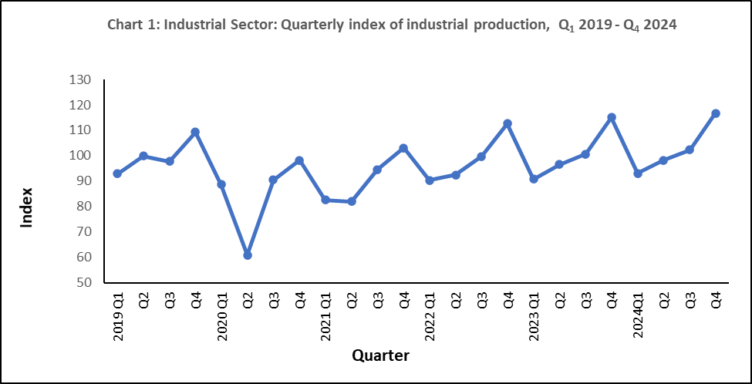

4. Changes by section

4.1 Mining and quarrying

“Mining and quarrying” comprise activities relating to quarrying of decorative stones, sand and salt extraction as well as stone crushing and represents only 2% of the output of the industrial sector. In the fourth quarter of 2024, real output decreased by 5.7% compared to the previous quarter but increased by 9.0% compared to the corresponding quarter of 2023. In year 2024, a growth of 6.8% was noted (Table 1).

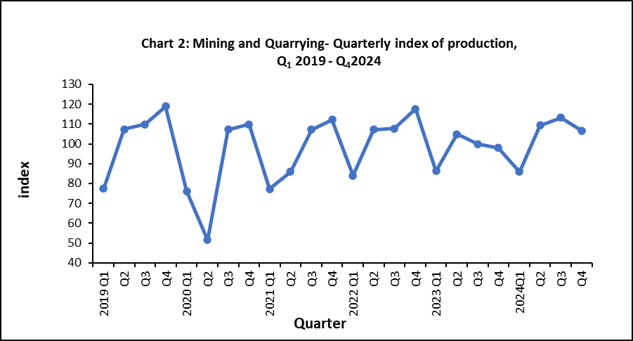

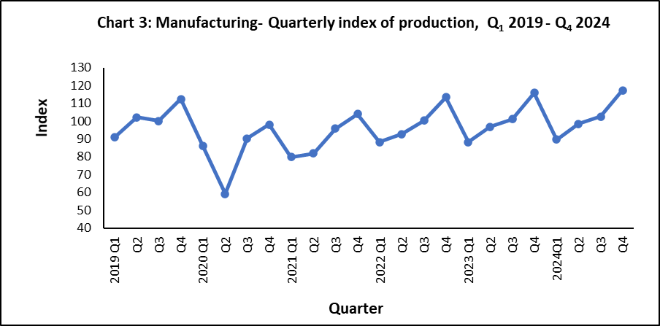
4.2 Manufacturing
Manufacturing output, which covers the production of a wide range of goods, represented 85% of the output of the industrial sector in 2018. For analysis purposes, “Manufacturing” is broken down into the following broad groups:
- Sugar milling representing 1.3% of manufacturing output
- EOE (40%)
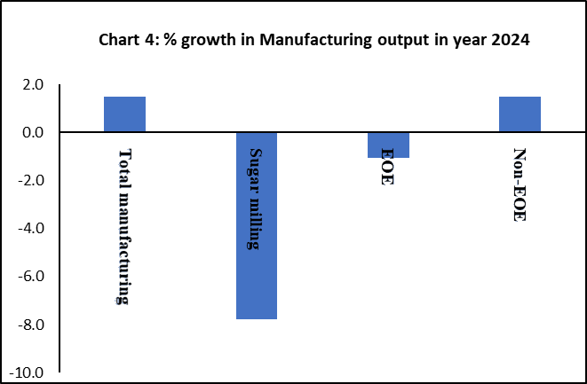
- Non–EOE (59%)

Manufacturing output in the fourth quarter of 2024 grew by 14.5% compared to the previous quarter and by 1.3% compared to the corresponding quarter of 2023 (Table 1). In year 2024, a growth of 1.5% was noted in real manufacturing output. This is due to a positive growth in “Non-EOE” (+1.5%) partly offset by negative growths of 7.8% in “Sugar milling” and 1.0% in “EOE”. The performances of “EOE” and “Non-EOE” by detailed industry group up to third quarter 2024 are analyzed separately in Section 5.

4.3 Electricity, gas, steam and air conditioning supply
“Electricity, gas, steam and air conditioning supply” accounts for 10.5% of the output of the industrial sector. In the fourth quarter of 2024, real output of this sector increased by 19.5% compared to the previous quarter and by 1.6% compared to the corresponding quarter of 2023. In year 2024, production grew by 3.4% (Table1).
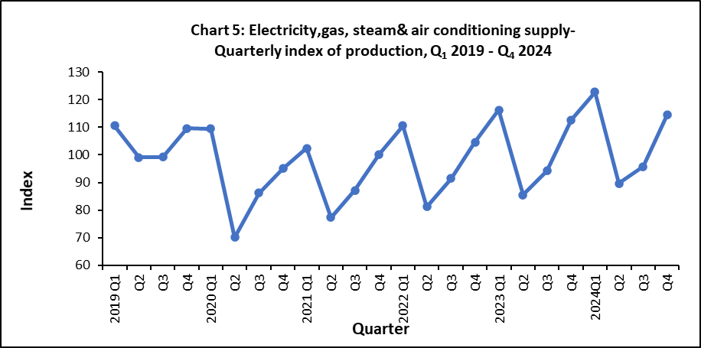

4.4 Water supply; sewerage, waste management and remediation activities
“Water supply; sewerage, waste management and remediation activities” accounts for around 2.4% of the output of the industrial sector. In the fourth quarter of 2024, real output of this sector increased by 0.1% compared to the previous quarter and by 1.1% when compared to the corresponding quarter of 2023. In year 2024, real output went up by 2.8% (Table1).

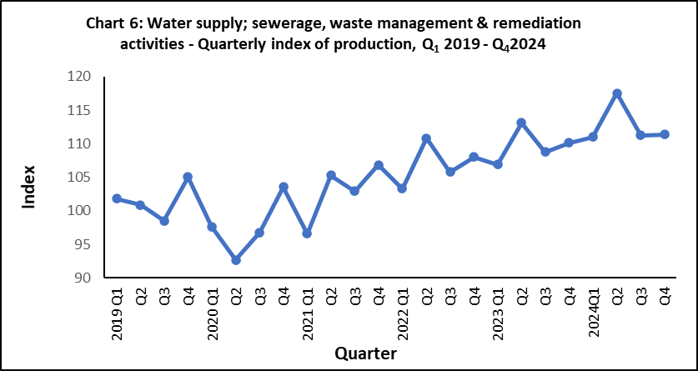

5. Changes by broad group
5.1 Export Oriented Enterprises (EOE)
Real output of EOE sector decreased by 1.4% in the fourth quarter of 2024 compared to the previous quarter and contracted by 0.3% compared to the corresponding quarter of 2023. In year 2024, the EOE sector decreased by 1.0% (Table 1).
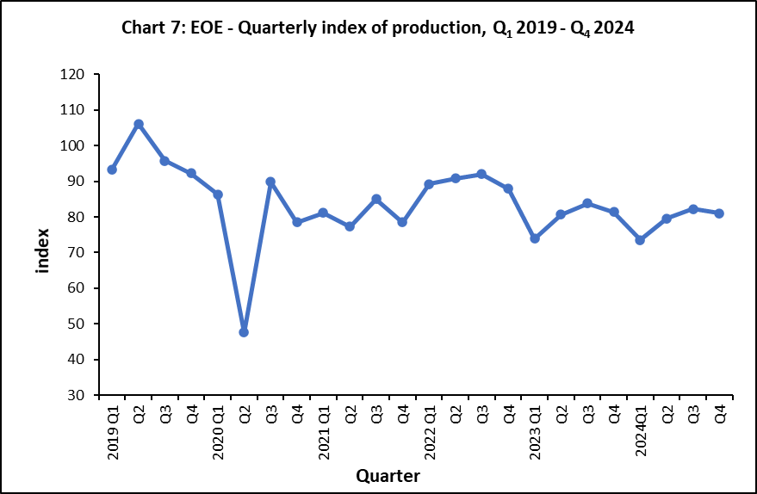

Lower-level indices for the fourth quarter of 2024 are not yet available. However, an indication of the annual performance at sub-group levels can be obtained by comparing indices available for year ending third quarter 2024 to those for year ending third quarter 2023 (Table 3). Real output of “Wearing apparel”, the most important industry group within the EOE, declined by 15.5% and that of “Textiles” grew by 2.4%. These two sub-groups account for almost 63% of the total weight allocated to the EOE. However, a positive growth of 22.3% is observed in “Other manufacturing” offset by negative growths of 4.6% in “Computer, electronic and optical products, 7.9 % in “Food products” and 31.1% in “Jewellery, bijouterie and related articles n.e.c”
Year and quarter

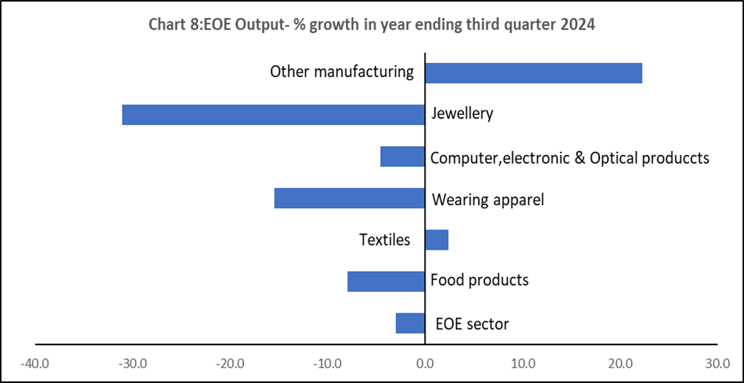

5.2 Non-EOE excluding “Sugar milling”
Chart 6
In the fourth quarter of 2024, the real output of Non-EOE sector increased by 19.8% compared to the previous quarter and by 0.5% when compared to the corresponding quarter of 2023. In year 2024, it grew by 1.5% (Table 1).
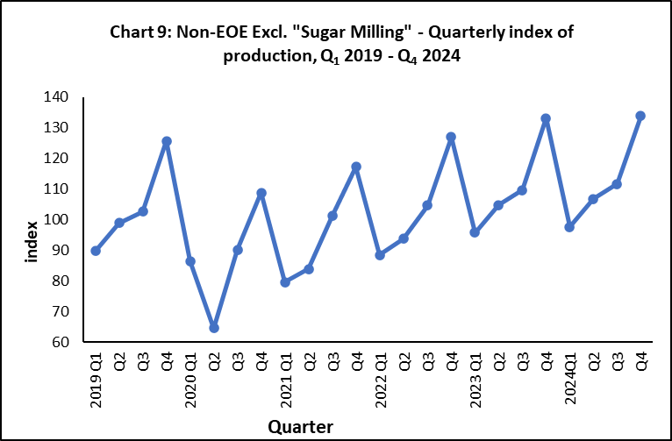

The annual performance at sub-group level is obtained by comparing the detailed indices available for year ending third quarter 2024 to those for year ending third quarter 2023 (Table 4). Expansions were noted in “Food products excluding sugar” (+0.2%), “Beverages” (+5.8%),), “Printing and reproduction of recorded media” (+1.1%), “Chemicals & chemical products” (+6.4%), “Plastic and non-metallic product” (+6.6%), “Basic metals and fabricated metal products” (+4.8%) and “Furniture” (+10.2) while negative growths were noted in “Textiles & wearing apparel” (-9.6%) and “Other manufacturing” (-2.7%) as illustrated in Chart 10.

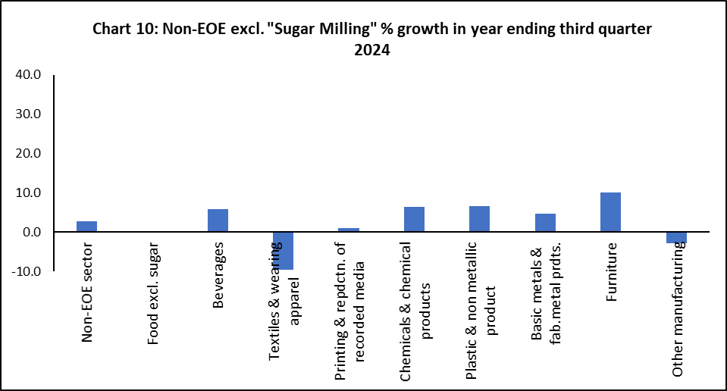

Statistics Mauritius
Ministry of Finance
PORT LOUIS
21 March 2025

Contact Person:
Mrs. V. Rama - Lahootan (Statistician/ Senior Statistician)
Manufacturing Unit
Statistics Mauritius
5th Floor LIC Building
Port Louis
Tel : (+230) 208 1800
E-mail : sm-qiip@govmu.org

