POPULATION AND VITAL STATISTICS
REPUBLIC OF MAURITIUS, YEAR 2024

- Introduction
This issue of Economic and Social Indicators presents population estimates as at 31 December 2023 and 2024 based on 2022 Population Census data as well as vital statistics and rates for years 2023 and 2024. The vital rates for year 2023 are revised figures. This publication also includes revised population estimates and vital rates for year 2022 at Annex 1.

Definitions of terms used are given at Annex 2.
Notes to users

The 2022 Population Census enumerated 1,233,097 residents as at mid-2022. Due to an under-enumeration of children by an estimated 18,038, the population enumerated at the census has been adjusted to 1,251,135.

The official estimate of resident population at mid-2022 is now 1,251,135, lower than the previous official estimate of 1,262,249 based on 2011 Census data. The difference is mainly explained by two key factors:
- revised estimate of migration of resident during the intercensal period 2011 -2022
- census undercount of the resident population.

Details on the evaluation of the 2022 Census data are given in the Report on ‘Population Data Evaluation on Statistics Mauritius website at:
https://statsmauritius.govmu.org/Pages/Censuses%20and%20Surveys/Census/census_2022.aspx

- Key points
- The population of the Republic of Mauritius was estimated at 1,244,477 as at 31 December 2024, with a net decrease of -2,840 from previous year’s figure.
- As at end 2024, the female population was higher than the male population by 12,909.
- The proportion of the population aged 0-14 years declined from 16.2% as at mid-2023 to 16.0%, one year later. The proportion aged 15-64 years declined from 70.2% to 69.8%, while for those aged 65 years and above, the proportion increased from 13.6% to 14.2% for the same period.
- The dependency ratio (the child population under 15 years of age and the elderly population aged 65 years and above per 1,000 population aged 15 to 64 years) was 424.8 for 2023 and 431.7 for 2024.
- The number of live births registered during year 2024 was 12,853, representing a decrease of 0.1% over the figure for 2023.
- The number of deaths registered in 2024 was 12,507, that is, 5.6% higher than in 2023.
- The number of infant deaths increased by 10.1%, from 168 in 2023 to 185 in 2024.
- The number of still births declined by 10.6%, from 104 in 2023 to 93 in 2024.
- The number of marriages registered in 2024 was 8,220, that is, 5.0% lower than in 2023.
- Over time, the population age structure depicted by a population pyramid has shifted from wide base to shrinking base and thickening body, showing an ageing of the population.

- Estimated resident population
Table 3.1 - Estimated resident population by sex, Republic of Mauritius, 31 December 2024
The estimated resident population of the Republic of Mauritius was 1,244,477 as at 31 December 2024. The female population was 628,693, compared to a male population of 615,784. There were 97.9 males for every 100 females.
The population was estimated at 1,199,834 and 44,313 respectively for the Island of Mauritius and the Island of Rodrigues. In both islands, females outnumbered males. However, Agalega and St Brandon, with an estimated population of 330, had slightly more males (167) than females (163).
The Republic of Mauritius, with a total land area of 2,007 km², had a population density of 620 persons per km² as at end 2024. Among its constituent islands, the Island of Mauritius had the highest density (642), compared to 402 for the Island of Rodrigues.

- Population growth
Table 4.1 - Population change, Republic of Mauritius, 31 December 2023 and 31 December 2024
The population of the Republic of Mauritius decreased by 2,840 from 31 December 2023 to 31 December 2024, representing a decrease of 0.23%.
Table 4.2 - Components of population growth, Republic of Mauritius¹, 2023 and 2024
¹ excluding Agalega and St Brandon
Population growth has two components: natural increase (the number of births minus the number of deaths) and net international migration (net international movement of residents).
During the year 2024, there was a natural increase of 346 persons, with births adding 12,853 babies and deaths removing 12,507 persons from the population. For the same period, net international migration of residents was estimated at -3,186 persons.

- Age distribution of population
Table 5.1 - Estimated resident population¹ by broad age group and sex, Republic of
Mauritius², 1 July 2023 and 1 July 2024
¹ based on 2022 Population Census data adjusted for underenumeration of children
² excluding Agalega and St Brandon
The proportion of the population aged 0-14 years declined from 16.2% as at mid-2023 to 16.0%, one year later. The proportion aged 15-64 years decreased to 69.8% in 2024 from 70.2% in 2023. As for the population aged 65 years and above, the proportion increased from 13.6% in 2023 to 14.2% in 2024. The dependency ratio (the child population under 15 years of age and the elderly population aged 65 years and above per 1,000 population aged 15 to 64 years) was 424.8 in 2023 and 431.7 in 2024.

- Population age structure
The structure of the pyramids in Figure 6.1 are determined by the patterns of births, deaths and migration which took place prior to the reference period of the pyramid. The pyramids compare the age structure of the population for years 1972, 2000 and 2024 and show some important trends in the demographics of Mauritius.
The main changes observed over time are:
- the shrinking of the base of the pyramid over time due to falling fertility;
- the thickening of the upper body of the pyramid indicating an increase in expectation of life;
- the relatively longer bars on the female side of the pyramid around its apex indicating the predominance of females among the elderly.
The pyramid for 1972 shows a typical young population with a wide base indicating a high birth rate, and a narrow top showing a relatively small proportion in the oldest ages. For 2000 and 2024, there is a ‘fill up’ of the pyramids above the base mainly due to the progression of the birth cohorts of the high fertility periods up the pyramid. The upper body of the 2024 pyramid is thicker than the one of 2000 due to improved life expectancy: the people born today are expected to live longer than previous generations. Women tend to live longer than men as can be seen from the population above 60 years in all the pyramids.

Figure 6.1 - Population pyramids, Republic of Mauritius¹, 1972, 2000 & 2024
¹ excluding Agalega and St Brandon

7. Vital statistics and rates
7.1 Live births and crude birth rate
Table 7.1 - Live births registered and crude birth rate, Republic of Mauritius¹, 2023 and 2024²
¹ excluding Agalega and St Brandon
² Provisional
³ Because of the small number of events, the rate for 2023 has been calculated by taking an average of events for three years (2022, 2023 and 2024) in order to remove wide fluctuations in the yearly data

For the year 2024, there were 12,853 live births registered in the Republic of Mauritius, representing a decrease of 0.1% over the 2023 figure of 12,872. The crude birth rate, i.e., the number of live births in a year per 1,000 mid-year population, remained at 10.3 for both years.
For the Island of Mauritius, the number of registered live births decreased from 12,097 in 2023 to 12,089 in 2024, but the crude birth rate increased from 10.0 to 10.1. For the Island of Rodrigues, the number of live births decreased from 775 in 2023 to 764 in 2024, with the crude birth rate decreasing from 18.3 to 17.3 during the same period.

7.2 Deaths and crude death rate

Table 7.2 - Deaths and crude death rate, Republic of Mauritius¹, 2023 and 2024²
¹ excluding Agalega and St Brandon
² Provisional
³ Because of the small number of events, the rate for 2023 has been calculated by taking an average of events for three years (2022, 2023 and 2024) in order to remove wide fluctuations in the yearly data.
The number of deaths registered in the Republic of Mauritius in 2024 was 12,507, representing an increase of 5.6% over the figure of 11,839 for 2023. The crude death rate, i.e., the number of deaths in a year per 1,000 mid-year population rose from 9.5 in 2023 to 10.0 in 2024.
The Island of Mauritius registered an increase in the number of deaths from 11,549 in 2023 to 12,165 in 2024, resulting in a rise in the crude death rate from 9.6 to 10.1 during the same period. For the Island of Rodrigues, the number of deaths also increased from 290 to 342, with the crude death rate increasing from 7.5 in 2023 to 7.7 in 2024.

7.3 Infant deaths and Infant mortality rate

Table 7.3 - Infant deaths and infant mortality rate, Republic of Mauritius¹, 2023 and 2024²
¹ excluding Agalega and St Brandon
² Provisional
³ Because of the small number of events, the rate for 2023 has been calculated by taking an average of events for three years (2022, 2023 and 2024) in order to remove wide fluctuations in the yearly data
For the year 2024, some 185 infant deaths (deaths to children aged under one year) were registered in the Republic of Mauritius against 168 in 2023, representing an increase of 10.1%. The infant mortality rate, defined as the number of infant deaths per 1,000 live births increased from 13.1 in 2023 to 14.4 in 2024.
The number of infant deaths in the Island of Mauritius was 157 for 2023 and 174 for 2024, with infant mortality rates of 13.0 and 14.4 respectively. For the Island of Rodrigues, the number of infant deaths were 11 for both 2023 and 2024, with the infant mortality rate increasing from 12.0 to 14.4 during the same period.

7.4 Still births and still birth rate
Table 7.4 - Still births and still birth rate, Republic of Mauritius¹, 2023 and 2024²
¹ excluding Agalega and St Brandon
² Provisional
³ Because of the small number of events, the rate for 2023 has been calculated by taking an average of events for three years (2022, 2023 and 2024) in order to remove wide fluctuations in the yearly data
In 2024, some 93 still births were registered in the Republic of Mauritius, which is 10.6% lower than the 2023 figure of 104. The still birth rate which is the number of still births in a year per 1,000 total births was 7.2 for 2024, compared to 8.0 in 2023.
The Island of Mauritius registered 86 still births in 2024 against 99 in 2023, with the still birth rate decreasing from 8.1 in 2023 to 7.1 in 2024. For the Island of Rodrigues, there were 5 still births registered in 2023 and 7 in 2024, and the still birth rate increased from 7.4 to 9.1 during the same period.

7.5 Marriages and crude marriage rate
Table 7.5 - Marriages and crude marriage rate, Republic of Mauritius¹, 2023 and 2024²
¹ excluding Agalega and St Brandon
² Provisional
³ Because of the small number of events, the rate for 2023 has been calculated by taking an average of events for three years (2022, 2023 and 2024) in order to remove wide fluctuations in the yearly data

The number of marriages registered in the Republic of Mauritius decreased by 5.0%, from 8,654 in 2023 to 8,220 in 2024. The crude marriage rate, i.e., the number of persons married in a year per 1,000 mid-year population, decreased from 13.9 to 13.2 for the same period.
For the Island of Mauritius, the number of marriages decreased from 8,471 in 2023 to 8,036 in 2024, resulting in a fall in the marriage rate from 14.1 to 13.4. For the Island of Rodrigues, the number of marriages registered was 183 in 2023 and 184 in 2024, showing an increase in the marriage rate from 8.2 to 8.3.

International Comparison
Population and demographic estimates for many countries of the world are published in the United Nations Demographic Yearbook. A negative population growth of 0.1 was registered for the Republic of Mauritius during the period 2022 to 2023. Almost all the other countries shown in Table 8.1 had a positive population growth for the period 2020 to 2023 namely South Africa (1.1%), Canada (1.8%), Germany (0.5%), Australia (1.3%) with the exception of Republic of Korea (-0.1%).

Table 8.1 – Demographic indicators for selected countries, 2023

Source: UN Demographic Yearbook, 2023 (except for the Republic of Mauritius)

¹ Average annual rate of population change refers to years 2022 to 2023
² Figures in italics refer to year 2022

9. How has life expectancy changed over time?
Life expectancy at birth is defined as the average number of years that a newborn could expect to live if he/she were to pass through life subject to the age specific mortality rates of a given period. For example, a girl born in 2022 is expected to reach age 77, however a woman who was 60 years old already in 2022 was expected to live a further 22 years, that is until she is 82. Life expectancy at birth is a summary indicator of mortality conditions and, by proxy, of health conditions. It summarizes mortality risks and trends across all age groups, including older people. Measurement of life expectancy at birth also allows for reporting of life expectancy at other ages to track health improvements for specific age groups in populations.
Calculation of life expectancy at birth is based on age-specific death rates for a particular calendar period and is presented in the form of a life table. The death rates are commonly tabulated for ages below 0 years, 1 to 4 years, and for 5-year age groups for ages 5 and above. Life expectancy may be calculated separately for males and females, or for both sexes combined, and can also be presented for particular ages after birth. These rates are derived directly from registered deaths and population counts.

Figure 9.1 – Life expectancy at birth, Republic of Mauritius, 1962 - 2022
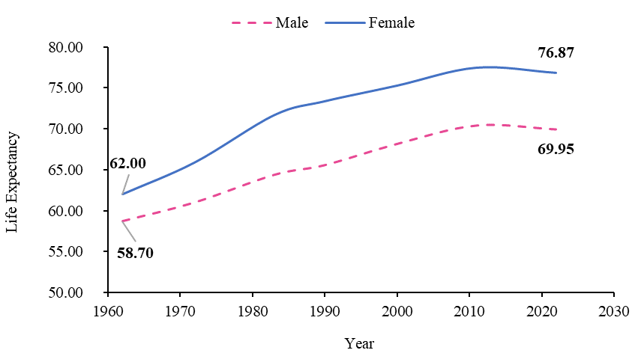
A new born boy was expected to live to 59 years in 1962, compared to 70 years in 2022, whereas a baby girl was expected to live 62 years in 1962 and 77 years in 2022 (Figure 9.1).

Historically infant mortality rates are directly associated with life expectancies

Low life expectancies can be explained by the higher number of infant deaths. Surviving the first year of life was historically a predominant factor in determining life expectancies and once a child had reached five years of age, he or she was much more likely to reach an advanced age. Whereas a newborn boy was expected to live to age 59 in 1962, a one-year-old boy in that same year had a life expectancy of 62 years, 3 years higher than a new born. Figure 9.2 highlights the increase in life expectancy at birth since 1962. Females show a similar pattern (Figure 9.3).

Figure 9.2 – Average age expected to reach by current age for males, Republic of Mauritius, 1962 and 2022
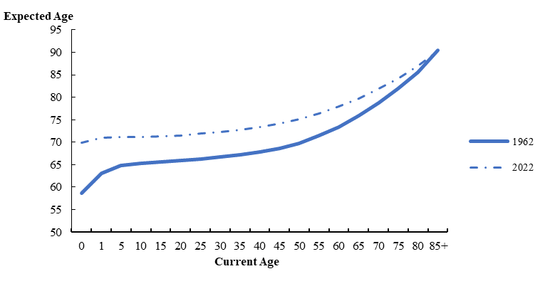

Figure 9.3 – Average age expected to reach by current age for females, Republic of Mauritius, 1962 and 2022
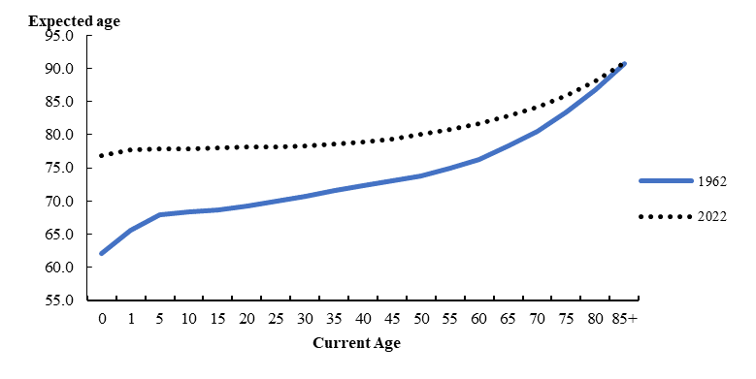
In 1972, 6.5% of babies died in the Republic of Mauritius before their first birthday compared to 1.4% in 2024, showing the big improvements made in reducing child mortality. Following the opening of Neonatal Intensive Care Service at Victoria Hospital in May 1999 and subsequently in other regional hospitals, the Infant Mortality Rate drastically fell from 19.5 in 1999 to 14.4 in 2024.

Life expectancy gap between male and female

Women tend to live longer than men. The cause of the gap in life expectancy between males and females, begins at birth with higher death rates among new born boys and it is sustained at older ages with men having higher death rates than women. Female life expectancy at birth was 6.92 years higher than for men in 2022, compared to 3.3 years in 1962 in the Republic of Mauritius. The smaller gap in the 1960’s may be due to higher mortality/infant mortality rate prevailing at that time. Over time, the gap has widened reaching a peak of 7.82 years in 1990, after which it fell down to 7.08 in 2011 and 6.92 in 2022.

Figure 9.4 – Difference in male and female life expectancy at birth, Republic of Mauritius, 1962 – 2022
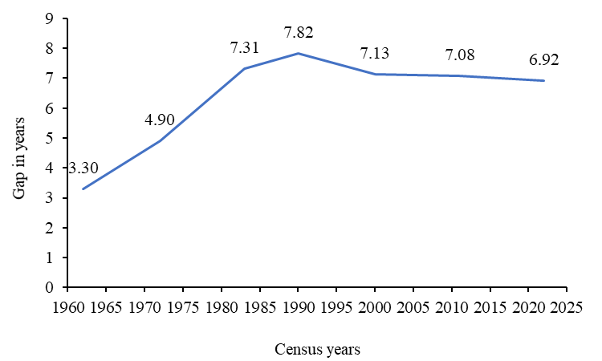

Increase in Life expectancy at older age

The life expectancy of a woman aged 60 in 1962 was 16.3 years and reached 21.8 in 2022. For men of the same age, it was 13.4 years in 1962 and 17.9 in 2022. Over the last 60 years, the life expectancy at age 60 has generally been increasing except for year 2022 where it has decreased slightly, to some extent due to COVID-19. The increased life expectancies are also contributing towards ageing.

Figure 9.5 – Life Expectancy at age 60, Republic of Mauritius, 1962 – 2022
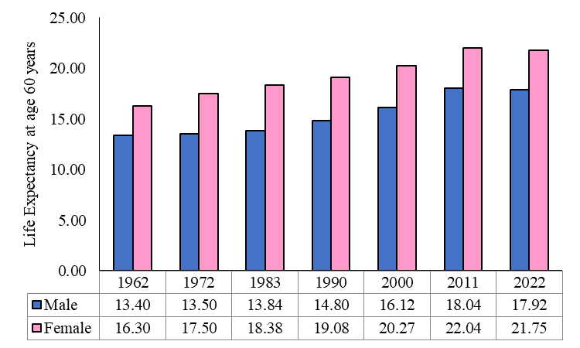

Statistics Mauritius
Ministry of Finance
Port Louis
11 March 2025
Contact person:
Mr C. K. Arianaick, Principal Statistician
Mrs. C. Martial, Statistician/Senior Statistician
Mrs. N. Fatha Mahomed, Statistical Officer/Senior Statistical Officer
Demography Unit
Statistics Mauritius
LIC Centre
John Kennedy Street
Port Louis
Tel: 208 1800
Email: cso_demography@govmu.org

Annex

Annex 1
Revised population estimates and vital rates for year 2022 based on 2022 Population census data – Republic of Mauritius ¹

 | 2022
Population at end of year | 1,249,140
Crude Birth Rate | 9.7
Crude Death Rate | 10.3
Infant Mortality Rate | 14.2
Still Birth Rate | 9.1
Crude Marriage Rate | 15.3
¹ - Excluding Agalega and St Brandon

Annex 2
1. Vital Statistics: The statistics pertaining to vital events which include live births, deaths, still births, marriages and divorces
2. Population density: The number of persons per square kilometre
3. Dependency ratio: The child population under 15 years of age and the elderly population aged 65 years and above per 1,000 population aged 15 to 64 years.
4. Child Dependency ratio The child population under 15 years of age per 1,000 population aged 15 to 64 years.
5. Old age Dependency ratio The elderly population aged 65 years and above per 1,000 population aged 15 to 64 years.
6. Median age The age which divides the population into two equal size groups, one of which is younger and the other older than the median.
7. Sex ratio: The number of males to every 100 females.
8. Natural increase: The excess of live births over deaths.
9. Crude birth rate: The number of live births in a year per 1,000 mid-year population.
10. Crude death rate: The number of deaths in a year per 1,000 mid-year population.
11. Infant mortality rate: The number of deaths in a year of infants aged under one year per 1,000 live births during the year.
12. Still birth rate: The number of still births in a year per 1,000 total births (live
births and still births) during the year.
13. Marriage rate: The number of persons married in a year per 1,000 mid-year
population.

Note: The vital rates for Rodrigues are usually calculated as an average for three years in order to remove wide fluctuations in the yearly data. The rates for year 2024 are however calculated on the basis of data for the year only.

