# SURVEY OF EMPLOYMENT AND EARNINGS IN LARGE

# (employing 10 or more persons) ESTABLISHMENTS (SEE)

**March 2024 (Preliminary results)**

1. **Introduction**

Statistics Mauritius carries out the annual Survey of Employment and Earnings in ‘large’ establishments with March as reference period so as to obtain a continuous series of comparable data on the level of employment and earnings in these establishments. This issue of the Economic and Social Indicators presents the preliminary results for March 2024 with comparative figures for 2022 and 2023.

Concepts and definitions are provided at section 4.

###### **Response**

The preliminary results of the survey presented below are based on responses obtained from 62% of large establishments, representing 74% of total employment in this category of establishments. Estimates have been worked out for non-response on the basis of previous data, observed trend and employment figures from the statistics unit of the Ministry of Industrial Development, SMEs and Cooperatives.

###### **Main results**

##### **Employment Level, March 2023 - March 2024**

A preliminary estimate of total employment in large establishments is 304,619 in March 2024 compared to 304,307 in March 2023, representing an increase of 312 (Table 1). This is the net result of employment increases in some industrial groups, partly offset by decreases in some other groups.

A sectorwise analysis shows that employment in the primary sector decreased by 110 from 9,033 in March 2023 to 8,923 in March 2024. During the same period, employment in the secondary sector showed decrease by 1,932 from 70,788 to 68,856 while the tertiary sector increased by 2,354 from 224,486 to 226,840.

The total employment figure includes 4,756 persons working in large establishments in Rodrigues, compared to 4,737 in March 2023. They are mainly government employees of the Rodrigues Regional Assembly numbering 2,845 in March 2024.

As at March 2024, the number of foreign workers stood at 26,636 *(21,643 males and 4,993 females)* of whom 16,454 were engaged in activities of the ‘Manufacturing’ sector, 5,626 in ‘Construction’, 1,481 in ‘Wholesale and retail trade; repair of motor vehicles and motorcycles’ and 750 in ‘Accommodation and food service activities’ (Table 6).

## **Employment by Industry**

Between March 2023 and March 2024, main increases occurred in the following industrial groups: ‘Financial and insurance activities’ (+606), ‘Wholesale and retail trade; repair of motor vehicles and motorcycles’ (+581), ‘Administrative and support service activities’ (+419) and ‘Accommodation and food service activities’ (+269).

Main decreases in employment were in ‘Manufacturing’ (-2,247), ‘Agriculture, forestry and fishing’ (-215) and ‘Education’ (-103) (Chart 1).

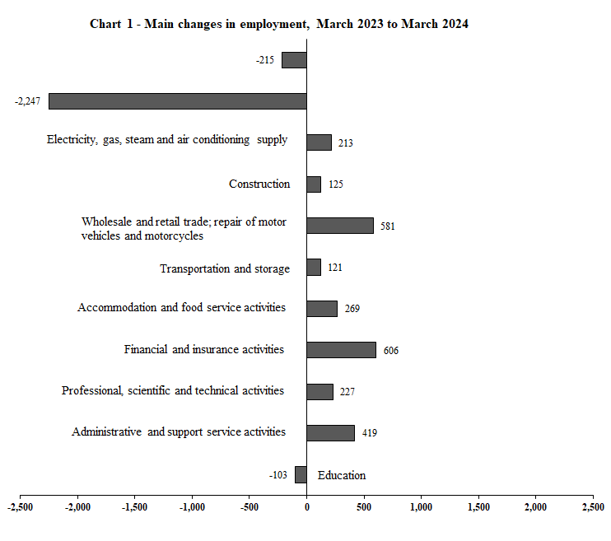

Manufacturing

Agriculture, forestry and fishing

## **Employment by Sex**

As at March 2024, among the 304,619 employees in large establishments, 179,354 or 58.9% were male. Compared to March 2023, male employment decreased by 615 while female employment increased by 927.

Male employment decreased mainly in ‘Manufacturing’ (-1,125), ‘Education’ (-274), ‘Administrative and support service activities’ (-170) and ‘Agriculture, forestry and fishing’ (-123) (Table 1).

Female employment increased mainly in ‘Administrative and support service activities’ (+589), ‘Financial and insurance activities’ (+402), ‘Accommodation and food service activities’ (+329) ‘Professional, scientific and technical activities’ (+182), ‘Education’ (+171) and ‘Public administration and defence; compulsory social security’ (+158).

## **Employment in General Government Sector**

Employment in the General Government Sector increased by 260 from 75,899 in March 2023 to 76,159 in March 2024. Male employment decreased by 95 from 42,934 to 42,839 and female employment increased by 355 from 32,965 to 33,320 (Tables 3, 3a & 3b).

## **Employment in large establishments of the Export Oriented Enterprises (EOE) sector**

The number of persons employed by large establishments of the EOE sector decreased by 2,499 from 34,649 *(19,079 Mauritians and 15,570 foreigners)* in March 2023 to 32,150 *(17,797 Mauritians and 14,353 foreigners)* in March 2024 (Table 4). The main decreases were in the ‘Wearing apparel (except footwear)’ (-2,210) and ‘Jewellery & related articles’ (-222).

From March 2023 to March 2024, the number of male employees showed decrease by 1,046 from 18,773 to 17,727 and the number of female employees showed decrease by 1,453 from 15,876 to 14,423.

* 1. **Employment of foreign workers**

The number of foreign workers in large establishments in March 2024 stood at 26,636 (21,643 males and 4,993 females) compared to 26,890 (21,457 males and 5,433 females) in March 2023, showing a net decrease of 254 (+186 males and -440 females) (Table 6).

Male employment increased mainly in ‘Wholesale and retail trade; repair of motor vehicles and motorcycles’ (+276).

Female employment decreased mainly in ‘Manufacturing’ (-527).

* 1. **Earnings**

The level of average earnings is influenced mainly by changes in basic salaries and wages. However, fluctuations may also occur because of:

1. Changes in the mix of employees of various categories or with various lengths of service. For example, a large intake of professionals by, say, an architectural firm can cause a sudden jump in the average monthly earnings. On the other hand, a large intake of employees at the lower end of a wage scale has the effect of lowering the average earnings.
2. Changes in overtime, regular bonuses and commissions.
   * 1. **Earnings in large establishments**

The industrial group with the highest average monthly earnings was ‘Electricity, gas, steam and air conditioning supply’ (Rs 73,756) followed by ‘Real estate activities’ (Rs 66,872) and ‘Financial and insurance activities’ (Rs 64,669). Lowest averages were registered in, ‘Administrative and support service activities’ (Rs 26,152) and in ‘Manufacturing’ (Rs 30,243). Within the ‘Manufacturing’ group, ‘Textiles and wearing apparel’ registered average monthly earnings of Rs 25,529.

Overall average monthly earnings in large establishments increased by 10.9% from Rs 39,206 in March 2023 to Rs 43,488 in March 2024. Highest increases were registered in: ‘Information and communication’ (+23.3%) and ‘Electricity, gas, steam and air conditioning supply’ (+20.9%) (Chart 2).

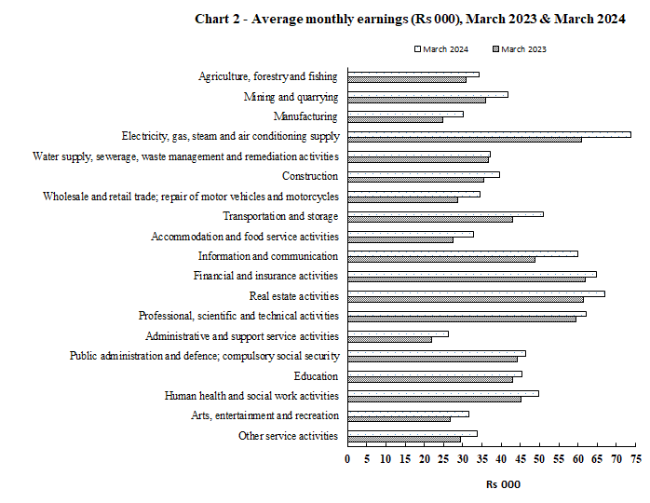

* + 1. **Earnings in large establishments of the EOE sector**

The average monthly earnings in this sector stood at Rs 29,684 in March 2024, showing an increase of 16.1% over the March 2023 figure of Rs 25,576 (Table 8). The average monthly earnings in the manufacturing establishments was Rs 25,510 compared to Rs 45,279 in the non-manufacturing establishments. The corresponding figures for 2023 were Rs 21,117 and Rs 44,974 respectively.

###### **Concepts and definitions**

* 1. **Large establishments** include:

1. Agricultural establishments comprising:
2. sugar cane plantations of 10 hectares or more;
3. tea plantations of 2 hectares or more;
4. Other agricultural establishments employing at least 10 persons during the reference period (March 2024).
5. Non-agricultural establishments employing at least 10 persons during the reference month. It is to be noted that “outworkers”, that is, piece rate workers who are working in their own homes on materials provided by the establishment, are excluded although they are remunerated by the establishment.
6. All central, regional and local government departments.
   1. **Primary, Secondary and Tertiary sector**

**Primary sector** comprises activities classified in the industrial groups:

1. Agriculture, forestry and fishing
2. Mining and quarrying

**Secondary sector** comprises activities classified in the industrial groups:

1. Manufacturing
2. Electricity, gas, steam and air conditioning supply
3. Water supply; sewerage, waste management and remediation activities
4. Construction

**Tertiary sector** comprises activities classified in the industrial groups:

1. Wholesale and retail trade; repair of motor vehicles and motorcycles
2. Transportation and storage
3. Accommodation and food service activities
4. Information and communication
5. Financial and insurance activities
6. Real estate activities
7. Professional, scientific and technical activities
8. Administrative and support service activities
9. Public administration and defence; compulsory social security
10. Education
11. Human health and social work activities
12. Arts, entertainment and recreation
13. Other service activities

**4.3** The **General Government** sector is made up of (i) Central Government (ii) Regional Government and (iii) Local Government.

**4.3.1** **Central Government** covers all units that are agencies of the country’s central authority. It consists of Budgetary Central Government and Extra Budgetary Units.

***Budgetary Central Government*** includes all ministries and departments.

***Extra Budgetary Units*** are agencies responsible for the performance of specialized governmental functions in such fields as health, education, social welfare, construction and so on, under the authority of Central Government

**4.3.2 Regional Government** consists of the administration of Rodrigues.

**4.3.3** **Local Government** consists of municipalities and district councils / village councils exercising an independent competence as government units.

**4.4 Export Oriented Enterprises (EOE)** comprise enterprises formerly operating with an export certificate and those export manufacturing enterprises holding a registration certificate issued by the Board of Investment.

**4.5 Employment in Large establishments** covers all persons in regular or casual employment and includes:

1. Persons temporarily absent on paid sick or vacation leave; and
2. Persons holding managerial posts, family workers receiving wages or salaries, and paid apprentices.

**4.6 Earnings** of employees in large establishments comprise all payments in cash made to employees in connection with work done. Amounts reported include overtime, productivity bonuses, commissions, travelling allowances, attendance bonuses, housing and rent allowances and other regular cash payments before any deductions such as taxes, insurance and pension contributions paid by the employees. They exclude pension payments, family allowances and other similar special benefits paid by the employers. Also excluded are arrears payments made at the end of March in respect of previous pay periods.

**Statistics Mauritius**

**Ministry of Finance, Economic Planning and Development**

**Port Louis**

**30 September 2024**

Contact persons:

Mrs D. Gangaram (Statistician/Senior Statistician)

Mrs S. D. Venkatasami (Temp. Principal Statistical Officer)

Labour Unit

Statistics Mauritius

LIC Building, Port Louis

Tel: 208 1800

Fax: 213 0234

Email: [cso_labour@govmu.org](mailto:cso_labour@govmu.org)

cso_quarterlylabour@govmu.org