EDUCATION STATISTICS – 2024
1. Introduction

This issue of the Economic and Social Indicators presents educational statistics, compiled based on data obtained from an annual survey conducted in schools together with data from other sources. The data refer to the Republic of Mauritius (excluding Agalega) and cover pre-primary, primary, secondary, technical & vocational, tertiary education as well as education in specialised institutions.

2. Expenditure

Total government expenditure for the financial years 2023/2024 and 2024/2025 are estimated as follows:
- Financial year 2023/2024: Rs 229,366 million, of which, Rs 21,390 million (9.3%) has been allocated to education and training; and
- Financial year 2024/2025: Rs 289,883 million, of which, Rs 23,167 million (8.0%) has been allocated to education and training.

Total budget on education and training has been allocated as follows:
- Financial year 2023/2024: 49.6% to secondary education, 24.4% to primary education, 9.1% to tertiary education, 3.6% to pre-primary education, 1.4% to technical and vocational education and the remaining 11.9% to other expenses; and
- Financial year 2024/2025: 49.0% to secondary education, 23.6% to primary education, 8.7% to tertiary education, 1.6% to technical and vocational education, 5.1% to pre-primary education and the remaining 12.0% to other expenses
(Figure 1).

Figure 1 - Total Expenditure on Education and Training, Republic of Mauritius

Financial Year: 2023/2024 Financial Year: 2024/2025

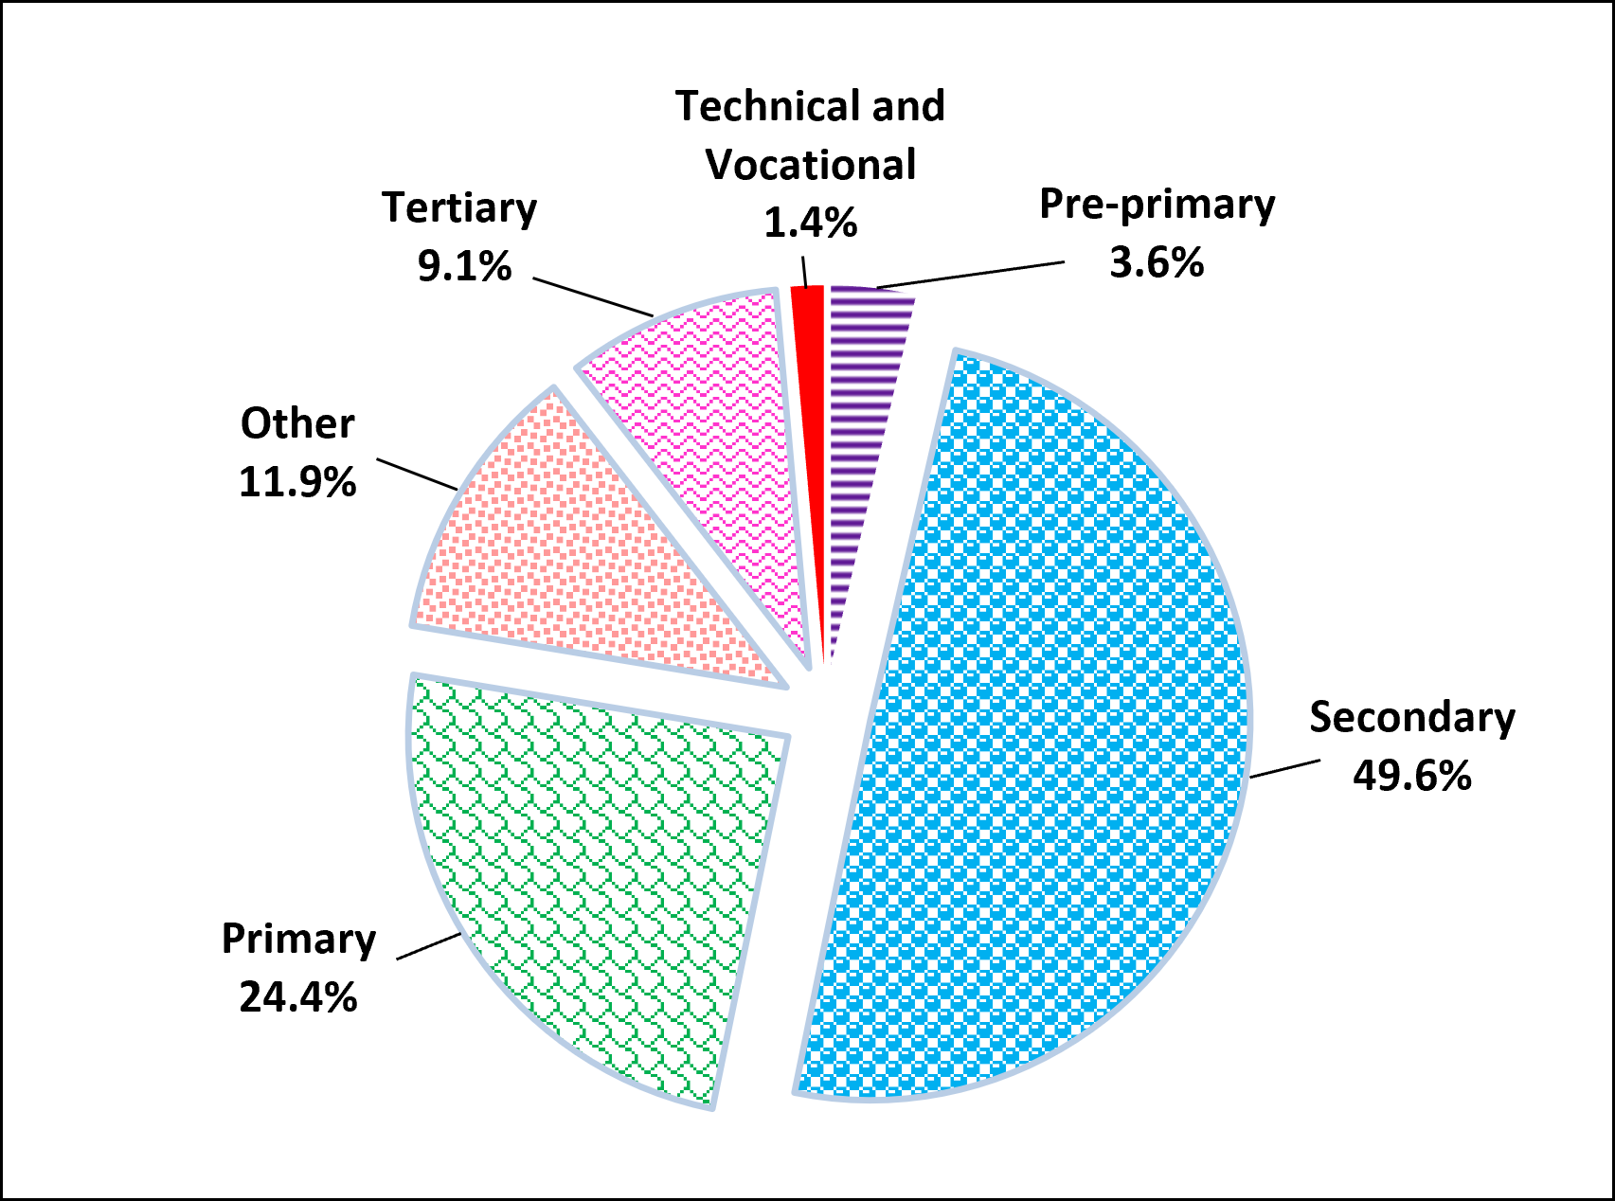
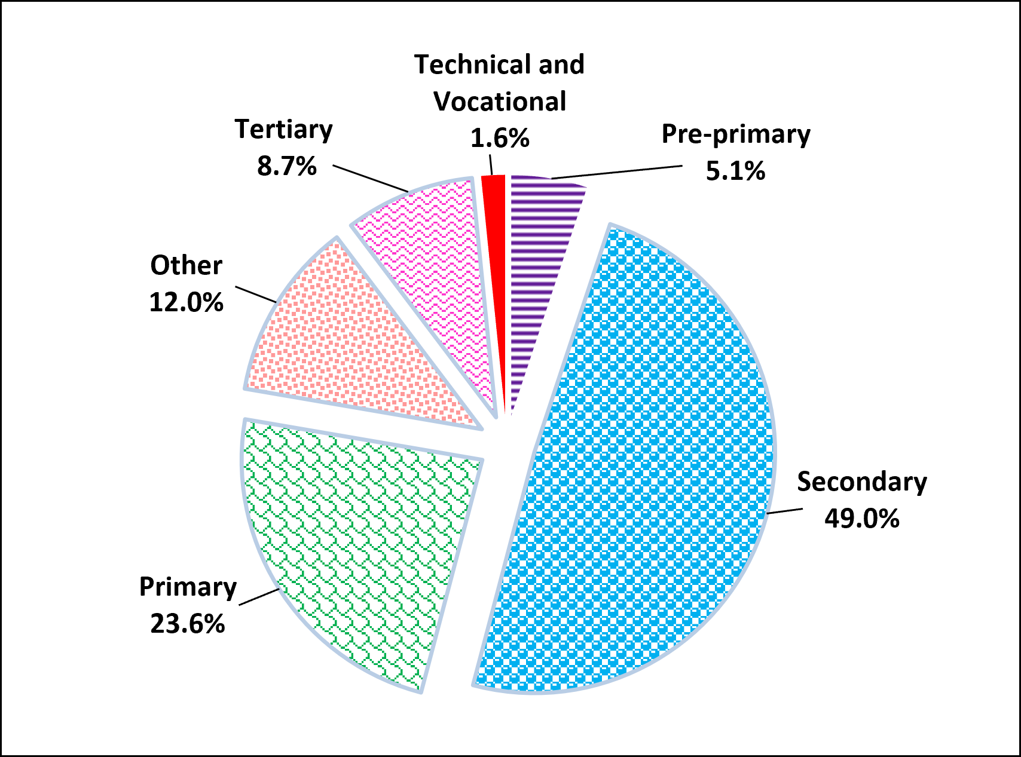

3. Pre-primary Education

  - Schools

The number of schools providing pre-primary education stood at 818 in March 2024: 784 in the Island of Mauritius and 34 in Rodrigues. Of these schools, 575 (70.3%) were privately run institutions; 188 (23.0%), operating on government primary school premises, were administered by the Early Childhood Care and Education Authority and the remaining 55 (6.7%) were administered by either Roman Catholic (RC) or Hindu Education Authorities or Municipal/Village Councils.

  - Enrolment

Enrolment in pre-primary schools increased by 16.5%, from 23,787 in March 2023 to 27,716 in March 2024. Girls represented 49.2% of the pre-primary school population. The Gross Enrolment Ratio (pre-primary enrolment as a percentage of the population aged 4 and 5 years) works out to 107.5% compared to 91.8% in 2023.

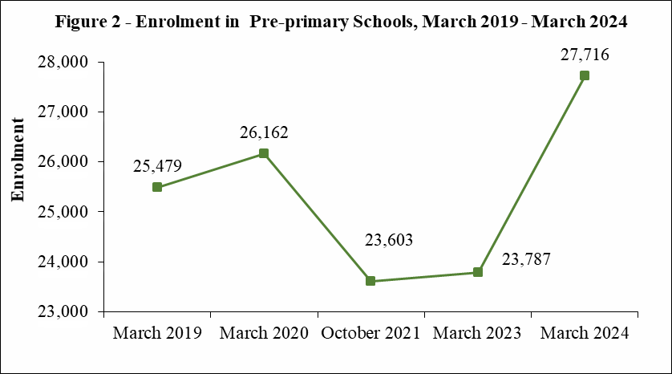

An analysis of the trends, as per figure 2, shows a rise in enrolment in
pre-primary schools from 25,479 in March 2019 to 26,162 in March 2020; and a decrease to 23,603 in October 2021 and thereafter increased to 23,787 in March 2023 followed by another increase to 27,716 in March 2024.

  - Personnel

In March 2024, total employment in pre-primary schools stood at 3,902, representing an increase of 26.4% compared to March 2023, of whom 1,962 were teaching and 1,940 non-teaching staff. The average number of pupils per teacher works out to 14.

4. Primary Education

4.1 Schools

In March 2024, there were 342 schools providing primary education: 325 in the Island of Mauritius and 17 in Rodrigues. The majority (220) of the schools were run by government, 52 by Roman Catholic Education Authority, 2 by Hindu Education Authority and the other 68 were private non-aided schools.

4.2 Enrolment

In March 2024, the primary school population in the Republic of Mauritius stood at 84,220, of whom 49.1% was girls. Some 58% was enrolled in government schools and the remaining was in private aided and non-aided schools.

Distribution by grade shows that grade 3 with 16,726 pupils, accounted for the highest number of pupils. The Gross Enrolment Ratio (primary enrolment as a percentage of the population aged 6 to 11 years) works out to 107.0% in 2024.

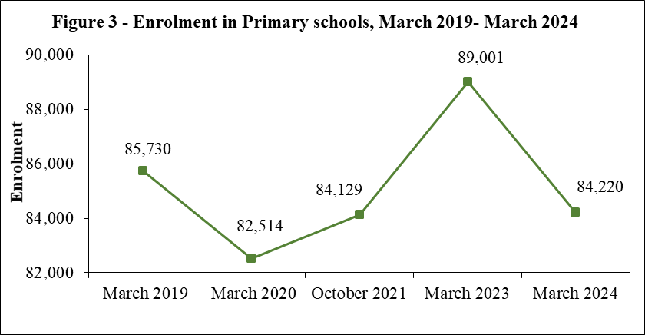

Figure 3 shows a decrease in primary enrolment from 85,730 in March 2019 to 82,514 in March 2020; thereafter it increased to 89,001 in March 2023 followed by a decrease to 84,220 in March 2024.

4.3 Personnel

The number of persons employed in primary schools registered an increase of 1,014 from 8,400 in March 2023 to 9,414 in March 2024. Of this number, 6,144 were teaching staff: 4,922 General Purpose teachers and 1,222 Asian Language/Arabic/Kreol Morisien teachers. The remaining 3,270 comprised 311 Head Masters, 1,020 Deputy Head Masters and 1,939 administrative and other workers. The pupil/teacher (general purpose) ratio in primary schools works out to 17 compared to 20 in March 2023.

  - Primary School Achievement Certificate (PSAC)

With the introduction of the Nine-Year Continuous Basic Education (NYCBE) in 2017, the Certificate of Primary Education (CPE) has been replaced by the Primary School Achievement Certificate (PSAC) which aims to assess learners holistically. The PSAC assessment thus comprises a School-Based Assessment component and a Modular component. The Modular assessments are taken at the end of Grade 5 and beginning of the third term of Grade 6.

In 2023, the number of school candidates who took part in PSAC Assessment was 15,054. Excluding re-assessment, the overall percentage meeting PSAC requirement works out to 77.5.

It is to be noted that the percentage meeting PSAC requirement, including re-assessed school candidates, works out to 82.0. The performance of girls, including re-assessment exceeded that of boys with respective pass rates of 86.0% and 78.0%
(Figure 4).

5. Secondary Education

5.1 Programmes of study
All children completing Primary Grade 6 move to Grade 7 in a secondary school to complete the last 3 years of the nine-year basic education cycle.
Pupils who have not reached the minimum standards at the PSAC Assessment are channeled to the Extended Programme in a secondary school where they follow an adapted curriculum and complete their basic education in 4 years instead of 3.
As at March 2024, the number of secondary schools, stood at 175, out of which 139 were offering both the Regular and the Extended Programmes from Grades 7 to 9+.
At the end of Grade 9, students continue their studies leading to Cambridge O/A level qualifications in either the same secondary school or in an Academie.

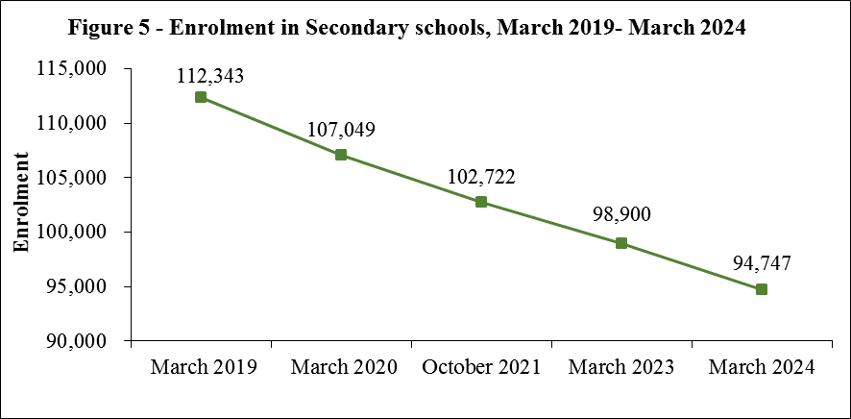
Figure 5 depicts a continuous fall in total secondary enrolment from March 2019 to March 2024.

5.2 Secondary Schools

5.2.1 Schools

Out of the 175 schools dispensing secondary Regular and Extended education, 167 were in the Island of Mauritius and 8 in Rodrigues. State administered schools numbered 69, while the other 106 were private aided and non-aided schools.

5.2.2 Enrolment

Secondary education enrolment decreased by 4,153 from 98,900 in March 2023 to 94,747 in March 2024. Some 44.2% of the secondary school population was in state schools and 55.8% in private (aided and unaided) schools. Gross Enrolment Ratio (secondary education enrolment as a percentage of the population aged 12 to 19 years) was 73.7%.
5.3 Personnel

The number of teachers working in secondary schools increased by 182 from 9,098 in March 2023 to 9,280 in March 2024. The pupil/teacher ratio works out to 10.

5.4 Cambridge School Certificate (SC)

In 2023, out of 12,917 candidates (5,830 males and 7,087 females) who took part in the Cambridge School Certificate examination, 9,522 were successful. Comparison with the 2022 results shows that the overall pass rate decreased from 78.5% to 73.7%
(Figure 6).

5.5 Cambridge Higher School Certificate (HSC)

The number of students taking part in the 2023 Cambridge Higher School Certificate examination stood at 7,528, of whom 59.6% were females. The overall pass rate was 84.4%, lower than the 2022 figure of 92.3% (Figure 7).

5.6 Technical and Vocational Education

In 2023, there were 8,730 students (of whom 75.0% were males) enrolled in publicly funded technical and vocational courses compared to 9,717 in 2021/2022. Some 31.3% of the students were enrolled in full-time courses, 42.3% in part-time courses and the rest (26.4%) in apprenticeship courses.

6. Special Education Needs (SEN)

6.1 Schools

As at March 2024, there were 77 Special Education Needs schools in the Republic of Mauritius registered with the Ministry of Education, Tertiary Education, Science and Technology. Seventeen schools were run by Government, while the other 60 were run by NGOs and the Roman Catholic Education Authority.

6.2 Enrolment

The number of students enrolled in the 77 special schools stood at 2,848 (of whom 69.2% were boys) as at March 2024, representing an increase of 5.7% compared to the 2023 figure of 2,694.

The three most frequent types of impairment among the pupils were intellectual/ learning disability (38.9%), autism spectrum disorder (18.1%) and mental health and emotional disabilities (7.8 %).

6.3 Personnel

As at March 2024, there were 974 persons employed in the special education needs institutions, representing an increase of 2.5% compared to 950 as at March 2023. Out of these, 411 were teaching staff, and 74 were medical and para-medical staff. The remaining 489 were administrative and ancillary workers.

7. ICT in Education

In March 2024, out of the 818 pre-primary schools in the Republic of Mauritius, 676 (83%) had computers. All primary and secondary schools were equipped with computers. Availability of internet access for students in schools was as follows: 35% in pre-primary, 92% in primary and 100% in secondary.

8. Tertiary Education

As at December 2023, the total number of students (part-time and full-time) enrolled on tertiary-level programmes (including Distance Education) was 50,011 compared to 50,566 in December 2022, representing a decrease of 1.1%.

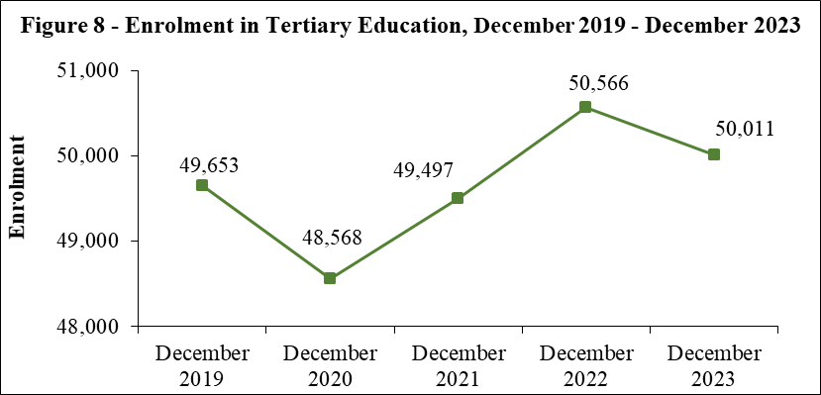

Figure 8 gives the evolution of total tertiary enrolment over the period 2019 to 2023. Total enrolment decreased from 2019 to 2020 followed by an increase from 2020 to 2022 and a decrease from 2022 to 2023.

The majority of students (83.6%) were enrolled in tertiary education locally in both public-funded institutions (57.2%) and private institutions (26.4%). The remaining 16.4% of the students were enrolled in tertiary education overseas.

The Gross Enrolment Ratio (tertiary education enrolment as a percentage of the population aged 20 to 24 years) for 2023 works out to 49.2 %.

.

9. Main Indicators on Education
The main indicators are given below:
Table 1 - Main Indicators, Republic of Mauritius, 2019 - 2024
 | 2019 | 2020 | 2021/2022 | 2023 | 2024
Pre-primary
Number of schools | 851 | 828 | 789 | 770 ¹ | 818
Enrolment | 25,479 | 26,162 | 23,603 | 23,787 ¹ | 27,716
Number of teachers | 2,134 | 2,103 | 1,831 | 1,762 ¹ | 1,962
Gross Enrolment Ratio (%) (3-4 years) ² | 99.2 | 102.5 | 91.2 ¹ | 92.3 ¹ | 106.8
Gross Enrolment Ratio (%) (4-5 years) | 96.2 | 102.0 | 91.9 ¹ | 91.8 | 107.5
Pupil/Teacher Ratio | 12 | 12 | 13 | 14 | 14
Primary
Number of schools | 319 | 318 | 319 | 325 | 342
Enrolment | 85,730 | 82,514 | 84,129 | 89,001 | 84,220
Number of teachers | 5,639 | 5,903 | 5,936 | 5,640 | 6,144
Gross Enrolment Ratio (%) (5-10 years) ² | 98.7 | 98.0 | 103.9 ¹ | 113.0 | 108.1
Gross Enrolment Ratio (%) (6-11 years) | 95.4 | 95.1 | 101.4 ¹ | 111.0 | 107.0
Pupil/Teacher Ratio | 20 | 18 | 18 | 20 ¹ | 17
Primary School Achievement Certificate (PSAC) | 77.3 | 78.0 | 83.1 | 82.0 | n.a
Secondary
Number of schools | 181 | 179 | 178 | 179 | 175
Enrolment | 112,343 | 107,049 | 102,722 | 98,900 | 94,747
Number of teachers | 9,783 | 9,542 | 9,379 | 9,098 ¹ | 9,280 ³
Gross Enrolment Ratio (%) (11-17 years) ² | 88.4 | 87.0 | 88.9 ¹ | 89.8 | 89.3
Gross Enrolment Ratio (%) (12-19 years) | 75.0 | 73.1 | 73.4 ¹ | 74.4 | 73.7
Pupil/Teacher Ratio | 11 | 11 | 11 | 11 | 10
Cambridge School Certificate Pass Rate | 70.9 | 85.7 | 78.5 | 73.7 | n.a
Cambridge Higher School Certificate Pass Rate | 75.0 | 90.0 | 92.3 | 84.4 | n.a

 | 2019 | 2020 | 2021 | 2022 | 2023
Tertiary ⁴
Number of institutions registered | 53 | 54 | 52 | 46 | 42 ³
Enrolment | 49,653 | 48,568 | 49,497 | 50,566 | 50,011 ³
Gross Enrolment Ratio (%) | 48.9 | 47.8 | 48.3 | 49.5 | 49.2 ³
Expenditure | 2020/2021 | 2021/2022 | 2022/2023¹ | 2023/2024¹ | 2024/2025⁵
Total Government Expenditure (Rs million) | 214,269 | 190,131 | 214,942 | 229,366 | 289,883
Total Government Expenditure on Education (Rs million) | 14,771 | 16,448 | 18,602 | 19,588 | 21,041
Total Government Expenditure on Education as a % of GDP at market price | 3.4 | 3.1 | 3.0 | 2.8 | n.a
Total Government Expenditure on Education as a % of Total Government Expenditure | 6.9 | 8.7 | 8.7 | 8.5 | 7.3

¹ Revised
² Based on the UNESCO definition of Gross Enrolment Ratio, i.e., total enrolment in a specific level of education, regardless of age expressed as a percentage of the eligible official school-age population
³ Provisional
⁴ Source: Higher Education Commission (ex- Tertiary Education Commission)
⁵ Budget Estimates
n.a: Not Available

Table 2- Total Government Expenditure, Republic of Mauritius, 2022/2023 - 2024/2025
(Rs million)
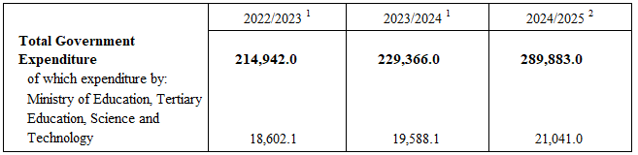

Table 3 - Government Expenditure on Education by sector, 2022/2023 - 2024/2025
(Rs million)
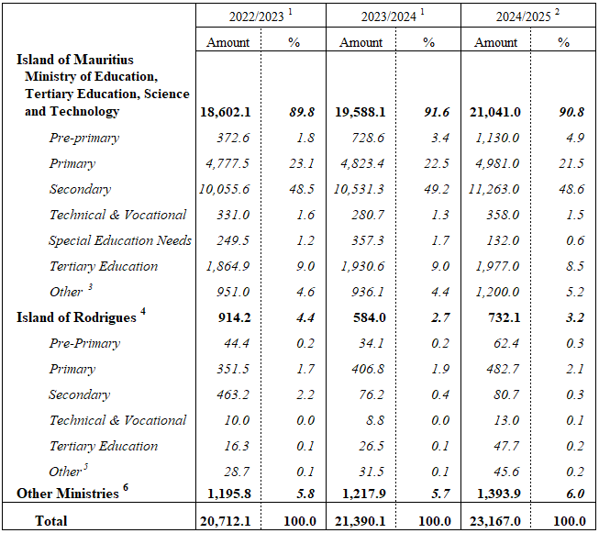¹ Revised
² Budget estimates
³ Includes policy and management costs for education and human resources and includes grant to parastatal bodies falling under the aegis of the Ministry of Education, Tertiary Education, Science and Technology
⁴ Expenditure on Education under Ministry of Rodrigues Vote
⁵ Administrative costs
⁶ Includes expenditure incurred by other Ministries to support education activities and training dispensed by all Ministries/Departments in line with the concept of lifelong learning
Note: Totals may not add up due to independent rounding of figures
The following tables together with the web version of this publication can be downloaded from Statistics Mauritius website at https://statsmauritius.govmu.org. From the homepage, click on ‘STATISTICS’ followed by ‘Statistics by subject’ then by ‘Education’ then select the publication under the heading ‘Economic and Social Indicators – Education Statistics, Year 2024’.
List of tables

Tables by Zone

1 PRE-PRIMARY EDUCATION
1.1 Distribution of pre-primary schools by zone and type of administration, 2024
1.2 Enrolment and personnel in pre-primary schools by zone and sex, 2024
2 PRIMARY EDUCATION
2.1 Distribution of primary schools by zone and type of administration, 2024
2.2 Enrolment in primary schools by zone, type of administration and sex, 2024
2.3 Enrolment in primary schools by zone and grade, 2024
2.4 Enrolment in primary schools by grade and sex, 2021/2022 - 2024
2.5 Enrolment in primary schools by type of administration, grade and sex, 2021/2022 - 2024,
Republic of Mauritius
2.6 Personnel in primary schools by zone and occupational status, 2024
2.7 Primary School Achievement Certificate (PSAC) Assessment by sex, 2023

3 SECONDARY EDUCATION - GENERAL
3.1 Distribution of secondary schools (general) by zone and type of administration, 2024
3.2 Enrolment in secondary schools (general) by zone and grade, 2024
3.3 Teaching staff in secondary schools (general) by zone and sex, 2024
3.4 Enrolment in secondary schools (general) by zone, type of administration and sex, 2024
3.5 Enrolment in secondary schools (general) by grade and sex, 2021/2022 - 2024
3.6 Enrolment in secondary schools (general) by type of administration, grade and sex,
2021/2022 - 2024, Republic of Mauritius
3.7 Cambridge School Certificate (SC) examination results by type of school administration and sex, 2020/2021 - 2023
3.8 Cambridge Higher School Certificate (HSC) examination results by type of school administration and sex, 2020/2021 - 2023
3.9 Enrolment in Mauritius Institute of Training and Development (MITD) Centres, Republic of Mauritius, 2023
3.10 Enrolment in Mauritius Institute of Training and Development (MITD) Centres by course level, year of study and sex (Full Time), Republic of Mauritius, 2023

4 SPECIAL EDUCATION NEEDS
4.1 Distribution of Special Education Needs (SEN) schools by zone and type of administration, 2024
4.2 Enrolment in Special Education Needs (SEN) schools by sex and zone, 2021/2022 - 2024
4.3 Enrolment in Special Education Needs (SEN) schools by age and sex, Republic of Mauritius, 2021/2022 - 2024
4.4 Number of pupils in Special Education Needs (SEN) schools by type of impairment and sex,
Republic of Mauritius, 2024
4.5 Personnel in Special Education Needs (SEN) schools by sex, Republic of Mauritius,
2021/2022 - 2024

5 ICT
5.1 ICT in pre-primary, primary and secondary schools - Republic of Mauritius, 2024

6 POST SECONDARY EDUCATION
6.1 Enrolment at Tertiary Education Level, both Locally and Overseas, by Source and Field of Study, as at December 2022
6.2 Enrolment at Tertiary Education Level, both Locally and Overseas, by Source and Field of Study, as at December 2023

Tables by District

7 PRE-PRIMARY EDUCATION
7.1 Distribution of pre-primary schools by district and type of administration, 2024
7.2 Enrolment and personnel in pre-primary schools by district and sex, 2024
8 PRIMARY EDUCATION
8.1 Distribution of primary schools by district and type of administration, 2024
8.2 Enrolment in primary schools by district, type of administration and sex, 2024
8.3 Enrolment in primary schools by district and grade, 2024
8.4 Personnel in primary schools by district and occupational status, 2024

9 SECONDARY EDUCATION - GENERAL
9.1 Distribution of secondary schools (general) by district and type of administration, 2024
9.2 Enrolment in secondary schools (general) by district, type of administration and sex, 2024
9.3 Enrolment in secondary schools (general) by district and grade, 2024
9.4 Teaching staff in secondary schools (general) by district and sex, 2024

10 SPECIAL EDUCATION NEEDS
10.1 Distribution of Special Education Needs (SEN) schools by district and type of administration, 2024
10.2 Enrolment in Special Education Needs (SEN) schools by sex and district, 2021/2022 - 2024
Definition of Indicators

Statistics Mauritius
Ministry of Finance, Economic Planning and Development
Port Louis

23 September 2024

Contact Person
Mrs F. Koussa (Statistician/Senior Statistician)
Statistics Unit
Ministry of Education, Tertiary Education, Science and Technology
10th Floor, NPF Bldg, Rose Hill
Tel: (230) 454 1411 Ext 4030
Email: fkoussa@govmu.org

