Quarterly Index of Industrial Production (QIIP)
Second Quarter 2024
(Base year: 2018 =100)

1. Introduction
The Index of Industrial Production shows the evolution of the volume of output of the Industrial Sector, which covers “Mining and quarrying”, “Manufacturing”, “Electricity, gas, steam and air conditioning supply” and “Water supply; sewerage, waste management and remediation activities”. The value added of these activities accounts for around 15% of Gross Value Added (GVA). The index compiled on a quarterly basis is one of the most important industrial short-term indicators, which aims at measuring, on a quarterly basis, the changes in the volume of industrial output.
2. Contents of publication
This issue of “Economic and Social Indicators” presents the quarterly indices for the first quarter of 2019 to the second quarter of 2024.
The indices are given separately for the four sections, namely, “Mining and quarrying”, “Manufacturing”, “Electricity, gas, steam and air conditioning supply” and “Water supply; sewerage, waste management and remediation activities”. Within “Manufacturing”, estimates by broad group, namely “Export Oriented Enterprises” (EOE), “Non-EOE” and “Sugar milling” as well as by main industry group are given. Wherever possible, the annual averages of the quarterly indices have been worked out and included in the tables. It is to be noted that, due to incomplete data, indices for the second quarter of 2024 are provisional and published at section and broad group level only. They are therefore subject to revision in future issues of the Economic and Social Indicators on QIIP.
The published indices are not seasonally adjusted. The user is therefore advised to base comparisons for a particular quarter of a year on the corresponding quarter of the previous year.
The methodology used for the computation of QIIP including its limitations, are given at Annex.
3. Overall index - Industrial Sector
In the second quarter of 2024, the overall index of industrial production increased by 6.5% compared to the previous quarter and by 3.3% when compared to the corresponding quarter of 2023.
The index for the year ending second quarter 2024, which is the average of quarterly indices for the period under review, grew by 2.4%. This is explained by expansions in “Electricity, gas, steam and air conditioning supply” (+5.4%), “Water supply; sewerage, waste management and remediation activities” (+3.1%) and “Manufacturing” (+2.3%) offset by a decreased in “Mining and quarrying” (-5.5%).

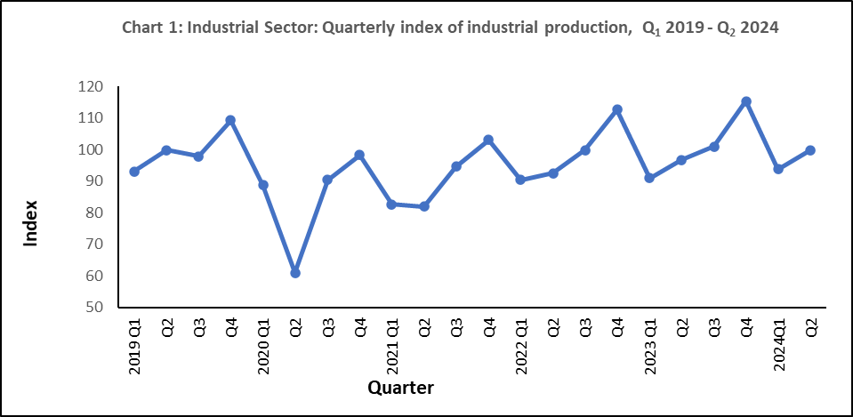

4. Changes by section

4.1 Mining and quarrying

“Mining and quarrying” comprise activities relating to quarrying of decorative stones, sand and salt extraction as well as stone crushing and represents only 2% of the output of the industrial sector. In the second quarter of 2024, real output increased by 27.6% compared to the previous quarter and by 4.6% compared to the corresponding quarter of 2023. However, in year ending second quarter 2024, a negative growth of 5.5% was noted (Table 1).

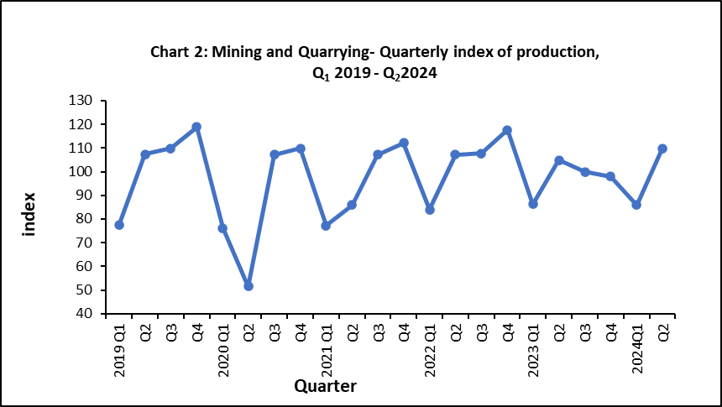

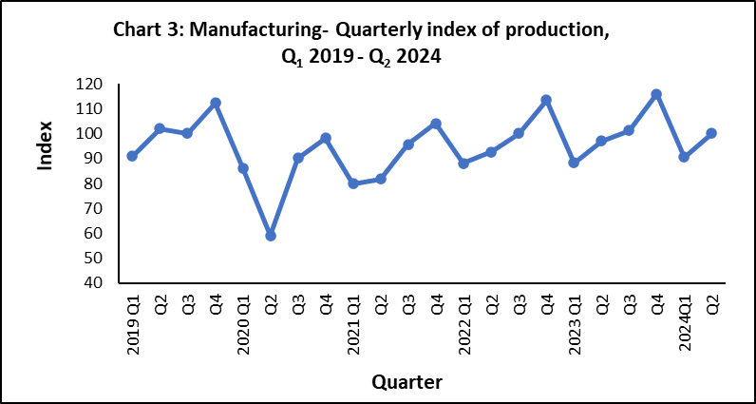
4.2 Manufacturing
Manufacturing output, which covers the production of a wide range of goods, represented 85% of the output of the industrial sector in 2018. For analysis purposes, “Manufacturing” is broken down into the following broad groups:
- Sugar milling representing 1.3% of manufacturing output
- EOE (40%)
- Non–EOE (59%)

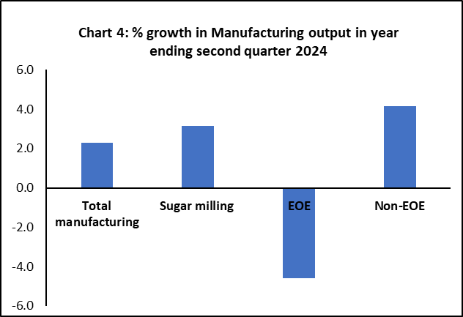
Manufacturing output in the second quarter of 2024 grew by 10.7% compared to the previous quarter and by 3.2% compared to the corresponding quarter of 2023 (Table 1). In year ending second quarter 2024, a growth of 2.3% was noted in real manufacturing output. This is due to positive growths in “Non-EOE” (+4.2%) and in “Sugar milling” (+3.1) partly offset by negative growth of 4.6% in “EOE”. The performances of “EOE” and “Non-EOE” by detailed industry group up to first quarter 2024 are analysed separately in Section 5.
4.3 Electricity, gas, steam and air conditioning supply
“Electricity, gas, steam and air conditioning supply” accounts for 10.5% of the output of the industrial sector. In the second quarter of 2024, real output of this sector decreased by 27.1% compared to the previous quarter and increased by 4.8% compared to the corresponding quarter of 2023. In year ending second quarter 2024, production grew by 5.4% (Table1).

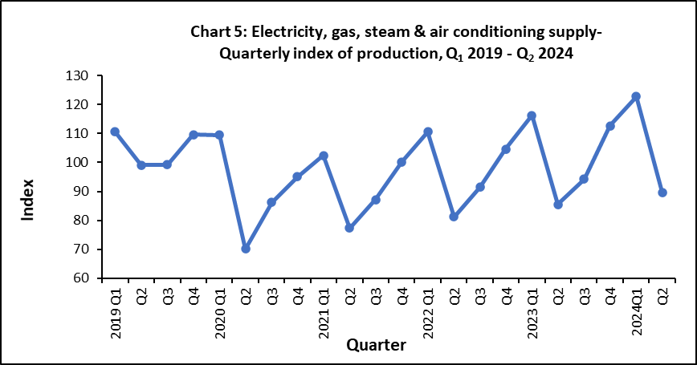

4.4 Water supply; sewerage, waste management and remediation activities
“Water supply; sewerage, waste management and remediation activities” accounts for around 2.4% of the output of the industrial sector. In the second quarter of 2024, real output of this sector increased by 5.9% compared to the previous quarter and by 3.9% when compared to the corresponding quarter of 2023. In year ending second quarter 2024, real output went up by 3.1% (Table1).
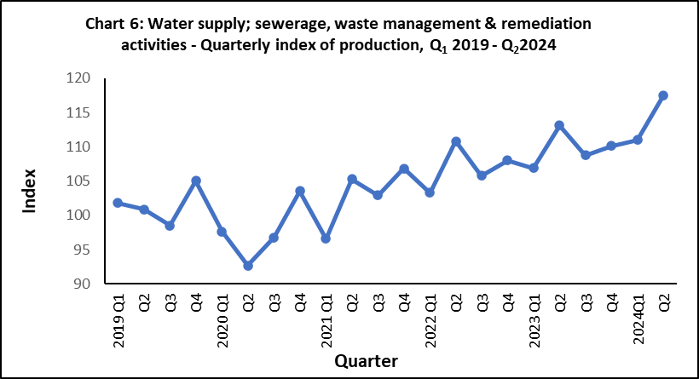

5. Changes by broad group
5.1 Export Oriented Enterprises (EOE)
Real output of EOE sector increased by 9.4% in the second quarter of 2024 compared to the previous quarter but contracted by 0.2% compared to the corresponding quarter of 2023. In year ending second quarter 2024, the EOE sector decreased by 4.6% (Table 1).

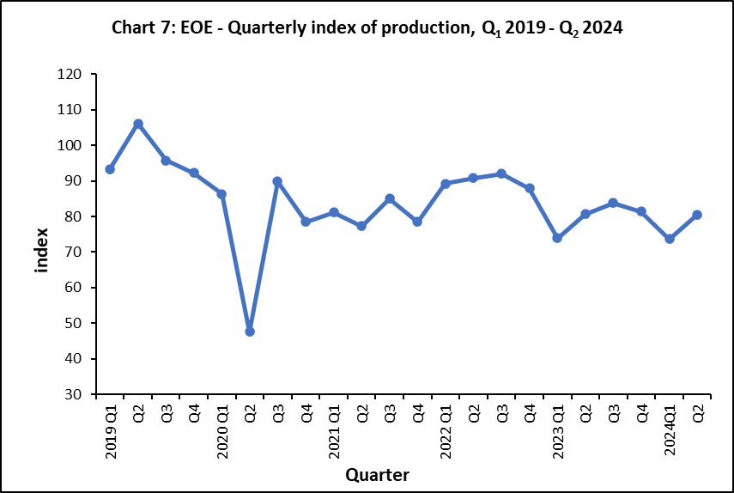

Lower-level indices for the second quarter of 2024 are not yet available. However, an indication of the annual performance at sub-group levels can be obtained by comparing indices available for year ending first quarter 2024 to those for year ending first quarter 2023 (Table 3). Real output of “Wearing apparel”, the most important industry group within the EOE, declined by 16.2% and that of “Textiles” contracted by 21.0%. These two sub-groups account for almost 63% of the total weight allocated to the EOE. Expansions were noted in “Jewellery” (+10.1%) and “Other manufacturing” (26.8%) While negative growths of 10.4% were observed in both “Food products” and “Computer, electronic and optical products”. Details of changes of selected sub-groups are shown in Chart 8.
Year and quarter

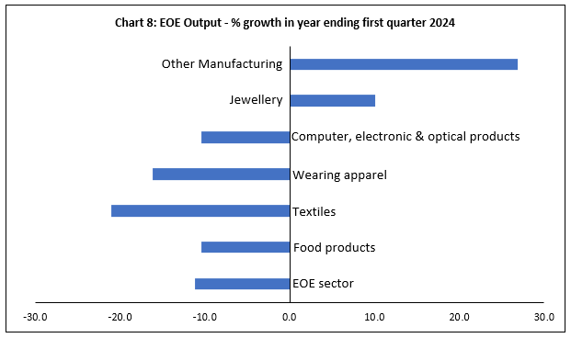

5.2 Non-EOE excluding “Sugar milling”
Chart 6
In the second quarter of 2024, the real output of Non-EOE sector increased by 10.2% compared to the previous quarter and by 3.4% when compared to the corresponding quarter of 2023. In year ending second quarter 2024, it grew by 4.2% (Table 1).

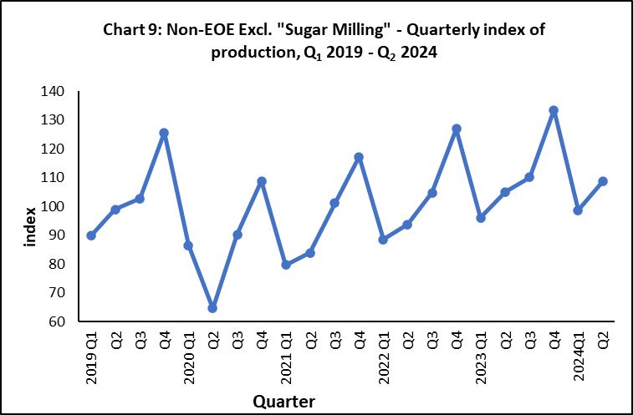

The annual performance at sub-group level is obtained by comparing the detailed indices available for year ending first quarter 2024 to those for year ending first quarter 2023 (Table 4). Expansions were noted in “Food products excluding sugar” (+6.0%), “Beverages” (+7.5%), “Textiles & wearing apparel” (+0.1%), Chemicals & chemical products” (+3.4%), “Plastic and non-metallic product” (+2.4%), “Basic metals and fabricated metal products” (+2.0%), “Furniture” (+25.7), and “Other manufacturing” (+12.0%). while a negative growth was noted in “Printing and reproduction of recorded media” (-0.7%), as illustrated in Chart 10.

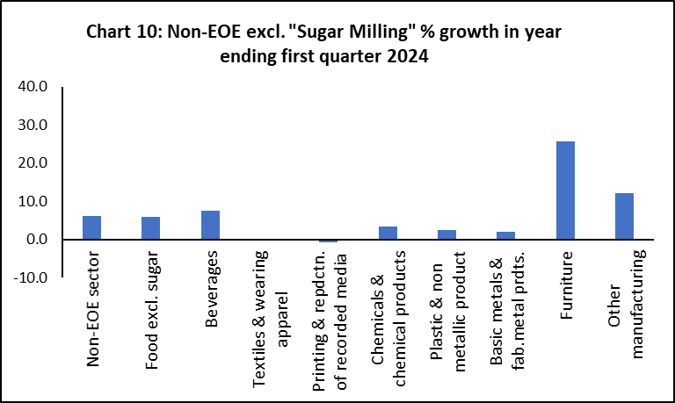

Statistics Mauritius
Ministry of Finance, Economic Planning and Development
PORT LOUIS
20 September 2024

Contact Person:
Mrs. K.Runjeet
Manufacturing Unit
Statistics Mauritius
5th Floor LIC Building
Port Louis
Tel : (+230) 208 1800
E-mail : sm-qiip@govmu.org

Annex

Quarterly Index of Industrial Production (QIIP)

Methodology for the computation of the QIIP

1. Introduction
The Index of Industrial Production shows the movement of the volume of output of the Industrial Sector. Prior to 2001, the index was calculated annually and published in the Digest of Industrial Statistics. Following the needs expressed by various institutions, both public and private, Statistics Mauritius started to compile and disseminate the index on a quarterly basis as from the first quarter of 2001. The compilation and dissemination of high frequency (monthly/quarterly) Index of Industrial Production is also one of the requirements of the International Monetary Fund (IMF) Special Data Dissemination Standard (SDDS).
2. Objectives
The Quarterly Index of Industrial Production (QIIP) is one of the most important industrial short-term indicators which aims at measuring, on a quarterly basis, the ups and downs of the volume of industrial output with a special focus on detecting, as early as possible, the turning points of the business cycle. This enables planners, decision makers and the business community at large to be aware of any sign of change in the progress of the economy in order to take appropriate and timely measures.
The index provides useful and reliable inputs for the estimates of quarterly and annual value added for the Industrial Sector.
3. Concepts and definitions
Basically, the Index of Industrial Production is a measurement of the change in real value added (value added at constant price). Value added is defined as the difference between output and input. Computation of quarterly value added at current and constant prices requires data on inputs and outputs in the different industry groups within a given time frame. In the absence of the detailed data required, an approximation of the index is based on change in deflated turnover, physical quantity of goods produced and other indicators of change in real value added generated by industrial enterprises.

The indicators/methods used in compiling QIIP and data sources by sector/industry group are given at section 5.
4. Scope and classification
The indices are compiled by industry group according to the National Standard Industrial Classification Rev.2 (NSIC Rev.2), based on the UN International Standard Industrial Classification Rev.4 (ISIC Rev.4).
The Quarterly Index of Industrial Production covers the Industrial Sector, which comprises the following sections of NSIC Rev.2:
Section B: Mining and quarrying;
Section C: Manufacturing;
Section D: Electricity, Gas, Steam and Air Conditioning Supply; and
Section E: Water Supply; Sewerage, Waste Management and Remediation Activities

5. Indicators and data sources
The table below shows price and volume indicators used as well as corresponding data sources by industry group.

Sector/Industry group | Indicators used | Data sources
Mining and quarrying | Value added deflated by relevant components of Consumer Price Index (CPI) | - Quarterly survey of establishments  - Monthly and quarterly data from VAT Department
Industry groups within manufacturing (excluding sugar milling) | Turnover data deflated by:  (i) Export Price Index (EPI) for EOE  (ii) Producer Price Index – Manufacturing (PPI-M) for Non-EOE | - Monthly and quarterly data from VAT Department  - Quarterly exports statistics  - Quarterly Stock Survey.  - Building permits statistics for small establishments engaged in the manufacture fabricated metal products.
Sugar milling | Gross output deflated by sugar prices and inputs deflated by a weighted price index based on relevant components of CPI. | - Annual survey of establishments  - Production of sugar and prices from Mauritius Sugar Syndicate
Electricity, gas, steam and air conditioning supply | Volume of electricity produced | - Quarterly returns from Central Electricity Board and Independent Power Producers (IPPs)
Water supply; sewerage, waste management and remediation activities | Volume of water sold used as volume indicator for water supply and waste management services;  Value added deflated by relevant components of CPI for other activities. | - Quarterly returns from Central Water Authority  - Monthly and quarterly data from VAT Department

6. Weights

For the manufacturing sector the weights are computed separately for Export Oriented Enterprises (EOE) and Non-EOE sub-sectors. Prior to 2008, the weight of the Non-EOE sub-sector was based on large establishments (engaging 10 or more persons) only. As from 2008, value added of small establishments (engaging less than 10 persons) has been considered in the calculation of the weights.

7. Reliability of the indices
The practical difficulties in compiling an index showing the evolution of value added at constant prices requires a number of approximation methods which are listed at section 5. Each of these methods has a number of constraints, the main ones being:

Deflated turnover:
- Quality of the data from the different sources. The output figures in a given industry group may include output of some other activities (secondary activities) which should have been classified elsewhere;
- Time-lag between production and sales may lead to a late identification of a turning point in the business cycle;
- Turnover data need to be adjusted for changes in stocks for a true picture of production. This exercise is partly done, based on available information from the Quarterly Stock Survey;
- The quality of the index is subject to the precision and relevance of the different price indices used for deflation; and
- The base year ratio of value added to gross output is maintained throughout the period covered by the indices, when, in fact, the ratio may change as a result of technological changes, productivity changes as well as seasonal variation in the production structure.

Volume of production:
- does not take account of quality changes

Indirect Indicators
- In the absence of data for small establishments, indirect indicators such as household consumption expenditure and building permits are used for activities concerned

In spite of the above limitations, it is observed that the index shows relative consistency and is of reliable quality for the measurement of quarterly and other changes. However, great care should be taken when interpreting small changes at the more detailed level.

8. Index calculation
The QIIP is calculated according to a modified Laspeyre's index as follows:

∑ W_{i} (Q_{it}/Q_{io})
I_{t} = X 100
∑ W_{i}

with I_{t} = index for quarter t
W_{i} = weight for activity i
(Q_{it}/Q_{io}) = is the growth in real value added of activity i in quarter t relative to the base year as estimated by an appropriate proxy indicator

