Gender Statistics - 2023

1. Introduction
This is the fifteenth issue of Economic and Social Indicators (ESI) on gender statistics. It presents a portrait of women and men in the Republic of Mauritius and includes their demographic profile, health, family status, educational attainment and labour force characteristics.
The ESI is based on latest available sex disaggregated data from administrative sources, household surveys and censuses. Some of the statistics presented therefore refer to years earlier than 2023.

2. Highlights
- In 2023, the population comprised 637,950 women compared to 622,817 men. Women outnumbered men by 15,133 as they lived on average 6.8 years longer than men.
- Women continue to give birth to fewer children than in the past.
- Both men and women are getting married at an older age and the age difference between them is narrowing over time.
- More women than men were enrolled in tertiary institutions.
- Only 11.4% of working women were heads of business compared to 25.2% among men.
- Unemployed women were more qualified than their male counterparts: 21.3% women possessed tertiary qualifications compared to 18.1% men.
- Women are largely under-represented in decision making at higher sphere of society: the number of female ministers was only 4 out of 23.
- The proportion of women in the most senior positions in government services (Senior Chief Executive, Permanent Secretary, Deputy Permanent Secretary, Director, Manager, Judge and Magistrate) was 38.9%.
- Among victims of domestic violence, 79.8% were women and 20.2% were men.
- Some 4,906 men were victims of homicides and assaults compared to 5,282 women whereas 650 women were victims of sexual violence and sexual exploitation compared to 59 men.
- Women participated less than men in sports as high level athletes (62.6% men against 37.4% women).
- According to the Global Gender Gap Index (GGI) of the World Economic Forum, Mauritius was ranked 98 out of 146 countries worldwide. The GGI measures gender equality across four key areas, namely: (a) economic participation and opportunity, (b) educational attainment, (c) health and survival and (d) political empowerment.

3. Population
Prior to 1950 women were fewer than men in number. However, the female population has been growing at a faster rate such that in the 50’s there were almost equal numbers of men and women. This balance in the population has been maintained for some 40 years. As from 1990, women have been increasingly outnumbering men over the years.
In 2023, there were 15,133 more women than men. Out of a total population of 1,260,767 there were 637,950 women against 622,817 men, i.e., 98 men for every 100 women (Table 1).
Though women were more numerous in the total population, this was not the case in all age groups. At the younger ages (under 50 years), men were more numerous, mainly due to more births of baby boys than girls. In 2023, there were an equal number of male and female, i.e for 107 male births for every 100 female births.
At ages 50 years and above, women outnumbered men and their proportion increased at higher ages. The male-female ratio stood at around 103 for those aged between 40 to 49 years compared to around 55 among those aged 80 years and over; there were around 2 women for every man in this age group. The main reason for this imbalance is that women live longer than men.

Table 1 – Population by age and sex, Republic of Mauritius, 1st July 2023
Women have a higher life expectancy than men. In fact, women live some 6.8 years longer than men. In 2023, life expectancy at birth for women was 77.0 years compared to 70.2 years for men. Life expectancy at birth has improved over the years for both men and women and the gap was on a decreasing trend and remained around 6.9 years since 2019 (Chart 1).

Chart 1 - Life Expectancy at birth, Republic of Mauritius, 2003 – 2023
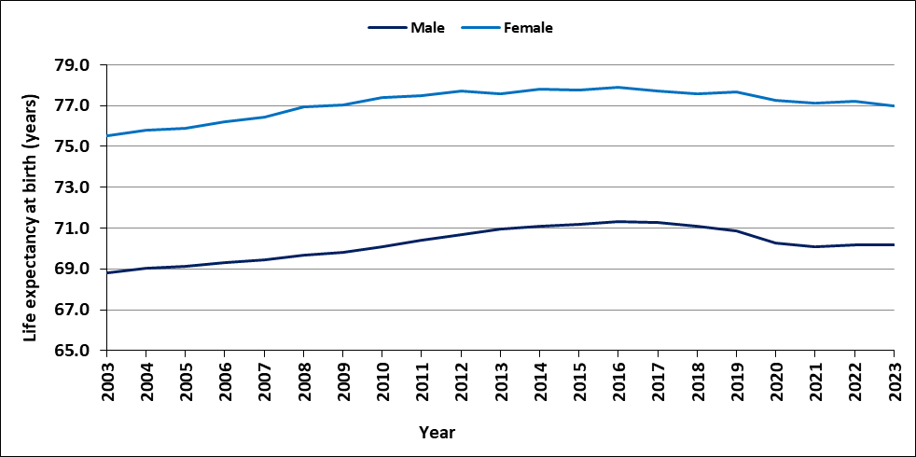
Source: Statistics Mauritius

4. Fertility and Contraceptive Use
Women continued to give birth to fewer children than in the past. The total fertility rate, which is an indication of the average number of babies born to a woman during her childbearing period, has maintained a general decreasing trend over the last 20 years. During that period, the total fertility rate dropped from 1.9 in 2003 to 1.4 in 2023. (Chart 2).
Chart 2 - Total Fertility Rate, Republic of Mauritius, 2003 – 2023
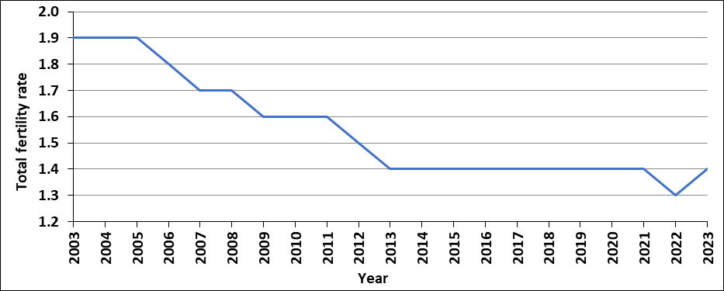
Source: Ministry of Health and Wellness
In 2003, women in the age brackets 20-24 years and 25-29 years had the highest fertility with 112 births per 1,000 women of those age groups (Chart 3). In 2023, the peak fertility rate is observed in the age bracket 30-34 years with 80 births per 1,000 women in that age group. One of the reasons explaining this shift is that women are getting married at an older age.
Chart 3 – Fertility Rate by age of mother, Republic of Mauritius, 2003 and 2023
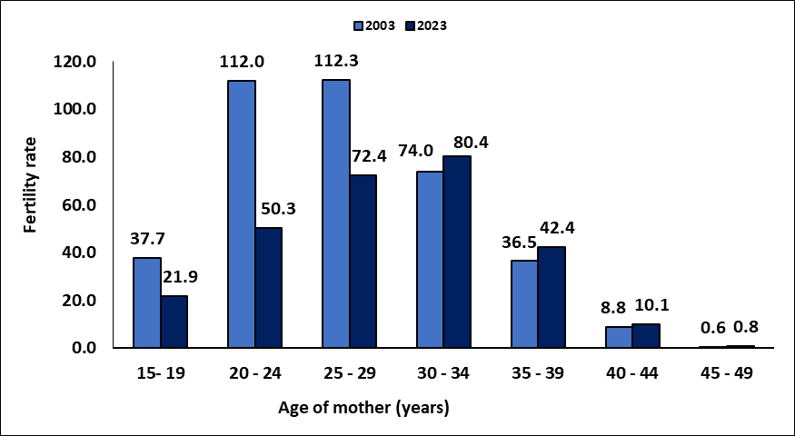
Source: Ministry of Health and Wellness
In 2023, Government Family Planning Clinics, Mauritius Family Planning & Welfare Association and “Action Familiale” registered a total of some 56,332 current users of contraceptive methods in the Island of Mauritius, an increase of 292 compared to 56,040 in 2022 (Chart 4).
Chart 4 – Number of current users of contraceptives, Island of Mauritius, 2013 and 2023
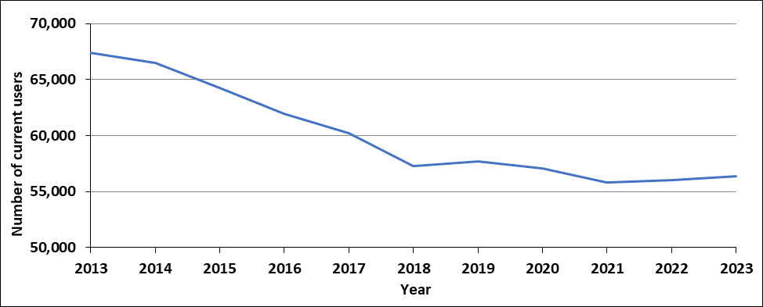

Source: Ministry of Health & Wellness
New acceptors of contraceptive methods registered in 2023 numbered 3,194, of whom 482 had sympto-thermal. A declining trend was observed in the number of new acceptors from 5,718 in 2013.
Among the new acceptors in 2023, 3-month injectable (24.0%), pill (21.2%) and tubal ligation (17.2%) were the three most preferred methods of contraception while for current users sympto-thermal (47.9%) was the preferred method (Table 2).

Table 2 – Method of family planning, Island of Mauritius, 2023
Source: Ministry of Health and Wellness

5. Family Status
While marriage rate is declining, divorce rate is on the rise. The marriage rate, i.e., the number of persons married per 1,000 mid-year population, fell from 17.8 in 2003 to 13.7 in 2023. The number of divorced persons per 1,000 mid-year population increased from 2.0 in 2003 to 4.3 in 2023 (Chart 5).

Chart 5 – Marriage and Divorce Rate, Republic of Mauritius, 2003 – 2023

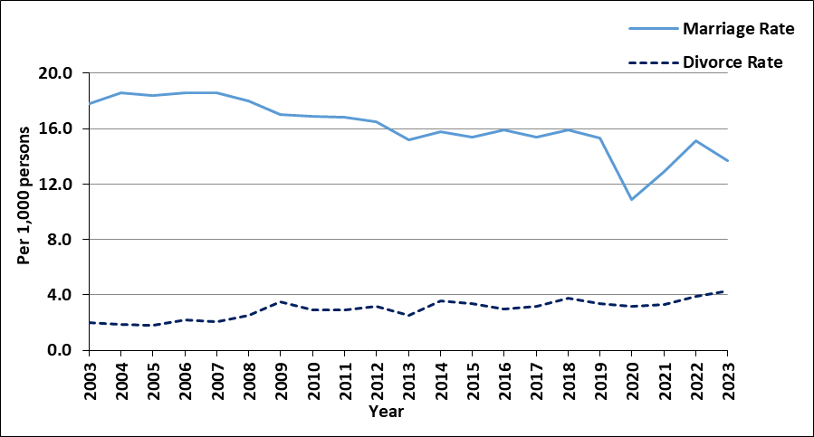

Source: Statistics Mauritius
Generally, women tend to marry men who are older than them. However, over the past 20 years the age difference between husband and wife narrowed from 3.9 years in 2003 to 3.1 years in 2023 (Chart 6).
The average age at first marriage has been gradually increasing over the years for both women and men. The average age at first marriage for women increased from 27.2 years in 2013 to reach 29.0 years in 2023, while that for men increased from 30.0 to 32.1 during the same period.

Chart 6 – Average age at first marriage, Republic of Mauritius, 2013 – 2023
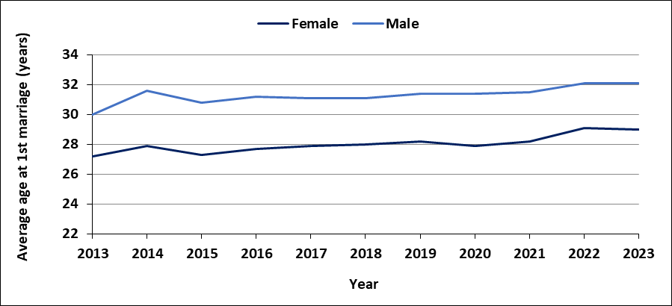
Source: Statistics Mauritius
Of the 2,696 divorces granted by the Supreme Court in 2023, women were the petitioners in 33.9% of the cases (Table 3).

Table 3 – Divorce by petitioner, Republic of Mauritius, 2022 & 2023
Source: The Judiciary

An analysis of the divorce statistics by duration of marriage indicate that couples had the highest tendency to divorce within the 5-10 years duration of marriage (Table 4).

Table 4 – Number of divorces by duration of union, Republic of Mauritius, 2023
Source: The Judiciary
Some 33.1% of couples who divorced in 2023 did not have any children, while 56% of them had 1 to 2 children. There were 61 couples with 4 or more children (Table 5).
Table 5 – Number of dependent children ¹, Republic of Mauritius, 2023

¹ dependent children are the living children who are dependent on either of the divorcees at the time the divorce petition is filed
Source: The Judiciary

6. Health
Since the first cases of HIV/AIDS were registered in October 1987, the number has been increasing to reach 9,213 in December 2023, of whom 28.6% were women.
During 2023, 382 new cases of HIV/AIDS were registered among Mauritians and the proportion of women among the new cases was 36.6% compared to 41.9% in 2013.

Chart 7 – New HIV/AIDS cases, Republic of Mauritius, 2013 – 2023
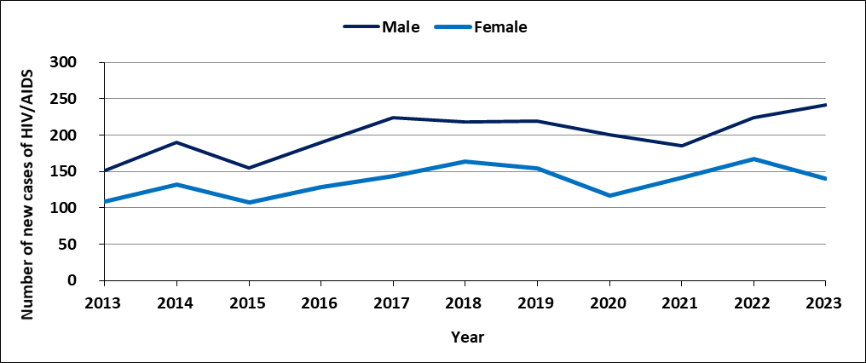
Source: Ministry of Health and Wellness
7. Mortality
Though women are more numerous than men in the population, there are fewer deaths among women than among men. In 2023, 6,585 men compared to 5,254 women died (Chart 8). The crude death rate for 2023 was 10.6 for man and 8.2 for woman.

Chart 8 – Number of deaths by sex, Republic of Mauritius, 2003 – 2023
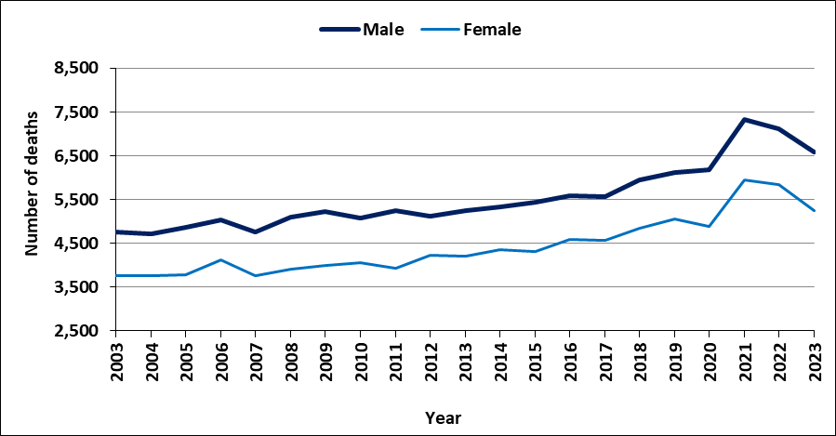
Source: Civil Status Division
In 2022, heart disease and diabetes mellitus were the leading causes of deaths among women and men. Diabetes mellitus and heart disease were respectively responsible for 22.8% and 20.6% of deaths among women and 21.0% and 21.2% of deaths among men. Cancer and diseases of the respiratory system were responsible for 10.1% and 8.5% of deaths among men. Causes of death specific to women, such as breast and uterus cancer, were responsible for 4.9% deaths while maternal deaths accounted for another 0.1%. Compared to men, women were more likely to die of hypertensive diseases and neoplasms but less likely to die of diseases of the liver, and to commit suicide (Table 6).
Table 6 – Deaths (%) by cause and sex, Republic of Mauritius, 2022

Napp: Not Applicable
Source: Ministry of Health and Wellness
The risk of a woman dying as a result of pregnancy or childbirth during her lifetime has generally been declining over the years with slightly higher level of maternal deaths in recent years. From 2002 to 2006, the maternal mortality ratio increased from 0.15 maternal death per 1,000 live births to 0.17. After 2006, the maternal mortality ratio was on a rising trend to reach 0.66 in 2013, but then decreased to reach 0.46 in 2016. The maternal mortality ratio increased again in 2017 to 0.74 and it dropped to 0.39 in 2018, then rose to 0.62 in 2019 and fell to 0.41 in 2022 (Chart 9).

Chart 9 – Maternal Mortality Ratio, Republic of Mauritius, 2002 – 2022
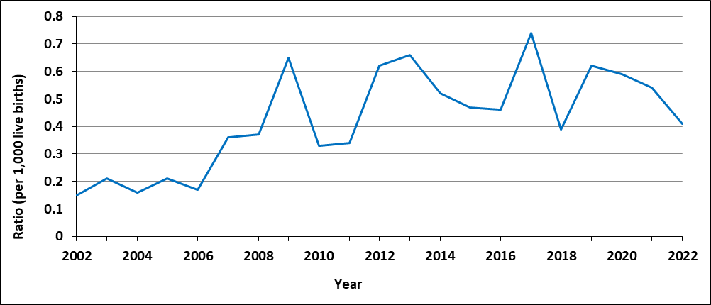
Source: Ministry of Health and Wellness

8. Education
Boys and girls are equally likely to go to pre-primary and primary schools.The Gender Parity Index (GPI) which measures the relative educational participation of boys and girls was 1.0 for pre-primary and primary indicating no disparity (Table 7).
Table 7 – Gross Enrolment Rate (%) by sex, Republic of Mauritius, 2023
Source: Ministry of Education, Tertiary Education, Science and Technology
At the end of primary, girls generally perform better than boys at the Primary School Achievement Certificate (PSAC) examinations. In 2023, the pass rate for girls was 86.0% against 78.1% for boys.
At secondary level, girls are more likely to be enrolled than boys. The Gender Parity Index (GPI) in secondary enrolment, which measures the relative access to secondary education of boys and girls was 1.1 in 2023 showing a disparity in favour of girls.
Girls generally perform better than boys at Higher School Certificate (HSC) examinations (Table 8).

Table 8 – Pass Rate (%) at HSC, Republic of Mauritius, 2013 – 2023
Source: Ministry of Education, Tertiary Education, Science and Technology
Consequently, more women than men are enrolled in tertiary institutions. Tertiary enrolment for both girls and boys increased over time but with a widening gap in favour of girls.Tertiary enrolment, as measured by Gross Tertiary Enrolment Rate (GTER), rose from 24.3% in 2003 to 58.2% in 2023 for women, and from 22.8% to 41.0% for men during the same period (Chart 10). In 2023, women enrolled in public, private and overseas tertiary institutions numbered 26,345 representing 57.6% of the student population which stood at 45,771.
Chart 10 – Gross Tertiary Enrolment Rate (GTER), Republic of Mauritius, 2003 – 2023
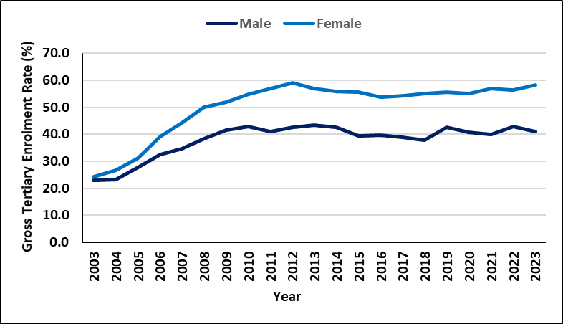
Source: Ministry of Education, Tertiary Education, Science and Technology
Both men and women were mostly enrolled in Bachelor Degree (Table 9). There were fewer women than men at PhD, MPhil and DBA² levels, 331 women against 336 men in 2023.
Table 9 – No. of student enrolled¹ in tertiary institutions by level, 2023
¹Enrolment in public and private institutions, including students studying through Distance Education mode but excluding overseas students
² Doctor of Business Administration
Source: Higher Education Commission

The most popular field of study for men was Information Technology (2,500) followed by Administration/Management (2,200) and Business and Commerce (1,600).
On the other hand, the most popular field of study for women was Administration/Management (3,800) followed by Education (3,500) and Accounting (2,600).
Women were under-represented in science-related field such as Engineering (300 against 1,200 men) and Information technology (1,200 against 2,500 men) whereas men were under-represented in Education (900 against 3,500 women) and Languages (200 against 800 women) (Chart 11).

Chart 11 – Number of students enrolled ¹ in tertiary institutions by field of study, 2023
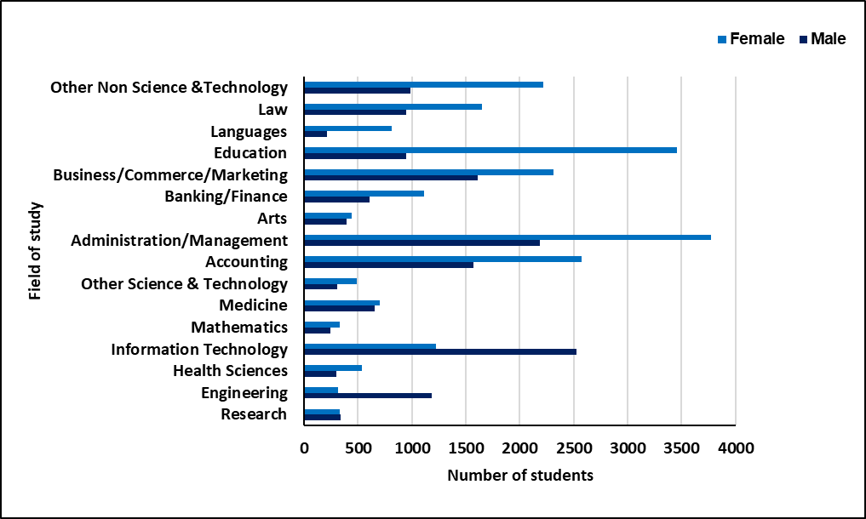
¹Enrolment in local public and private institutions, excluding overseas students
Source: Higher Education Commission
9. Economics Characteristics
In 2023, the active Mauritian population (aged 16 years and above) stood at 592,800 with 344,300 men and 248,500 women. Some 41.9% of women of working age were in the labour force compared to 58.1% of men.
The number of persons aged 16 years and over not forming part of the labour force (population outside the labour force) stood at 422,200 (147,500 males and 274,700 females).
During the period 2013 to 2023, male activity rate was consistently higher than female activity rate. However, the gap has been narrowing over time as the activity rate for men has been decreasing over the years from 75.1% in 2013 to 70.0% in 2023, and that of females ranged from 45.4% to 47.5% during the same period (Chart 12).

Chart 12 – Activity rate (%) by sex, 2013 – 2023
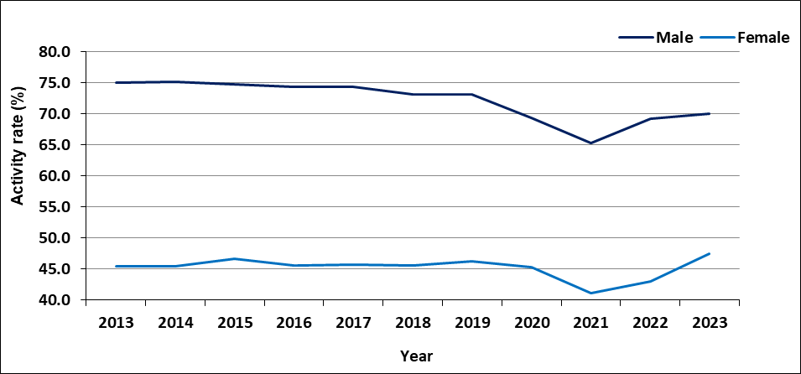
Source: Continuous Multi-Purpose Household Survey (CMPHS), Statistics Mauritius
Men and women have a similar age pattern of economic activity, i.e., less active at the younger and older age-groups (Chart 13). Over the years, the shape of the curve for female activity rate by age has been tending towards that of the male.

Chart 13 – Activity rate (%) by age-group and sex, 2013 and 2023
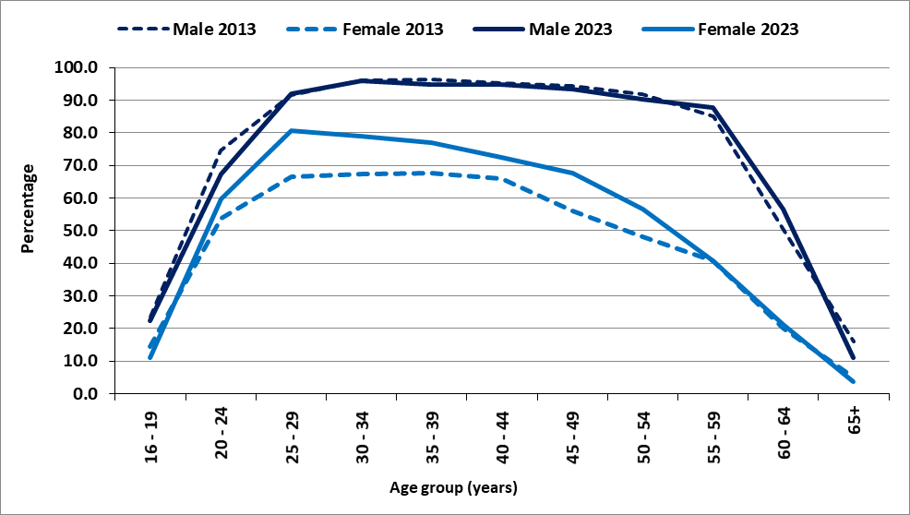
Source: Continuous Multi-Purpose Household Survey (CMPHS), Statistics Mauritius
Table 10 – Employed persons by industrial sector and sex, 2023
Source: Continuous Multi-Purpose Household Survey (CMPHS), Statistics Mauritius

Both women and men had a high proportion of their working population in the tertiary sector (covering trade, accommodation service, transportation, health, education and other service industries), 66.4% for men and 84.5% for women. The secondary sector (covering manufacturing, electricity & water and construction) accounted for 27.1% of the working men and 12.0% of the working women. The primary sector (comprising agriculture and mining & quarrying) employed 6.5% and 3.5% of the working men and women respectively (Table 10).

Table 11 – Distribution (%) of employed population by employment status and sex, 2023

Source: Continuous Multi-Purpose Household Survey (CMPHS), Statistics Mauritius

Women were more likely than men to be employees, with 85.1% of the female workforce in that employment status as compared to 73.4% for the male workforce. Women were also less likely than men to work for themselves. Some 25.2% of working men were employers or own account workers compared to 11.4% for women (Table 11).
In spite of being fewer in the labour force (representing only 41.9%), women were over-represented among the unemployed; they made up 57.4% of the total unemployed. Unemployed women numbered 21,600 in 2023 compared to 16,000 men. Female unemployment rate stood at 8.7%, much higher than the rate of 4.6% for male. The disparity between male and female unemployment rate was highest in the lower age-groups; the difference was nearly 5 percentage points among the unemployed below 25 years and around 1.0 percentage point among those aged 50 years and above (Chart 14).
Chart 14 – Unemployment rate (%) by age group and sex, 2023
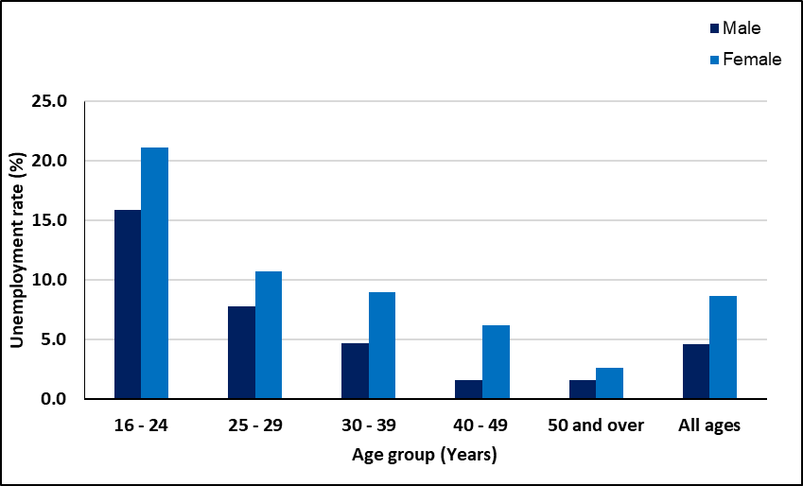
Source: Continuous Multi-Purpose Household Survey (CMPHS), Statistics Mauritius
Unemployed women were generally more qualified than their male counterparts; 6,800 (31.5%) of them possessed the School Certificate (SC) or Higher School Certificate (HSC) against 3,700 males (23.1%). At tertiary level also, there were 4,600 (21.3%) unemployed women compared to 2,900 (18.1%) unemployed men (Table 12).
Table 12 – Unemployed persons by educational attainment, 2023
Source: Continuous Multi-Purpose Household Survey (CMPHS), Statistics Mauritius
10. Poverty
Poor households are households found below the relative poverty line estimated from the Household Budget Survey (HBS). The poverty lines for 2012 and 2017 were estimated at Rs 5,652 and Rs 7,509 respectively (Table 13).
Women are more likely than men to live in poverty. In 2017, 11.0% of the female population was living below poverty line compared to 9.6% for the males. Out of 131,300 persons in relative poverty, 70,800 were females and 60,500 were males.
The 2017 HBS showed that poverty was more likely to be among female headed households than male headed households (15.9% compared to 7.6% in 2017).

Table 13 – Number of persons in relative poverty, 2012 and 2017
Source: Household Budget Surveys, Statistics Mauritius

11. Social benefits and inmates of infirmaries
As at June 2023, out of 259,747 Basic Retirement pensioners, 55.0% were women (Table 14). During that period, the number of women receiving Basic Retirement Pension outnumbered their male counterparts by 26,155 and this number is expected to be around 27,500 by 2063. Both male and female pensioners were concentrated in the age-group 60 to 69 years. It is to be noted that 64.6 % of the pensioners in the age group 90 to 99 were women. For every male centenary pensioner, there were 7 female centenary pensioners.
There were 17,753 recipients of Basic Widows Pension as at June 2023, a decrease of 16.7% compared to 21,323 in 2000. A large majority (67.3%) of widows were aged between 50 and 59 years.
Invalids pensioners numbered 30,728 as at June 2023, with a higher proportion of men (54.0%) compared to women (46.0%).
As at June 2023, some 398 children received Basic Orphans Pension, amongst whom 57.0% were girls.

Table 14 – Number of beneficiaries of selected benefits, 2000 and 2023
NA: Not available; Napp: Not applicable
Source: Ministry of Social Integration, Social Security and National Solidarity

In 2023, some 57.7% of the 631 inmates living in infirmaries and orphanages registered at the Ministry of Social Integration, Social Security and National Solidarity (Social Security Division), were women. The women residents were older than men with 59.1% aged 70 years and over compared to 31.1% for men (Chart 15).

Chart 15 – Number of Inmates in infirmaries and orphanages by age group and sex, 2023
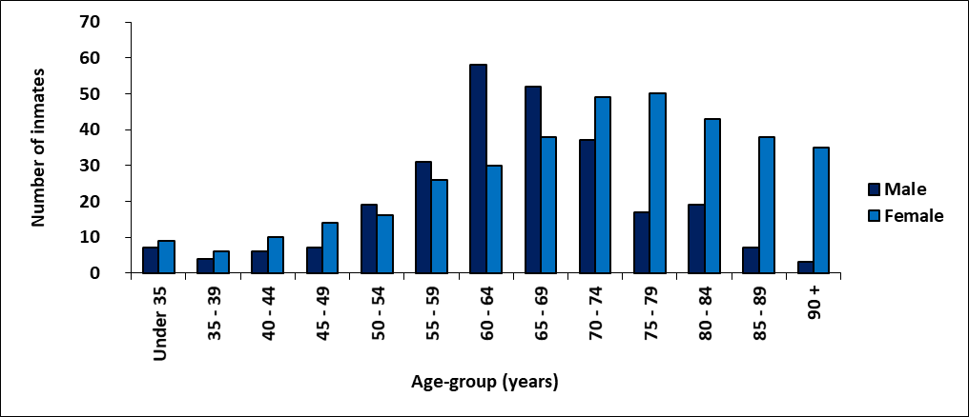
Source: Ministry of Social Integration, Social Security and National Solidarity

Both women and men inmates were prone to mental disease (33.5% and 40.3%) while more men inmates than women suffered from diabetes (13.0% compared to 8.0% among women) (Table 15).

Table 15 – Distribution (%) of inmates in infirmaries and orphanages by disability, 2023
Source: Ministry of Social Integration, Social Security and National Solidarity

12. Women in decision making
Women continue to be underrepresented in decision-making position in Government cabinet. The share of women among cabinet ministers was 17.4% in 2023 (4 out of 23 Ministers).
Even though the proportion of women elected at Municipal Council elections has increased over the years, the number of female mayors remained low. In 2023, there were two female mayors in the five municipalities.
More women are holding senior positions in government services. The proportion of women in the most senior positions has increased from 38.6% in 2022 to 38.9% in 2023 (Chart 16).
Chart 16 – Senior positions¹ in Government Services, 2013– 2023

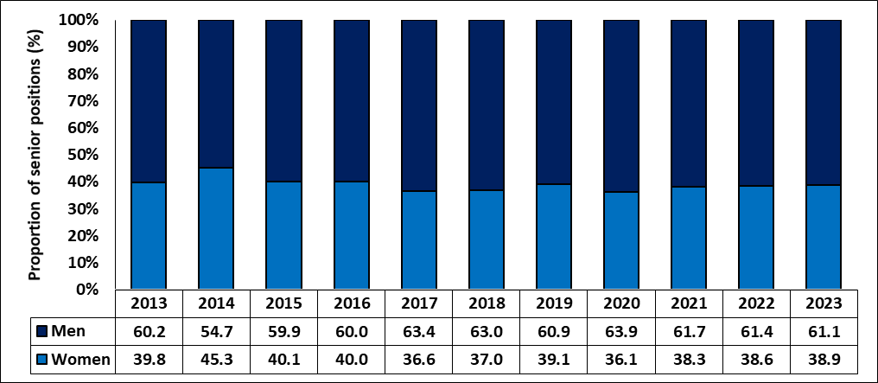
¹ Senior Chief Executive, Permanent Secretary, Deputy Permanent Secretary, Director, Manager, Judge and Magistrate
Source: Administrative data from CISD & Survey of Employment in Government Services, Ministry of Gender Equality and Family Welfare

13. Domestic violence
Women are more likely to be victims of domestic violence. The number of cases of domestic violence, reported at the Ministry of Gender Equality and Family Welfare, went up in 2023 to reach 7,177 from 5,381 in 2022. The total number of domestic violence against women increased from 4,420 in 2022 to 5,729 in 2023 and those against men rose from 961 to 1,448 (Chart 17).

Chart 17 – Number of reported cases of domestic violence, 2013 – 2023
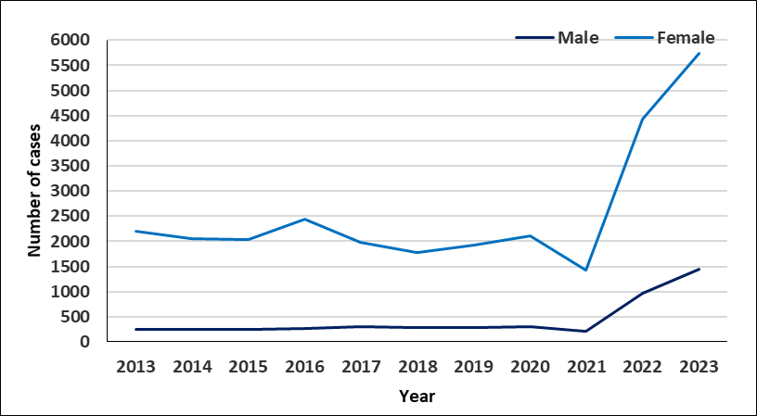
Source: Ministry of Gender Equality and Family Welfare

In 2023, verbal abuse and physical violence were the main types of violence reported by both men and women followed by emotional violence (Table 16).

Table 16 – Reported cases of domestic Violence by types and sex, 2023
Source: Ministry of Gender Equality and Family Welfare

14. Child Abuse
The total number of cases of child abuse reported at the Child Development Unit went up to 5,729 in 2023 from 5,448 in 2022 (Chart 18).

Chart 18 – Number of reported cases of child abuse at the Child Development Unit, 2013 – 2023
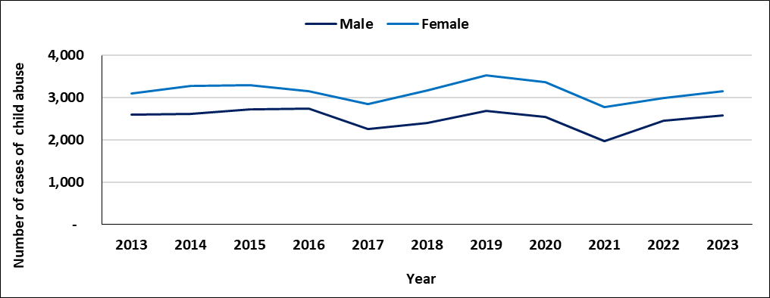
Source: Ministry of Gender Equality and Family Welfare

Of the reported cases in 2023, some 55.0% of the victims were females (Table 17). The most common nature of abuse was for both male and female was custody of child (23.6% for male and 21.2% for female), followed by psychological/emotional abuse (20.0% for male and 17.8% for female) and neglect cases (18.8% for male and 15.4% for females).

Table 17 – Reported cases of child abuse at Child Development Unit by nature of problem, 2023
Source: Ministry of Gender Equality and Family Welfare

15. Offences
Men are more likely to be victims of homicides, while women are more prone to sexual violence and sexual exploitation. In 2023, some 72.0% of the intentional homicides were committed against men. Some 91.7% of victims of sexual violence and sexual exploitation were women (Table 18).

Table 18 –Victims ¹ of selected offences ² reported at the Police, Republic of Mauritius, 2023
¹ A person may be victim of one or more than one offence and/or an offence may involve one or more victims
² Based on latest Classification of Crime for Statistical Purposes (ICCS) Version 1.0, developed by United Nations Office on Drugs and Crime (UNODC)
Source: Mauritius Police Force

Boys are much more likely to commit offences than girls. In 2023, only 10.3% of the juvenile offences were committed by girls. The female juvenile delinquency rate stood at 1.6, while that for male was 12.9 (Table 19).
Table 19 – Number of Juvenile ¹ offenders reported, Republic of Mauritius, 2023
¹ A person may be victim of one or more than one offence and/or an offence may involve one or more victims
² Exclude contraventions established by camera
³ Rate per 1,000 mid-year juvenile population and exclude contraventions
Source: Mauritius Police Force

16. Sports
During the period 2021 to 2023, participation in high level sports was consistently lower among female athletes than male athletes. In 2023, participation among female athletes was 37.4% against 62.6% among male athletes (Table 20).

Table 20 – Participation of high-level athletes in sports, 2021 – 2023
Source: Ministry of Youth Empowerment, Sports and Recreation
The most common sporting disciplines in which women participated in 2023 were “athletics” (26.9%), “handisports” (17.3%) followed by “Judo’ (9.6%) and “Weight Lifting” (9.6%). For men, the most common sporting disciplines were athletics (19.5%), handisports (17.2%) followed by boxing (16.1%) and kick boxing (11.5%) (Table 21).

Table 21 – Participation of high-level athletes in sports, as at December 2023
Source: Ministry of Youth Empowerment, Sports and Recreation

17. Global Gender Gap Indices
Since 2006, through the Global Gender Gap Report series, the World Economic Forum has been quantifying the magnitude of gender-based disparities and tracking their progress over time. By providing a comprehensive framework for benchmarking global gender gaps, the report identified countries that are role models in dividing their resources equitably between women and men, regardless of the overall resource level.
The Global Gender Gap Index (GGI) seeks to measure one important aspect of gender equality; their relative gaps between women and men across a large set of countries and across four key areas, namely: (a) economic participation and opportunity, (b) educational attainment, (c) health and survival and (d) political empowerment. The equality benchmark is considered to be one with no gap between men and women.
In 2023, Mauritius was ranked 98 out of 146 countries worldwide (Table 22). Mauritius has closed both its education attainment, and health and survival gender gaps with indices nearing 1 (Table 23).

Table 22 – Global Gender Gap Index by selected countries, 2021 – 2023
Source: Global Gender Gap Report 2023, World Economic Forum
Table 23 – Global Gender Gap Index for overall and four key areas, Republic of Mauritius, 2013 -2023
Source: Global Gender Gap Report 2023, World Economic Forum
Statistics Mauritius
Ministry of Finance, Economic Planning and Development
Port Louis
22 July 2024

Contact persons:

(1) Ms N. Ramjan (Statistician/Senior Statistician)
Email: nramjan@govmu.org

(2) Ms S. Sham-Jacmohun (Ag. Principal Statistical Officer)
Email : ssham-jacmohun@govmu.org
Statistics Mauritius
LIC Centre, Port Louis
Tel: (230) 4053300 Ext 4354, 4053314
Fax: (230) 2082041

Appendix: Glossary
Activity rate: The ratio (%) of the economically active population (employed and unemployed) to population aged 16 years and above.
Age specific fertility rate: the number of live births to women of a specified age-group per 1,000 women in that age-group.
Assault: Assault is defined as intentional or reckless application of physical force inflicted upon the body of a person.
Athletics: Athletics is a collection of sporting events that involve competitive running, jumping, throwing and walking, such as sprints (100 m, 200 m), relays (4×100 m, 4×400 m), running (800 m, 1500 m), long jump, triple jump, high jump, hammer throw, javelin throw, race walking, etc
Contraventions: Contraventions are defined as offences that are punishable by: (a) imprisonment for a term not exceeding 10 days; (b) fine not exceeding 5,000 rupees.
Contributing family worker: A contributing family worker is a person who works without pay in an enterprise operated by a family worker.
Crimes: Offences that are punishable by: (a) penal servitude (b) fine exceeding 5,000 rupees.
Crude death rate: the number of deaths in a year per 1,000 mid-year population.
Current user of contraceptive method: A new acceptor who continues with the same or different method of contraception and pays regular return visits to the family planning service point to receive services and supplies.
Divorce rate: the number of persons divorced in a year per 1,000 mid-year population.
Employee: An employee is a person who works for pay for someone else, even in a temporary capacity.
Employer: An employer is a person who operates his/her own business or trade and hires one or more employees.
Employment: Employed population consists of Mauritians aged 16 years and above who have worked for pay, profit or family gain for at least one hour during reference week of a month. It includes those who are temporarily absent from work for reason such as leave with pay, leave without pay and temporary disorganisation of work (bad weather, breakdown of equipment, lack of order, etc).
Gross Enrolment Ratio (GER): Number of pupils enrolled in a given level of education, regardless of age, expressed as a percentage of the population in the relevant age-group
- 4 - 5 years for pre-primary
- 6 – 11 years for primary
- 12 – 19 years for secondary
Gender Parity Index (GPI): Ratio of the GER for female to the GER for male. It measures the relative education participation of boys and girls. A GPI of 1 reflects equal enrolment rate for boys and girls, whereas a GPI greater than 1 shows disparity in favour of girls.
HIV/AIDS: AIDS (Acquired immune deficiency syndrome or acquired immunodeficiency syndrome) is a disease caused by a virus called HIV (Human Immunodeficiency Virus).
Household income: It comprises income from work (both paid and self-employment), transfer income (mainly government pensions, regular allowances from relatives and organisations), property income, and income from owned produced goods and it also includes imputed rent – a rental value for non-renting households.
Intentional homicide: Intentional homicide is defined as unlawful death inflicted upon a person with the intent to cause death.
Juvenile: a person aged below 18 years.
Juvenile delinquency rate: the number of juvenile offenders involved in offences (excluding contraventions) per 1,000 juvenile population.
Life expectancy at birth: the number of years a new born infant would live if prevailing patterns of mortality at the time of its birth were to stay the same throughout it life.
Marriage rate: the number of persons married in a year per 1,000 mid-year population.
Maternal mortality rate: number of deaths due to pregnancy, childbirth and the puerperium per 10,000 live births during that year.
Misdemeanours: Offences that are punishable by:(a) imprisonment for a term exceeding 10 days; (b) fine exceeding 5,000 rupees.
New acceptor of contraceptive methods: Someone who accepts a contraceptive method for the first time from a provider of a family planning programme.
Own Account Worker: An own account worker is a person who operates his/her own business or trade but does not hire employees. He/She may be working alone or with the help of contributing family workers.
Primary sector: Primary Sector comprises activities related to ‘Agriculture, hunting, forestry and fishing’ and ‘Mining’.
Relative poverty line (RPL): It is a threshold below which a household/ person is deemed poor and is set as the ‘half median monthly household income per adult equivalent’.
Secondary sector: Secondary Sector comprises activities related to ‘Manufacturing, ‘Electricity, gas and water supply’ and ‘Construction’.
Sex ratio: The sex ratio is defined as the number of males per 100 females.
Sexual violence: Sexual violence is defined as unwanted sexual act, attempt to obtain a sexual act, or contact or communication with unwanted sexual attention without valid consent or with consent as a result of intimidation, force, fraud, coercion, threat, deception, use of drugs or alcohol, or abuse of power or of a position of vulnerability.
Sexual exploitation: Sexual exploitation is defined as acts of abuse of a position of vulnerability, power or trust, or use of force or threat of force, for profiting financially, physically, socially or politically from the prostitution or sexual acts of a person.
Total fertility rate: the average number of children born to an average woman assuming that she survives to the end of her child-bearing age and is subjected to a fixed schedule of age-specific fertility rates.
Unemployment rate: Unemployment rate is the ratio (%) of unemployment to economically active population (employed and unemployed).
Unemployment: Unemployed population comprises all Mauritians aged 16 years and over who are not working but who are looking for work and are available for work during the reference week.

