CONSUMER PRICE INDEX
(Base period: January – December 2023 = 100)
April to June 2024

INTRODUCTION

This issue of Economic and Social Indicators presents the Consumer Price Index (CPI) for the period April to June 2024. A new CPI series, based on an updated basket of goods and services derived from the 2023 Household Budget Survey, has been introduced as from April 2024. The base period is January to December 2023. Henceforth, all monthly CPI figures will refer to this new base period.

The methodology used for computing the CPI and the inflation rate is given in the technical note at Annex.

KEY POINTS

2.1 The overall CPI

The Consumer Price Index, which stood at 103.2 in April 2024, registered a net decrease of 0.6 point (or -0.6%) to reach 102.6 in June 2024 (Table 1a).

On a monthly basis, the CPI decreased by 0.3 point in both May and June.

2.2 Overview of CPI movements

The main reasons for the net decrease in the CPI from April to June 2024 (Table 2) were:
- lower prices of vegetables (-0.6 point), cigarettes (-0.1 point) and cooking gas (-0.1 point) and;
- lower interest rates on housing loan (-0.1 point);
partly mitigated by
- higher prices of other food products (+0.1 point) and, other goods and services (+0.2 point).

MOVEMENT OF CPI SUB INDICES

Percentage change in CPI sub-indices from April to June 2024

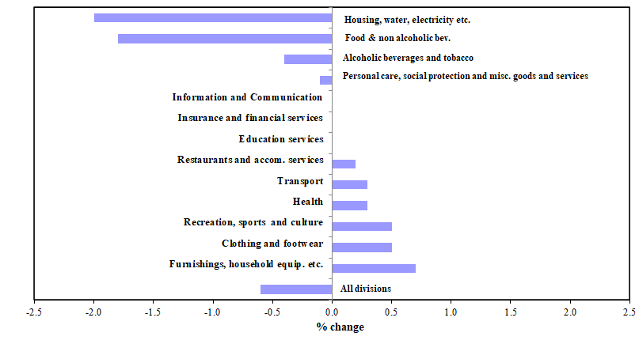

The changes in the sub-indices (Table 3) for the thirteen divisions of consumption expenditure from April to June 2024 were as follows:

Food and non-alcoholic beverages (-1.8%) | The decrease was mainly due to lower prices for vegetables (-12.5%), trader’s rice (-2.3%) and milk preparations (-5.5%), partly mitigated by higher prices of margarine and ghee (+12.5%), and eggs (+4.1%).
Alcoholic beverages and tobacco (-0.4%) | The decrease was mainly due to lower prices of cigarettes (-1.8%), partly mitigated by higher prices of whisky (+4.4%) and wine (+0.6%).
Clothing and footwear (+0.5%) | The increase was due to higher prices of footwear (+1.2%), ready-made clothing (+0.3%) and clothing materials (+5.1%).
Housing, water, electricity, gas  and other fuels (-2.0%) | The decrease was mainly due to lower prices of cooking gas (-15.8%) and lower interest rates on housing loan (-3.0%), partly mitigated by higher rentals fees of residential dwellings (+2.2%).
Furnishings, household equipment and routine household maintenance (+0.7%) | The increase was due to higher prices of detergents (+3.6%) and other washing materials (+3.1%), partly offset by lower prices of major kitchen appliances (-0.8%).
Health (+0.3%) | The increase was mainly due to higher prices of medicinal products (+0.7%), spectacles (+1.1%) and adult diapers (+1.1%).
Transport (+0.3%) | The increase was mainly due to higher prices of air tickets for international travel (+1.4%), some lubricants (+11.0%) and motor vehicles (+0.1%).
Information and Communication | Unchanged.
Recreation, sports and culture (+0.5%) | The increase was mainly due to higher prices of pet foods (+2.1%) and some celebration articles (+4.9%), partly offset by lower prices of video games (-0.7%) and, copybooks and other stationeries (-0.1%).
Education services | Unchanged.
Restaurants and accommodation  services (+0.2%)  Insurance and financial services | The increase was mainly due to higher prices of prepared food in restaurants (+1.0%), partly offset by lower rates in hotel accommodation (-0.6%).  Unchanged.
Personal care, social protection  and miscellaneous goods and  services (-0.1%) | The decrease was mainly due to lower prices of goods for personal care and hygiene (-0.4%) partly mitigated by higher prices of some religious items (+3.0%) and some other personal effects (+0.2%).
- INFLATION RATE
The headline inflation rate was 7.0% for year 2023 compared to 10.8% for year 2022 (Table 5).
The headline inflation rate excluding 'Alcoholic beverages and tobacco' was 6.6% for year 2023 compared to 11.0% for year 2022.

The headline inflation rate for the twelve months ending June 2024 works out to 4.5%, compared to 10.5% for the twelve months ending June 2023.

The headline inflation rate excluding “Alcoholic beverages and tobacco” for the twelve months ending June 2024 works out to 4.1% compared to 10.5% for the twelve months ending June 2023.

- INTERNATIONAL COMPARISON OF INFLATION RATE

The table below compares the inflation rate (as measured by the percentage change in the average CPI for a given year relative to the previous year) of Mauritius with those of our main importing countries and some countries in the region for year 2023.

Table 1 - Inflation rate (%) of selected countries, year 2023

Country | Inflation rate (%) | Country | Inflation rate (%)
France | 5.7 | Australia | 5.6
United Kingdom | 7.3 | United States | 4.1
China | 0.2 | Botswana | 5.1
India | 5.4 | Mauritius | 7.0
Japan | 3.3 | Seychelles | -1.0
Singapore | 4.8 | South Africa | 5.9

Source – World Economic Outlook Database, April 2024

Statistics Mauritius
Ministry of Finance and Economic Development
Port Louis
July 2024

Note :

- This publication is available on the website of Statistics Mauritius at http://statsmauritius.govmu.org From the homepage, choose “Publications” followed by “Economic and Social Indicators”, then “Consumer Price Index”.

- The monthly CPI is also available on our website. It is posted within 5 working days after the reference month.

- More detailed information on CPI can be made available upon request.
Contact persons:

(1) Ms Ashwinee Devi Soobhug
Statistician/Senior Statistician
asoobhug@govmu.org

(2) Mrs Gyantee Jugoo
Principal Statistical Officer
gjugoo@govmu.org

CPI Unit
Statistics Mauritius
LIC Building, Port Louis
Tel: (230) 212 2316/17
Fax: (230) 211 4150
Email: cso_cpi@govmu.org

Technical note

ANNEX

1. Methodology used for the computation of the Consumer Price Index
(Base period: January - December 2023 = 100)

(a) Definition

The Consumer Price Index (CPI) is an indicator of changes over time in the general level of prices of goods and services acquired by Mauritian consumers.

(b) Measurement of the CPI

The CPI measures price change by comparing, through time, the cost of a fixed basket of goods and services. As prices vary over time, the total cost of the basket also changes and thus the CPI measures the change in the cost of this basket. It provides a way to compare what this basket costs at a given period relative to a reference or base period.

The cost of the CPI basket is assigned a value of 100 in the base period and the costs in other periods are expressed as percentage changes compared to the base period. For example, if the CPI is 110, this means that there has been an increase of 10% in the cost of the basket since the base year; similarly an index of 90 means a 10% decrease in the cost of the basket.

(c) The CPI basket

The CPI basket is based on the expenditures of private households in a reference period, currently January to December 2023. The composition of the current CPI basket has been derived from the 2023 Household Budget Survey (HBS) data. It has been determined in accordance with latest ILO and SADC recommendations.

The items constituting the basket have been selected on the basis of the importance of household consumption expenditure on them. The basket includes all important items on which consumption expenditure is significant, i.e. accounting for around 0.1% or more of total household consumption expenditure. Each item’s relative importance, which is called the “weight” (usually expressed on a total of 1000), is the expenditure share of the item. Non-consumption items such as income tax, social security contributions, purchase of land, shares and life insurance are excluded.

The commodities in the basket are classified according to the UN COICOP (Classification of Consumption Expenditure according to Purpose) with 13 divisions, 44 groups, 92 classes and 173 subclasses.

(d) Price coverage

The prices used in the CPI calculation are those that any member of the public would have to pay to purchase the specified goods or services. Any taxes on products attached to the goods are included.

Price collection is done on a regular basis. Each month, around 8,740 price quotations are collected in respect of around 1,300 item indicators from some 610 outlets selected to be representative of regions across the islands of Mauritius and Rodrigues.

Prices of non-perishable items are collected monthly in the nine geographical districts of the island of Mauritius and in Rodrigues.

Prices of fresh fruits, vegetables, meat and fish are collected on a weekly basis from 9 markets in Port Louis, Rose Hill, Quatre Bornes, Vacoas, Rose Belle, Flacq, Goodlands, Pamplemousses and Port Mathurin.

Information on rent is obtained from a quarterly rent survey of some 100 rented dwellings.

(e) Formula for computation of the CPI

The CPI is computed according to the Laspeyres Formula as a weighted average of price relatives of individual items. The weights are fixed and correspond to the base period expenditures. The Laspeyres Index measures the cost of a basket of goods and services at different points in time, relative to the cost of the same basket in the base period.

The formula used for computing the CPI at time t is

∑ W_{i} (P_{it} / P_{i0} )
I _{t} = X 100
∑ W_{i}
where,
I _{t} : CPI for period t with reference to a base period 0
P_{io} : Price of item i at time 0, i.e. during base period
P_{it} : Price of item i at time t
W_{i} : Weight of item i
The base period is January to December 2023, the period during which the latest HBS was conducted.

2. Inflation

- Definition of Inflation

Inflation is the percentage change in the level of prices (as measured by the CPI) from one period to another.

- Calculating the Inflation Rate

The headline inflation rate in Mauritius, like in many other countries, is calculated by using the annual average method, i.e. by comparing the average level of prices during a twelve-month period with the average level during the corresponding previous twelve-month period. This type of inflation rate is more appropriate for adjusting wages, salaries and pensions to compensate for loss of purchasing power. All inflation rates presented in this publication relate to the headline inflation.

Another commonly used method of calculating the inflation rate is the so called ‘year-on-year’ method. The year-on-year inflation rate is calculated as the percentage change in the CPI for a given month with respect to the CPI for the corresponding month of the previous year. It is generally used by central banks for monetary policy decisions. Year-on-year inflation rates are not presented in this publication but can be easily calculated through the available monthly CPI.

Note: More information about the concept, computation and use of the CPI is available online in the publication “Household Budget Survey”.

