Productivity and Competitiveness Indicators

(2012 – 2022)

**1. Introduction**

This issue of the Economic and Social Indicators presents Productivity and Competitiveness Indicators for the years 2012 to 2022 for the total economy, manufacturing sector and Export Oriented Enterprises (EOE).

Tables 1.1 to 1.4 present the various indices for the total economy, tables 2.1 to 2.5 for the manufacturing sector and tables 3.1 to 3.6 for the EOE and its sub-sectors (textile and non-textile). Concepts and definitions used are given on pages 10 to 12.

**2. Indicators for the total economy**

Table A below presents the growth rates of productivity, unit labour cost and other competitiveness related indicators for the total economy.

**Table A: Productivity and competitiveness indicators for the total economy**

|  |  |  |  |
| --- | --- | --- | --- |
| **Indicator** | **Growth rate (%)** | | |
| **Annual Average** | **20211** | **20222** |
| **2012-2022** |
| Output (GVA at basic prices) | 2.2 | 4.0 | 9.8 |
| GDP at market prices | 2.1 | 3.4 | 8.8 |
| GDP per capita (market prices) | 2.1 | 3.4 | 9.1 |
| Labour input | 0.2 | -6.4 | 6.5 |
| Capital input | 2.5 | 1.7 | 2.1 |
| Capital - Output ratio | 0.3 | -2.2 | -7.0 |
| Capital - Labour ratio | 2.3 | 8.6 | -4.2 |
| Labour productivity | 2.0 | 11.1 | 3.1 |
| Capital productivity | -0.3 | 2.3 | 7.6 |
| Multifactor productivity | 0.6 | 5.9 | 5.5 |
| Average compensation of employees | 5.0 | 17.0 | 6.0 |
| Unit Labour Cost (Mauritian Rupees) | 3.0 | 5.3 | 2.8 |
| Unit Labour Cost (US Dollars) | -0.9 | -0.5 | -2.8 |

***1Revised 2 Provisional***

***2.1 Output (Gross Value Added)***

Output, as measured by the Gross Value Added (GVA), is the total value of goods and services (exclusive of taxes) produced within a country. From 2012 to 2022, GVA at basic prices, in real terms, grew on average by 2.2% per annum. The growth rate for 2022 was 9.8%, higher than the growth of 4.0% registered in 2021.

GDP per capita at market prices is an indicator of the standard of living of the population. With an average annual growth of 0.1% in the population and 2.1% in GDP at market prices, GDP per capita grew by 2.1% per annum during the period 2012 to 2022.

***2.2 Labour and capital inputs***

During the period 2012 to 2022, whilst real GVA at basic prices increased by an average of 2.2% per annum, capital input and labour input grew by 2.5% and 0.2% respectively. The capital-labour ratio, defined as the ratio of the stock of fixed capital to labour input grew by 2.3% annually during the period under review. Annual growth rates of output and inputs for the years 2012 to 2022 are given in table 1.1.

***2.3 Productivity trends***

**Figure 1: Trends in productivity indices – Total economy, 2012 to 2022**

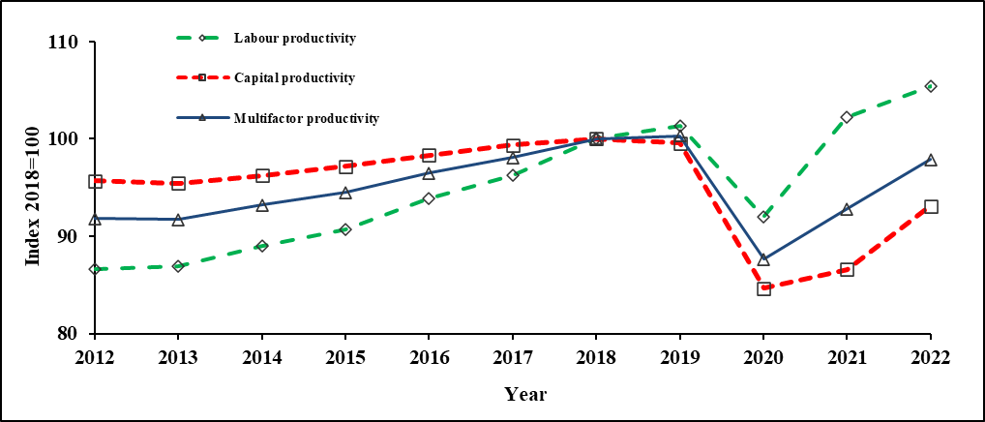

***2.3.1 Labour productivity***

Labour productivity for the whole economy is a measure of real output (GVA) per worker. From table 1.2 and Figure 1, it is observed thattheindex of labour productivity, improved from 86.7 in 2012 to 105.4 in 2022, giving an average annual growth of 2.0%.

In 2022, labour productivity rose by 3.1% compared to an increase of 11.1% in 2021. This was the result of a higher GVA growth of 9.8% in 2022 compared to 4.0% in 2021 while labour input grew by 6.5% in 2022 compared to a fall of 6.4% in 2021.

***2.3.2 Capital productivity***

Capital productivity is a measure of real GVA per unit of capital. During the period 2012 to 2022, the index of capital productivity decreased from 95.7 in 2012 to 93.1 in 2022. The average annual rate of change worked out to -0.3%.

Capital productivity registered an increase of 7.6% in 2022 after a rise of 2.3% in 2021 (Table 1.2). The 7.6% growth in 2022 is explained by a higher growth in GVA (9.8%) compared to a lower growth in capital input (2.1%).

***2.3.3 Multifactor productivity (MFP)***

The MFP index shows the rate of change in “productive efficiency”. In addition to labour and capital inputs, it takes into account qualitative factors such as better management and improved quality of inputs through training and technology. During the period 2012 to 2022, MFP increased by 0.6% annually. In 2022, MFP rose by 5.5% after increasing by 5.9% in 2021 (Table 1.2).

***2.4 Growth accounting***

The contribution of different factors to economic growth is determined by the growth accounting technique. From 2012 to 2022, the contribution of labour to the 2.2% average annual growth in GVA worked out to 8% and that of capital to 41%. The remaining 51% represents qualitative factors such as training, management and technology.

**Figure 2: Contribution of labour, capital and other qualitative factors to average annual GVA growth during the period 2012 to 2022**



***2.5 Unit Labour Cost (ULC)***

Unit labour cost measures the remuneration of labour per unit of output. It is affected by changes in both average compensation of employees and labour productivity. During the period 2012 to 2022, average annual compensation of employees increased by 5.0% whilst labour productivity grew by 2.0%. This resulted in an average annual growth of 3.0% in ULC. In 2022, ULC rose by 2.8% after an increase of 5.3% in 2021 (Table 1.3).

To compare changes in competitiveness across economies, the impact of exchange rate fluctuations has to be taken into account. When a national currency appreciates against the US Dollar, more dollars are paid in exchange for each national currency unit. On the other hand, when a national currency depreciates against the US Dollar, fewer dollars are paid in exchange for each national currency unit. From 2012 to 2022, ULC in Mauritian Rupees rose at an average annual rate of 3.0%. In Dollar terms, it fell by 0.9% annually as a result of an average annual depreciation of 3.9% of the Mauritian Rupee vis-à-vis the US Dollar. In 2022, ULC in Dollar terms declined by 2.8% after a fall of 0.5% in 2021 (Table 1.4).

**Figure 3: Trends in Unit Labour Cost - Total economy, 2012 to 2022**

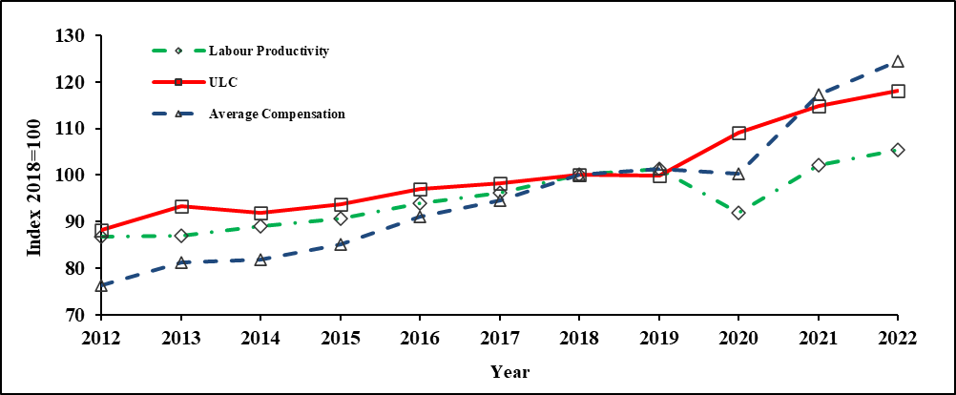

**3. Indicators for the Manufacturing sector**

Table B summarises the main indicators for the Manufacturing sector for the period   
2012 to 2022.

**Table B: Productivity and competitiveness indicators for the Manufacturing sector**

|  |  |  |  |
| --- | --- | --- | --- |
| **Indicator** | **Growth rate (%)** | | |
| **Annual Average** | **20211** | **20222** |
| **2012-2022** |
| Output (Value added at constant prices) | 0.7 | 8.3 | 9.1 |
| Labour input | -1.7 | -6.0 | -2.5 |
| Capital input | -2.8 | -3.4 | -1.8 |
| Capital - Output ratio | -3.5 | -10.8 | -10.0 |
| Capital - Labour ratio | -1.1 | 2.8 | 0.7 |
| Labour productivity | 2.5 | 15.2 | 11.9 |
| Capital productivity | 3.6 | 12.1 | 11.1 |
| Multifactor productivity | 3.0 | 14.0 | 11.6 |
| Average compensation of employees | 4.0 | 23.2 | 24.1 |
| Unit Labour Cost (Mauritian Rupees) | 1.5 | 7.0 | 10.9 |
| Unit Labour Cost (US Dollars) | -2.3 | 1.1 | 4.8 |

***1Revised 2 Provisional***

***3.1 Output and inputs***

From 2012 to 2022, real output in the manufacturing sector increased on average by 0.7% annually. In 2022, the sector witnessed a growth of 9.1% after an increase of 8.3% in 2021.

During the period 2012 to 2022, labour and capital inputs fell by an average annual rate of 1.7% and 2.8% respectively.

In 2022, labour input declined further by 2.5% after a fall of 6.0% in 2021. Capital input fell by 1.8% in 2022 after the decrease of 3.4% observed in 2021 (Table 2.1).

***3.2 Productivity trends***

**Figure 4: Trends in productivity indices – Manufacturing sector, 2012 to 2022**

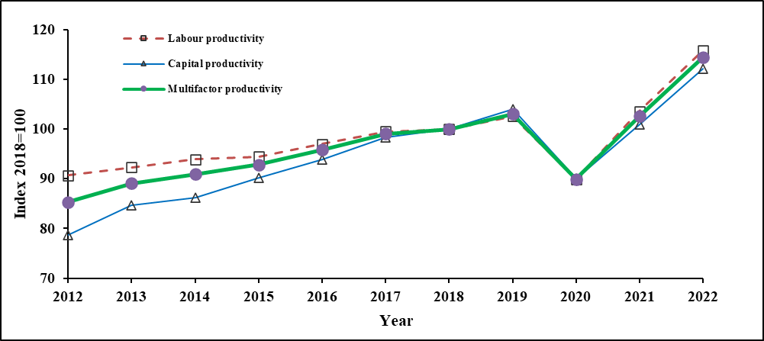

During the period 2012 to 2022, labour productivity in the manufacturing sector registered an average annual growth of 2.5%. This was the result of a low positive growth of 0.7% in real output compared to a high decline of 1.7% in labour input. During the same period, capital productivity increased by an average of 3.6% annually due to the negative growth of 2.8% in capital input compared to the positive growth in real output (0.7%). In that same period, multifactor productivity increased by an average of 3.0% per annum (Table 2.2).

In 2022, labour productivity in manufacturing rose further by 11.9% after that of 15.2% in 2021. Capital and multifactor productivity witnessed increases of 11.1% and 11.6% respectively in 2022 after increases of 12.1% and 14.0% in 2021.

***3.3 Unit Labour Cost (ULC)***

Figure 5 shows the trend of the ULC index in the manufacturing sector for the period 2012 to 2022. During that period, ULC grew at an average annual rate of 1.5% due to a higher growth in average compensation of employees (4.0%) compared to labour productivity (2.5%). In Dollar terms, ULC fell by 2.3% annually due to an average annual depreciation of 3.9% in the exchange rate of the rupee against the Dollar.

In 2022, ULC for the manufacturing sector rose further by 10.9% after an increase of 7.0% in 2021. In Dollar terms, ULC increased by 4.8% in 2022 after increasing by 1.1% in 2021. (Table 2.4). lllllll

**Figure 5: Trends in Unit Labour Cost -Manufacturing sector, 2012 to 2022**

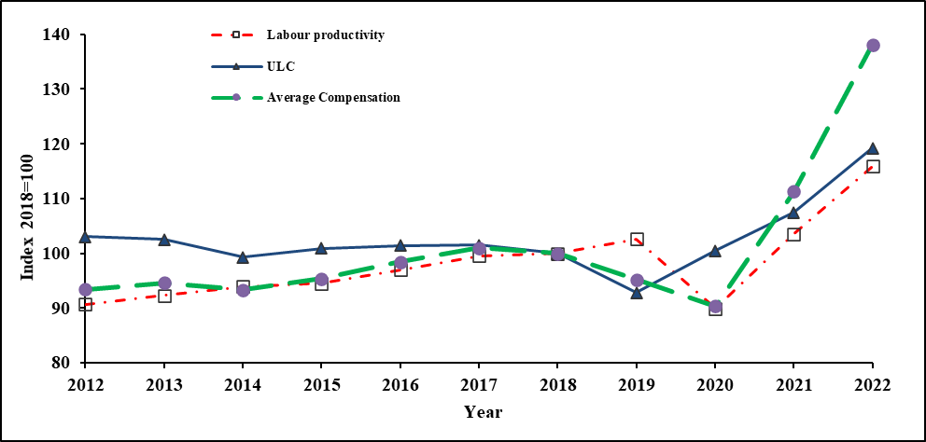

***3.4 International comparison of Unit Labour Cost in Manufacturing – 2018***

An international comparison of growth in ULC in the manufacturing sector for the year 2018, in national currency and in US Dollar is given in table C and figure 6 based on latest available estimates published by The Conference Board International Labour Comparisons program.

**Table C: Manufacturing Unit Labour Cost Growth rate of selected countries, 2018**



# Figure 6: International comparison of ULC in Manufacturing – Growth rate (%), 2018

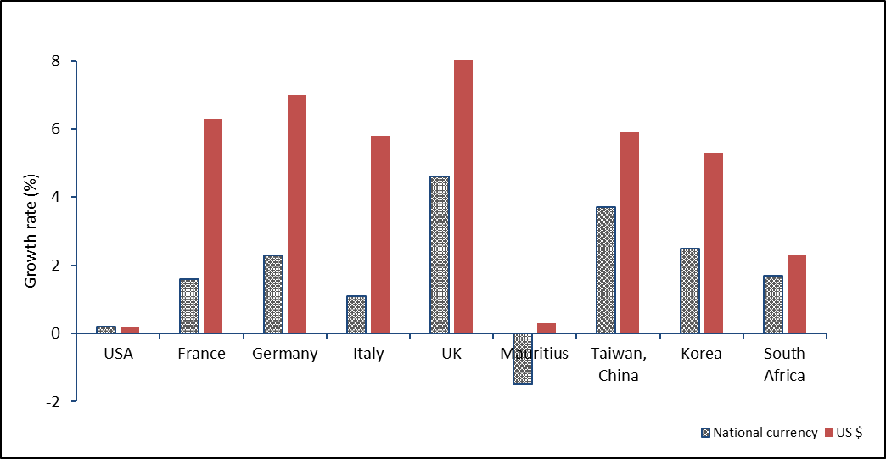

***Source: The Conference Board and Statistics Mauritius estimates***

It is observed that, in 2018, ULC in the manufacturing sector, expressed in national currency registered the highest increase in UK (4.6%) whilst Mauritius registered a decline of 1.5% (table C).

In 2018, ULC in US Dollar showed highest increase in UK (8.4%) and lowest in USA (0.2%). Mauritius witnessed an increase of 0.3%.

***3.5 International comparison of Hourly Labour Cost (HLC)***

The HLC is another indicator of international competitiveness. Table 2.5 compares the evolution of HLC in the Mauritian manufacturing sector with available hourly labour cost for some other countries in US dollars. HLC is highest in Germany and lowest in Philippines. In 2022, the HLC for Mauritius stood at 3.06 US Dollar compared to 3.00 US Dollar in 2021.

**4. Indicators for Export Oriented Enterprises (EOE)**

Table D below shows the main indicators for Export Oriented Enterprises during the period   
2012 – 2022.

**Table D: Productivity and competitiveness indicators for Export Oriented Enterprises**

|  |  |  |  |
| --- | --- | --- | --- |
| **Indicator** | **Growth rate (%)** | | |
| **Annual Average** | **20211** | **20222** |
| **2012-2022** |
| Output (Value added at constant prices) | -2.3 | 6.5 | 11.8 |
| Labour input | -4.3 | -12.0 | -1.1 |
| Capital input | -1.8 | -4.8 | -2.7 |
| Capital - Output ratio | 0.5 | -10.6 | -12.9 |
| Capital - Labour ratio | 2.5 | 8.3 | -1.6 |
| Labour productivity | 2.0 | 21.1 | 13.1 |
| Capital productivity | -0.5 | 11.8 | 14.8 |
| Multifactor productivity | 0.6 | 15.5 | 14.0 |
| Average compensation of employees | 3.8 | 31.7 | 16.8 |
| Unit Labour Cost (Mauritian Rupees) | 1.8 | 8.8 | 3.3 |
| Unit Labour Cost (US Dollars) | -2.0 | 2.8 | -2.3 |

***1Revised 2 Provisional***

***4.1 Output and inputs***

In 2022, the share of Export Oriented Enterprises (EOE) in the economy was 5.0%. The contribution of the textile and non-textile subsectors in the total output of the EOE sector was 54% and 46% respectively.

During the period 2012 to 2022, real output of the EOE sector fell at an average annual rate of 2.3%. Within the sector, the real output of non-textile establishments increased by 2.1% while that of textile establishments fell by 5.5% annually.

During the same period, labour and capital input of the EOE sector registered average annual decreases of 4.3% and 1.8% respectively.

In 2022, labour input in the EOE sector registered another fall of 1.1% after that of 12.0% in 2021. In a similar way, Capital input recorded a decrease of 2.7% in 2022 after a fall of 4.8% in 2021 (Table 3.3).

***4.2 Productivity trends***

**Figure 7: Trends in productivity indices – Export Oriented Enterprises, 2012 to 2022**

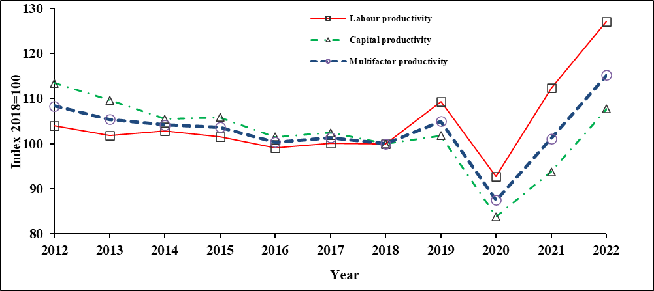

Figure 7 shows the trends in the labour, capital and multifactor productivity indices of Export Oriented Enterprises for the years 2012 to 2022. Labour productivity registered average annual increase of 2.0% while capital productivity witnessed a contraction of 0.5% annually. This is due to a fall in real output (2.3% annually) while labour input and capital input registered annual decreases of 4.3% and 1.8% respectively. Multifactor productivity increased by 0.6% annually during the same period (Table 3.2).

In 2022, labour productivity in EOE rose by 13.1% after an increase of 21.1% in 2021. Likewise, Capital productivity and Multifactor productivity moved up by 14.8% and 14.0% respectively in 2022 after increasing by 11.8% and 15.5% in 2021.

***4.3 Unit Labour Cost (ULC)***

**Figure 8: Trends in Unit Labour Cost – Export Oriented Enterprises, 2012 to 2022**

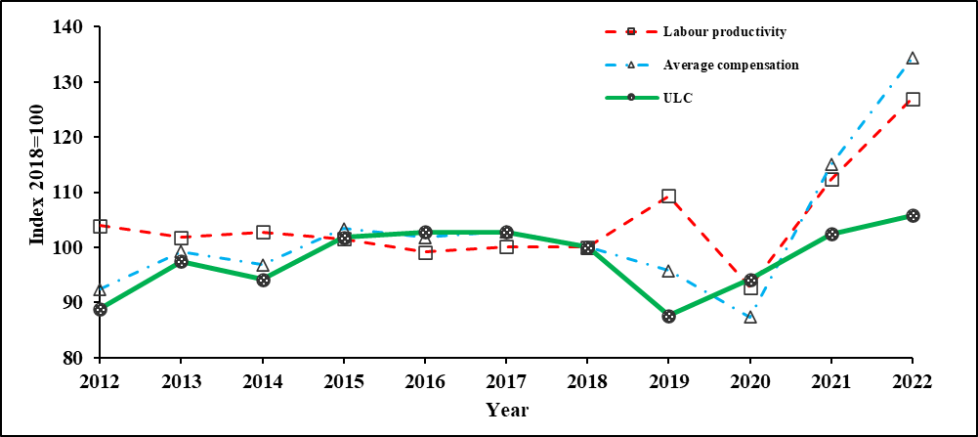

From 2012 to 2022, average compensation of employees in the EOE sector increased by an annual rate of 3.8%. During the same period, labour productivity rose by 2.0% annually. The high growth in average compensation of employees compared to labour productivity caused ULC to increase at an average annual rate of 1.8% during that period. In 2022, ULC increased by 3.3% after increasing by 8.8% in 2021 (Table 3.5).

In Dollar terms, ULC witnessed an average annual contraction of 2.0% during the period 2012 to 2022. In 2022, ULC in Dollar terms fell by 2.3% compared to an increase of 2.8% in 2021.

**Statistics Mauritius**

**Ministry of Finance, Economic Planning and Development**

**Port Louis.**

**04 August 2023**

**Contact persons**

**Mr. K. Persand (Statistician)**

**Mr. R. Krishnan (Senior Statistical Officer)**

**Statistics Mauritius**

**L.I.C Centre**

**Port-Louis**

**Tel: (+230) 208 1800**

**Fax: (+230) 213 0234**

**Technical Notes**

Concepts and definitions

Productivity expresses the relationship between the output of goods and services (real output) and the various inputs required for production (e.g. labour and capital). Two important productivity indicators used are: labour productivity, that is, the ratio of real output to labour input, and capital productivity, the ratio of real output to stock of fixed capital used in the production process. However, these indicators are limited in the sense that they indicate the influence of only one factor of production at a time on productivity. An improvement over these partial indicators is the multifactor productivity which takes into account the simultaneous influences of several factors on production, including qualitative factors such as better management, improved quality of inputs and higher quality of goods.

Unit Labour Cost (ULC) is another important indicator of competitiveness which is defined as the remuneration of labour for producing one unit of real output. Using compensation of employees, which is more readily available from national accounts data as a proxy for labour costs, ULC can hence be expressed as the ratio of average compensation per person engaged to labour productivity. This ratio indicates how improvement in productivity offsets increases in average compensation per worker.

1. Output

The term output in this publication refers to real output, that is value added of current year at constant prices (i.e., after removing price effect).

*Output index* = Value added (constant price) in year n x 100

Value added in base year

**2. Employment/Labour input**

Employment/Labour input is most appropriately measured by hours worked and its price by average compensation per hour. However, due to lack of data, the total number of persons engaged, defined as employers, own account workers, contributing family workers and employees in any type of economic activity is used. Prior to 2000, employment for year n was calculated as the average of employment at June of year (n) and June of year (n+1). As from 2000, average employment for a given year is available and thus the data has been used for the computation of labour input.

*Labour input index* = Average number of persons engaged in year n x 100

Average number of persons engaged in base year

**3. Capital input**

Capital refers to the net stock of investment in reproducible fixed assets. Reproducible fixed assets are investments in residential and non-residential building (excluding land), infrastructural work, machinery and equipment.

*Capital input index* = Stock of fixed capital in year n x 100

Stock of fixed capital in base year

**4. Labour Productivity**

Labour productivity index shows the rate of change in output per person engaged.

*Labour Productivity Index* = Output index x 100

Labour input index

**5. Capital productivity**

The capital productivity index shows the rate of change in output per unit of capital.

*Capital Productivity Index* = Output index x 100

Capital input index

**6. Multifactor/Total factor productivity**

Multifactor productivity (MFP)/Total factor productivity (TFP) index shows the rate of change in “productive efficiency”, and is obtained as the ratio of the output to a weighted combination of labour and capital inputs. The limitation of partial productivity measures is that they attribute to one factor of production, changes in efficiency that are attributable to other factors. MFP reflects many influences including qualitative factors such as better management and improved quality of inputs through training and technology.

# *Multifactor productivity index =* Output index x 100

Multifactor input index

A (t) = Q(t) x 100 where

{WL(t) x L(t)} + {WK(t) x K(t)}

A(t) = Multifactor Productivity index in time t

Q(t) = Output index in time t

WL(t) = Labour’s input share in time t (ratio of compensation of employees to value added)

L(t) = Labour input index in time t

WK(t) = 1- WL(t)

K(t) = Capital input index in time t

**7. Unit Labour Cost**

Unit labour cost is the remuneration of labour (compensation of employees) to produce one unit of output. It is computed as the ratio of the labour cost index to an index of production. The index shows the rate of change in labour cost per unit of output.

*Unit Labour Cost Index* = Labour Cost Index x 100 or Average Compensation Index x 100

Output Index Labour Productivity Index

For Competitiveness purposes, the exchange rate effect has to be taken into account. ULC is therefore computed both in local currency and in US dollar.

ULC index (US $) = ULC index (MUR) / Exchange rate index of MUR/ US $.

8. Hourly Labour Cost

Hourly labour cost is the ratio of total compensation of employees to total hours worked, inclusive of overtime. Compensation of employees comprises wages & salaries in cash and in kind, bonus, overtime and social contribution incurred by employers. The source of data is the Survey of Employment, Earnings and Hours of work.

**9. Capital-labour ratio**

The Capital-labour ratio gives the proportion of stock of fixed capital to labour inputs. If the ratio increases, capital deepening takes place whilst, when it declines capital widening occurs.

Capital-labour ratio = Real fixed capital utilised in an industry

Number of persons engaged in the industry

**10. Capital-output ratio**

The capital-output ratio represents the units of capital required to produce one unit of output. This ratio indicates how efficiently investment is contributing to economic growth.

Capital-output ratio = Real fixed capital stock in a specific year

Real GDP for the same year