Crime, Justice and Security Statistics, 2022
(Police, Prosecution, Judiciary, Prisons and Probation)

- Introduction

This is the sixteenth issue of the Economic and Social Indicator (ESI) on Crime, Justice and Security (CJS) statistics. It is based on administrative data for 2022 from the Mauritius Police Force (MPF), the Office of Director of Public Prosecutions (ODPP), the Judiciary, the Mauritius Prison Service (MPS) and the Probation and After Care Service.

All data in this ESI relate to the Republic of Mauritius, unless otherwise stated.

Table 1 presents the key indicators of Crime, Justice and Security Statistics while detailed tables are given at Annex 1. To assist in interpreting the figures, a reference chart of the flow through the criminal justice system is at Annex 2. A glossary of terms and a general structure of International Classification of Crime for Statistical Purposes (ICCS) Version 1.0 are at Annex 3 and Annex 4 respectively.

More detailed statistics will be released in September 2023 through the “Digest of Crime, Justice & Security Statistics, 2022”.

- Summary Statistics
Table 1: Crime, Justice and Security Statistics, Republic of Mauritius, 2021 & 2022
Key indicator | 2021 | 2022
Overall offence rate (excluding contraventions) per 1,000 population | 57.6 | 45.8
Intentional homicide rate¹ per 100,000 population | 2.7 | 2.2
of which murder | 2.6 | 2.2
Theft rate per 1,000 population | 9.2 | 11.2
Drug rate per 1,000 population | 3.8 | 3.6
Road traffic contravention rate per 1,000 population | 88.8 | 90.3
Juvenile delinquency rate per 1,000 population | 4.2 | 4.6
Conviction rate² pronounced in court per 1,000 population (excluding contraventions) | 18.2 | 24.4
Imprisonment rate³ per 100,000 population | 208.4 | 198.8
Average prison occupancy level ⁴ (%) | 70.1 | 66.2
¹ Intentional homicide rate excludes "abortion" and "arson causing death"
² Number of offences that led to conviction (as opposed to the number of persons convicted) per 1,000 population
³ Daily average number of detainees per 100,000 population
⁴ Prison population as a percentage of the prison capacity

- Police Statistics

  - Offences reported to police (Annex 1 – Table A1.1)

The offence rate (excluding contraventions) decreased from 57.6 in 2021 to 45.8 in 2022

- From 2021 to 2022, cases reported to the police (which include overall offences and other occurrences) decreased by 4.3%, from 248,139 to 237,551. In 2022, some 53,480 cases were related to offences not classified as crime and misdemeanours against 48,307 in 2021, representing a rise of 10.7%.

- Some 31.4% of the overall offences reported in 2022 were linked to crimes (3.7%) and misdemeanours (27.7%). The remaining 68.6% were contraventions, the majority of which were related to road traffic offences.

- Between 2021 and 2022, the general level of crime and misdemeanour, excluding contraventions, decreased from 72,935 to 57,846 (-20.7%).

- The offence rate (excluding contraventions) per 1,000 population decreased from 57.6 in 2021 to 45.8 in 2022.

- Contravention rate per 1,000 population decreased slightly from 100.2 to 100.0 during the same period, mostly due to decreases in certain road traffic contraventions by type of offence such as “Failing to produce driving license on demand” and “Making use of cellular phone whilst driving” (Table 2 and Table A1.3).

Table 2: Offence rate per 1,000 population by type, Republic of Mauritius, 2021 & 2022
 | Offences | 2021 | 2022
 | Crimes¹ | 5.1 | 5.4
 | Misdemeanours¹ | 52.5 | 40.4
 | Offence rate (excl. contraventions) | 57.6 | 45.8
 | of which drug offences | 3.8 | 3.6
 | Contraventions | 100.2 | 100.0
 | ¹ Crime and misdemeanour rates include drug offences

  - Reported offences (Annex 1 - Tables A1.2 & A1.7)

Homicide

55.2% of the victims for intentional homicide were committed in private households

- From 2021 to 2022, the number of intentional homicide decreased from 34 to 28 (-17.6%), resulting in a fall in the rate of intentional homicide per 100,000 population from 2.7 to 2.2 (Table A1.2). It is to be noted that non intentional homicide also decreased from 34 to 31 while attempted intentional homicide increased from 11 to 16.

- In 2022, 69.0% (20 of the 29) victims of intentional homicide were male (Table A1.7). Some 44.8% of the victims were aged 45 years & over and another 44.8% between 25 and 44 years (Chart 1). Some 55.2% (16 of the 29) victims were killed in private households, of whom 37.5% (6) were related to their offenders.

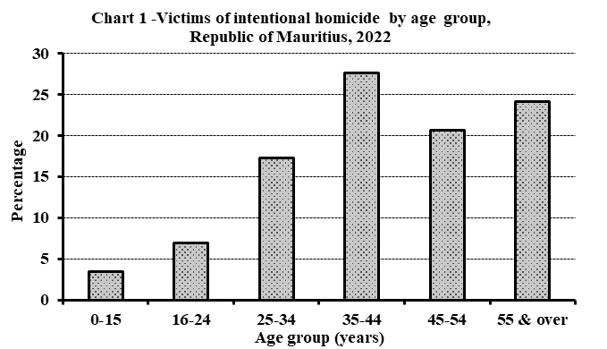

Assault

50.9% of victims were related to their offenders in 2022

- In 2022, some 8,189 assaults (serious and minor) were reported, representing a decrease of 1.5% over the figure of 8,314 in 2021. The rate per 100,000 population dropped from 656.7 in 2021 to 648.8 in 2022 (Table A1.2).

- Some 50.6% of the 8,365 victims of assaults registered in 2022 were male and more than half (50.9%) were related to their offenders. Some 60.3% of victims were assaulted in private households, 31.4% in public places such as commercial area, hotel, bungalow, public road and public beach and the remaining 8.2% in educational institutions and other places such as workplace, hospital, airport, concert, etc. (Table A1.7).

Sexual violence and sexual exploitation

The majority (92.8%) of victims of sexual violence and sexual exploitation were female

- Between 2021 and 2022, the number of reported sexual violence and sexual exploitation decreased by 1.2% from 608 to 601. Consequently, the rate per 100,000 population fell from 48.0 to 47.6. It is to be noted that rape showed a rise from 36 to 53 while sodomy dropped from 41 to 28 for the same period (Table A1.2).

- From 2021 to 2022, the female victimisation rate for sexual violence and sexual exploitation fell from 91.9 to 89.0 per 100,000 female population. Among the 612 victims of these sexual offences, 92.8% were female, 59.5% were aged below 16 years (Chart 2), 59.0% were students, 26.5% had family relationship with their offenders and 73.0% occurred in private households (Table A1.7).

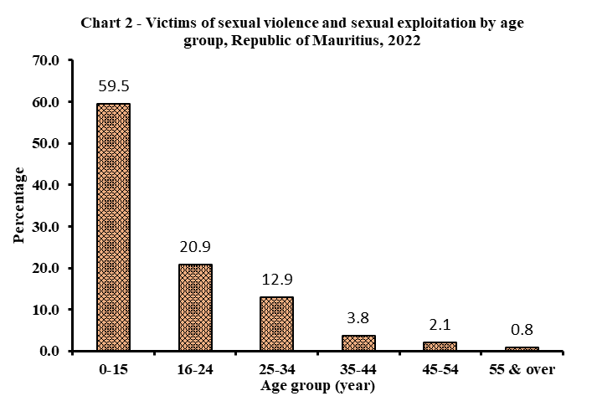
Theft/Robbery/Burglary

Theft increased in year 2022 compared to year 2021

- From 2021 to 2022, theft increased by 21.4% from 11,601 to 14,087 mainly due to a rise in “simple larcenies”. Consequently, theft rate per 1,000 population increased from 9.2 to 11.2. For the same period, an increase was registered for ‘larceny from motor vehicles’ from 540 to 675 (Table A1.2).

- During the same period, burglary and robbery showed increases of 17.7% from 1,077 to 1,268 and 12.6% from 620 to 698 respectively.

Drug offences

Drug offences decreased in year 2022 compared to year 2021

- From 2021 to 2022, the number of registered drug offences decreased by 6.7% from 4,826 to 4,502 resulting in a fall in the drug offence rate per 1,000 population from 3.8 to 3.6 (Table A1.2).

- In 2022, out of the 4,502 drug offences reported, 43.0% were cannabis (commonly known as “gandia”) related offences, 30.0% for heroin related offences, 3.7% for sedatives/tranquilizers and 17.8 % for synthetic cannabinoids. Other type of drugs, comprising mainly methadone and hashish, represented 5.5% of drug offences.

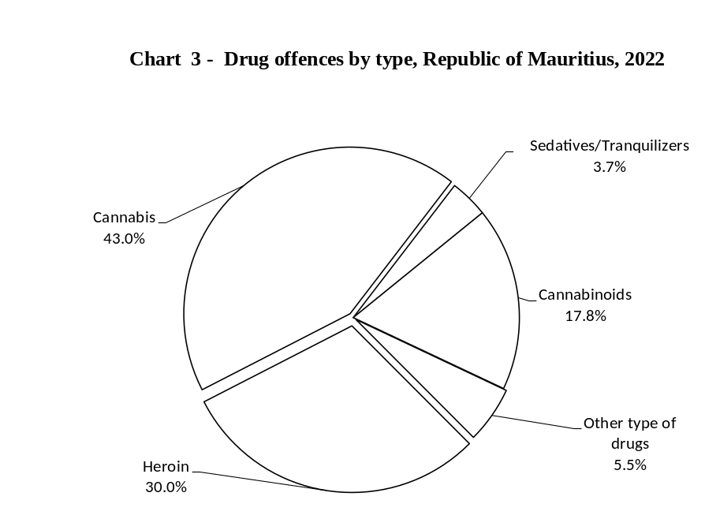

- The market value of all drugs seized in 2022 was estimated at around Rs 1.25 billion.

- Some 55,726 plants of cannabis were uprooted by Anti-Drug and Smuggling Unit (ADSU) in 2022 against 50,058 in 2021.

Road traffic offences

Contraventions (Annex 1 - Tables A1.2 & A1.3)

Road traffic contraventions increased between 2021 and 2022

- The number of registered road traffic contraventions increased by 1.4% from 112,454 in 2021 to 113,977 in 2022.

- From 2021 to 2022, road traffic contraventions for “exceeding speed limit” increased by 42.0% from 41,393 to 58,773. The remaining road traffic contraventions showed decreases ranging from -2.2% for “Parking on footpath/pavement to -87.6% for “Allowing oil to drop”, except among others, increases ranging from 25.7% from 2,032 to 2,555 for “Failing to comply with traffic sign” to 81.4 % for “dangerous driving”.

Cumulative Road Traffic Offences (CRTO)

- From January to December 2022, 42.6% of fines paid were due to exceeding speed limit.

- From January to December 2022, some 16,890 persons were convicted for offences specified in the third schedule as CRTO. Some 1,478 drivers (8.8%) had been convicted for more than once under the third schedule as CRTO, of whom, 17 (1.2%) had already been convicted for four offences and above.
- Twenty-one Mauritians and one foreign driver holding competent driving licences have been disqualified due to the CRTO from January to December 2022.
  - Investigation and prosecution

Persons suspected, arrested and/or cautioned (Annex 1 - Table A1.4)

- The number of persons suspected, arrested and/or cautioned increased by 72.4% from 20,951 in 2021 to 36,128 in 2022. For the same period in this category, increases were noted mainly for property damage from 347 to 1,233 (+255.3%), theft from 3,204 to 7,796 (+143.3%), and fraud/forgery/counterfeiting/corruption from 569 to 1,206 (+112.0%). It is to be noted that robbery decreased from 948 to 564 (-40.5 %).

- In 2022, offences for which persons were being suspected, arrested and/or cautioned were mostly in theft (21.6%), followed by assault (13.2%) and drug offences (9.2%).

Persons prosecuted (Annex 1 - Table A1.5)

- The number of persons prosecuted rose by 9.3% from 14,556 in 2021 to 15,903 in 2022.

- The number of persons prosecuted by type of offence between 2021 and 2022 declined mostly in assault from 2,494 to 1,766 (-29.2%) and drug offences from 2,964 to 2,360 (-20.4%) while robbery rose from 836 to 1,892 (+126.3%).

- Prosecution - Office of Director of Public Prosecutions (ODPP)

- From 2022 to 2021, the total number of cases referred by the Police for advice to ODPP increased by 27.8% from 8,850 to 11,308. Out of 11,308 cases in 2022, 56.4% (6,377) of them were referred to ODPP for initial advice after enquiry, based on their seriousness, complexity and special nature, i.e. parties involved including civil servants and minors, government property involved, etc.

- The number of cases referred by ODPP to the Intermediate and Supreme Courts increased by 58.1% from 651 in 2021 to 1,029 in 2022.

- In 2022, 86 cases were lodged by ODPP before the Assizes against 46 in 2021.

- In 2022, 139 criminal “Appeal and motions” were conducted by ODPP before the Supreme Court compared to 113 in 2021.

- Judiciary statistics

Civil and Criminal cases (Annex 1 - Table A1.8)

Rise in divorce cases lodged in year 2022 compared to year 2021

Lodged

Between 2021 and 2022, the number of civil cases lodged in Court increased by 3.7%, from 14,618 to 15,162. Similarly, for the same period, a rise was noted in divorce cases from 2,462 to 2,756 (11.9%). However, the number of ‘cases under the Protection from Domestic Violence Act’ decreased from 1,589 to 1,420 (-10.6%) from 2021 to 2022.
For the same period, the number of criminal cases lodged in Court increased by 25.6% from 75,038 to 94,212.
Disposed of

The number of civil cases disposed of increased by 13.7% from 12,987 in 2021 to 14,765 in 2022. During the same period, divorce cases rose by 5.7% from 2,415 to 2,552 while “cases under the Protection from Domestic Violence Act” fell by 7.2% from 1,503 to 1,395.

For the same period, a rise of 21.9% was noted in the number of criminal cases disposed of from 64,484 to 78,612.

Outstanding

From 2021 to 2022, outstanding cases rose by 2.0% for civil cases from 17,644 to 18,005 and by 25.2% for criminal cases from 56,140 to 70,291 respectively.

Conviction

Conviction rate increased from year 2021 to year 2022

- Some 94,984 criminal offences were disposed of by the Court in 2022. The prosecuted persons were found guilty in 63.7% (60,483) of these offences, of whom more than 99% were adults. The remaining 36.3% (34,501) were dismissed or discontinued.

- From 2021 to 2022, the overall convicted offences increased by 20.8% from 50,052 to 60,483, largely due to increases in robbery (+61.5%), assault (+37.7%), homicide (+28.9%), non-injurious traffic violations (+10.5%) and (Annex 1 - Table A1.9). For the same period, there was a decline in fraud /forgery /counterfeiting
(-12.9%).

- In 2022, 48.4% of the convicted offences were due to the conviction for non-injurious traffic violations.

- From 2021 to 2022, the conviction rate per 1,000 population increased from 18.2 to 24.4 (Annex 1 - Table A1.9).

Convicted offences (Annex 1 - Table A1.9)
Homicide
From 2021 to 2022, the conviction for intentional homicide remained same at 12 and for non-intentional homicide increased from 33 to 46.

Assault
In 2022, there were 1,078 convicts for assault representing a rise of 37.7% over the figure of 783 in 2021.

Sexual violence & sexual exploitation
From 2021 to 2022, there was a decline of 28.9% in convictions for sexual violence and sexual exploitation from 97 to 69. It is to be noted that convictions for rape and sodomy increased from 4 to 5 and 6 to 8 respectively.

Theft/Robbery/Burglary
Compared to the previous year, convictions for robbery and theft in 2021 increased by 61.5% from 879 to 1,420 and by 40.7% from 2,147 to 3,020 respectively. Similarly, burglary showed an increase of 69.5% from 571 to 968.

Drug offences
From 2021 to 2022, the conviction for drug offences rose by 19.8% from 1,817 to 2,177.

Sentence imposed (Annex 1 - Table A1.9)

- Out of the 60,483 offences for which sentences have been imposed in 2022, the accused persons were either sentenced to pay fines (87.0%) or imprisoned (10.3%). The remaining 2.7% were either committed to community service works or issued with probation orders, or discharged either conditionally or absolutely.

- From 2021 to 2022, the number of fines imposed increased by 18.1% from 44,565 to 52,643. Imprisonment rose by 72.9% from 3,604 to 6,232.

- Statistics from Mauritius Prison Service

  - Prison and detention statistics (Annex 1 - Tables A1.10 to A1.13)

The majority of adult convicts admitted were re-offenders

- Out of every 100 detainees in prison in 2022:

- 44 were convicted detainees and 56 were on remand awaiting trial;

- 93 were male adult detainees, 6 were female adult detainees and one was juvenile
inmate.

- The daily average for remand and trial population decreased by 11.8% from 1,582 in 2021 to 1,396 in 2022.
- The imprisonment rate per 100,000 mid-year population fell from 208.4 in 2021 to 198.8 in 2022.

- In 2022, the average prison occupancy level was 66.2%, with the highest occupancy level being 90.6% and the lowest, 29.2%. From 2021 to 2022, the occupancy rate has decreased from 70.1% to 66.2%.

- The number of convicted detainees admitted increased by 51.2% from 3,319 in 2021 to 5,019 in 2022 (Annex 1 - Table A1.11).

- Out of every 100 convicted detainees admitted to prison in 2022 (Annex 1 - Table A1.11):

- 97 were male and 3 were female;

- 56 were in the age group 18 - 30 years.
- In 2022, the convict admission rate peaked at the age group of “26-30 years” (Chart 4) same as in 2021.
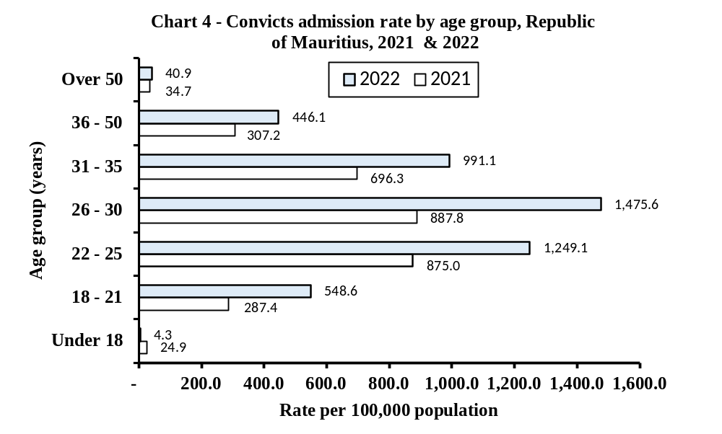
- Out of the 5,019 convicts admitted in 2022, some of the offences they committed were theft (27.6%), offences related to acts against public order (20.4%), robbery (10.8%), burglary (10.6%), assault (8.4%), drug offences (6.8%) and breach of protection order (2.7%).

- From 2021 to 2022, the increase in the number of admissions was mainly due to a rise of 36.5% in the admissions for theft from 1,016 to 1,387. It is to be noted, for the same period, that admissions for drug offences increased from 312 to 340 (Annex 1 - Table A1.13).

- The adult convicted detainees, who were readmitted to prison, increased by 58.3% from 2,362 in 2021 to 3,740 in 2022 (Annex 1 - Table A1.10). Regardless of any observation period, out of every 100 adult convicted detainees admitted to prison in 2022:

- 75 were re-offenders who had been imprisoned in the past;
- 64 were imprisoned more than once in the past.

- The number of convicts with short sentences of less than one month increased by 74.1% from 930 in 2021 to 1,619 in 2022 and similarly, those sentenced for 1-3 months increased by 44.5% from 1,143 to 1,652 (Annex 1 - Table A1.13). There were no convicted detainees who were sentenced to life imprisonment in 2022 compared to two in 2021.

- From 2021 to 2022, the number of fine defaulters admitted to prison increased by 82.2% from 213 to 388 (Annex 1 - Table A1.12). The admissions due to non-payment of fines of Rs 30,000 or less rose from 202 in 2021 to 361 in 2022.

- The main offences committed by fine defaulters were drug offences (26.0%), theft (18.3%), non-injurious traffic violations (17.8%) and breach of condition of release (13.7%).

- There was one escape from prison in 2022, compared to none in 2021.

- An average amount of Rs 858 was spent daily on each detainee in 2022 in the Island of Mauritius compared to Rs 800 in 2021.

- Probation statistics

Offenders subjected to Probation orders decreased by 39.2% and Community Service Orders increased by 24.2%

- In 2022, 32 probation orders were issued (29 for male and 3 for female), representing a fall of 37.3% compared to 51 (44 for male and 7 for female) in 2021. The number of offenders, also decreased by 39.2% from 51 (45 adults and 6 juveniles) in 2021 to 31 (28 adults and 3 juveniles) in 2022.

- The number of offenders, subjected to Community Service Orders, increased by 24.2% from 380 in 2021 to 472 in 2022. In 2022, the majority (91.7%) of the offenders were male.

- Juvenile statistics

Juvenile offenders (Annex 1 - Table A1.6)

Number of juvenile offenders for crimes and misdemeanours decreased by 12.7%

- From 2021 to 2022, the juvenile offenders (excluding those who had contraventions) involved in crimes and misdemeanours increased by 6.0% from 436 to 462. Sexual violence and sexual exploitation rose from 71 to 84, robbery/burglary/theft from 104 to 142 and assault from 101 to 122. For the same period, homicide fell from 9 to 1. A decrease of 42.6% was noted in the number of juveniles contravened from 272 to 156. Out of the 156 juvenile offenders for contraventions in 2022, some 85.9% were road traffic contraveners.

- In 2022, the juvenile delinquency rate (excluding contraventions) increased to 4.6 per 1,000 juvenile population from 4.2 in 2021. The rate for boys was 8.2 compared to 0.9 for girls in 2022.

Juvenile victims of offences against person (Annex 1 - Table A1.7)

Homicide
In 2022, two juveniles were victims of attempted intentional homicide for attempted murder and there was one victim of intentional homicide. Three victims for non-intentional homicide in 2022 were male.

Assault
The number of victims for assault increased by 8.6% from 500 in 2021 to 543 in 2022. Juveniles were mostly victims of simple assaults. Some 61.9% of victims for simple assaults were boys.

Sexual violence & sexual exploitation
- From 2021 to 2022, victims of sexual violence and sexual exploitation decreased by 13.7% from 503 to 434 mainly due to falls in “Causing child to be sexually abused; accessing to a brothel; and engaging in prostitution” from 193 to 145 (-24.9%) and “Sexual intercourse with minor under the age of 16” from 181 to 179 (-1.1%). It is to be noted that rape rose from 8 to 10 and sodomy fell from 24 in 2021 to 9 in 2022.

- The majority (93.1%) of the juvenile victims of sexual violence and sexual exploitation were female.

Juvenile conviction in Court (Annex 1- Table A1.9)

There has been a decline in juvenile conviction rate

- In 2022, the number of convictions, which involved juveniles, stood at 6 against 35 in 2021. Out of the 6 convicts, 4 were sentenced to ‘Correctional Youth Centre (CYC)’ and 2 were conditionally discharged.

- The juvenile conviction rate per 1,000 juvenile population fell from 0.3 in 2021 to 0.1 in 2022.

Juvenile detainees (Annex 1 - Tables A1.10 & A1.11)

The majority of juveniles admitted to CYC had committed theft/robbery/burglary

From year 2021 to 2022, the conviction rate per 100,000 juveniles decreased from 24.9 to 4.3.

Correctional Youth Centre (CYC)

From year 2021 to 2022, the number of juveniles admitted decreased by 72.4% from 123 to 34. Some 66.7% (2) of the 3 juvenile convicts admitted to CYC in 2022 had committed theft/robbery/burglary.

Rehabilitation Youth Centre (RYC)

The number of juveniles admitted for detention and training at RYC decreased by 85.0% from 40 in 2021 to 6 in 2022. Some 50.0% of the juveniles admitted in 2022 were on remand. All cases admitted were of juvenile beyond control.

Probation Home/Hostel

The number of juveniles admitted in probation institutions increased from 1 in 2021 to 10 in 2022.

Other juvenile sentencing

- Some three juveniles (down from six in 2021) were under probation orders in 2022 and all of them were boys.

- One juvenile was ordered to perform community service work in 2022 compared to two in 2021.

- Longer time series

Offence rate (crimes and misdemeanours) & contraventions

From 2010, the general level of crime and misdemeanour (offence rate) was 37.4 per 1,000 population. It, then, declined gradually to stabilize at around 33 from 2012 to 2014, increased to 37.8 in 2017, fell to around 35 in 2018 to 2019, increased to 57.6 in 2021 and finally declined to 45.8 in 2022(Chart 5).

On the other hand, as from 2010, contravention rate per 1,000 population was on the rise from 139.4 to reach 182.3 in 2012. Thereafter, it oscillated around that level and then, picked up followed by a rising trend from 195.3 in 2016 to peak at 204.6 in 2018 thereafter to finally drop to 100.0 in 2022.

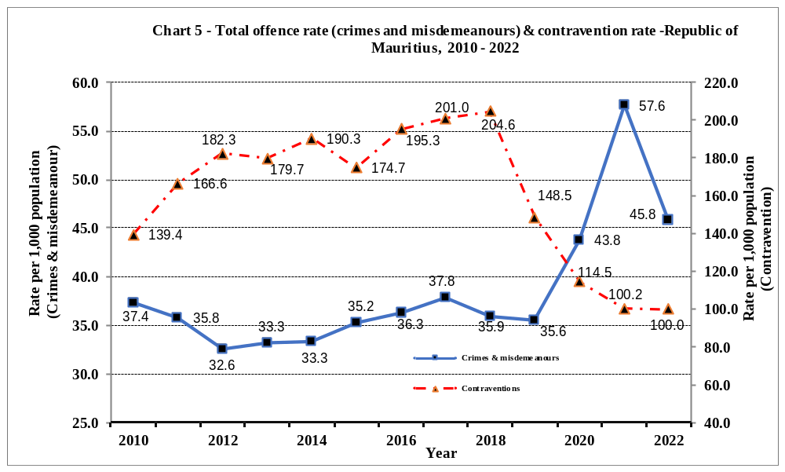
Conviction rate (excluding contraventions)

In 2012, the conviction rate per 1,000 population stood at 24.0 (Chart 6). It decreased to 20.7 in 2014 followed by an increase in 2015 reaching 22.8. A gradual decrease is then observed from 2015 to 2019 reaching 19.2. Thereafter a sharp decline, due to COVID 19 as courts were closed, was noted to reach 13.5 in 2020 followed by a steep rise reaching 24.4 in 2022.

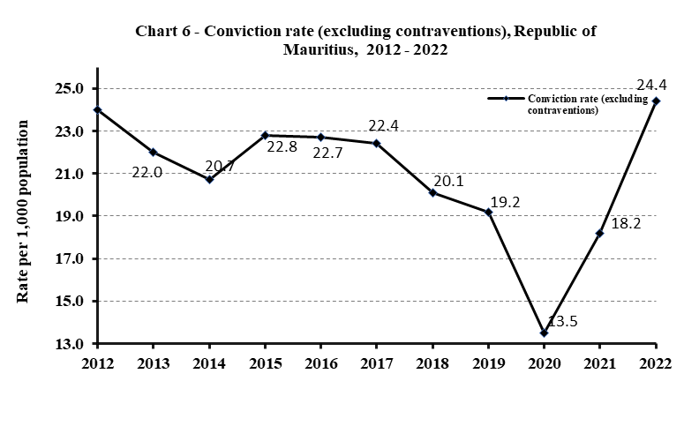
Imprisonment rate

From 2009 to 2012, the imprisonment rate per 100,000 mid-year population showed an increasing trend to reach 214.2 in 2012 (Chart 7). It then declined gradually to 169.0 in 2015 but rose again during the period 2016 to 2019. However, the rate for 2021 (208.4) is lower than in 2020 (210.7).

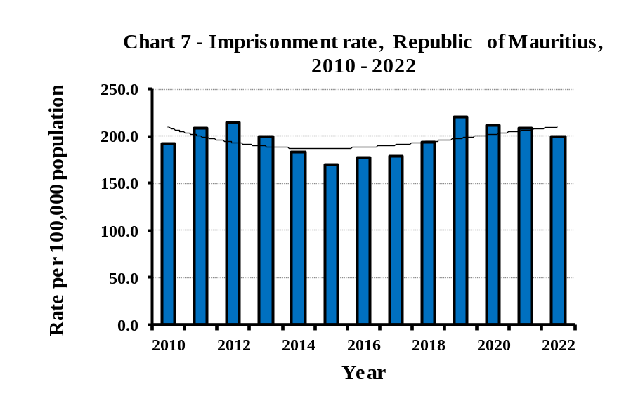

- Notes to Users

Release of data on Crime, Justice and Security statistics

This indicator is released on a yearly basis according to an advance release calendar posted on the website of Statistics Mauritius
(http://statsmauritius.govmu.org/English/Publications/Pages/Publication-Programme.aspx).

More information on Crime, Justice and Security statistics can be obtained from the website of Statistics Mauritius on the fol. URL:
https://statsmauritius.govmu.org/Pages/Statistics/By_Subject/CJS/SB_CJS.aspx

Specific information on:
Judiciary can be accessed at: https://supremecourt.govmu.org
Prisons can be accessed at: http://prisons.govmu.org/English/Pages/default.aspx

Caution to users

The following points should be recalled when drawing any conclusions from the figures in this publication:

- When comparing figures, it should be realised that police and judiciary figures are based on offences but prison and probation figures are based on offenders, and that an offender can be sentenced for more than one offence.

- Offences can sometimes be reclassified, usually as less serious, as they proceed from police investigation through prosecution to final court sentence. This is usually due to evidence not being as robust as at first thought or more evidence coming to light following the initial report.

- The trends in offences like drug offences and road traffic contraventions should be interpreted with caution since they may be subject to fluctuations as a result of sensitisation/awareness campaigns and intelligence-led operations. For example, the Road Traffic Act has been amended in August 2018.

- Police statistics are often better indicators of prevalence of law and willingness to report offences than actual prevalence. Therefore, surveys on the experience of victimization from the public together with the data from the reported cases can give a more comprehensive picture on the actual number of victims.

- Care should be taken while comparing statistics on the number of cases lodged and disposed of over time. Cases lodged in Court are more directly comparable. However, cases disposed of are not comparable, given that these cases might have been lodged during the reference year or any year before.

List of tables (Annex 1)

Table A1.1: Cases reported and offence rate per 1,000 population by type, Republic of Mauritius, 2021 & 2022
Table A1.2: Reported offences and rate per 100,000 population by offence, Republic of Mauritius, 2021 & 2022
Table A1.3: Road traffic contraventions, Republic of Mauritius, 2021 & 2022
Table A1.4: Persons suspected, arrested and/or cautioned by type of offence, Republic of Mauritius, 2021 & 2022
Table A1.5: Persons prosecuted by type of offence, Republic of Mauritius, 2021 & 2022
Table A1.6: Offences involving juveniles reported by type, category and sex, Republic of Mauritius, 2021 & 2022
Table A1.7: Victims of selected offences by socio-demographic and other characteristics, Republic of Mauritius, 2021 & 2022
Table A1.8: Number of civil and criminal cases, Republic of Mauritius, 2021 & 2022
Table A1.9: Convicted offences involving adults and juveniles by outcome of judgment and offence, Republic of Mauritius, 2021 & 2022
Table A1.10: Daily average and admission of detainees for adults and Juveniles, Republic of Mauritius, 2021 & 2022
Table A1.11: Convicts admission rate by age-group and sex, Republic of Mauritius, 2021 & 2022
Table A1.12: Fine defaulters admitted to prisons by amount of fine due, Republic of Mauritius, 2021 & 2022
Table A1.13: Admission of convicts to prisons by offence and length of sentence, Republic of Mauritius, 2021 & 2022

Contacts

For further information, please contact:

- Mr J.A. Laloo, Statistician/ Senior Statistician (Police, Prison, Probation and After Care Service)

- Ms H. Murdan, Statistical Officer /Senior Statistical Officer (Police)

- Mr V. Sewnundun Statistical Officer /Senior Statistical Officer (Police)

- Ms. S. Nunhuck, Statistician/ Senior Statistician (ODPP & Judiciary)

- Ms. V. Busgeeth, Statistical Officer/Senior Statistical Officer (Judiciary)

Office address: Statistics Mauritius, L.I.C Centre, Port-Louis

Email : jlaloo@govmu.org

smurdan@govmu.org

vsewnundun@govmu.org

snunhuck@govmu.org

vbusgeeth@govmu.org

sm-cjs@govmu.org

Tel: (230) 213-0710 (Police)
: (230) 213-3055 (Judiciary)
: (230) 401-6600 ext 6694 (Prison)
: (230) 465-1156 (Probation)
: (230) 405-5673 ext 116 (ODPP)

Statistics Mauritius
Ministry of Finance, Economic Planning and Development
Port Louis
30 June 2023

Annex 3
GLOSSARY
- Absolute discharge is complete and unconditional release.
- Acts against liberty is taking away or limiting the movement or liberty of a person.
- Admission rate is defined as the number of people admitted to prison in a given year per 100,000 mid-year population.
- Assault is defined as intentional or reckless application of physical force inflicted upon the body of a person.
- Acquitted means dismissed.
- Burglary is defined as unlawful entry into someone else’s premises with the intention to commit a theft.
- Cases to the police are:
- either offences punishable by law such as crimes (which are punishable by penal servitude and/or a fine exceeding Rs 10,000), misdemeanours (which are punishable by imprisonment for a term exceeding 30 days and/or a fine exceeding Rs 10,000) and contraventions (which are punishable by imprisonment for a term not exceeding 30 days and/or a fine not exceeding Rs 10,000),
- or relate to other occurrences such as accidental deaths, accidental fires, suicides or attempted suicides and street accidents.
- Coercion is demanding a particular course of action through the use of force, threat intimidation, threat to reveal compromising information, or threat of defamation.

- Community Service Order is a sentence requiring an offender to perform unpaid community work in lieu of imprisonment or non-payment of fines.

- Conditional discharge is a sentence whereby an offender is released under certain conditions, e.g. to be of good behaviour for a specified period of time.

Contraventions (least serious offences) are defined as offences that are punishable by:
  - imprisonment for a term not exceeding 30 days;

  - fine not exceeding 10,000 rupees.

- Cost of detainee is based on the recurrent expenditure of the prisons, the social aid granted to the detainees’ ward(s) and the value of labour contribution of detainees to the prisons’ workshops.

- Crimes (most serious offences) are defined as offences that are punishable by:
  - penal servitude;

  - fine exceeding 10,000 rupees.

- Criminal case is a case dealing with an offender indicted for an offence.
- Cumulative Road Traffic Offences (CRTO)
Cumulative Road Traffic Offence (CRTO) means an offence stipulated in the third Schedule of the Road Traffic Act (Sect 123 AG of RTA).
  - Where a person is convicted on a fifth occasion for one or more offences specified in the third schedule and those offences committed within a period of 24 months, the Court shall disqualify him/her from holding or obtaining a driving license for all classes of motor vehicles for a period of not less than 6 months nor more than 12 months.
  - Whereas when a person is convicted on a third occasion for a Cumulative Road Traffic Offence (CRTO) within a period of 24 months, the Licensing Officer shall inform that person by way of a Notice that he/she has been convicted three times for a CRTO.
- Fines for exceeding speed
As per the Road Traffic (Amendment) Act 2018 (Act No. 12 of 2018), with effect from 01 October 2018, a new graduated scale of fines for exceeding speed limits was introduced as follows:
  - fine of Rs 2,500 for exceeding the speed limit by not more than 15 km per hour;
  - fine of Rs 5,000 for exceeding the speed limit by more than 15 but not more than 25 km per hour and
  - fine of Rs 10,000 for driving at a speed exceeding the authorised speed limit by more than 25 km per hour.

- Dangerous acts are bodily harm or potential for bodily harm caused by a person’s dangerous behaviour or act carried out with the knowledge that the act has potential to cause harm.
- Detainee is referred to as any person confined to prison and is classified as follows:
  - Convict: person sentenced to imprisonment.
  - Person on remand and trial: person charged for an offence with a court of law and awaiting judgment.
- Drug offences are as spelt out under the Dangerous Drug Act 2000. They relate mainly to drugs like gandia, heroin, hashish, opium, cocaine and other psychotropic substances.
- Embezzlement is defined as the wrongful appropriation of another person’s property that is already in the possession of the person doing the appropriating.
- Fine defaulters are convicts sentenced to imprisonment for non-payment of fines; they either stay in prison for a specified period, benefit from a community service order or are released as soon as they pay the fines.
- Forgery/counterfeiting is creating, manufacturing, selling, passing or possessing a false imitation of goods, or an instrument to create a false imitation of goods.
- Fraud is defined as the acquisition of another person’s property by deception.
- Illegal feticide is defined as unlawful death of a foetus intentionally procured or conducted by a person.
- Intellectual property offences are unlawful copying, using, reproducing or other infringements of copyrights, patents, trademarks or other intellectual property.

- Intentional homicide is defined as unlawful death inflicted upon a person with the intent to cause death.
- Investigation and prosecution
On completion of police enquiries/investigations, cases are taken to court for prosecution either as decided by Police or upon the advice of the Director of Public Prosecutions (DPP). However, for some cases, prosecution does not follow for the following reasons: (a) false or doubtful complaint, (b) no offence committed (c) trifling cases, (d) accused unknown, (e) accused absconded, (f) evidence insufficient, (g) accused dead or insane, (h) caution administered, (i) no further action as advised by the DPP.
- Juvenile is defined as person aged below 18 years.
- Juvenile delinquency rate is defined as the number of juvenile offenders involved in offences (excluding contraventions) per 1,000 juvenile population.
- Minor assault is intentional or reckless application of minor physical force inflicted upon the body of a person resulting in no injury or minor bodily injury.

Misdemeanours (less serious offences) are defined as offences that are punishable by:
  - imprisonment for a term exceeding 30 days;

  - fine exceeding 10,000 rupees.

- Murder is unlawful death inflicted upon a person with the intent to cause death or serious injury, including when premeditated and/or with malice aforethought.
- Negligence is defined as bodily harm or potential for bodily harm from a person’s negligent, reckless or careless behaviour.
- Non-adjudicated is the formal withdrawal of charge(s) by the Police, Director of Public Prosecutions or Attorney-General or by the courts; it includes nolle prosequi and struck out.
- Non-injurious traffic violations is the criminal acts under the traffic code and traffic regulations by a person that do not result in injury or death.
- Non-intentional homicide is unlawful death unintentionally inflicted upon a person by another person.
- Prison occupancy level is defined as the prison population divided by the prison capacity (number of beds).
- Probation order is a sentence whereby an offender is placed under the supervision of a probation officer for a period not less than one nor more than three years.
- Property damage is willful destruction, damage or defacement of property.
- Robbery is defined as the theft of property from a person, overcoming resistance by force or threat of force.
- Serious assault is defined as intentional or reckless application of serious physical force inflicted upon the body of a person resulting in serious bodily injury.
- Sexual violence is defined as unwanted sexual act, attempt to obtain a sexual act, or contact or communication with unwanted sexual attention without valid consent or with consent as a result of intimidation, force, fraud, coercion, threat, deception, use of drugs or alcohol, or abuse of power or of a position of vulnerability.
- Sexual exploitation is defined as acts of abuse of a position of vulnerability, power or trust, or use of force or threat of force, for profiting financially, physically, socially or politically from the prostitution or sexual acts of a person.
- Theft is defined as unlawfully taking or obtaining of property with the intent to permanently withhold it from a person or organization without consent and without the use of force, threat of force or violence, coercion or deception.
- Victim is referred to as a person who has been affected by an offence committed by another person.

Annex 4
General Structure of International Classification of Crime for Statistical Purposes (ICCS) Version 1.0
Section 01 Acts leading to death or intending to cause death
0101 | Intentional homicide
0102 | Attempted intentional homicide
0103 | Non-intentional homicide
0104 | Assisting or instigating suicide
0105 | Euthanasia
0106 | Illegal feticide
0107 | Unlawful killing associated with armed conflict
0109 | Other acts leading to death or intending to cause death
Section 02 Acts causing harm or intending to cause harm to the person
0201 | Assaults and threats
 |  | 02011 Assault
 |  |  |  | 020111 Serious assault
 |  |  |  | 020112 Minor assault
 |  | 02012 Threat
 |  | 02019 Other assaults or threats
0202 | Acts against liberty
0203 | Slavery and exploitation
0204 | Trafficking in persons (TIP)
0205 | Coercion
0206 | Negligence
 |  | 02063 Making use of cellular phone whilst driving
0207 | Dangerous acts
 |  | 020721 Driving motor vehicle with alcohol concentration above prescribed limit
0208 | Acts intended to induce fear or emotional distress
0209 | Defamation or insult
0210 | Discrimination
0211 | Acts that trespass against the person
0219 | Other acts causing harm or intending to cause harm to the person
Section 03 Injurious acts of a sexual nature
0301 | Sexual violence
 |  | 03011 Rape
 |  | 03019 Sodomy
0302 | Sexual exploitation
0309 | Other injurious acts of a sexual nature
Section 04 Acts against property involving violence or threat against a person
0401 | Robbery
0409 | Other acts against property involving violence or threat against a person
Section 05 Acts against property only
0501 | Burglary
0502 | Theft
050211 Theft of a motorized land vehicle (Larceny of motor vehicles)
050229 Other theft of personal property (e.g. simple larcenies)
 | Intellectual property offences
0504 | Property damage
0509 | Other acts against property only
Section 06 Acts involving controlled drugs or other psychoactive substances
0601 | Unlawful acts involving controlled drugs or precursors
0602 | Unlawful acts involving alcohol, tobacco or other controlled substances
0609 | Other acts involving controlled drugs or other psychoactive substances
Section 07 Acts involving fraud, deception or corruption
0701 | Fraud
0702 | Forgery/counterfeiting
0703 | Corruption
 |  |  | 07031 Bribery by public official
 |  |  | 07031 Bribery of public official
0704 | Acts involving the proceeds of crime
0709 | Other acts involving fraud, deception or corruption
Section 08 Acts against public order, authority and provisions of the State
0801 | Acts against public order behavioural standards
0802 | Acts against public order sexual standards
0803 | Acts related to freedom of expression or control of expression
0804 | Acts contrary to public revenue or regulatory provisions
0805 | Acts related to migration
0806 | Acts against the justice system
0807 | Acts related to democratic elections
0808 | Acts contrary to labour law
0809 | Other acts against public order, authority and provisions of the State
Section 09 Acts against public safety and state security
0901 | Acts involving weapons, explosives and other destructive materials
0902 | Acts against health and safety
0903 | Acts against computer systems
0904 | Acts against state security
0905 | Acts related to an organized criminal group
0906 | Terrorism
0907 | Non-injurious traffic violations
0907 | Speeding
0907 | Failing to wear seat belt whilst driving
0907 | Driving without licence
0907 | Protective helmet improperly secured
0909 | Other acts against public safety and state security
Section 10 Acts against the natural environment
1001 | Acts that cause environmental pollution or degradation
1002 | Acts involving the movement or dumping of waste
1003 | Trade or possession of protected or prohibited species of fauna and flora
1004 | Acts that result in the depletion or degradation of natural resources
1009 | Other acts against the natural environment
Section 11 Other criminal acts not elsewhere classified
1101 | Acts under universal jurisdiction
1102 | Acts contrary to youth regulations and acts on minors
1109 | Other criminal acts not elsewhere classified

