WAGE RATE INDEX (WRI)
(Base: fourth quarter 2021 = 100)

Third Quarter 2022

- Introduction

This issue of the Economic and Social Indicators (ESI) on wage rate index presents data for the third quarter of 2022 using as base the fourth quarter of 2021 (Q₄ 2021=100).

The Wage Rate Index (WRI) measures changes in the price of labour, i.e., changes in the average rates actually paid by employers to their employees for work during normal working hours.

The methodology used for computing the index is given in the technical note at Annex 1.

Indices, presented here, are based on wage rates applicable during the month of September 2022.

- Movement of the overall wage rate index

The Wage Rate Index increased by 1.6% or 1.7 points to reach 105.3 in third quarter 2022 from 103.6 in second quarter 2022 (Tables 1 and 2).

The wage rate indices for the first and second quarters 2022 stood at 102.1 and 103.6 respectively.

- Movement of the sub-indices, 2nd Quarter 2022 to 3rd Quarter 2022

Main increases were registered in the following (Chart 1 & Table 2):

Agriculture, forestry and fishing | 9.6%
Wholesale and retail trade; repair of motor vehicles and motorcycles | 4.0%
Financial and insurance activities | 3.3%
Professional, scientific and technical activities | 2.8%
Construction | 2.8%

Main decreases were as follows:

Public administration and defence; compulsory social security | -0.2%
Information and communication | -0.2%
Decreases in these sectors were mainly due to changes in the mix of employees within occupations and decrease in regular allowances.

2

Chart 1: % Change in Wage Rate Index from
2nd Quarter 2022 to 3rd Quarter 2022

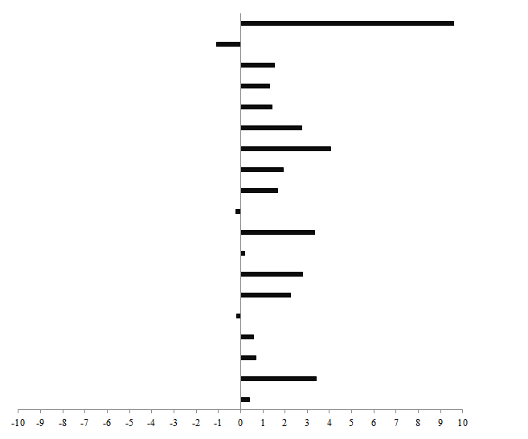
0.3
0.7
0.6
4.0
1.4
2.8
3.3
1.9
1.7
Agriculture, forestry and fishing
0.4
Other service activities

Human health & social work activities activities
Education
2.3
Real estate activities
Financial and insurance activities
-0.2
Accommodation and food service activities
Transportation and storage
Wholesale and retail trade; repair of motor vehicles and motorcycles
Construction
Water supply; sewerage, waste management and remediation activities
Manufacturing
Electricity, gas, steam and air conditioning supply
Mining and quarrying
-1.1
Arts, entertainment and recreation
Administrative and support service activities

Professional, scientific and technical activities
Information and communication
3.4
-0.2
2.8
1.3
1.5
9.6
Public administration and defence; compulsory social security

The Wage Rate Index for the general government sector, comprising ministries, government departments and agencies operating under them, municipalities, district councils and Rodrigues Regional Assembly remained at 103.2 in third quarter 2022.

This sector accounts for around 34% of the total weight of the wage rate index.

4. Indices for the Private and Public sectors

The index for the private sector which accounts for around 54% of the total weight of the wage rate index increased by 2.5% or 2.6 points from 103.9 in second quarter 2022 to 106.5 in third quarter 2022 (Tables 5 & 6).

The index for the public sector which comprises general government and public enterprises and accounting for around 46% of the wage rate index, increased by 0.3% or 0.3 point from 103.5 in second quarter 2022 to 103.8 in third quarter 2022 (Tables 7 & 8).

3

5. Past trend

Table 3 presents the quarterly indices from first quarter 2012 to third quarter 2022 with different base periods. As from 2022, the base period is fourth quarter 2021.

To enable comparison between the two series, chain link series, with fourth quarter 2021 as base, have been worked out and are provided in Table 4.

Chart 2 depicts the trend of the quarterly wage rate index from 2017 to 2022 using fourth quarter 2021 as base period. It shows a general upward movement in the index throughout the period up to third quarter 2022 except for a decline in second quarter 2020. The sharp increase in fourth quarter 2021 is mainly explained by salary revision in the government sector.

Chart 2 - Wage Rate Index,
1st quarter 2017 – 3rd quarter 2022
(Base: fourth quarter 2021=100)

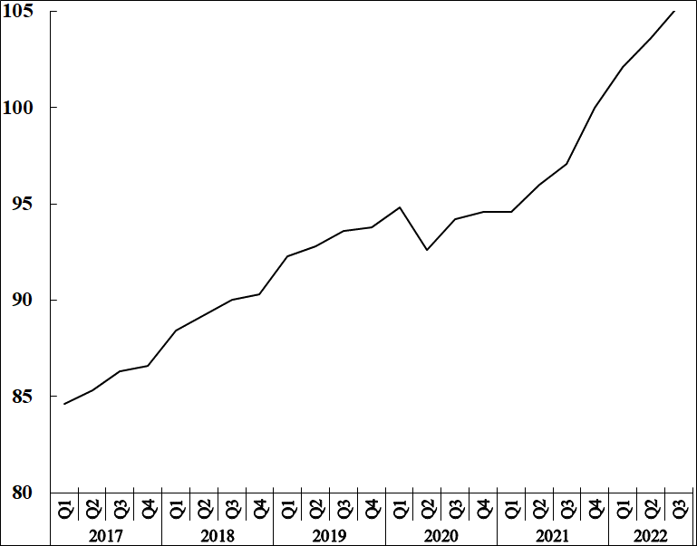

Statistics Mauritius

Ministry of Finance, Economic Planning and Development
Port Louis
19 December 2022
Contact persons:

(1) Mrs. D. Gangaram (Statistician)
(2) Mrs. S. D. Venkatasami (Senior Statistical Officer)
Labour Unit
Statistics Mauritius
LIC Centre
Port-Louis
Tel: 208 1800 Fax: 213 0234
Email: cso_labour@govmu.org
cso_quarterlylabour@govmu.org

i

Annex 1

Technical Note

Methodology used for the compilation of the Wage Rate Index

- Definition

The Wage Rate Index (WRI) measures changes in the price of labour, i.e., changes in the average rates actually paid by employers to their employees for work during normal working hours.

2. Adopted approach

To show genuine changes in the price of labour, it would have been necessary for wages of specific workers at specific establishments to be measured over time. Since this is not possible, the next best approach has been adopted, that is, to follow changes in the wages of groups of employees performing the same jobs. This gives a measure of changes in wage rates of specific occupations but has the following limitations:

    - any changes in the mix of employees within the selected occupations is bound to affect the calculated rates and hence the corresponding sectoral indices. Such changes occur, for example, with a new intake of employees in a specific group - when the wages of the new recruits pull down the average wages for the whole group from one period to the next.

    - wage adjustments resulting from changes in the tasks associated with a particular occupation, which cannot be separated from pure price changes of labour.

    - it is difficult to separate the effects of productivity from the overall change.

3. Coverage

The wage rate index is based on wage rates applicable in ‘large’ establishments only. Employment in these establishments accounted for around 59% of total employment in year 2021. ‘Large’ establishments comprise sugar cane plantations of 10 hectares or more; tea plantations of 2 hectares or more; other agricultural and non-agricultural establishments having 10 or more employees as well as General Government Services, i.e. ministries, government departments and agencies operating under them; municipalities; district councils and Rodrigues Regional Assembly.

The frame consists of a list of around 2500 ‘large’ establishments as at March 2021. Establishments were stratified according to industry and arranged in order of size, i.e., the number of employees, within the industrial group. Within the strata, selection was proportional to size of establishment. A sample of about 12% was surveyed, representing some 300 establishments. Time-rated as well as piece-rated wage earners and salaried employees are covered. Apprentices, workers on probation, part-time workers and employees working on a temporary basis are excluded.

4. Sectors covered

Indices are disseminated by the Public and Private sectors.

The Public sector comprises Ministries, Government departments and agencies operating under them; municipalities; district councils, the Rodrigues Regional Assembly and Public enterprises.

5. Calculating the Wage Rate Index

A Laspeyres formula is used. The occupational structure is held constant with reference to the base period of the index, i.e. December 2021. The relative changes in average wage rates are measured at the occupational level and these changes are then weighted to give a combined measure of the change. The following formula is used

I_{t} = Σw _{i} (R _{i}^{t} / R _{i}º) X 100

Σ w _{i}

where I_{t} = index for quarter t compared to base period o
w_{i} = Nº_{i}Rº_{i} which represents the total wages paid to all employees in the i ^{th}
occupation base period, December 2021
R_{i}º = wage rate of occupation i in base period, December 2021
R_{i}^{t} = wage rate of occupation i in quarter t

The index is, first, calculated for each industry group and the overall index (covering all industry groups) is computed as a weighted average of the individual industry group indices.

6. Reference period

The base period for the index is quarter 4 2021 (i.e. Quarter 4, 2021=100) as from the first quarter of 2022. The wage rate indices, for the first to fourth quarter, are based on wage rates applicable during the months of March, June, September and December respectively.

7. Weights

Two sets of weights are used:

(i) Weight for the industry groups derived from the ‘Survey of Employment & Earnings, March 2020’ and

(ii) Weight for occupations within each activity (NSIC) sectorwise. Questionnaires were sent to around 2,500 large establishments at the end of March 2021 to cater for number employed in each category of occupation.

8. Wage rates used

The wage/salary rates of specific occupations, used in the calculation of the index, are the rates paid for normal time work, comprising basic wages and salaries, cost of living allowances and other guaranteed and regular allowances paid at the end of each pay period. Overtime payments are, therefore, excluded.

