WAGE RATE INDEX (WRI)
(Base: fourth quarter 2021 = 100)

Second Quarter 2022

- Introduction

This issue of the Economic and Social Indicators (ESI) presents a new series of quarterly Wage Rate Indices with fourth quarter 2021 as base period. Previous published series were computed using the fourth quarter 2016 as base. A review of the weights is necessary to reflect changes in the industrial and occupational structure of the economy.

The Wage Rate Index (WRI) measures changes in the price of labour, i.e., changes in the average rates actually paid by employers to their employees for work during normal working hours.

The methodology used for computing the index is given in the technical note at Annex 1.

Indices, presented here, are based on wage rates applicable during the month of June 2022.

- Changes in weights from year 2016 to year 2021

Main decreases in weights were registered in the following sectors from year 2016 to year 2021:
“Education” from 120 to 111 and “Manufacturing” from 110 to 85
Main increases in the weights were in “Public administration and defence; compulsory social security” from 181 to 185 and “Human health and social work activities” from 69 to 73 (see annex 2).

- Movement of the overall wage rate index

The Wage Rate Index increased by 2.0% or 2.0 points to reach 102.0 in first quarter 2022 from 100.0 in fourth quarter 2021 (Tables 1 and 2).

The Index for the second quarter 2022 registered an increase of 1.2% or 1.2 points to reach 103.2 from 102.0 in the first quarter 2022 (Tables 1 and 2)

- Movement of the sub-indices, 1st Quarter 2021 to 2nd Quarter 2022

Main increases were registered in the following (Chart 1 & Table 2):

Construction | 4.1%
Manufacturing | 3.3%
Accommodation and food service activities | 2.4%
Wholesale and retail trade; repair of motor vehicles and motorcycles | 2.2%

Decreases were as follows:

Human health and social work activities | -0.5%
Real estate activities | -0.1%
Decreases in these sectors were mainly due to changes in the mix of employees within occupations and decrease in regular allowances.

2

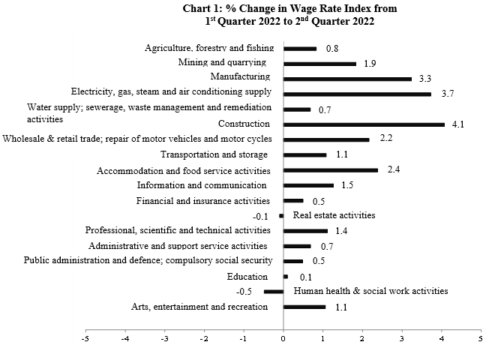

The Wage Rate Index for the general government sector, comprising ministries, government departments and agencies operating under them, municipalities, district councils and Rodrigues Regional Assembly, increased by 3.0% or 3.0 points from 100.0 in fourth quarter 2021 to 103.0 in first quarter 2022. The index for the second quarter 2022 registered an increase of 0.2% or 0.2 point to reach 103.2.

This sector accounts for around 34% of the total weight of the wage rate index.

4. Indices for the Private and Public sectors

The index for the private sector which accounts for around 54% of the total weight of the wage rate index increased by 1.5% or 1.5 points from 100.0 in fourth quarter 2021 to 101.5 in first quarter 2022.

The index increased by 1.9% or 1.9 points from 101.5 in the first quarter 2022 to 103.4 in the second quarter 2022 (Tables 5 & 6).

The index for the public sector which comprises general government and public enterprises and accounting for around 46% of the wage rate index, increased by 2.7% or 2.7 points from 100.0 in fourth quarter 2021 to 102.7 in first quarter 2022 (Tables 7 & 8).

The index increased by 0.4% or 0.4 point from 102.7 in the first quarter 2022 to 103.1 in the second quarter 2022.

3

6. Past trend

Table 3 presents the quarterly indices from first quarter 2012 to first quarter 2022 with different base periods. As from 2022, the base period is fourth quarter 2021.

To enable comparison between the two series, chain link series, with fourth quarter 2021 as base, have been worked out and are provided in Table 4.

Chart 2 depicts the trend of the quarterly wage rate index from 2017 to 2022 using fourth quarter 2021 as base period. It shows a general upward movement in the index throughout the period up to second quarter 2022 except for a decline in second quarter 2020. The sharp increase in fourth quarter 2021 is mainly explained by salary revision in the government sector.

Chart 2 - Wage Rate Index,
1st quarter 2017 – 2nd quarter 2022
(Base: fourth quarter 2021=100)

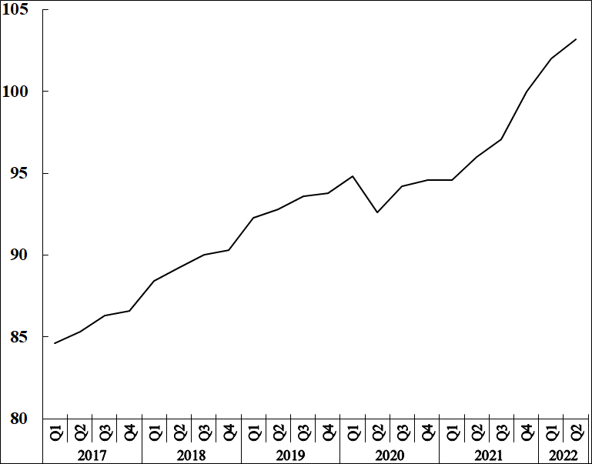

Statistics Mauritius

Ministry of Finance, Economic Planning and Development
Port Louis
26 September 2022
Contact persons:

(1) Mrs. D. Gangaram (Statistician)
(2) Mrs. S. D. Venkatasami (Senior Statistical Officer)
Labour Unit
Statistics Mauritius
LIC Centre
Port-Louis
Tel: 208 1800 Fax: 213 0234
Email: cso_labour@govmu.org
cso_quarterlylabour@govmu.org

i

Annex 1

Technical Note

Methodology used for the compilation of the Wage Rate Index

- Definition

The Wage Rate Index (WRI) measures changes in the price of labour, i.e., changes in the average rates actually paid by employers to their employees for work during normal working hours.

2. Adopted approach

To show genuine changes in the price of labour, it would have been necessary for wages of specific workers at specific establishments to be measured over time. Since this is not possible, the next best approach has been adopted, that is, to follow changes in the wages of groups of employees performing the same jobs. This gives a measure of changes in wage rates of specific occupations but has the following limitations:

    - any changes in the mix of employees within the selected occupations is bound to affect the calculated rates and hence the corresponding sectoral indices. Such changes occur, for example, with a new intake of employees in a specific group - when the wages of the new recruits pull down the average wages for the whole group from one period to the next.

    - wage adjustments resulting from changes in the tasks associated with a particular occupation, which cannot be separated from pure price changes of labour.

    - it is difficult to separate the effects of productivity from the overall change.

3. Coverage

The wage rate index is based on wage rates applicable in ‘large’ establishments only. Employment in these establishments accounted for around 59% of total employment in year 2021. ‘Large’ establishments comprise sugar cane plantations of 10 hectares or more; tea plantations of 2 hectares or more; other agricultural and non-agricultural establishments having 10 or more employees as well as General Government Services, i.e. ministries, government departments and agencies operating under them; municipalities; district councils and Rodrigues Regional Assembly.

The frame consists of a list of around 2500 ‘large’ establishments as at March 2021. Establishments were stratified according to industry and arranged in order of size, i.e., the number of employees, within the industrial group. Within the strata, selection was proportional to size of establishment. A sample of about 12% was surveyed, representing some 300 establishments. Time-rated as well as piece-rated wage earners and salaried employees are covered. Apprentices, workers on probation, part-time workers and employees working on a temporary basis are excluded.

4. Sectors covered

Indices are disseminated by the Public and Private sectors.

The Public sector comprises Ministries, Government departments and agencies operating under them; municipalities; district councils, the Rodrigues Regional Assembly and Public enterprises.

5. Calculating the Wage Rate Index

A Laspeyres formula is used. The occupational structure is held constant with reference to the base period of the index, i.e. December 2021. The relative changes in average wage rates are measured at the occupational level and these changes are then weighted to give a combined measure of the change. The following formula is used

I_{t} = Σw _{i} (R _{i}^{t} / R _{i}º) X 100

Σ w _{i}

where I_{t} = index for quarter t compared to base period o
w_{i} = Nº_{i}Rº_{i} which represents the total wages paid to all employees in the i ^{th}
occupation base period, December 2021
R_{i}º = wage rate of occupation i in base period, December 2021
R_{i}^{t} = wage rate of occupation i in quarter t

The index is, first, calculated for each industry group and the overall index (covering all industry groups) is computed as a weighted average of the individual industry group indices.

6. Reference period

The base period for the index is quarter 4 2021 (i.e. Quarter 4, 2021=100) as from the first quarter of 2022. The wage rate indices, for the first to fourth quarter, are based on wage rates applicable during the months of March, June, September and December respectively.

7. Weights

Two sets of weights are used:

(i) Weight for the industry groups derived from the ‘Survey of Employment & Earnings, March 2020’ and

(ii) Weight for occupations within each activity (NSIC) sectorwise. Questionnaires were sent to around 2,500 large establishments at the end of March 2021 to cater for number employed in each category of occupation.

8. Wage rates used

The wage/salary rates of specific occupations, used in the calculation of the index, are the rates paid for normal time work, comprising basic wages and salaries, cost of living allowances and other guaranteed and regular allowances paid at the end of each pay period. Overtime payments are, therefore, excluded.

ii

Annex 2

Evolution of weights from 2016 to 2021
Weights by industry group, previous and new base periods
Industry Section |  |  | Previous weight |  | New weight
 |  |  | Base period: Dec 2016 = 100 |  | Base period: Dec 2021 = 100
Agriculture, forestry and fishing |  |  | 32 |  | 23
Mining and quarrying |  |  | 3 |  | 3
Manufacturing |  |  | 110 |  | 85
of which Sugar |  |  | 4 |  | 4
Food (excluding sugar) |  |  | 17 |  | 22
Textiles |  |  | 46 |  | 28
Electricity, gas, steam and air conditioning supply |  |  | 16 |  | 17
Water supply; sewerage, waste management and remediation activities |  |  | 8 |  | 8
Construction |  |  | 38 |  | 35
Wholesale and retail trade; repair of motor vehicles and motorcycles |  |  | 73 |  | 79
Transportation and storage |  |  | 69 |  | 68
Accommodation and food service activities |  |  | 65 |  | 63
Information and communication |  |  | 44 |  | 48
Financial and insurance activities |  |  | 75 |  | 83
Real estate activities |  |  | 4 |  | 6
Professional, scientific and technical activities |  |  | 48 |  | 57
Administrative and support service activities |  |  | 33 |  | 43
Public administration and defence; compulsory social security |  |  | 181 |  | 185
Education |  |  | 120 |  | 111
Human health and social work activities |  |  | 69 |  | 73
Arts, entertainment and recreation |  |  | 10 |  | 11
Other service activities |  |  | 4 |  | 4

