# WAGE RATE INDEX (WRI)

***(Base: fourth quarter 2016 = 100)***

**Fourth Quarter and Year 2021**

1. **Introduction**

This issue of the Economic and Social Indicators (ESI) on wage rate index presents data for the fourth quarter and year 2021 using as base the fourth quarter of 2016 (Q4 2016=100).

The Wage Rate Index (WRI) measures changes in the price of labour, i.e., changes in the average rates actually paid by employers to their employees for work during normal working hours.

The methodology used for computing the index is given in the technical note at Annex 1.

Indices, presented here, are based on wage rates applicable during the month of December 2021.

1. **Movement of the overall wage rate index**

The wage rate index increased by 2.9% or 3.4 points to reach 121.0 in fourth quarter 2021 from 117.6 in third quarter 2021 (Tables 1 and 2).

Compared to fourth quarter 2020, the wage rate index, which stood at 114.5, increased by 5.7% or 6.5 points (Table 3).

1. **Movement of the sub-indices, 3rd Quarter 2021 to 4th Quarter 2021**

Main increases were registered in the following (Chart 1 & Table 2):

|  |  |
| --- | --- |
| *Human health and social work activities* | *6.9%* |
| *Public administration and defence; compulsory social security* | *5.8%* |
| *Education* | *5.6%* |
| *Transport, storage and communication* | *3.1%* |
| *Manufacturing* | *2.9%* |

Decreases were as follows:

|  |  |
| --- | --- |
| *Administrative and support service activities* | *-1.4%* |
| *Electricity, gas, steam and air conditioning supply* | *-0.8%* |
| *Professional, scientific and technical activities* | *-0.5%* |
| *Agriculture, forestry and fishing* | *-0.5%* |
|  |  |

Decreases in these sectors were mainly due to changes in the mix of employees within occupations and decrease in regular allowances.

2

**Chart 1: % Change in Wage Rate Index from**

**3rd Quarter 2021 to 4th Quarter 2021**



-1.4

-0.5

Public administration and defence; compulsory social security

Administrative and support service activities

Wholesale & retail trade; repair of motor vehicles and motorcycles

6.9

Human health and social work activities

Real estate activities

Financial and insurance activities

0.3

0.8

Arts, entertainment and recreation

Other service activities

1.5

5.8

5.6

0.3

0.2

1.7

Information and communication

0.4

Accommodation and food service activities

3.1

Transportation and storage

1.0

15.8

-0.8

Electricity, gas, steam and air conditioning supply

Manufacturing

-1.6

Agriculture, forestry and fishing

Mining and quarrying

-0.5

-0.7

2.9

Education

Professional, scientific and technical activities

Construction

Water supply; sewerage, waste management and remediation activities

-0.4

Other service activities

-0.5

Arts, entertainment and recreation

The wage rate index for the general government sector, comprising ministries, government departments and agencies operating under them, municipalities, district councils and Rodrigues Regional Assembly, increased by 6.5% or 7.3 points from 112.0 in third quarter 2021 to 119.3 in fourth quarter 2021. This increase is mainly explained by the salary revision, as per the 2021 PRB Report, paid as from November 2021.

Compared to fourth quarter 2020, the index, which stood at 110.3, increased by 8.2% or 9.0 points. This sector accounts for around 34% of the total weight of the wage rate index.

**4**. **Movement of the sub-indices, 4th Quarter 2020 to 4th Quarter 2021**

Table 3 compares the indices for the fourth quarter of 2021 with those of the corresponding quarter of 2020.

Main increases were registered in the following industry groups:

|  |  |
| --- | --- |
| *Transportation and storage* | *9.4%* |
| *Public administration and defence; compulsory social security* | *7.8%* |
| *Human health and social work activities* | *7.6%* |
| *Education* | *6.9%* |
| *Financial and insurance activities* | *6.8%* |

-0.6

3

A decrease was registered in ‘real estate activities’ (-0.6%), mainly explained by a decline in regular allowances.

**5. Indices for the Private and Public sectors, Q4 2021**

The index for the private sector which accounts for around 54% of the total weight of the wage rate index increased by 0.9% or 1.1 points from 120.6 in third quarter 2021 to 121.7 in fourth quarter 2021 (Tables 7 & 8).

Compared to fourth quarter 2020, the index for the private sector, which stood at 117.4, increased by 3.7% or 4.3 points (Table 9).

The index for the public sector which comprises general government and public enterprises and accounting for around 46% of the wage rate index, increased by 5.3% or 6.1 points from 114.1 in third quarter 2021 to 120.2 in fourth quarter 2021 (Tables 11 & 12).

Compared to fourth quarter 2020, the index for the public sector, which stood at 111.0, increased by 8.3% or 9.2 points (Table 13).

**6. Wage Rate Index, Year 2021**

The wage rate index for year 2021, worked out as the average of the quarterly indices, reached 117.4 compared to 113.9 for year 2020, representing an increase of 3.1% or 3.5 points. (Table 4).

The wage rate index for the general government sector increased by 3.5% or 3.9 points to reach 114.2 in 2021 from 110.3 in 2020. This increase is mainly explained by the salary revision, as per the 2021 PRB Report, paid as from November 2021.

The sectoral indices for year 2021, compared to 2020, show main increases in the following groups:

|  |  |
| --- | --- |
| *Financial and insurance activities* | *10.3%* |
| *Professional, scientific and technical activities* | *7.4%* |
| *Public administration and defence; compulsory social security* | 3.7% |
| *Education* | *2.9%* |

A decrease was registered in ‘Water supply; sewerage, waste management and remediation activities’

(-12.6%), mainly due to changes in the mix of employees within occupations and decrease in regular allowances.

**7. Indices for the Private and Public sectors, Year 2021**

The index for the private sector for year 2021, which is an average of the four quarters, worked out to 119.2 compared to 115.8 for year 2020. This corresponds to an increase of 2.9% or 3.4 points in the index (Table 10).

The index for the public sector for year 2021, worked out to 115.2 compared to 111.7 for year 2020, representing an increase of 3.1% or 3.5 points (Table 14).

4

**8. Past trend**

Table 5 presents the quarterly indices from first quarter 2007 to fourth quarter 2021 with different base periods. As from 2017, the base period is fourth quarter 2016.

To enable comparison between the two series, chain link series, with fourth quarter 2016 as base, have been worked out and are provided in Table 6.

Chart 2 depicts the trend of the quarterly wage rate index from 2014 to 2021 using fourth quarter 2016 as base period. It shows a general upward movement in the index throughout the period up to fourth quarter 2021 except for a decline in second quarter 2020.

**Chart 2 - Wage rate index,**

**1st quarter 2014 – 4th quarter 2021**

*(Base: fourth quarter 2016=100)*

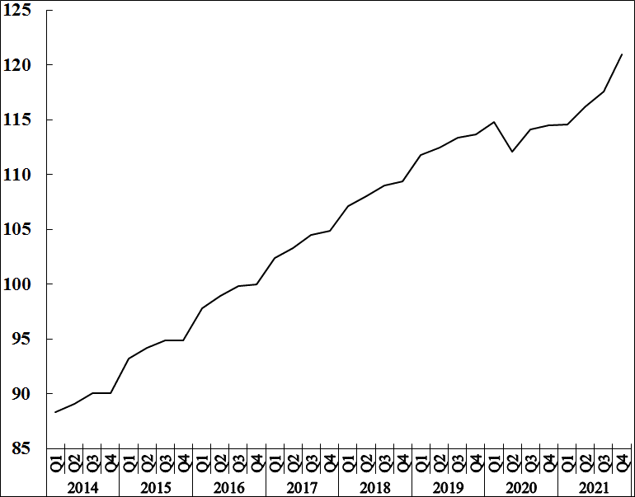

**Statistics Mauritius**

**Ministry of Finance, Economic Planning and Development**

**Port Louis**

**28 March 2022**

Contact persons:

**(1) Mrs. D. Gangaram (Statistician)**

**(2) Mrs. S. D. Venkatasami (Senior Statistical Officer)**

Labour Unit

Statistics Mauritius

LIC Centre

Port-Louis

Tel: 208 1800 Fax: 213 0234

**Email:** [**cso­_labour@govmu.org**](mailto:cso_labour@govmu.org)

**cso_quarterlylabour@govmu.org**

i **Annex 1**

**Technical Note**

**Methodology used for the compilation of the Wage Rate Index**

1. **Definition**

The Wage Rate Index (WRI) measures changes in the price of labour, i.e., changes in the average rates actually paid by employers to their employees for work during normal working hours.

**2. Adopted approach**

To show genuine changes in the price of labour, it would have been necessary for wages of specific workers at specific establishments to be measured over time. Since this is not possible, the next best approach has been adopted, that is, to follow changes in the wages of groups of employees performing the same jobs. This gives a measure of changes in wage rates of specific occupations but has the following limitations:

* + 1. any changes in the mix of employees within the selected occupations is bound to affect the calculated rates and hence the corresponding sectoral indices. Such changes occur, for example, with a new intake of employees in a specific group - when the wages of the new recruits pull down the average wages for the whole group from one period to the next.
    2. wage adjustments resulting from changes in the tasks associated with a particular occupation, which cannot be separated from pure price changes of labour.
    3. it is difficult to separate the effects of productivity from the overall change.

**3. Coverage**

The wage rate index is based on wage rates applicable in ‘large’ establishments only. Employment in these establishments accounted for around 55% of total employment in year 2017. ‘Large’ establishments comprise sugar cane plantations of 10 hectares or more; tea plantations of 2 hectares or more; other agricultural and non-agricultural establishments having 10 or more employees as well as General Government Services, i.e. ministries, government departments and agencies operating under them; municipalities; district councils and Rodrigues Regional Assembly.

The frame consists of a list of all ‘large’ establishments (about 2,750) as at March 2016. Establishments were stratified according to industry and arranged in order of size, i.e., the number of employees, within the industrial group. Within the strata, selection was proportional to size of establishment. A sample of about 9% was surveyed, representing some 250 establishments.

Time-rated as well as piece-rated wage earners and salaried employees are covered. Apprentices, workers on probation, part-time workers and employees working on a temporary basis are excluded.

**4. Sectors covered**

Indices are disseminated by the Public and Private sectors.

The **Public sector** comprises Ministries, Government departments and agencies operating under them; municipalities; district councils, the Rodrigues Regional Assembly and Public enterprises.

**5.** **Calculating the Wage Rate Index**

A Laspeyres formula is used. The occupational structure is held constant with reference to the base period of the index, i.e. December 2016. The relative changes in average wage rates are measured at the occupational level and these changes are then weighted to give a combined measure of the change. The following formula is used

It = Σw i (R it / R io) X 100

Σ w i

where It  = index for quarter t compared to base period o

wi = NoiRoi which represents the total wages paid to all employees in the i th

occupation base period, December 2016

Rio= wage rate of occupation i in base period, December 2016

Rit= wage rate of occupation i in quarter t

The index is, first, calculated for each industry group and the overall index (covering all industry groups) is computed as a weighted average of the individual industry group indices.

**6. Reference period**

The base period for the index is quarter 4 2016 (i.e. Quarter 4, 2016=100) as from the first quarter of 2017. The wage rate indices, for the first, second, third and fourth quarters of 2007 and 2008, are based on wage rates applicable during the months of February, May, August and November respectively. As from 2009, the wage rate indices, for the first to fourth quarter, are based on wage rates applicable during the months of March, June, September and December respectively.

**7. Weights**

Two sets of weights are used:

(i) ***Weight for the industry groups*** derived from the ‘Survey of Employment & Earnings, March 2015’ and

(ii) ***Weight for occupations*** within each activity (NSIC) sectorwise. Questionnaires were sent to around 1,200 large establishments at the end of March 2016 to cater for number employed in each category of occupation.

**8. Wage rates used**

The wage/salary rates of specific occupations, used in the calculation of the index, are the rates paid for normal time work, comprising basic wages and salaries, cost of living allowances and other guaranteed and regular allowances paid at the end of each pay period. Overtime payments are, therefore, excluded.