Economic and Social Indicators

Information and Communication Technologies (ICT) Statistics - 2020

1. Introduction

This is the fifteenth issue of the Economic and Social Indicators on Information and Communication Technologies (ICT) statistics compiled by Statistics Mauritius. It presents statistics on ICT sector, including ICT infrastructure, access and usage based on information gathered from various administrative sources as well as from surveys conducted by Statistics Mauritius.

Data presented in this report relate to the Republic of Mauritius and, unless otherwise stated, refer to the period 2016 to 2020. The concepts and definitions used are given at Annex.

2. ICT infrastructure and access

2.1 Service providers and available infrastructure

Number of service providers

At the end of 2020, there were two fixed-line telephone service providers, three mobile cellular service providers and eleven internet service providers (Table 1).

Internet Usage

International Bandwidth Usage includes all international links used by all types of operators, namely fixed, mobile and satellite operators.

In 2020, International Bandwidth Usage was 144,973 Mbit/s (Megabits per second) compared to 101,657 Mbit/s in 2019. The usage per inhabitant moved up from 80,331 bits per second in 2019 to 114,510 bits per second in 2020, that is, an increase of 42.5%.

The volume of internet downloads went up by 60.1% from 444,397 terabytes in 2019 to 711,287 terabytes in 2020. Similarly, during the same period, the volume of internet uploads increased by 50.6% from 49,279 terabytes to 74,232 terabytes.

2.2 Fixed and Mobile cellular subscriptions

The number of fixed telephone lines increased by 4.4% from 458,700 in 2019 to 478,700 in 2020. The number of fixed telephone lines per 100 inhabitants moved up from 36.2 in 2019 to 37.8 in 2020.

The population covered by mobile cellular telephony comprises the number of inhabitants who live within areas covered by a mobile cellular network, irrespective of whether they subscribe to the service. In 2020, some 99% of the population was covered by mobile cellular telephony, same as in 2019 (Table 1).

Between 2019 and 2020,

- the total number of mobile cellular subscriptions went up by 2.5% from 1,866,600 to 1,912,900. Prepaid subscriptions increased by 1.9% from 1,659,600 to 1,691,200 and postpaid subscriptions registered an increase of 7.1% from 207,000 to 221,700; and

- mobidensity (the number of mobile cellular subscriptions per 100 inhabitants) went up by 2.4%, from 147.5 to 151.1 (Table 2).
As shown in Figure 1, over the period 2011 to 2020 both mobidensity and teledensity (fixed telephone lines per 100 inhabitants) follow an upward trend (Table 2).

Figure 1 – Fixed telephone lines and mobile cellular subscriptions per 100 inhabitants, 2011 – 2020

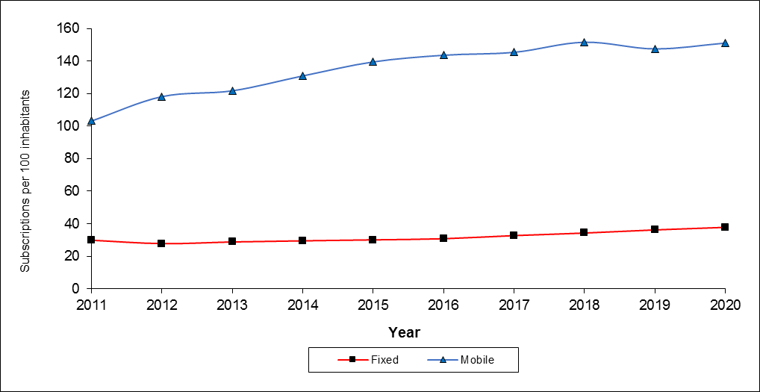

2.3 Internet subscriptions

Between 2019 and 2020,

- the number of internet subscriptions increased by 10.1% from 1,496,300 to 1,648,000 (Table 2) as a result of increases of 11.4% in the number of mobile internet subscriptions (from 1,189,100 to 1,324,700) and 5.2% in that of fixed internet subscriptions (from 307,200 to 323,300); and

- the number of internet subscriptions per 100 inhabitants went up from 118.2 to 130.2.

2.4 Type of Internet access

Broadband internet is defined as internet connectivity at a speed of at least 256 kilobits per second (Kbps), whereas narrowband internet is defined as connectivity of less than 256 Kbps.

In 2020, Broadband Internet subscriptions constituted 95.2% of total internet subscriptions and increased by 10.7% from 1,416,700 in 2019 to 1,568,800 in 2020. On the other hand, Narrowband Internet subscriptions went down by 0.5% from 79,600 to 79,200.

Among the Broadband Internet subscriptions, those based on mobile network rose by 12.3% from 1,109,500 to reach 1,245,600, and those based on fixed (including wireless) network increased by 5.2% from 307,200 to 323,200. Mobile Broadband Internet subscriptions accounted for 79.4% of total Broadband Internet subscriptions.

Narrowband subscriptions based on mobile access network decreased by 0.5% from 79,500 to 79,100 and those based on fixed access network remained the same as in 2019, i.e, 100 (Table 3).
2.5 Tariffs

Selected telephone and internet tariffs for the period 2016 to 2020 are shown in Table 4. Data presented are from the main service provider as at end of year.

2.5.1 Telephone Charges

Between 2019 and 2020, the telephone tariff,
- from a fixed line remained unchanged; and
- from a mobile cellular prepaid service remained unchanged for calls: (i) on the same network, (ii) to a different network and (iii) to a fixed telephone (Table 4).

The average mobile cellular tariff (for 100 minutes of use during a month), expressed as a percentage of Gross National Income (GNI) per capita, stood at 1.0% in 2020, higher than in 2019 (0.8%).

2.5.2 Internet Charges

A new set of tariffs for fibre-based internet connection is presented in this report (Table 4).

The tariff for Fibre To The Home (FTTH) of 10 Mbps with different volume allowances for both residential and business remained unchanged in 2020 compared to 2019.

The internet access tariff (for 20 hours of use during a month) as a percentage of GNI per capita increased from 2.1% in 2019 to 2.5% in 2020. This indicator is computed based on the monthly standard residential offer of 10 Mbps and volume allowance 150 GB.

2.6 Communication traffic

2.6.1 Local calls

Local calls are mostly done through mobile phones. Out of every 10 local calls in 2020, around 8 were made through mobile phones, same as in 2019 (Table 5).

However, mobile phone calls are generally shorter than those through fixed phones. In 2020, a mobile phone call lasted on average 1.2 minutes against 2.4 minutes for a call through a fixed phone, almost the same as in 2019.

Local calls from mobile phones between 2019 and 2020 decreased by:
- 10.8% in number from 1,514.9 million to 1,350.8 million, and
- 7.6% in volume from 1,717.9 million minutes to 1,587.5 million minutes.

2.6.2 International calls

Between 2019 and 2020, the volume of international phone calls for outgoing traffic went down by 15.4% (from 41.0 to 34.7 million minutes). Similarly, incoming traffic fell by 33.7% (from 42.1 to 27.9 million minutes) (Table 5).

2.6.3 Short Message Service (SMS)

Between 2019 and 2020,

- the number of messages sent through the Short Message Service (SMS) declined by 31.8% from 728.5 to 497.0 million.

3. ICT access and use

Figures in this section are based on the results of the Continuous Multi-Purpose Household Survey (CMPHS) and are updated every two years, the latest update being for year 2020. Due to the outbreak of the COVID-19 pandemic in March 2020, data collection on ICT access and use was discontinued as from April 2020. Hence, the 2020 estimates are based on responses from 2,815 households compared to 5,640 households in 2018 but are reliable based on sampling variability measures.

3.1 ICT access by households

Comparative figures between 2018 and 2020 show that ICT access by households improved as follows (Table 6); the proportion of households with:

- smartphones: 71.3% to 81.4%;
- internet access: 69.7% to 72.6%
- paid TV channels: 38.9% to 42.4%;
- Smart TV: 22.6% to 37.7%.

3.2 ICT access and use by individuals

In 2020, some 91% of persons aged five years and above used a mobile phone, compared to around 88% in 2018 (Table 7).

Data on computer use (Table 9) showed that in 2020:

- 46.8% of persons aged five years and above used computer, compared to 49.6% in 2018;
- younger people, particularly those in the age bracket 12 - 29 years are more likely to be computer users than older ones, same as in 2018.

Data on internet use (Table 9) revealed that in 2020:

- 68.3% persons aged twelve years and above were internet users, compared to 61.1% in 2018;
- 94.2% of young persons in age group 12 - 19 years and 96.1% in age group 20 - 29 years were using internet in 2020, compared to around 91% for both age groups in 2018.

Data on ownership and purpose of use of smartphone (Tables 13 & 14) indicate that in 2020:

- 61.9% of persons aged twelve years and above owned a smartphone, compared to 52.9% in 2018;

- The highest number of smartphone owners was in the age bracket 20 to 29 years, same as in 2018.

Main uses of smartphones in 2020 were:

- Instant messaging (Whatsapp, Viber, Wechat) – (87.1%);
- Visiting social networking sites (81.0%);
- General internet browsing (75.9%);
- Sending/receiving emails (41.9%).

4. ICT usage in business

Based on data collected through the Survey of Employment and Earnings among ‘large establishments’ employing 10 or more persons, the following changes have been observed in ICT usage for years 2019 and 2020 (Table 16).

‘large’ establishments
- having computer stood at 98.8% in 2020, same as in 2019;
- having internet increased from 97.8% in 2019 to 98.6% in 2020;
- having placed orders over the internet increased from 48.8% in 2019 to 51.9% in 2020.

5. Contribution of ICT sector to the economy (see Annex for definition)

5.1 Employment

The number of large establishments (employing 10 or more persons) operating in the ICT sector in 2020 was 121, lower than the figure of 123 in 2019 (Table 17).

However, employment in large establishments increased by 0.4%, i.e. 16,800 (8,735 males and 8,065 females) in 2019 and 16,865 (8,780 males and 8,085 females) in 2020. The share of employment in the ICT sector over total employment for 2020 stood at 5.2%, against 5.0% in 2019.

5.2 Gross Value Added (GVA)

GVA at current basic prices comprises the sum of value added of each firm, government institution and producing households in a given country (GVA = ∑ Value added).

The ICT sector comprises manufacturing activities, telecommunications services, wholesale and retail trade, and other activities such as call centres, software development, website development and hosting, multimedia, IT consulting and disaster recovery.

In 2020, value added at current prices generated by the ICT sector was Rs 26,432 million, 4.2% higher in nominal terms than in 2019 (Rs 25,356 million). The contribution of ICT to Gross Value Added (GVA) at current basic prices was 7.0% in 2020, higher than in 2019 (5.8%). The real growth rate (after removing price effects), went up from 4.7% to 4.9% (Table 17).

In 2020, around 53% of value added of the sector was generated by activities of telecommunications, 14% by wholesale and retail trade and 33% by the remaining activities such as manufacturing, call centres, software development and website development.

5.3 External Trade – share of ICT goods and services (see Annex for definition)

Trade in ICT goods between 2019 and 2020 was as follows:
- imports went down by 22.8 % from Rs 11,524 million to Rs 8,892 million;
- exports which includes re-exports, decreased by 35.3% from Rs 1,074 million to Rs 695 million.

Trade in ICT services between 2019 and 2020 was as follows:
- imports increased by 21.7% from Rs 3,830 million to Rs 4,662 million; while
- exports decreased by 1.3% from Rs 4,970 million to Rs 4,907 million.

Between 2019 and 2020, the share of ICT goods and services increased:

- from 5.7% to 6.5% over total imports; and
- from 3.1% to 4.4% over total exports.

- ICT Development Index (IDI)

The ICT Development Index (IDI) has been devised by the International Telecommunication Union (ITU) to assess the level of digital development of countries. The construction of the IDI is guided by previous ITU composite indices, such as, Digital Access Index (DAI), Digital Opportunity Index (DOI) and the ICT Opportunity Index (ICT-OI).

Latest available figures on IDI for Mauritius date back to year 2016. Mauritius with an index of 5.88 ranked first among African countries and 72nd out of 176 countries worldwide.

The methodology for the computation of a revised version of IDI, based on a set of new indicators taking on board the “Sustainable Development Goals” (SDGs), is still under review. Consensus has not been reached on the new methodology. Hence, the index is not available for the years 2017 onwards.

Statistics Mauritius
Ministry of Finance, Economic Planning and Development
Port Louis
13 July 2021

Contact Persons:

Mr. A. Bundhoo (Statistician)

Mrs. N. Joomun (Senior Statistical Officer)

Information and Communication Technologies (ICT) Unit
Statistics Mauritius
2nd Floor, LIC Centre, Port Louis
Tel: (230) 208 1800
Email: statsmauritius@govmu.org
cso-ict@govmu.org
Website: http://statsmauritius.govmu.org

