Productivity and Competitiveness Indicators

(2007 – 2017)
1. Introduction

This issue of the Economic and Social Indicators presents Productivity and Competitiveness Indicators for the years 2007 to 2017 for the total economy, the manufacturing sector and Export Oriented Enterprises (EOE).

Tables 1.1 to 1.4 present the various indices for the total economy, tables 2.1 to 2.5 for the manufacturing sector and tables 3.1 to 3.6 for the EOE and its sub-sectors (textile and non-textile). Concepts and definitions used are given on pages 10 to 12.

2. Indicators for the total economy

Table A below presents the growth rates of productivity, unit labour cost and other competitiveness related indicators for the total economy.

Table A: Productivity and competitiveness indicators for the total economy

Indicator |  | Growth rate (%)
 |  | Annual Average | 2016¹ | 2017
 |  | 2007-2017 | 2016¹ | 2017
1 | Output (GVA at basic prices) | 3.8 | 3.6 | 3.5
2 | GDP at market prices | 3.9 | 3.8 | 3.8
3 | GDP per capita (market prices) | 3.7 | 3.7 | 3.7
4 | Labour input | 1.3 | 0.1 | 1.1
5 | Capital input | 3.9 | 2.4 | 2.6
6 | Capital - Output ratio | 0.1 | -1.1 | -0.9
7 | Capital - Labour ratio | 2.5 | 2.3 | 1.5
8 | Labour productivity | 2.5 | 3.4 | 2.4
9 | Capital productivity | -0.1 | 1.1 | 0.9
10 | Multifactor productivity | 0.9 | 1.9 | 1.4
11 | Average compensation of employees | 5.4 | 5.9 | 4.1
12 | Unit Labour Cost (Mauritian Rupees) | 2.8 | 2.4 | 1.7
13 | Unit Labour Cost (US Dollars) | 1.8 | 0.2 | 4.9
¹Revised

2.1 Output (Gross Value Added)

Output, as measured by the Gross Value Added (GVA), is the total value of goods and services (exclusive of taxes) produced within a country. From 2007 to 2017, GVA at basic prices, in real terms, grew on average by 3.8% per annum. The growth rate for 2017 was 3.5%, lower than the growth of 3.6% registered in 2016.

GDP per capita at market prices is an indicator of the standard of living of the population. With an annual growth of 0.2% in the population and 3.9% in GDP at market prices, GDP per capita grew by 3.7% per annum during the period 2007 to 2017.

2.2 Labour and capital inputs

During the period 2007 to 2017, whilst real GVA at basic prices increased by an average of 3.8% per annum, capital input grew by 3.9% compared to a growth of 1.3% for labour input. The capital-labour ratio, defined as the ratio of the stock of fixed capital to labour input grew by 2.5% annually during the period under review. Annual growth rates of output and inputs for the years 2007 to 2017 are given in table 1.1.

2.3 Productivity trends

Figure 1: Trends in productivity indices – Total economy, 2007 to 2017
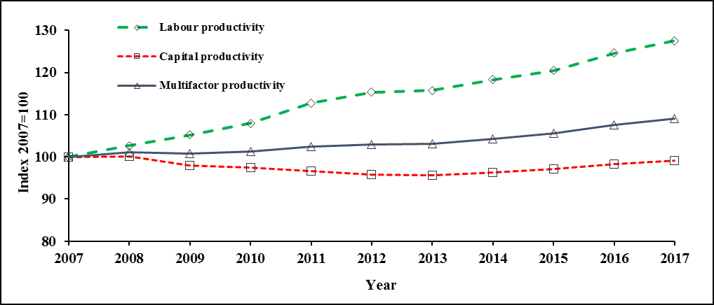

2.3.1 Labour productivity

Labour productivity for the whole economy is a measure of real output (GVA) per worker. From table 1.2 and Figure 1, it is observed that the index of labour productivity, improved from 100.0 in 2007 to 127.5 in 2017, giving an average annual growth of 2.5%.

In 2017, labour productivity grew at a lower rate of 2.4% compared to 3.4% in 2016. This was the result of a lower GVA growth of 3.5% compared to 3.6% in 2016 while labour input grew by a higher rate of 1.1% in 2017 compared to 0.1% in 2016.

2.3.2 Capital productivity

Capital productivity is a measure of real GVA per unit of capital. During the period 2007 to 2017, the index of capital productivity declined from 100.0 in 2007 to 99.2 in 2017. The average annual rate of change worked out to -0.1%.
Capital productivity registered an increase of 0.9% in 2017 compared to 1.1% in 2016 (Table 1.2). The 0.9% increase in 2017 is explained by a lower growth in capital input (2.6%) compared to that of GVA (3.5%).

2.3.3 Multifactor productivity (MFP)

The MFP index shows the rate of change in “productive efficiency”. In addition to labour and capital inputs, it takes into account qualitative factors such as better management and improved quality of inputs through training and technology. The average annual change in MFP during the period 2007 to 2017 worked out to 0.9%. MFP growth in 2017 (1.4%) was lower than in 2016 (1.9%) (Table 1.2).

2.4 Growth accounting

The contribution of different factors to economic growth is determined by the growth accounting technique. From 2007 to 2017, the contribution of labour to the 3.8% average annual growth in GVA worked out to 13% and that of capital to 61%. The remaining 26% represents qualitative factors such as training, management and technology.

Figure 2: Contribution of labour, capital and other qualitative factors to average annual GVA growth during the period 2007 to 2017


2.5 Unit Labour Cost (ULC)
Unit labour cost measures the remuneration of labour per unit of output. It is affected by changes in both average compensation of employees and labour productivity. During the period 2007 to 2017, average annual compensation of employees increased by 5.4% whilst labour productivity grew by 2.5%. The growth of 5.4% in average annual compensation of employees and 2.5% in labour productivity resulted in an average annual growth of 2.8% in ULC. In 2017, ULC increased by 1.7% compared to 2.4% growth in 2016 (Table 1.3).

To compare changes in competitiveness across economies, the impact of exchange rate fluctuations has to be taken into account. When a national currency appreciates against the US Dollar, more dollars are paid in exchange for each national currency unit. On the other hand, when a national currency depreciates against the US Dollar, fewer dollars are paid in exchange for each national currency unit. From 2007 to 2017, ULC in Mauritian Rupees grew at an average annual rate of 2.8%. In Dollar terms, it increased by 1.8% as a result of an average annual depreciation of 1.0% of the Mauritian Rupee vis-à-vis the US Dollar. In 2017, ULC in Dollar terms increased by 4.9% compared to 0.2% in 2016 (Table 1.4).

Figure 3: Trends in Unit Labour Cost - Total economy, 2007 to 2017

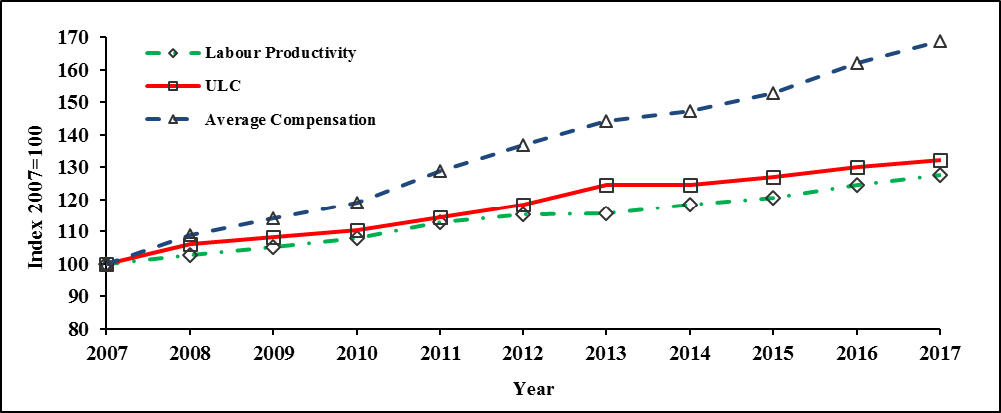

3. Indicators for the Manufacturing sector

Table B summarises the main indicators for the Manufacturing sector for the period
2007 to 2017.

Table B: Productivity and competitiveness indicators for the Manufacturing sector

Indicator |  | Growth rate (%)
 |  | Annual average | 2016¹ | 2017
 |  | 2007-2017 | 2016¹ | 2017
1 | Output (Value added at constant prices) | 1.8 | 0.3 | 1.4
2 | Labour input | -1.2 | -2.3 | 1.1
3 | Capital input | -2.1 | -3.6 | -2.8
4 | Capital - Output ratio | -3.9 | -3.9 | -4.1
5 | Capital - Labour ratio | -0.9 | -1.4 | -3.9
6 | Labour productivity | 3.1 | 2.7 | 0.3
7 | Capital productivity | 4.0 | 4.1 | 4.3
8 | Multifactor productivity | 3.5 | 3.3 | 1.9
9 | Average compensation of employees | 5.1 | 4.6 | -0.3
10 | Unit Labour Cost (Mauritian Rupees) | 2.0 | 1.9 | -0.6
11 | Unit Labour Cost (US Dollars) | 0.9 | -0.3 | 2.4
¹Revised

3.1 Output and inputs

From 2007 to 2017, real output in the manufacturing sector grew on average by 1.8% annually. In 2017, the sector witnessed a higher growth of 1.4% compared to that of 0.3% in 2016.

During the period 2007 to 2017, labour input fell by an average of 1.2% annually and capital input by 2.1%.

In 2017, labour input rose by 1.1% compared to the contraction of 2.3% in 2016. Capital input fell further by 2.8% in 2017 after the decrease of 3.6% observed in 2016 (Table 2.1).

3.2 Productivity trends

Figure 4: Trends in productivity indices – Manufacturing sector, 2007 to 2017

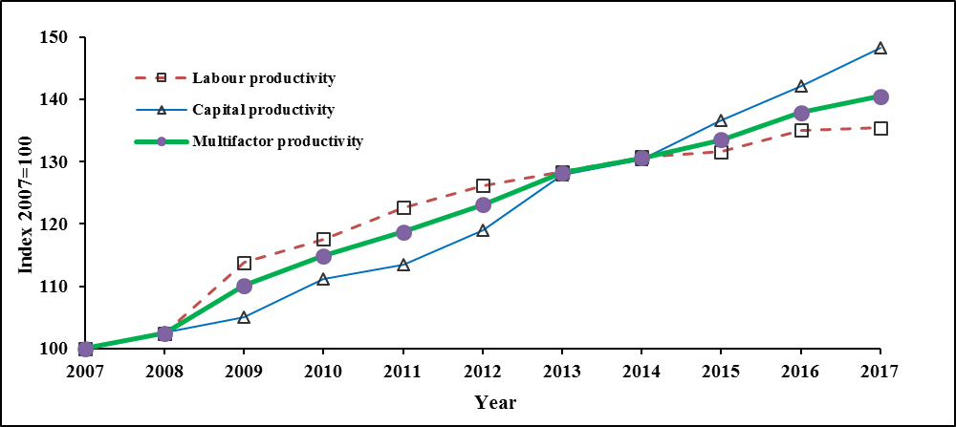
During the period 2007 to 2017, labour productivity in the manufacturing sector registered an average annual growth of 3.1% and capital productivity increased by an average of 4.0% annually. That was the result of a growth of 1.8% in real output and declines of 1.2% and 2.1% in labour input and capital input respectively. During the same period, multifactor productivity increased by an average of 3.5% per annum (Table 2.2).

In 2017, labour productivity in manufacturing grew by 0.3%, lower than the 2.7% growth in 2016. Capital and multifactor productivity witnessed increases of 4.3% and 1.9% respectively in 2017 compared to increases of 4.1% and 3.3% in 2016.

3.3 Unit Labour Cost (ULC)

Figure 5 shows the trend of the ULC index in the manufacturing sector for the period 2007 to 2017. During that period, ULC grew at an average annual rate of 2.0% due to a higher growth in average compensation of employees (5.1%) compared to labour productivity (3.1%). In Dollar terms, ULC increased at a lower rate of 0.9% due to an average annual depreciation of 1.0% in the exchange rate of the rupee against the Dollar.

In 2017, ULC for the manufacturing sector fell by 0.6% compared to an increase of 1.9% in 2016. In Dollar terms, ULC rose by 2.4% in 2017 after a fall of 0.3% in 2016 (Table 2.4).

Figure 5: Trends in Unit Labour Cost – Manufacturing sector, 2007 to 2017

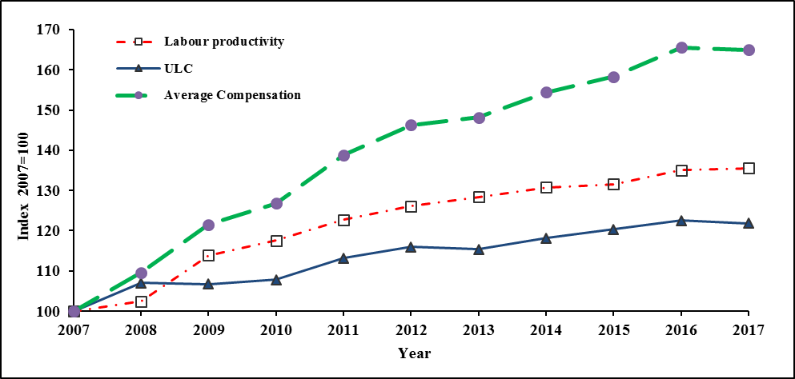

3.4 International comparison of Unit Labour Cost in Manufacturing – 2016

An international comparison of growth in ULC in the manufacturing sector for the year 2016, in national currency and in US Dollar is given in table C and figure 6 based on latest estimates published by The Conference Board International Labour Comparisons program.

Table C: Manufacturing Unit Labour Cost Growth rate of selected countries, 2016

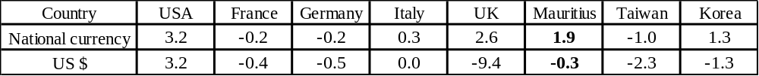

Figure 6: International comparison of ULC in Manufacturing – Growth rate (%), 2016

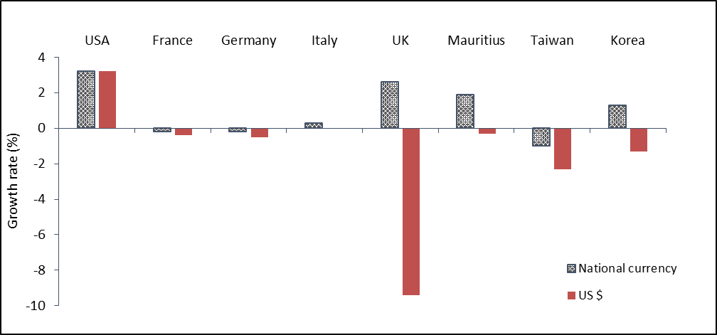

Source: The Conference Board and Statistics Mauritius estimates

It is observed that, in 2016, ULC in the manufacturing sector, expressed in national currency, increased in Mauritius, USA, United Kingdom and South Korea. Mauritius registered an increase of 1.9%.

In the same year, ULC in US Dollar showed decreases in all the selected countries except USA. This is explained by appreciation of the national currencies under review against the US Dollar. Mauritius witnessed a fall of 0.3%.

3.5 International comparison of Hourly Labour Cost (HLC)

The HLC is another indicator of international competitiveness. Table 2.5 compares the evolution of HLC in the Mauritian manufacturing sector with available hourly labour cost for some other countries in US dollars. HLC is highest in Germany and lowest in Philippines from 2006 to 2016. In 2016, the HLC for Mauritius stood at 2.65 US Dollar compared to 2.53 US Dollar in 2015.

4. Indicators for Export Oriented Enterprises (EOE)

Table D below shows the main indicators for Export Oriented Enterprises during the period
2007 – 2017.

Table D: Productivity and competitiveness indicators for Export Oriented Enterprises

Indicator |  | Growth rate (%)
 |  | Annual average | 2016¹ | 2017
 |  | 2007 - 2017 | 2016¹ | 2017
1 | Output (Value added at constant prices) | 0.5 | -5.1 | 0.3
2 | Labour input | -2.5 | -2.8 | -0.6
3 | Capital input | -3.3 | -1.0 | -0.6
4 | Capital – Output ratio | -3.8 | 4.3 | -0.9
5 | Capital – Labour ratio | -0.8 | 1.8 | 0.0
6 | Labour productivity | 3.1 | -2.4 | 0.9
7 | Capital productivity | 3.9 | -4.1 | 0.9
8 | Multifactor productivity | 3.4 | -3.3 | 0.8
9 | Average compensation of employees | 6.4 | 3.5 | 0.9
10 | Unit Labour Cost (Mauritian Rupees) | 3.3 | 6.0 | 0.0
11 | Unit Labour Cost (US Dollars) | 2.2 | 3.8 | 3.1
¹Revised
4.1 Output and inputs

In 2017, the share of Export Oriented Enterprises (EOE) in the economy was 6.1%. The contribution of the textile and non-textile subsectors in the total output of the EOE sector was 68.2% and 31.8% respectively.

During the period 2007 to 2017, real output of the EOE sector increased at an average annual rate of 0.5%. Within the sector, the real output of non textile establishments grew by 2.1% while that of textile establishments decreased by 0.1%.

During the same period, labour and capital input of the EOE sector registered average annual decreases of 2.5% and 3.3% respectively.

In 2017, labour input in the EOE sector registered another fall of 0.6% after that of 2.8% in 2016. In a similar way, Capital input recorded a decrease of 0.6% in 2017 after a fall of 1.0% in 2016 (Table 3.3).

4.2 Productivity trends

Figure 7: Trends in productivity indices – Export Oriented Enterprises, 2007 to 2017

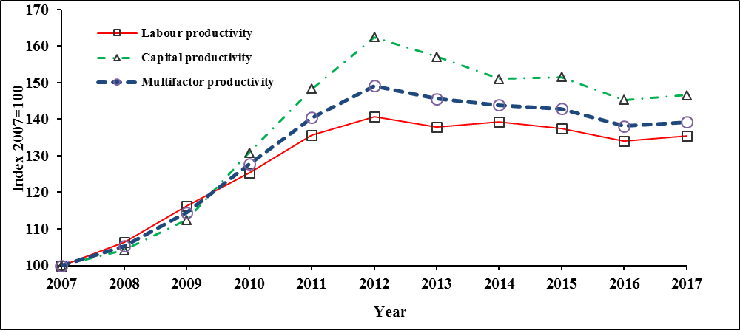

Figure 7 shows the trends in the labour, capital and multifactor productivity indices of Export Oriented Enterprises for the years 2007 to 2017. Labour and capital productivity registered average annual growths of 3.1% and 3.9 % respectively. This is due to a rise in real output (0.5% annually) while labour input and capital input registered decreases of 2.5% and 3.3% respectively. Multifactor productivity grew at an average annual rate of 3.4% (Table 3.2).

In 2017, labour productivity in EOE increased by 0.9% after a fall of 2.4% in 2016. Likewise, capital and multifactor productivity witnessed increases of 0.9% and 0.8% respectively in 2017. In 2016, capital productivity fell by 4.1% and multifactor productivity fell by 3.3%.

4.3 Unit Labour Cost (ULC)

Figure 8: Trends in Unit Labour Cost – Export Oriented Enterprises, 2007 to 2017

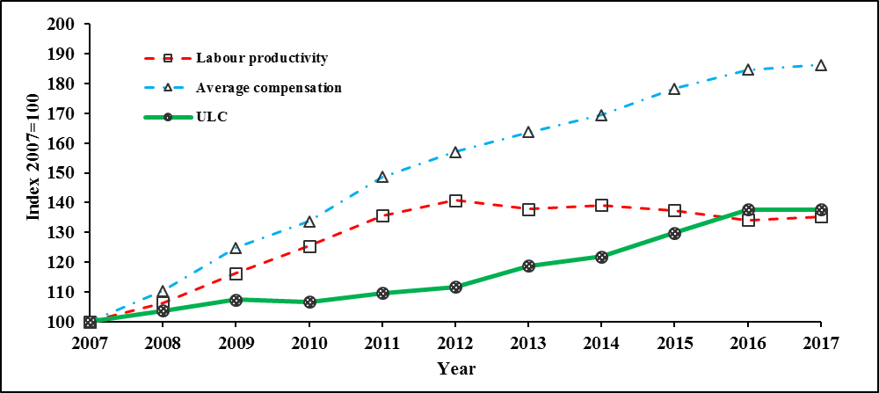

From 2007 to 2017, average compensation of employees in the EOE sector increased by an annual rate of 6.4% and labour productivity by 3.1%. The higher growth in average compensation of employees compared to labour productivity caused ULC to increase at an average annual rate of 3.3% during that period. In 2017, the ULC index stagnated, after a growth of 6.0% in 2016 (Table 3.5).

In Dollar terms, ULC witnessed an average annual growth of 2.2% during the period 2007 to 2017. In 2017, ULC in Dollar terms increased by 3.1% compared to 3.8% in 2016.

Statistics Mauritius
Ministry of Finance and Economic Development
Port Louis.

May 2018

Contact persons

Mr. K. Persand (Statistician)
Mr. R. Krishnan (Senior Statistical Officer)
Statistics Mauritius
L.I.C Centre
Port-Louis
Tel: 208 1800
Fax: 213 0234

Technical Notes

Concepts and definitions

Productivity expresses the relationship between the output of goods and services (real output) and the various inputs required for production (e.g. labour and capital). Two important productivity indicators used are: labour productivity, that is, the ratio of real output to labour input, and capital productivity, the ratio of real output to stock of fixed capital used in the production process. However, these indicators are limited in the sense that they indicate the influence of only one factor of production at a time on productivity. An improvement over these partial indicators is the multifactor productivity which takes into account the simultaneous influences of several factors on production, including qualitative factors such as better management, improved quality of inputs and higher quality of goods.

Unit Labour Cost (ULC) is another important indicator of competitiveness which is defined as the remuneration of labour for producing one unit of real output. Using compensation of employees, which is more readily available from national accounts data as a proxy for labour costs, ULC can hence be expressed as the ratio of average compensation per person engaged to labour productivity. This ratio indicates how improvement in productivity offsets increases in average compensation per worker.

1. Output

The term output in this publication refers to real output, that is value added of current year at constant prices (i.e., after removing price effect).

Output index = Value added (constant price) in year n x 100

Value added in base year
2. Employment/Labour input

Employment/Labour input is most appropriately measured by hours worked and its price by average compensation per hour. However, due to lack of data, the total number of persons engaged, defined as employers, own account workers, contributing family workers and employees in any type of economic activity is used. Prior to 2000, employment for year n was calculated as the average of employment at June of year (n) and June of year (n+1). As from 2000, average employment for a given year is available and thus the data has been used for the computation of labour input.

Labour input index = Average number of persons engaged in year n x 100
Average number of persons engaged in base year
3. Capital input

Capital refers to the net stock of investment in reproducible fixed assets. Reproducible fixed assets are investments in residential and non-residential building (excluding land), infrastructural work, machinery and equipment.

Capital input index = Stock of fixed capital in year n x 100
Stock of fixed capital in base year
4. Labour Productivity

Labour productivity index shows the rate of change in output per person engaged.

Labour Productivity Index = Output index x 100

Labour input index

5. Capital productivity

The capital productivity index shows the rate of change in output per unit of capital.

Capital Productivity Index = Output index x 100
Capital input index
6. Multifactor/Total factor productivity

Multifactor productivity (MFP)/Total factor productivity (TFP) index shows the rate of change in “productive efficiency”, and is obtained as the ratio of the output to a weighted combination of labour and capital inputs. The limitation of partial productivity measures is that they attribute to one factor of production, changes in efficiency that are attributable to other factors. MFP reflects many influences including qualitative factors such as better management and improved quality of inputs through training and technology.

Multifactor productivity index = Output index x 100

Multifactor input index

A (t) = Q(t) x 100 where
{WL(t) x L(t)} + {WK(t) x K(t)}

A(t) = Multifactor Productivity index in time t

Q(t) = Output index in time t

WL(t) = Labour’s input share in time t (ratio of compensation of employees to value added)

L(t) = Labour input index in time t

WK(t) = 1- WL(t)

K(t) = Capital input index in time t

7. Unit Labour Cost

Unit labour cost is the remuneration of labour (compensation of employees) to produce one unit of output. It is computed as the ratio of the labour cost index to an index of production. The index shows the rate of change in labour cost per unit of output.

Unit Labour Cost Index = Labour Cost Index x 100 or Average Compensation Index x 100

Output Index Labour Productivity Index

For Competitiveness purposes, the exchange rate effect has to be taken into account. ULC is therefore computed both in local currency and in US dollar.

ULC index (US $) = ULC index (MUR) / Exchange rate index of MUR/ US $.

8. Hourly Labour Cost

Hourly labour cost is the ratio of total compensation of employees to total hours worked, inclusive of overtime. Compensation of employees comprises wages & salaries in cash and in kind, bonus, overtime and social contribution incurred by employers. The source of data is the Survey of Employment, Earnings and Hours of work.

9. Capital-labour ratio

The Capital-labour ratio gives the proportion of stock of fixed capital to labour inputs. If the ratio increases, capital deepening takes place whilst, when it declines capital widening occurs.

Capital-labour ratio = Real fixed capital utilised in an industry
Number of persons engaged in the industry

10. Capital-output ratio

The capital-output ratio represents the units of capital required to produce one unit of output. This ratio indicates how efficiently investment is contributing to economic growth.

Capital-output ratio = Real fixed capital stock in a specific year
Real GDP for the same year

