External Merchandise Trade Statistics – 2nd Quarter 2017

Introduction

This issue of Economic and Social Indicators presents external merchandise trade statistics for the first and second quarters of 2017 and the years 2015 and 2016. These statistics are compiled from declarations lodged at Customs by importers and exporters. Some of these declarations are at times revised at a later period and corrections made accordingly on the computerised database of the Mauritius Revenue Authority (MRA) - Customs Department.

Thus, while revised figures for 2015 are published in this indicator, those for 2016 are still provisional and subject to revision as and when MRA - Customs Department submits latest amendments to Statistics Mauritius.

Data on external merchandise trade are compiled as per the recommendations of the United Nations General Trade System. According to this system, all goods entering and leaving the national frontier, including trading activities of the Freeport zone should be accounted for.

- Total value of trade and trade balance

Total external merchandise trade for the second quarter of 2017 was valued at Rs 64,695 million, i.e. 6.3% higher than the previous quarter and 5.4% higher compared to the corresponding quarter of 2016.

During the second quarter of 2017, total exports (including ship’s stores & bunkers) were valued at Rs 20,348 million against imports of Rs 44,347 million. The resulting trade deficit worked out to Rs 23,999 million, 11.6% higher than the deficit of Rs 21,506 million of the previous quarter and 26.5% higher than the deficit of Rs 18,975 million of the corresponding quarter of 2016.

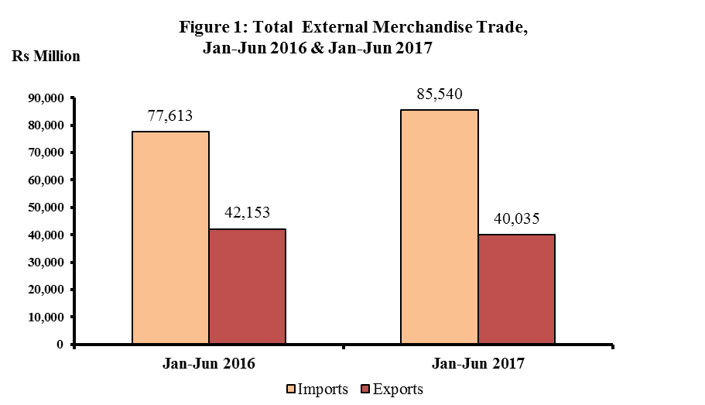

- Exports

3.1 Total exports (Tables 1 & 3) – 2nd Quarter 2017

Total export proceeds for the second quarter of 2017, including domestic exports¹, re-exports² and ship’s stores and bunkers amounted to Rs 20,348 million, showing an increase of 3.4% compared to the previous quarter. This is mainly explained by increases in exports of “Chemicals and related products” (+31.2%), “Miscellaneous manufactured goods” (+15.6%) and “Manufactured goods classified by material” (+8.8%), partly offset by decreases in the exports of “Machinery and transport equipment” (-22.1%), and “Food and live animals” (-2.6%).

Compared to the corresponding quarter of 2016, total exports for the second quarter of 2017 dropped by 4.0%. This is mainly explained by decreases in exports of “Machinery and transport equipment” (-50.0%), “Miscellaneous manufactured goods” (-13.9%) and “Manufactured goods classified by material” (-6.5%), partly offset by increases in exports of “Ship’s stores & bunkers” (+65.6%) and “Food and live animals” (+5.6%).

Domestic exports amounting to Rs 13,871 million, accounted for 68.2% of total exports in the second quarter of 2017. Compared to a value of Rs 11,945 million recorded in the previous quarter, domestic exports increased by 16.1%, while comparison against the corresponding quarter of 2016 shows a decrease of 3.8%.

In the second quarter of 2017, re-exports stood at Rs 4,274 million, i.e. lower by 22.8% compared to the previous quarter, mainly due to decreases in re-exports of “Mineral fuels, lubricants and related materials” (-57.4%), “Food and live animals” (-50.6%) and “Machinery and transport equipment” (-22.5%), partly offset by an increase in “Chemicals & related products, n.e.s (+36.6%). Compared to the corresponding quarter of 2016, re-exports were lower by 21.6%, mainly due to decreases in the re-exports of “Telecommunications equipment & accessories” (-90.0%), “Mineral fuels and related products” (-25.9%), “Miscellaneous manufactured articles” (-20.1%) and “Food and live animals” (-18.1%), partly offset by an increase of 6.3% in “Chemicals & related products, n.e.s” (Table 5).

3.2 Exports by SITC section (Tables 1 & 3) – First Semester 2017
Around 39.4% of total exports for the first semester of 2017 consisted of “Food and live animals” (Rs 14,024 million), 35.4% of Miscellaneous manufactured goods” (Rs 12,628 million) and 10.5% of “Manufactured goods classified chiefly by material” (Rs 3,727 million).
Compared to the first semester of 2016, the main changes by section are as follows:
- “Machinery and transport equipment” fell by 52.7%, due to a decrease in the re-exports of “Telecommunications equipment & accessories” (-91.1%).
- “Miscellaneous manufactured goods” dropped by 18.3% mainly due to decreases in the exports of “Jewellery, goldsmiths & silver smith wares” (-63.3%), “Travel goods, handbags & similar containers” (-23.0%), “Articles of apparel & clothing accessories” (-15.5%) and “Watches & clocks” (-10.1%).
- “Manufactured goods classified chiefly by material” decreased by 2.8%, mainly explained by decreases in exports of “Pearls, precious and semi-precious stones” (-26.3%)” and “Textile yarns, fabrics, made up articles” (-2.2%).

¹ Domestic exports are defined as goods of national origin
² Re-exports are goods which are exported in the same condition as imported or after undergoing minor operations which leave them essentially unchanged.
- “Food and live animals” registered an increase of 7.9%, mainly due to increases in exports of “Cane sugar” (+15.9%) and “Fish and fish preparations” (+0.6%), partly offset by decreases in “Live primates” (-1.1%).

3.3 Exports of Export Oriented Enterprises (EOE) – First Semester 2017

During the first semester of 2017, exports of EOE amounted to Rs 20,546 million, compared to Rs 22,221 million in the corresponding period of 2016 (Table 1). Further details on these transactions will be presented in the issue of the Economic and Social Indicator on Export Oriented Enterprises, to be released on 29 September 2017.

3.4 Exports by country of destination (Table 7) – First Semester 2017

Analysis of exports figures by country of destination for the first semester of 2017 shows that the European countries were our main buyers, purchasing some 50.9% of our exports for a value of Rs 18,120 million. Among countries, the major destinations for our exports were France (12.2%), UK (11.4%), USA (11.4%), Italy (8.4%), South Africa (8.2%), Madagascar (6.9%) and Spain (5.6%).

Compared to the corresponding period of 2016, exports to Spain and Italy went up by 18.5% and 4.2% respectively. On the other hand, exports to Madagascar, UK and South Africa dropped by 17.8%, 14.4% and 7.1% respectively.
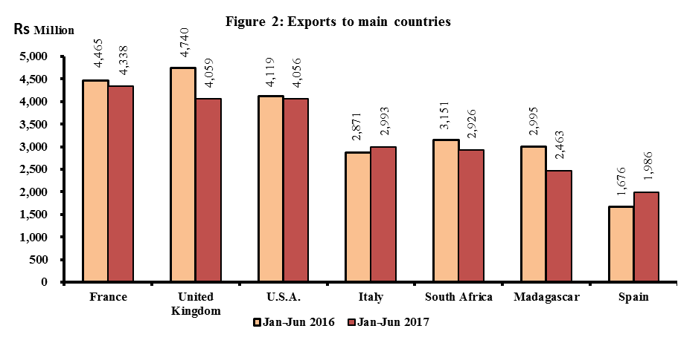
4. Imports

4.1 Total imports (Table 10) – 2nd Quarter 2017

Total imports for the second quarter of 2017 amounted to Rs 44,347 million, showing an increase of 7.7% over the previous quarter. This is mainly due to increases in imports of “Miscellaneous manufactured articles” (+31.2%), “Manufactured goods classified chiefly by materials” (+23.0%), “Chemicals & related products” (+18.2%) and “Machinery and transport equipment” (+9.0%), partly offset by decreases in imports of “Mineral fuels, lubricants and related products” (-15.8%) and “Food and live animals” (-1.5%).

Compared to the corresponding quarter of 2016, imports in the second quarter of 2017 rose by 10.4%. This is mainly due to increases in imports of “Mineral fuels, lubricants and related products” (+30.5%), “Food and live animals” (+10.3%) “Manufactured goods classified chiefly by materials” (+6.2%), “Machinery and transport equipment” (+5.1%) and “Miscellaneous manufactured articles” (+2.7%), partly offset by a decrease in the imports of “Beverages and tobacco” (-15.8%).

4.2 Imports by SITC section (Table 10) – First Semester 2017

Around 23.5% of imports in the first semester of 2017 consisted of “Machinery and transport equipment” (Rs 20,080 million), 21.0% of “Food and live animals” (Rs 17,984 million), 17.2% of “Mineral fuels, lubricants and related materials” (Rs 14,673 million) and 14.8% of “Manufactured goods classified chiefly by materials” (Rs 12,638 million).

Compared to the corresponding period of 2016, total imports increased by 10.2%. Main changes by section are as follows:

- “Mineral fuels, lubricants, & related products” increased by 49.6%, mainly due to a rise of 52.1% in the imports of “Refined petroleum products”.

- “Food and live animals” increased by 12.2%, mainly due to higher imports of “Wheat” (+59.4%), “Rice” (+17.5%), “Meat and meat preparations” (+8.3%), “Cereal preparations” (+7.4%), “Dairy products and bird’s eggs” (+4.5%) and “Fish and fish preparations” (+3.3%), partly offset by a decrease in import of “Vegetables and fruits” (-4.8%).

- “Miscellaneous manufactured articles” increased by 3.5%, mainly due to increases in “Prefabricated buildings, sanitary plumbing, heating & lighting fixtures & fittings, n.e.s” (+48.1%), “Articles of apparel and clothing” (+18.4%) and “Jewellery, goldsmiths’ & silversmiths’ wares, n.e.s” (+10.2%), partly offset by a decrease in “Professional, scientific & controlling instruments & apparatus, n.e.s” (-12.7%).

- “Manufactured goods classified chiefly by material” increased by 0.6%, mainly due to increases in the imports of “Iron and steel” (+38.4%), textile yarn (+16.2%) and “Manufactures of metals, n.e.s” (+13.3%), partly offset by decreases in imports of “Pearls & precious stones” (-27.8%), “Cotton fabrics” (-20.8%) and “Cement” (-17.5%).

  - Imports by country of origin – First Semester 2017

During the first semester of 2017, our imports originated from four main countries, namely: India (16.2%), China (15.9%), South Africa (8.2%) and France (7.6%) (Table 13).

Among continents, Asia was our main supplier with a share of Rs 43,384 million, representing 50.7% of total imports.

Compared to the corresponding period of 2016, total imports from South Africa, India and France rose by 23.1%, 13.5% and 6.8% respectively while those from China fell by 2.1%.

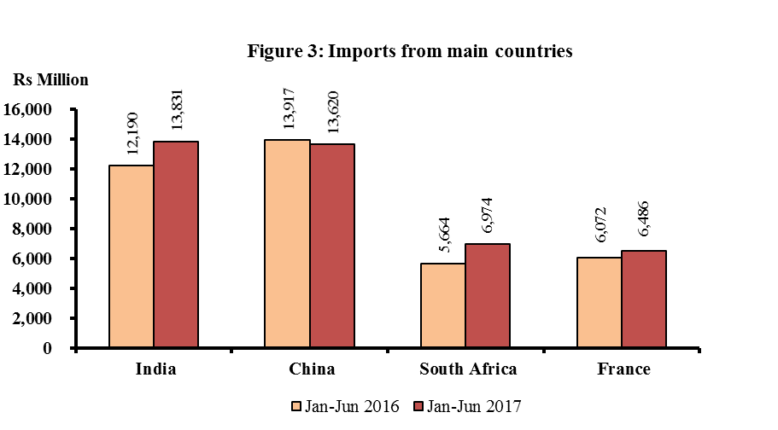

5. Trade with Member States of Regional Organisations – First Semester 2017

During the first semester of 2017, total exports to African, Caribbean and Pacific (ACP) States stood at Rs 7,799 million against imports of Rs 11,415 million (Table 14). The trade deficit with ACP countries worked out to Rs 3,616 million.

Exports to COMESA member states attained Rs 4,013 million while imports from these countries amounted to Rs 4,332 million, resulting in a trade deficit of Rs 319 million. Madagascar was the main buyer with a share of 61.4% followed by Kenya (19.6%). Our main suppliers were Madagascar (34.7%), Seychelles (29.7%), and Kenya (16.4%) - (Table 15).

Trade with SADC countries showed a deficit of Rs 4,114 million, resulting from imports of Rs 10,269 million against exports worth Rs 6,155 million. The main supplier was South Africa (67.9%) and our main buyers were South Africa (47.5%) and Madagascar (40.0%) - (Table 16).

6. Trade in Freeport Zone – First Semester 2017

During the first semester of 2017, total imports of the Freeport Zone stood at Rs 6,835 million, lower by 15.9% compared to the corresponding period of 2016 – (Table 12). Re-exports were valued at Rs 7,304 million, representing a decrease of 10.2% compared to the corresponding period of 2016 (Table 6). The main items imported and re-exported were from “Food and live animals”, “Machinery and transport equipment” and “Chemicals & related products, n.e.s”.

7. Forecast 2017

Based on recent past trends and information from various sources, total exports for 2017 is forecasted at around Rs 84,000 million and imports at Rs 178,000 million. Trade deficit for 2017 is therefore expected to be around Rs 94,000 million.

Statistics Mauritius
Ministry of Finance and Economic Development

Port Louis

August 2017

Contact Persons

Mr B. Unmar
Senior Statistician

Mr E. Lukshmudu
Senior Statistical Officer

Statistics Mauritius
L.I.C Centre
J. Kennedy Street
Port Louis
Telephone: (230) 210 8091
Fax: (230) 211 4150
Email: cso_trade@govmu.org

Notes

(1) Scope and coverage

External merchandise trade statistics are compiled according to the General Trade System as recommended by the United Nations. Using the national boundary as the statistical frontier, the General Trade System is a record of all goods entering (imports) and leaving the country (exports).

Imports include goods brought in directly for domestic consumption plus goods imported into customs bonded warehouses.
Exports cover:

- Domestic exports defined as goods of national origin, that is goods produced in the exporting country.

- Re-exports which are exported in the same condition as imported or after undergoing minor operations which leave them essentially unchanged and include re-exports from customs bonded warehouses.

- Ship’s Stores and Bunkers (SSB) are included in total exports and are shown separately.

Trade by parcel post is also included in imports and exports.

(2) Valuation

Imports are valued on a C.I.F. (Cost, Insurance and Freight) basis whilst exports on a F.O.B. (Free on Board) basis.

Cost, Insurance and Freight (C.I.F) value is the value of a country's imports of goods, including all charges for transporting and insuring the goods from the country of exports to the given country but excluding the cost of unloading from the ship, aircraft unless it is borne by the carrier.

Free on Board (F.O.B) value is the value of a country's exports of goods, including all costs of transporting the goods to the customs frontier, export duties.

(3) Classification of commodities

Commodities are coded according to the Harmonised Commodity Description and Coding System Nomenclature (HS2017). However, for the purposes of economic analysis and to facilitate international comparison of trade by commodity data, the commodities are also classified according to the Standard International Trade Classification (Revision 4) (SITC Rev. 4). The HS and the SITC Rev. 4 are six and five digit codes respectively but have been extended to eight and seven digits to accommodate national requirements.

(4) Symbols used
- Nil or negligible
-.- Not applicable
... Not available

