Gender Statistics, 2015

1. Introduction
This is the seventh issue of Economic and Social Indicators (ESI) on gender statistics. It presents a portrait of women and men in the Republic of Mauritius and includes their demographic profile, health, family status, educational attainment and labour force characteristics.
The ESI is based on latest available sex disaggregated data from administrative sources, household surveys and censuses. Some of the statistics presented therefore refer to years earlier than 2015.

2. Highlights
- In 2015, the population comprised 637,836 women compared to 624,769 men. Women outnumbered men by 13,067 as they live on average seven years longer than men.
- Women continue to give birth to fewer children than in the past.
- Both men and women are getting married at an older age and the age difference between them is narrowing over time.
- Men are more likely to suffer from overweight, cholesterol and hypertension while women are more prone to obesity and depression.
- Diabetes, heart disease, cerebrovascular disease and cancer together accounted for 64.3% of causes of deaths among women against 56.6% of men’s deaths.
- More women than men are enrolled in tertiary institutions but there are fewer women in research (PhD, MPhil and DBA).
- Working women are more likely than men to be employees and contributing family workers but less likely to be heading a business.
- In spite of being fewer in the labour force, women are more numerous among the unemployed.
- Unemployed women were generally more qualified than their male counterparts.
- Average income tends to be lower for women than for men across all occupations.
- Women are largely under-represented in decision making at higher sphere of society. The number of female parliamentarians is 8 out of a total of 70.
- More women are occupying high positions in government services. The proportion of women in the most senior positions has increased from 23% in 2000 to 40% in 2015.
- Domestic violence against women is declining, though women are more likely to be victims.
- Men are more likely to be victims of homicides and assaults while women are more prone to sexual offences.
- Men are more likely than women to do physical exercise.
- In 2015, Mauritius held the 120th position out of 145 countries compared to the 106th position the previous year according to the Global Gender Gap Index (GGI) of the World Economic Forum. The GGI seeks to measure gender equality across four key areas: economic participation and opportunity, educational attainment, health and survival and political empowerment.

3. Population
Prior to 1950 women were fewer than men in number. However, the female population has been growing at a faster rate such that in the 50’s there were almost equal numbers of men and women. This balance in the population has been maintained for some 40 years. As from 1990, women have been increasingly outnumbering men over the years.
In 2015, there were 13,067 more women than men. Out of a total population of 1,262,605, there were 637,836 women against 624,769 men, i.e., 98 men for every 100 women.
Though women were more numerous in the total population, this was not the case in all age groups. At the younger ages (under 50 years), men were more numerous mainly due to more births of baby boys than girls. In 2015, there were 107.0 male births for every 100 female births.
At ages 50 years and above, women outnumbered men and their proportion increases at higher ages. The male-female ratio stood at around 102 for those aged between 40 to 49 years compared to 53 among those aged 80 years and over; there were around 2 women for every man in this age group. The main reason for this imbalance is that women live longer than men.

Table 1 – Population by age and sex, Republic of Mauritius, 1st July 2015
Age Group (years) | Male | Female | Both sexes | Sex ratio (males per 100 females)
Under 10 | 76,771 | 74,457 | 151,228 | 103.1
10 - 19 | 98,314 | 95,563 | 193,877 | 102.9
20 - 29 | 94,981 | 93,067 | 188,048 | 102.1
30 - 39 | 96,765 | 94,886 | 191,651 | 102.0
40 - 49 | 88,715 | 86,861 | 175,576 | 102.1
50 - 59 | 86,887 | 88,927 | 175,814 | 97.7
60 - 79 | 74,594 | 89,471 | 164,065 | 83.4
80+ | 7,742 | 14,604 | 22,346 | 53.0
Total | 624,769 | 637,836 | 1,262,605 | 98.0

Women have a higher life expectancy than men. In fact, women live around 7 years longer than men. In 2014, life expectancy at birth for women was 78 years compared to 71 years for men. Life expectancy at birth has improved over the years for both men and women and over the past fifteen years, the gap between life expectancy of men and women tends to stabilise at around 7 years (Chart 1).

Chart 1 - Life Expectancy at birth, Republic of Mauritius, 1962 - 2015
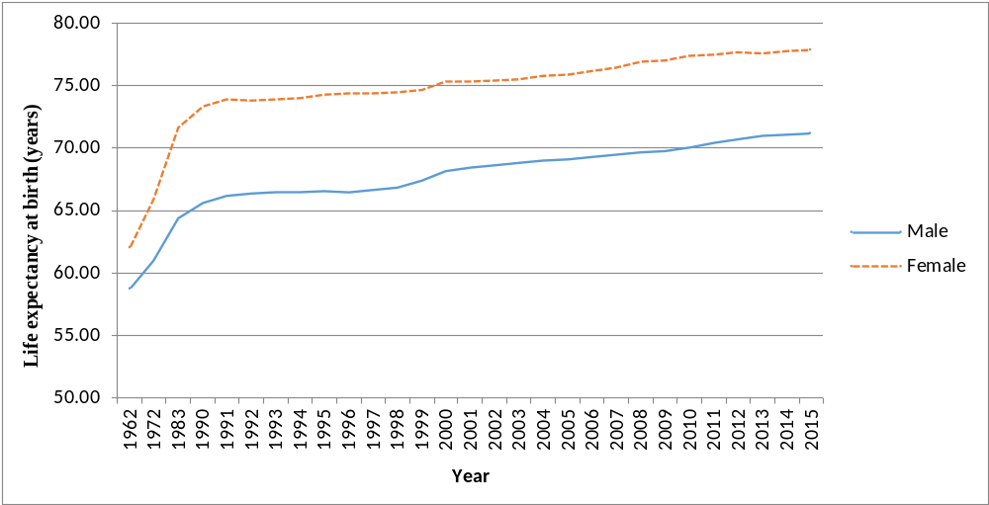

4. Fertility and Contraceptive Use
Women continue to give birth to fewer children than in the past. The total fertility rate, which is an indication of the average number of babies born to a woman during her childbearing period, has maintained a general decreasing trend over the last 24 years. The average number of children born to a woman dropped by nearly one child to reach a total fertility rate of 1.4 in 2015.
Chart 2 - Total Fertility Rate, Republic of Mauritius, 1984 - 2015
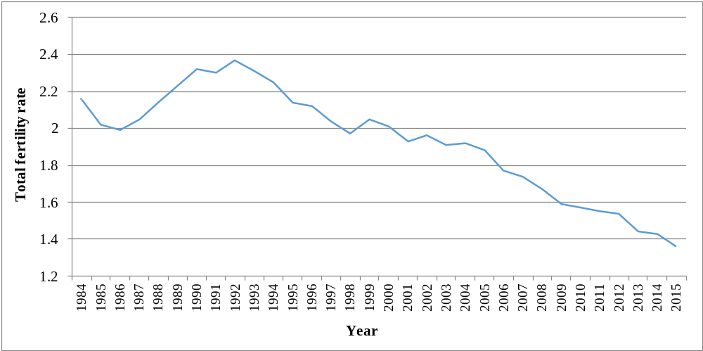

In the 1990’s, women in the age bracket 20-24 years had the highest fertility with 147 births per 1,000 women of that age group (Chart 3). The peak fertility shifted to the age bracket 25-29 years in 2015, with only 85.2 births per 1,000 women in that age group. This shift is mostly explained by women getting married at an older age.
Chart 3 – Fertility Rate by age of mother, Republic of Mauritius, 1990 and 2015
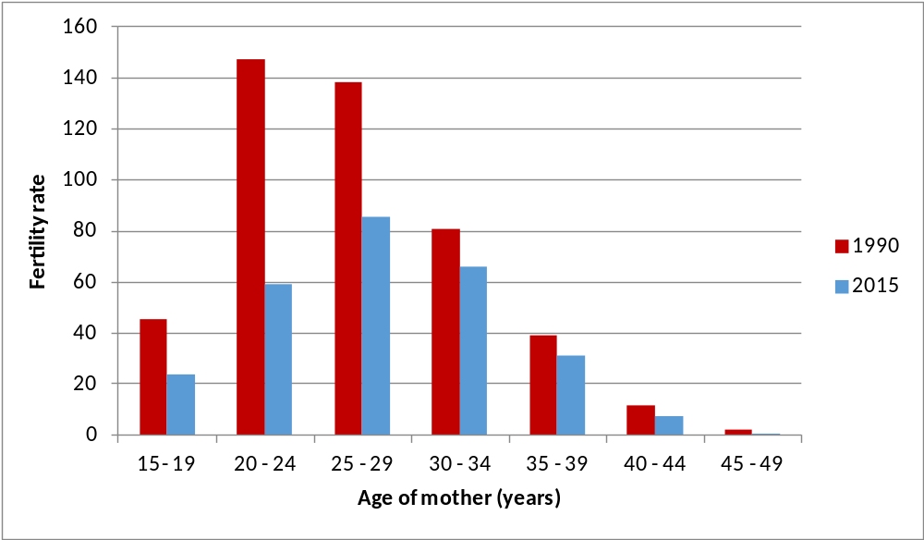
In 2015, Government Family Planning Clinics, Mauritius Family Planning & Welfare Association and Action Familiale registered a total of some 64,263 current users of contraceptive methods in the Island of Mauritius, a decrease of 26,158 from 90,421 in 2005.
Chart 4 – Number of current users of contraceptive, Island of Mauritius, 2000 - 2015
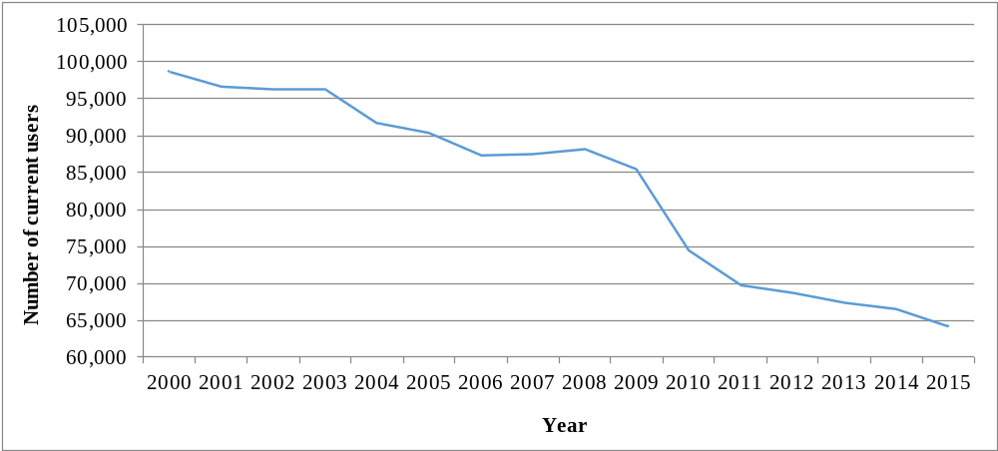

New acceptors of contraceptive methods registered in 2015 numbered 4,570 of whom 471 had tubal ligation. A declining trend is observed in the number of new acceptors from 8,987 in 2005.
Among the new acceptors in 2015, Pill (22.6%), Sympto-thermal (25.3%) and Male Condom (19.0%) are the preferred methods of contraception while for current users Sympto-thermal (43.2%) is the preferred method.
Table 2 – Method of family planning, Island of Mauritius, 2015
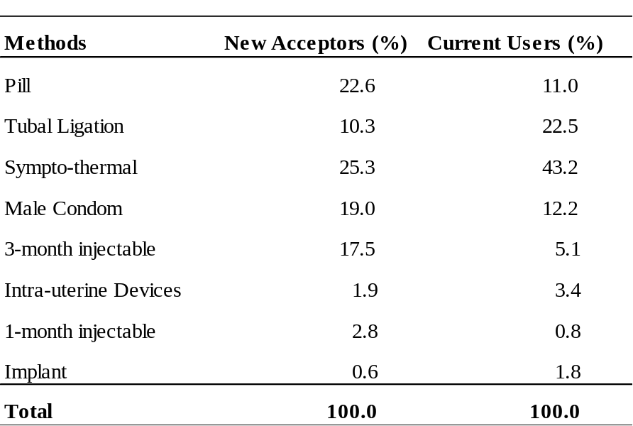

5. Family Status
While marriage rate is declining, divorce rate is on the rise. The marriage rate, i.e., the number of persons married per 1,000 mid-year population, fell from 21.1 in 1993 to 15.4 in 2015. The number of divorced persons per 1,000 mid-year population increased from 1.4 in 1993 to 3.4 in 2015 (Chart 5).

Chart 5 – Marriage and Divorce Rate, Republic of Mauritius, 1993 - 2015
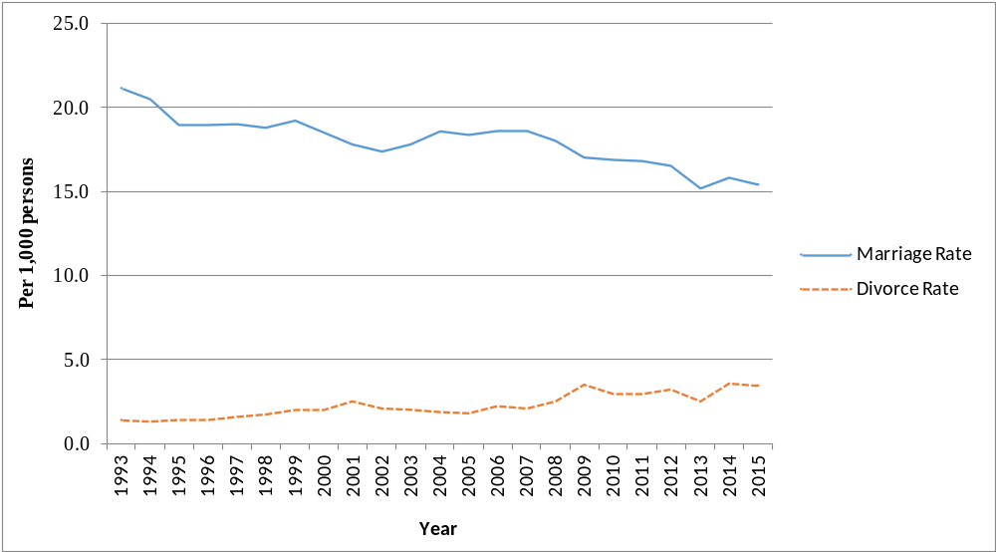
Generally women tend to marry men who are older than them. However, over the past 25 years the age difference between husband and wife narrowed from 4.7 years in 1990 to 3.5 years in 2015.
The average age at first marriage is gradually increasing over the years for both women and men. The average age at first marriage for women increased from 24.3 years in 1990 to reach 27.3 years in 2015 while that for men increased from 29.0 to 30.8 during the same period.

Chart 6 – Average age at first marriage, Republic of Mauritius, 1990 - 2015
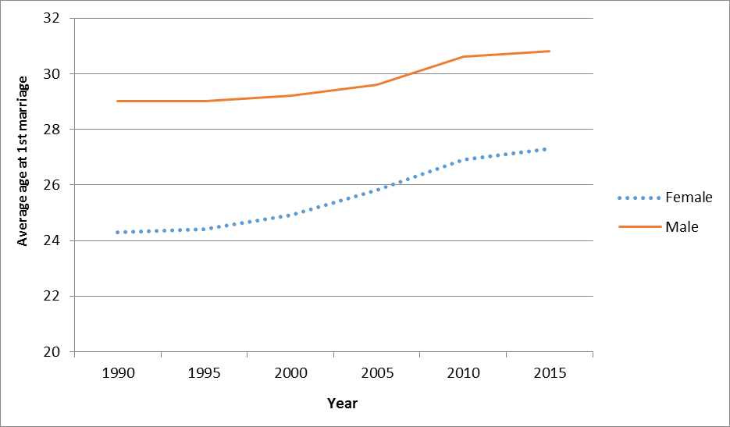
In 2015, around 47% of the petitioners for pronounced divorce were women (Table 3). In the same year, 2,161 divorces were granted by the Supreme Court, the majority of which (26.5%) occurred after 5 to under 10 years of union. The number of divorces after 25 years of union accounted for 8.7% of all divorces. Also, 3 divorces were registered within the first year of marriage (Table 4).

Table 3 – Divorce by petitioner, Republic of Mauritius, 2014 & 2015
Petitioner | 2014 | % | 2015 | %
Husband | 617 | 27.3 | 628 | 29.1
Wife | 1,118 | 49.4 | 1,011 | 46.8
Joint petitioner (both husband & wife) | 527 | 23.3 | 522 | 24.2
Total divorces | 2,262 | 100.0 | 2,161 | 100.0

Table 4 – Divorce by duration of union, Republic of Mauritius, 2015
Duration of union (years) | Number | %
< 1 year | 3 | 0.1
1 and <3 | 165 | 7.6
3 and <5 | 247 | 11.4
5 and <10 | 572 | 26.5
10 and <15 | 471 | 21.8
15 and <25 | 515 | 23.8
25 or more | 188 | 8.7
Total divorces | 2,161 | 100.0

About one third of the couples who divorced in 2015 did not have children while slightly more than half of them had 1 to 2 children. There were 43 couples with 4 or more children.
Table 5 – Divorce by number of dependent children¹, Republic of Mauritius, 2015
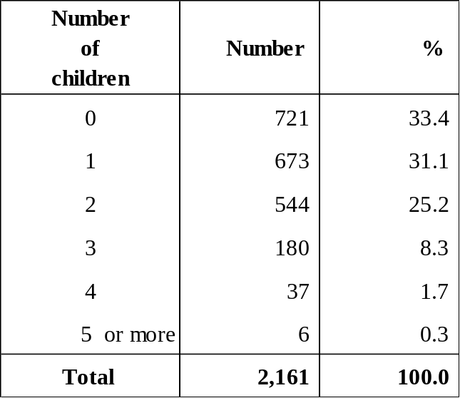
¹ dependent children are the living children who are dependent on either of the divorcees at the time the divorce petition is filed

6. Health
The 2015 Non-Communicable Diseases (NCD) Survey revealed that women are more prone to obesity and depression while men are more prone to overweight, cholesterol and hypertension.

Table 6 – Prevalence (%) of Non-Communicable Diseases (NCD), 2015
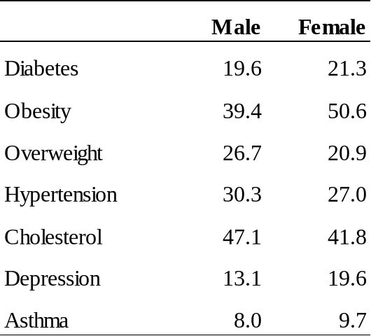

Since October 1987 when the first cases of AIDS were registered, the number has been increasing to reach 6,352 at December 2015, of whom 23 % were women.

During 2015, 262 new cases of HIV/AIDS were registered among Mauritians and the proportion of women among the new cases was 41% compared to 12% in 2005.

Chart 7 – New HIV/AIDS cases, Republic of Mauritius, 2004 - 2015
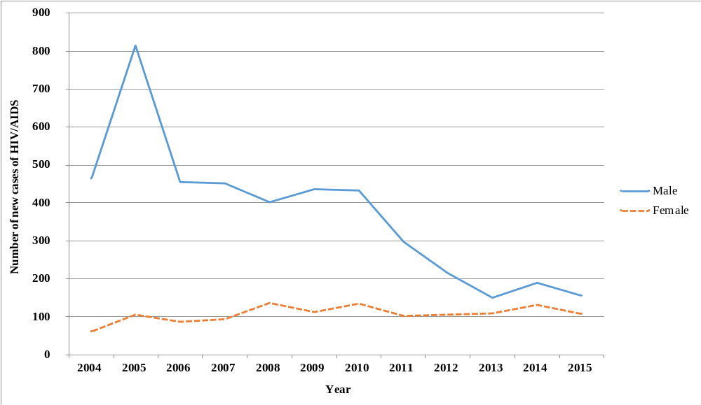
In 2015, out of the 107 new HIV cases detected among females, 68% was due to heterosexual as mode of transmission and 19% due to drug injection. As regards males, among the 155 new cases, the percentages were 41% and 46% respectively

Chart 8 – Number of new HIV/AIDS cases by sex and age, 2015
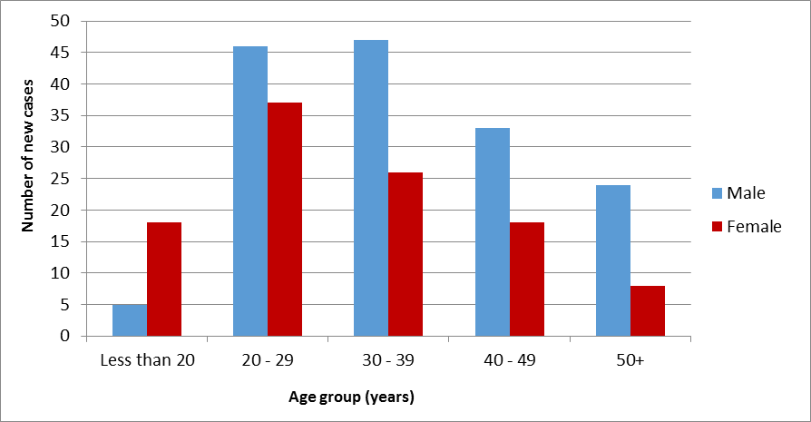
Among the newly detected cases in 2015, 59.5% were in the age group 20-39 years. However, women were predominant in the age group 20-29 years (34.6%) while men were mostly in the age group 30-39 years (30.3%).

7. Mortality
Though women are more numerous than men in the population, there are fewer deaths among women than among men. In 2015, 5,444 men compared to 4,303 women died. The crude death rate for 2015 was 8.7 for man and 6.7 for woman.

Chart 9 – Number of deaths by sex, Republic of Mauritius, 1995 - 2015
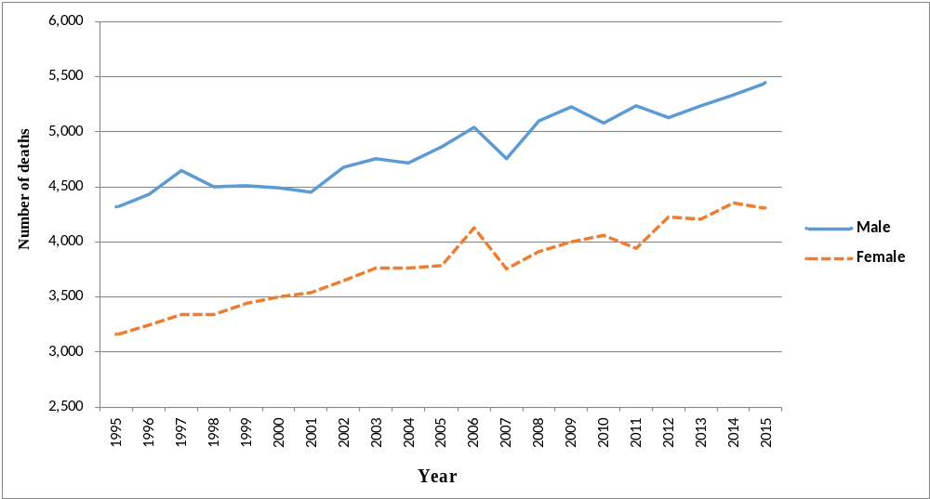
Diabetes, heart disease, cerebrovascular disease and cancer (neoplasms) together accounted for 64.3% of causes of deaths among women against 56.6% of men’s deaths in 2015. Causes of death specific to women, such as breast and uterus cancer were responsible for 5.9% of deaths among women while maternal deaths was responsible for another 0.1%. Compared to men, women were more likely to die of diabetes and neoplasms but less likely to die of cirrhosis of the liver and to commit suicide.

Table 7 – Deaths (%) by cause and sex, Republic of Mauritius, 2015
Cause of death | Male | Female
Diabetes mellitus | 22.2 | 26.2
Heart disease | 19.6 | 20.3
Hypertensive Disease | 3.9 | 5.7
Neoplasm: | 6.2 | 9.2
of which: breast cancer (malignant) | - | 4.3
uterus cancer (malignant) | n/a | 1.6
Cerebrovascular disease | 8.6 | 8.6
Cirrhosis of liver | 2.6 | 0.8
Suicide | 1.4 | 0.6
Maternal death | n/a | 0.1
Other | 35.5 | 28.5
Total | 100.0 | 100.0

The risk of a woman dying as a result of pregnancy or childbirth during her lifetime has generally been declining over the years with slightly higher level of maternal deaths in recent years. From 1995 to 2006, the maternal mortality ratio declined from 0.58 maternal death per 1,000 live births to 0.17. After 2006, the maternal mortality ratio was on a rising trend to reach 0.66 in 2013, but then decreased to reach 0.47 in 2015.

Chart 10 – Maternal Mortality Ratio, Republic of Mauritius, 1995 - 2015
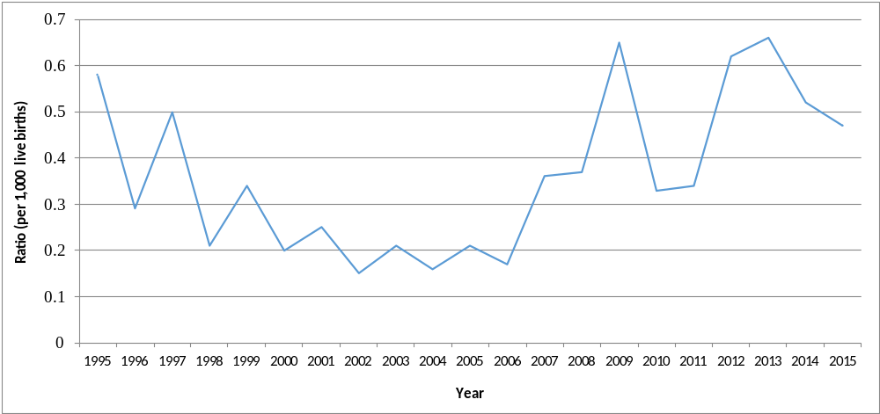

8. Education
Boys and girls are equally likely to go to pre-primary and primary schools. The Gender Parity Index (GPI) which measures the relative education participation of boys and girls was 1.0 for both pre-primary and primary, indicating no disparity.
Table 8 – Gross Enrolment Rates (%) by sex, Republic of Mauritius, 2015
GER | Male | Female | Total | Gender Parity Index
Pre-Primary (4 - 5 years) | 101 | 101 | 101 | 1.0
Primary (6 - 11 years) | 93 | 94 | 94 | 1.0
Secondary (12 - 19 years) | 78 | 83 | 80 | 1.1

At the end of primary, girls generally perform better than boys at the Certificate of Primary Education (CPE) examinations. In 2015, the pass rate for girls was nearly 81% against 68% for boys.
Consequently at secondary level, girls are more likely to be enrolled than boys. The transition rate, i.e. the proportion of pupils stepping from primary level to secondary level in 2014 was around 95% for boys and 97% for girls.
The Gender Parity Index (GPI) in secondary enrolment, which measures the relative access to secondary education of males and females was 1.1 in 2015 showing a disparity in favour of girls.
Girls are less likely than boys to drop out from secondary academic stream, 2% against 4% for boys.
Chart 11 –Drop-out Rate at secondary academic stream, Republic of Mauritius, 2009 - 2014
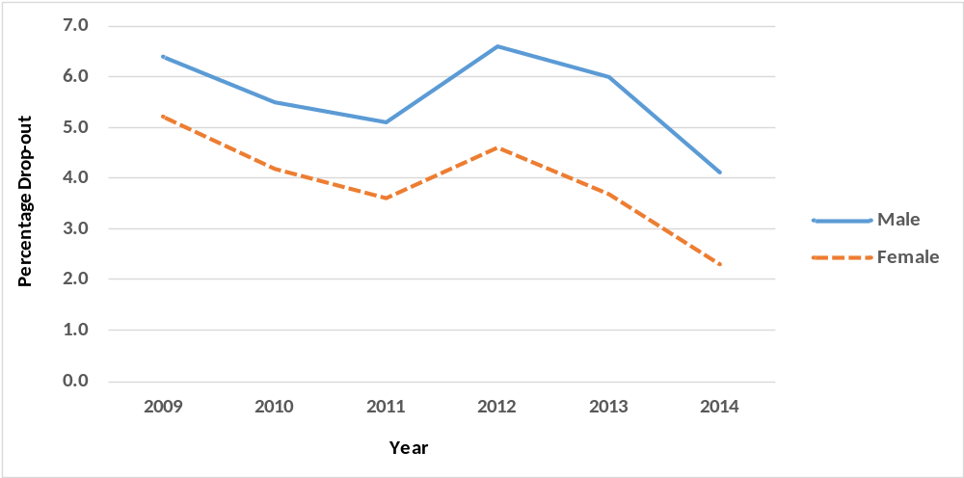

Girls generally perform better than boys at the Higher School Certificate (HSC) examinations.
Table 9 – Pass Rate (%) at HSC, Republic of Mauritius, 2010 - 2015
Year | Male | Female
2010 | 73.7 | 81.7
2011 | 75.3 | 82.3
2012 | 74.8 | 82.2
2013 | 73.9 | 80.8
2014 | 70.0 | 79.1
2015 | 72.0 | 77.8

Consequently, more women than men are enrolled in tertiary institutions. Tertiary enrolment for both girls and boys increased over time but with a widening gap in favour of girls. In 2014, women enrolled in public, private and overseas tertiary institutions numbered 28,281, representing 56% of the student population which stood at 50,608.

Chart 12 – Gross Tertiary Enrolment Rate (GTER), Republic of Mauritius, 2000 - 2014
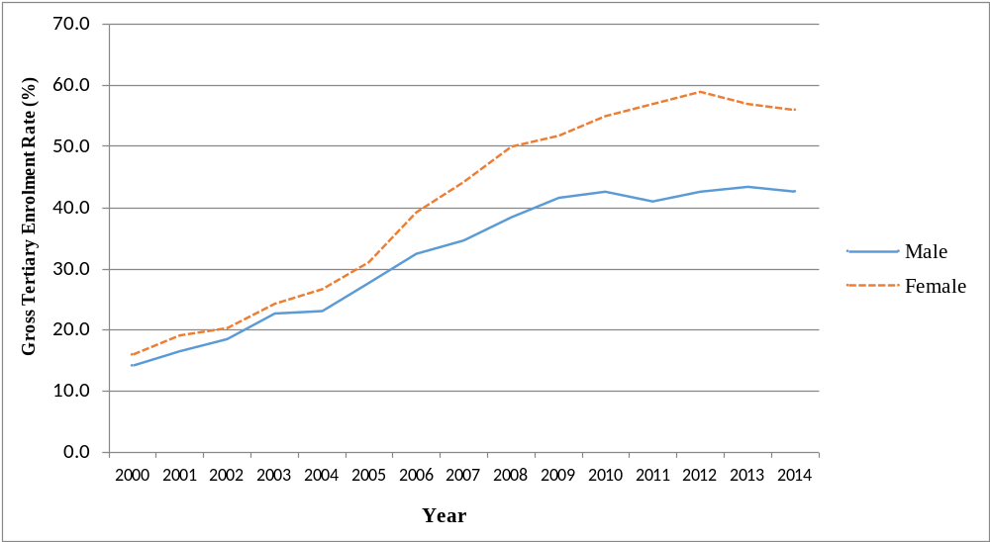

Both men and women were mostly enrolled in Bachelor Degree. There were fewer women than men in research, 198 women against 265 men.
Table 10 – No. of student enrolled¹ in tertiary institutions by level, 2014
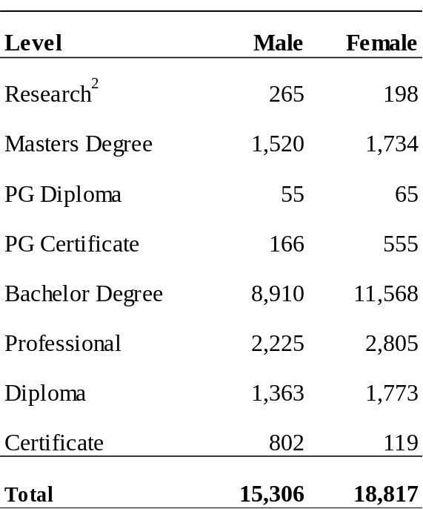
¹Enrolment in local public and private institutions, excluding overseas students
²PhD, MPhil and DBA
Administration/Management and Accounting were the most popular field of study for both men (16% each) and women (18% and 17% respectively). Information Technology was the third most popular subject for men (14%) followed by Engineering (13%). Education was the third choice for women (9%).
Women were underrepresented in science related fields such as Engineering (2% against 13%) and Information Technology (6% against 14%) whereas men were underrepresented in Social Science (1% against 3%) and Languages (1% against 5%).
Chart 13 – Percentage of student enrolled¹ in tertiary institutions by field of study, 2014
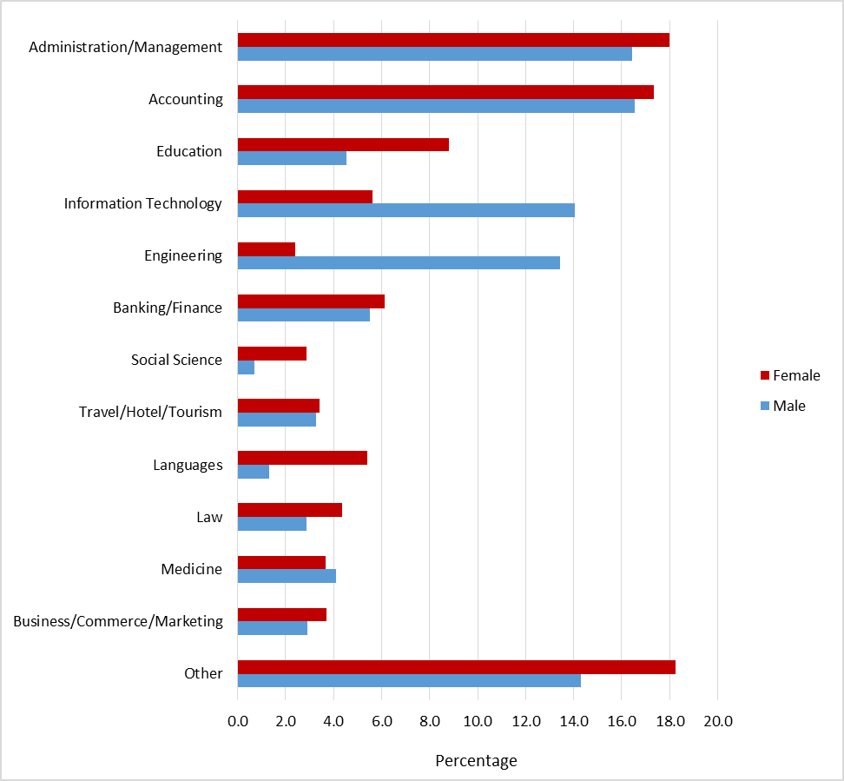
¹Enrolment in local public and private institutions, excluding overseas students

9. Economics Characteristics
In 2015, the active Mauritian population (aged 16 years and above) stood at 584,600 with 353,300 men and 231,300 women. Around 47% of women of working age are in the labour force compared to 75% of men.
During the period 2005 to 2015, male activity rate was consistently higher than female activity rate. However, the gap was narrowing over time as the activity rate for men has been constantly decreasing over the years while that of females has been generally increasing.

Chart 14 – Activity rate (%) by sex, 2005 - 2015
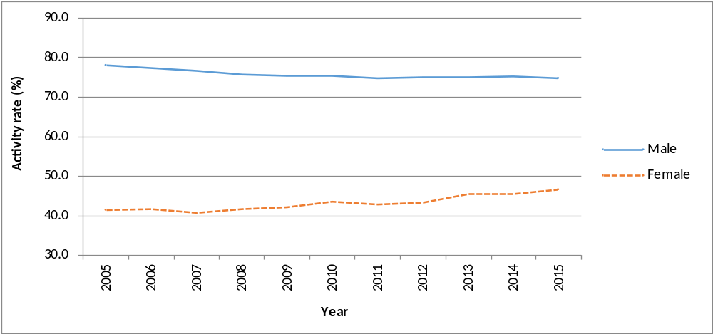
Men and women have a similar pattern of economic activity during their life, i.e., less active at the younger and older age groups. Over the years, the shape of the curve for female activity rate by age has been tending towards that of the male. The increase in the level of activity among women was more pronounced for those aged 25 to 29 years.

Chart 15 – Activity rate (%) by age group and sex, 2005 and 2015
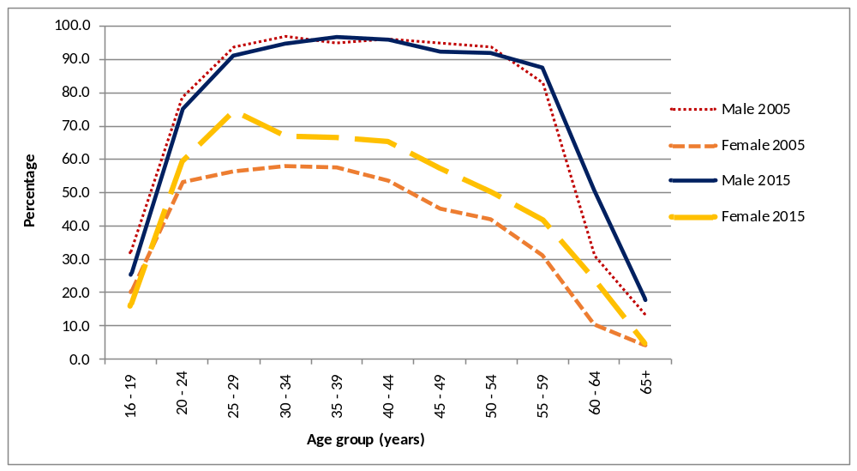
Both women and men had a high proportion of their working population in the tertiary sector (covering trade, accommodation service, transportation, health, education and other service industries), 61% for men and 77% for women. The secondary sector (covering manufacturing, electricity & water and construction) accounted for about one third of the working men and one sixth of the working women. The primary sector (comprising agriculture and mining & quarrying) employed 9% and 6% of the working men and women respectively.
Table 11 – Distribution (%) of employed persons by employment status and sex, 2015
Employment status | Male | Female
Employer | 5.4 | 1.7
Own Account Worker | 17.5 | 9.7
Employee | 76.1 | 83.9
Contributing Family Worker | 1.0 | 4.7
Total | 100.0 | 100.0

Women were more likely than men to be employees, with 83.9% of the female workforce in that employment status as compared to 76.1% for the male workforce. They were also much less likely than men to work for themselves. Some 22.9% of working men were employers or own accounts workers compared to about only 11.4% for women.
On average, a woman works 6 hours less than man. In 2015, the average number of hours worked by women was 35.2 compared to 41.1 for men.
In spite of being fewer in the labour force (representing only 40%), women are over represented among the unemployed; they make up nearly 58% of the total unemployed. Unemployed women numbered 26,800 in 2015 compared to 19,500 men. Female unemployment rate stood at 11.6%, much higher than the rate of 5.5% for male. The disparity between male and female unemployment rate was highest in the lower age groups; the difference was nearly 11 percentage points among the unemployed below 25 years and around 1 percentage point among those aged 50 years and above.

Chart 16 – Unemployment rate (%) by age group and sex, 2015
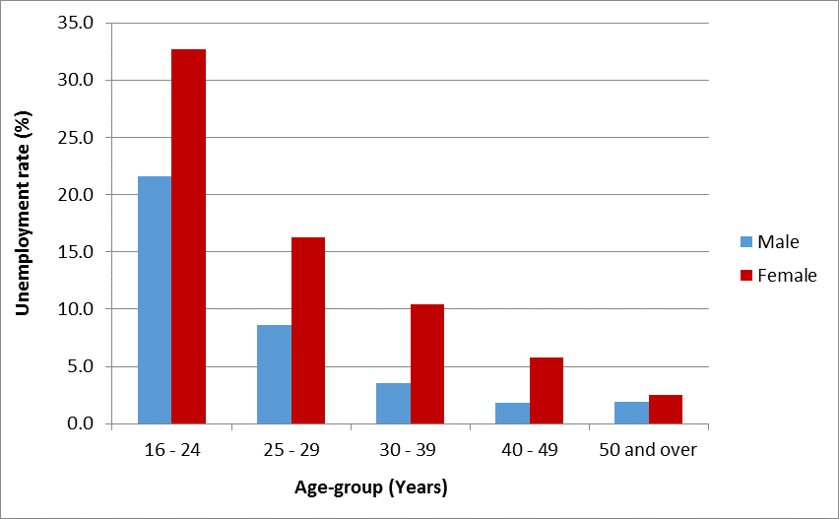

Unemployed women were generally more qualified than their male counterparts; around 54% of them possessed the School Certificate or above against 45% among males. Similarly, a higher proportion of unemployed women (21%) attained tertiary level education as compared to unemployed men (17%).
Table 12 – Distribution (%) of unemployed persons by educational attainment, 2015
Educational attainment | Male | Female
Primary | 19.5 | 17.9
of which passed CPE | 5.1 | 5.2
Secondary | 63.1 | 61.2
of which passed SC | 13.8 | 16.4
of which passed HSC | 13.8 | 17.2
Tertiary | 17.4 | 20.9
Total | 100.0 | 100.0

Across all occupational groups, women on average earn less than men. In the occupational category of managers, professionals and associate professionals, women earn on average 70 per cent of what men earn. In elementary occupations, women earn half of what men earn.

Table 13 – Average monthly income (Rs) from employment by occupational group, 2015
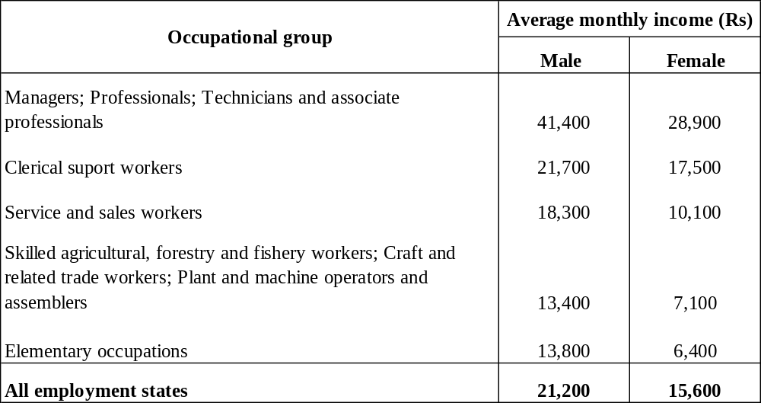

10. Social benefits and senior living in infirmaries
In 2014, the number of women receiving Basic Retirement Pension outnumbered their male counterparts by 22,593 and this number is expected to increase to 30,400 by 2044. Out of 184,487 Basic Retirement pensioners, 56% were women. Both male and female pensioners were concentrated in the age group 60 to 69 years. However, 72% of the pensioners in the age group 90 to 99 were women.
There were 20,302 recipients of Basic Widows Pension in 2014, a decrease of 11% compared to 22,757 in 2004. A large majority of widows (67%) were aged between 50 to 59 years.
Invalids pensioners numbered 30,715 in 2014, with an almost equal proportion of men and women.
In 2014, 372 children received Basic Orphans Pension, 49% of them were girls.

Table 14 – Number of beneficiaries of selected benefits, 2004 and 2014
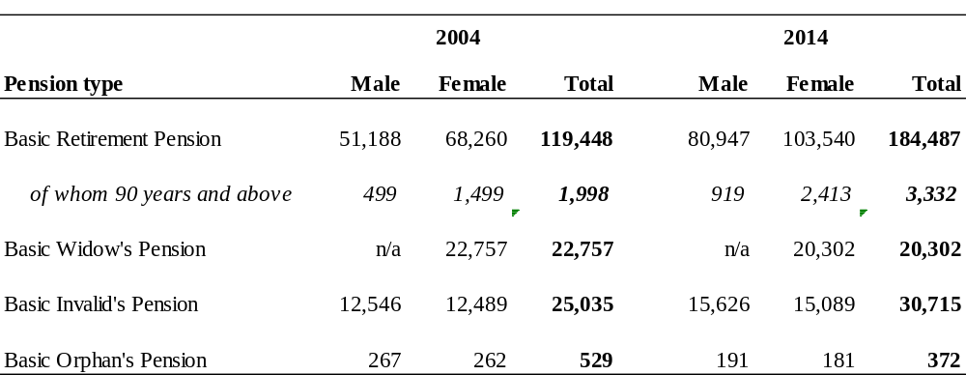
In 2014, 57% of the 677 inmates living in infirmaries registered at the Ministry of Social Security, National Solidarity and Reforms Institutions were women. The women residents were older than men with 33% aged 80 years and over compared to 14% for men.

Chart 17 – Number of Inmates in infirmaries and orphanages by age group and sex, 2014
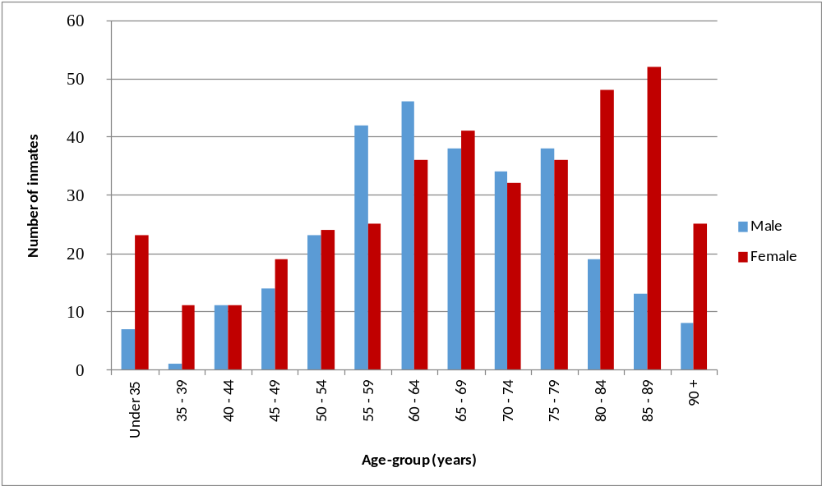
Both men and women inmates were likely to suffer from a disease or a disability. Both men and women inmates suffered mostly from mental diseases (26% for men and 31% for women) and multiple disabilities (28% for men and 39% for women).

Table 15 – Distribution (%) of inmates in infirmaries by disability, 2014
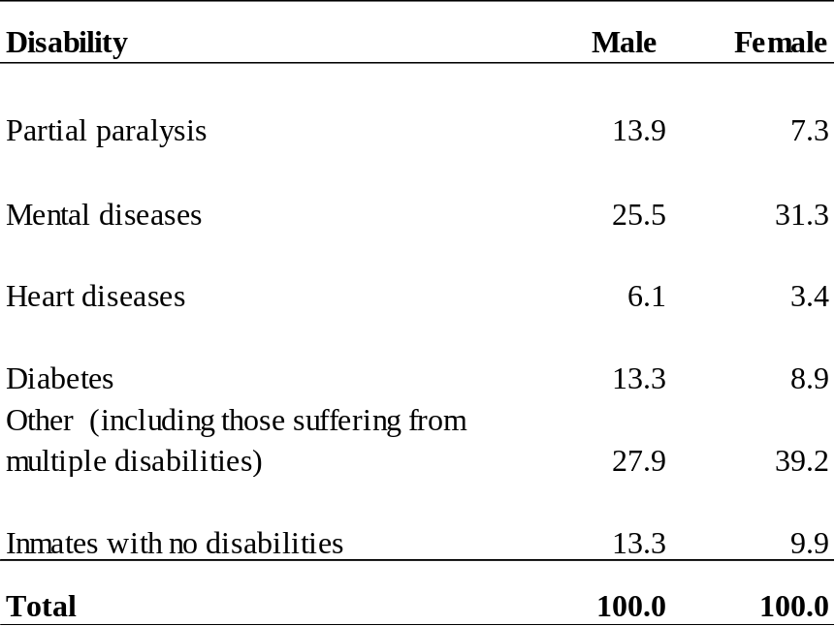
11. Women in politics and decision making
Women are under-represented in the highest sphere of decision making. The number of women among parliamentarians was only 8 out of a total of 70 (11%) in 2014 compared to 13 (19%) in 2010.
Table 16 –Elected Members at National Assembly Elections, 2000 - 2014
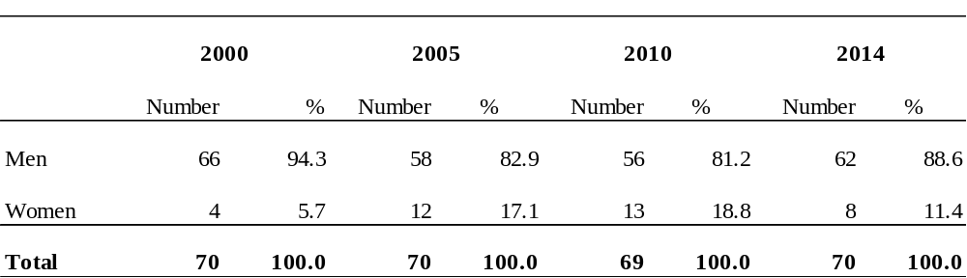

More women are occupying high positions in government services. The proportion of women in the most senior positions has increased from 23% to 40% over the past 15 years.

Table 17 – Senior position¹ in Government Services, 2000 - 2015
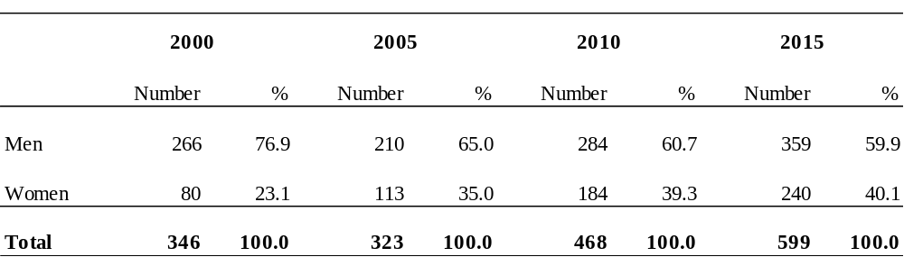
¹ Senior Chief Executive, Permanent Secretary, Deputy Permanent Secretary, Director, Manager, Judge and Magistrate

12. Domestic violence
Women are more likely to be victims of domestic violence. In 2015, out of 1,626 new cases of domestic violence reported at the Ministry of Gender Equality, Child Development and Family Welfare, nearly 89% were against women. Over the past five years, domestic violence against women has been declining slightly.
Some 34% of women victims of domestic violence reported physical assault by spouse or partner, 14% verbal assault by spouse or partner (ill treatment, harassment, abuse, and humiliation), 12% threatening assault by spouse and an equal proportion has been subjected to harassment by spouse. Reported cases by men relate mostly to physical assault by spouse or partner (17%), physical assault by others living under the same roof (17%) and verbal assault by spouse or partner (12%).

Chart 18 – Number of new cases of domestic violence reported, 2010 - 2015
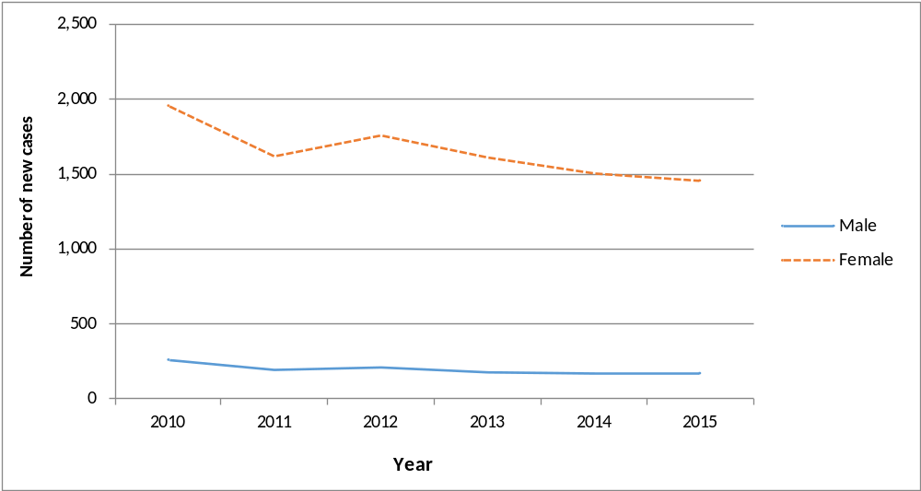
The total number of cases reported at the Child Development Unit of the Family Support Bureau is on the rise from 5,903 in 2014 to 6,035 in 2015.

Chart 19 – Number of cases reported at the Child Development Unit, 2000 - 2015
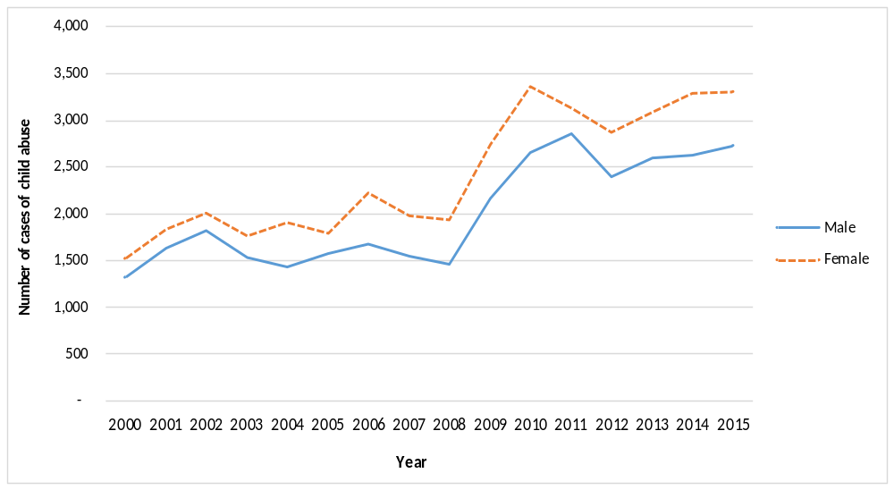
Of the reported cases in 2015, 55% were females. The most common nature of abuse is psychological/emotional (27% for male and 25% for female) followed by neglect cases (20% male and 15% for female) and physical abuse (14% for male and 9% for female).

Chart 20 – Distribution (%) of cases reported at the Child Development Unit by nature of problem, 2015
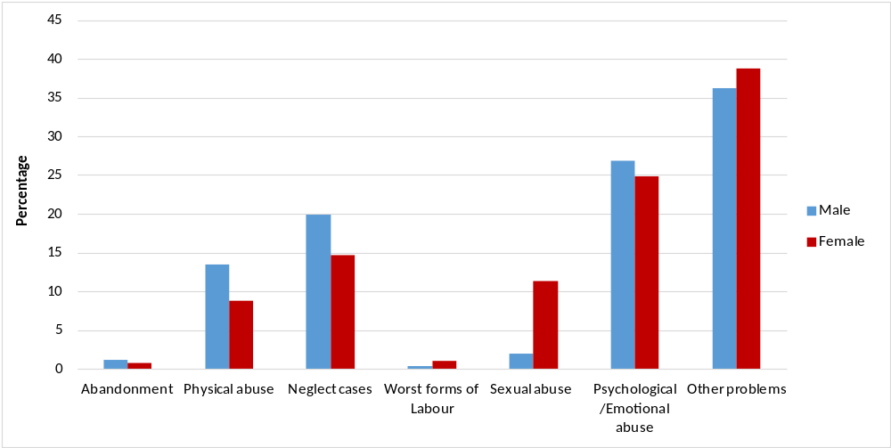

13. Offences
Men are more likely to be victims of homicides and assaults while women are more prone to sexual offences. In 2014, 64% of the intentional homicides and 56% of the assaults were committed against men. Women were victims to 91% of the sexual offences.

Table 18 – Victims¹ of selected offences reported at the Police, Republic of Mauritius, 2014
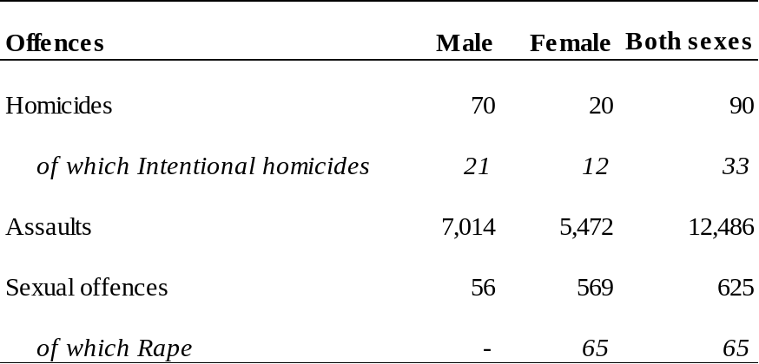
¹A person may be victim of one or more than one offence and/or an offence may involve one or more victims
Boys are much more likely to commit offences than girls. In 2014, only 5% of the juvenile offences were committed by girls. The female juvenile delinquency rate stood at 1.3 while that for male was 10.2.

Table 19 – Number of Juvenile offenders¹ reported, Republic of Mauritius, 2014
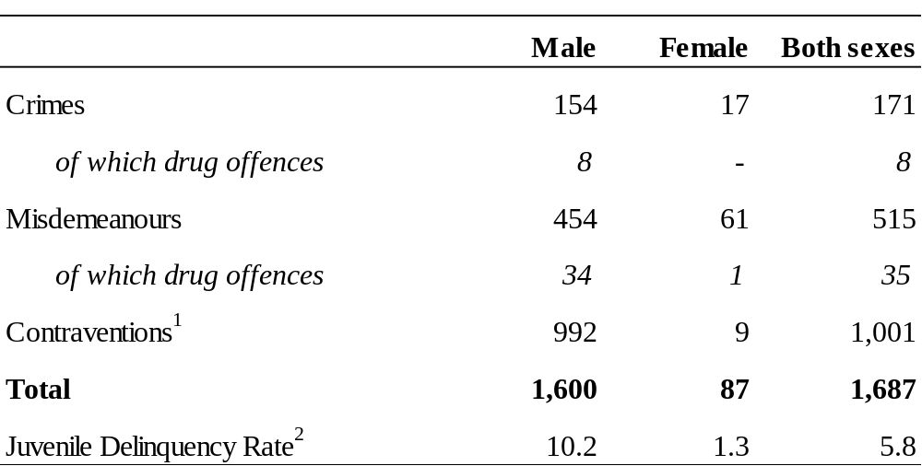
¹Persons aged 12 to 17 years
² Exclude contraventions established by camera
³Rate per 1,000 mid-year juvenile population and exclude contraventions

14. Physical Activity
Men are more likely than women to do physical activities. In 2015, among persons participating in at least one physical activity, 42% were women.

Table 20 – Participation in physical activities¹, 2012 and 2015
 | 2012 |  | 2015
 | Number | % | Number | %
Male | 269,612 | 59.3 | 253,868 | 57.6
Female | 185,428 | 40.7 | 187,238 | 42.4
Total | 455,040 | 100.0 | 441,106 | 100.0

¹Jogging, Yoga, Swimming, Aerobics, Tai-chi, Football, Badminton,…

Women preferred mostly jogging (20%), walking (19%) and aerobics (14%) whereas men preferred mostly football (27%), jogging (20%) and walking (11%).

Around 68% men and 84% women reported that the main reason for undertaking physical activity was to maintain good health and fitness.

Table 21 – Main reason for doing physical exercise, 2015
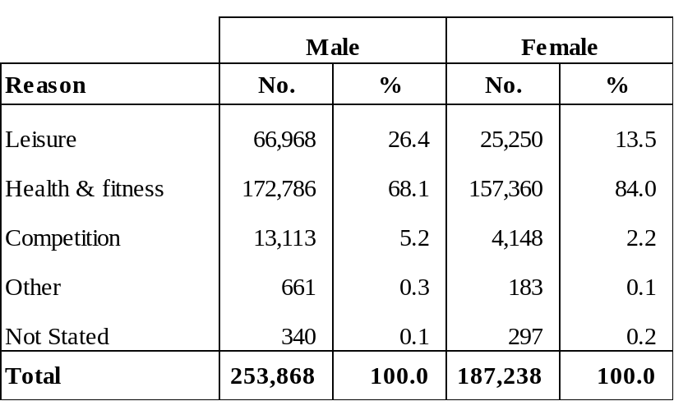

15. Global Gender Gap Indices
Since 2006, through the Global Gender Gap Report series, the World Economic Forum has been quantifying the magnitude of gender-based disparities and tracking their progress over time. By providing a comprehensive framework for benchmarking global gender gaps, the report identified countries that are role models in dividing their resources equitably between women and men, regardless of the overall resource level.
The Global Gender Gap Index (GGI) seeks to measure one important aspect of gender equality; their relative gaps between women and men across a large set of countries and across four key areas: economic participation and opportunity, educational attainment, health and survival and political empowerment. The equality benchmark is considered to be one with no gap between men and women.
Mauritius holds the 120th position overall out of 145 countries in 2015, regressing from the 106th position held in 2014. Although Mauritius has closed both its education attainment and health and survival gender gaps with indices nearing 1, it has regressed due to decreases on the Economic Participation & Opportunity and Political Empowerment subindexes (Table23)

Table 22 – Global Gender Index by selected countries, 2013 - 2015
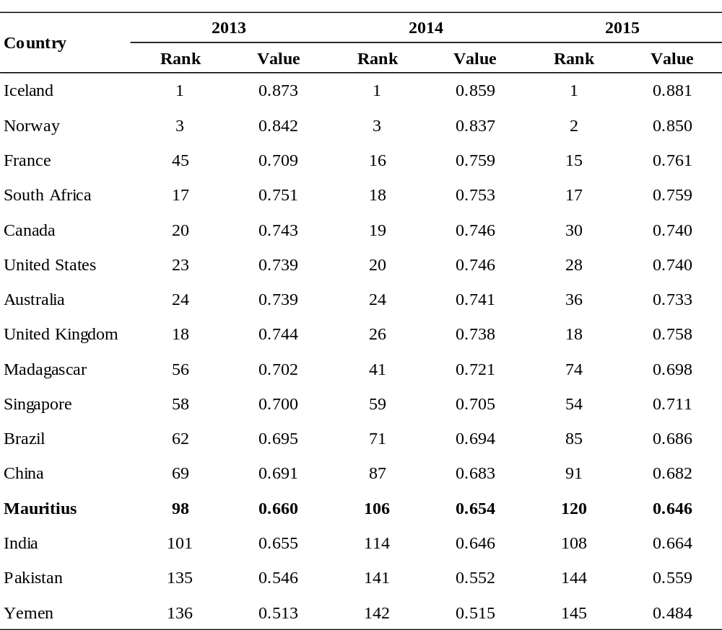
Source: The Global Gender Gap Report 2015, World Economic Forum

Table 23 – Gender Gap Index for overall and four key areas, Republic of Mauritius, 2006 - 2015
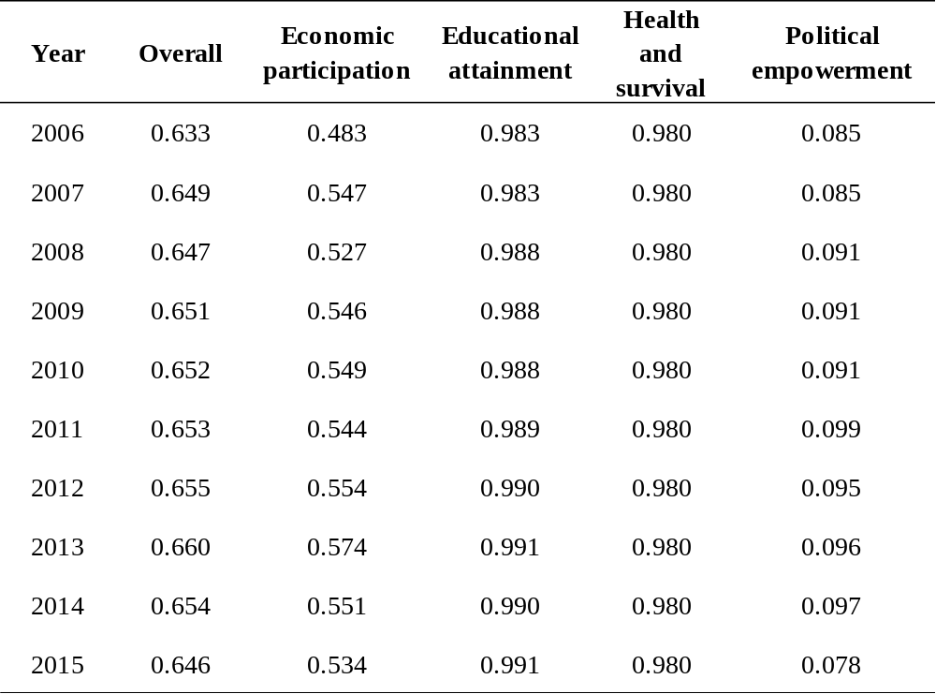

Contact person: Mr D. Pothegadoo
Statistician
Statistics Mauritius
LIC Centre, Port Louis
Tel: 4053310
Fax: 2082041

Statistics Mauritius
Ministry of Finance and Economic Development
Port Louis
July 2016

Appendix: Definitions of terms
Activity rate: The ratio (%) of the economically active population (employed and unemployed) to population aged 16 years and above.
Age specific fertility rate: the number of live births to women of a specified age-group per 1,000 women in that age-group.
Contributing Family Worker: A contributing family worker is a person who works without pay in an enterprise operated by a family worker.
Crimes: Offences that are punishable by: (a) penal servitude (b) fine exceeding 5,000 rupees.
Crude death rate: the number of deaths in a year per 1,000 mid-year population.
Current User of contraceptive method: A new acceptor who continues with the same or different method of contraception and pays regular return visits to the family planning service point to receive services and supplies.
Divorce rate: the number of persons divorced in a year per 1,000 mid-year population.
Employee: An employee is a person who works for pay for someone else, even in a temporary capacity.
Employer: An employer is a person who operates his/her own business or trade and hires one or more employees.
Employment: Employed population consists of Mauritians aged 16 years and above who have worked for pay, profit or family gain for at least one hour during reference week of a month. It includes those who are temporarily absent from work for reason such as leave with pay, leave without pay and temporary disorganisation of work (bad weather, break down of equipment, lack of order, etc).
Gross Enrolment Ratio (GER): Number of pupils enrolled in a given level of education, regardless of age, expressed as a percentage of the population in the relevant age-group
- 4 - 5 years for pre-primary
- 6 – 11 years for primary
- 12 – 19 years for secondary
Gender Parity Index (GPI): Ratio of the GER for female to the GER for male. It measures the relative education participation of boys and girls. A GPI of 1 reflects equal enrolment rate for boys and girls, whereas a GPI greater than 1 shows disparity in favour of girls.
Juvenile: a person aged below 18 years.
Juvenile delinquency rate: the number of juvenile offenders involved in offences (excluding contraventions) per 1,000 juvenile populations.
Life Expectancy at birth: the number of years a new born infant would live if prevailing patterns of mortality at the time of its birth were to stay the same throughout it life.
Marriage rate: the number of persons married in a year per 1,000 mid-year population.
Maternal mortality rate: number of deaths due to pregnancy, childbirth and the puerperium per 10,000 live births during that year.
Misdemeanors: Offences that are punishable by:(a) imprisonment for a term exceeding 10 days; (b) fine exceeding 5,000 rupees.
New acceptor of contraceptive methods: Someone who accepts a contraceptive method for the first time from a provider of a family planning programme.
Own Account Worker: An own account worker is a person who operates his/her own business or trade but does not hire employees. He/She may be working alone or with the help of contributing family workers.
Primary sector: Primary Sector comprises activities related to ‘Agriculture, hunting. Forestry and fishing’ and ‘Mining’
Secondary sector: Secondary Sector comprises activities related to ‘Manufacturing, ‘Electricity, gas and water supply’ and ‘Construction’.
Sex Ratio: The sex ratio is defined as the number of males per 100 females.
Total fertility rate: the average number of children born to an average woman assuming that she survives to the end of her child-bearing age and is subjected to a fixed schedule of age-specific fertility rates.
Unemployment Rate: Unemployment rate is the ratio (%) of unemployment to economically active population (employed and unemployed).
Unemployment: Unemployed population comprises all Mauritians aged 16 years and over who are not working but who are looking for work and are available for work during the reference week.

