SOCIAL SECURITY STATISTICS
2010 – 2014
- Introduction
This issue of the ‘Economic and Social Indicators’ presents statistics on the main social security benefits provided by the Ministry of Social Security, National Solidarity and Reform Institutions for the period January 2010 to December 2014. Social Security benefits are classified as:
- Non-contributory benefits financed by government and are payable to every Mauritian citizen under certain conditions and
- Contributory benefits payable only to, or on behalf of, those persons who have contributed to the National Pensions Fund (NPF)
Social Security Statistics are reported on a calendar (January to December) year basis instead of the financial (July to June) year basis as from year 2010. This follows Government decision taken in July 2008 to change reporting period of Government account from year ending 30th June to year ending 31st December.
Thus for 2014 the number of beneficiaries relates to December 2014 while the amount paid refers to calendar year, January to December 2014. Figures for 2014 are also subject to revision in future issues as additional information becomes available.
Detailed explanatory notes on the different benefits are given at section 10.
- Highlights – Republic of Mauritius
- Expenditure on Social Security and Welfare amounted to Rs. 26,028 million in 2013, representing 26.7% of total government expenditure and 7.1% of the Gross Domestic Product (GDP) at market prices.
- At the end of 2014, the number of beneficiaries of Basic Retirement Pension reached 184,487, 3.8% more than at the end of 2013. The cost to Government was Rs. 9,960 million, 14.0% higher than in 2013.
- There were 20,302 Basic Widow’s Pensioners at the end of 2014 compared to 20,511 one year ago, showing a decrease of 1.0%. However, due to increases in the rates payable, the amount disbursed increased by 9.1% to reach Rs. 1,040 million during year 2014.
- The number of Basic Invalid’s Pensioners at the end of 2014 was 30,715, compared to 30,930 a year ago. The total amount disbursed in 2014 rose by 10.6% to reach Rs. 1,679 million.
- At end 2014, the number of beneficiaries of Basic Orphan’s Pension stood at 372 compared to 374 at end 2013 and expenditure increased to Rs. 27.7 million, from Rs 26.5 million in 2013.
- Social Aid benefits were paid to 21,246 families as at December 2014, i.e., an increase of 3.3% over 2013. Amount paid registered a 3.7% increase to reach Rs. 764 million in 2014.
- A forty years’ projection indicates that the number of Basic Retirement Pensioners would reach around 343,000 in 2054 from 184,487 in 2014 and the amount disbursed is expected to increase from Rs. 10 billion to Rs. 18.5 billion.
- Expenditure on Social Security and Welfare – (Table 1)
Overall expenditure exceeds Rs 26 billion in 2013
Government expenditure on Social Security and Welfare consists of expenditure and transfers made by government for the social welfare of the community, in line with the recommendations of the Government Finance Statistics Manual 2001 of the International Monetary Fund. It covers all expenses made by the Ministry of Social Security, National Solidarity & Reform Institutions and the Ministry of Gender Equality, Child Development & Family Welfare together with components of social welfare of all government organizations as well as Local Government.

Expenditure on Social Security and Welfare increased by 14.7% from Rs. 22,691 million in 2012 to 26,028 million in 2013. In 2013, it represents 26.7% of total government expenditure and 7.1% of the Gross Domestic Products (GDP) at market prices.
The main components were the Basic Retirement Pension with a share of 33.6%, followed by Public Service Pensions, 20.6%. 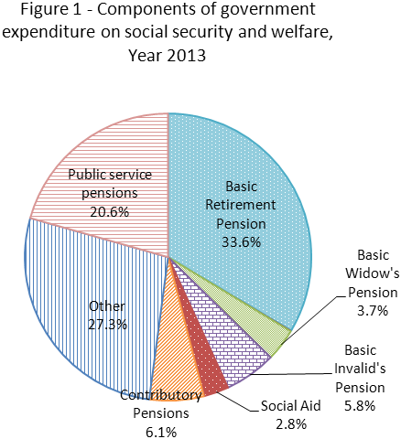

- Non-contributory benefits
These benefits include:
- Basic pensions which cater for the elderly, the invalids, the widows and the orphans irrespective of their economic status;
- Allowances such as Social Aid, Food Aid, Unemployment Hardship Relief and Funeral Grant which are payable to the low-income group of the population; and
- Inmates allowance and indoor relief payable to, or on behalf of, those Mauritians residing in government-subsidized institutions such as old-people homes, infirmaries and orphanages.
The pension rates payable for non-contributory benefits are given at table 11.
4.1 Basic Pensions
4.1.1 Basic Retirement Pension – BRP (Table 2.1)

An average increase of some 7,700 beneficiaries each year since 2010

Basic Retirement Pension, also known as old-age pension, is payable to every Mauritian citizen aged 60 years and above, subject to certain residency conditions.
The number of old-age pensioners, which stood at 177,721 as at end 2013 increased by 3.8% to reach 184,487 as at end 2014. The old-age pension cost government Rs. 9,959.6 million during 2014 representing an increase of 14% over 2013.
A forty years’ projection indicates that Basic Retirement Pensioners would increase to reach around 342,700 in 2054 and the amount disbursed is expected to increase to Rs. 18.5 billion (Table 10).
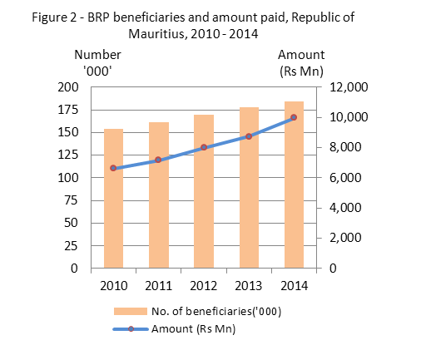

4.1.2 Basic Widow’s Pension – BWP (Table 2.1)

Expenditure on the increase despite fewer beneficiaries

Basic Widow's Pension is payable to widows aged 15 to 59 years who were either civilly and/or religiously married to their late husband. The number of beneficiaries of Widow’s pension decreased by 1%, from 20,511 as at December 2013 to 20,302 as at December 2014.
On the other hand, government expenditure on such Pension, which was Rs. 952.6 million during 2013, rose by 9.1% to reach Rs. 1,039.6 million during 2014, due to higher rate of pension.
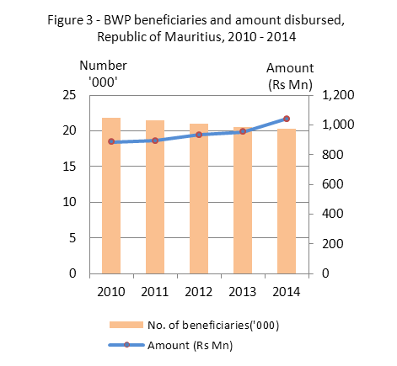

4.1.3 Basic Invalid’s Pension – BIP – (Table 2.1)

Number of invalid pensioners remained at around 31,000

The Basic Invalid’s Pension is payable to any person aged 15 to 59 years if certified by a Medical Board that the person is either permanently or substantially incapacitated to work to a degree of 60% or more for at least 12 months. The number of such beneficiaries decreased from 30,930 as at December 2013 to 30,715 as at December 2014, showing a slight decrease of 0.7%.
The total amount spent on Basic Invalid's Pension rose by 10.6% from Rs. 1,517.4 million in 2013 to Rs. 1,678.7 million in 2014.
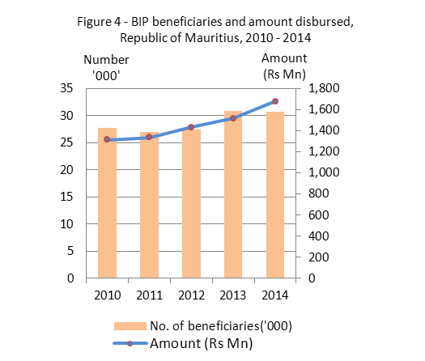

4.1.4 Basic Orphan’s Pension (BOP) – (Table 2.1)

Basic Orphan’s Pension is payable to all orphans under the age of 15, or under 20 years, if they are in full-time education.
The number of beneficiaries of Basic Orphan’s Pension in the Republic of Mauritius decreased from 374 in December 2013 to 372 in December 2014. Its cost amounted to Rs. 27.7 million in 2014 representing a 4.7% increase over 2013.

4.1.5 Child’s Allowance – (Table 2.1)
Child’s allowance is payable to children of beneficiaries of Basic Retirement Pension, Basic Widow’s Pension and Basic Invalid's Pension in respect of a child below 15 years, or below 20 years, if in full-time education. The total number of children benefiting from Child’s allowance decreased by 9.5% from 18,022 in December 2013 to 16,311 in December 2014. Out of this total, 60% were children of Basic Invalid’s pensioners followed by those of Basic Widow’s Pensioners (36%).

4.2 Other Non - Contributory Social Benefits – (Tables 3 & 4)
4.2.1 Social Aid

Over 21,000 beneficiaries in 2014
Social Aid is an income-tested scheme. It is payable to the head of a family who is incapable of earning his living adequately and who has insufficient means to support himself and his dependents. The total number of families benefiting from such assistance increased by 3.3% from 20,570 in December 2013 to 21,246 in December 2014. Consequently, the total amount paid to beneficiaries increased by 3.7% to reach Rs. 764.2 million in 2014.
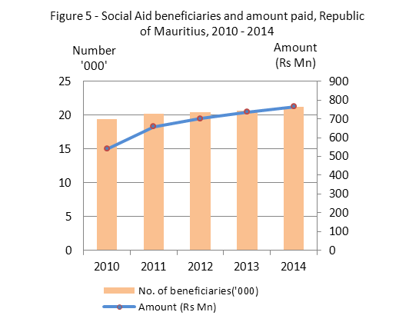

4.2.2 Income Support for the purchase of rice and flour
In order to support needy Mauritians for the purchase of rice and flour, a Food Aid Scheme and an Income Support Scheme was introduced when government subsidy on rice and flour was discontinued.
The number of persons who were benefiting from Food Aid scheme or Income Support Scheme was 93,150 in December 2014 and the total amount paid in 2014 was Rs. 292.2 million.
4.2.3 Indoor Relief
Indoor relief is the grant paid to an institution in respect of every person residing in the institution, if that person would have otherwise benefited from a basic pension or from Social Aid. The number of beneficiaries decreased from 690 in December 2013 to 677 in December 2014. However, the amount paid under that scheme increased by 15.8% from Rs. 54.6 million in 2013 to Rs. 63.2 million in 2014.
4.2.4 Inmate’s Allowance
Inmate's Allowance refers to the pocket money given to certain residents of government-subsidized institutions and of the government psychiatric hospital, Brown Sequard Hospital. In December 2014, 809 persons received such allowance as compared to 828 in December 2013 representing a decrease of 2.3%. The amount spent under this item increased by 10.1% from Rs 8.1 million in 2013 to Rs 8.9 million in 2014.
4.2.5 Unemployment Hardship Relief
The Unemployment Hardship Relief (UHR) is payable to unemployed heads of families whose family income is not sufficient to meet the needs of the members. The number of beneficiaries of UHR increased by 8.1%, from 816 in December 2013 to 882 in December 2014 and the amount paid to these beneficiaries rose by 16% from Rs 22.5 million in 2013 to Rs 26.1 million in 2014.
4.2.6 Funeral Grant
A funeral grant is meant to cover funeral expenses of persons from low-income families. The number of payments for funeral expenses increased from 3,091 during 2013 to 3,218 during 2014. The amount disbursed increased from Rs 13.9 million to Rs 14.6 million during the same period.
5. National Pension Fund, National Savings Fund and contributory benefits
5.1 The National Pensions Fund – (Table 5)
Size of NPF reached Rs 92 billion in 2014 compared to Rs 69 billion in 2010

The National Pension Scheme, introduced in April 1976, provides for the payment of contributory pensions to those employees of the private sector who have contributed to the National Pensions Fund (NPF).
In 2014, there were around 328,600 employees who have contributed to the NPF while contributions received from both employees and employers amounted to Rs. 3,012.1 million.
As at 31st December 2014, total net assets (size of fund) of the National Pension Fund was around Rs. 92 billion.
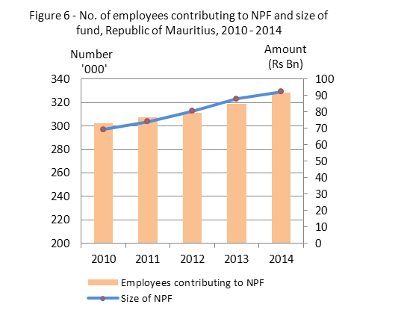

5.2 The National Savings Fund – (Table 6)
More than 402,000 employees covered by the NSF
The National Savings Fund (NSF) has been set up in 1995 to replace the Employees Welfare Fund. The objectives of the National Savings Fund are:
- To provide for the payment of a lump sum to every employee on his retirement at the age of 60 or earlier, or to the beneficiary on his death; and
- To set up and operate for the benefit of employees, such schemes, including loan schemes, as may be prescribed.
The number of employees covered by the Fund rose from around 378,800 in 2013 to 402,200 in 2014, showing an increase of 6.2%. At the same time, the total contribution received, exclusive of surcharge, rose by 13%, from Rs. 1,314.9 million in 2013 to Rs. 1,485.4 million in 2014.

5.3 Contributory benefits

Contributory benefits are payable only to, or on behalf of, those persons who have contributed to the National Pensions Fund (NPF). The contributory pensions include old age, invalidity, widows and orphans pensions in addition to industrial injury allowances.

In the case of contributory benefits, the allowances payable vary according to the amount contributed to the NPF by the insured worker. For those persons whose contributions were marginal, government guarantees a minimum contributory pension.
In 2014, amount disbursed on Contributory Retirement Pension (CRP) represented the main component with 74.3% of the total, followed by Contributory Widows Pension (CWP) with 20.2% (Table 7(b) and Figure 7).
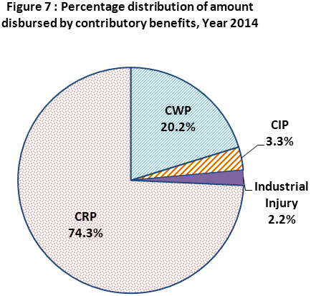

5.3.1 Contributory Pensions – (Tables 7(a) - (b))
5.3.1.1 Contributory Retirement Pension (CRP)

The Contributory Retirement Pension is payable to a person on reaching the age of 60 years, if that person has contributed to the National Pension Fund. The number of beneficiaries of this type of pension rose from 72,221 in December 2013 to reach 78,185 in December 2014, showing a rise of 8.3%. Consequently, an increase of 11.9% was noted in the amount disbursed, from Rs. 1,176 million to Rs. 1,316.1 million.

5.3.1.2 Contributory Widow’s Pension (CWP)
The Contributory Widow’s Pension is payable to a widow whose late husband had contributed to the National Pensions Fund. The total number of widows who benefited from such a pension increased by 5.4%, from 23,263 in December 2013 to 24,512 in December 2014. The amount paid thus went up from Rs. 322.1 million in 2013 to Rs. 358.4 million in 2014, showing an increase of 11.3%.

5.3.1.3 Contributory Invalid’s Pension (CIP)
A person is entitled to a Contributory Invalid’s Pension if he/she has previously contributed to the National Pension Fund and suffers from a permanent incapacity of at least 60%. The number of such beneficiaries rose by 3.5%, from 9,469 in December 2013 to 9,799 in December 2014. The amount paid increased by 7.4% from Rs. 54.7 million in 2013 to Rs. 58.8 million in 2014.

5.3.1.4 Contributory Orphan’s Pension (COP)
The Contributory Orphan’s pension is payable to orphans under the age of 15 years (or 18 years if the child is at school), if any of the deceased parents had contributed to the National Pension Fund. During 2014 the number of orphans benefiting from this pension was 173 against 168 in 2013, whilst the amount disbursed was Rs 0.3 million, slightly lower than the amount of Rs. 0.4 million disbursed during the previous year.

5.3.1.5 Industrial Injury Benefits
This comprises only those cases who, being insured under the NPF, have been awarded Industrial Injury Allowance in respect of work accidents. The number of cases of Industrial Injury decreased from 822 in December 2013 to 797 in December 2014. The total amount paid decreased from Rs 39.4 million in 2013 to Rs 38.2 million in 2014.
6. The National Solidarity Fund – (Table 8(a) – (b))

The National Solidarity Fund started operating on 1 June 1991 with the objective to provide financial assistance to:
- Mauritian citizens residing in Mauritius who require surgical operations that can only be performed abroad.
- Those undergoing Severe Personal Hardships such as tragic accidents, needy students, victims of natural calamities, multiple births, medical cases, etc.
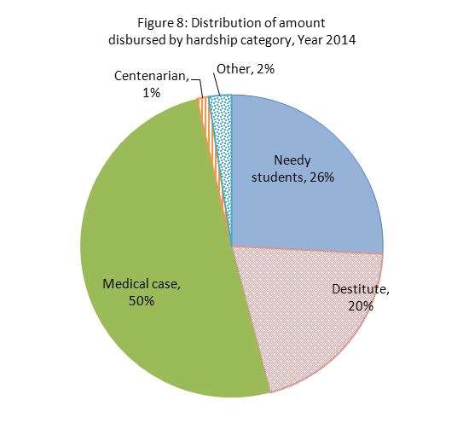

During the year 2014, the National Solidarity Fund assisted 2,987 cases compared to 1,775 in 2013. During that period, the amount spent has more than doubled, from Rs. 14.7 million to Rs. 34.2 million.
7. Projected number of basic pension beneficiaries and their related future costs (Tables 9 – 10)
Assumptions used in the projections of the number of beneficiaries of basic pensions and their eventual costs are given at section 11.
The pensioner support ratio, defined as the number of persons of working age (15-59 years) per old age pensioner (aged 60 years and over), which stood at 4.6 in 2014 is expected to fall to about 1.6 by 2054.
The index of ageing defined as the number of persons aged 60 years and over per 100 children aged less than 15 years would increase to 280.9 in 2054, from 70.4 in 2014.
The number of beneficiaries of Basic Retirement Pension is expected to reach 342,700 in 2054, from 184,487 as at December 2014.
There were 20,302 beneficiaries of Basic Widow's Pension in December 2014. This is expected to decrease to about 17,600 in the next four decades. During that time, the number of beneficiaries of Basic Invalid’s Pension would decrease from 30,715 to around 23,500.
Based on rates applicable in 2014, the amount to be disbursed by government on Basic Retirement pension (including Enhanced Basic Retirement Pension and Child’s Allowance) is expected to almost double, from Rs 9,960 million in 2014 to Rs 18,489 million in some forty years, due to the ageing of the population.

Figure 9 shows the evolution in the number of beneficiaries and the future cost of the Basic Retirement Pension.
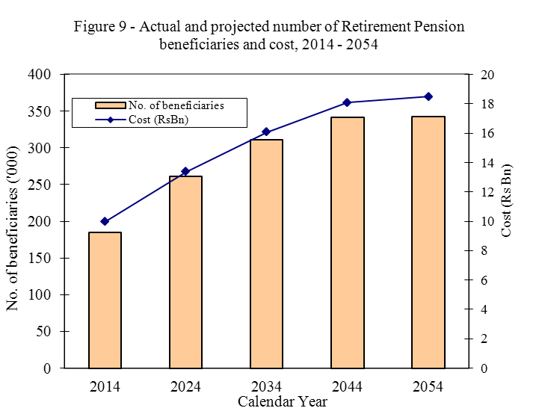
As for the other pensions, namely, Basic Widow's pensions, Basic Invalid's pensions and Basic Orphan's pensions, the future costs are expected to amount to Rs 1,993 million within the next forty years compared to Rs 2,747 million in 2014.
8. List of tables
The following tables together with the web version of this publication can be downloaded from Statistics Mauritius website at http://statsmauritius.govmu.org From the homepage click on ‘Statistics by subject’ followed by ‘Social security’, then select the appropriate publication under the heading ‘Publications – Economic and Social Indicators’.
Table 1 – Government Expenditure on Social Security & Welfare,
Republic of Mauritius, 2010 - 2013
Table 2.1 - 2.3 – No. of beneficiaries of basic pensions and amount paid
by island, 2010 - 2014
Table 3 – Number of beneficiaries of other non-contributory social benefits
and amount paid, Republic of Mauritius, 2010 - 2014
Table 4 – Number of cases of Social Aid paid by district, 2010 - 2014
Table 5 – Contribution to the National Pensions Fund (NPF), 2010 - 2014
Table 6 – Contribution to the National Savings Fund (NSF), 2010 - 2014
Table 7 – Number of beneficiaries of contributory pensions and amount paid
2010 - 2014, Republic of Mauritius
Table 8 – No. of cases receiving assistance from the National Solidarity Fund (NSF) by type
and amount disbursed 2010 - 2014,Republic of Mauritius
Table 9 – Projected mid-year population by broad age group and sex,
Republic of Mauritius, 2014 - 2054
Table10 – Projected number of beneficiaries and estimated future costs of basic pension,
Republic of Mauritius, 2014 - 2054
Table11 – Non-contributory benefits by type and rate payable, 2010 - 2014
9. Notes
9.1 Release of data on social security
This publication is a yearly issue to be released by end of August according to an advance calendar posted on Statistics Mauritius website (http://statsmauritius.govmu.org). The next issue is scheduled for August 2016. This indicator will also be followed by a more comprehensive report on the same subject and period, with release scheduled for May 2016.
9.2 Inquiries
For further information regarding the indicators presented in this ESI and other statistics on social security please contact:

Mr. A. RAMASAMY, Statistician

Statistical Unit,
Ministry of Social Security,
National Solidarity and Reform Institutions
3rd floor, Social Security House,
Rose Hill
Tel: 465 4119, 403 2700 (Ext. 1157)
Fax: 465 4119, 465 4665
E-mail : aramasamy@govmu.org

10 Explanatory Notes
10.1 Non – Contributory Benefits
10.1.1 Enhanced Basic Retirement Pension
The Enhanced Basic Retirement Pension is an additional allowance payable to old-age pensioners who are either
- totally blind, or
- suffer from total paralysis, or
- need the constant care of another person
10.1.2 Additional Basic Invalid Pension
Basic Invalid Pensioners, who need the constant care and attention of another person, benefit from an additional allowance known as the Carer’s Allowance.
10.1.3 Guardian Allowance (GA)
A Guardian’s allowance is also paid to the person looking after one or more orphans. However, only one allowance is payable per guardian irrespective of the number of orphans under his/her care.
10.1.4 Child’s Allowance
Child’s allowance is payable to children of beneficiaries of Basic Retirement Pension, Basic Widow’s Pension and Basic Invalid's Pension in respect of a child below 15 years, or below 20 years, if in full-time education. Child’s allowance is payable for up to three dependent children. It is to be noted that child allowance is payable even after discontinuation of pensions to the parents for some reasons (e.g. when the widowed mother got married).

10.1.5 Social Aid
Social Aid is an income-tested scheme. It is payable to the head of a family who is incapable of earning his living adequately and who has insufficient means to support himself and his dependents. Social Aid is payable to the poorer section of the population, including the dependents of prisoners and abandoned spouses, especially those with dependent children. The allowance payable is calculated as the difference between the total income and the expected overall expenditure of the family.
10.1.6 Income Support for the purchase of rice and flour
In order to support needy Mauritians for the purchase of rice and flour, the Food Aid Scheme was introduced in May 1993 when government subsidy on rice and flour was temporarily discontinued. Under the Food Aid Scheme, a monthly stipend is given to every needy Mauritian for the purchase of rice and flour. The beneficiaries are:
- All recipients of Social Aid and their dependents
- All those receiving the Unemployment Hardship Relief
- All needy beneficiaries of a basic pension under the National Pensions Act, i.e. beneficiaries of Basic Retirement Pension, Basic Widow’s Pension, Basic Invalid’s Pension and Basic Orphan’s Pensions, who would have qualified to receive social aid if the basic pensions were not payable
The monthly stipend increased from Rs 30 in May 1993 to Rs 50 in October 2004, then to Rs 85 as from 1 July 2006 and later to Rs100 as from 1 July 2008.
In addition, as from 1 July 2006 with the government discontinuation of subsidy on rice and flour, an Income Support Scheme was introduced whereby a monthly allowance of Rs 40 is given to:
- Any head of household and his/her dependents whose average monthly electricity consumption does not exceed 75 KWh and who are not in receipt of Food Aid.
- Any beneficiary of basic pension and his/her dependents (under the National Pensions Act) and who would have been eligible to receive social aid if he/she was not in receipt of that basic pension.
This allowance also increased to Rs 100 as from 1 July 2008.
10.1.7 Inmate’s Allowance
Inmate's Allowance refers to the pocket money given to certain residents of government-subsidized institutions and of the government psychiatric hospital, Brown Sequard Hospital.
10.1.8 Unemployment Hardship Relief
The Unemployment Hardship Relief (UHR) is payable to unemployed heads of families whose family income is not sufficient to meet the needs of the members. The head should be
- Registered as unemployed at the Employment Exchange
- Be willing and able to take up employment and
- Be actively looking for work
A disabled person, who can work but has not been able to find a job, receives an Unemployment Hardship Relief in addition to his Basic Invalid's Pension.
10.1.9 Funeral Grant
A funeral grant is meant to cover funeral expenses of persons from low-income families.
10.2 Contributory Benefits
10.2.1 The National Pension Scheme
The National Pension Scheme was introduced in April 1976. It provides for the payment of contributory pensions to those employees of the private sector who have contributed to the National Pensions Fund (NPF). All employees working for employers with more than 10 employees had to join the Scheme as from July 1978. Other employees joined the Scheme as from January 1980, except household workers for whom the operative date was July 1980. The self-employed were also eligible to join the Scheme as from July 1980 on a voluntary basis.
Contributions to the Scheme are payable at the rate of 10.5% by millers and large employers of the Sugar Industry (those having at least 100 arpents under sugar cane cultivation); other employers pay contribution at the rate of 6%. For all employees, the contribution rate is 3 %. Contributions are not payable on bonus, overtime pay and allowances. The minimum monthly remuneration on which contributions are payable was Rs 900 for household employees and Rs 1,440 for other employees during the financial year 2008/2009. During that period, as from a monthly remuneration of Rs 9,435 a flat contribution is applicable for both categories.
10.2.2 The National Savings Fund
The National Savings Fund has been set up in 1995 to replace the Employees Welfare Fund. The objectives of the National Savings Fund are:
- To provide for the payment of a lump sum to every employee on his retirement at the age of 60 or earlier, or to the beneficiary on his death; and
- To set up and operate for the benefit of employees, such schemes, including loan schemes, as may be prescribed.
This Fund is compulsory in respect to all employees, except non-citizens, of both public and private sector. Contributions to the Fund were payable at the rate of 2.5 % by employers. As from February 2009, following the proclamation of the Employment Rights Act, the contribution increased to 3.5%, comprising of 2.5% from employers and 1% from employees of the Private Sector and those of parastatal bodies. This additional 1% contribution is being used to pay part of the Transitory Unemployment Benefit (TUB) to laid-off workers.
10.2.3 Industrial Injury Benefits
The different types of allowances payable in respect of a work accident affecting an employee insured under the National Pension Scheme are:
- Industrial Injury allowance as a result of a total temporary incapacity, subject to medical evidence.
- Disablement pension due to a permanent incapacity (partial or total).
- Survivor’s Pension as a result of the death.
- Constant attendance allowance resulting in a total temporary incapacity or a 100% disability and requiring the constant attendance of another person.
- Dependent’s pension, orphan’s pension, child allowance, clinical expenses, clothing expenses, hospital expenses, artificial aid.
10.3 The National Solidarity Fund
The National Solidarity Fund started operating under the aegis of the Ministry of Social Security and National Solidarity on 1 June 1991. Initially, its objectives were to provide financial assistance to:
- Mauritian citizens residing in Mauritius who require surgical operations that can only be performed abroad.
- Those undergoing Severe Personal Hardships.
Since November 1999, with the creation of the “Trust Fund for Overseas Treatment” operating under the aegis of the Ministry of Health, all surgical operations cases are referred there. The National Solidarity Fund has then widened the scope of its activities under the “Severe Personal Hardship Scheme” to cover also tragic accidents, needy students, victims of natural calamities, multiple births, medical cases, etc.
The sources of revenue of the Fund are manifold. These include:
- Contribution from the General Public
- Contribution from Ministries and Departments
- Interests on investment
- Unclaimed prizes and unclaimed winning tickets from e.g. Automatics Systems Ltd., Mauritius Turf Club and commercial promotions.
11. assumptions used in the projections of basic pensions and their future costs
The future costs of basic pensions are calculated on the basis of the pension rates of 2014 (flat rate) and the latest population projection based on the estimated population as at June 2014, which was worked out by Statistics Mauritius.
11.1 Basic Retirement Pension (including Severely Handicapped Pension and Child's Allowance)
- The beneficiaries of Basic Retirement Pension (BRP) are assumed to be the projected population aged 60 years and over based on estimated population as at 30 June 2014.
- The proportion of beneficiaries of BRP who were severely handicapped (BRP/SH) by age group and sex in December 2014 has been assumed to remain constant in the future.
- The proportion of children receiving Child's Allowance (BRP cases) by age group and sex in December 2014 has been assumed to remain constant in the future.
11.2 Basic Widow's Pension (including Child's Allowance)
- The proportion of women receiving Basic Widow’s Pension (BWP) by age group in December 2014 has been assumed to remain constant in the future.
- The proportion of children receiving Child's Allowance (BWP cases) by age group and sex in December 2014 has been assumed to be the same for the next 40 years.
11.3 Basic Invalid's Pension (including Carer's Allowance and Child's Allowance)
- The proportion of pensioners receiving Basic Invalid’s Pension (BIP) by age group and sex in December 2014 has been assumed to remain constant in the future.
- It has been assumed that the proportion of BIP beneficiaries who obtain an additional pension (Carer’s Allowance) by age group and sex remains the same as in December 2014.
- The proportion of children receiving Child's Allowance (BIP cases) by age group and sex in December 2014 has been assumed to remain constant in the future.
11.4 Basic Orphan's Pension (including Guardian's Allowance)
- The proportion of children receiving Basic Orphan’s Pension (BOP) by age group and sex in December 2014 has been assumed to remain constant in the future.
- The proportions of children receiving Basic Orphan’s Pension (BOP) who attended full time education and those not attending full time education by age group and sex have been assumed to be the same as in December 2014
- The proportion of Basic Orphan's Pension beneficiaries per guardian has been assumed to remain the same as in December 2014.

Statistics Mauritius
Ministry of Finance and Economic Development

Port Louis
August 2015

