INTERNATIONAL TRAVEL AND TOURISM
1st Semester 2015

- INTRODUCTION
This issue of the Economic and Social Indicators presents data on International Travel and Tourism for the first semester of 2015. A brief on the compilation of these statistics is given at Annex I and a glossary of terms at Annex II.

- INTERNATIONAL TRAVEL

Passenger traffic, 1st Semester 2014 and 2015
 |  | 2014 | 2015 | % change
Arrivals by
 | Air | 640,200 | 686,284 | + 7.2
 | Sea | 21,026 | 27,749 | + 32.0
 | of which Cruise travellers | 19,702 | 24,915 | + 26.5
Total |  | 661,226 | 714,033 | + 8.0
Departures by
 | Air | 674,596 | 722,981 | + 7.2
 | Sea | 21,560 | 26,221 | + 21.6
Total |  | 696,156 | 749,202 | + 7.6

  - Arrivals in 1st Semester 2015
Compared to 1st semester 2014:
- total arrivals increased by 8.0% to 714,033;
- tourist arrivals increased by 8.9% to 534,182; and
- the number of excursionists (arriving and leaving on the same day) decreased by 21.5% to 13,417.

In the 1st semester of 2015, 17 cruise ships arrived in the country and carried some 24,915 cruise travellers which include 10,513 tourists, 5,926 excursionists, 206 Mauritian residents and 8,270 crew members.

  - Departures in 1st Semester 2015
Compared to 1st semester 2014:
- total departures increased by 7.6% to 749,202;
- departures of Mauritian residents increased by 2.4% to 123,214.

In the 1st semester of 2015, the main countries of disembarkation (country of final destination or transit country) for Mauritian residents were United Arab Emirates (29,472 or 23.9%), Reunion Island (18,241 or 14.8%), France (15,456 or 12.5%), Republic of South Africa (13,155 or 10.7%), India (9,686 or 7.9%) and United Kingdom (9,054 or 7.3%).
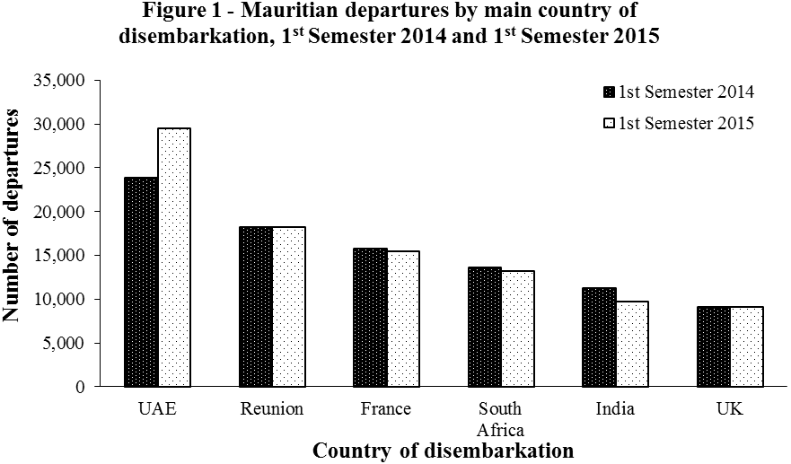

- TOURISM
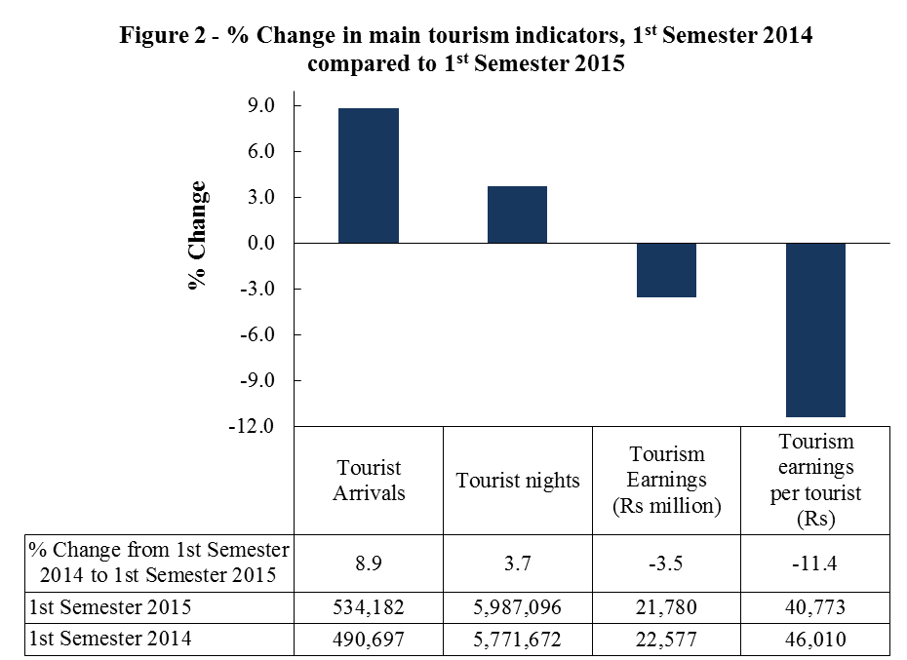
Note: Henceforth tourist nights for a reference period will refer to nights spent by tourists departing in that reference period.

  - Tourist Arrivals
Compared to 1st semester 2014, the number of tourist arrivals increased by 43,485 or 8.9% to 534,182 in 1st semester 2015 as a result of main changes shown below.
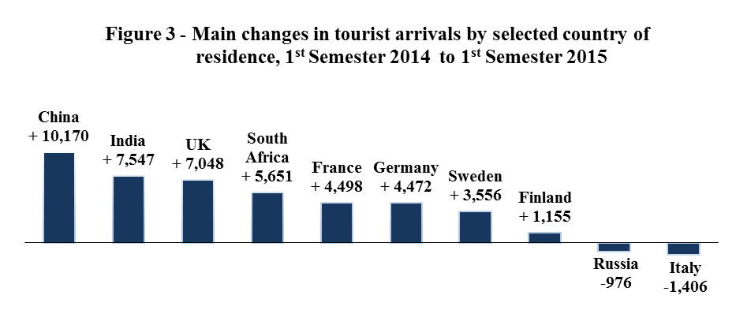
In the 1st semester of 2015, Russia registered a decline of 12.9% while France, our top tourist generating country, registered a growth of 3.8%. Sweden and Finland registered high growth of 141.1% and 86.2% respectively as a result of direct flights from Stockholm and Helsinki. 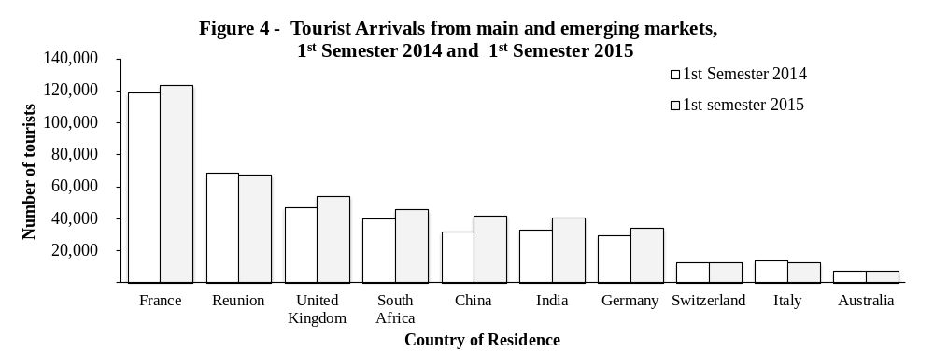

  - Tourist arrivals by age
During the 1st semester of 2015, 78,165 or 15% of tourists who visited Mauritius were aged 60 years and above. Among those who arrived by sea, the proportion was much higher at 53%.
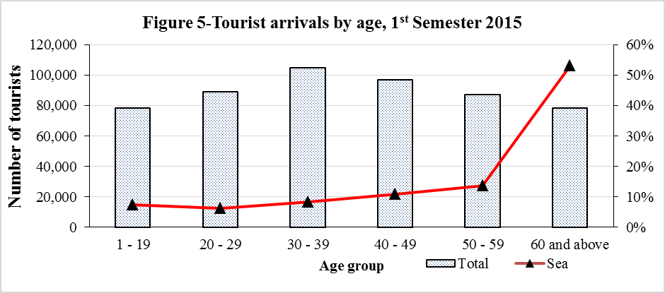

  - Tourist arrivals in Mauritius compared to selected tourist destinations
During 1st semester 2015, tourist arrivals in Mauritius increased by 8.9%. This compares with a lower growth of 1.3% in Maldives and higher growths of 15.4% in Seychelles and 14.1% in Sri Lanka.
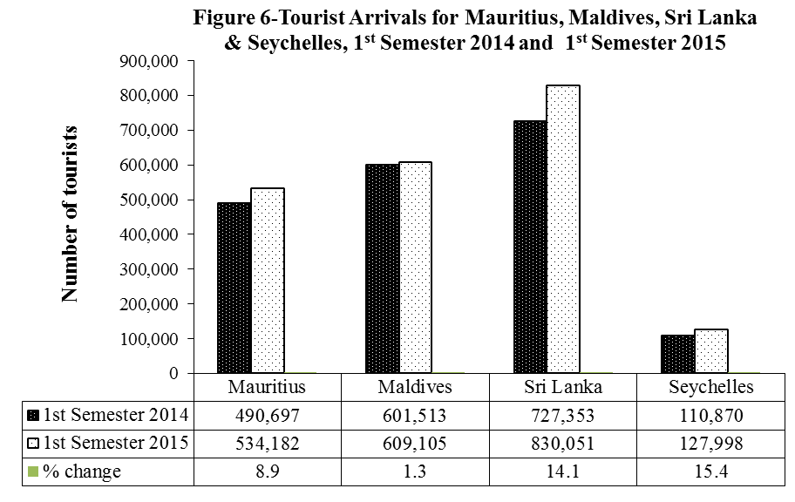
Source :Maldives Statistics section - Ministry of Tourism Arts & Culture; Sri Lanka Tourism Development Authority; Seychelles National Bureau of Statistics

  - Tourist Nights
Compared to 1st Semester 2014:
- the number of nights spent by tourists who departed during the 1st semester of 2015 increased by 3.7% from 5,771,672 to 5,987,096;
- the average length of stay decreased from 11.0 to 10.6 nights.

  - Tourism Earnings
According to the Bank of Mauritius, the gross tourism earnings decreased by 3.5% from Rs 22,577 million in the 1st semester 2014 to Rs 21,780 million in the 1st semester 2015. Tourism earnings per tourist also declined by 11.4%, from Rs 46,010 to Rs 40,773.

  - Employment
Employment data for the tourism sector as obtained from the Survey of Employment and Earnings relate to employment in restaurants, hotels and travel and tourism establishments with 10 or more workers. Latest available data for March 2014 indicate that employment in these establishments increased slightly by 1.1% to 28,872 as compared to 28,562 for March 2013.

  - Accommodation
Licensed hotels in the island of Mauritius
As at end of June 2015, there were 116 licensed hotels of which 107 were in operation and 9 were not operating due to renovation works. The total room capacity of the 107 operating hotels was 12,264 with 25,085 bed places.
During the 1st semester of 2015,
- the room occupancy rate of all licensed hotels in operation averaged 67%, up from 62% in the 1st semester of 2014; and
- the bed occupancy rate was 62%, higher than 55% in the 1st semester of 2014.

‘Large’ hotels in the island of Mauritius
At the end of June 2015, 51 ‘large’ hotels (i.e. well-established beach hotels with more than 80 rooms) were in operation; they had a total room capacity of 9,267 with 19,020 bed places. These ‘large’ hotels represent 48% of all licensed hotels in operation but make up 76% of total room capacity and 76% of total bed places.

During the 1st semester of 2015,
- the room occupancy rate of large hotels was 69% up from 64% in the 1st semester 2014;
- the bed occupancy rate was 64%, higher than 56% in the 1st semester 2014.

  - Forecast Year 2015

Based on latest available data on tourist arrivals and information gathered from stakeholders, the forecast of tourist arrivals for the year 2015 is revised upwards from 1,100,000 to 1,115,000. This represents an increase of 7.3% over the figure of 1,038,968 in 2014.

The Bank of Mauritius has revised its forecast of tourism earnings for the year 2015 downwards from Rs 48,500 million to Rs 46,500 million. This revised forecast represents an increase of 5% when compared to Rs 44,304 million in 2014.

Statistics Mauritius
Ministry of Finance and Economic Development
Port Louis
21 August 2015

Contact persons

Mr. E. Romjon, Acting Statistician
Mrs T. Joomun, Senior Statistical Officer
Ministry of Tourism and External Communications
3rd Floor, Victoria House, Port Louis
Tel: (230) 211-9043, Fax: (230) 210-3901
Email: sm-tourism@govmu.org

ANNEX I

COMPILATION OF PASSENGER TRAFFIC STATISTICS

Sources of data

The main source of data for the compilation of passenger traffic statistics is the Passport and Immigration Office, which maintains a database of all travellers entering and leaving the country. The data are collected from the passport of travellers, disembarkation cards filled in by non-residents and questions put to non-residents entering the country. At the end of every month, the electronic database of passenger traffic for that particular month is downloaded and supplied to the statistics unit of the Ministry of Tourism and External Communication within fifteen days. Additional data on cruises are obtained from the Mauritius Ports Authority.

Tourism earnings

The Bank of Mauritius is responsible for the estimation of tourism earnings based on monthly statements of Inward and Outward Remittances of Commercial Banks.

Monthly Occupancy Rates

All hotels are contacted by phone at the end of every month for data on room/bed nights available and rented during the month for the calculation of room and bed occupancy rates.

Short-term projections of tourist arrivals

A Tourism Statistics Committee grouping various stakeholders of the tourism industry meet regularly under the chairmanship of Statistics Mauritius to discuss performance of the tourism sector and to provide information for short-term forecast of tourist arrivals.

Publications

The regular publications of the unit are:

- Monthly tourist arrivals (by mid of each month)
- Quarterly Economic and Social Indicators on International Travel and Tourism (with a lag of seven weeks)
- Quarterly tourism statistics (Pamphlet)
- Digest of International Travel and Tourism
- Handbook of statistical data on tourism
- Report of the Survey of Inbound and Outbound Tourism

ANNEX II

GLOSSARY OF TERMS
1. Tourist
A tourist is defined as a non-resident staying overnight but less than a year, and who has no employer-employee relationship with a resident.

2. Transit
A transit passenger is one who stops over in the country for flight connections to other destinations. There are two types of transit passengers:
Type I: Passengers who do not leave the transit area of the airport or the harbour.
Type II: Passengers who do leave the airport or harbour and stay in the country overnight but only for flight connection purposes.
Only Type II transit passengers, as defined above, are included in the definition of “Tourists”.

3. Excursionist or Same-day Visitor
Excursionists are non-resident visitors, other than those who do not leave the airport, who depart on the same day they arrived.

4. Tourist Nights
"Tourist nights" for year Y refer to nights spent by tourists who departed in year Y.

5. Large Hotels
Large hotels are well established beach hotels with more than 80 rooms.

6. Occupancy rate
The room/bed occupancy rate is the ratio of room/bed nights rented to the total number of room/bed nights available.
= Total number of room/bed nights rented x 100

Total number of room/bed nights available

