POPULATION AND VITAL STATISTICS
REPUBLIC OF MAURITIUS, YEAR 2010
- Introduction
This issue of Economic and Social Indicator presents population estimates as at December 2010 and vital statistics including rates for the year 2010.
The Central Statistics Office compiles vital statistics from data obtained from the computerised system in place at the Central Civil Status Office.
Definitions of terms used are given at Annex.
- Key points
- The population of the Republic of Mauritius was estimated at 1,283,415 as at 31 December 2010, growing at a rate of 0.4% since end 2009.
- As at end 2010, female population was higher than the male population by 17,841.
- In 2010, the population aged 0-14 years comprised 21.6% of the total population. The population aged 15-64 years and that aged 65 years and over comprised 71.1% and 7.3% respectively of the total population.
- The dependency ratio (the child population under 15 years of age and the elderly population aged 65 years and above per 1,000 population aged 15-64 years) decreased from 412 in 2009 to 406 in 2010.
- The number of live births registered during year 2010 was 15,005 representing a decrease of 2.2% over the figure of 2009.
- The number of deaths registered in 2010 stood at 9,131, 1.0% lower than for 2009.
- The number of infant deaths decreased by 8.8% from 205 in 2009 to 187 in 2010.
- The number of still births decreased by 25.4%, from 138 in 2009 to 103 in 2010.
- The number of marriages registered in 2010 was 10,555, that is, 0.6% less than in 2009.
- Estimated resident population
Table 3.1 - Estimated resident population by sex, Republic of Mauritius,
31 December 2010
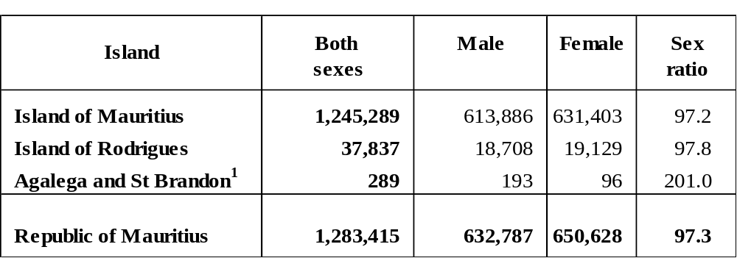
¹ The figures for Agalega And St Brandon are 2000 Population Census figures

The estimated resident population of the Republic of Mauritius was 1,283,415 as at 31 December 2010. The female population was 650,628 compared to a male population of 632,787. There were 97.3 males for every 100 females.
The population was estimated at 1,245,289 and 37,837 respectively for the Island of Mauritius and the Island of Rodrigues. In both islands, females outnumbered males. However, Agalega and St Brandon, with an estimated population of 289, had more males (193) than females (96).

Table 3.2 - Population density, Republic of Mauritius, 31 December 2010

¹ The figures for Agalega And St Brandon are 2000 Population Census figures

The Republic of Mauritius, with a total land area of 2,040 km² had a population density of 629 persons per km² as at end 2010. Among its constituent islands, the Island of Mauritius had the highest density (668), followed by Rodrigues (364). The population density for the Republic of Mauritius increased from 626 in 2009 to 629 in 2010.

Table 3.3 - Estimated resident population by sex, Republic of Mauritius,
2008 - 2010 (end of year estimates)

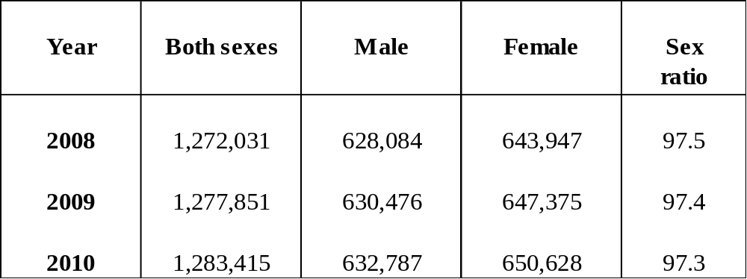

Comparative population estimates and sex ratios for the past three years are given in Table 3.3. From the year 2008 to 2010, there was a slight decline in the sex ratio indicating an increasing proportion of females over time.

- Population growth
Table 4.1 - Population change, Republic of Mauritius, 31 December 2009 and
31 December 2010
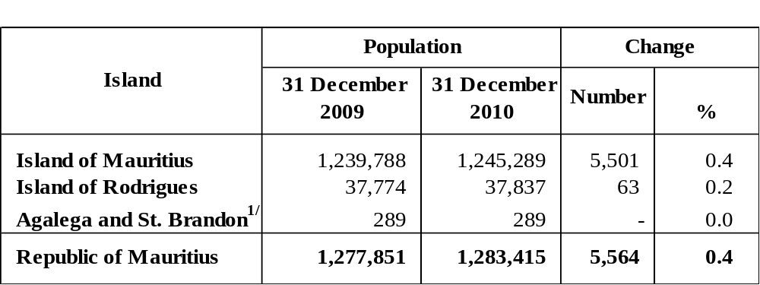
^{1/} The figures for Agalega and Saint Brandon are 2000 Population Census figures

The population of the Republic of Mauritius increased by 5,564 persons from 31 December 2009 to 31 December 2010. The population growth rate was thus 0.4% during the 12-month period. The growth rate for the Island of Mauritius was also 0.4%; whilst for Rodrigues it was around 0.2%.

Table 4.2 - Components of population growth, Republic of Mauritius^{1/}, 2009 and 2010

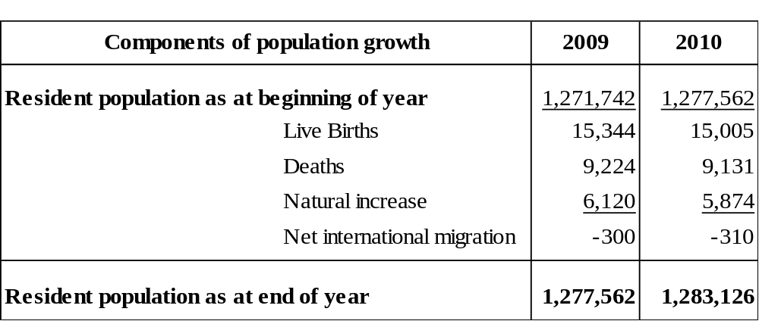
^{1/} excluding Agalega and St Brandon

Population growth has two components: natural increase (the number of births minus the number of deaths) and net international migration (net international movement of residents).

During the year 2010, the natural increase was 5,874, with births adding 15,005 babies and deaths removing 9,131 persons from the population. For the same period, net international migration of residents was estimated at -310 persons.

- Age distribution of the population
Table 5.1 - Estimated resident population^{1/} by broad age group and sex –
Republic of Mauritius^{2/}, 1 July 2009 and 1 July 2010

Age group (Years) | 1st July 2009 |  |  | 1st July 2010
Age group (Years) | Male | Female | B. Sexes | Male | Female | B. Sexes
0 | 7,873 | 7,824 | 15,697 | 7,637 | 7,503 | 15,140
1 - 4 | 35,637 | 34,337 | 69,974 | 34,052 | 32,935 | 66,987
5 - 9 | 49,593 | 47,849 | 97,442 | 48,937 | 47,416 | 96,353
10 - 14 | 50,381 | 49,304 | 99,685 | 49,841 | 48,410 | 98,251
15 - 19 | 55,121 | 53,606 | 108,727 | 54,905 | 53,675 | 108,580
20 - 29 | 101,514 | 99,717 | 201,231 | 99,958 | 97,994 | 197,952
30 - 39 | 97,774 | 99,791 | 197,565 | 99,783 | 101,880 | 201,663
40 - 49 | 97,348 | 97,886 | 195,234 | 97,470 | 98,171 | 195,641
50 - 59 | 75,457 | 77,924 | 153,381 | 77,443 | 79,951 | 157,394
60-64 | 21,743 | 25,098 | 46,841 | 23,450 | 26,639 | 50,089
65+ | 36,716 | 52,539 | 89,255 | 38,216 | 54,658 | 92,874
All ages | 629,157 | 645,875 | 1,275,032 | 631,692 | 649,232 | 1,280,924

^{1/} based on 2000 Population Census data adjusted for underenumeration of young children
^{2/} excluding Agalega and St Brandon

The proportion of the population aged 0-14 years declined from 22.2% in 2009 to 21.6% in 2010. In contrast, increases were registered in the proportion aged 15-64 years from 70.8% to 71.1% and the proportion aged 65 years and above from 7.0% to 7.3% during the same period. The overall effect was a decrease in the dependency ratio from 412 to 406; a decreasing trend in the dependency ratio is being observed (see Figure 5.1).

Figure 5.1 - Dependency Ratio, 2002 - 2010

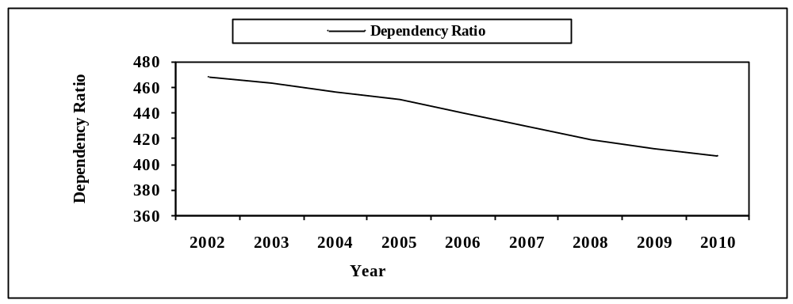

The population pyramid in Figure 5.2 compares the age structure of the population between 2000 and 2010. The main changes observed over time are:
- the shrinking of the base of the pyramid due to falling fertility;
- the thickening of the upper body of the pyramid indicating an increase in expectation of life
- the relatively longer bars on the female side of the pyramid around its apex indicating the predominance of females among the elderly.

Figure 5.2 - Population pyramid – Republic of Mauritius, 2000 & 2010

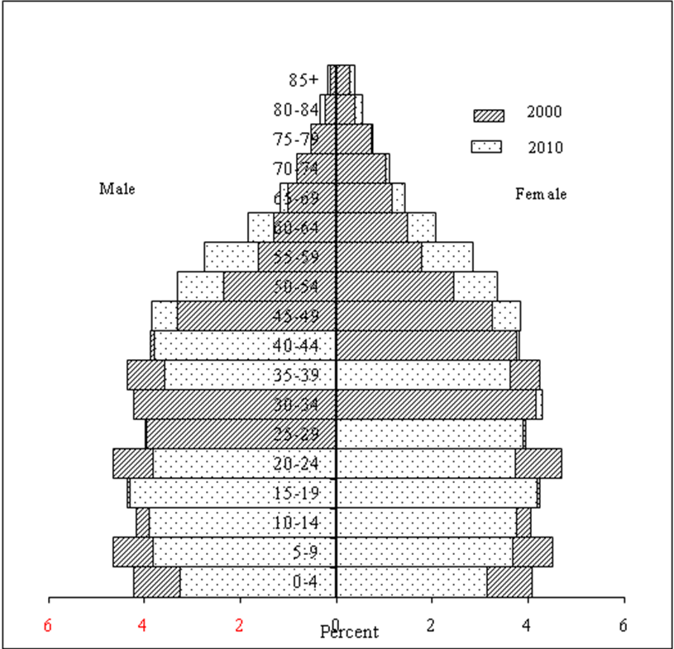

6 Vital statistics and rates
6.1 : Live births and crude birth rate
Table 6.1 - Live births registered and crude birth rate, Republic of Mauritius,
2009 and 2010^{1/}
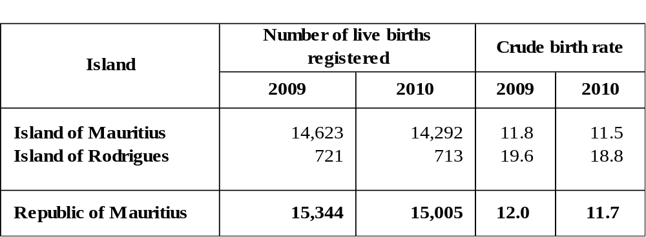
^{1/} Provisional

During the year 2010, 15,005 live births were registered in the Republic of Mauritius, representing a 2.2% fall over the 2009 figure of 15,344. The crude birth rate, i.e., the number of live births in a year per 1,000 mid-year population, fell from 12.0 in 2009 to 11.7 in 2010.
In the Island of Mauritius, the number of live births registered decreased from 14,623 in 2009 to 14,292 in 2010 bringing about a fall in the crude birth rate from 11.8 to 11.5. Similarly, for the Island of Rodrigues, the number of live births decreased from 721 (rate of 19.6) in 2009 to 713 (rate of 18.8) in 2010.

6.2 : Deaths and crude death rate

Table 6.2 - Deaths and crude death rate, Republic of Mauritius, 2009 and 2010^{1/}

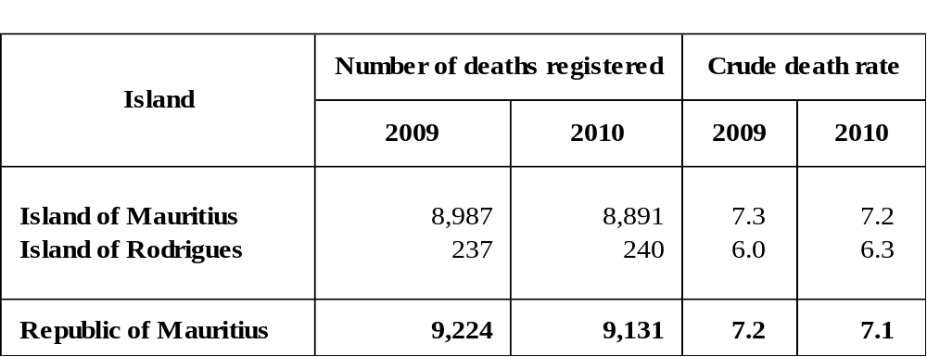

^{1/} Provisional

The number of deaths registered in the Republic of Mauritius in 2010 was 9,131, representing a 1.0% decrease over the figure of 9,224 for 2009. The crude death rate, i.e., the number of deaths in a year per 1,000 mid-year population decreased slightly from 7.2 to 7.1.
The Island of Mauritius registered a decrease in the number of deaths, from 8,987 in 2009 (rate of 7.3) to 8,891 in 2010 (rate of 7.2). During the same period, the number of deaths in Rodrigues increased from 237 (rate of 6.0) to 240 (rate of 6.3).

6.3: Infant deaths and Infant mortality rate

Table 6.3 - Infant deaths and infant mortality rate, Republic of Mauritius,

2009 and 2010^{1/}
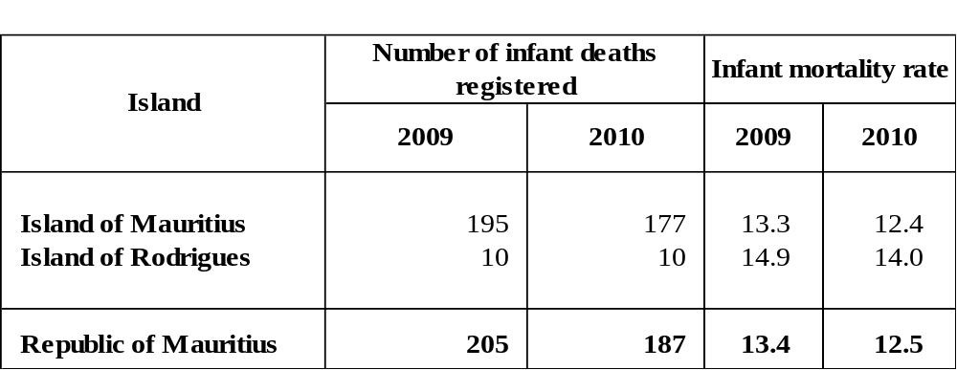

^{1/} Provisional

During the year 2010, 187 infant deaths (deaths to children aged under one year) were registered in the Republic of Mauritius against 205 in 2009, representing a decrease of 8.8%. The infant mortality rate, defined as the number of infant deaths per 1,000 live births, fell from 13.4 in 2009 to 12.5 in 2010.
A decrease in the number of infant deaths was also noted in the Island of Mauritius from 195 in 2009 to 177 in 2010. The infant mortality rate thus declined from 13.3 to 12.4. For Rodrigues, the number of infant deaths remained the same i.e 10 for both 2009 and 2010 . The infant mortality rate however declined from 14.9 in 2009 to 14.0 in 2010.

6.4 : Still births and still birth rate
Table 6.4 - Still births and still birth rate, Republic of Mauritius, 2009 and 2010^{1/}
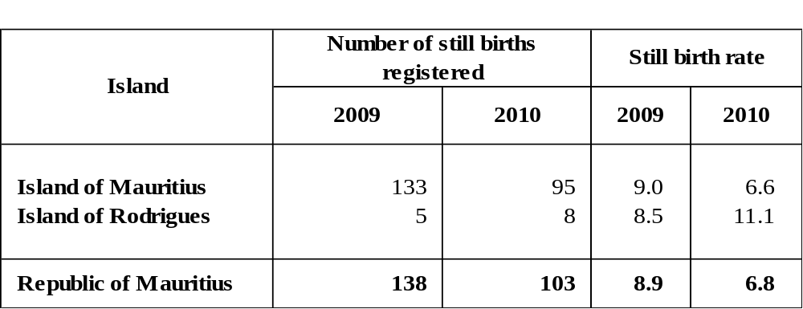
^{1/} Provisional

In 2010, 103 still births were registered in the Republic of Mauritius, which is 25.4% lower than the 2009 figure of 138. Consequently, the still birth rate which is the number of still births in a year per 1,000 total births during the year fell from 8.9 in 2009 to 6.8 in 2010.
The Island of Mauritius registered 95 still births in 2010 against 133 in 2009, with the still birth rate falling from 9.0 in 2009 to 6.6 in 2010. In Rodrigues, 8 still births were registered in 2010 compared to 5 in 2009. The still birth rate rose from 8.5 in 2009 to 11.1 in 2010.

6.5 : Marriages and crude marriage rate
Table 6.5 - Marriages and crude marriage rate, Republic of Mauritius, 2009 and 2010^{1/}

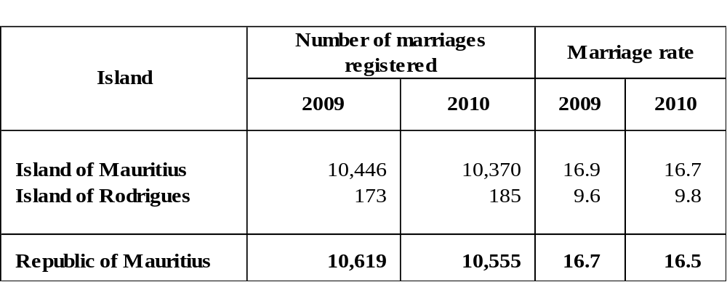
^{1/} Provisional

The number of marriages registered in the Republic of Mauritius decreased by 0.6% from 10,619 in 2009 to 10,555 in 2010. The crude marriage rate, i.e., the number of persons married in a year per 1,000 mid-year population, fell from 16.7 to 16.5 during the same period.

The number of marriages in the Island of Mauritius decreased from 10,446 in 2009 (rate of 16.9) to 10,370 in 2010 (rate of 16.7). The Island of Rodrigues registered an increase in the number of marriages from 173 in 2009 (rate of 9.6) to 185 in 2010 (rate of 9.8).

- International Comparison
Population growth rates for various countries in the world are published in the UN publication “The World Population Prospects 2008 Revision”. The figures indicate that the population growth rate for the Republic of Mauritius during the period 2005 to 2010 was 0.7%, lower than the estimated world’s population growth rate of 1.2%. The Republic’s growth rate was lower than that for Singapore (2.5%) and India (1.4%), but was higher than that for the United Kingdom (0.5%), Japan (-0.1%) and Belgium (0.5%).

Central Statistics Office
Ministry of Finance and Economic Development
Port Louis
01 March 2011

Contact person: Mr. C. Arianaick
Statistician (Demography Unit)
Central Statistics Office
LIC Centre
John Kennedy Street
Port Louis
Tel: 208 0859
Email: cso_demography@mail.gov.mu

Annex

1. Vital Statistics: The statistics pertaining to vital events which include live births, deaths, still births, marriages and divorces
2. Population density: The number of persons per square kilometre
3. Dependency ratio: The child population under 15 years of age and the elderly population aged 65 years and above per 1,000 population aged 15-64 years.
4. Sex ratio: The number of males to every 100 females.
5. Natural increase: The excess of live births over deaths.
6. Crude birth rate: The number of live births in a year per 1,000 mid-year population.
7. Crude death rate: The number of deaths in a year per 1,000 mid-year population.
8. Infant mortality rate: The number of deaths in a year of infants aged under one year per 1,000 live births during the year.
9. Still birth rate: The number of still births in a year per 1,000 total births (live
births and still births) during the year.
10. Marriage rate: The number of persons married in a year per 1,000 mid-year
population.
Note: The vital rates for Rodrigues are usually calculated as an average of three years in order to remove wide fluctuations in the yearly data. The rates for year 2010 are however calculated on the basis of data for the year only.

