
CensusAtSchool


Mini Survey Reports
The Mini Survey reports prepared for each school was based on data collected on Questionnaire No. 2 - ‘Questions to head of family’.
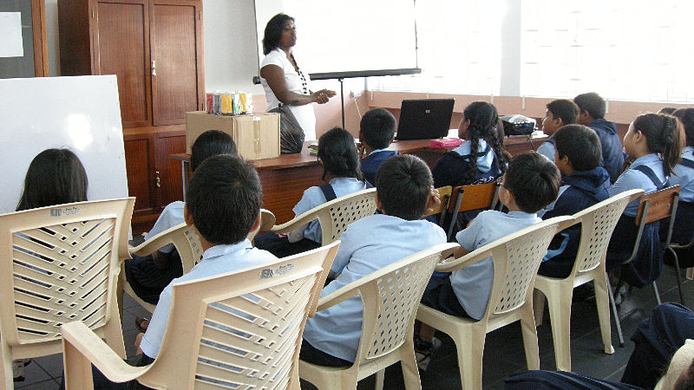
The participation of the students and their family is gratefully acknowledged.

Mini Survey reports
D. Sewraz GS | Mohabeer Foogooa GS
De La Salle RCA | Amaury GS
Petit Verger GS | Shri Rajiv Gandhi GS
Bheewa Mahadoo GS | Notre Dame De Lourdes RCA
New La Tour Koenig GS | Willoughby GS
Hugh Otter Barry GS | Rev. Edward Walter GS
Bon Acceuil RCA | Villiers Rene GS
Mare D’Albert GS | Saint Benoit RCA
Rivière des Anguilles GS | Nouvelle France GS
Appendix I Appendix II Appendix III

