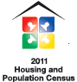
CensusAtSchool


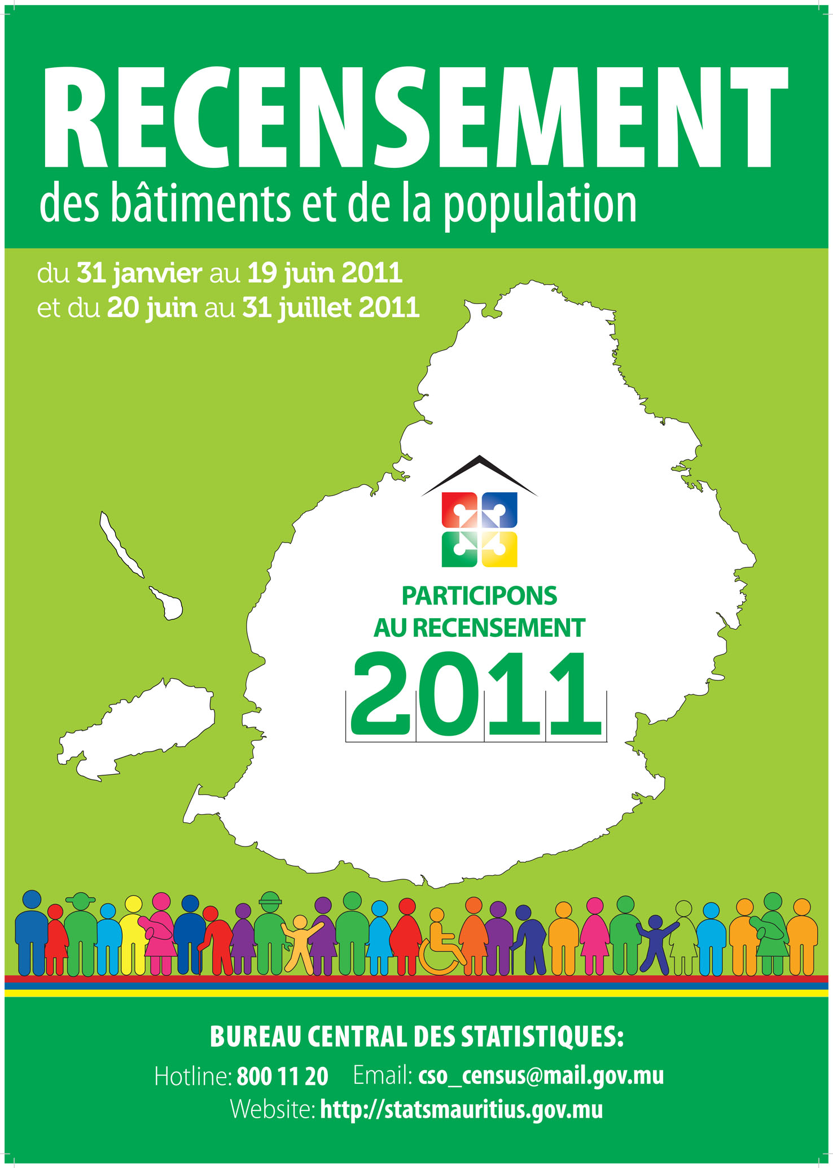
About Census

What is a Census?
The census is a count of all people and households in the country. It also provides information about the demographic, social and economic characteristics of the population.

Why take a Census?
Every country needs a Census to plan ahead.

How many of us live in this country, town or locality? How many are men, women and children? How many are old enough to vote? What kind of jobs are we doing? How many have moved out to live in other parts of the country? The Census helps to answer these questions and many others.

The information collected is used by policy makers to make plans for improving the living conditions of the people, for building houses, roads, schools and training centres, health centres, baby care centres, old people’s homes and industrial estates, etc.

Is it compulsory to participate in the Census?
Participation at the census is compulsory by law.

Is the Census safe for me?
By law, the Central Statistics Office will not share your answers with anyone, including government and non-government agencies. Census officers as well as other officers having access to the questionnaires have taken oath of non-disclosure and will keep your answers secret. The law provides penalties, including imprisonment, regarding any breach of confidentiality. More.....

