SURVEY OF EMPLOYMENT AND EARNINGS IN LARGE

(employing 10 or more persons) ESTABLISHMENTS (SEE)

March 2023 (Preliminary results)

- Introduction

Statistics Mauritius carries out the annual Survey of Employment and Earnings in ‘large’ establishments with March as reference period so as to obtain a continuous series of comparable data on the level of employment and earnings in these establishments. This issue of the Economic and Social Indicators presents the preliminary results for March 2023 with comparative figures for 2021 and 2022.
Concepts and definitions are provided at section 4.

Response

The preliminary results of the survey presented below are based on responses obtained from 66% of large establishments, representing 80% of total employment in this category of establishments. Estimates have been worked out for non-response on the basis of previous data, observed trend and employment figures from the statistics unit of the Ministry of Industrial Development, SMEs and Cooperatives.

Main results

Employment Level, March 2022 - March 2023

A preliminary estimate of total employment in large establishments is 303,668 in March 2023 compared to 300,990 in March 2022, representing an increase of 2,678 (Table 1). This is the net result of employment increases in some industrial groups, partly offset by decreases in some other groups.

A sectorwise analysis shows that employment in the primary sector increased by 117 from 9,046 in March 2022 to 9,163 in March 2023. During the same period, employment in the secondary sector showed decrease by 1,214 from 72,016 to 70,802 while the tertiary sector increased by 3,775 from 219,928 to 223,703.

The total employment figure includes 4,737 persons working in large establishments in Rodrigues, compared to 4,707 in March 2022. They are mainly government employees of the Rodrigues Regional Assembly numbering 2,850 in March 2023.

As at March 2023, the number of foreign workers stood at 26,658 (21,269 males and 5,389 females) of whom 17,740 were engaged in activities of the ‘Manufacturing’ sector and 5,231 in ‘Construction’ (Table 6).

Employment by Industry

Between March 2022 and March 2023, main increases occurred in the following industrial groups: ‘Information and communication’ (+1,642), ‘Wholesale and retail trade; repair of motor vehicles and motorcycles’ (+712), ‘Financial and insurance activities’ (+566), and ‘Administrative and support service activities’ (+456).

Main decreases in employment were in ‘Construction’ (-1,449), ‘Education’ (-468) and ‘Human health and social work activities’ (-132) (Chart 1).

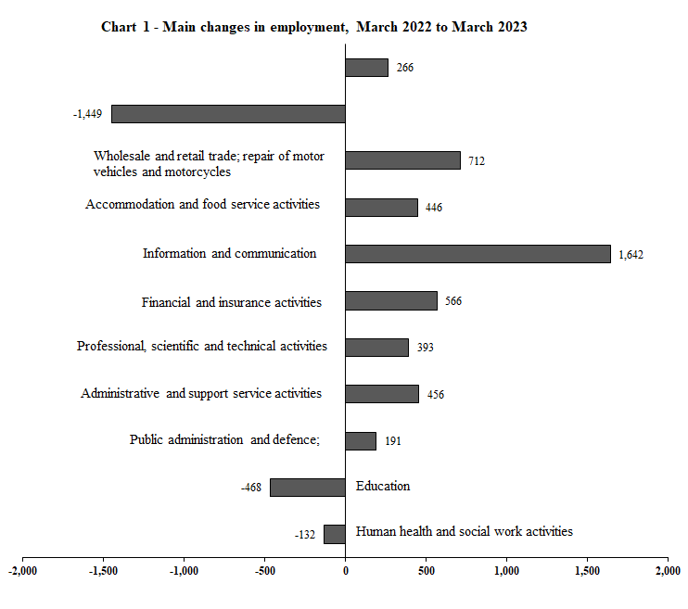
Construction
Manufacturing

Employment by Sex

As at March 2023, among the 303,668 employees in large establishments, 179,709 or 59.2% were male. Compared to March 2022, male employment decreased by 1,405 while female employment increased by 4,083.

Male employment decreased mainly in ‘Construction’ (-1,460), ‘Administrative and support service activities’ (-470), ‘Public administration and defence; compulsory social security’ (-451), ‘Education’ (-368) and ‘Human health and social work activities’ (-213) (Table 1).

Female employment increased mainly in ‘Administrative and support service activities’ (+926), ‘Information and communication’ (+875), ‘Wholesale and retail trade; repair of motor vehicles and motorcycles’ (+748), ‘Public administration and defence; compulsory social security’ (+642), ‘Accommodation and food service activities’ (+472) and ‘Financial and insurance activities’ (+453).

Employment in General Government Sector

Employment in the General Government Sector decreased by 143 from 76,081 in March 2022 to 75,938 in March 2023. Male employment decreased by 859 from 43,847 to 42,988 and female employment increased by 716 from 32,234 to 32,950 (Tables 3, 3a & 3b).

Employment in large establishments of the Export Oriented Enterprises (EOE) sector

The number of persons employed by large establishments of the EOE sector increased by 306 from 34,623 (19,394 Mauritians and 15,229 foreigners) in March 2022 to 34,929 (19,057 Mauritians and 15,872 foreigners) in March 2023 (Table 4). The main increases were in the ‘non-manufacturing sector’ (+443) and ‘Textiles’ (+124).

From March 2022 to March 2023, the number of male employees showed increase by 490 from 18,463 to 18,953 and the number of female employees showed decrease by 184 from 16,160 to 15,976.

Employment of foreign workers

The number of foreign workers in large establishments in March 2023 stood at 26,658 (21,269 males and 5,389 females) compared to 26,381 (21,259 males and 5,122 females) in March 2022, showing a net increase of 277 (+10 males and +267 females) (Table 6).

Male employment decreased mainly in ‘Construction’ (-1,151) while increases was mainly observed in ‘Manufacturing’ (+657).

Female employment increased mainly in ‘Manufacturing’ (+162).

Earnings

The level of average earnings is influenced mainly by changes in basic salaries and wages. However, fluctuations may also occur because of:
- Changes in the mix of employees of various categories or with various lengths of service. For example, a large intake of professionals by, say, an architectural firm can cause a sudden jump in the average monthly earnings. On the other hand, a large intake of employees at the lower end of a wage scale has the effect of lowering the average earnings.

- Changes in overtime, regular bonuses and commissions.

Earnings in large establishments

The industrial group with the highest average monthly earnings was ‘Financial and insurance activities’ (Rs 61,795) followed by ‘Real estate activities’ (Rs 61,511) and ‘Electricity, gas, steam and air conditioning supply’ (Rs 60,993). Lowest averages were registered in, ‘Administrative and support service activities’ (Rs 21,984) and in ‘Manufacturing’ (Rs 24,764). Within the ‘Manufacturing’ group, ‘Textiles and wearing apparel’ registered average monthly earnings of Rs 21,080.

Overall average monthly earnings in large establishments increased by 5.7% from Rs 37,151 in March 2022 to Rs 39,274 in March 2023. Highest increases were registered in: ‘Water supply, sewerage, waste management and remediation activities’ (+20.6%) and ‘Accommodation and food service activities’ (+13.5%). A decrease was noted in ‘Information and communication’ (-1.7%), (Chart 2).

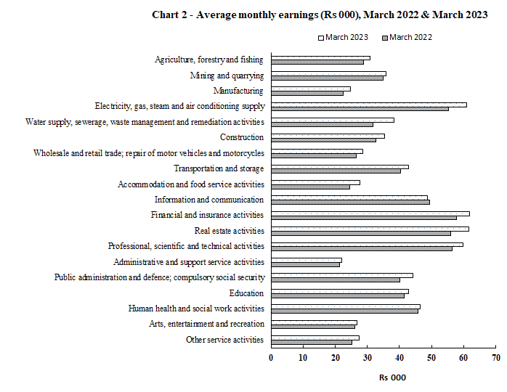

    - Earnings in large establishments of the EOE sector

The average monthly earnings in this sector stood at Rs 25,356 in March 2023, showing an increase of 16.2% over the March 2022 figure of Rs 21,827 (Table 8). The average monthly earnings in the manufacturing establishments was Rs 20,785 compared to Rs 44,711 in the non-manufacturing establishments. The corresponding figures for 2022 were Rs 18,515 and Rs 36,734 respectively.

Concepts and definitions

  - Large establishments include:

- Agricultural establishments comprising:
- sugar cane plantations of 10 hectares or more;
- tea plantations of 2 hectares or more;
- Other agricultural establishments employing at least 10 persons during the reference period (March 2023).

- Non-agricultural establishments employing at least 10 persons during the reference month. It is to be noted that “outworkers”, that is, piece rate workers who are working in their own homes on materials provided by the establishment, are excluded although they are remunerated by the establishment.

- All central, regional and local government departments.

  - Primary, Secondary and Tertiary sector
Primary sector comprises activities classified in the industrial groups:
- Agriculture, forestry and fishing
- Mining and quarrying
Secondary sector comprises activities classified in the industrial groups:
- Manufacturing
- Electricity, gas, steam and air conditioning supply
- Water supply; sewerage, waste management and remediation activities
- Construction
Tertiary sector comprises activities classified in the industrial groups:
- Wholesale and retail trade; repair of motor vehicles and motorcycles
- Transportation and storage
- Accommodation and food service activities
- Information and communication
- Financial and insurance activities
- Real estate activities
- Professional, scientific and technical activities
- Administrative and support service activities
- Public administration and defence; compulsory social security
- Education
- Human health and social work activities
- Arts, entertainment and recreation
- Other service activities

4.3 The General Government sector is made up of (i) Central Government (ii) Regional Government and (iii) Local Government.

4.3.1 Central Government covers all units that are agencies of the country’s central authority. It consists of Budgetary Central Government and Extra Budgetary Units.
Budgetary Central Government includes all ministries and departments.

Extra Budgetary Units are agencies responsible for the performance of specialized governmental functions in such fields as health, education, social welfare, construction and so on, under the authority of Central Government

4.3.2 Regional Government consists of the administration of Rodrigues.

4.3.3 Local Government consists of municipalities and district councils / village councils exercising an independent competence as government units.

4.4 Export Oriented Enterprises (EOE) comprise enterprises formerly operating with an export certificate and those export manufacturing enterprises holding a registration certificate issued by the Board of Investment.

4.5 Employment in Large establishments covers all persons in regular or casual employment and includes:
- Persons temporarily absent on paid sick or vacation leave; and
- Persons holding managerial posts, family workers receiving wages or salaries, and paid apprentices.

4.6 Earnings of employees in large establishments comprise all payments in cash made to employees in connection with work done. Amounts reported include overtime, productivity bonuses, commissions, travelling allowances, attendance bonuses, housing and rent allowances and other regular cash payments before any deductions such as taxes, insurance and pension contributions paid by the employees. They exclude pension payments, family allowances and other similar special benefits paid by the employers. Also excluded are arrears payments made at the end of March in respect of previous pay periods.

Statistics Mauritius
Ministry of Finance, Economic Planning and Development
Port Louis
29 September 2023

Contact persons:
Mrs D. Gangaram (Statistician/Senior Statistician)
Mrs S. D. Venkatasami (Statistical Officer/Senior Statistical Officer)
Labour Unit
Statistics Mauritius
LIC Building, Port Louis
Tel: 208 1800
Fax: 213 0234
Email: cso_labour@govmu.org
cso_quarterlylabour@govmu.org

