**2022 POPULATION CENSUS - MAIN RESULTS**

1. **Introduction**

This issue of the Economic and Social Indicators (ESI) presents the main results of the 2022 Population Census conducted in July 2022, in line with the United Nations Principles and Recommendations for Population and Housing Censuses, Revision 3. It also includes the main changes that occurred since the last Population Census in 2011.

This is the first digital Population Census using Computer Assisted Personal Interviews (CAPI) technology whereby tablets were used as an instrument to record answer from respondents. It is to be noted that the Population Census was conducted successfully in the midst of the COVID-19 pandemic.

Figures for 2022 are provisional and are subject to revision.

**Note to Users**

The data published in this ESI is unadjusted for any net undercount of households and persons. The intercensal comparisons are based on unadjusted data; this reduces the effects of errors on analysis of trends since both censuses are expected to be affected by similar types of errors.

Statistics Mauritius will also carry out an exhaustive analysis and evaluation of the census data; the results will be published as from next year. A new series of population data based on adjusted data will also be published in due course.

A list of definition of terms is at Annex 1.

1. **Highlights**

**From 2011 to 2022**,

* The resident population of:
* Republic of Mauritius decreased from 1,237,090 (611,020 males and 626,070 females) to 1,235,260 (608,090 males, 627,170 females);
* Island of Mauritius decreased from 1,196,390 (590,950 males and 605,440 females) to 1,191,280 (586,590 males and 604,690 females);
* Island of Rodrigues increased from 40,430 (19,900 males and 20,530 females) to 43,650 (21,330 males and 22,320 females);
* Island of Agalega increased from 270 (170 males and 100 females) to 330 (170 males and 160 females).
* The population of the Republic of Mauritius decreased by 1,830, with Island of Mauritius registering a decrease of 5,110 while the population of the Island of Rodrigues increased by 3,220;
* The population continued to age as indicated by an increase in the median age of the population from 34 to 38 years;
* The average household size went down from 3.5 to 3.3;
* The literacy rate went up from 90.1% to 91.9%;
* The level of education of the population improved – the proportion of people who studied up to tertiary level increased from 3.8% to 8.8%;
* The number of employed persons increased from 522,200 to 539,200;
* Port Louis district is still top in the list receiving the highest number of commuters (64,600 daily in 2022 against 66,800 in 2011), ahead of Plaines Wilhems with 51,200 in 2022 against 43,300 in 2011;
* The proportion of people with disabilities rose from 4.8% to 6.8%.

1. **Population distribution and Change**

***3.1* *Resident population***

The 2022 Census enumerated a resident population of 1,235,260 of whom 96.4% lived in the Island of Mauritius and the remaining 3.6% lived mainly in the Island of Rodrigues.

Overall, there were 627,170 women and 608,090 men, with women outnumbering men by some 19,080 in the Republic of Mauritius. There were 97 men for every 100 women.

**Table 1 – Resident population, Republic of Mauritius, 2022 Population Census**



***3.2 Population change***

**3.2.1 Population change over the years**

***The Mauritian population has started to show a declining trend***

Over the last century, the resident population has progressively increased by more than threefold. However, the 2022 Census has registered a decline in the population size for the first time compared to the previous census years.

Compared to 2011, the population of the Republic of Mauritius decreased by 1,830, with the Island of Mauritius registering a decrease of 5,110, whereas the Islands of Rodrigues and Agalega registering increases of 3,220 and 60 respectively.

**Figure 1 - Population, Republic of Mauritius, 1921 - 2022 Censuses**

**Table 2 – Population change, Republic of Mauritius, 2011 and 2022 Censuses**

|  |  |  |  |  |
| --- | --- | --- | --- | --- |
| **Island** | **Population Census** | | **Change** | **Average Annual Growth Rate (%)** |
| **2011** | **2022** | **Number** |
| Island of Mauritius | 1,196,390 | 1,191,280 | -5,110 | -0.04 |
| Island of Rodrigues | 40,430 | 43,650 | +3,220 | +0.70 |
| Island of Agalega | 270 | 330 | +60 | +1.70 |
| **Republic of Mauritius** | **1,237,090** | **1,235,260** | **-1,830** | **-0.01** |

The Republic of Mauritius registered a negative population growth, with an average annual growth rate of -0.01%, during the 2011-2022 intercensal period, following a period of declining positive growth since the 1960s.

Figure 2 displays the intercensal average annual growth rate enumerated during the last century. The observed declining and eventually negative population growth are mainly the result of decades of low and falling fertility levels prevailing in the country.

**Figure 2 – Average annual growth rate (%) of the resident population, Republic of Mauritius, 1921 - 2022 Censuses**

**3.2.2** **Population Growth Rate**

***The intercensal population growth differs across the islands***

The Island of Mauritius registered a negative growth, -0.04% during the 2011-2022 intercensal period compared to a positive growth of 0.42% during the 2000-2011 intercensal period. For the Island of Rodrigues, population growth rate decreased from 1.12% during period 2000-2011 to 0.70% during period 2011-2022. In contrast, for the Island of Agalega, the population growth rate increased from -0.48% to 1.70% during the same period (Figure 3).

**Figure 3 – Comparison of the intercensal growth rate (%) across the Republic of Mauritius, 2000 - 2011 & 2011 - 2022**



**3.2.3 International Comparison**

***On the international front, Mauritius has joined the league of countries with negative population growth***

Figure 4 depicts the annual growth rate for some selected countries. A negative annual growth rate was observed for Italy (-0.2%), Japan (-0.4%), Maldives (-0.7%) and Mauritius (-0.01%). Developed countries such as France and United Kingdom registered a positive growth rate of less than 0.5%.

**Figure 4 – Annual growth rate (%) for selected countries**

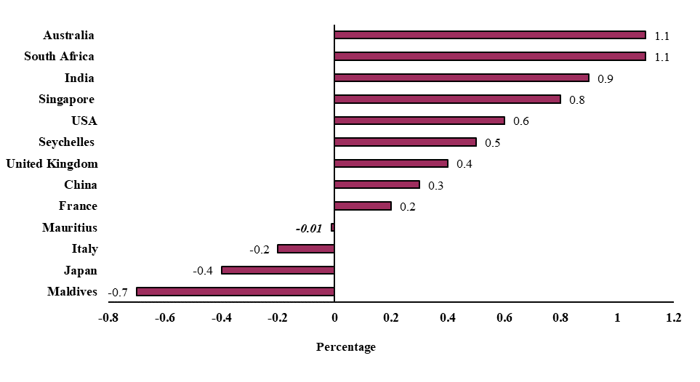

***Source: 2022 Population Census of Mauritius and United Nations Population Fund, 2020 – 2022***

***3.3 Population density***

Population density is a measurement of the number of people within a specific unit area. With a total land area of 2,007 sq km, the population density of the Republic decreased from 616 to 615 persons per sq km during the period 2011-2022. At this level, Mauritius ranking among the 10 most densely populated countries worldwide in 2011, has moved to the 11th position as shown in Figure 5.

**Figure 5 – Population density of the most densely populated countries worldwide, 2022**

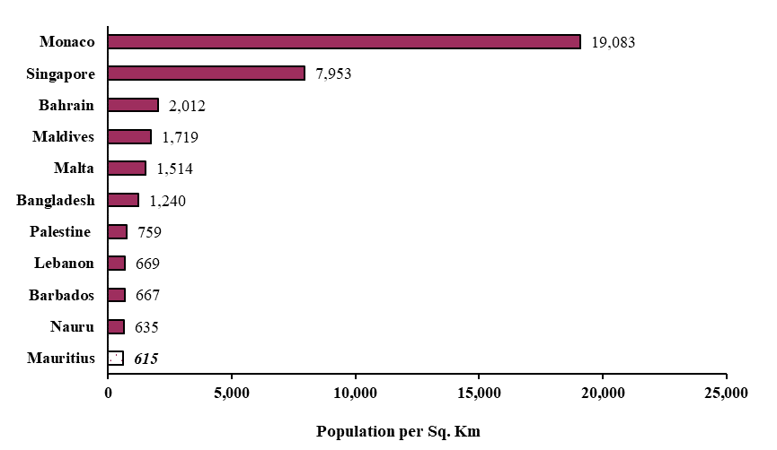

***Source: 2022 Population Census of Mauritius and World Atlas 2021***

***Population density was higher in towns***

The urban areas comprising the five towns of the Republic of Mauritius, together made up around 12% of the land area of the country. In 2022, these five towns contained around 39% of the total population.

By contrast, the rural areas comprising the villages, made up around 88% of the land area and contained around 61% of the population of the Republic. Thus, the population was denser in urban regions (2,100 persons per square km) than in villages (400 persons per square km) as shown in Figure 6.

**Figure 6 – Percentage distribution of population and land area by rural and urban, Republic of Mauritius, 2022 Population Census**

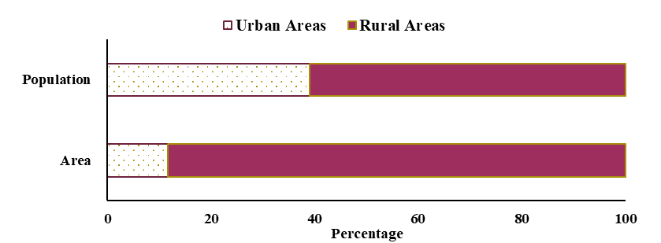

***3.4 Age and Sex composition***

***The population comprises more women than men***

Between 2011 and 2022, the population has undergone various changes in its age composition, such as increased proportion of the elderly and decreased proportion of children. The sex ratio, however, has remained almost same as in 2011, and stands at 97 males for every 100 females.

It is a known fact that the sex ratio at birth is usually above 100, indicating more males being born than females. Cumulating the population by sex over the ages, a threshold is reached whereby the number of males equals the number of females. Above that threshold age, the cumulated number of females rapidly surpasses that of males as a result of higher life expectancy of females compared to males. This threshold point was 67.2 years in 2011 compared to 65.1 years in 2022, indicating that over the years, women are surpassing men in terms of cumulated number at a less older age resulting in increasing proportion of women in the population.

***The grey tsunami is coming***

The population pyramid is no longer a pyramid but is now more of a barrel like shape. In addition, the apex of the pyramid for 2022 is more bulging and more prominently on the female side compared to the 2011 pyramid, as a result of higher life expectancy among females as well as a maintained differential in life expectancy between males and females over the years.

Also, the base of the pyramid for 2022 has shrunk further compared to the 2011 pyramid as a result of low fertility prevailing in the population.

The grey tsunami is partly due to the fact that the population is living longer. Equally important is the declining fertility rate which means less growth at the bottom of the pyramid. 2022 Census indicated that

* The median age of the population rose from 34 years in 2011 to 38 years in 2022;
* The proportion of children aged below 15 years went down from 20.7% in 2011 to 15.4% in 2022; and
* The share of persons aged 60 years and over has risen from 12.7% in 2011 to 18.7% in 2022.

**Figure 7 - Population Pyramids, Republic of Mauritius, 2011 and 2022 Population Censuses**

# **Marital Status**

Among the resident population aged 15 years and above, the following were observed:

* + A decrease from 58.9% in 2011 to 54.9% in 2022 of persons who were married or living with a partner;
  + An increase from 27.6% in 2011 to 31.5% in 2022 of persons who were never married; and
  + Around 12.8% had lost their partner either through death, divorce or separation in 2022 compared to 12.4% in 2011.

**Figure 8 – Marital status of resident population aged 15 years and over, Republic of Mauritius,**

**2011 and 2022 Population Censuses**

[

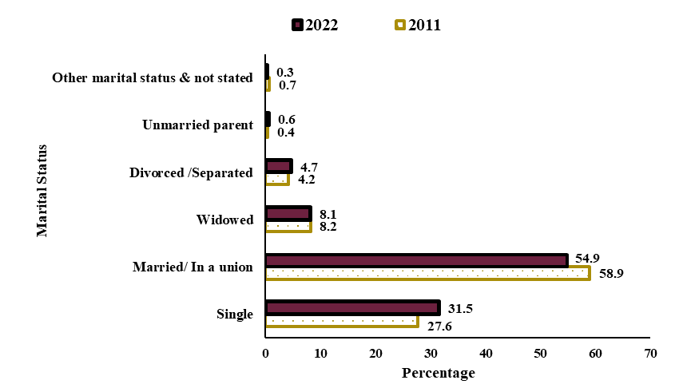

***Marital breakdown is going up***

In 2022, some 48,800 persons were reported as divorced and separated. It made up around 6.9% of the ever-married population (699,300 in 2011 and 706,700 in 2022) compared to 5.9% (or 41,000) in 2011.

***Decline in the proportion of married persons***

The proportion of the population married/in a union has decreased from 58.9% in 2011 to 54.9% in 2022 and contrasts with the observed increase in the proportion consensually married from 2.8% to 3.3% during the same period.

Analysing the marital characteristics of persons in the prime age of marriage, 25-44 years, it is observed that 59.0% were married /in a union in 2022 compared to 71.1% in 2011. Coupled with the fact that proportion of single in the population has increased, indicating that nowadays people have a lesser tendency to marry.

# **Living arrangements**

***The number of households has increased but the average household size has decreased***

2022 Census enumerated 367,900 private households, up by 5.6% from 348,300 at 2011 Census. The average household size decreased from 3.5 in 2011 to 3.3 in 2022.

***One out of every two families consisted of couple with unmarried children***

As in 2011, the most common family type in the Republic of Mauritius is still the couple with unmarried children making up nearly half of all family types in 2022, followed by couple without children (15.8%).

Also, there have been increases in the following household types:

* Lone parent households with unmarried children, from 38,700 (11.1%) to 52,300 (14.2%);
* Persons living alone (single member households), from 34,700 (10.0%) to 44,900 (12.2%); and
* Couples without children, from 45,400 (13.0%) to 58,100 (15.8%).

**Figure 9 - Proportion of households by type, Republic of Mauritius, 2011 and 2022 Population Censuses**

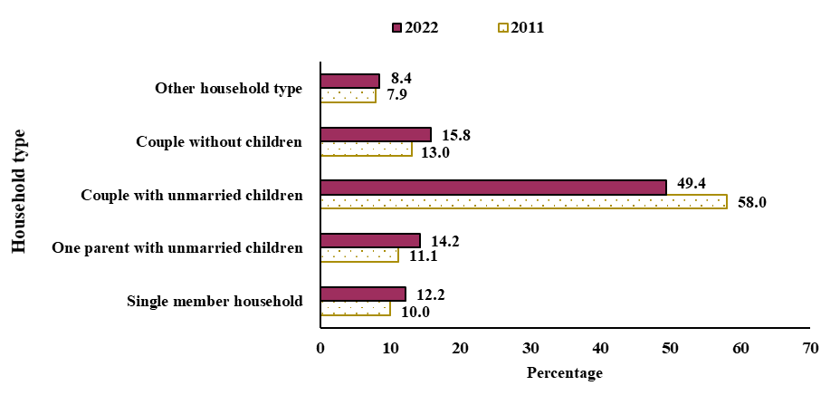

# **Language spoken**

***Creole remains the most common spoken language***

In 2022,

* 90.0% of people reported to speak only Creole at home, compared to 89.8% in 2011;
* 5.1% speak Bhojpuri only, compared to 5.5% in 2011; and
* 4.4% speak French only, compared to 4.3% in 2011.

**Figure 10 - Proportion of the population by language most often spoken at home, Republic of Mauritius, 2011 and 2022 Population Censuses**

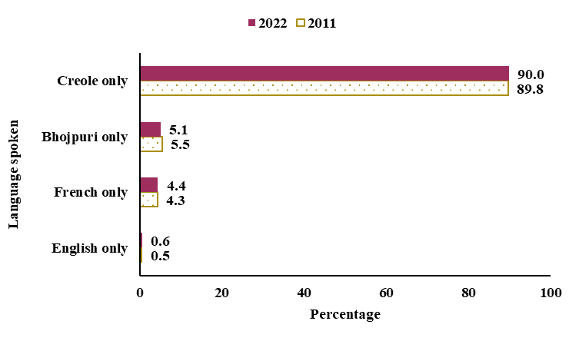

# **Education**

***7.1 Literacy***

***Literacy gap between men and women continues to narrow***

The literacy rate of the population aged 10 years and above increased from 90.1% in 2011 to 91.9% in 2022 (Table 3). The increase was higher among females than among males, resulting in a decrease in the literacy gap between males and females, from 4.8 to 3.3 percentage points.

**Table 3 - Literacy Rates, Republic of Mauritius, 2011 and 2022 Population Censuses**

|  |  |  |  |
| --- | --- | --- | --- |
| **Sex** | **2011** | **2022** | **Difference** |
| Male | 92.5 | 93.6 | +1.1 |
| Female | 87.7 | 90.3 | +2.6 |
| **Both Sexes** | **90.1** | **91.9** | **+1.8** |

* 1. ***Tertiary level***

***Holders of qualification at tertiary level has more than doubled***

The proportion of people who have studied/was studying up to university level or equivalent has more than doubled from 45,600 (3.8%) to 106,300 (8.8%) from 2011 to 2022 respectively. In 2011, the sex ratio among those who have studied or are studying at least up to degree level was 138 indicating a predominance of males. In 2022, the sex ratio has reached 98, indicating female predominance.

***Business, Administration and Law is the preferred field of study among both males and females***

The figures for 2022 Census indicate that:

* Among males, there is greater interest in pursuing studies in
* Business, Administration and Law (37.6%);
* Engineering, Manufacturing and Construction (15.6%);
* Information and Communication Technologies (14.0%); and
* Natural Sciences, Mathematics and Statistics (6.4%);

**Figure 11 - Proportion of males with tertiary education by field of study, Republic of Mauritius, 2022 Population Census**

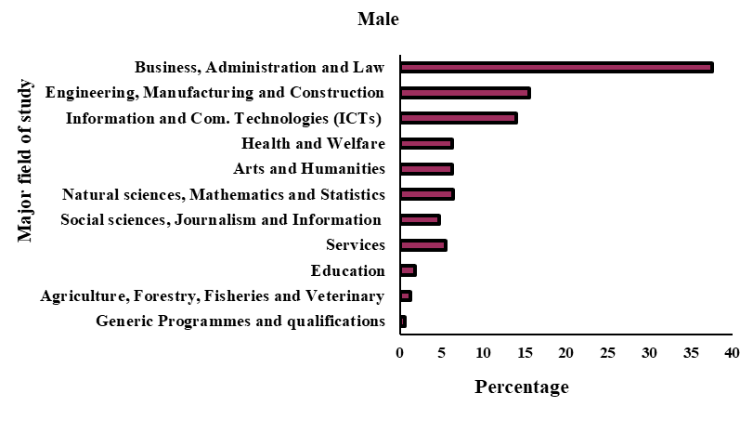

* Among females, there is greater interest in pursuing studies in
* Business, Administration and Law (47.4%);
* Arts and Humanities (12.6%);
* Social Sciences, Journalism and Information (7.7%); and
* Information and Communication Technologies (6.9%).

**Figure 12 - Proportion of females with tertiary education by field of study, Republic of Mauritius, 2022 Population Census**

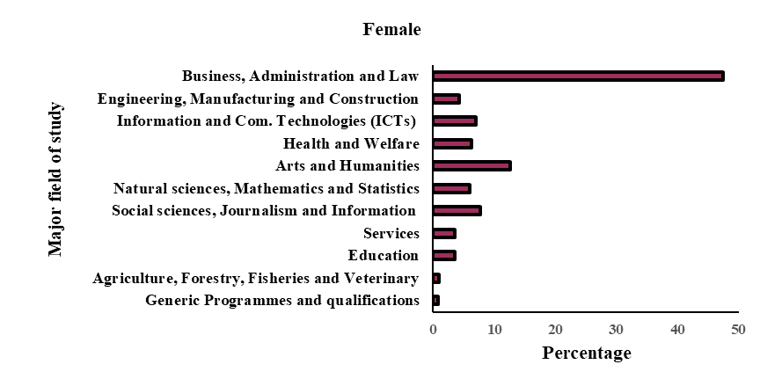

# **Employment**

***More women are taking jobs***

Between 2011 and 2022,

* the number of economically active (employed and unemployed) persons increased from 564,400 to 580,500; and
* the number of employed persons increased from 522,200 (337,100 men and 185,100 women) to 539,200 (335,500 men and 203,700 women) in the Republic of Mauritius.

In 2011, the number of men per 100 women was 182 among the employed persons and in 2022, this ratio fell to 165, indicating more women are taking jobs.

**Figure 13 - Employed persons by sex, Republic of Mauritius, 2011 and 2022 Population Censuses**

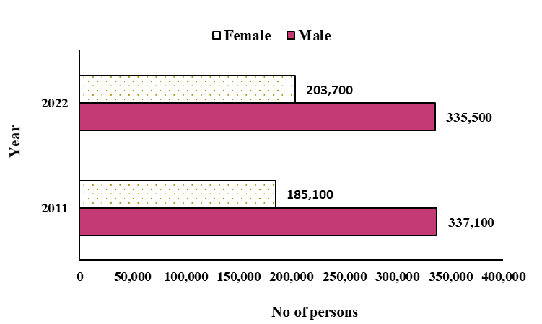

***Employment in the tertiary sector increases***

In 2022, among the employed population,

* 71.3% worked in the tertiary sector, compared to 63.0% in 2011;
* 24.5% worked in the secondary sector compared to 29.8% in 2011; and
* 4.1% worked in the primary sector, compared to 7.2% in 2011.

**Figure 14 – Employed persons aged 16 years and over by sector*, Republic of Mauritius, 2011 and 2022 Population Censuses**

*\*Primary sector: Agriculture, mining & quarrying*

*Secondary sector: Electricity & water, manufacturing & construction*

*Tertiary sector: Trade, hotels & restaurants, transport & communication, financial services, community, social & personal services*

***Persons with tertiary education are more likely to be professionals***

In 2022, the three most common groups of occupations held by persons with tertiary education were:

Professionals (47%), Technicians/Associate professionals (21%) and Managers (15%).

Among persons in employment with all educational backgrounds,

* Around 28.9% were engaged in the highest occupational groups which comprised chief executives, senior officials and legislators; professionals; technicians and associate professionals;
* Clerical and support workers made up 8.2% of the workforce;
* Service and sales workers 19.9%;
* 28.0% were skilled agricultural, forestry and fishery workers; craft and related trade workers; plant and machine operators and assemblers; and
* Those engaged in elementary occupations made up 15.0% of the workforce.

**Figure 15 - Employed persons by major occupational group*, Republic of Mauritius, 2011 and 2022 Population Census**

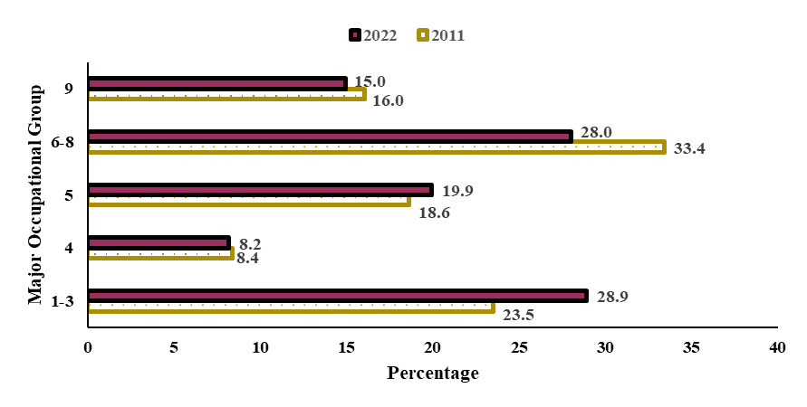

*\*1-3: Managers, Professionals, Technicians and associate professionals*

*4: Clerical support workers*

*5: Service and sales workers*

*6-8:* *Skilled agricultural, forestry and fishery workers, Craft and related trades workers, Plant and machine operators and assemblers*

*9:* *Elementary occupations*

# **Movement from residence to workplace**

***Around 198,500 employed persons commute to another district daily***

In 2022, out of a total of 512,500 employed persons in the Island of Mauritius, 198,500 or 38.7% pursued a profession outside of the district they lived in. Moka remained the district with the highest proportion of people commuting to other districts to work (54% of its working population) followed by Savanne district (49%).

Between 2011 and 2022,

* The proportion of employed persons who are commuting slightly decreased from 40% to 38.7%;
* Port Louis remained the district receiving the highest number of commuters, 64,600, in 2022 against 66,800 in 2011; and
* Plaines Wilhems is the second highest district receiving commuters 51,200 in 2022 compared to 43,300 in 2011.

**Figure 16 - Number of commuters by district of workplace, Island of Mauritius,**

**2011 and 2022 Population Censuses**

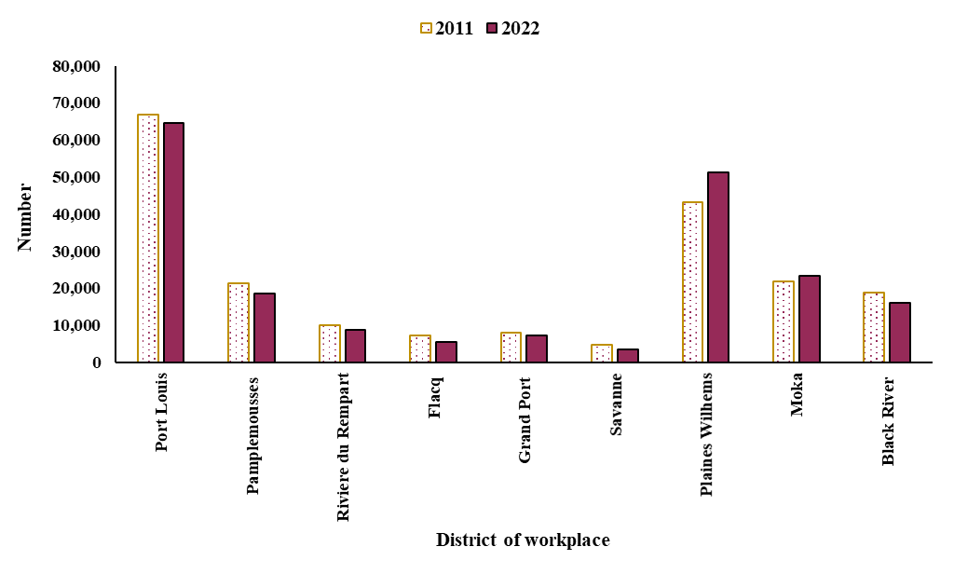

# **Disability**

***Disability on the increase***

In 2022, some 84,500 persons reported some forms of disability, up from 59,900 in 2011. In terms of proportion, persons with disabilities made up 6.8% of the population in 2022 compared to 4.8% in 2011. The prevalence of disability generally increases with age.

**Table 4 – Proportion of people with a disability by age group, Republic of Mauritius, 2011 and 2022 Population Censuses**

|  |  |  |
| --- | --- | --- |
| **Age Group(years)** | **2011(%)** | **2022(%)** |
| Under 15 | 1.5 | 2.3 |
| 15 - 59 | 3.5 | 3.4 |
| 60 and over | 17.1 | 22.6 |
| **All ages** | **4.8** | **6.8** |

The most common types of disability reported at 2022 Census were:

* Walking (36.8% of all persons with disabilities);
* Seeing even if wearing glasses (17.9% of all persons with disabilities);
* Self-care (10.2% of all persons with disabilities); and
* Behaviour (8.1% of all persons with disabilities).

**Figure 17 - Disabled population by main types of disability, Republic of Mauritius, 2022 Population Census**

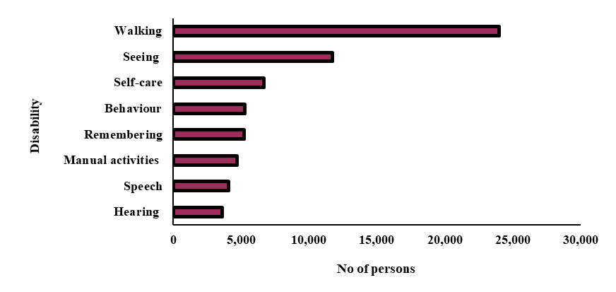

**Statistics Mauritius**

**Ministry of Finance, Economic Planning and Development**

**Port Louis**

**18 November 2022**

**Contact persons:**

1. Ms C. Martial, Statistician

Email: [cmartial@govmu.org](mailto:cmartial@govmu.org)

1. Ms S. Soogun, Statistician

Email: [ssoogun@govmu.org](mailto:ssoogun@govmu.org)

1. Ms M. Dookhy, Senior Statistical Officer

Email: [madookhy@govmu.org](mailto:madookhy@govmu.org)

1. Ms L. Bhowon, Senior Statistical Officer

Email: [lbhowon@govmu.org](mailto:lbhowon@govmu.org)

Statistics Mauritius

LIC Centre, Port Louis

Tel: (230) 208 1800 Fax: (230) 211 4150

Note: Figures presented in tables or charts may not add up to totals due to rounding.

**Annex 1**

**Definition of terms**

**Resident population**

The resident population is a count of all usual residents of a country at the time of the census. For census purposes, “usual residence” is defined as the place at which the person lives at the time of the census, and has been there continuously for the past 12 months or intends to live there continuously for at least 12 months.

**Sex Ratio**

The number of males to every 100 females.

**Median age**

The age which divides the population into two equal-size groups, one of which is younger and the other older than the median.

**Household**

A household is either:

1. a one-person household, i.e., a person who makes provision for his own food or other essentials for living without combining with any other person to form part of a multi-person household; or
2. a multi-person household, i.e., a group of two or more persons living together who make common provision for food or other essentials for living. The persons in the group may pool their incomes and have a common budget to a greater or lesser extent; they may be related or unrelated persons or a combination of both.

**Literacy rate**

A literate person is one, who can, with understanding, both read and write a short, simple statement on his or her everyday life.

**Educational attainment**

For persons not attending school, this refers to the highest level of education completed, whereas for persons attending school it refers to the standard, form or course being attended.

**Employment**

Employed population refers to persons aged 16 years and above (16+) who have worked for pay, profit or family business for at least one hour during the reference week of a month. It includes those who are temporarily absent from work for reasons such as leave with pay, leave without pay and temporary disorganisation of work (bad weather, breakdown of equipment, lack of order, etc.).

**Disability**

The reduced ability to perform one or more basic, universal activities (e.g., difficulty seeing, hearing, walking etc) that, in an unaccommodating environment, would put that person at risk of reduced social participation (in things like education or employment, civic engagement or leisure activities).