Economic and Social Indicators

Information and Communication Technologies (ICT) Statistics - 2021

1. Introduction

This is the sixteenth issue of the Economic and Social Indicators on Information and Communication Technologies (ICT) statistics compiled by Statistics Mauritius. It presents latest available statistics on ICT sector namely ICT infrastructure, access and usage based on information gathered from various administrative sources as well as from surveys conducted by Statistics Mauritius.

Data presented in this report relate to the Republic of Mauritius and most tables refer to the period 2017 to 2021. The concepts and definitions used are given at Annex.

2. ICT infrastructure

2.1 Service providers and available infrastructure

Number of service providers

At the end of 2021, there were two fixed-line telephone service providers, three mobile cellular service providers and eleven internet service providers (Table 1).

Internet Usage

International Bandwidth Usage includes all international links used by all types of operators, namely fixed, mobile and satellite operators.

In 2021, International Bandwidth Usage was 211,312 Megabits per second (Mbit/s) compared to 144,973 Mbit/s in 2020. The usage per inhabitant progressed by 46.0% from 114,510 bits per second in 2020 to 167,192 bits per second in 2021.

The volume of internet downloads surged by 60.2% from 711,287 terabytes in 2020 to 1,139,560 terabytes in 2021. Similarly, during the same period, the volume of internet uploads registered an increase of 50.5% from 74,232 terabytes to 111,723 terabytes.

2.2 Fixed and Mobile cellular subscriptions

The number of fixed telephone lines went down by 2.0% from 478,700 in 2020 to 469,100 in 2021. The number of fixed telephone lines per 100 inhabitants decreased from 37.8 in 2020 to 37.1 in 2021.

The population covered by mobile cellular telephony comprises the number of inhabitants who live within areas covered by a mobile cellular network, irrespective of whether they subscribe to the service. In 2021, some 99% of the population was covered by mobile cellular telephony, same as in 2020 (Table 1).

Between 2020 and 2021,

- the total number of mobile cellular subscriptions increased by 3.1% from 1,912,900 to 1,971,300. Prepaid subscriptions went up by 2.0% from 1,691,200 to 1,724,800 and postpaid subscriptions rose by 11.2% from 221,700 to 246,500; and

- mobidensity (the number of mobile cellular subscriptions per 100 inhabitants) increased by 3.2%, from 151.1 to 156.0 (Table 2).
As shown in Figure 1, over the period 2012 to 2021 mobidensity followed an upward trend while teledensity (fixed telephone lines per 100 inhabitants) remained almost constant (Table 2).

Figure 1 – Fixed telephone lines and mobile cellular subscriptions per 100 inhabitants, 2012 – 2021

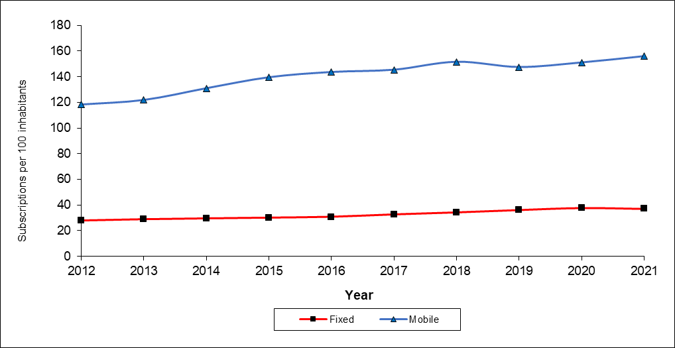

2.3 Internet subscriptions

Between 2020 and 2021,

- the number of internet subscriptions increased by 9.9% from 1,648,000 to 1,811,700 (Table 2) due to the combined effect of increases of 11.9% in mobile internet subscriptions (from 1,324,700 to 1,482,700) and 1.8% in fixed internet subscriptions (from 323,300 to 329,000); and

- the number of internet subscriptions per 100 inhabitants registered an increase of 10.1% from 130.2 to 143.3.

2.4 Type of Internet access

Broadband internet is defined as internet connectivity at a speed of at least 256 kilobits per second (Kbps), whereas narrowband internet is defined as connectivity of less than 256 Kbps.

In 2021, Broadband Internet subscriptions which constituted 96.1% of total internet subscriptions, increased by 11.0% to reach 1,740,600 compared to 1,568,800 in 2020. On the other hand, Narrowband Internet subscriptions contracted by 10.2% from 79,200 in 2020 to 71,100 in 2021.

Broadband Internet subscriptions based on mobile access, accounting for 81.1% of total Broadband Internet subscriptions network in 2021, reached 1,411,700 showing a growth of 13.3% over the figure of 1,245,600 in 2020. Those based on fixed (including wireless) network increased by 1.8% from 323,200 in 2020 to 328,900 in 2021.

Narrowband subscriptions based on mobile access network decreased by 10.2% from 79,100 to 71,000 and those based on fixed access network remained at 100, same as in 2020 (Table 3).
2.5 Tariffs

Selected telephone and internet tariffs for the period 2017 to 2021 are shown in Table 4. Data presented are from the main service provider and are as at end of year.

2.5.1 Telephone Charges

Between 2020 and 2021, the telephone tariff remained unchanged:
- from a fixed line; and
- from a mobile cellular prepaid service for calls: (i) on the same network, (ii) to a different network and (iii) to a fixed telephone (Table 4).

The average mobile cellular tariff for 100 minutes of use during a month, expressed as a percentage of Gross National Income (GNI) per capita, stood at 0.9% in 2021, same as in 2020.

2.5.2 Internet Charges

The tariff for Fibre to The Home (FTTH) of 10 Mbps with different volume allowances for both residential and business remained unchanged in 2021 compared to 2020.

The internet access tariff for 20 hours of use during a month as a percentage of GNI per capita decreased from 2.4% in 2020 to 2.2% in 2021. This indicator is computed based on the monthly standard residential offer of 10 Mbps and volume allowance 150 GB with unlimited internet access.

2.6 Communication traffic

2.6.1 Local calls

Local calls are mostly done through mobile phones. Out of every 10 local calls in 2021, around 8 were made through mobile phones, same as in 2020 (Table 5).

However, mobile phone calls are generally shorter than those through fixed phones. In 2021, a mobile phone call lasted on average 1.2 minutes against 2.4 minutes for a call through a fixed phone, same as in 2020.

Local calls from mobile phones between 2020 and 2021 decreased by:

- 10.4% in number from 1,350.8 million to 1,210.6 million, and
- 12.2% in volume from 1,587.5 million minutes to 1,393.9 million minutes.

2.6.2 International calls

Between 2020 and 2021, the volume of international phone calls for outgoing traffic went down by 11.0% (from 34.7 to 30.9 million minutes). Similarly, incoming traffic volume fell by 12.2% (from 27.9 to 24.5 million minutes) (Table 5).

2.6.3 Short Message Service (SMS)

Between 2020 and 2021,

- the number of messages sent through the Short Message Service (SMS) declined by 36.8% from 497.0 million to 314.3 million.

3. ICT access and use in households

Figures in this section are based on the results of the Continuous Multi-Purpose Household Survey (CMPHS), the latest update being for year 2020.

3.1 ICT access by households

Comparative figures between 2018 and 2020 show that ICT access by households improved as shown in Table 6. The proportion of households with:

- smartphones: from 71.3% to 81.4%;
- internet access: from 69.7% to 72.6%
- paid TV channels: from 38.9% to 42.4%;
- Smart TV: from 22.6% to 37.7%.

3.2 ICT use by individuals

In 2020, some 91% of persons aged five years and above used a mobile phone, compared to around 88% in 2018 (Table 7).

Data on computer use (Table 8) showed that in 2020:

- 46.8% of persons aged five years and above used computer, compared to 49.6% in 2018;
- younger people, particularly those in the age bracket 12 - 29 years are more likely to be computer users than older ones, same as in 2018.

Data on internet use (Table 8) revealed that in 2020:

- 68.3% persons aged twelve years and above were internet users, compared to 61.1% in 2018;
- 94.3% of young persons in age group 12 - 19 years and 96.1% in age group 20 - 29 years were using internet in 2020, compared to around 91% for both age groups in 2018.

4. ICT usage in education sector

Statistics on ICT usage in education for primary and secondary levels are compiled by the statistics unit of the Ministry of Education from the annual survey conducted in schools together with data from other sources. Data on ICT usage in tertiary education is obtained from the Higher Education Commission (Table 9).

4.1 Primary Education

- 75% of schools had internet access for students for study purposes in 2021 against 67% in 2020.
- The ratio of students per computer was 13 for both 2020 and 2021.

4.2 Secondary Education

- 100% of schools have internet access for students for study purposes since 2018.
- The ratio of students per computer was 10 for both 2020 and 2021.
- The percentage of students examined in ICT at School Certificate level was 42.8% in 2021 compared to 40.7% in 2019.
- The percentage of students examined in ICT at Higher School Certificate level was 14.3% in 2021 compared to 12.2% in 2019.

It is to be noted that School Certificate and Higher School Certificate examinations were not held in 2020 due to the outbreak of the Covid-19 pandemic.

4.3 Tertiary Education

- The percentage of students who enrolled in ICT or an ICT-related field at tertiary level was around 9.0% in 2021 compared to 8.3% in 2020.

5. ICT usage in business

Based on data collected through the Survey of Employment and Earnings among ‘large establishments’ employing 10 or more persons, the following changes have been observed in ICT usage for years 2020 and 2021 (Table 10).

‘Large’ establishments

- having computer stood at 99.0% in 2021, against 98.8% in 2020;
- having internet increased from 98.6% in 2020 to 98.9% in 2021;
- having placed orders over the internet increased from 51.9% in 2020 to 55.3% in 2021.

6. Contribution of ICT sector to the economy (see Annex for definition)

6.1 Employment

The number of large establishments (employing 10 or more persons) operating in the ICT sector in 2021 was 113, lower than the figure of 122 in 2020 (Table 11).

Employment in large establishments went down by 0.47%, from 16,980 (8,865 males and 8,115 females) in 2020 to 16,900 (8,865 males and 8,035 females) in 2021. The share of employment in the ICT sector over total employment for 2021 stood at 5.5%, against 5.2% in 2020.

6.2 Gross Value Added (GVA)

GVA at current basic prices comprises the sum of value added of each firm, government institution and producing households in a given country (GVA = ∑ Value added).

The ICT sector comprises telecommunications services, wholesale and retail trade, and other activities such as call centres, software development, website development and hosting, multimedia, IT consulting and disaster recovery.

In 2021, value added at current prices generated by the ICT sector was Rs 28,174 million, 6.7% higher in nominal terms than in 2020 (Rs 26,397 million). The contribution of ICT to Gross Value Added (GVA) at current basic prices was 6.6% in 2021, lower than in 2020 (6.7%). The real growth rate (after removing price effects), went up from 1.5% in 2020 to 6.9% in 2021 (Table 11).

In 2021, around 36% of value added of this sector was generated by activities of telecommunications, 35% by software and website development and IT consultancy, 12% by wholesale and retail trade, and the remaining 17% by activities such as call centres.

6.3 External Trade – share of ICT goods and services (see Annex for definition)

Trade in ICT goods and services from 2020 to 2021 progressed as follows:
- Imports by 26.6% from Rs 13,552 million to Rs 17,160 million; and
- Exports, including re-exports, by 23.7% from Rs 5,602 million to Rs 6,929 million.

Trade in ICT goods between 2020 and 2021 was as follows:
- imports went up by 23.6 % from Rs 8,890 million to Rs 10,986 million;
- exports which include re-exports, decreased by 10.8% from Rs 695 million to Rs 620 million.

Trade in ICT services between 2020 and 2021 improved as follows:
- imports by 32.4% from Rs 4,662 million to Rs 6,174 million;
- exports by 28.6% from Rs 4,907 million to Rs 6,309 million.

Between 2020 and 2021, the share of ICT goods and services increased:
- from 6.5% to 7.1% over total imports of goods and services; and
- from 4.3% to 5.2% over total exports of goods and services.

7. ICT Development Index (IDI)

The ICT Development Index (IDI) has been devised by the International Telecommunication Union (ITU) to assess the level of digital development of countries. The construction of the IDI is guided by previous ITU composite indices, such as, Digital Access Index (DAI), Digital Opportunity Index (DOI) and the ICT Opportunity Index (ICT-OI).

Latest available figures on IDI for Mauritius date back to year 2016. Mauritius with an index of 5.88 ranked first among African countries and 72nd out of 76 countries worldwide.

The methodology for the computation of a revised version of IDI, based on a set of new indicators is still under review. Consensus has not been reached on the new methodology. Hence, the index is not available for the years 2017 onwards.

Statistics Mauritius
Ministry of Finance, Economic Planning and Development
Port Louis
12 July 2022

Contact Persons:

Mr. D. Chinnee (Statistician)

Mrs. N. Joomun (Senior Statistical Officer)

Information and Communication Technologies (ICT) Unit
Statistics Mauritius
2nd Floor, LIC Centre, Port Louis
Tel: (230) 208 1800
Email: statsmauritius@govmu.org
cso-ict@govmu.org
Website: http://statsmauritius.govmu.org

