CONSUMER PRICE INDEX
(Base period: January – December 2017 = 100)
1st Quarter 2022

INTRODUCTION

This issue of Economic and Social Indicators presents the Consumer Price Index (CPI) for the first quarter 2022. The methodology used for computing CPI and inflation rate is given in the technical note at Annex.

KEY POINTS

2.1 Overall CPI

The Consumer Price Index, which stood at 113.3 in December 2021, registered a net increase of 6.8 points (or +6.0%) to reach 120.1 in March 2022 (Table 1A).

On a monthly basis, the CPI increased by 1.6 points in January, 2.7 points in February and 2.5 points in March.

2.2 Overview of CPI movements

The main contributors for the net increase in CPI from December 2021 to March 2022 (Table 2) were:

      - higher prices of vegetables (+3.0 points), meat (+0.2 point), culinary herbs (+0.2 point), fish (+0.1 point), trader’s rice (+0.1 point), fruits (+0.1 point), sugar (+0.1 point), frozen semi- prepared foods (+0.1 point), and some other food products (+0.3 point);
      - higher interest rates on housing loans (+0.1 point) and higher workman’s wages (+0.1 point);
      - higher prices of washing materials and softeners (+0.1 point), some major household appliances (+0.1 point) and furniture (+0.1 point);
      - higher doctor’s fees (+0.2 point);
      - higher prices of gasolene (+1.1 points), diesel (+0.1 point) and motor vehicles (+0.3 point);
      - higher prices of some prepared foods (+0.1 point), goods for personal care (+0.2 point) and, some other goods and services (+0.3 point);
partly offset by
      - lower electricity tariffs (-0.2 point).

MOVEMENT OF CPI SUB INDICES

Percentage change in CPI sub-indices from December 2021 to March 2022

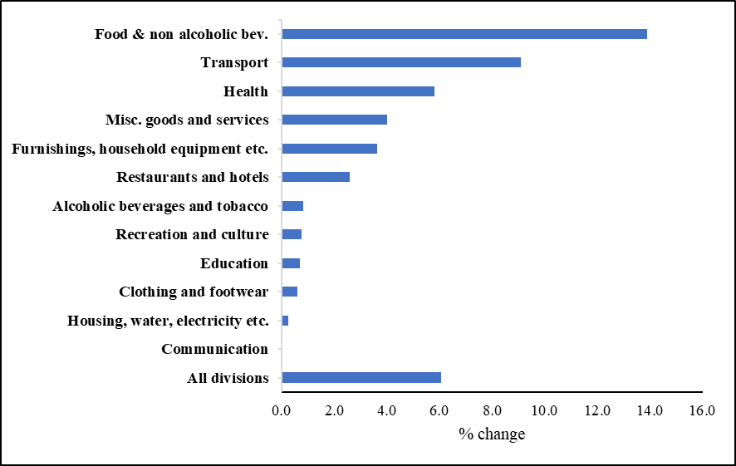
The changes in the sub-indices (Table 3) for the twelve divisions of consumption expenditure from December 2021 to March 2022 were as follows:

Division of consumption expenditure | Main contributors to change
Food and non-alcoholic beverages (+13.9%) | Higher prices of vegetables (+60.2%), meat (+4.8%), culinary herbs (+43.7%), fish (+4.4%), trader’s rice (+6.1%), fruits (+5.4%), sugar (+19.0%), frozen semi-prepared foods (+6.2%), milk preparations (+7.2%), eggs (+9.4%), soft drinks (+3.6%), ginger (+24.5%), ice cream and sweets (+7.2%), fruit juice (+8.6%), flour preparations (+3.9%), cereals (+3.8%), powdered milk (+0.8%) and biscuits (+2.3%).
Alcoholic beverages and tobacco (+0.8%) | Higher prices of whisky (+4.0%), cigarettes (+0.5%), wine (+3.1%), beer and stout (+0.3%) and, rum and other cane spirits (+0.6%).
Clothing and footwear (+0.6%) | Higher prices of ready-made clothing (+0.5%), footwear (+0.8%) and tailoring charges (+6.6%).
Housing, water, electricity, gas  and other fuels (+0.3%) | Higher interest rates on housing loans (+4.1%) and workman’s wages (+7.4%) and higher prices of materials for the maintenance and repair of dwellings (+5.6%), partly offset by lower electricity tariffs due to implementation of government subsidies (-4.7%).
Furnishings, household equipment and routine household maintenance (+3.6%) | Higher prices of washing materials and softeners (+5.4%), some major household appliances (+5.0%), furniture (+3.3%), and higher charges for domestic services (+4.3%).
Health (+5.8%) | Higher doctor’s fees (+15.3%) and higher prices of some medicinal products (+1.2%).
Transport (+9.1%) | Higher prices of gasolene (+19.8%), motor vehicles (+5.6%), diesel (+19.8%) and air-tickets (+1.8%).
Communication | Unchanged.
Recreation and culture (+0.8%) | Higher prices of stationery (+4.0%), audio-visual equipment (+3.2%) and pet foods (+3.1%).
Education (+0.7%) | Higher tuition fees (+13.6%) and university fees in private institutions (+0.7%).
Restaurants and hotels (+2.6%) | Higher prices of prepared foods (+1.9%), cakes and snacks (+6.2%) and higher rates in hotel accommodation (+9.5%).
Miscellaneous goods and services (+4.0%) | Higher prices of goods for personal care (+8.0%) and higher medical insurance (+3.3%).
- INFLATION RATE
The headline inflation rate was 4.0% for year 2021, compared to 2.5% for year 2020 (Table 5).
The headline inflation rate excluding 'Alcoholic beverages and tobacco' was 3.7% for year 2021, compared to 2.7% for year 2020.

The headline inflation rate for the twelve months ending March 2022 worked out to 6.0%, compared to 2.2% for the twelve months ending March 2021.

The headline inflation rate excluding “Alcoholic beverages and tobacco” for the twelve months ending March 2022 worked out to 5.7%, compared to 2.3% for the twelve months ending March 2021.

- INTERNATIONAL COMPARISON OF INFLATION RATE

The table below compares inflation rate (as measured by the percentage change in the average CPI for a given year relative to the previous year) of Mauritius with those of our main importing countries and some countries in the region for year 2020.

Inflation rate (%) of selected countries, year 2020

Country | Inflation rate (%)
France | 0.5
United Kingdom | 0.9
China | 2.4
India | 6.2
Japan | 0.0
Singapore | -0.2
Australia | 0.9
United States | 1.2
Botswana | 1.9
Mauritius | 2.5
Seychelles | 1.2
South Africa | 3.3

Source – World Economic Outlook Database, October 2021

Statistics Mauritius
Ministry of Finance, Economic Planning and Development
Port Louis
14 April 2022

Note:

- This publication is available on the website of Statistics Mauritius at http://statsmauritius.govmu.org From the homepage, choose “Publications” followed by “Economic and Social Indicators”, then “Consumer Price Index”.
- The monthly CPI is also available on our website. It is posted within 5 working days after the reference month.
- More detailed information on CPI can be made available upon request.

Contact persons:

(1) Ms. Ashwinee Devi Soobhug
Statistician
asoobhug@govmu.org

(2) Mrs. Gyantee Jugoo
Temporary Principal Statistical Officer
gjugoo@govmu.org

CPI Unit
Statistics Mauritius
LIC Building, Port Louis
Tel: (+230) 208 1800
Fax: (+230) 211 4150
Email: cso_cpi@govmu.org

Technical note

ANNEX

1. Methodology used for the computation of the Consumer Price Index

(Base period: January - December 2017 = 100)

(a) Definition

The Consumer Price Index (CPI) is an indicator of changes over time in the general level of prices of goods and services acquired by Mauritian consumers.

(b) Measurement of the CPI

The CPI measures price change by comparing, through time, the cost of a fixed basket of goods and services. As prices vary over time, the total cost of the basket also changes and thus the CPI measures the change in the cost of this basket. It provides a way to compare what this basket costs at a given period relative to a reference or base period.

The cost of the CPI basket is assigned a value of 100 in the base period and the costs in other periods are expressed as percentage changes compared to the base period. For example, if the CPI is 110, this means that there has been an increase of 10% in the cost of the basket since the base year; similarly an index of 90 means a 10% decrease in the cost of the basket.

(c) The CPI basket

The CPI basket is based on the expenditures of private households in a reference period, currently January to December 2017. The composition of the current CPI basket has been derived from the 2017 Household Budget Survey (HBS) data. It has been determined in accordance with latest ILO and SADC recommendations.

The items constituting the basket have been selected on the basis of the importance of household consumption expenditure on them. The basket includes all important items on which consumption expenditure is significant, i.e. accounting for around 0.1% or more of total household consumption expenditure. Each item’s relative importance, which is called the “weight” (usually expressed on a total of 1000), is the expenditure share of the item. Non-consumption items such as income tax, social security contributions, purchase of land, shares and life insurance are excluded.

The commodities in the basket are classified according to the UN COICOP (Classification of Consumption Expenditure according to Purpose) with 12 divisions, 42 groups and 80 classes.

(d) Price coverage

The prices used in the CPI calculation are those that any member of the public would have to pay to purchase the specified goods or services. Any taxes on products attached to the goods are included.

Price collection is done on a regular basis. Each month, around 8,000 price quotations are collected in respect of 1,093 item indicators from some 520 outlets selected to be representative of regions across the islands of Mauritius and Rodrigues.

Prices of non-perishable items are collected monthly in the nine geographical districts of the island of Mauritius and in Rodrigues.

Prices of fresh fruits, vegetables, meat and fish are collected on a weekly basis from 9 markets in Port Louis, Rose Hill, Quatre Bornes, Vacoas, Mahebourg, Flacq, Goodlands, Pamplemousses and Port Mathurin.

Information on rent is obtained from a quarterly rent survey of some 100 rented dwellings.

(e) Formula for computation of the CPI

The CPI is computed according to the Laspeyres Formula as a weighted average of price relatives of individual items. The weights are fixed and correspond to the base period expenditures. The Laspeyres Index measures the cost of a basket of goods and services at different points in time, relative to the cost of the same basket in the base period.

The formula used for computing the CPI at time t is

∑ W_{i} (P_{it} / P_{i0} )
I _{t} = X 100
∑ W_{i}
where,
I _{t} : CPI for period t with reference to a base period 0
P_{io} : Price of item i at time 0, i.e. during base period
P_{it} : Price of item i at time t
W_{i} : Weight of item i
The base period is January to December 2017, the period during which the latest HBS was conducted.

2. Inflation

Definition of Inflation

Inflation is the percentage change in the level of prices (as measured by the CPI) from one period to another.

Calculating the Inflation Rate

The headline inflation rate in Mauritius, like in many other countries, is calculated by using the annual average method, i.e. by comparing the average level of prices during a twelve-month period with the average level during the corresponding previous twelve-month period. This type of

inflation rate is more appropriate for adjusting wages, salaries and pensions to compensate for loss of purchasing power. All inflation rates presented in this publication relate to the headline inflation.

Another commonly used method of calculating the inflation rate is the so called ‘year-on-year’ method. The year-on-year inflation rate is calculated as the percentage change in the CPI for a given month with respect to the CPI for the corresponding month of the previous year. It is generally used by central banks for monetary policy decisions. Year-on-year inflation rates are not presented in this publication but can be easily calculated through the available monthly CPI.

Note: More information about the concept, computation and use of the CPI is available online in the publication ‘ HBS 2017 Methodological Report and updated CPI ’

