EDUCATION STATISTICS – 2020

1. Introduction

This issue of the Economic and Social Indicators presents data on education, compiled on the basis of information collected through the annual survey conducted in schools in March 2020, together with data from other sources. The data refer to the Republic of Mauritius (excluding Agalega) and cover pre-primary, primary, secondary, technical & vocational, tertiary education as well as education in specialised institutions. Data for the year 2020 are provisional.

2. Expenditure

Total government expenditure for the financial years 2019/2020 and 2020/2021 are estimated as follows:
- Financial year 2019/2020: Rs 197,524 million, of which, Rs 18,303 million (9.3%) has been allocated to education and training; and
- Financial year 2020/2021: Rs 185,029 million, of which, Rs 16,993 million (9.2%) has been allocated to education and training.

Total budget on education and training has been allocated as follows:
- Financial year 2019/2020: 50.3% to secondary education, 24.6% to primary education, 7.8% to tertiary education, 2.8% to technical and vocational education, 1.6% to pre-primary education and the remaining 12.9% to other expenses; and
- Financial year 2020/2021: 51.5% to secondary education, 24.8% to primary education, 7.2% to tertiary education, 1.4% to technical and vocational education, 1.7% to pre-primary education and the remaining 13.4% to other expenses
(Figure 1).

Figure 1 - Total Expenditure on Education, Republic of Mauritius

Financial year: 2019/2020
Financial year: 2020/2021
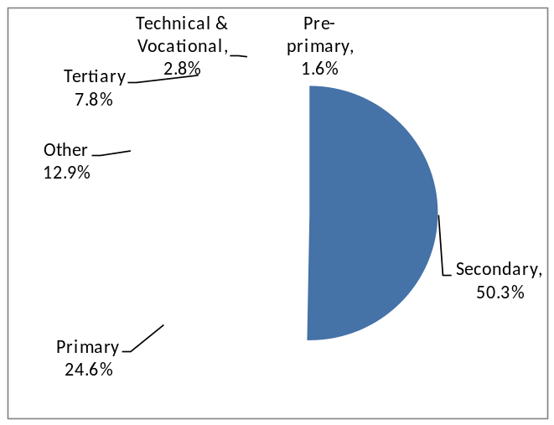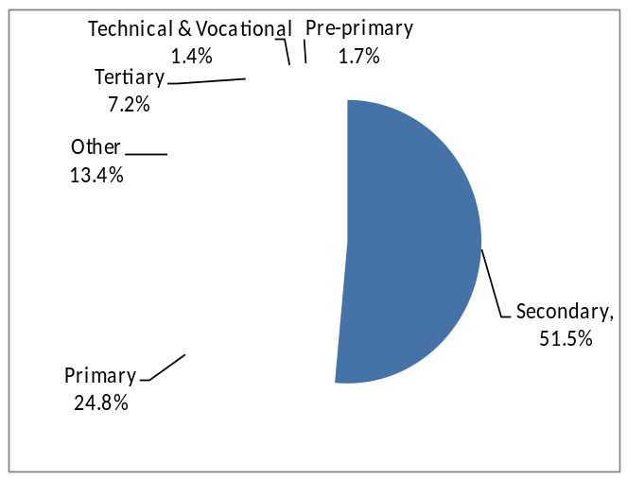
3. Pre-primary education

  - Schools

The number of schools providing pre-primary education stood at 833 in March 2020: 799 in the Island of Mauritius and 34 in Rodrigues. Of these schools, 584 (70.1%) were privately run institutions; 190 (22.8%), operating on government primary school premises, were administered by the Early Childhood Care and Education Authority and the remaining 59 (7.1%) were administered by either Roman Catholic (RC) or Hindu Education Authorities or Municipal/Village Councils.

  - Enrolment

Enrolment in pre-primary schools decreased by 2.4%, from 25,479 in March 2019 to 24,859 in March 2020. Girls represented 48.6% of the pre-primary school population. The Gross Enrolment Ratio (pre-primary enrolment as a percentage of the population aged 4 and 5 years) works out to 96.9% compared to 96.2% in 2019.

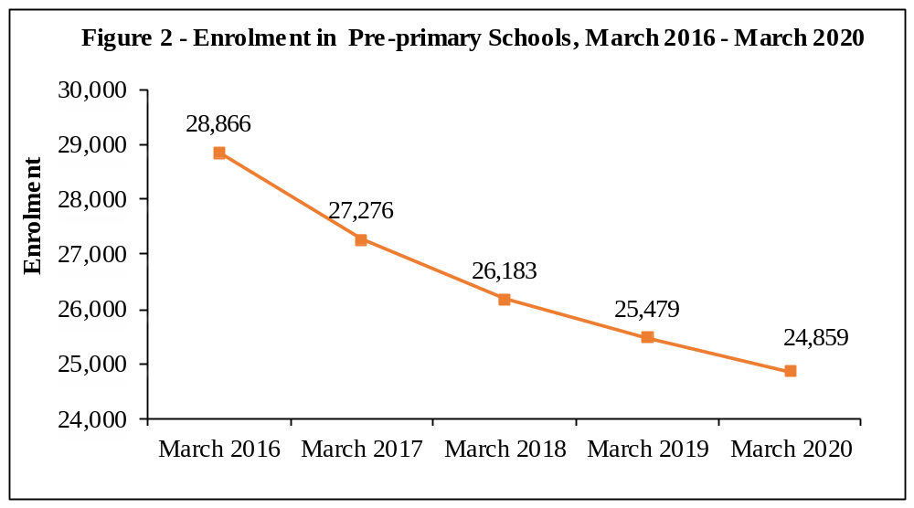

Figure 2 shows a declining trend in enrolment in pre-primary schools over the period 2016 to 2020.

  - Personnel

In March 2020, total employment in pre-primary schools stood at 3,106, of whom 2,111 were teaching and 995 non-teaching staff. This represents a decrease of 0.4% compared to 2019. The average number of pupils per teacher works out to 12, same as in 2019.

4. Primary education

4.1 Schools
In March 2020, there were 319 schools providing primary education, same as in March 2019: 302 in the Island of Mauritius and 17 in Rodrigues. The majority (221) of the schools were run by government, 51 by Roman Catholic Education Authority,
2 by Hindu Education Authority and the other 45 were private non-aided schools.

4.2 Enrolment
In 2020, the primary school population in the Republic of Mauritius stood at 82,004, of whom 49.6% was girls. Some 63% was enrolled in government schools and the remaining was in private aided and non-aided schools.

Distribution by grade shows that grade 6 with 14,493 pupils, accounted for the highest number of pupils. The Gross Enrolment Ratio (primary enrolment as a percentage of the population aged 6 to 11 years) works out to 94.5% in 2020.

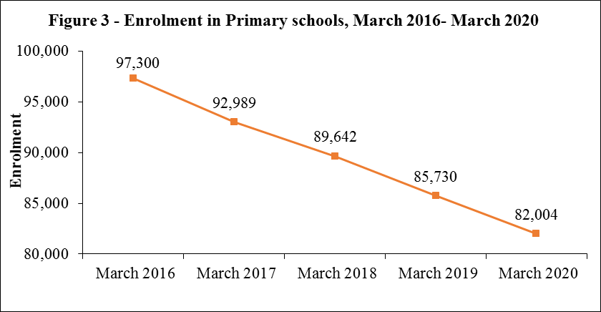

The graph shows a marked decline in primary enrolment from March 2016 to March 2020.

4.3 Personnel

The number of persons employed in primary schools registered an increase of 256 from 8,560 in March 2019 to 8,816 in March 2020. Of this number, 5,811 were teaching staff: 4,527 General Purpose Teachers and 1,284 Oriental Language Teachers. The remaining
3,005 comprised 266 Head Teachers, 937 Deputy Head Teachers and 1,802 administrative and other workers. The pupil/teacher (general purpose) ratio in primary schools works out to 18, compared to 20 in 2019.

  - Primary School Achievement Certificate (PSAC)

With the introduction of the Nine-Year Continuous Basic Education (NYCBE) in 2017, the Certificate of Primary Education (CPE) has been replaced by the Primary School Achievement Certificate (PSAC) to assess learners holistically. Assessment leading to PSAC also comprises a School-Based Assessment component consisting of two modular assessments at the end of Grade 5 and beginning of third term of Grade 6.

In 2019, the number of school candidates who took part in PSAC Assessment was 14,985. Excluding re-assessment, the overall percentage meeting PSAC requirement works out to 73.9.

It is to be noted that the percentage meeting PSAC requirement, including re-assessed school candidates, works out to 77.3. The performance of girls, including re-assessment exceeded that of boys with respective pass rates of 82.8% and 71.7%
(Figure 4).

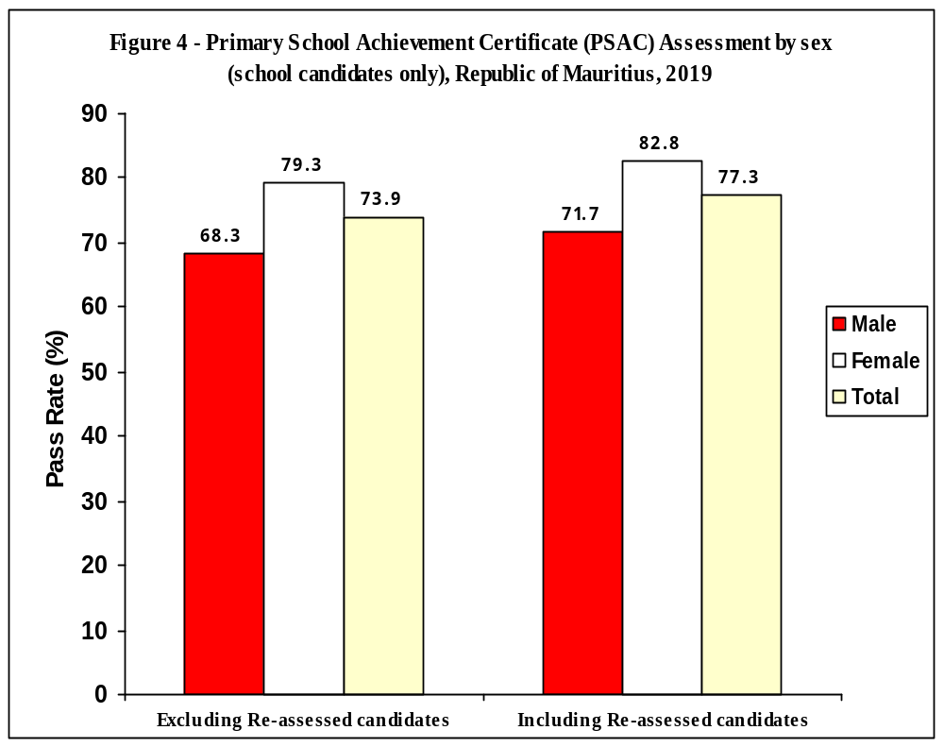

5. Secondary Education

5.1 Programmes of study

With the Nine-Year Continuous Basic Education, all children completing Grade 6 of Primary move on smoothly to Grade 7 in a secondary school to complete the last 3 years of the nine-year basic education cycle.
Pupils who have not reached the minimum standards at the Primary School Achievement Certificate (PSAC) Assessment are channeled to the Extended Programme in a secondary school. The curriculum is specially adapted to their needs and allow them to complete their basic education in 4 years instead of 3.
As at March 2020, the number of secondary schools, stood at 179, out of which 143 were offering both the Regular and the Extended Programmes in Grades 7 to 9. It is to be noted that as from 2020, the Pre-vocational Education Programmes has phased out of secondary schools. The Mauritius Institute for Training and Development (MITD) Training Centres are, however, running Year 4 of the programme for the last year.
As from Grades 10 onwards, secondary schools offer general education Programmes leading to Cambridge O/A level qualifications or their equivalent.

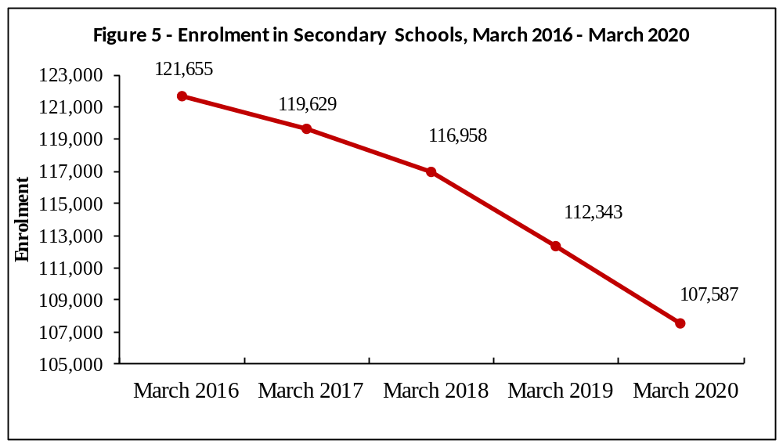
The graph depicts a continuous fall in total secondary enrolment from March 2016 to March 2020.

5.2 Secondary Schools

5.2.1 Schools
Out of the 179 schools dispensing secondary Regular and Extended education, 171 were in the Island of Mauritius and 8 in Rodrigues. State administered schools numbered 69, while the other 110 were private aided and non-aided schools.

5.2.2 Enrolment
Secondary education enrolment decreased by 3,241 from 108,562 in 2019 to 105,321 in 2020. Some 43.1% of the secondary school population was in state schools and 56.9% in private (aided and unaided) schools. Gross Enrolment Ratio (secondary education enrolment as a percentage of the population aged 12 to 19 years) was 71.9%.

5.3 Personnel

The number of teachers working in secondary schools decreased by 159 from 9,783 in March 2019 to 9,624 in March 2020. The pupil/teacher ratio works out to 11.

5.4 Cambridge School Certificate (SC)

In 2019, out of 15,419 candidates (6,796 males and 8,623 females) who took part in the Cambridge School Certificate examination, 10,937 were successful. Comparison with the 2018 results shows that the overall pass rate decreased from 71.5% to 70.9%
(Figure 6).
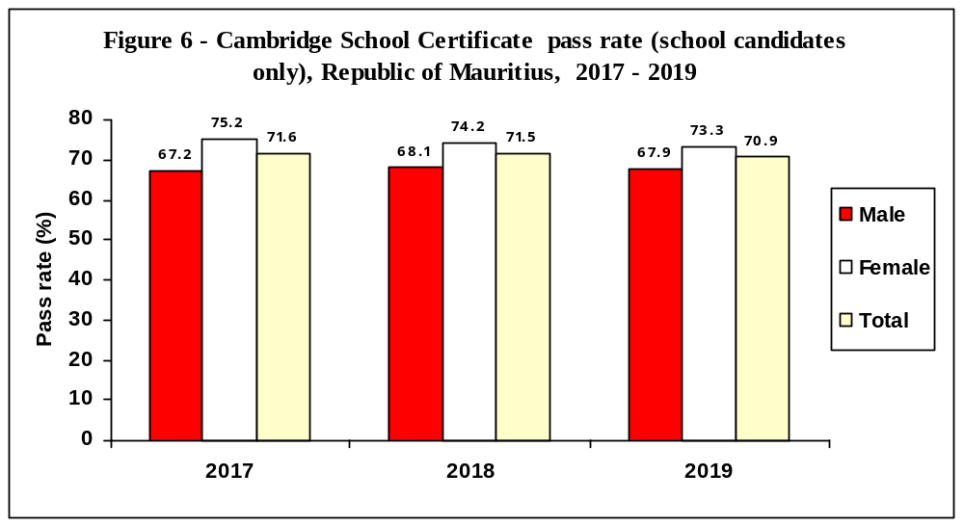

5.5 Cambridge Higher School Certificate (HSC)
The number of students taking part in the 2019 Cambridge Higher School Certificate examination stood at 8,975, of whom 59% were females. The overall pass rate was 75.0%, slightly higher than the 2018 figure of 74.9% (Figure 7).

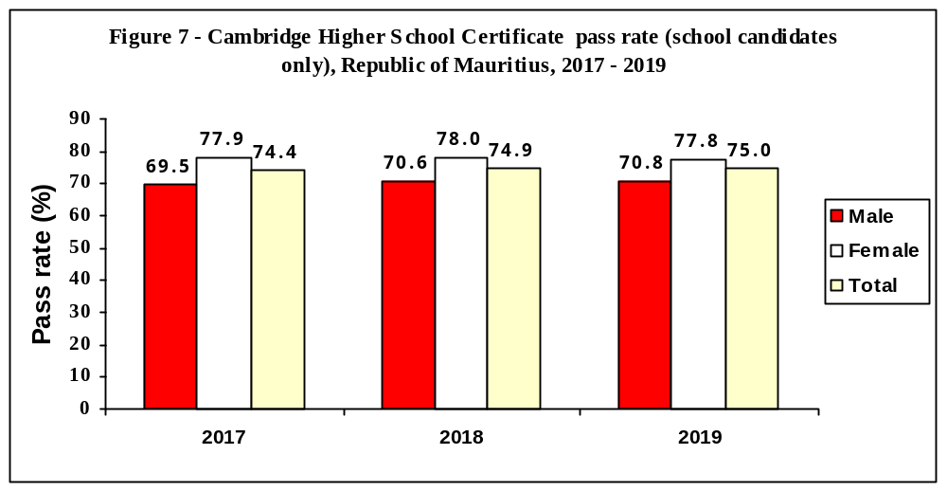

5.6 Technical and Vocational Education

In 2019, there were 8,024 students (of whom 76.5% were males) enrolled in publicly funded technical and vocational courses compared to 6,973 in 2018. Some 36.1% of the students were enrolled in full-time courses, 33.5% in part-time courses and the rest (30.4%) in apprenticeship courses.

6. Special Education Needs (SEN)
6.1 Schools

As at March 2020, there were 71 Special Education Needs schools in the Republic of Mauritius registered with the Ministry of Education, Tertiary Education, Science and Technology. Twenty-one schools were run by Government, while the other 50 were run by NGOs and the Roman Catholic Education Authority.

6.2 Enrolment

The number of students enrolled in the 71 special schools stood at 2,731 (of whom 66.4% were boys) as at March 2020, representing a decrease of 2.1% compared to the 2019 figure of 2,790.

The three most frequent types of impairment among the pupils were intellectual impairment (27.6%), dyslexia (20.8%) and autism (10.4%).

6.3 Personnel
As at March 2020, there were 1,007 persons employed in the special education needs institutions, representing an increase of 13.5% compared to 887 as at March 2019. Out of these, 494 were teaching staff, and 188 were medical and para-medical staff. The remaining 325 were administrative and ancillary workers.

7. ICT in Education

In March 2020, out of the 833 pre-primary schools in the Republic of Mauritius, 504 (61%) had computers. All primary and secondary schools were equipped with computers. Availability of internet access for students in schools was as follows: 19% in pre-primary, 63% in primary and 100% in secondary.

8. Tertiary Education

As at December 2019, the total number of students (part-time and full-time) enrolled on tertiary-level programmes (including Distance Education) was 49,205 compared to 47,398 in December 2018, representing an increase of 3.8%.

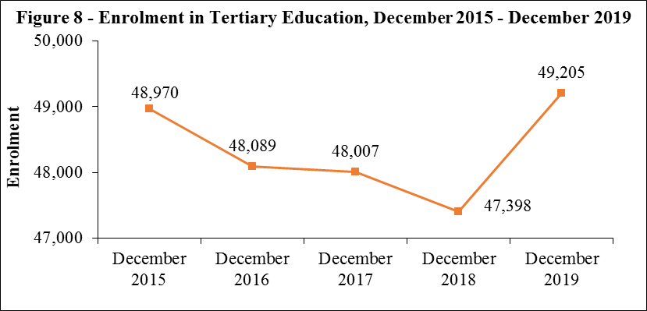

Figure 8 gives the evolution of total tertiary enrolment over the period 2015 to 2019. Total enrolment decreased from 2015 to 2018 and increased from 2018 to 2019.

The majority of students (83.7%) were enrolled in tertiary education locally in both public-funded institutions (48.5%) and private institutions (35.2%). The remaining 16.3% of the students were enrolled in tertiary education overseas.

The Gross Enrolment Ratio (tertiary education enrolment as a percentage of the population aged 20 to 24 years) for 2019 works out to 48.0 %.

It is to be noted that figures for 2019 are provisional and subject to the approval of the Higher Education Commission (HEC) Board.

9. Main Indicators on Education
The main indicators are given below
Table 1 - Main Indicators, Republic of Mauritius, 2016 - 2020
 | 2016 | 2017 | 2018 | 2019 | 2020
Pre-primary
Number of schools | 911 | 883 | 846 | 851 | 833
Enrolment | 28,866 | 27,276 | 26,183 | 25,479 | 24,859
Number of teachers | 2,256 | 2,219 | 2,115 | 2,134 | 2,111
Gross Enrolment Ratio (%) (3-4 years) ¹ | 102.0 | 99.9 | 98.9 | 99.2 | 97.4
Gross Enrolment Ratio (%) (4-5 years) | 100.0 | 96.5 | 95.9 | 96.2 | 96.9
Pupil/Teacher Ratio | 13 | 12 | 12 | 12 | 12
Primary
Number of schools | 318 | 318 | 318 | 319 | 319
Enrolment | 97,300 | 92,989 | 89,642 | 85,730 | 82,004
Number of teachers | 5,468 | 5,184 | 5,534 | 5,639 | 5,811
Gross Enrolment Ratio (%) (5-10 years) ¹ | 100.9 | 100.1 | 99.8 | 98.7 | 97.4
Gross Enrolment Ratio (%) (6-11 years) | 96.8 | 96.6 | 96.5 | 95.4 | 94.5
Pupil/Teacher Ratio | 24 | 24 | 21 | 20 | 18
Certificate of Primary Education Pass Rate | 74.7
Primary School Achievement Certificate (PSAC) |  | 81.2 ² | 78.8 ² | 77.3 ² | n.a
Secondary
Number of schools | 175 | 176 | 179 | 181 | 179
Enrolment ³ | 121,655 | 119,629 | 116,958 | 112,343 | 107,587
Number of teachers | 9,359 | 8,359 | 9,590 | 9,783 | 9,624
Gross Enrolment Ratio (%) (11-17 years) ¹ | 90.0 | 90.0 | 89.7 | 88.4 | 87.4
Gross Enrolment Ratio (%) (12-19 years) | 78.0 | 78.0 | 76.9 | 75.0 | 73.5
Pupil/Teacher Ratio | 13 | 14 | 12 | 11 | 11
Cambridge School Certificate Pass Rate | 72.0 | 71.6 | 71.5 | 70.9 | n.a
Cambridge Higher School Certificate Pass Rate | 75.5 | 74.4 | 74.9 | 75.0 | n.a

 | 2016 | 2017 | 2018 | 2019 ⁴ | 2020
Tertiary ⁵
Number of institutions ⁶ | 46 | 45 | 49 | 45 | n.a
Enrolment | 48,089 | 48,007 | 47,398 | 49,205 | n.a
Gross Enrolment Ratio (%) | 46.6 | 46.6 | 46.4 | 48.0 | n.a
Expenditure | 2016/2017 | 2017/2018 | 2018/2019 ⁷ | 2019/2020 ⁷ | 2020/2021 ⁸
Total Government Expenditure (Rs million) | 132,164 | 140,209 | 150,511 | 197,524 | 185,029
Total Government Expenditure on Education (Rs million) | 15,360 | 15,767 | 16,284 | 16,296 | 15,025
Total Government Expenditure on Education as a % of GDP at market price | 3.4 | 3.3 | 3.3 | n.a | n.a
Total Government Expenditure on Education as a % of Total Government Expenditure | 11.6 | 11.2 | 10.8 | 8.3 | 8.1

¹Based on the UNESCO definition of Gross Enrolment Ratio, i.e, total enrolment in a specific level of education, regardless of age expressed as a percentage of the eligible official school-age population
² % Meeting the PSAC Requirement including Re-assessed Candidates
³ Figures include Prevocational Education which is being run for the last time in 2020 ⁴ Provisional Estimate
⁵ Source Higher Education Commission (ex- Tertiary Education Commission) ⁶ In operation ⁷ revised
⁸ Budget Estimates n.a Not Available

The following tables together with the web version of this publication can be downloaded from Statistics Mauritius website at http://statsmauritius.govmu.org From the homepage, click on ‘STATISTICS’ followed by ‘Statistics by subject’ then by ‘Education’ then select the publication under the heading ‘Economic and Social Indicator – Education Statistics, Year 2020’.
List of tables

Tables by Zone

1 PRE-PRIMARY EDUCATION
1.1 Distribution of pre-primary schools by zone and type of administration, 2020
1.2 Enrolment and personnel in pre-primary schools by zone and sex, 2020
2 PRIMARY EDUCATION
2.1 Distribution of primary schools by zone and type of administration, 2020
2.2 Enrolment in primary schools by zone, type of administration and sex, 2020
2.3 Enrolment in primary schools by zone and grade, 2020
2.4 Enrolment in primary schools by grade and sex, 2018 - 2020
2.5 Enrolment in primary schools by type of administration, grade and sex, 2018 - 2020,
Republic of Mauritius
2.6 Personnel in primary schools by zone and occupational status, 2020
2.7 Primary School Achievement Certificate (PSAC) Assessment by sex, 2019

3 SECONDARY EDUCATION - GENERAL
3.1 Distribution of secondary schools (general) by zone and type of administration, 2020
3.2 Enrolment in secondary schools (general) by zone and grade, 2020
3.3 Teaching staff in secondary schools (general) by zone and sex, 2020
3.4 Enrolment in secondary schools (general) by zone, type of administration and sex, 2020
3.5 Enrolment in secondary schools (general) by grade and sex, 2018 - 2020
3.6 Enrolment in secondary schools (general) by type of administration, grade and sex, 2018 - 2020, Republic of Mauritius
3.7 Cambridge School Certificate (SC) examination results by type of school administration and sex, 2017 - 2019
3.8 Cambridge Higher School Certificate (HSC) examination results by type of school administration and sex, 2017 - 2019
3.9 Enrolment in Mauritius Institute of Training and Development (MITD) Centres, Republic of Mauritius, 2019
3.10 Enrolment in Mauritius Institute of Training and Development (MITD) Centres by course level, year of study and sex (Full Time), Republic of Mauritius, 2019

4 SPECIAL EDUCATION NEEDS
4.1 Distribution of Special Education Needs (SEN) schools by zone and type of administration, 2020
4.2 Enrolment in Special Education Needs (SEN) schools by sex and zone, 2018 - 2020
4.3 Enrolment in Special Education Needs (SEN) schools by age and sex, Republic of Mauritius, 2018 - 2020
4.4 Number of pupils in Special Education Needs (SEN) schools by type of impairment and sex,
Republic of Mauritius, 2020
4.5 Personnel in Special Education Needs (SEN) schools by sex, Republic of Mauritius, 2018 - 2020

5 ICT
5.1 ICT in pre-primary, primary and secondary schools - Republic of Mauritius, 2020

6 POST SECONDARY EDUCATION
6.1 Enrolment at Tertiary Education Level, both Locally and Overseas, by Source and Field of Study, as at December 2018
6.2 Enrolment at Tertiary Education Level, both Locally and Overseas, by Source and Field of Study, as at December 2019

Tables by District

7 PRE-PRIMARY EDUCATION
7.1 Distribution of pre-primary schools by district and type of administration, 2020
7.2 Enrolment and personnel in pre-primary schools by district and sex, 2020
8 PRIMARY EDUCATION
8.1 Distribution of primary schools by district and type of administration, 2020
8.2 Enrolment in primary schools by district, type of administration and sex, 2020
8.3 Enrolment in primary schools by district and grade, 2020
8.4 Personnel in primary schools by district and occupational status, 2020

9 SECONDARY EDUCATION - GENERAL
9.1 Distribution of secondary schools (general) by district and type of administration, 2020
9.2 Enrolment in secondary schools (general) by district, type of administration and sex, 2020
9.3 Enrolment in secondary schools (general) by district and grade, 2020
9.4 Teaching staff in secondary schools (general) by district and sex, 2020

10 SPECIAL EDUCATION NEEDS
10.1 Distribution of Special Education Needs (SEN) schools by district and type of administration, 2020
10.2 Enrolment in Special Education Needs (SEN) schools by sex and district, 2018 - 2020
Definition of Indicators

Statistics Mauritius
Ministry of Finance, Economic Planning and Development
Port Louis

September 2020

Contact Person
F. Koussa (Mrs)
Statistician
Statistics Unit
Ministry of Education, Tertiary Education, Science and Technology
10th Floor, NPF Bldg, Rose Hill
Tel: (230) 464 1303
Email: fkoussa@govmu.org

