Gender Statistics - 2018

1. Introduction
This is the tenth issue of Economic and Social Indicators (ESI) on gender statistics. It presents a portrait of women and men in the Republic of Mauritius and includes their demographic profile, health, family status, educational attainment and labour force characteristics.
The ESI is based on latest available sex disaggregated data from administrative sources, household surveys and censuses. Some of the statistics presented therefore refer to years earlier than 2018.

2. Highlights
- In 2018, the population comprised 639,273 women compared to 626,030 men. Women outnumbered men by 13,243 as they live on average 6.4 years longer than men.
- Diabetes mellitus, heart disease, cerebrovascular disease and hypertensive disease together accounted for 57.6% of all deaths among women against 53.5% among men.
- More women than men are enrolled in tertiary institutions, but there are fewer women in research (PhD, MPhil and Doctor of Business Administration).
- Working women are more likely than men to be employees and contributing family workers, but less likely to be heading a business.
- In spite of being fewer in the labour force, women are more numerous among the unemployed.
- Unemployed women are generally more qualified than their male counterparts.
- Average monthly income tends to be lower for women than men – Rs 18,600 against Rs 24,400 in 2018.
- Women are more likely than men to live in poverty. Poor households are more likely to be headed by women.
- Women are largely under-represented in decision making at higher sphere of society. The number of female ministers was only 2 out of 23 and the number of female mayors was 1 out of 5 in 2018.
- The proportion of women in the most senior positions in government services (Senior Chief Executive, Permanent Secretary, Deputy Permanent Secretary, Director, Manager, Judge and Magistrate) has remained around 37% in 2017 and 2018.
- Women are more likely to be victims of domestic violence than men.
- Men are more likely to be victims of homicides and assaults, while women are more prone to sexual violence and sexual exploitation.
- Men are more likely than women to participate in sports as high level athletes.
- Between 2017 and 2018, Mauritius improved its ranking from 112 to 109, out of 149 countries worldwide with regard to Global Gender Gap Index (GGI) of the World Economic Forum. GGI seeks to measure gender equality across four key areas, namely: (a) economic participation and opportunity, (b) educational attainment, (c) health and survival and (d) political empowerment.

3. Population
Prior to 1950 women were fewer than men in number. However, the female population has been growing at a faster rate such that in the 50’s there were almost equal numbers of men and women. This balance in the population has been maintained for some 40 years. As from 1990, women have been increasingly outnumbering men over the years.
In 2018, there were 13,243 more women than men. Out of a total population of 1,265,303, there were 639,273 women against 626,030 men, i.e., 98 men for every 100 women.
Though women were more numerous in the total population, this was not the case in all age groups. At the younger ages (under 50 years), men were more numerous, mainly due to more births of baby boys than girls. In 2018, there were 107 male births for every 100 female births.
At ages 50 years and above, women outnumbered men and their proportion increased at higher ages. The male-female ratio stood at around 103 for those aged between 40 to 49 years compared to 53 among those aged 80 years and over; there were around 2 women for every man in this age group. The main reason for this imbalance is that women live longer than men.

Table 1 – Population by age and sex, Republic of Mauritius, 1st July 2018
Age group (years) | Male | Female | Both sexes | Sex ratio (males per 100 females)
Under 10 | 70,329 | 68,105 | 138,434 | 103.3
10 - 19 | 94,846 | 91,545 | 186,391 | 103.6
20 - 29 | 97,777 | 95,721 | 193,498 | 102.1
30 - 39 | 92,313 | 90,115 | 182,428 | 102.4
40 - 49 | 87,183 | 84,998 | 172,181 | 102.6
50 - 59 | 89,075 | 91,281 | 180,356 | 97.6
60 - 79 | 86,037 | 101,634 | 187,671 | 84.7
80+ | 8,470 | 15,874 | 24,344 | 53.4
All age groups | 626,030 | 639,273 | 1,265,303 | 97.9

Women have a higher life expectancy than men. In fact, women live some 6.4 years longer than men. In 2018, life expectancy at birth for women was 77.8 years compared to 71.4 years for men. Life expectancy at birth has improved over the years for both men and women and over the past eight years, the gap between life expectancy of men and women has decreased from 7.3 years in 2010 to 6.4 years in 2018 (Chart 1).

Chart 1 - Life Expectancy at birth, Republic of Mauritius, 1962 - 2018
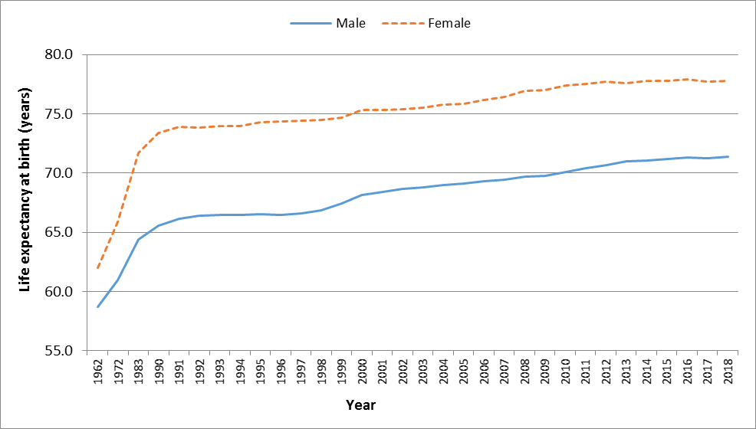

4. Fertility and Contraceptive Use
Women continue to give birth to fewer children than in the past. The total fertility rate, which is an indication of the average number of babies born to a woman during her childbearing period, has maintained a general decreasing trend after 1992 until 2013. Compared to 1992, the average number of children born to a woman dropped by nearly one child to reach a total fertility rate of 1.4 from 2013 to 2018.
Chart 2 - Total Fertility Rate, Republic of Mauritius, 1984 - 2018
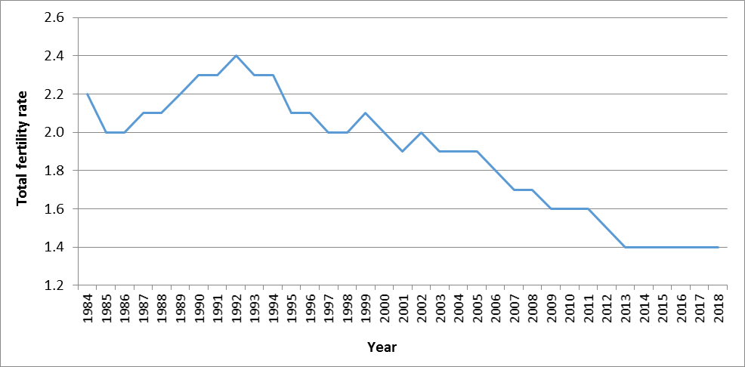
In the 1990’s, women in the age bracket 20-24 years had the highest fertility with 147 births per 1,000 women of that age group (Chart 3). In 2018, the peak fertility rate is observed in the age bracket 25-29 years but with only 84 births per 1,000 women in that age group. One of the reasons explaining this shift is that women are getting married at an older age.
Chart 3 – Fertility Rate by age of mother, Republic of Mauritius, 1990 and 2018
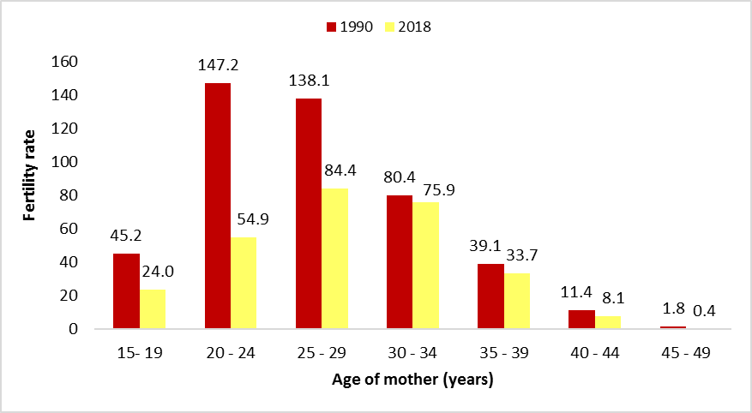
In 2018, Government Family Planning Clinics, Mauritius Family Planning & Welfare Association and Action Familiale registered a total of some 57,275 current users of contraceptive methods in the Island of Mauritius, a decrease of 30,950 from 88,225 in 2008.
Chart 4 – Number of current users of contraceptives, Island of Mauritius, 2000 - 2018
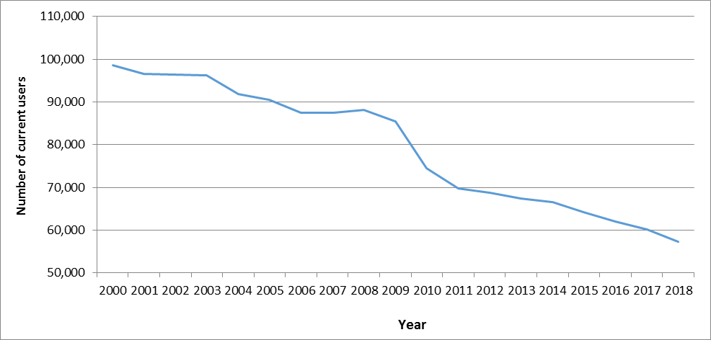
New acceptors of contraceptive methods registered in 2018 numbered 3,741, of whom 499 had tubal ligation. A declining trend was observed in the number of new acceptors from 6,744 in 2008.
Among the new acceptors in 2018, Sympto-thermal (21.6%), Pill (20.4%) and 3-month injectable (19.3%) were the preferred methods of contraception while for current users Sympto-thermal (46.2%) was the preferred method (Table 2).
Table 2 – Method of family planning, Island of Mauritius, 2018
Method | New Acceptors (%) | Current Users (%)
Pill | 20.4 | 8.9
Tubal Ligation | 13.3 | 24.9
Sympto-thermal | 21.6 | 46.2
Male Condom | 18.3 | 9.9
3-month injectable | 19.3 | 4.9
Intra-Uterine Devices | 1.4 | 2.7
1-month injectable | 3.2 | 0.9
Implant | 2.5 | 1.6
All methods | 100.0 | 100.0

5. Family Status
While marriage rate is declining, divorce rate is on the rise. The marriage rate, i.e., the number of persons married per 1,000 mid-year population, fell from 21.1 in 1993 to 15.9 in 2018. The number of divorced persons per 1,000 mid-year population increased from 1.4 in 1993 to 3.8 in 2018 (Chart 5).

Chart 5 – Marriage and Divorce Rate, Republic of Mauritius, 1993 - 2018
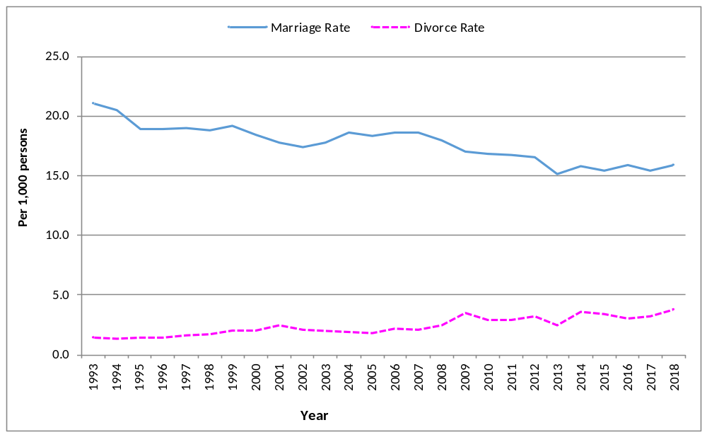
Generally women tend to marry men who are older than them. However, over the past 25 years the age difference between husband and wife narrowed from 4.9 years in 1993 to 3.1 years in 2018 (Chart 6).
The average age at first marriage has been gradually increasing over the years for both women and men. The average age at first marriage for women increased from 24.4 years in 1993 to reach 28.0 years in 2018, while that for men increased from 29.3 to 31.1 during the same period.

Chart 6 – Average age at first marriage, Republic of Mauritius, 1993 - 2018
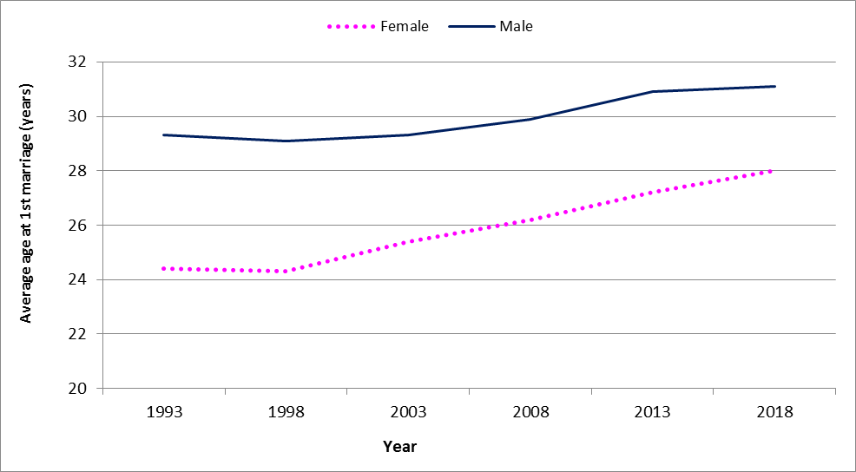
Of the 2,425 divorces granted by the Supreme Court in 2018, woman was the petitioner in 44.3% of the cases (Table 3).
An analysis of the divorce statistics by single year duration of marriage indicate that couples had the highest tendency to divorce within the 3-10 years duration of marriage (Table 4).

Table 3 – Divorce by petitioner, Republic of Mauritius, 2017 & 2018
Petitioner | 2017 | % | 2018 | %
Husband | 587 | 29.4 | 643 | 26.5
Wife | 872 | 43.7 | 1,075 | 44.3
Joint petitioner (both husband & wife) | 537 | 26.9 | 707 | 29.2
All types of petitioners | 1,996 | 100.0 | 2,425 | 100.0
Table 4 – Divorce by duration of union, Republic of Mauritius, 2018
Duration of union (years) | Number | %
< 1 year | 7 | 0.3
1 and <3 | 173 | 7.1
3 and <5 | 274 | 11.3
5 and <10 | 638 | 26.3
10 and <15 | 526 | 21.7
15 and <25 | 562 | 23.2
25 or more | 245 | 10.1
All durations | 2,425 | 100.0

Some 37.2% of couples who divorced in 2018 did not have any children, while 52.2% of them had 1 to 2 children. There were 55 couples with 4 or more children.
Table 5 – Divorce by number of dependent children¹, Republic of Mauritius, 2018
Number  of  dependent  children | Number | %
0 | 906 | 37.4
1 | 697 | 28.7
2 | 570 | 23.5
3 | 197 | 8.1
4 | 40 | 1.6
5 or more | 15 | 0.6
Total | 2,425 | 100.0

¹ dependent children are the living children who are dependent on either of the divorcees at the time the divorce petition is filed

6. Health
Since October 1987 when the first cases of HIV/AIDS were registered, the number has been increasing to reach 7,421 in December 2018, of whom 25.8 % were women.
During 2018, 382 new cases of HIV/AIDS were registered among Mauritians and the proportion of women among the new cases was 42.9% compared to 11.6% in 2004.

Chart 7 – New HIV/AIDS cases, Republic of Mauritius, 2004 - 2018
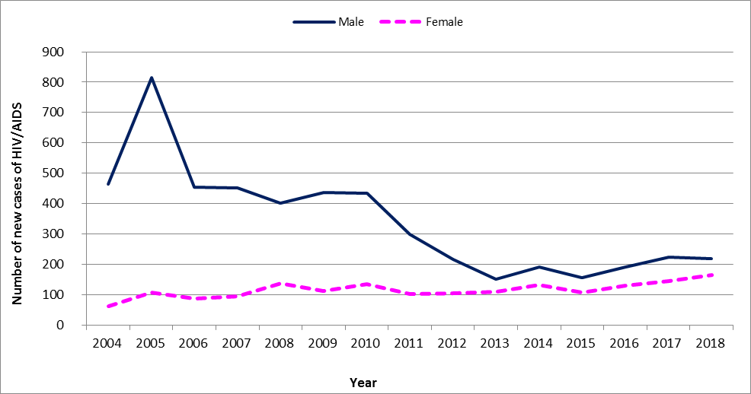
In 2018, out of the 164 new HIV/AIDS cases detected among females, 80.5% was mainly due to heterosexual as mode of transmission and 11.6% to drug injection. As regards males, among the 218 new cases, the mode of transmission mainly due to heterosexual and drug injection were respectively 46.3% and 45.9%.

Chart 8 – Number of new HIV/AIDS cases by sex and age, 2018
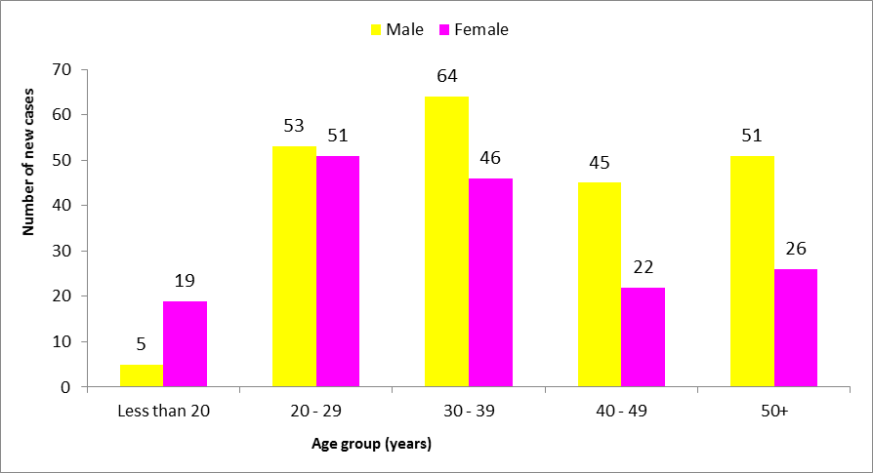
Among the newly detected cases in 2018, some 56.0% were in the age-group 20-39 years. However, women were predominant in the age-group 20-29 years with 31.1%, while men were mostly in the age-group 30-39 years with 28.8%.

7. Mortality
Though women are more numerous than men in the population, there are fewer deaths among women than among men. In 2018, 5,939 men compared to 4,848 women died (Chart 9). The crude death rate for 2018 was 9.5 for man and 7.6 for woman.

Chart 9 – Number of deaths by sex, Republic of Mauritius, 1995 - 2018
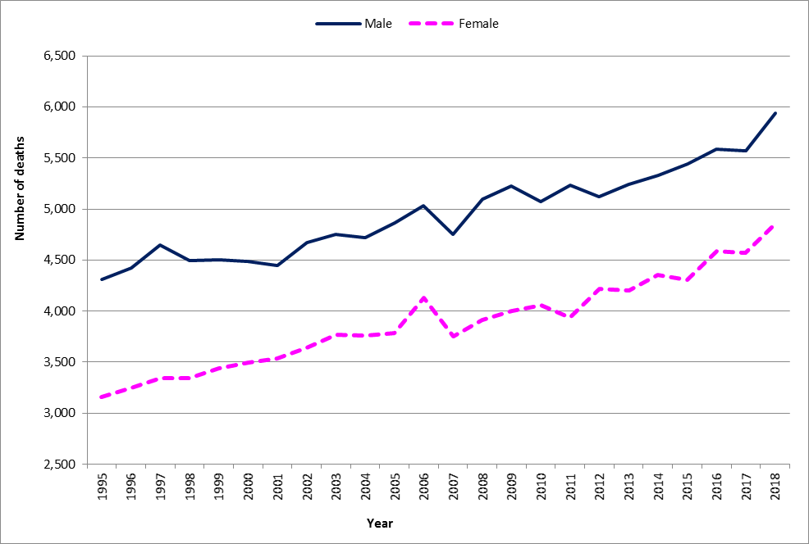

In 2018, diabetes mellitus and heart disease were the leading causes of deaths among women and men. Diabetes mellitus and heart disease were respectively responsible for 21.6% and 19.0% of deaths among women and 19.6% and 20.5% of deaths among men. Cerebrovascular disease was responsible for 9.7% of deaths among women and 8.3% of deaths among men. Causes of death specific to women, such as breast and uterus cancer, were responsible for 5.3% of deaths among women while maternal deaths was responsible for another 0.1%. Compared to men, women were more likely to die of hypertensive disease and neoplasms but less likely to die of cirrhosis of the liver and to commit suicide (Table 6).

Table 6 – Deaths (%) by cause and sex, Republic of Mauritius, 2018
Cause of death | Male | Female
Diabetes mellitus | 19.6 | 21.6
Heart disease | 20.5 | 19.0
Hypertensive disease | 5.1 | 7.3
Neoplasm: | 6.1 | 8.2
of which: breast cancer (malignant) | 0.1 | 3.6
uterus cancer (malignant) | Napp | 1.7
Cerebrovascular disease | 8.3 | 9.7
Cirrhosis of liver | 2.2 | 0.5
Suicide | 1.4 | 0.6
Maternal death | Napp | 0.1
Other | 36.8 | 33.0
All causes | 100.0 | 100.0
Napp: Not Applicable

The risk of a woman dying as a result of pregnancy or childbirth during her lifetime has generally been declining over the years with slightly higher level of maternal deaths in recent years. From 1995 to 2006, the maternal mortality ratio declined from 0.58 maternal death per 1,000 live births to 0.17. After 2006, the maternal mortality ratio was on a rising trend to reach 0.66 in 2013, but then decreased to reach 0.46 in 2016. In 2017, the maternal mortality ratio increased again to reach 0.74 and in 2018, it dropped to 0.39.

Chart 10 – Maternal Mortality Ratio, Republic of Mauritius, 1995 - 2018
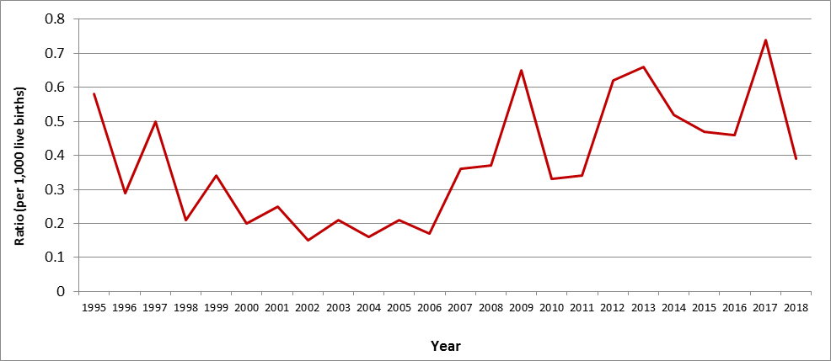

8. Education
Boys and girls are equally likely to go to pre-primary and primary schools.The Gender Parity Index (GPI) which measures the relative educational participation of boys and girls was 1.0 for both pre-primary and primary, indicating no disparity (Table 7).
Table 7 – Gross Enrolment Rates (%) by sex, Republic of Mauritius, 2018
Gross Enrolment Rate | Male | Female | Total | Gender Parity Index
Pre-Primary (4 - 5 years) | 95 | 97 | 96 | 1.0
Primary (6 - 11 years) | 96 | 97 | 97 | 1.0
Secondary (12 - 19 years) | 74 | 80 | 77 | 1.1

At the end of primary, girls generally perform better than boys at the Primary School Achievement Certificate (PSAC) examinations. In 2018, the pass rate for girls was nearly 84.5% against 73.2% for boys.
At secondary level, girls are more likely to be enrolled than boys. The Gender Parity Index (GPI) in secondary enrolment, which measures the relative access to secondary education of males and females was 1.1 in 2018 showing a disparity in favour of girls.
Girls are less likely than boys to drop out from secondary academic stream, 4.7% against 8.0% for boys (Chart 11).
Chart 11 – Drop-Out Rate at secondary academic stream, Republic of Mauritius, 2009 - 2017
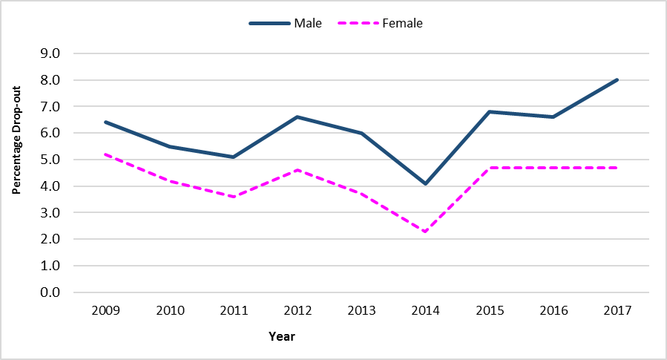

Girls generally perform better than boys at Higher School Certificate (HSC) examinations (Table 8).
Table 8 – Pass Rate (%) at HSC, Republic of Mauritius, 2010 - 2018
Year | Male | Female
2010 | 73.7 | 81.7
2011 | 75.3 | 82.3
2012 | 74.8 | 82.2
2013 | 73.9 | 80.8
2014 | 70.0 | 79.1
2015 | 72.0 | 77.8
2016 | 70.9 | 78.2
2017 | 69.5 | 77.9
2018 | 70.6 | 78.0

Consequently, more women than men are enrolled in tertiary institutions. Tertiary enrolment for both girls and boys increased over time but with a widening gap in favour of girls.Tertiary enrolment, as measured by Gross Tertiary Enrolment Rate (GTER), rose from 16.0 in 2000 to 54.3 per cent in 2017 for women, and from 14.1 to 38.9 per cent for men during the same period. In 2017, women enrolled in public, private and overseas tertiary institutions numbered 27,655, representing 57.6% of the student population which stood at 48,007.
Chart 12 – Gross Tertiary Enrolment Rate (GTER), Republic of Mauritius, 2000 - 2017
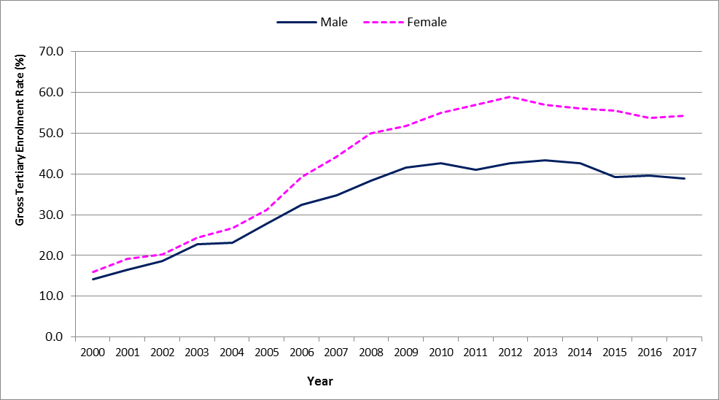
Both men and women were mostly enrolled in Bachelor Degree (Table 9). There were fewer women than men at PhD, MPhil and DBA² levels, 235 women against 285 men. As a result, women continue to be under-represented in research.
Table 9 – No. of student enrolled¹ in tertiary institutions by level, 2017
Level | Male | Female | Total
PhD | 164 | 133 | 297
MPhil | 82 | 87 | 169
DBA² | 39 | 15 | 54
Masters Degree | 1,816 | 2,015 | 3,831
Post Graduate Diploma | 51 | 42 | 93
Post Graduate Certificate | 190 | 505 | 695
Professional | 2,527 | 3,486 | 6,013
Bachelor Degree | 8,298 | 11,431 | 19,729
Diploma | 1,111 | 1,582 | 2,693
Certificate | 153 | 400 | 553
All levels | 14,431 | 19,696 | 34,127

¹Enrolment in public and private institutions, including students studying through Distance Education mode but excluding overseas students
² Doctor of Business Administration

Accounting and Administration/Management were the most popular fields of study for both men (20.9% and 16.6% respectively) and women (21.8% and 18.1% respectively). Information Technology was the third most popular subject for men (15.0%) followed by Engineering (10.3%). Education was the third choice for women (10.6%).
Women were under-represented in science related fields such as Engineering (2.0% against 10.3%) and Information Technology (5.4% against 15.0%) whereas men were under-represented in Education (4.1% against 10.6%) and Languages (1.3% against 4.5%) (Chart 13).

Chart 13 – Number of student enrolled¹ in tertiary institutions by field of study, 2017
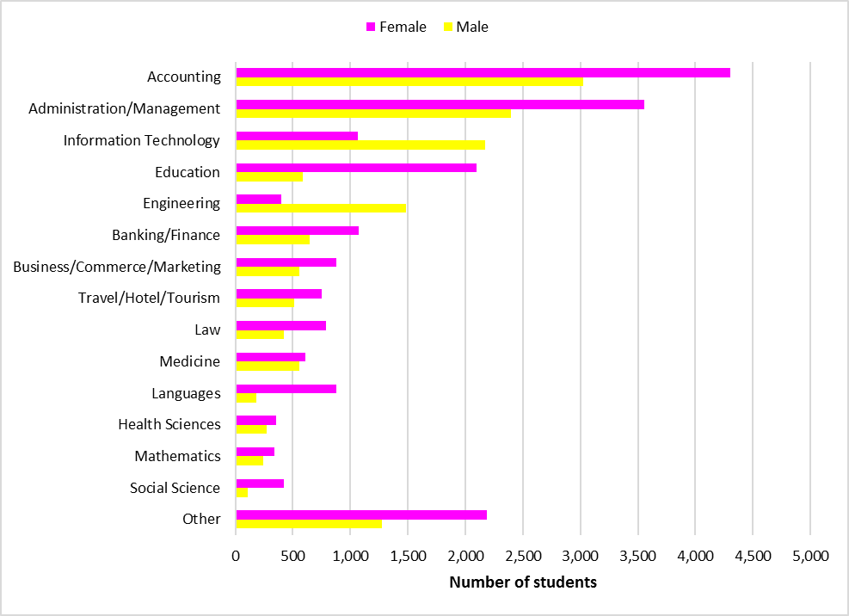
¹Enrolment in local public and private institutions, excluding overseas students

9. Economics Characteristics
In 2018, the active Mauritian population (aged 16 years and above) stood at 583,800 with 352,800 men and 231,000 women. Around 46% of women of working age was in the labour force compared to 73% of men.
The number of persons aged 16 years and over not forming part of the labour force (population outside the labour force) stood at 407,100 (130,000 males and 277,100 females).
During the period 2005 to 2018, male activity rate was consistently higher than female activity rate. However, the gap has been narrowing over time as the activity rate for men has been decreasing over the years from 78.8% in 2005 to 73.1% in 2018, while that of females has been generally increasing from 41.6% in 2005 to 46.6% in 2015. However, the female activity rate dropped to 45.5% in 2016. After a slight increase in 2017 to 45.7%, it dropped again to 45.5% in 2018 (Chart 14).

Chart 14 – Activity rate (%) by sex, 2005 - 2018
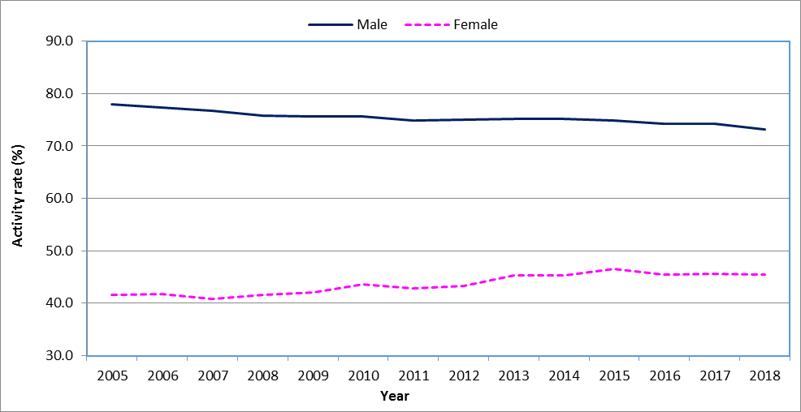

Men and women have a similar age pattern of economic activity, i.e., less active at the younger and older age-groups (Chart 15). Over the years, the shape of the curve for female activity rate by age has been tending towards that of the male. The increase in the level of activity among women was more pronounced among those aged 25 to 29 years.

Chart 15 – Activity rate (%) by age-group and sex, 2008 and 2018
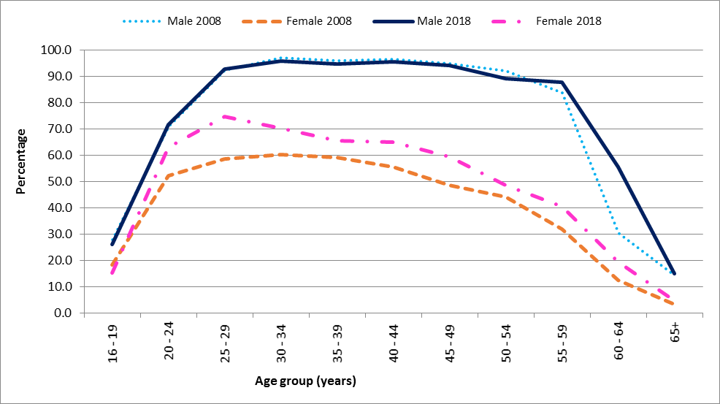
Table 10 – Employed persons by industrial sector and sex, 2018
 | Male |  | Female
Industrial sector | Number | % | Number | %
Primary | 26,300 | 7.8 | 8,700 | 4.2
Secondary | 97,400 | 29.0 | 32,400 | 15.6
Tertiary | 212,400 | 63.2 | 166,500 | 80.2
All sectors | 336,100 | 100.0 | 207,600 | 100.0

Both women and men had a high proportion of their working population in the tertiary sector (covering trade, accommodation service, transportation, health, education and other service industries), 63.2% for men and 80.2% for women. The secondary sector (covering manufacturing, electricity & water and construction) accounted for 29.0% of the working men and 15.6% of the working women. The primary sector (comprising agriculture and mining & quarrying) employed 7.8% and 4.2% of the working men and women respectively (Table 10).

Table 11 – Distribution (%) of employed persons by employment status and sex, 2018
Employment status | Male (%) | Female (%)
Employer | 4.7 | 1.5
Own Account Worker | 17.9 | 8.7
Employee | 76.6 | 86.1
Contributing Family Worker | 0.8 | 3.7
All status | 100.0 | 100.0

Women were more likely than men to be employees, with 86.1% of the female workforce in that employment status as compared to 76.6% for the male workforce. Women were also less likely than men to work for themselves. Some 22.6% of working men were employers or own account workers compared to 10.2% for women (Table 11).
On average, a woman worked 5 hours less than a man. In 2018, the average number of hours worked per week by women was 35.4 compared to 40.7 for men.
Across all occupational groups, women on average earned less than men. In the occupational category of managers, professionals and associate professionals, women earned on average 76.2% of what men earned. In elementary occupations, women earned 55.1% of what men earned (Table 12).

Table 12 – Average monthly income (Rs) of employees by occupational group, 2018
Occupational group | Average monthly income (Rs)
Occupational group | Male | Female
Managers; Professionals; Technicians and associate professionals | 42,800 | 32,100
Clerical support workers | 21,800 | 19,800
Service and sales workers | 21,400 | 12,700
Skilled agricultural, forestry and fishery workers; Craft and related trade workers; Plant and machine operators and assemblers | 16,300 | 10,700
Elementary occupations | 14,700 | 8,100
All occupational groups | 24,400 | 18,600

In spite of being fewer in the labour force (representing only 39.6%), women were over represented among the unemployed; they made up 58.4% of the total unemployed. Unemployed women numbered 23,400 in 2018 compared to 16,700 men. Female unemployment rate stood at 10.1%, much higher than the rate of 4.7% for male. The disparity between male and female unemployment rate was highest in the lower age-groups; the difference was nearly 8 percentage points among the unemployed below 25 years and around 1 percentage point among those aged 50 years and above (Chart 16).

Chart 16 – Unemployment rate (%) by age-group and sex, 2018
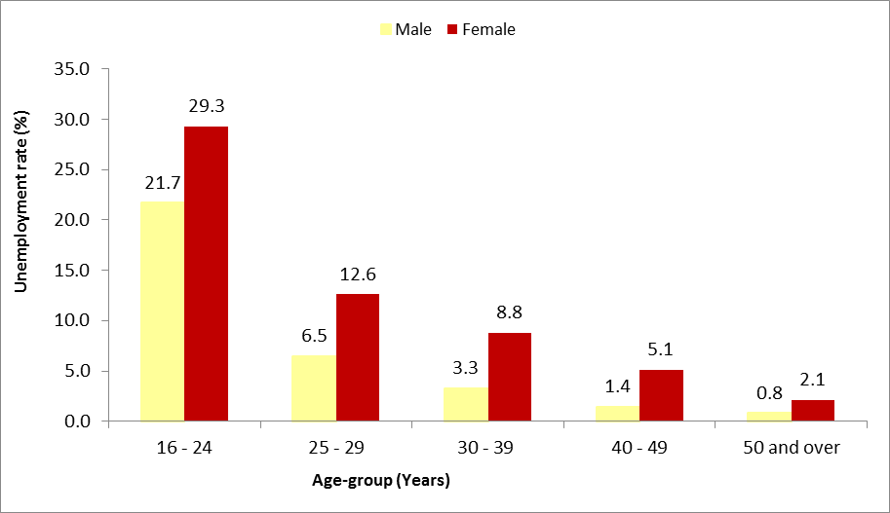
Unemployed women were generally more qualified than their male counterparts; 7,300 (31.2%) of them possessed the School Certificate (SC) or Higher School Certificate (HSC) against 4,300 males (25.7%). Also, 6,800 (29.1%) unemployed women attained tertiary level education compared to 3,700 (22.2%) unemployed men.
Table 13 – Unemployed persons by educational attainment, 2018
 | Male |  | Female
Educational attainment | Number | % | Number | %
Primary | 1,900 | 11.4 | 2,600 | 11.1
Below CPE | 1,400 | 8.4 | 2,200 | 9.4
Passed CPE | 500 | 3.0 | 400 | 1.7
Secondary | 11,100 | 66.5 | 14,000 | 59.8
Form I - V but not passed SC | 6,800 | 40.7 | 6,700 | 28.6
Passed SC | 2,100 | 12.6 | 3,900 | 16.7
Passed HSC | 2,200 | 13.2 | 3,400 | 14.5
Tertiary | 3,700 | 22.2 | 6,800 | 29.1
All Educational attainments | 16,700 | 100.0 | 23,400 | 100.0

10. Poverty
Poor households are households found below the relative poverty line estimated from the Household Budget Survey (HBS). The poverty lines for 2012 and 2017 were estimated at Rs 5,652 and Rs 7,497¹ respectively,
Women are more likely than men to live in poverty. In 2017, 11.0% of the female population was living below poverty line compared to 9.6% for the males. Out of 130,500 persons in relative poverty, 70,300 were females and 60,200 were males.
The 2017 HBS showed that poverty is more likely to be among female headed households than male headed households (15.9% compared to 7.6% in 2017).

Table 14 – Number of persons in relative poverty, 2012 and 2017
 | 2012 | 2017¹
Relative poverty line (Rs) | 5,652 | 7,497
Persons in relative poverty
Both sexes | 122,700 | 130,500
Male | 56,000 | 60,200
Female | 66,700 | 70,300
¹ Provisional
11. Social benefits and senior living in infirmaries
As at June 2018, out of 215,334 Basic Retirement pensioners, 55.5% were women (Table 15). During that period, the number of women receiving Basic Retirement Pension outnumbered their male counterparts by 23,698 and this number is expected to increase to around 32,800 by 2047. Both male and female pensioners were concentrated in the age-group 60 to 69 years. It is to be noted that 73.3% of the pensioners in the age group 90 to 99 were women. For every male centenary pensioner, there were 4 female centenary pensioners.
There were 19,282 recipients of Basic Widows Pension as at June 2018, a decrease of 7.3% compared to 20,795 in 1998. A large majority (68.7%) of widows were aged between 50 and 59 years.
Invalids pensioners numbered 32,075 as at June 2018, with a higher proportion of men (53%) compared to women (47.2%).
As at June 2018, some 349 children received Basic Orphans Pension, amongst whom 51.3% were girls.

Table 15 – Number of beneficiaries of selected benefits, 1998 and 2018
 | June 1998 |  |  |  | June 2018
Pension type | Male | Female | Total |  | Male | Female | Total
Basic Retirement Pension | 37,059 | 48,210 | 85,269 |  | 95,818 | 119,516 | 215,334
of whom 90 years and above | 399 | 1,191 | 1,590 |  | 1,117 | 3,104 | 4,221
Basic Widow's Pension | n/a | 20,795 | 20,795 |  | n/a | 19,282 | 19,282
Basic Invalid's Pension | 8,814 | 8,692 | 17,506 |  | 16,927 | 15,148 | 32,075
Basic Orphan's Pension | 387 | 351 | 738 |  | 170 | 179 | 349

In 2018, some 57.0% of the 644 inmates living in infirmaries and orphanages registered at the Ministry of Social Security, National Solidarity and Environment and Sustainable Development (Social Security Division), were women. The women residents were older than men with 32.2% aged 80 years and over compared to 15.9% for men.

Chart 17 – Number of Inmates in infirmaries and orphanages by age group and sex, 2018
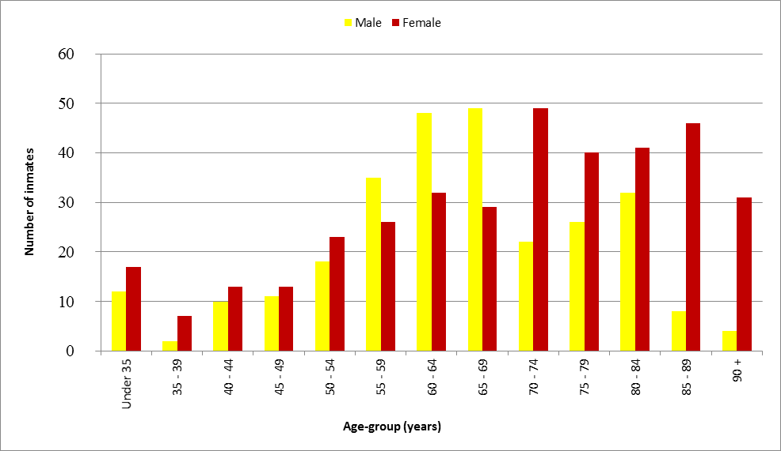
Women inmates were more likely than men to suffer from a disease or a disability (Table 16). Women inmates suffered mostly from other disabilities including multiple disabilities (45.5%) and from mental diseases (19.6%), whereas men inmates suffered mostly from mental diseases (36.1%) and other disabilities including multiple disabilities (21.7%).

Table 16 – Distribution (%) of inmates in infirmaries and orphanages by disability, 2018
Disability | Male (%) | Female (%)
Loss of sight | 2.5 | 1.6
Partial paralysis | 9.7 | 4.9
Mental diseases | 36.1 | 19.6
Heart diseases | 2.9 | 3.3
Rheumatism | 2.2 | 2.5
Asthma | 3.6 | 1.1
Diabetes | 6.5 | 13.1
Other (including those suffering from multiple disabilities) | 21.7 | 45.5
Inmates with no disabilities | 14.8 | 8.4
Total | 100.0 | 100.0
12. Women in decision making
Women continue to be underrepresented in decision-making position in Government cabinet. The share of women among cabinet ministers was 8.7% in 2018 (2 out of 23 Ministers).
Even though the proportion of women elected at Municipal Council elections has increased over the years, the number of female mayors remained low. In 2018, out of the five municipalities, only one has a female mayor
There has been an increase in the proportion of women holding senior positions in government services from 19.2% in 1997 to 40.0% in 2016. However, data from 2017 to 2018 indicate that the proportion of women in the most senior positions was 37.0%.

Chart 18 – Senior position¹ in Government Services, 1997– 2018
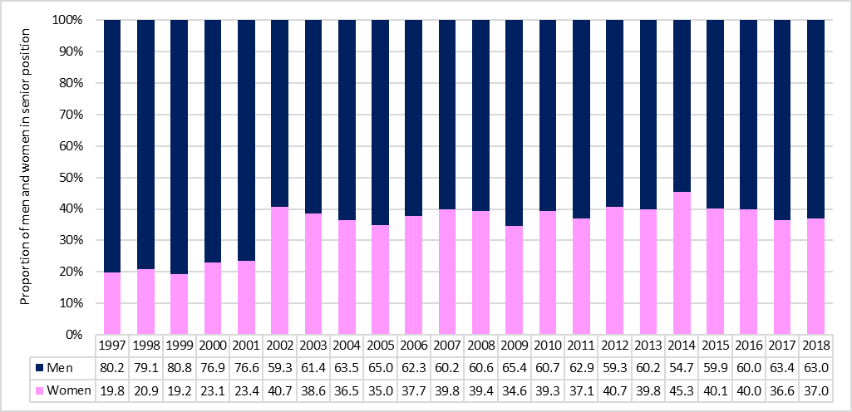
¹ Senior Chief Executive, Permanent Secretary, Deputy Permanent Secretary, Director, Manager, Judge and Magistrate

13. Domestic violence
Women are more likely to be victims of domestic violence. In 2018, out of 1,527 new cases of domestic violence reported at the Ministry of Gender Equality, Child Development and Family Welfare, 84.6% were against women. The number of new cases of domestic violence against women decreased from 1,483 in 2017 to 1,292 in 2018. On the other hand, the number of men victims of domestic violence increased from 220 to 235 during the same period (Chart 19).

Chart 19 – Number of new cases of domestic violence reported, 2010 - 2018
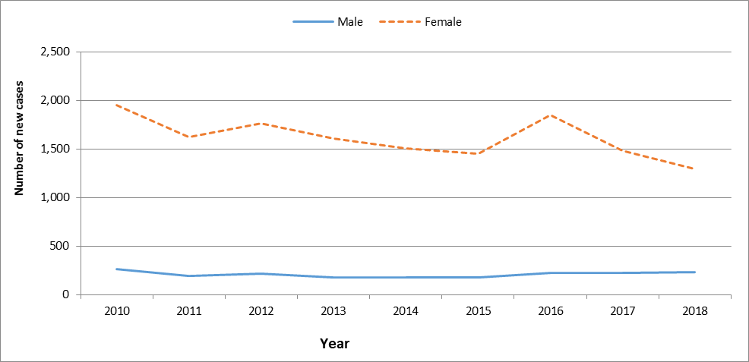
Some 32.1% of women victims of domestic violence reported physical assault by spouse or partner, 28.1% verbal assault by spouse or partner (ill treatment, harassment, abuse, and humiliation), 8.1% threatening assault by spouse and nearly 6.6% has been subjected to physical assault by others living under the same roof. Reported cases by men related mostly to verbal assault by spouse or partner (29.9%), physical assault by spouse or partner (21.5%) and verbal assault by others living under the same roof (10.0%).

The total number of cases reported at the Child Development Unit of the Family Support Bureau is generally on the rise and reached 5,565 in 2018 compared to 5,104 in 2017 (Chart 20).

Chart 20 – Number of cases reported at the Child Development Unit, 2000 - 2018
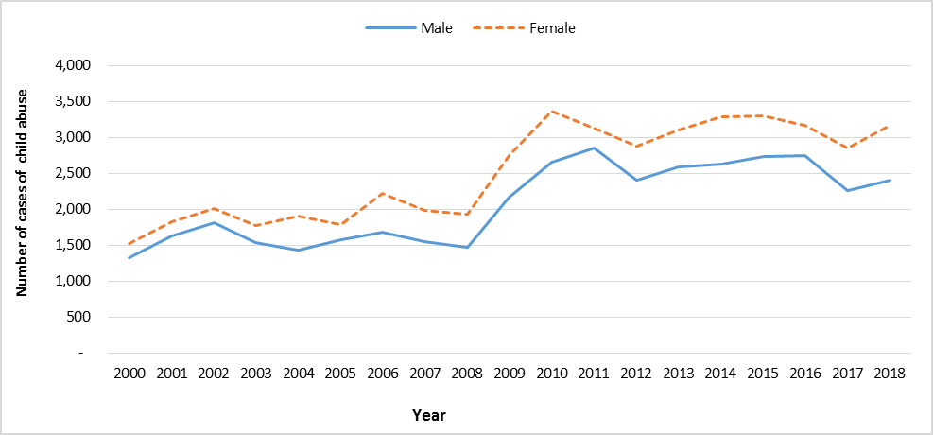
Of the reported cases in 2018, some 56.9% of the victims were females. The most common nature of abuse was psychological/emotional (27.6% for male and 24.1% for female) followed by neglect cases (17.3% male and 13.0% for female) and physical abuse (9.8% for male and 7.0% for female).

Table17 – Cases reported at Child Development Unit by nature of problem, 2018
Nature of Problem | Male |  | Female
Nature of Problem | Number | % | Number | %
Abandonment | 34 | 1.4 | 41 | 1.3
Physical abuse | 236 | 9.8 | 223 | 7.0
Neglect cases | 415 | 17.3 | 412 | 13.0
Worst forms of Labour | 5 | 0.2 | 5 | 0.2
Sexual abuse | 30 | 1.3 | 331 | 10.5
Psychological /Emotional abuse | 661 | 27.6 | 762 | 24.1
Other problems | 1,018 | 42.4 | 1,392 | 44.0
All problems | 2,399 | 100.0 | 3,166 | 100.0

14. Offences
Men are more likely to be victims of homicides and assaults, while women are more prone to sexual violence and sexual exploitation. In 2018, some 55.8% of the assaults and 64.0% of the intentional homicides were committed against men. Some 92.9% of victims of sexual violence and sexual exploitation were women (Table 18).

Table 18 –Victims¹ of selected offences² reported at the Police, Republic of Mauritius, 2018
Offences | Male | Female | Both sexes
Homicides | 77 | 32 | 109
of which Intentional homicides | 32 | 18 | 50
Assaults | 6,053 | 4,788 | 10,841
Sexual violence and sexual exploitation | 44 | 573 | 617
of which Rape | - | 48 | 48
¹A person may be victim of one or more than one offence and/or an offence may involve one or more victims
²Based on latest Classification of Crime for Statistical Purposes (ICCS) Version 1.0, developed by United Nations Office on Drugs and Crime (UNODC)
Boys are much more likely to commit offences than girls. In 2018, only 5% of the juvenile offences were committed by girls. The female juvenile delinquency rate stood at 1.1, while that for male was 9.9.

Table 19 – Number of Juvenile offenders¹ reported, Republic of Mauritius, 2018
 | Male | Female | Both sexes
Crimes | 245 | 7 | 252
of which drug offences | 20 | 1 | 21
Misdemeanours | 330 | 53 | 383
of which drug offences | 67 | 3 | 70
Contraventions¹ | 717 | 10 | 727
Total | 1,292 | 70 | 1,362
Juvenile Delinquency Rate² | 9.9 | 1.1 | 5.6

¹Persons aged 12 to 17 years
² Exclude contraventions established by camera
³Rate per 1,000 mid-year juvenile population and exclude contraventions

15. Sports
During the period 2015 to 2018, participation in high level sports was consistently lower among female athletes than male athletes. In 2018, participation among female athletes was 34.0% against 66.0% among male athletes (Table 20).

Table 20 – Participation of high level athletes in sports, 2015 - 2018
 | 2015 |  | 2016 |  | 2017 |  | 2018
 | Number | % | Number | % | Number | % | Number | %
Male | 80 | 65.0 | 63 | 63.6 | 69 | 67.0 | 93 | 66.0
Female | 43 | 35.0 | 36 | 36.4 | 34 | 33.0 | 48 | 34.0
Total | 123 | 100.0 | 99 | 100.0 | 103 | 100.0 | 141 | 100.0

The most common sporting disciplines in which women participated in 2018 were “athletics” (25.0%) followed by “handisports” (14.6%) and “weight lifting” (14.6%). For men, the most common sporting disciplines were “boxing” (19.4%), “judo” (17.2%) and “athletics” (17.2%) (Table 21).
Table 21 – Participation of high level athletes in sports, as at December 2018
Sports discipline | Male |  | Female
Sports discipline | No. | % | No. | %
Athletics | 16 | 17.2 | 12 | 25.0
Tennis | - | - | 1 | 2.1
Badminton | 5 | 5.4 | 5 | 10.4
Swimming | 6 | 6.5 | 3 | 6.3
Table Tennis | 4 | 4.3 | 4 | 8.3
Cycling | 5 | 5.4 | 2 | 4.2
Boxing | 18 | 19.4 | 1 | 2
Judo | 16 | 17.2 | 5 | 10.4
Weight lifting | 7 | 7.5 | 7 | 14.6
Triathlon | 1 | 1.1 | - | -
Fencing | 1 | 1.1 | - | -
Kick boxing | 4 | 4.3 | 1 | 2.1
Handisports | 8 | 8.6 | 7 | 14.6
Ju Jitsu | 2 | 2.2 | - | -
Total | 93 | 100.0 | 48 | 100.0
.

16. Global Gender Gap Indices
Since 2006, through the Global Gender Gap Report series, the World Economic Forum has been quantifying the magnitude of gender-based disparities and tracking their progress over time. By providing a comprehensive framework for benchmarking global gender gaps, the report identified countries that are role models in dividing their resources equitably between women and men, regardless of the overall resource level.
The Global Gender Gap Index (GGI) seeks to measure one important aspect of gender equality; their relative gaps between women and men across a large set of countries and across four key areas, namely: (a) economic participation and opportunity, (b) educational attainment, (c) health and survival and (d) political empowerment. The equality benchmark is considered to be one with no gap between men and women.
Between 2017 and 2018, Mauritius improved its ranking from 112 to 109 out of 149 countries worldwide (Table 22). Mauritius has closed both its education attainment, and health and survival gender gaps with indices nearing 1, and it has progressed due to increase in Political Empowerment subindexes (Table 23).

Table 22 – Global Gender Gap Index by selected countries, 2016 - 2018
Country | 2016 |  | 2017 |  | 2018
Country | Rank | Value | Rank | Value | Rank | Value
Iceland | 1 | 0.874 | 1 | 0.878 | 1 | 0.858
Norway | 3 | 0.842 | 2 | 0.830 | 2 | 0.835
France | 17 | 0.755 | 11 | 0.778 | 12 | 0.779
United Kingdom | 20 | 0.752 | 15 | 0.770 | 15 | 0.774
Canada | 35 | 0.731 | 16 | 0.769 | 16 | 0.771
South Africa | 15 | 0.764 | 19 | 0.756 | 19 | 0.755
Australia | 46 | 0.721 | 35 | 0.731 | 39 | 0.730
United States | 45 | 0.722 | 49 | 0.718 | 51 | 0.720
Singapore | 55 | 0.712 | 65 | 0.702 | 67 | 0.707
Madagascar | 60 | 0.704 | 80 | 0.692 | 84 | 0.691
Brazil | 79 | 0.687 | 90 | 0.684 | 95 | 0.681
China | 99 | 0.676 | 100 | 0.674 | 103 | 0.673
India | 87 | 0.683 | 108 | 0.669 | 108 | 0.665
Mauritius | 113 | 0.652 | 112 | 0.664 | 109 | 0.663
Pakistan | 143 | 0.556 | 143 | 0.546 | 148 | 0.550
Yemen | 144 | 0.516 | 144 | 0.516 | 149 | 0.499

Source: The Global Gender Gap Report 2018, World Economic Forum

Table 23 – Global Gender Gap Index for overall and four key areas, Republic of Mauritius, 2007 -2018
Year | Overall | Economic participation | Educational attainment | Health and survival | Political empowerment
2007 | 0.649 | 0.547 | 0.983 | 0.980 | 0.085
2008 | 0.647 | 0.527 | 0.988 | 0.980 | 0.091
2009 | 0.651 | 0.546 | 0.988 | 0.980 | 0.091
2010 | 0.652 | 0.549 | 0.988 | 0.980 | 0.091
2011 | 0.653 | 0.544 | 0.989 | 0.980 | 0.099
2012 | 0.655 | 0.554 | 0.990 | 0.980 | 0.095
2013 | 0.660 | 0.574 | 0.991 | 0.980 | 0.096
2014 | 0.654 | 0.551 | 0.990 | 0.980 | 0.097
2015 | 0.646 | 0.534 | 0.991 | 0.980 | 0.078
2016 | 0.652 | 0.550 | 0.991 | 0.980 | 0.087
2017 | 0.664 | 0.595 | 0.992 | 0.980 | 0.090
2018 | 0.663 | 0.585 | 0.991 | 0.980 | 0.097

Contact Person: Ms S. Sham-Jacmohun
Senior Statistical Officer
Statistics Mauritius
LIC Centre, Port Louis
Tel: (230) 4053315
Fax: (230) 2082041
Email: mow-stats@govmu.org

Statistics Mauritius
Ministry of Finance and Economic Development
Port Louis
July 2019

Appendix: Definitions of terms
Activity rate: The ratio (%) of the economically active population (employed and unemployed) to population aged 16 years and above.
Age specific fertility rate: the number of live births to women of a specified age-group per 1,000 women in that age-group.
Assault: Assault is defined as intentional or reckless application of physical force inflicted upon the body of a person.
Athletics: Athletics is a collection of sporting events that involve competitive running, jumping, throwing and walking, such as sprints (100 m, 200 m,..), relays (4×100 m, 4×400 m), running (800 m, 1500 m,...), long jump, triple jump, high jump, hammer throw, javelin throw, race walking, etc
Contraventions: Contraventions are defined as offences that are punishable by: (a) imprisonment for a term not exceeding 10 days; (b) fine not exceeding 5,000 rupees.
Contributing Family Worker: A contributing family worker is a person who works without pay in an enterprise operated by a family worker.
Crimes: Offences that are punishable by: (a) penal servitude (b) fine exceeding 5,000 rupees.
Crude death rate: the number of deaths in a year per 1,000 mid-year population.
Current User of contraceptive method: A new acceptor who continues with the same or different method of contraception and pays regular return visits to the family planning service point to receive services and supplies.
Divorce rate: the number of persons divorced in a year per 1,000 mid-year population.
Employee: An employee is a person who works for pay for someone else, even in a temporary capacity.
Employer: An employer is a person who operates his/her own business or trade and hires one or more employees.
Employment: Employed population consists of Mauritians aged 16 years and above who have worked for pay, profit or family gain for at least one hour during reference week of a month. It includes those who are temporarily absent from work for reason such as leave with pay, leave without pay and temporary disorganisation of work (bad weather, breakdown of equipment, lack of order, etc).
Gross Enrolment Ratio (GER): Number of pupils enrolled in a given level of education, regardless of age, expressed as a percentage of the population in the relevant age-group
- 4 - 5 years for pre-primary
- 6 – 11 years for primary
- 12 – 19 years for secondary
Gender Parity Index (GPI): Ratio of the GER for female to the GER for male. It measures the relative education participation of boys and girls. A GPI of 1 reflects equal enrolment rate for boys and girls, whereas a GPI greater than 1 shows disparity in favour of girls.
HIV/AIDS: AIDS (Acquired immune deficiency syndrome or acquired immunodeficiency syndrome) is a disease caused by a virus called HIV (Human Immunodeficiency Virus).

Household income: It comprises income from work (both paid and self-employment), transfer income (mainly government pensions, regular allowances from relatives and organisations), property income, and income from owned produced goods and it also includes imputed rent – a rental value for non-renting households.
Intentional homicide: Intentional homicide is defined as unlawful death inflicted upon a person with the intent to cause death.
Juvenile: a person aged below 18 years.
Juvenile delinquency rate: the number of juvenile offenders involved in offences (excluding contraventions) per 1,000 juvenile population.
Life Expectancy at birth: the number of years a new born infant would live if prevailing patterns of mortality at the time of its birth were to stay the same throughout it life.
Marriage rate: the number of persons married in a year per 1,000 mid-year population.
Maternal mortality rate: number of deaths due to pregnancy, childbirth and the puerperium per 10,000 live births during that year.
Misdemeanors: Offences that are punishable by:(a) imprisonment for a term exceeding 10 days; (b) fine exceeding 5,000 rupees.
New acceptor of contraceptive methods: Someone who accepts a contraceptive method for the first time from a provider of a family planning programme.
Own Account Worker: An own account worker is a person who operates his/her own business or trade but does not hire employees. He/She may be working alone or with the help of contributing family workers.
Primary sector: Primary Sector comprises activities related to ‘Agriculture, hunting. Forestry and fishing’ and ‘Mining’.
Relative poverty line (RPL): It is a threshold below which a household/ person is deemed poor and is set as the ‘half median monthly household income per adult equivalent’.
Secondary sector: Secondary Sector comprises activities related to ‘Manufacturing, ‘Electricity, gas and water supply’ and ‘Construction’.
Sex Ratio: The sex ratio is defined as the number of males per 100 females.

Sexual violence: Sexual violence is defined as unwanted sexual act, attempt to obtain a sexual act, or contact or communication with unwanted sexual attention without valid consent or with consent as a result of intimidation, force, fraud, coercion, threat, deception, use of drugs or alcohol, or abuse of power or of a position of vulnerability.

Sexual exploitation: Sexual exploitation is defined as acts of abuse of a position of vulnerability, power or trust, or use of force or threat of force, for profiting financially, physically, socially or politically from the prostitution or sexual acts of a person.

Total fertility rate: the average number of children born to an average woman assuming that she survives to the end of her child-bearing age and is subjected to a fixed schedule of age-specific fertility rates.
Unemployment Rate: Unemployment rate is the ratio (%) of unemployment to economically active population (employed and unemployed).
Unemployment: Unemployed population comprises all Mauritians aged 16 years and over who are not working but who are looking for work and are available for work during the reference week.

