EDUCATION STATISTICS - 2015
1. Introduction

This issue of the Economic and Social Indicators presents data on education, compiled on the basis of information collected through the annual survey conducted in schools in March 2015, together with data from other sources. The data refer to the Republic of Mauritius (excluding Agalega) and cover pre-primary, primary, secondary (general and pre-vocational), technical & vocational, tertiary as well as education in specialised institutions.

It is to be noted that the Gross Enrolment Ratios for 2015 are based on Population figures revised according to the 2011 Population Census data. Ratios for year 2011 to 2014 are revised figures.

2. Expenditure

Total government expenditure for the first six months January to June 2015 and the financial year 2015/2016 are as follows:
- January to June 2015: Rs 58,480 million, of which, Rs 7,867 million (13.5%) has been allocated to education and training and
- July 2015 to June 2016: Rs 120,645 million, of which, Rs 16,003 million (13.3%) has
been allocated to education and training.

The total budget on education and training has been allocated as follows:
- January to June 2015: 52% to secondary education, 23% to primary education, 9% to
tertiary education, 3% to technical and vocational education, 2% to pre-primary
education and the remaining 11% to other expenses and
- July 2015 to June 2016: 51% to secondary education, 25% to primary education, 8%
to tertiary education, 3% to technical and vocational education, 2% to pre-primary
education and the remaining 11% to other expenses (Table 2.2 and Figure 1).

Figure 1 - Total Expenditure on Education, Republic of Mauritius
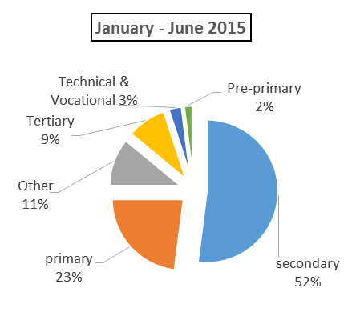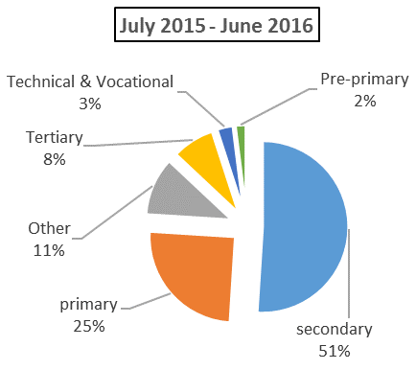
3. Pre-primary education

  - Schools

The number of schools providing pre-primary education stood at 939 in March 2015: 906 in the Island of Mauritius and 33 in Rodrigues. Of these schools, 686 (73%) were privately run institutions; 188 (20%), operating on government primary school premises, were administered by the Early Childhood Care and Education Authority (Ex Pre-School Trust Fund) and the remaining 65 (7%) were administered by either Roman Catholic (RC) or Hindu Education Authorities or Municipal/Village Councils (Table 3.1).

  - Enrolment

Enrolment in pre-primary schools decreased by 1%, from 30,142 in March 2014 to 29,832 in March 2015. Girls represented around 50% of the pre-primary school population (Table 3.3). The Gross Enrolment Ratio (pre-primary enrolment as a percentage of the population aged 4 and 5 years) works out to 101% compared to 98% in 2014.

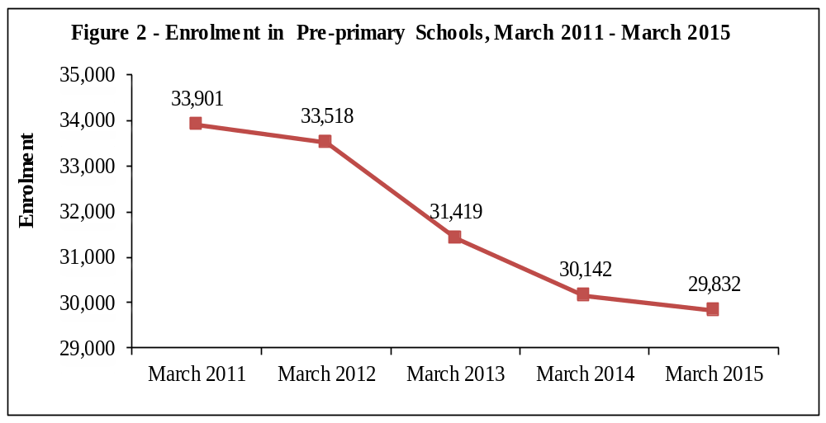
Figure 2 shows enrolment in pre-primary schools over the period 2011 to 2015. Enrolment dropped steadily from 2011 to 2012 followed by a significant decline from 2012 to 2014 after which it decreased slightly from 2014 to 2015.

  - Personnel

In March 2015, total employment in pre-primary schools stood at 3,300 of whom 2,284 were teachers and 1,016 non-teaching staff. This represents a decrease of 0.7% compared to 2014. The average number of pupils per teacher works out to 13, as in 2014.

4. Primary education

4.1 Schools

In March 2015, there were 320 schools providing primary education, same as in March 2014: 305 in the Island of Mauritius and 15 in Rodrigues. The majority (223) of the schools were run by government, 51 by the Roman Catholic Education Authority (RCEA),
2 by the Hindu Education Authority and the other 44 were private non-aided schools
(Table 4.1).

4.2 Enrolment

The primary school population in the Republic of Mauritius stood at 103,642 in 2015. Boys represented 51% of the 2015 primary school population. Around 68% of the primary school population was enrolled in government schools and the remaining was in private aided and non-aided schools (Table 4.3).

Distribution by grade (Table 4.5) shows that the highest number of pupils were in standard VI (19,600 pupils including 985 repeaters). The Gross Enrolment Ratio (primary enrolment as a percentage of the population aged 6 to 11 years) works out to 99%, against 97% in 2014.

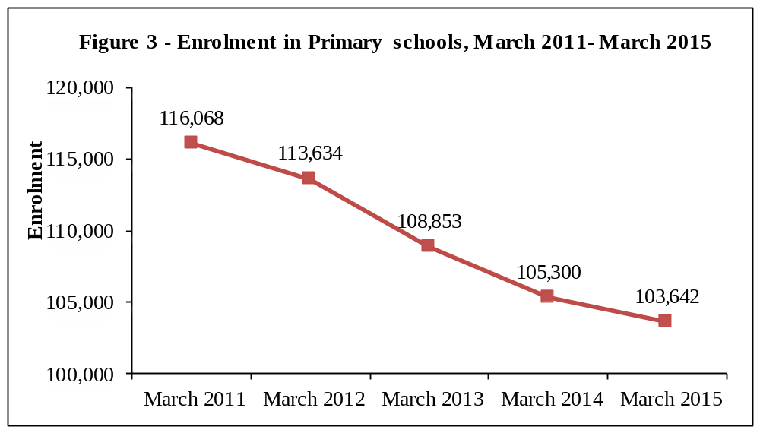

The graph shows a marked decline in primary enrolment from 2011 to 2014 followed by a steady decrease from March 2014 to March 2015.

4.3 Personnel

The number of persons employed in primary schools registered a decrease of 163 from 8,117 in March 2014 to 7,954 in March 2015. Of this number, 5,351 were teaching staff: 4,074 General Purpose Teachers and 1,277 Oriental Language Teachers. The remaining 2,603 comprised 285 Head Teachers, 924 Deputy Head Teachers and 1,394 administrative and other workers (Table 4.9). The pupil/teacher (general purpose) ratio in primary schools works out to 25, as in 2014.

  - Certificate of Primary Education (CPE)

In 2014, the number of school candidates who took part in the CPE examination was 20,717. Excluding re-sit, the overall pass rate works out to 69.4% compared to 70.3% in 2013.

The performance of girls exceeded that of boys with respective pass rates of 76.1% and 63.1% (Table 4.11 and Figure 4).
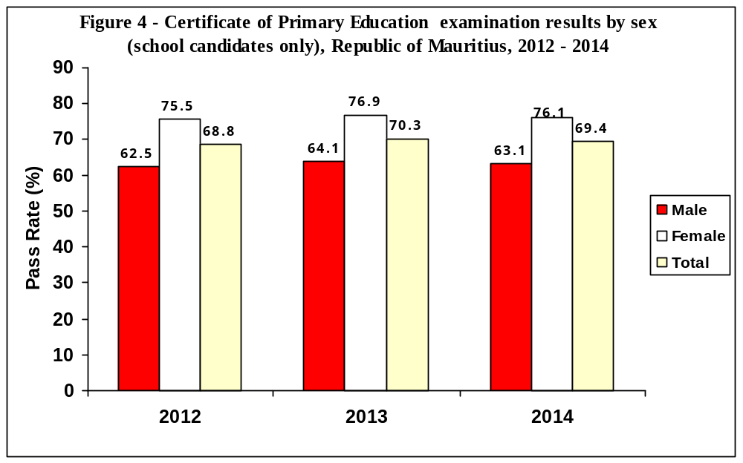

It is to be noted that the pass rate including re-sit school candidates works out to 72.9% (66.6% boys and 79.7% girls).

According to the analysis carried out by the Mauritius Examinations Syndicate on performance, the pass rate among the 2013 cohort of school candidates works out to 84.3%. The pass rate relates to school candidates who either passed at their first sitting in 2013 or their second sitting in 2014.

5. Secondary General and Pre-vocational Education

5.1 General and pre-vocational education

As at March 2015, the number of secondary schools offering both general and
pre-vocational education stood at 118 while 59 schools were offering general education only and one pre-vocational education only.

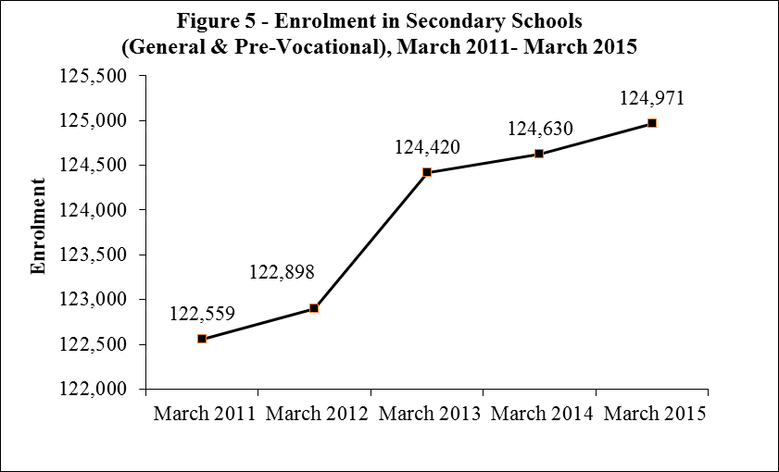

The graph depicts a steady rise in total secondary (including pre-vocational) enrolment from 2011 to 2012. Enrolment increased sharply in 2013 followed by a gradual increase from 2013 to 2015.

5.2 Secondary education (General)

5.2.1 Schools

Out of the 177 schools dispensing secondary general education, 170 were in the Island of Mauritius and 7 in Rodrigues. State administered schools numbered 68, while the other 109 were private aided and non-aided schools (Table 5.1).

5.2.2 Enrolment

Secondary education enrolment increased by 72 from 114,239 in 2014 to reach 114,311 in 2015. Table 5.3 shows that 59,617 (52%) were girls. Around 43% of the secondary school population was in state schools and 57% in private (aided and unaided) schools. Gross Enrolment Ratio (secondary education enrolment as a percentage of the population aged 12 to 19 years) for the general stream was 73% compared to 74% in 2015.

5.3 Pre-vocational education

5.3.1 Schools

As at March 2015, 119 schools were offering pre-vocational education: 112 in the Island of Mauritius and 7 in Rodrigues. Forty-four of these schools were state pre-vocational schools while the remaining 75 were private schools (Table 5.9).

5.3.2 Enrolment

Enrolment in the schools offering pre-vocational education was 10,660 comprising 6,976 boys (Table 5.11). Boys pre-dominate in secondary pre-vocational classes representing around 65% of enrolment. About 25% of the students in pre-vocational schools were in state schools. It is to be noted that some 1,975 Year IV students of the prevocational stream joined the 17 Mauritius Institute of Training and Development (MITD) centres as from January 2015 (1,300 boys and 675 girls).

5.4 Personnel

The number of teachers working in secondary schools offering general and
pre-vocational education decreased by 40 from March 2014 to reach 8,370 in March 2015.

The secondary education teaching staff in the general stream stood at 7,480
(2,395 males and 5,085 females), representing an increase of 0.7% over the 2015 figure. The pupil/teacher ratio works out to 15. On the other hand, the pre-vocational education teaching staff was 890, of whom 569 were females, giving an average of 12 pupils per teacher.

5.5 Cambridge School Certificate (SC)

In 2014, out of 15,632 candidates (7,061 males and 8,571 females) who took part in the Cambridge School Certificate examination, 11,475 were successful. Comparison with the 2013 results shows that the overall pass rate decreased from 75.0% to 73.4%
(Table 5.19 and Figure 6).
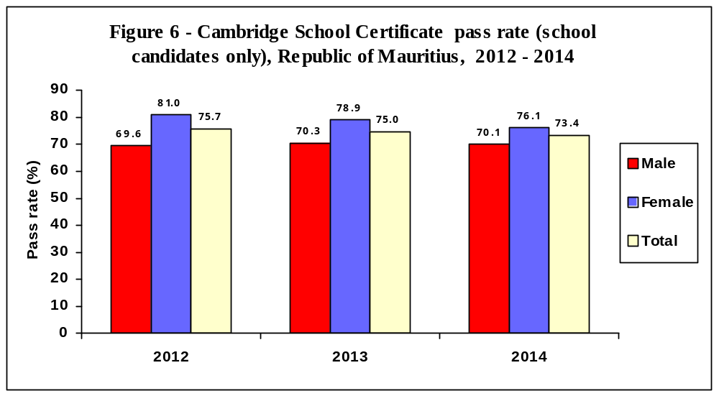

5.6 Cambridge Higher School Certificate (HSC)
The number of students taking part in the 2014 Cambridge Higher School Certificate examination stood at 10,429, of whom 59% were females. The overall pass rate is 75.4%, lower than the 2013 figure of 77.9% (Table 5.20 and Figure 7).

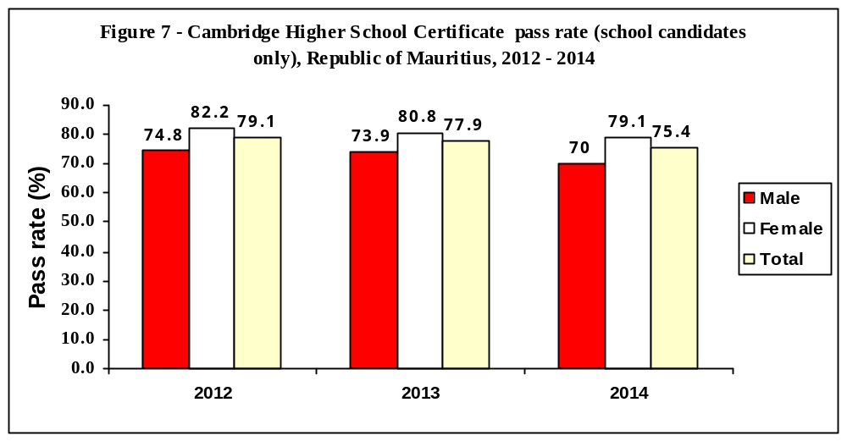

5.7 Technical and Vocational Education

In 2014, there were 8,290 students (of whom 70% were males) enrolled in publicly funded technical and vocational courses compared to 10,463 in 2013. Thirty three per cent of the students were enrolled in full-time courses, 51% in part-time courses and the rest (16%) in apprenticeship courses (Table 5.21).

6. Special Education Needs (SEN)
6.1 Schools

As at March 2015, there were 70 Special Education Needs schools in the Republic of Mauritius registered with the Ministry of Education and Human Resources, Tertiary Education and Scientific Research. Thirteen schools were run by Government, while the other 57 were run by NGOs (Table 6.1).

6.2 Enrolment

The number of students enrolled in the 70 special schools stood at 2,301 (of whom 64% were boys) as at March 2015 and has remained more or less stable compared to 2,291 in March 2014 (Table 6.3).

Table 6.6 shows that the two most frequent types of impairment were Intellectual Impairment (41%) and Physical Disability (9%).

6.3 Personnel
As at March 2015, there were 694 persons employed in the special education needs institutions representing an increase of 14% compared to March 2014. Out of these, 387 were teaching staff, and 108 were medical and para-medical staff. The remaining 199 were administrative and ancillary workers (Table 6.7).

7. ICT in Education

In March 2015, out of the 939 pre-primary schools in the Republic of Mauritius 439, (47%) had computers. All primary and secondary schools (general & pre-vocational) were equipped with computers. Availability of internet access for students in schools was as follows: 10% in pre-primary, 41% in primary and 99% in secondary (Table 7.1).

8. Tertiary Education

As at December 2014, the total number of students (part-time and full-time) enrolled on tertiary-level programmes (including Distance Education) reached 50,608 compared to 50,579 in December 2013, representing an increase of 0.1%. In 2013, there was an increase of 1.9% compared to 2012.

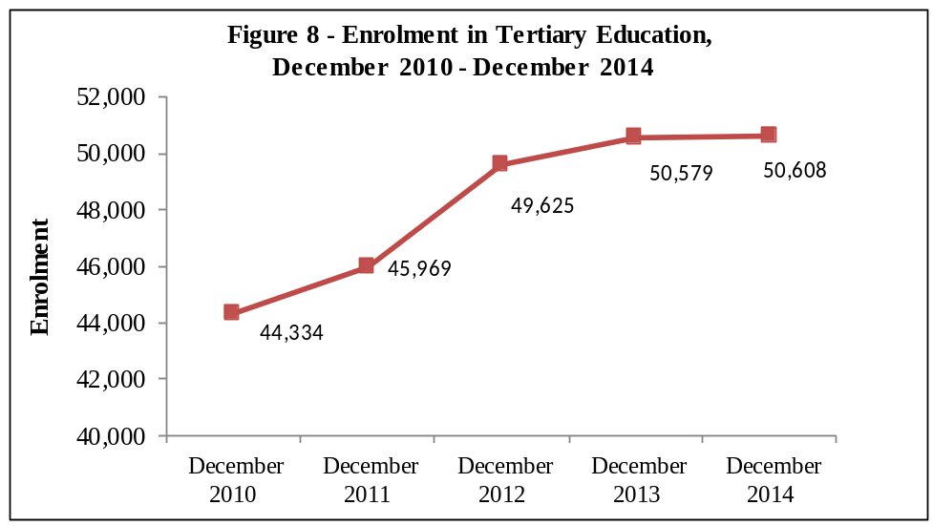.

Figure 8 gives the evolution of total tertiary enrolment over the period 2010 to 2014. Total enrolment rose appreciably from 2010 to 2013 and then almost stabilized in 2014.

The majority of students (80%) were enrolled in tertiary education locally in both public-funded institutions (45%) and private institutions (35%). The remaining 20% of the students were enrolled in tertiary education overseas (Table 8.1b).

The Gross Enrolment Ratio (tertiary education enrolment as a percentage of the population aged 20 to 24 years), which was 50.1 % in 2013, decreased to 49.2% in 2014.

Contact Person
F. Koussa (Mrs)
Statistician
Statistics Unit
Ministry of Education and Human Resources, Tertiary Education and Scientific Research
10th Floor, NPF Bldg, Rose Hill
Tel: 464 1303
Email: fkoussa@govmu.org
Statistics Mauritius
Ministry of Finance and Economic Development
Port Louis
Mauritius
September 2015

